Investigation of continuous induction welding of C/PAEK laminates

Gerard Bernhart, Gregory Erb

IRT Saint-Exupery, Composite Materials and Processes, B612, 3 rue Tarfaya, CS34436, 31405 Toulouse cedex 4, France
Email: gerard.bernhart@irt-saintexupery.com, gregory.erb@irt-saintexupery.com

Keywords: Thermoplastic, PAEK, welding, induction, temperature profiles

Abstract
Welding of thermoplastic materials requires a temperature at welding interface that is higher than polymer melting temperature. Induction heating of laminates manufactured with unidirectional C/PAEK plies was investigated in this work. Results gained during static tests, show that heating arises in the volume of the material and that fast heating rates can be achieved with a low thermal gradient trough the thickness of the laminate. In static and dynamic heating trials the surface temperature homogeneity and history is closely linked to induction coil geometry.

1. Introduction

Over the recent years there is an increased interest for the use of carbon fiber reinforced thermoplastic composites in aeronautical structures. Amongst the main advantages of these materials when compared with thermoset, infinite shelf life and higher production rate manufacturing processes have been highlighted. Another less considered interest is related to their ability to be assembled by welding that can lead to a decrease of manufacturing cost and time.

Amongst the numerous welding techniques available [1], the induction welding process shows a particular economical and industrial interest [2, 3] as it can be used in a continuous joining process that can be applied for example for stringer to skin bonding of large parts. If usefulness of this process has been demonstrated for welding of fabric reinforced composites, it was also reported that heating of unidirectional reinforced composites may be very difficult or impossible depending of the composite microstructure [4].

As a matter of fact, even if inducting heating of carbon fiber reinforced polymers is mainly related to the conductive fiber reinforcement, heating can occur only if a closed electrical path exists in the material. Three main heating mechanisms may be involved in the loop generation [5]: fiber heating mechanism related to Joule losses, dielectric hysteresis heating and contact resistance heating between fibers. Main mechanism may change with the change of fiber preform (i.e. woven fabrics or UD plies or angle plies) and fiber volume fraction. Most of available open literature is based on carbon fiber reinforced PPS or PA polymers. This work investigates the ability of C/PAEK laminates, intended to be used in future aircraft structures, to be heated by induction in a continuous susceptorless induction welding process.

In order to be able to compare with results reported in literature, a pancake coil geometry (figure 1a) was used. In a first step a static investigation was performed in subjecting several laminate stacking sequences to induction heating in changing coil-sample distance, heating power and heating time. It was shown that induction heating is possible for such laminates. Temperature profiles registered with thermocouples integrated between laminate plies, and rear side infrared thermography (figure 1b) temperature fields are discussed with respect to stacking sequence and heating parameters.

2. Materials and methods

2.1. Materials

Laminates were manufactured with unidirectional Carbon Poly-Ether-Ketone-Ketone (PEKK) prepregs (AS4 Hexcel carbon fibers and Arkema Kepstan® PEKK grade). The volume fraction of fibers is 60% and final ply thickness 0,136mm.
In order to investigate static heating response, 150 x 150 mm flat pregregs where press consolidated with two staking sequences : a 16 plies isotropic stacking (ISO16) and a non-isotropic 14 plies (QUD14) containing a majority of 0° plies (58%). Material temperature increase was registered using 0,1 mm type N thermocouples that have been integrated (before press consolidation) at top and rear surface as well as in the middle of the laminate. Type N thermocouples where chosen instead K ones due to their low sensitivity against electromagnetic heating. Rear face surface temperature field was also monitored with a Fluke Infra-red camera.
Samples for continuous induction welding trials where machined in autoclave consolidated sheets. The typical configuration for heating is shown in Figure 1b where thermocouples are inserted between the two samples to be welded. No additional susceptor material aiming to focus and promote local interface heating is included between the two samples. For interface temperature profile monitoring, the thermocouples are located and glued in surface grooves that are machined on the top of the bottom sample.

2.2. Induction welding equipment

A dedicated continuous induction welding equipment (Figure 1a) was designed and integrated. It is composed by three main sub-components : a 12kW induction generator supplied by CEIA, an own designed induction head and an ABB robot. Nominal working frequency with the pancake coil design used during this study is close to 200 kHz, and level of power can be set as a fraction of total 12kW power. The induction welding head integrates the induction coil, a pyrometer in order to control surface temperature, two compacting cylinders and two cooling nozzles that can be located either on the top or with a chosen angle with respect to surface. Welding head location and motion is selected through the programming of the robot. Typical motion speeds are between 1 and 10mm/s and coil/sample surface distances between 1 to 6 mm.

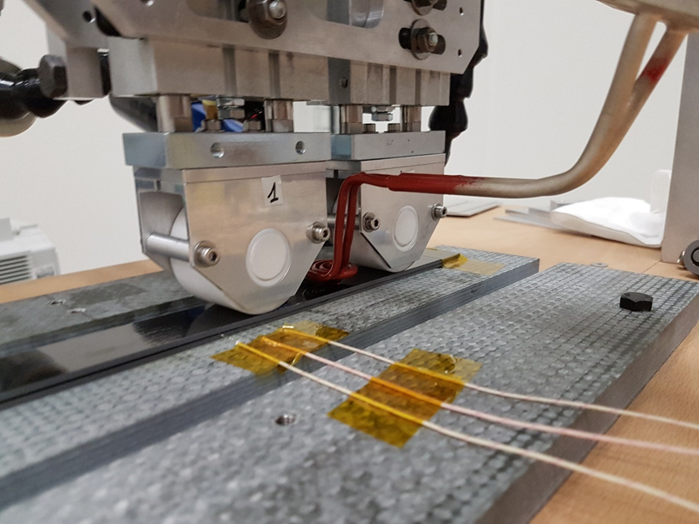
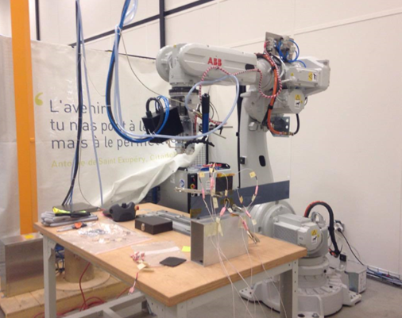

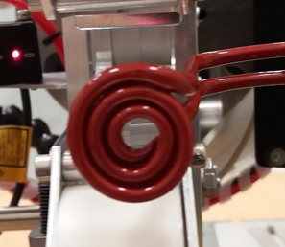
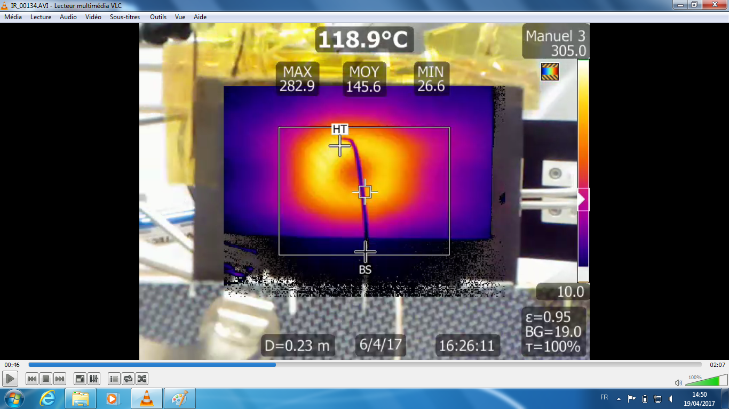
Figure 1. Induction welding equipement (a) and welding configuration (b)

3. Results and discussion

3.1. Static temperature increase during direct induction heating

Amongst the various coil geometries, results on pancake like shapes are often reported in literature [3,4,6] and such a shape is one who was also investigated during this work. It generates a circular heating area as it can be seen on the rear surface of the samples (Figure 2a). Local temperature profiles have been recorded with thermocouples located as shown in Figure 2b with respect to coil geometry : three thermocouples are located in the front of the hottest point of the coil (one at the top in front of the coil, one in the middle of the laminate and one on the rear of the sample) and one another at rear surface in the center of the coil.

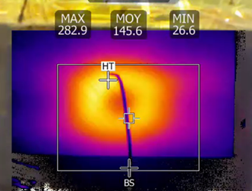

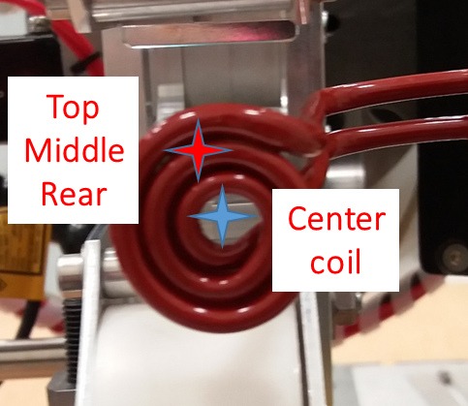
Figure 2. Rear surface temperature field (a) and thermocouple location (b)

Temperature profiles registered on sheet QUD14 during a heating run of 5 seconds at 25% power level and coil surface distance of 3mm are shown figure 3. Temperature increase of all thermocouples located under the coil is linear, very rapid and reaches 270°C in less than 5s. If maximum temperature is obtained in the center of the laminate, the thermal gradient across the thickness is very low (<10°C), indicating that laminates manufactured with high fiber volume fraction UD plies are able to generate electric close loops when subjected to electromagnetic fields. The low relative magnetic permeability combined with electrical resistivity at working frequency induces a high penetration depth that explains the low thermal gradient. There is no skin effect as observed on metallic materials.

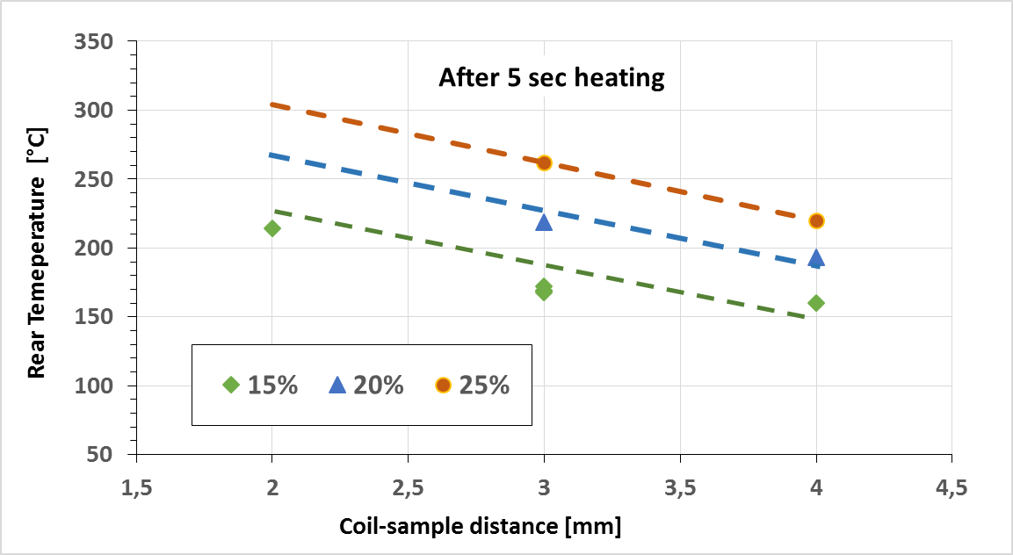
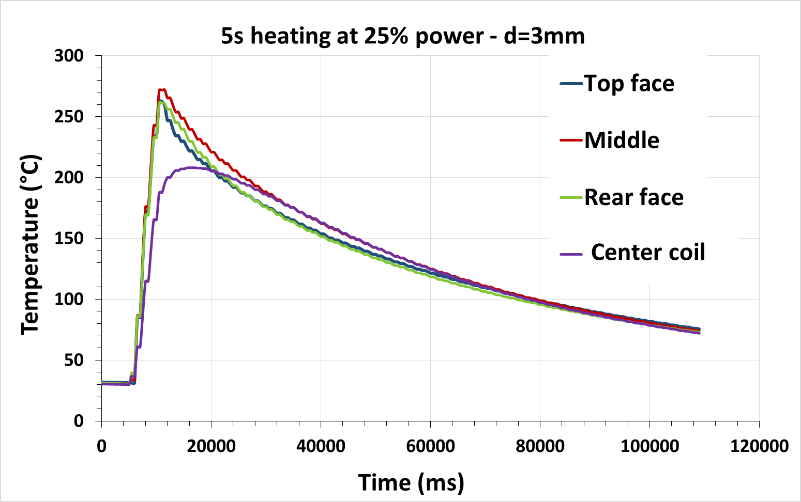
Figure 3 : Temperature profile during a 5s heating at 25% power |  | Figure 4 : Rear surface temperature with respect power and coil-sample distance

Response of rear center coil thermocouple is delayed when compared with those located under the coil. Temperature profile is mainly related to the in plane thermal conductivity of the laminate. It can be seen that due to the thermal delay maximum temperature reached is much lower (210°C) but temperature becomes quite uniform under the coil 10 s after power cut off.

Many test runs have been performed in order to investigate the effect of induction power level, heating time, coil-sample distance. Whatever the laminate stacking sequence the trends are similar. The maximum rear temperature after 5s heating on QUD14 sheet is plotted in Figure 4 against the coil-sample distance for 3 power levels (15%, 20% and 30%). For a given power level temperature decreases linearly with coil-distance, level of drop is close to 40°C for a 1mm coil-sample distance increase. A linear maximum temperature increase is also registered with respect to heating time whatever the power as shown in Figure 5. Nevertheless the slopes are not parallel on the contrary to coil-sample distance (Figure 4) and as expected, the higher the power the more rapid is temperature increase.

All these linear relationships are only valid up to the melting temperature of PEKK matrix that is close to 330°C. As it can be seen in Figure 5, for a power of 25% after a heating time of 10 s, rear sample maximum temperature is only 350°C in comparison to a value of 410°C with a linear evolution. As a matter of fact when overpassing melting temperature, as no mechanical pressure is applied during the induction heating test, a de-consolidation happens and intralaminar/interlaminar porosities appear. This has two main consequences : first the efficiency of the electrical induced loops decreases as the contact between the plies decreases and second thermal conductivity drops with respect to the level of porosities. This non linearity has to be taken into account when selecting the welding operational conditions.

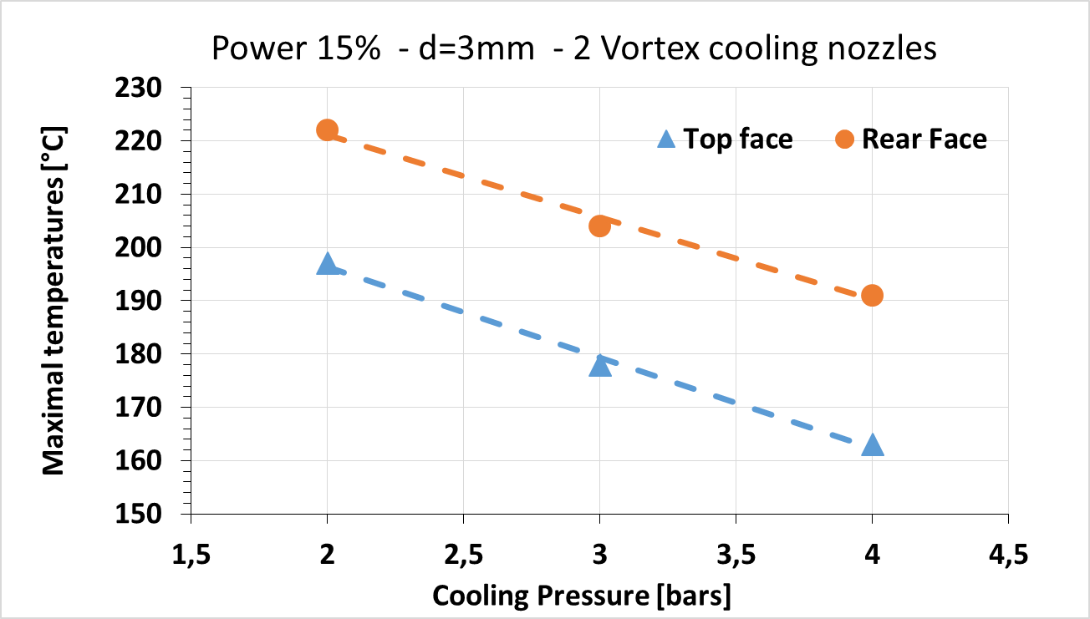
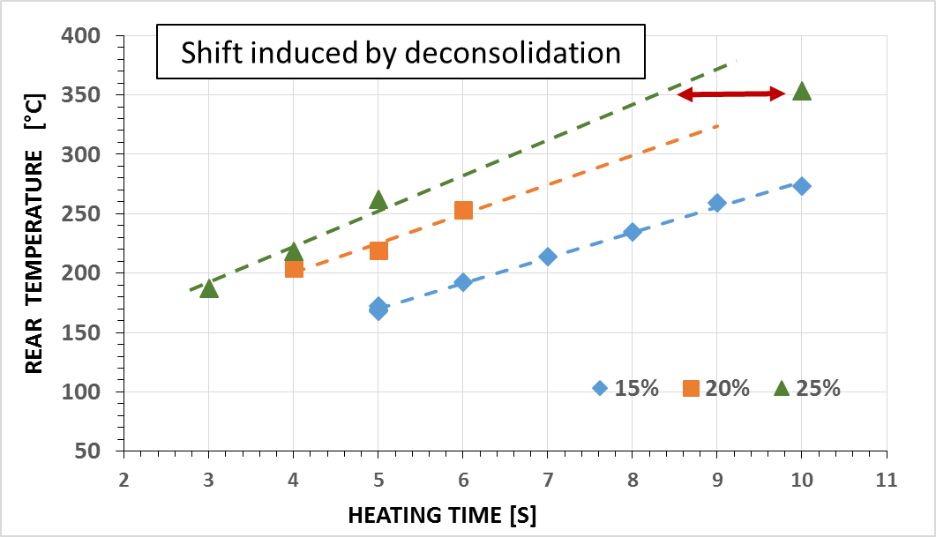

Figure 5 : Rear surface maximum temperature with respect to heating time and power |  | Figure 6 : Top and rear surface temperatures with Top surface air cooling

Top surface air jet cooling is reported [3,4,6] to be an interesting parameter in order to decrease maximum surface temperature and to localize maximum temperature at welding interface. Main surface degradation observed in this work is related to a modification of surface smoothness after re-consolidation by the compaction rollers. The induction head (Figure 1b) is equipped with 2 Vortex type cooling nozzles and air jet impact location can be modified if requested. For the test results reported in Figure 6, the two nozzles are blowing quasi orthogonal to the top surface on each side of the coil. Exhaust air temperature is lower than 5°C and cooling efficiency can be adjusted in varying air pressure. It can be seen on Figure 6, that for iso-conditions of power and coil-sample distance, the maximum temperature gradient that could be generated under these cooling conditions on the QUD14 laminate who has a thickness of 1.9mm is close to 25°C whatever the air pressure; top surface temperature is lower than rear face temperature. Increasing air pressure decreases mean sheet temperature without increasing thermal gradient, as a consequence to reach the same rear face temperature induction power has to be increased.

3.2. Dynamic interface temperature profiles during continuous induction welding

Temperature homogeneity and profile control are key parameters to be mastered if high mechanical properties of the joints are requested; such properties may be obtained if duration over the melting temperature is long enough to promote polymer chain reptation and if an adequate cooling speed is generated to promote crystallization. There are many extrinsic process parameters who interact during welding (coil design, coil-sample distance, induction power, welding speed, active cooling nozzle position) and it is difficult to find an optimum without having information’s on interface temperature evolution during a continuous welding run. Figure 7 shows a typical interface temperature profile during a welding run (welding speed of 2mm/s) performed with a 30mm wide top QUD14 sample on a 40mm ISO16 bottom sample. Thermocouples are located in a same section, one in the middle of the welding surface and the two others on the right and on the left, each at 12mm form the middle one. As expected, due to the pancake design of the coil, the center temperature profile is different from the two others. As a matter of fact in the center, the coil passes two times over the thermocouple location point which generates a first temperature increase, followed by a little dwell and a second increase. Nevertheless the surface homogeneity is good (surface gradient less than 20°C) and temperature profiles of the tree thermocouples are close to each other.

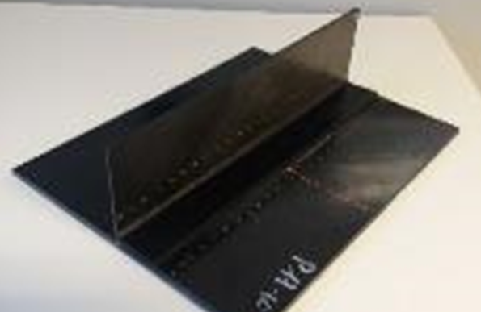
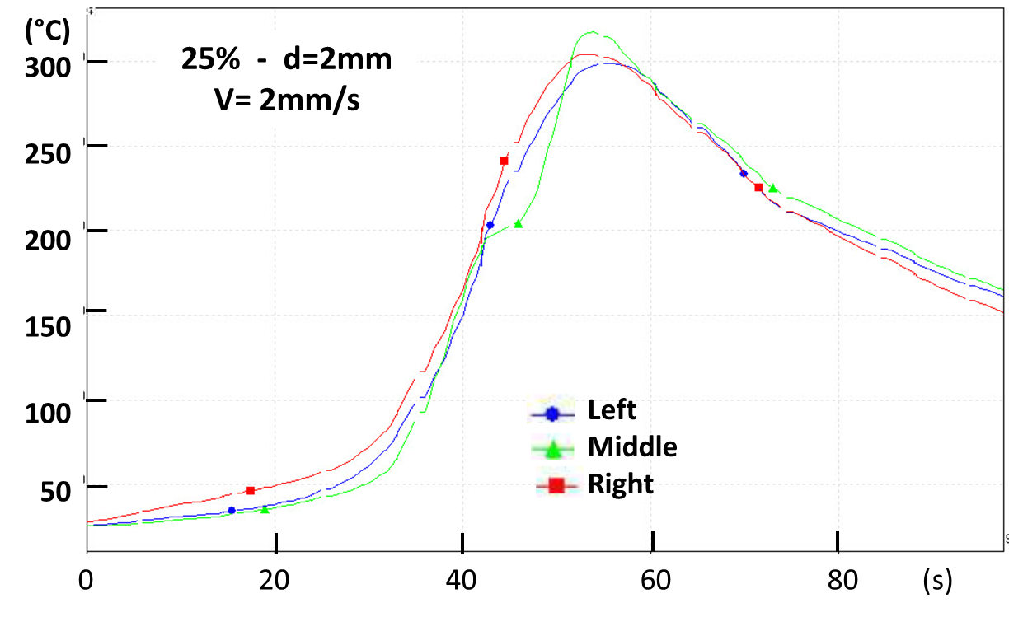

Figure 7 : Welding interface temperature profile during a welding run |  | Figure 8 : L-stringer welded on a flat sheet for mechanical pull of testing

Selection of optimized welding process parameter is a key step before aiming to weld stringers on flat sheets as shown in Figure 8.

3. Conclusions

Laminates manufactured by stacking of unidirectional plies of C/PEKK materials where investigated for direct induction heating. It was shown that whatever the staking sequence, induction heating is possible and very fast for such laminates. Moreover in the range of laminate thicknesses tested a very low thermal gradient was measured indicating that the volume heating is quite uniform through the thickness. As long as temperatures are lower than PEKK melting temperatures, linear evolution have been found between process parameters as induction power, heating time and coil-surface distance. If temperature overcomes polymer melting temperature a non-linear response appears related to laminate de-consolidation. Top surface cooling is able to generate a thermal gradient that may help to limit surface quality degradation after consolidation roller passing. Welding process parameter optimization needs the knowledge of temperature profiles on welding interface.

Acknowledgments

These results were obtained under the research project “SOFUSIN” at the IRT Saint Exupéry. We thank the industrial and academic members of IRT who supported this project through their contributions, both financial and in terms of specific knowledge:
Industrial members: Airbus Operations, ARKEMA, AVIACOMP, DAHER, STELIA, HUTCHINSON
Academic members: LTEN, CNRS
We also thank the “Commissariat Général aux Investissements” and the “Agence Nationale de la Recherche” for their financial support in the Programme d'Investissement d'Avenir (PIA).

References

[1] A. Yousefpour, M. Hojjati, and J. P. Immarigeon. Fusion Bonding/Welding of Thermoplastic Composites. Thermoplastic Composite Materials, 17: 303-341, 2004.
[2] T.J. Ahmed, D. Stavrov, H.E.N. Bersee, A. Beukers. Induction welding of thermoplastic composites – an overview. Composites: Part A, 37, 1638-1651, 2006
[3] T. Bayrel, M. Duhovic, P. Mitschang, and D. Bhattachryya. The heating of polymer composites by electromagnetic induction – A review, Composites: Part A, 57:27-40, 2014.
[4] R. Rudolf, P. Mitschang, and M. Neitzel. Induction heating of continuous carbon-fiber-reinforced thermoplastics, Composites/ Part A, 31:1191-1202, 2000.
[5] S. Yarlagadda, H.J. Kim, J.W. Gillespie, N.B. Shevchenko, and B.K. Fink. A study on the Indcution Heating of Conductive Fiber Reinforced Composites. Journal of Composite Materials, 36, 4:401-421, 2002.
[6] S. Pappada, A. Salomi, J. Montanaro, A. Passaro, A. Caruso, A. Maffezzoli. Fabrication of a thermoplastic matrix composite stiffened panel by induction welding. Aerospace Science and Technology, 43, 314-320, 2015

