**Comparative Study of Strain Energy Storage mechanisms between Carbon fibre-Reinforced PEEK and Epoxy composites subjected to Static and Cyclic Loading**

Thibault. P. A. Hernandez1, Andrew R. Mills1 and Hamed Yazdani Nezhad1

1Composite Centre, Cranfield University, Building 56, Cranfield, Bedfordshire MK43 0AL, UK

Email: t.p.hernandez@cranfield.ac.uk, Web Page: https://www.cranfield.ac.uk/people/thibault-hernandez-662815

**Keywords:** Thermoplastic PEEK, Strain energy storage, Plasticity, CFRP

**Abstract**

Experimental studies were performed on the strain energy storage behaviour of aerospace grade PEEK and toughened epoxy carbon fibre-reinforced composite prepreg laminates having identical fibre content. The strain energy stored up to failure was recorded at the highest point of deflection for static three point bending (3PtB) samples laminates with different thicknesses. Ductile and brittle behaviors at failure have been the key focuses of this study therefore cyclic loading tests were also performed. Firstly, high strain 3PtB fatigue loading was carried out on the two prepregs with identical quasi-isotropic stacking sequences, and secondly in order to characterise the plasticity parameters for the two laminates cyclic shear tests at high strain levels was carried out. The results have shown that the strain energy storage characteristics of the PEEK laminates are much better than those of the epoxy laminates in several ways; such as the independence of the strain energy storage level to thickness. Furthermore, at the same level of applied stress, the PEEK laminates tend not to lose strain energy compared to the toughened epoxy laminates. This study shows that the thermoplastic nature of the PEEK gives it an improved plasticity level which enhances its strain energy storage capability. PEEK carbon laminates are therefore serious candidates for spring applications.

# Introduction

Aerospace structures are transitioning from metallic to mixed metal/ composite materials. This move is directly linked with the need of lightweight and more efficient structure in term of lifetime, maintenance levels and structural integrity. Among those new materials, composite reinforced fibre polymers (CRFP) are one of the areas under strong investigations. Aerospace epoxy resins composite structures tend to lack in energy absorbance behaviour when impacted or highly strained. Indeed these composites tend to crack quickly due to the brittleness of the thermoset resin thus shorten the fatigue life [1]. The aerospace industry has therefore introduced toughened resin systems. Two categories could be distinguished into those resins types:

* Toughened epoxy resins (introduction of rubber mainly) like M21 or 977-6 [2]
* Thermoplastics and in particular PEEK which suits the aerospace requirement in harsh environments, having a high glass transition temperature and low moisture absorbance [3]

Increasing the toughness leads to high mechanical capabilities, many researchers [4, 5, and 6] have established the following conclusions on the subject:

* High energy stored in impact
* Resistance to moisture levels
* Fatigue resistance
* Resistance after damage or notches
* Strength retention after damage or scratching

Nevertheless strain energy storage capabilities have not been investigated as such; references 7 and 8 have shown the qualities of composites made of carbon or glass fibres qualities for springs applications but these were not focused on materials investigation but on design.

This study therefore looks focused on high strain testing of PEEK (TC1200/IM7) and 977-6 (977-6/T800) resins systems with carbon fibres in static and dynamic loadings cases to established the differences in their strain energy storage responses. Those differences have then been analysed to appoint their means in terms of design and manufacturing for best possible structural performance. Because of the industry targets of producing quasi-infinite lifetime structures, this study have chosen to test carbon fibre composites because of the low strain at the failure point of the carbon fibre. The current study is focused on strain energy based constitutive equations applied to composite laminas therefore unidirectional (UD) laminates were manufactured.

This paper is divided into three main sections:

* The samples manufacturing procedures
* The Test methods and data acquisition
* Results and discussions on material behaviour appliances

# Specimen manufacturing procedures and geometry

In order to produce aerospace grade materials related technical study, this comparative study has chosen two aerospace grades UD prepregs. One a toughened thermoset (TS) epoxy resin system (977-6/T800 [2]), and a thermoplastic (TP) PEEK one (TC1200/IM7 [3]). Those UD prepregs have a comparable thickness per layers as well as the resin content so that, lay-ups and structure comparison are actually possible. Although some studies on similar subjects choose comparable manufacturing process for both TS and TP, the optimum manufacturing processes are actually different for this study’s prepreg choice.

The though epoxy system, 977-6/T800, suits very well into a vacuum bag/autoclave process. It gives it its ideal lay-up mechanical properties and actually is recommended by aerospace industry to deal with this material. This study has then chosen vacuum bagging in an autoclave process for epoxy samples. The TS laminate curing cycle is described in Cytec specifications [2] with temperature ramp at 2°C/min to reach 135°C, curing duration of 3 hours and cooling rate of 3°C/min down to room temperature.

Even though autoclave process is an option for PEEK materials, a number of studies revealed that PEEK suffer from interlaminar weakness if processed without high pressured manufacturing processes [9]. This study then chooses compression moulding process for the PEEK samples. A mould had been then designed, made of D2 Steel (constant thermal expansion coefficient steel), that can handle very high temperature such as that in PEEK processing. The PEEK processing method was to manually stack 150mm×100mm layer into the mould cavity, heat the mould to 385°C, and apply a highly controlled 25kN onto the laminate to melt it. The cooling was done by air, maintaining the pressure during the cooling process.

The three different tests had different sample geometries and stacking sequences according to Table 1. Five samples were made for each tests, materials and thicknesses.

**Table 1: Samples geometries and stacking sequences**

|  |  |  |  |  |  |
| --- | --- | --- | --- | --- | --- |
| **Specimen Types** | **L (lengths mm)** | | **W (widths mm)** | **T (thicknesses mm)** | **Stacking sequences** |
| Static 3PtB test Epoxy | | 95 | 15 | 2.3mm/3.2 mm/4.5 mm/5.2mm | (45X/-45X/0X/90X)s with X=2 for 2.3mm and X=3 for 3.2mm X=4 for 4.5 and X= 5 for 5.2mm |
| Static 3PtB test PEEK | | 95 | 15 | 2.3mm/3.2 mm/4.5 mm/5.2mm | (45X/-45X/0X/90X)s with X=2 for 2.3mm and X=3 for 3.2mm X=4 for 4.5 and X= 5 for 5.2mm |
| Fatigue 3PtB test Epoxy | | 150 | 20 | 3.2 mm | (453/-453/03/903)s |
| Fatigue 3PtB test PEEK | | 150 | 20 | 3.2 mm | (453/-453/03/903)s |
| Cyclic shear test Epoxy | | 150 | 25 | 2.3mm | (45/-45)8s |
| Cyclic shear test PEEK | | 150 | 25 | 2.3mm | (45/-45)8s |

# Test methods

## Energy levels in Static 3 points bending

Composite 3pt Bending test is usually done on UD pre-pregs with anisotropic lay-up. It allows simpliefied straight-forward characterisation of the materials. In order to study the materials from a structural point a view, the 3pt Bending tests were carried out on quasi-isotropic lay-up as presented in Table 1. The span length chosen was 70mm on 5mm radius rolls with 1mm/min cross head displacement and extensometer data recording as shown in figure 1. As shown in the Table 1, this test had been performed on four different thickness of same stacking sequence order for the TS and TP.

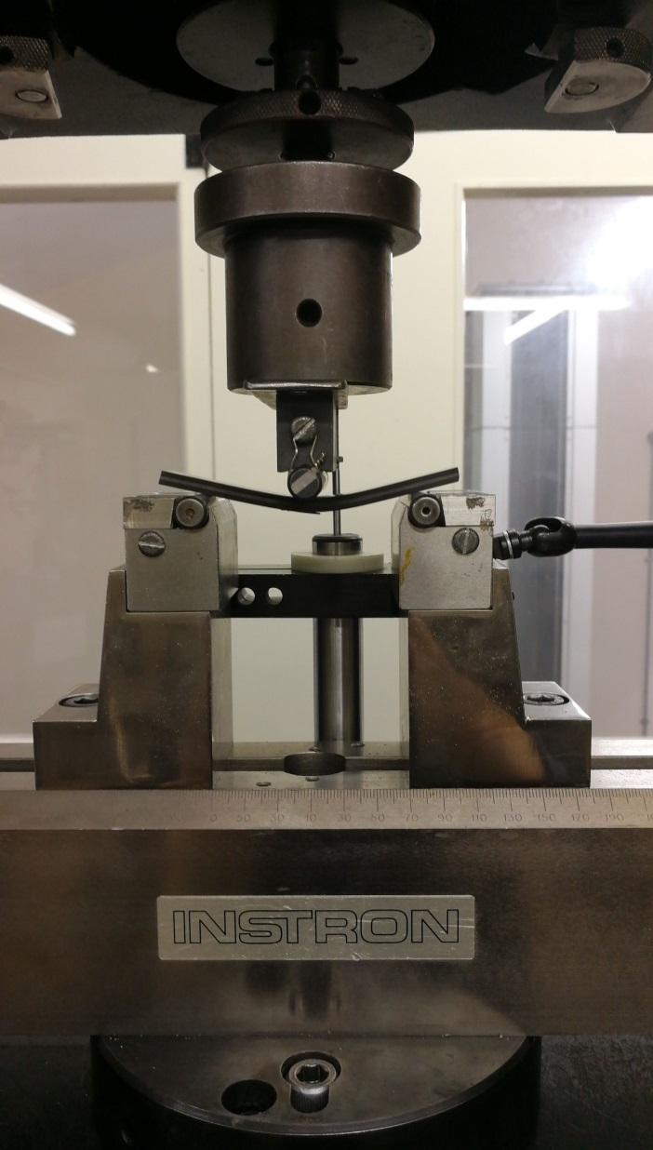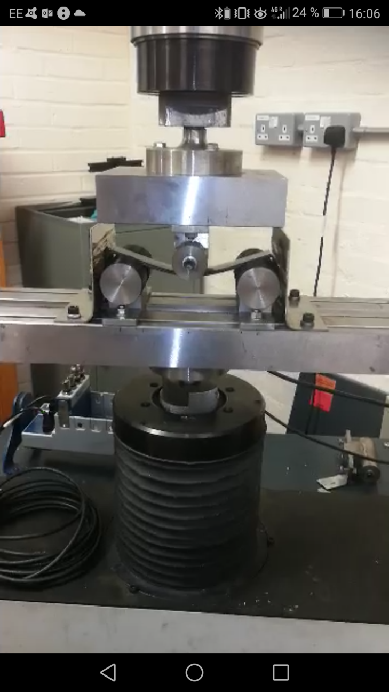

**Figure 1.** Static 3PtB (a) and Fatigue 3PtB (b) configurations

## Energy levels in Fatigue 3 points bending behaviour comparison

The fatigue 3pt Bending test was performed on similar arrangements of the static 3pt Bending one. The sample dimensions were slightly bigger in order to emphasize the differences. The span chosen was 100mm on 100mm radius rolls. The fatigue mechanical set up was chosen to be from 5 up to 75% of the epoxy sample’s ultimate static strength as shown in figure 2 making the fatigue test in a high strain region. The frequency of 2Hz for 10,000 cycles also gave this study a very severe strained sample output to identify the differences between the two materials.

968.93 N/25.74 mm

Region tested

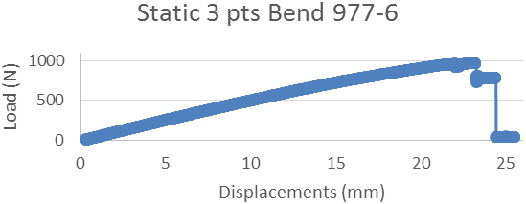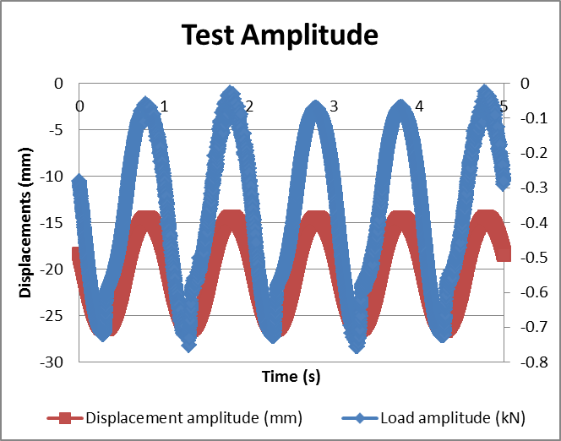

**Figure 2.** Fatigue mechanical set (a)/ Static 3 ptB 977-6/T800(b)

## Plastic cycle loading characterisations

In order to provide mechanical comparisons in high strain behaviour from the resin point of view, [45/-45]8S lay-ups were manufactured to be tested in cyclic tensile tests. From the ultimate strength of the two materials, some load-unload cycles had been targeted in a load-controlled testing condition. The micromechanical (e.g. failure and plasticity) mechanisms were then studied after the cycles under microscopy afterwards. Table 2 summarizes the targeted cycles:

Table 2: Cyclic tensile tests

|  |  |  |
| --- | --- | --- |
|  | **Cyclic shear test Epoxy** | **Cyclic shear test PEEK** |
| **Ultimate Strength (kN)** | 12,6 | 24,5 |
| **1st cycle (kN)** | 4 | 4 |
| **2nd cycle (kN)** | 8 | 8 |
| **3rd cycle (kN)** | 6 | 12 |
| **4th cycle (kN)** | 8 | 16 |
| **5th cycle (kN)** | 12 | 20 |

25mm×50mm tabs were adhered on both TS and TP samples in order to strain the middle section of the samples only, as shown in Figure 3. The samples then were tested at 2mm/min with strain being recorded with laser extensometer.

b

a

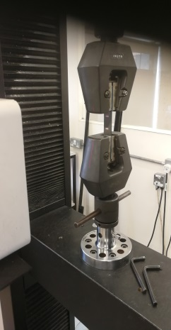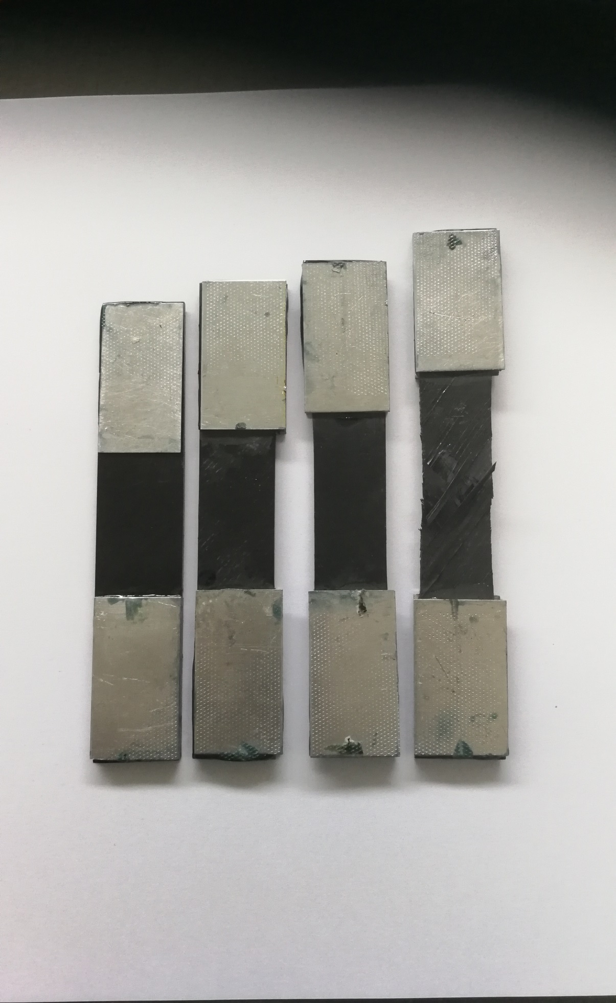

**Figure 3.** Tensile test + laser strain recording (a)/ Tabs (b)

# Strain Energy Storage and energy dissipations

The strain energy is dissipated via deformation and damage mechanisms when whichever materials are strained. When a stress field (𝝈) is applied to a structure of volume $V$ with a strain field output (𝜺), the strain energy ( $U$ in joules) is stored in the material and it could be computed with the following equation (Eq. 1). It represents the area below the stress/strain curve. Using Eq. 1 with constant displacement recordings, it was possible to display strain energy in Joules.

 (Eq. 1)

The strain energy storage could be divided into two parts; the linear strain energy storage and the plastic strain energy storage if it exists in the strained materials. Strain energy is therefore a good criterion in order to characterize micromechanics of a material taking into account of stiffness, localized damages, failures, and design of a possible component.

The linear strain energy is damageless, the plastic strain energy is not and should then be treated differently. Plastic strain energy relies on energy dissipation for composites through:

* Micro-failures ( delamination, cracks, ply failure and buckling)
* Plasticity, hardening levels and relaxation in fatigue

In the study’s tests, the focus was done on linear strain energy thus the identification of the damage steps had been set up.

For example:

* Static recording, the linear region should take loads linearly without load dropping of more than 0.05N.
* The fatigue test recording of the strain energy behavior alterations between first cycles and end cycles (hysteresis, strain energy loses, hysteresis changes)

# Results and Discussions

## Energy levels in Static 3 points bending

Three point bending test on prepreg laminates load samples in two loading cases, flexural case and shear case. Being subjected to such loading, the laminates tend to delaminate, thus this test is usually done in order to characterize such behavior as well as flexural mechanical data. Although mechanical data are important, this study is more focus on the structural behaviour, thus the laminate is quasi isotropic (45X/-45X/0X/90X)s. As shown in figure 4, in varying thickness with identical stacking sequence, tough epoxy and PEEK have two distinct mechanical evolutions. From a macro mechanical approach, the strain energy stored in the laminate tends to remain constant or slightly increase when bent up to the first failure. Its tough epoxy rivals have linear decreasing evolutions.

Strain energy storage (J)

Strain energy storage (J)

Strain energy storage (J)

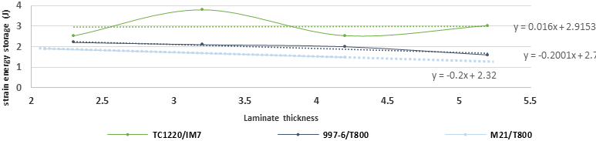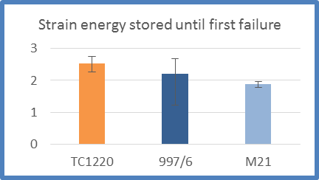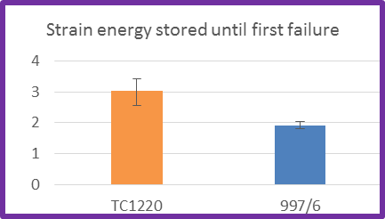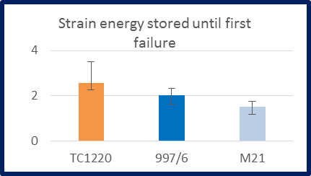

**Figure 4.** Strain energy evolution with thickness in static 3ptB loading

Modes of failures are directly linked to this phenomenon (Figure 5). When in very thin profile both laminate are bent up to extensive delamination as the first dominant occurring failure, the tough epoxy cracked through the structure when directly increasing its thickness from 2.3mm to 3.2mm (one ply more in each orientation). When those cracks could be observed in those thin thicknesses in epoxy samples, none are observed in PEEK samples up to more than twice the original thin thickness. Delamination occurred in each thickness. Straining more the matrice, even if it means entering to plastic deformation, allow a higher strain energy absorbance levels up to 35% in thick laminates.

|  |  |  |
| --- | --- | --- |
|  | 977-6/T800 | TC1200/IM7 |
| 2.3mm |  |  |
| 3.2mm |  |  |
| 4.2mm |  |  |

**Figure 5.** Cracks (Blue circles) and delaminations (Red circles) in 3ptB samples

## Energy levels in Fatigue 3 points bending behaviour comparison

The higher strain energy storage levels (24% differences to 35%) of PEEK against tough epoxies are mainly due to toughness. The independence of the strain energy storage level from the thicknesses is a nice finding but is not sufficient to design reliable structures. Fatigue has to be performed in order to see, under high strain level, how epoxies and PEEK behaves in a structural environment. Composite safety factor of carbon/epoxy structure for aerospace uses are up to 1.5. Thus at 50% of the ultimate strength, the epoxy structure should not take any damage under fatigue. Pushing this level to 75% allows the identification of damage propagations and comparison of such events for both PEEK and epoxy structures. As shown in figure 6, degradations could be seen in both structures but as very different levels. When the epoxy starts to crack and loose proportionally all its mechanical strength (Ultimate load, stiffness: 10% looses, strain energy rate 15%, hysteresis), the PEEK still is damaged but without brutal loses. Indeed the stiffness remains stable or even increase (up to 4%) because of hardening processes. The hysteresis of the PEEK also drafts by half due to plastic relaxation but the strain energy storage remain almost stable. Under loads, the safety factor of 1.5 is actually not appropriate for PEEK. And should or can be increase by 20%.

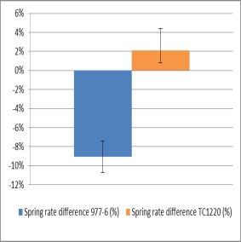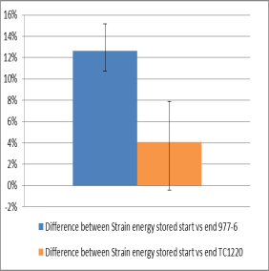

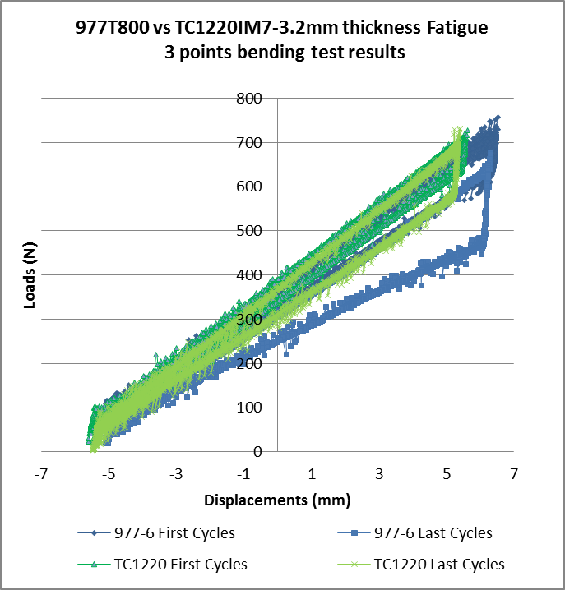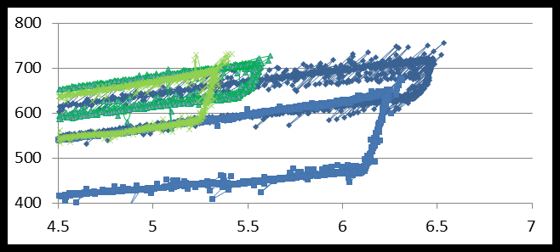

**Figure 6.** Energy levels evolution with thickness in static 3ptB loading

## Plastic cycle loading characterisations

As described in the fatigue and static testing results, the matrices properties influence the strain energy storage processes, and the differences in a composite structure are significant. Thus the identification of such behavior in a purely matrices dependent test is relevant in order to define high strain behavior of the PEEK and Epoxies.

[45/-45]8S samples of both TS and TP pre-pregs had been manufactured in order to show the mechanical responses in matrices tension behavior. First of all, from a tensile test up to failure, the PEEK is extremely resilient to handle the load. For the given thickness, more than twice the ultimate strength can be achieved in the PEEK laminate compared to the Epoxy one. From the tensile test up to failure, different steps could be observed. The cyclic load-unload tests helpe us to identify the differences of those steps and how it affects the mechanical responses:

1. In the first step and cycle, from 0% to 0.1% of strain, the samples stay in the linear region. It is governed by the Young’s modulus of the laminate and the hysteresis effects are thus negligible. The differences observed from the PEEK to the epoxy can be seen in the pure linear region which is higher in the Epoxy than the PEEK. The PEEK changes its behaviour from elastic to plastic at approximately 75% of the epoxy linear region before becoming plastic. (red square region in figure 7)
2. In the second step, from 0.1% to 0.7% strain, the clearest difference could be observed. The plasticity of the PEEK allows it to realign the fibre to take the load. The epoxy, which does lack of plasticity, does not deal it, the results is a level load from 0.2% to 0.5% strain. (second half red in figure 7)
3. The step before failure which goes from 0.7% up to failure is comparable for both structures. The epoxy, geometrical realigned its fibre to take the load but in doing so, crack the matrices. The PEEK does the same behavior but in the same way than step 2. (purple in figure 7)
4. The failure step happed also very differently, while the epoxy loses load progressively, shearing each ply almost one by one, the PEEK loses all the load in a brutal way

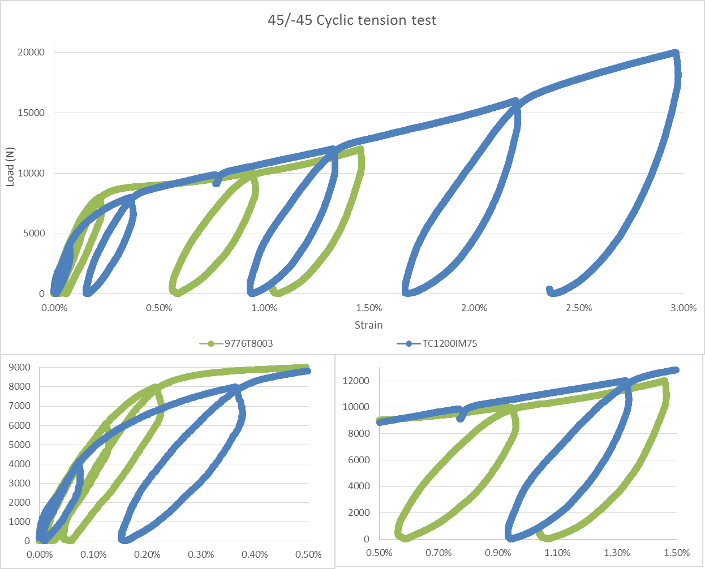

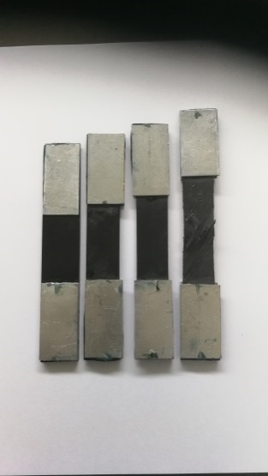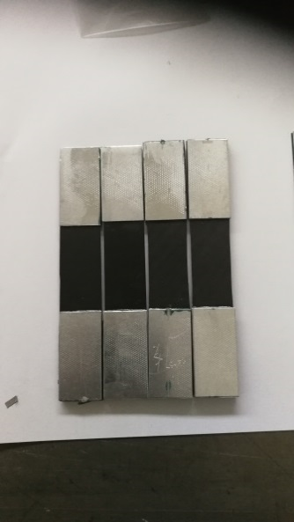

PEEK samples

Epoxy samples

**Figure 7.** Energy levels evolution with thickness in static 3ptB loading

The evolution of the hysteresis between each loop also proves a point concerning the reliability of the PEEK against the epoxy. While the epoxy when reaching suddenly a point loose much of its mechanical property, the PEEK hysteresis evolution is smoother, as shown in figure 8. This gives the PEEK time to deal with such loading but also rearrange the fibre structure as said previously. This explains the fatigue stability of the PEEK when subjected to overshoot loads.

**Figure 8.** Hysteresis levels evolution with thickness in static 3ptB loading

# Conclusion

A thorough investigation of the high strain mechanical responses of both carbon/PEEK and carbon/Epoxy had been carried out. Those tests show PEEK’s superiority in terms of reliability and strength for strain energy storage structures. With up to 35% more strain energy storage capability compared to epoxy in static testing, a better fatigue response behaviour as well as smoother degradation levels makes it a CFRP type which could be design with a higher service range and less severe safety factors. For strain energy storage components such as springs, PEEK could move the use of the structure to an even more strained level, overloaded resistant and more efficient structures than epoxies. Leaf springs, Belleville washers, torsion bar but also coil springs made of composite materials with epoxy resin have proven the good use of such materials for weight and mechanical efficiency. But PEEK, as described in this study, even though being started to be used in composite spring’s application can be design to another level

Acknowledgments

This study was supported by TENCATE [3]. Without their help, appliance of the material to rigorous and reliable product, this study as well as the PhD it comes from, nothing could have been possible.

References

[1] “Modern Trends in Composite Laminates Mechanics” (pp.281-294),Ramesh Talreja, January 2003

[2] Cytec 977-6 product datasheet http://www.cytec.com/products/cycom-977-6

[3]TENCATE TC1200 resin system: https://www.tencatecomposites.com/product-explorer/products/ovl4/TenCate-Cetex-TC1200

[4] H. Koerber, J. Xavier, P.P. Camanho, Y.E. Essa, and F. Martín de la Escalera. High strain rate behaviour of 5-harness-satin weave fabric carbon-epoxy composite under compression and combined compression-shear loading. International Journal of Solids and Structures, 54:172–182, 2015.

[5] P. Morgan. Carbon fibers and their composites. CRC Press Taylor & Francis Group, 2005.

[6] T. Hans and R. Hinterhölzl. A numerical approach modeling the braiding process for arbitrary mandrel shapes to calculate preform properties. Proceedings of the 20th International Conference on Composite Materials ICCM-20, Copenhagen, Denmark, July 19-24 2015.

[7] “An investigation into the mechanics of fiber reinforced composite disk springs”, Peng Yang, Rani, Elhajjar, Steel and Composite structures, March 2015

[8] “Design, Analysis and Fabrication of a Composite Leaf Spring for Weight Reduction in Light Weight Automobile” Krushankant R. Jani, Prof. Nirav Kamdar/ IJSART - Volume 1 Issue 11 –NOVEMBER 2015 ISSN: 2395-1052

[9] “A comparative study of impact damage tolerance between carbon fibre-reinforced Thermoplsatic and Thermoset Composite Panels” Hamed Yazdani Nezhad, Antony Auffray, Conor T. McCarthy, Ronan O’Higgins, Jul 2015, 20th International Conference on Composite Materials