Compression sensing using fragmented carbon fibers by means of plastic deformations in partially cured epoxy matrix
R. Höhne¹, M. Müller¹ and N. Modler¹

¹Institute of Lightweight and Polymer Technology, Faculty of Mechanical Science and Engineering, Technische Universität Dresden, 01307 Dresden, Germany
Email: robin.hoehne@tu-dresden.de, Web Page: http://www.tu-dresden.de/mw/ilk

Keywords: strain measurement, carbon fiber sensor, epoxy curing

Abstract

A novel carbon fiber (CF) strain sensor is developed providing the unique feature of a fracture-based, resistive measuring principle enabling a spatially resolved strain measurement. So far the sensing function is applicable to the measurement of positive strain (elongation), but not for negative strain (compression) since the filament fractures are closed in unloaded condition. In this work, a 3-step sensor manufacturing process is established making use of plastic deformations of partially cured epoxy networks in order to overcome this current limit. After performing the procedure the filament fractures are open in the unloaded condition and pushed together during compression enabling the measurement of negative strain. An elongation-compression ratio of 0.3 was identified in a cantilever arm configuration. The results show that the measuring range of the sensor can be shifted towards the compression domain by means of the advanced sensor manufacturing process making use of plastic deformations in partially cured epoxy networks.

1. Introduction

The increasing knowledge of the material behavior of fiber-reinforced plastics allows more and more frequently the use of this high-performance material group for multi-axial loaded and complex shaped structures. Due to the high mechanical anisotropy of the FRP the existing strain fields are also highly complex in these scenarios, meaning multi-axial and non-uniformly distributed over the entire structure. The proper measurement of such strain fields in the development phase, e.g. for load tests, or for operando purposes, e.g. in order to reliably monitor abuse cases, aging or damage, places manifold requirements on a strain sensor. The challenge is to make a strain measurement system available, that combines a high spatial resolution with manageable complexity, low weight and low costs. In this context, a novel carbon fiber strain sensor that features a spatial resolved strain measurement is developed at the Institute of Lightweight Engineering and Polymer Technology.
The known measurement principles of commonly used strain sensor for fiber-reinforced composites are (i) resistive (e.g. metal strain gauges [1]), (ii) piezoelectric (by means of polymer [2], ceramic [3] or carbon fibers [4] sensors) or fiber optics (like FBG [5] and Rayleigh sensor [6]). The first two groups are suitable for elongation and compression sensing but not for a spatial resolved measurement. (iii) Fiber optics on contrary are suitable for spatial resolved measurement of elongation and compression but have high costs and complex handling. However, the measurement principle of the novel sensor is limited to elongation measurement to date [7,8]. Large deformations of partially cured epoxy networks were examined in this work in order to overcome the limits of the current sensing function. The method makes use of the thermo-mechanical behavior of thermosets in the plastic domain [9].

1.1 Measurement principle of the proposed strain sensor

A novel carbon fiber (CF) strain sensor is developed that’s unique feature is a resistive, fracture-based measuring principle enabling a spatially resolved strain measurement. The sensor patch basically represents a microstrip-like configuration composed of a CF roving and a second conductor (copper strip to date) that are embedded in glass-fiber epoxy material as carrier. The measurement principle is based on the reversible opening and closing of single CF fragments that are mechanically introduced during the functionalization cycle [7]. The functionalization cycle is realized by applying a static tensile load on the sensor patch that results in elastic deformation of the carrier material, but introduces an initial pattern of sensing filament fractures. The immense resistance change of the broken CF roving during loading results in a change of the characteristic impedance of the microstrip that can be spatially resolved by means of the electrical time domain reflectometry (ETDR). The mapping of the ETDR signals to the existing strain profile was demonstrated using Neuronal Network with supervised learning procedure [8].

1.2 Current limit and solution approach

The measurement principle relies on the reversible opening and closure of fiber fractures at loading and unloading, enabling a significant resistance change. This principle is possible due to the significant different stiffnesses by several orders of magnitude between CF (900 GPa for the fiber used) and GF-EP carrier. It can be assumed that the strain of the carrier material is almost not transferred to the CF fragments but causes the opening and closure of the CF fractures.
In the preliminary sensor configuration the CF fractures are closed in unloaded condition, see Figure 1. This is due to the fact, that the GF-EP carrier material is elastically deformed in the functionalization cycle. At unloading it recovers its initial shape and the CF fragments return to their initial position, where the CF fractures are closed. In the initial position the end faces of the fractured filaments are in contact and the resistance of the fragmented but contacted CF resembles the unbroken CF. If the sensor patch is compressed, the CF show only a slight change of resistance which is likely due to a further decrease of the contact resistance at the end faces pressed on top of each other. However, this resistance change is not measurable by means of the focused ETDR for the spatial resolved strain measurement.
The ambition of the proposed work is to shift the measurement range of the sensor to negative strains, see Figure 1. Therefore, a modified functionalization procedure needs to be identified that enables the setting of open CF fractures at the unloaded condition of the sensor. Thus, in case of an existing compression, the CF fractures can be closed even further causing the necessary significant change of resistance. Therefore, the use of plastic deformations of partially cured epoxy networks is investigated. The methodology makes use of the enhanced deformation ability of the partially cured polymer matrix at elevated temperatures in the range just below the glass transition temperature T_{g} [9].
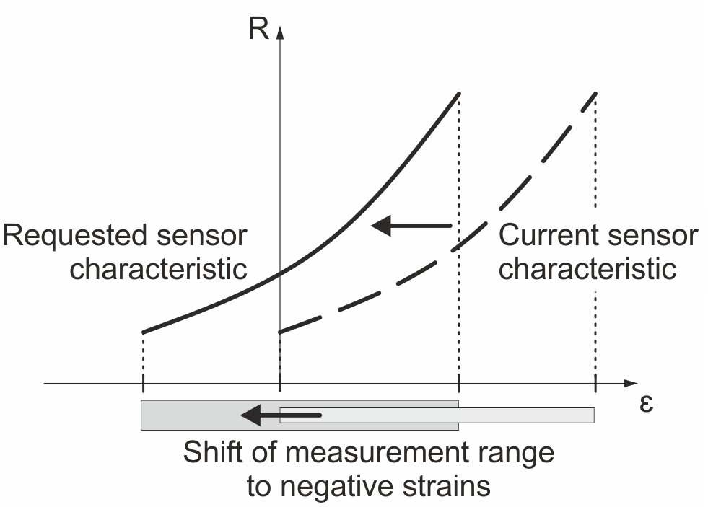
Figure 1. Sensor characteristic in preliminary configurations [1,2] and requested sensor characteristic.

2. Materials and method

2.1. Materials and sensor configuration

Sensor patches, see Figure 2, with an active length of 80 mm and cross-section of 5 mm x 10 mm were manufactured in autoclave process. The detailed procedure is described in the following section. A sensor patch consists of a CF-roving (2K Dialead K13C2U) that was positioned in top of a layup of uncured GF-EP prepreg (GGBD 5806, Krempel Group). The CF-roving was led through the sensor patch to the front surface. Drops of conductive epoxy were applied with a distance of 80 mm to ensure electrical contacting of the filaments. GF-EP clamp pads were adhesively bonded to the sensor patches for a reliable application of tensile loads.

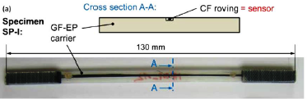
Figure 2. Schematic cross-section and exemplary sensor patch [7].

2.2.Manufacturing and functionalization of sensor patches

The investigated approach for manufacturing of the sensors with compression sensing capability consists of three steps: (i) pre-curing, (ii) thermo-mechanical functionalization and (iii) post-cure of the sensor patch. Pre-cure was conducted at a moderate temperature of 90 °C inside a convection oven, which represents the lower bound of the manufacturer’s recommendation. Dwell time was set to 2 h, in order to ensure homogenous partial cure. Subsequently, DSC scans at nitrogen atmosphere and a heating rate of 10 K/min were performed to determine the glass transition temperature. A value of 51 °C was measured, which indicates a low degree of cure (DOC) as the maximum glass transition temperature is about 125 °C according to the material data sheet. The three functionalization temperature levels of 36 °C, 41 °C and 46 °C were selected, which will be labelled as T-Tg = -15 K; T-Tg = -10 K and T-Tg = -5 K in the following. For each temperature level three sensor patches were investigated.

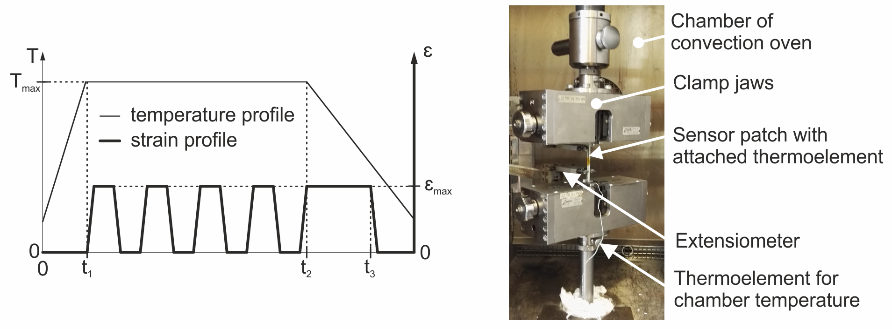
Figure 3. Schematic functionalization cycle (left) and image of a sensor patch clamped in the testing machine with integrated convection oven (right)

Functionalization took place in a universal testing machine with integrated convection oven, see Figure 3 (right). The desired oven temperature was adjusted without the sensor patches and monitored by a thermocouple. After equilibration to ±0.5 K, the sensors were attached to the clamping of the test machine. An additional thermocouple was placed on the sensor surface. After another equilibration to a temperature of ±0.5 K the functionalization cycle was initiated at t1 according to Figure 3 (left). The temperature was held constant while the indicated cyclic strain program was applied to the sensor patch (t1 to t2). The maximum strain was limited to 0.8 %. After the final strain step the elongation is held constant and maintained during cool-down (t2 to t3). Cooling was initiated by opening the oven door. The sensor was unloaded und removed as soon as the sensor surface has reached room temperature. Post-cure was not part of the present investigations and will be topic to future work.

2.3. Measurement setup and testing

The sensor behavior of the sensor patches functionalized according the described previously procedure was examined in a cantilever arm configuration. This configuration features a simple application of compression and elongation at the sensor patch and is sufficient for a proof of concept of the novel functionalization procedure. The sensor patch was curved by means of weights up to 400 g that were attached at the free end of the patch. Since the CF roving is not located at mid-height of the sensor patch, it is also off the neutral axis in the focused bending configuration. Thus, the CF roving is compressed when the sensor patch is clamped with the roving on the underside or elongated when the roving is on the topside. For testing the sensor patch was loaded with the same weight levels in both positions giving a full loading cycle from compression to elongation. At each weight level, the electrical resistance of the CF roving was measured. For comparison reason a sensor patch from preliminary investigation [7] was also tested. Due to a thinner cross-section this patch could only be loaded up to 200 g.

3. Results and discussion

3.1 Microscopic investigation of fractured CF after functionalization

After the functionalization procedure, the sensor patches were microscopically investigated in order to prove the existence of opened CF fractures at the unloaded condition. As shown in Figure 4, opened fiber fractures are visible for all three investigated temperature levels. The relation can be identified that the higher the temperature the greater the distances of related fracture ends. This is in good agreement with the findings in [9], stating that the plastic deformation of the partially cured epoxy is greater the closer the processing temperature (here referred to as functionalization temperature) is to the glass transition temperature T_{G}. The increase of the functionalization temperature by 5 K leads to an increase of the fracture distance by 100 % from 15 µm to 30 µm.
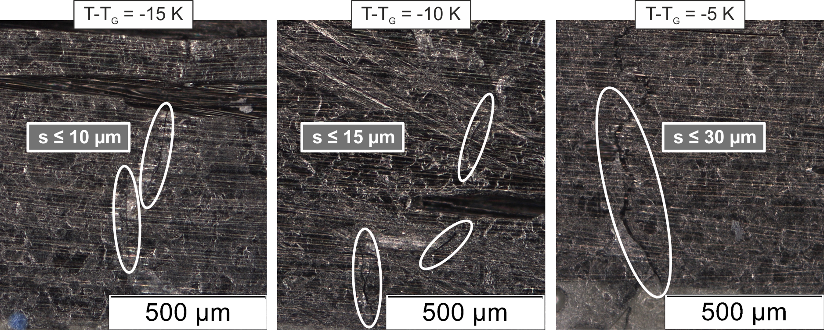
Figure 4. Microscopic images showing opened fiber fractures at unloaded condition of the sensor patch for the three manufacturing variants

3.2 Geometrical and electrical investigation of plastically deformed sensor patches

From each sensor patch the length and the electrical resistance were measured at several time stamps after the functionalization in order to investigate the time course. An initial value of each measurand was taken immediately before the functionalization. Based on the change of the sensor length an immanent residual strain of the unloaded patch in relation to the initial length was calculated. Each measurement point in Figure 5 represents the mean value of the three tested patches at equal temperature levels (T-T_{g} = -15 K; T-T_{g} = -10 K and T-T_{g} = -5 K).

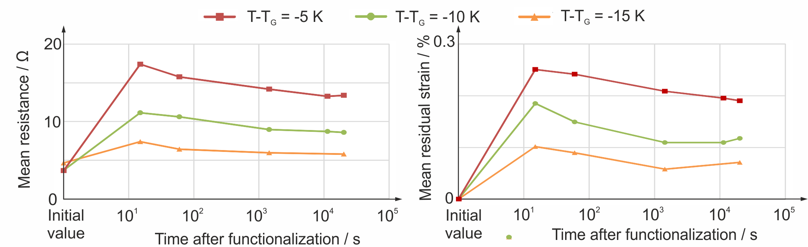
Figure 5. Determination of the time course of electrical resistance and residual strain of the sensor patch after functionalization
As already observed, with the severity of the fracture distances, the electrical resistance as well as the residual strain of the sensor patch are greater the closer the functionalization temperature is to the glass transition temperature T_{G}. Furthermore, a relaxation of both measurands for all three temperature levels with asymptotic behavior to a stable final value after 10⁴ s can be identified. This indicates that a stable sensor behavior can be realized using the investigated functionalization procedure.

3.3 Characterization of measurement range

The sensing characteristic of the functionalized sensors was investigated based on the measured resistances at different deflection curves in the cantilever arm configuration. In Figure 6 the resistance is plotted over the applied weight at the free end of the sensor patch corresponding to different curvatures. At positive weight values the sensor patch is positioned in a way that the CF roving is elongated. Thus the negative weights represent the compression range. For comparison reasons the results of a sensor patch from preliminary investigations (loaded only up to 200 g) are added in the diagram. As can be seen, the sensor patches which were functionalized according the novel procedure show a resistance change in the compression range. The comparison with the sensor patch from preliminary investigations highlights the feasibility of the shift of the measurement range by using plastic deformations in partially cured epoxy matrix. Once again, the greatest change in resistance can be found for the highest functionalization temperature (T-T_{g} = -5 K). This means that the sensor patch functionalized at T-T_{g} = -5 K has the highest sensitivity in the compression range and most widely shifted measurement range of the investigated patches.
The distribution of the measurement range to the compression and elongation area can be expressed based on the resistance chance in each area as the following ratio:
$$\frac{{\text{dR}}_{\text{Compression}}}{{\text{dR}}_{\text{Elongation}}}=\frac{R(0g)−R(−\text{400}g)}{R(\text{400}g)−R(0g)}$$ | (1)
A ratio of 1 corresponds to a sensor that can measure compressions as large as elongations thus features a symmetric sensing behavior. A ration of 0 indicates a sensor that cannot measure any compression. In this context, the sensor from the preliminary investigations has a ratio close to 0, see Table 1. The sensor patch functionalized at T-T_{g} = -5 K shows a ratio of 0.3 meaning that one third of the measurement range is shifted into the compression areahighlighting again the feasibility of the novel functionalization procedure, see Table 1.

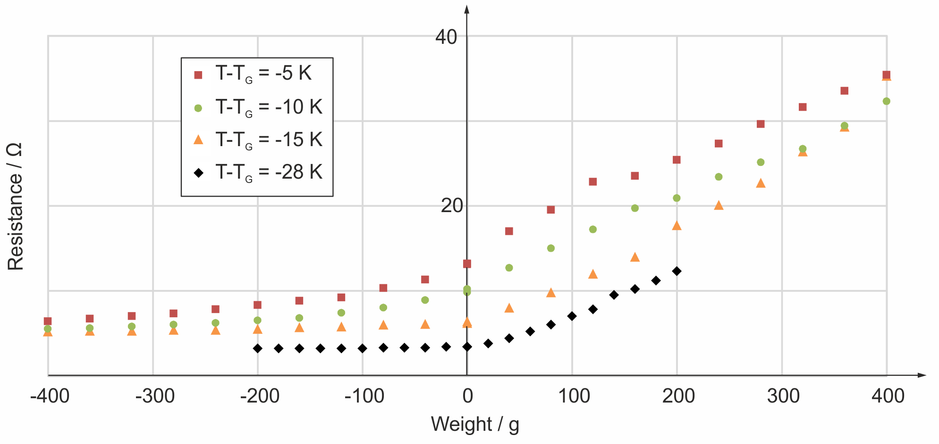
Figure 6: Resistance of fractured CF roving functionalized at different DOC over different loading conditions showing different elongation-compression ratios.

Table 1. Compression/ elongation ration based on measured resistance change for different temperature levels at functionalization
Temperature level | T-T_{g} = -28 K* | T-T_{g} = -15 K | T-T_{g} = -10 K | T-T_{g} = -5 K
Compression/elongation ratio | 0,02 | 0,08 | 0,20 | 0,3
*sensor patch from preliminary investigations loaded only up to 200 g

4. Summary

A meaningful application of a strain sensors requires the possibility of measuring negative strains (compression). Therefore, the central objective of this contribution was the identification of a proper functionalization cycle of a novel carbon fiber sensor in order to enable compression sensing. Large deformations of partially cured epoxy networks were successfully applied to create open fiber fractures in the unloaded condition of the sensor. The applied functionalization procedure consists of three steps: (i) pre-curing, (ii) thermo-mechanical functionalization and (iii) post-cure of the sensor patch. The mechanical functionalization was performed at three sensor patch groups each with a different temperature level just below the glass transition temperature determined in DSC analysis. By means of microscopy investigations of fracture distances, resistance as well as length measurements after the functionalization cycle, the feasibility of the proposed approach was demonstrated showing the highest effect on the sensing function at a functionalization temperature of T-Tg = -5 K. In this setup, the fracture distance at the unloaded conditions is approx. 30 µm and the measurement range is shifted by one-third into the compression range. The investigation of the sensor behavior in the compression range raises a number of open questions that needs to be focused in further studies. Especially the observation of the ongoing relaxation as wells as the stability of the sensing function at recurring loading is a major task for ongoing work. Additionally, stability of the sensor properties during post-cure will be investigated.

Acknowledgments

The 3Ccar project has received funding from ECSEL Joint Undertaking under grand agreement No. 662192. This Joint Undertaking received support from the European Union’s Horizon 2020 research and innovation programme and Germany, Austria, Czech Republic, Romania, Belgium, United Kingdom, France, Netherlands, Latvia, Finland, Spain, Italy, Lithuania. The authors also thank student Janek Zäh for preparing the specimen and conducting the experiments.

References

[1] Filippatos, A.; Höhne, R.; Maron, B.; Holeczek, K.; Kostka, P.; Modler, N.: Development of a composite, load-adaptive leaf spring: A multi-domain approach, 2015. – ISBN 978–618–80527–6–5, S. 171–178.
[2] Hamey, C. S.; Lestari, W.; Qiao, P.; Song, G.: Experimental Damage Identification of Carbon/Epoxy Composite Beams Using Curvature Mode Shapes. Structural Health Monitoring 3 (2004), Nr. 4, 333-353. – DOI 10.1177/1475921704047502.
[3] Sathyanarayana, C. N.; Raja, S.; Ragavendra, H. M.: Procedure to Use PZT Sensors in Vibration and Load Measurements. Smart Materials Research 2013 (2013). – DOI 10.1155/2013/173605
[4] A. Horoschenkoff, C. Christner: Carbon Fiber Sensor: Theory and Application. Composites and Their Applications, InTech, 2012.
[5] Hufenbach, W.; Gude, M.; Czulak, A.; Kretschmann, M.: Development and implementation of an automatic integration system for fibre optic sensors in the braiding process with the objective of online-monitoring of composite structures. Proceedings SPIE 9061 (2014). – DOI 10.1117/12.2035613.
[6] Masoudi, A.; Newson, T. P.: Contributed Review: Distributed optical fibre dynamic strain sensing. Review of Scientific Instruments 87 (2016), Nr. 1, 011501. –DOI 10.1063/1.4939482.
[7] Höhne, R., Ehrig, T., Kostka, P., Modler, N.: Phenomenological investigation of a carbon fiber based strain sensor with spatial resolution by means of time domain reflectometry. Material Science and Engineering Technology, Volume 47, Issue 11, November 2016, Pages 1024–1033.7.
[8] Höhne, R., Kostka, P., Modler, N., Inverse Calculation of strain profiles from ETDR measurement by means of neural networks. J. Sens. Sens. Syst., 6, 389-394, 2017.
[9] Müller, M., Jäger, H., Gude, M., Füßel, R. and Dohmen, E.: Mechanical Behaviour of Epoxy Networks In Dependence on Time, Cure and Temperature. 17th ECCM, 26.-30.06.2016, München. - ISBN 978-3-00-053387-7

