Manufacture and performance evaluation of hat-stiffened structure made by chopped carbon fiber tape reinforced thermoplastics
Bohan Xiao^{1*}, Qitao Guo, Isamu Ohsawa, Michinobu Fujita and Jun Takahashi
¹Department of Systems Innovation, School of Engineering, The University of Tokyo
7-3-1, Hongo, Bunkyo-ku, Tokyo 113-8656 Japan
*Email: xiao-bohan@cfrtp.t.u-tokyo.ac.jp, Web Page: http://www.u-tokyo.ac.jp

Keywords: Chopped carbon fiber tape reinforced thermoplastics (CTT); hat-stiffened structure; three-point bending test

Abstract
Carbon fiber reinforced plastics (CFRP) has been applied as structural components in not only aeronautics and astronautics but also in automobile industry. Among those CFRP material, randomly oriented carbon fiber reinforced thermoplastics, in particular chopped carbon fiber tape reinforced thermoplastics (CTT), have been one of the research focus due to its exclusive merits such as high-productivity, design flexibility and potential energy absorbing performance. Thus, as a potential solution in near future facing escalating demand of lightweight material, mass application of randomly oriented CFRTP in automobile industry has been widely investigated.

This study investigated into the manufacture process of CTT hat-shaped hollow beam. Three-point bending test was conducted to check its flexural stiffness and failure mode. After that, local slices were cut out from respective bottom panel and upper hat part of the specimen. Four-point bending test was conducted on these local slices to check flexural strength and modulus which indicates the mechanical properties of local material from the specimen. Experimental result showed low scatter and acceptable mechanical property which can be applied to further study basing on same hat-stiffened structures.

- Introduction

Due to the outstanding specific modulus and specific strength, carbon fiber reinforced plastics (CFRP) has been applied as structural components in not only aeronautics and astronautics but also in automobile industry. Among those CFRP material, randomly oriented carbon fiber reinforced thermoplastics, in particular chopped carbon fiber tape reinforced thermoplastics (CTT), have been one of the research focus due to its exclusive merits such as high-productivity, design flexibility and potential energy absorbing performance [1-4]. Thus, as a potential solution in near future facing escalating demand of lightweight material, mass application of randomly oriented CFRTP in automobile industry has been widely investigated [5,6].

Hat-stiffened structure has been widely used in automobile structure, like B-pillar. Scatter during fabrication however, has been one of the obstacle that limit randomly oriented short fiber material to further commercial application.

This study investigated into the manufacture process of CTT hat-stiffened structure using hand dispersion method. Three-point bending test was conducted to check its flexural stiffness and failure mode. After that, local slices were cut out from respective bottom panel and upper hat part of the specimen. Four-point bending test was conducted on these local slices to check flexural strength and modulus which indicates the mechanical properties of local material from the specimen.

Experimental result showed low scatter and acceptable mechanical property which can be applied to further study based on same hat-stiffened structures. Several factors that influence product quality during manufacture were pointed out which can be used as reference for further quality improvement of CTT component manufacture.

2. Specimen fabrication

2.1. UT-CTT

CTT were made from ultra-thin unidirectional CF/PA6 prepreg sheet with thickness of 44µm. This sheet was provided by Industrial Technology Center of Fukui Prefecture. The volume fraction of CF (Vf) is 55%. The sheet was cut into chopped tapes with 19 mm in length and 5 mm in width. The thickness of the hat-shaped structure and the panel was both 2 mm.

Tapes are dispersed on a flat surface by manual work with 325 g/m² in order to obtain intermediate material with thickness of 0.14 mm. Dispersed UT-CTT tape is shown as Fig 1.

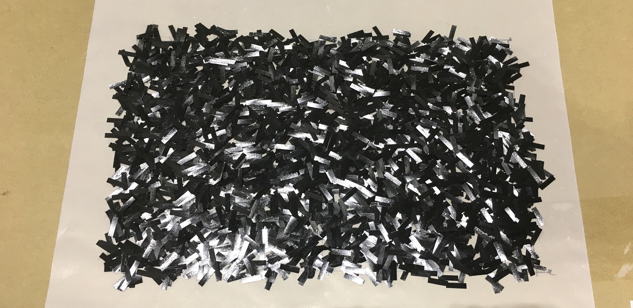
Figure 1. dispersed UT-CTT tape

2.2. Hat-shaped hollow beam

14 layers of intermediate material are heated under temperature of 250 ℃ and pressure of 5 MPa for 5 minutes. Mould used is shown as Fig. 2 left and hat-shaped parts are obtained as is shown in Fig. 2 right. The length of the hat-shaped part is 400 mm, other parameters is as shown as Fig. 3 and Table 1. Panel is moulded under same condition with hat-shaped part.

Thickness of both hat-shaped part and panel part after moulding process are expected to be 2 mm. However during dispersion process, material may be dispersed nonuniform and it will finally influence mechanical properties of specimens, thus investigating in specimens’ thickness is necessary. Local slices is cut out respectively from hat-shaped part and panel part. Cutting scheme is as shown in Fig. 4. Average thickness of hat-shaped part is 2.15 mm on top surface of hat and 1.94 mm on side surface of hat, and 2.08 mm on panel. Largest Sdev occurs on side surface on hat-shaped part which is 0.16, indicates that this local part is more sensitive under current moudling condition.

During specimens’ fabrication, several processes that influence final molding quality were observed. Molding quality were evaluated through specimen’s three point bending experiment. Before molding process, moving layers of intermediate materials onto male die will be conducted manually. In this stage, inclined placing of intermediate material may cause asymmetrical pressure on UT-CTT during molding and lead to UT-CTT squeezed out at single side of mould, as is shown in Fig. 5. This ends up with not enough volume in hat-shaped part and also asymmetrical thickness through side edge. Average thickness is 1.7 mm, compared with 2 mm target thickness. Mechanical property drop is observed during three point bending test as is shown in the blue curve in Fig. 6. Another point of concern is the process of ultrasonic welding. Welding machine without enough welding power may lead to poor welding quality which is more critical in the case of thick composite material. In this case poor molding will lead to debonding of hat-shaped part and panel part under shear stress during three point bending test. The force-displacement curve of debonded specimen is as shown as the yellow curve in Fig. 6.

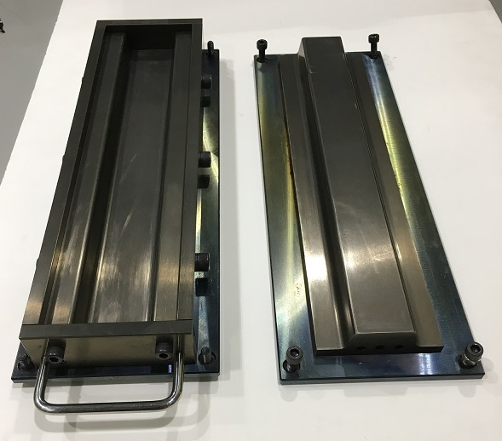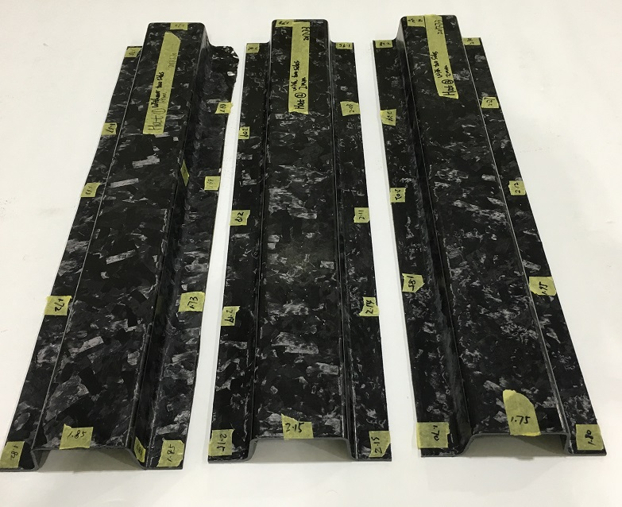
Figure 2. Mould (left) and UT-CTT hat part (right)

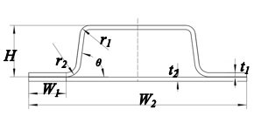
Figure 3. Parameters and section of hat-shaped part

Table 1. Parameters of hat-shaped part

Unit | W₁ | W₂ | H | t₁ | t₂ | r₁ | r₂ | θ | L₁ | L₂ | R₁ | R₂
(mm) | 18 | 100 | 26 | 2 | 2 | 5 | 7 | 83° | 370 | 400 | 75 | 15

Table2. Thickness of local material on hat-shaped part and panel

 | Hat | Panel | Side
Specimen number | 4 | 4 | 8
Average Thickness(mm) | 2.15 | 2.08 | 1.94
Sdev | 0.08 | 0.09 | 0.16
% | 3.5 | 4.1 | 8.3

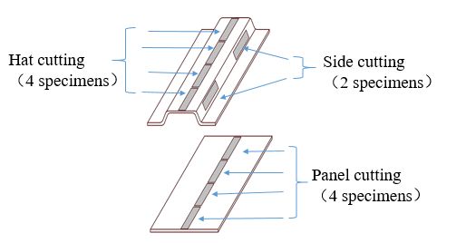

Figure 4. Cut-out scheme of local slices

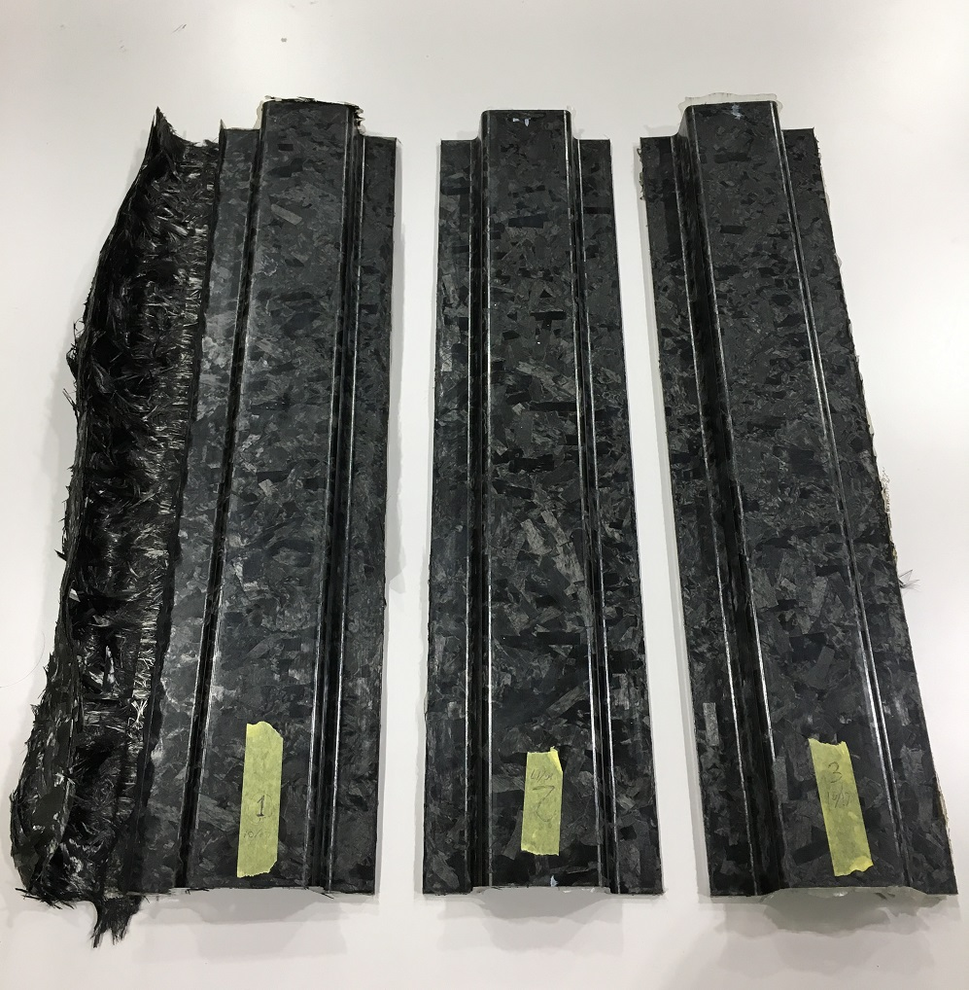

Figure 5. Comparison between normal (middle and right) and poor molding specimens (left).

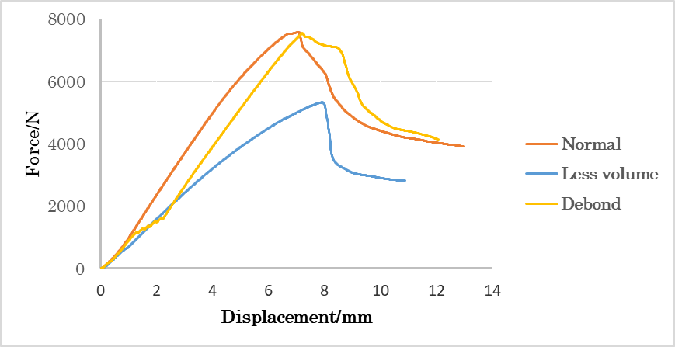

Figure 6. Comparison between normal and poor molding specimens

3. Experiments and results

3.1. Four point bending experiment on local slices

Local slices was cut out from hat and panel part, each part cut out 4 slices which length is 100 mm and width is 15 mm. Four-point bending test (shown in Fig. 5) was conducted on these specimens to check local mechanical properties including flexural modulus and flexural strength. Flexural modulus of hat part and panel part is respectively 34.44 GPa and 37.00 GPa. Flexural strength is respectively 448 MPa and 430 MPa, as shown in Fig. 7. Results show good consistency with existing mechanical properties data obtained on antecedent UT-CTT plate specimen, indicates that raw material’s quality is eligible and molding condition is reasonable.

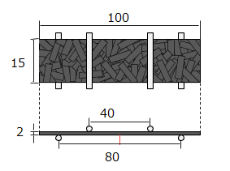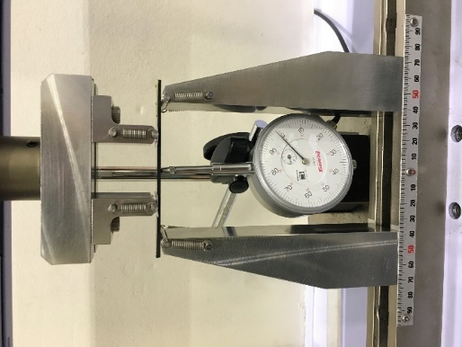

Figure 5. Experiment set-up and specimen parameters (Unit: mm)

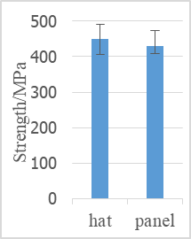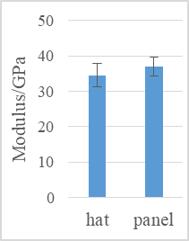

Figure 6. Flexural strength and flexural modulus of cut-out slices

3.2. Three point bending experiment on hat-shaped hollow beam

Three-point bending test was conducted on hat-shaped hollow beam with span of 370 mm and loading speed of 1 mm/min as shown in Fig. 7. Test was based on Standard: ASTM D7264 / D7264M-07, using universal test machine. Indenter’s radius was 75 mm, and in terms of two supports, their radius were 15 mm.

According to the load-displacement curve as shown in Fig. 8A, when displacement is between 10 mm to 40 mm, force maintained and gradually decreased which indicates energy absorption capacity in this stage. Meanwhile, the following three failure stages during the experiment can be observed.

First stage: compressive failure of top surface of hat part due to stress concentration, as is shown in Fig. 8B.

Second stage: crack propagated along the side surface of hat part, as is shown in Fig. 8C. On both side surfaces of hat, local carbon fiber was squashed by flexural strain, this process occurred with energy continuously absorbed by fracture;

Final stage: panel failure due to tensile stress as is shown in Fig. 8D. On bottom surface of panel, local carbon fiber fractured by tensile stress. This is supposed to be the final energy absorbing stage of hat-shaped hollow beam structure.

Until final stage, the structure totally absorbed 135.71 J energy, indicates a 452.38 J/kg specific energy absorption, showing potential of this material in the further application of energy absorption.

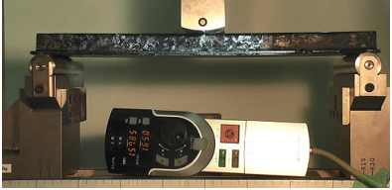

Figure 7. Three-point bending test set-up

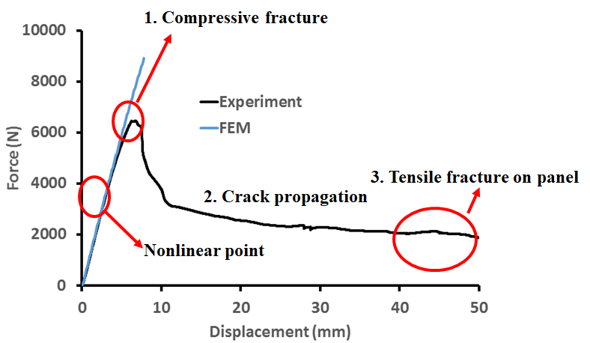  A | 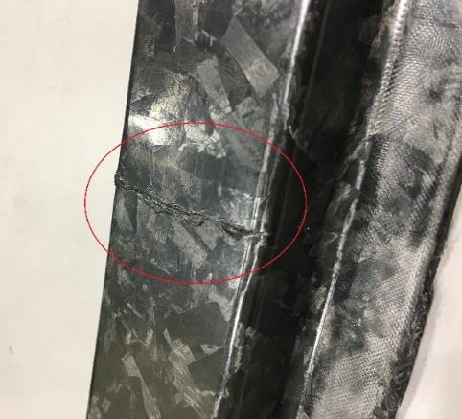B
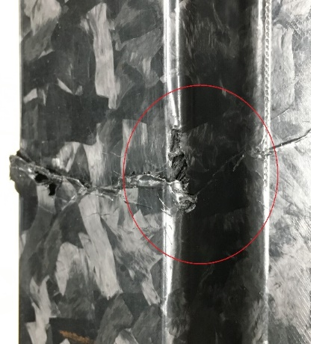  C | 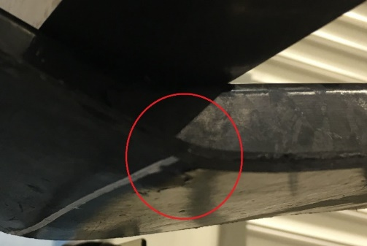  D
Figure 8. Displacement-force curves and stress distribution and local failure

4. Conclusions

- Complex shape molding of UT-CTT specimen was conducted and thickness variation was investigated on UT-CTT hat-shaped hollow beam, indicates that uniform thickness distribution is critical to specimen’s mechanical property.

- Mechanical property of local material in UT-CTT hat-shaped hollow beam was investigated through four point bending test, showing good consistency with previous data of UT-CTT material, proving that this processing method is reasonable.

- Failure behavior of UT-CTT hat-shaped hollow beam under static three point bending condition is investigated. Force-displacement graph and energy absorption until structure failure are obtained. The results can be a reference for further research on failure behavior and energy absorption of UT-CTT hat-shaped hollow beam under dynamic loading condition.

Acknowledgments

Part of this study was conducted as Japanese METI project "The Future Pioneering Projects/ Innovative Structural Materials Project" since 2013fy. Authors would like to express sincerely appreciation to the project members who have provided valuable information and useful discussions.

References

[1] Selezneva M and Lessard L. Characterization of mechanical properties of randomly oriented strand thermoplastic composites. J Compos Mater 2016; 50: 2833-2851.
[2] Lee H, Tang S, Ohori T, et al. Applicability of FEM to complex shape parts made by ultra-thin chopped carbon fiber tape reinforced thermoplastics. In: Proceedings of 14th Japan international SAMPE symposium and exhibition, Kanazawa, Japan, 6-9 December 2015.
[3] Y. Wan and J. Takahashi, Effect of tape length and impregnation conditions on mechanical properties of carbon fiber tape reinforced thermoplastics, 12th International Conference on Textile Composites, Raleigh, NC, USA, 26-29 May 2015.
[4] Eguemann N, Giger L, Roux M, et al. Compression moulding of complex parts for the aerospace with discontinuous novel and recycled thermoplastic composite materials. In: Proceedings of the 19th International conference on composite materials, Montreal, Canada, 28 July-2 August 2013, pp. 6718-6725.
[5] Y. Wan and J. Takahashi, Effect of tape length and impregnation conditions on mechanical properties of carbon fiber tape reinforced thermoplastics, 12th International Conference on Textile Composites, Raleigh, NC, USA, 26-29 May 2015.
[6] Levy A. and Hubert P. Inter-strand void content evolution in compression molding of randomly oriented strands (ROS) of thermoplastic composites. Composites Part A, Vol. 70, pp 121-131, 2015.

