Theoretical and experimental validation of critical thermal properties of advanced vacuum bagging for composite manufacturing

A. Haeberle¹, A. Herrmann² and P. Fideu³

¹Faserinstitut Bremen e.V., Strukturdesign und Fertigungstechnologien, University Bremen, Gebäude IW3 Am Biologischen Garten 2, 28359 Bremen, Germany
Email: anja.haeberle.external@airbus.com, Web Page: https://www.faserinstitut.de
²CTC GmbH, CTC GmbH, Airbus-Straße 1, 21684 Stade, Germany
Email: axel.herrmann@airbus.com, Web Page: https://ctc-composites.com/de/
³Airbus Operations GmbH, Airbus Operations GmbH, Kreetslag 10, 21129 Hamburg, Germany
Email: paulin.fideu@airbus.com, Web Page: http://www.airbus.com/

Keywords: Composite, Vacuum bagging, Heat transfer

Abstract
Within the manufacturing process of CFRP components one of the most critical steps is the vacuum bagging. During this specific step, several layers of polymer foils are draped over complex shaped parts to build the vacuum bag. The specific properties of each layer, which are needed for the process (i.e. breather, release property, air tightness), result into a complex overall behaviour of the package along the process curve.

Whilst developing a new generation of vacuum bagging, the necessity to simulate and to understand the new process prior to implementation has been exercised. One critical key feature of the new technology is the short exposition of fresh prepreg material to a high heat flow and therefore this has been subjected in an analysis for a better risk assessment.

A multiphysics based FE analysis of the new vacuum bagging has been performed to predict the transient temperature field under consideration of realistic process conditions such as radiation, part geometry and process velocity. The modelling steps as well as the outcome are presented in the following paragraphs. Also included within the paper is a section dedicated to the comparison of the obtained results with measurements performed on a representative system.

1. Introduction

The new bagging material exists only out of one layer compared to standard vacuum bagging set-ups out of three or more layers. The necessary properties will be included in one foil, which can be shaped to the needed geometry. To form the material in part shapes either classical plastic forming methods can be used or the heat introduction can be done with an IR emitter. The idea is to directly shape the material on the existing part to reduce the tolerancing efforts. Therefore the first step is to identify the specific thermal behaviour of the materials with an IR emitter and to validate them using a simulation model in parallel.

Having a detailed look at the set-up, the following features have been selected to be further considered in the modelling exercise:
- Heat transfer through conduction in the aluminium plate as well as in all thin components such as single foil
- Convective heat transfer between all free surfaces and the environment (forced convection at the IR-emitters and free convection on the remaining surfaces)
- Radiation between IR-emitter and exposed surfaces.
- Motion of the heat source over the targeted surfaces

In the following picture (Figure 1) the set-up to perform the manufacturing trials can be seen compared with the reproduction in a 3D model. For the basic model without the bagging material an aluminium plate with a moving IR emitter is used. The emitter is moving with a constant distance and velocity to the substrate surface.

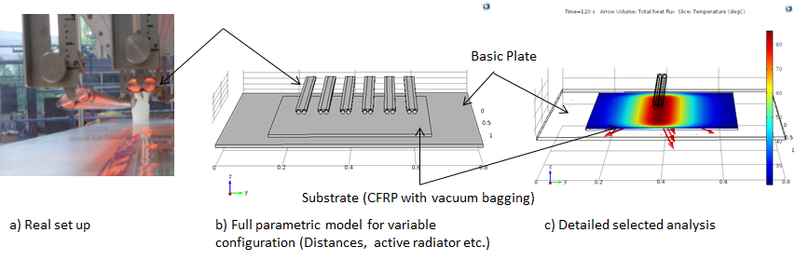
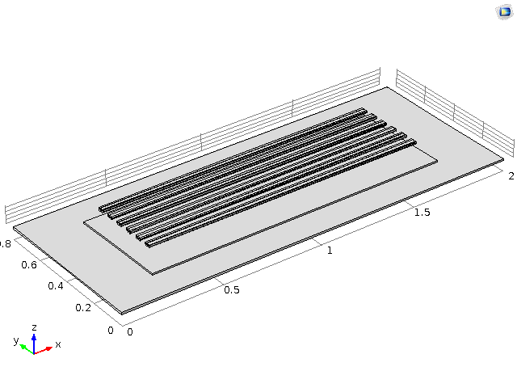
Figure 1: Real set-up and reproduction in 3D model

For simplification reasons, assumptions have been made, that any mechanical responses (stress-strain, thermal dilation) can be neglected due to the expected low impact on the thermal behaviour of the system. In addition to that the investigation has been made with a 2D model to evaluate the order of magnitude of the simulation results compared to the measurements. This causes a computation time of 43 sec compared to 1h 29 min within a 3D model due to the lower amount of 7699 equations.

2. Materials and Methods

2.1. Materials

First of all the temperature dependent specific heat capacity of the bagging material has been determined with the help of a differential scanning calorimetry. As a comparison the specific thermal capacity has also been measured with the calorimeter between 18°C and 190°C. The measured data can be found in Figure 2.

Figure 2: Heat capacity of bagging material measured with different methods

The results from DSC are further considered for higher reliability of the calibration. As further parameters the material density has been measured as well as the thermal conductivity with the laser flash method and the results are shown in Figure 3. [3]

Figure 3: Measured thermal conductivity of bagging material

For the characterization of the IR emitter the technical datasheet of the Hereaus Carbon emitter has been used as well as literature data. [2][1] Therefore five spectral bands have been defined to describe the radiation.

2.1. Methods

The heat transfer is composed out of the three different mechanisms thermal conduction, convection
and radiation as shown in the following equation (Eq. 1)[5]:

(1)

During a first analysis and the general set up of the model it has been determined, that the most relevant part of the study is the radiation. This can be seen by the low measured heat intake only by a pre heated emitter without radiation. The heat flux is included as an external forced convection with a velocity of 3 m/s in the model from the cooling fans of the emitter. The thermal radiation from the IR emitter is described by the Stefan-Boltzmann Law and the resulting heat flux density:

(2)
(3)

Herein is the emission of a real emitter, ε the emission coefficient, ∆T the temperature difference of the IR emitter and the substrate and σ the Stefan-Boltzmann constant of 5.67*10⁻⁸ W/m² K².

For the simulation COMSOL software is used with different modules to simulate the same boundary conditions as in reality. The heat transfer with its components is included in the model with the module ‘Heat Transfer with Surface-to-Surface Radiation’.

The new bagging material with a thickness 0.5 mm of is placed as a thin layer on the surface of the aluminium plate within the heat transfer module assuming a perfect connection of the surface between aluminium substrate and bagging material.

The radiation is divided into five different spectral bands coming from the emitter manufacturer. The spectral irradiance for the used carbon emitter can be found in Figure 4 and with a maximum of 110kW/m² as mentioned in the datasheets [2]. The model is calculating only with the primary radiation and no extra reflection surfaces are used.

To simulate the movement of the IR emitter, the module ‘Solid Mechanics’ from the physics interface is used with a prescribed velocity of 2.5 m/min.

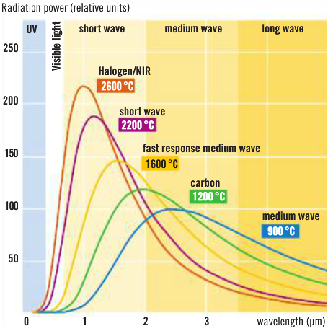
Figure 4: Spectral irradiance of IR emitter [2]

2. Experimental and Measured Results

2.1. Experimental Results

In a first step, a test only with the aluminium plate and without the bagging material has been done. The three thermocouples on the surface are located under 90° (Middle) and 60° (Left and Right) angle to the IR emitter. The one directly located under the emitter is increasing up to 105°C and the other two are significantly lower between 42°C and 50°C as shown in Figure 5.

Figure 5: Measured temperature profile of aluminium plate without bagging material

The same test has been done with the surface covered by a bagging material under vacuum for the trial and the thermocouples where located under the bag at the same locations as in the measurement before. The results can be found in Figure 6.

Figure 6: Measured temperature profile of aluminium plate including bagging material

Comparing these figures to the results from the simulation without movement in Figure 7 and Figure 8 we can see the increase of the thermocouples located directly under the emitter is slightly lower for the trial without the material and slightly higher for the test including the material. This effect can be caused by the non-perfect connection of the aluminium plate and the new bagging material. For the thermocouples located to the left and right of the emitter, we can see for both trials a slight lower temperature as reality. The slightly different curvatures of the angled thermocouples in the simulation can be explained by the different edge distances to the aluminium plate. After the peak temperature the curve is showing only a slight decrease compared to the measurements and the angled thermocouples are showing still a slight increase in temperature.

Figure 7: Simulated temperature profile of aluminium plate without bagging material and movement

Figure 8: Simulated temperature profile of aluminium plate including bagging material and without movement

The simulation has also been done including the movement of the emitter and it shows an increase curve comparable to the ones we see in reality (Figure 9). Nevertheless also during this execution the cooling of the surface is lower than measured. This effect for example could be caused by the difference in volume of the aluminium plate.

Figure 9: Simulated temperature profile of aluminium plate including bagging material and movement

3. Conclusion and Outlook

Current results show that the 2D model assumptions can be used to predict the temperature distribution under the emitter up to the peak temperatures. Nevertheless especially the cooling rates of the model are not consistent to the measured results so far. Therefore the same assumptions will be transferred to a 3D model as seen in Figure 10 and investigations will be performed to determine the share of specific boundary conditions on the deviations. During the next step a finer adjustment of these parameters between measurements and simulation can be done for example with the help of additional material measurement series.

Figure 10: 3D setup of model

References

[1] M.-L. Bopp Kunststoffen individuell einheizen. Kunststoffe, 03:60–62, 2017.
[2] Hereaus Noblelight GmbH. Infrared Emitters for Industrial Processes. Heraeus, 2018.
[3] R. Joven, R. Das, A. Ahmed, P. Roozbehjavan, B. Minaie. Thermal properties of carbon fibre-epoxy composites with different fabric weaves. SAMPE International Symposium Proceedings, Charleston, USA, January 2012.
[4] A. Jhaveri, M. Kushare and A. Bhargav, Radiation Heat Transfer in Imaging Infrared Spectrometer, COMSOL Conference Bangalore 2016
[5] P. W. Atkins, Physikalische Chemie, Wiley-VCH Verlag GmbH & Co. KGaA, Weinheim, 1990
[6] R. T. Reavely, P. C. Ogle and R. V. Kromrey, Method of vacuum bagging using a solid flowable polymer, US 4755341 A Patent
[7] H. Domininhaus, P. Elsner, P. Eyerer et al, Kunststoffe, Springer Verlag, Heidelberg (2008)
[8] G. Gottstein, Physikalische Grundlagen der Materialkunde, 439-440, Springer, Volume 3

