EFFECT OF ULTRASONIC WELDING PROCESS ON THE CRYSTALLINITY AT THE WELDING INTERFACE OF CF/PPS JOINTS

N.Koutras¹, I.F. Villegas¹ and R. Benedictus¹
¹ Structural Integrity and Composites, Delft University of Technology, Kluyverweg 1, 2629 HS, Delft, The Netherlands
Email: n.koutras@tudelft.nl,
Email: I.FernandezVillegas@tudelft.nl,
Email: R.Benedictus@tudelft.nl,

Keywords: Ultrasonic Welding, Thermoplastic Composites, Crystallinity, PPS, DSC

Abstract

The influence of the ultrasonic welding process parameters, namely the force and the vibration amplitude, on the crystallinity degree at the welding interface of CF/PPS (carbon fibre reinforced poly(phenylene) sulphide) joints is investigated. Two different sets of parameters, one representing high force and high vibration amplitude (1000 N, 86.2 μm) and one representing low force and low vibration amplitude (300 N, 51.8 μm), were used in this study. The temperature at the centre of the overlap was measured using K-type thermocouples in order to obtain the cooling rate for each set of parameters. Differential scanning calorimetry (DSC) and X-ray diffraction (XRD) measurements were performed in order to determine the crystallinity degree of PPS at the welding interface. It was found that a force of 300 N and a vibration amplitude of 51.8 μm could obtain a PPS of a moderate crystallinity degree (14.6%) and an average PPS crystallite size of 41.3 Å, showing that it is possible to obtain a semi-crystalline welding interface by appropriately modifying the process parameters.

1. Introduction

Ultrasonic welding is classified as a friction welding technique, which converts high frequency (typically 20-40 kHz) and low amplitude mechanical vibrations into heat via friction. The vibrations cause surface and intermolecular friction in the materials to be welded which lead to heat generation. It is a very fast process, it does not require a foreign material in the interface and it produces excellent quality joints [1]. However, due to the very fast cycle times, the cooling rates at the welding interface are expected to be very high. Most of the high-performance thermoplastics such as PEEK, PEKK and PPS are semi-crystalline polymers, therefore the cooling rates could affect the final properties of the polymer at the welding interface. It is well known that very fast cooling of semi-crystalline thermoplastics can result in predominantly amorphous structures [2-5]. Grouve et al. showed that cooling rates of 20 °C/s were sufficient to yield amorphous PPS [3] and, similarly, Furushima et al. found that the critical cooling rate to suppress crystallisation of PPS was 30 °C/s [4]. Thus, the effect of the ultrasonic welding process on the degree of crystallinity at the welding interface is expected to be significant due to the very fast cycle times (3-4 sec).

The semi-crystalline nature of thermoplastic matrix systems has been documented to play a dominant role on properties such as stiffness, shear strength, fibre/matrix interfacial strength, fracture toughness and chemical resistance. Talbott et al. studied the mechanical properties of PEEK and found that decreasing crystallinity led to a lower elastic modulus, lower tensile strength and lower shear strength for neat PEEK [5]. Crystallinity has been shown to have a beneficial effect on the tensile properties of PPS and its composites [3, 6], as well as on the interfacial shear strength of carbon fibre reinforced PPS and carbon reinforced PEEK [7, 8]. On the contrary, it was found that a lower crystallinity degree resulted in higher Mode-I interlaminar fracture toughness of PEEK and PPS composites [5, 9, 10]. Hence, by taking into account the very fast welding times of the ultrasonic welding process and the major influence of the degree of crystallinity on the properties of polymers and fibre reinforced polymers, the investigation of the polymer state at the welding interface of ultrasonically welded thermoplastic composites joints is of significant importance.

This article presents a characterisation of crystallinity at the welding interface of ultrasonically welded CF/PPS joints, having two main objectives. First, to study the influence of the ultrasonic welding process parameters on the degree of crystallinity at the welding interface of CF/PPS joints and, second, to determine whether it is possible to obtain a semi-crystalline welding interface by appropriately modifying the process parameters.

2. Experimental Procedure

2.1. Materials and Manufacturing

The material used in this study was Cetex® woven (five harness satin) carbon fibre reinforced polyphenylene sulphide composite (CF/PPS) supplied by Ten Cate Advanced Composites, The Netherlands. Laminates measuring 580 mm x 580 mm were built from six powder-impregnated CF/PPS layers with a stacking sequence of [(0°/90°)₃]_{s}. The laminates were consolidated using a hot platen press at 320°C and 1 MPa pressure for 20 min, at a cooling rate of 15 °C/min.

A 20 kHz Rinco 3000 microprocessor-controlled ultrasonic welder (Rinco Ultrasonics, Romanshorn, Switzerland) was utilised to manufacture the joints in this work. More information on the ultrasonic welding set-up can be found in previous studies [1, 11]. Two different sets of force and vibration amplitude, (1000 N, 86.2μm) and (300 N, 51.8μm), were selected to study the effect of the process parameters on crystallinity of PPS at the welding interface, representing the fast process and the slow process, respectively. The process was controlled through the vertical displacement of the sonotrode (“displacement-controlled”) and the optimum displacement values were 0.15 mm for (1000 N, 86.2μm) and 0.13 mm for (300 N, 51.8μm). The procedure that was followed in order to determine the displacement values has been described in previous work [1]. The average corresponding vibration times were 400 ms and 1500 ms, respectively. The solidification time was 4000 ms and the solidification force remained constant for all the welded joints produced in this study. Thin polymer films, called flat energy directors (ED) were used at the welding interface in order to concentrate the heat. The EDs were consolidated by placing three 0.08 mm thick amorphous PPS films in a hot platen press at 260 °C and 1 MPa pressure for 20 min. The cooling rate was 15 °C/min, and the final thickness was 0.24 mm.

2.2. Temperature Measurements

In order to obtain the temperature profile of the ultrasonic welding process, the temperature at the centre of the overlap was measured by embedding a thermocouple inside an energy director. K-type thermocouples with a diameter of 0.1 mm were sandwiched between four films of amorphous PPS. A Rinco handheld ultrasonic welder was used to manually fix the thermocouples on the PPS films, prior to press consolidation. The pressure was uniformly distributed by using a silicon layer of 1.95 mm thickness (the presence of the thermocouples caused a non-uniform pressure distribution). The silicon layer was sandwiched between two Kapton films of 25 μm thickness to prevent contact with the EDs. The stack was consolidated in a hot platen press at 260 °C and 1 MPa pressure for 20 min. The material was cooled down at 15 °C/min, obtaining a final thickness of 0.32 mm. The thermocouple tip was located at the centre of the overlap, as it can be seen in Figure 1. “Displacement-controlled” welding was also used for the temperature measurements, as described in 2.1. The optimum displacement value for both sets of parameters was 0.22 mm. The temperature was recorded during ultrasonic welding using a Thermocouple Data Logger, TC-08, from Pico Technology, at a frequency of 10Hz. The samples welded using a force of 1000 N and a vibration amplitude of 86.2 μm are denoted by ETC_1000_86.2, while the samples welded using a force of 300 N and a vibration amplitude of 51.8 μm are denoted by ETC_300_51.8. In order to calculate the cooling rate, the temperature at which the crystallisation rate is maximum, needs to be known. The maximum crystallisation rate of a semi-crystalline polymer occurs at a temperature approximately around the midpoint of the glass transition temperature (around 100 °C for PPS) and the melting temperature (around 280°C for PPS) [6]. Thus, in this study we considered that PPS reaches its maximum crystallisation rate at 190 °C.

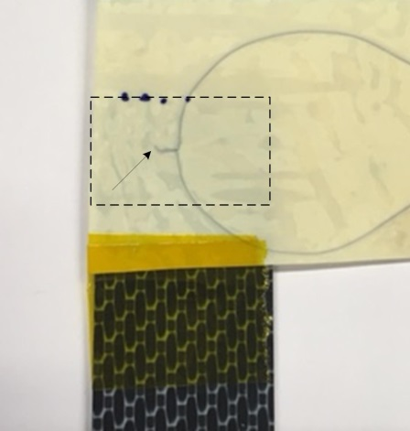

Figure 1. ED with embedded thermocouple prior to ultrasonic welding, positioned in such way to measure the temperature at the centre of the overlap (highlighted area). The arrow in the picture points at the tip of the thermocouple (location of the temperature measurements).

2.3. Crystallinity Assessment

In order to measure the degree of crystallinity of PPS at the welding interface, a simple method to remove material from the welding interface was adopted. In particular, prior to welding, two Kapton films, 250 μm thick, were fixed with a tape, one on each adherend and, subsequently, the ED was sandwiched between the two Kapton films. After ultrasonic welding was carried out, the ED was easily removed from the welding interface due to the Kapton films. The removed ED was used for standard DSC and XRD measurements. The ED film welded with high force and high vibration amplitude is denoted by ED_1000_86.2 and the film welded with low force and low vibration amplitude is denoted by ED_300_51.8. The ED film in the initial state is denoted by ED_reference. A Sapphire DSC from Perkin Elmer was used to carry out the DSC measurements. Calibration was performed by using indium standards. The samples were heated from 25 °C to 320 °C at 10 °C/min, and the degree of crystallinity was determined from the heating run and calculated using equation (1). All measurements were performed under nitrogen.
X_{c} = 100*(${ΔH}_{m}{+ ΔH}_{c})$/ ${ΔH}_{f}^{o}$${ΔH}_{f}^{o}$ (%) (1)

Where ${ΔH}_{m}$ is the enthalpy of melting, ${ΔH}_{c}$ is the energy associated with the cold crystallisation peak, and ${ΔH}_{f}^{o}$${ΔH}_{f}^{o}$ is the enthalpy of fusion of an ideal PPS crystal (112 J/g [12]).${ΔH}_{f}^{o}=112 J/g [\frac{Chung}{Cebe}])$

An X-ray powder diffractometer from Bruker was used for the XRD measurements and the diffractograms were obtained using Cobalt radiation. The average crystallite size was calculated through the software using the Scherrer equation:
D = Κλ / (β cos θ) (Å) (2)

Where K is a shape factor (ca. 0.9), λ is the X-ray wavelength (1.789 Å for Cobalt), β is the full-width at the half maximum intensity of the diffraction peak and θ is the Bragg angle.

3. Results

  - Temperature measurements

In total, two ETC_1000_86.2 samples and three of ETC_300_51.8 samples were tested for which the maximum temperature and cooling rates are shown in Table 1. Figure 2 depicts the temperature evolution during ultrasonic welding for two samples, one ETC_1000_86.2 sample and one ETC_300_51.8 sample. Since the temperature did not exhibit a linear decrease, as illustrated in Figure 2, it was considered inaccurate to provide a global cooling rate. Hence, the temperature profile was divided into smaller temperature regions and the cooling rates in each region were calculated, approximately, based on the assumption of a linear time-temperature relationship. As mentioned in section 2.2, the maximum crystallisation rate of PPS occurs at 190 °C, therefore, we considered the temperature range between 280 °C and 190 °C, as the range at which the cooling rates should be calculated. It was demonstrated that using low force and low amplitude lowered the cooling rates of the ultrasonic welding process substantially (for example, 38.1 °C/s compared to 130.3 °C/s for the temperature range between 280 °C and 190 °C). An additional point to be made from this figure is the large experimental errors in most of the cooling rates calculated.

Table 1. Cooling rates and maximum temperature per set of parameters.

Sample | T_{max} (°C) | Cooling Rates (°C/s)
 |  | 280 °C - 250 °C | 250 °C - 190 °C | 190 °C - 150 °C | 280 °C - 190 °C
ETC_1000_86.2 | 629.2 ± 46.8 | 130.3 ± 24.3 | 130.3 ± 24.3 | 47.7 ± 17.8 | 130.3 ± 24.3
ETC_300_51.8 | 583.6 ± 87.6 | 54 ± 15.1 | 29 ± 6.5 | 14.5 ± 2.5 | - ± 11.4

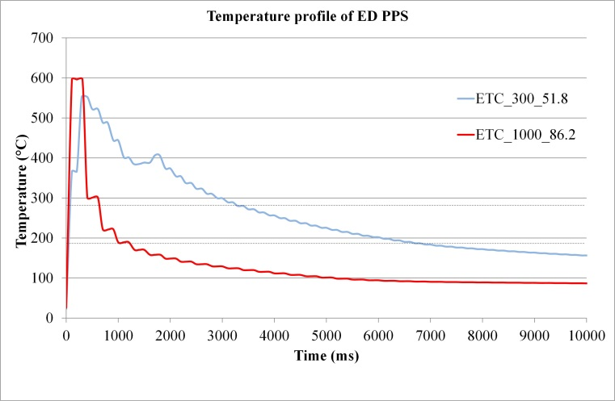

Figure 2. Temperature evolution during ultrasonic welding for two different sets of force and amplitude, (1000N, 86.2μm) and (300N, 51.8μm). It can be noted that low force and low amplitude decreased the cooling rates significantly. The two lines highlight the temperature range in which the cooling rates were calculated (190°C, 280 °C).

  - DSC and XRD analysis of welded energy directors

Figure 3 illustrates two E that were removed from the welding interface. Clear differences in appearance were observed. In specific, a force of 1000 N and a vibration amplitude of 86.2 μm produced a predominantly transparent film, with some small opaque areas. On the contrary, a force of 300 N and a vibration amplitude of 51.8 μm produced an opaque film with some randomly distributed small transparent areas. Figure 4 presents the average crystallinity degree values as measured from DSC and calculated using equation (1). The crystallinity degree of ED_reference was 24.9%, ED_300_51.8 showed moderate crystallinity, 14.6 %, while ED_1000_86.2 was predominantly amorphous. An additional point to be made for Figure 4 is the large standard deviation of crystallinity degree values of ED films removed from the welding interface, especially for ED_300_51.8.

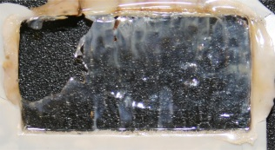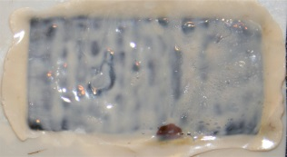

Figure 3. ED_1000_86.2 (left) and at ED_300_51.8 (right). High force and high vibration amplitude produced a predominantly transparent film, while low force and low vibration amplitude produced an opaque film. A black background was used in order to facilitate observation of the films.

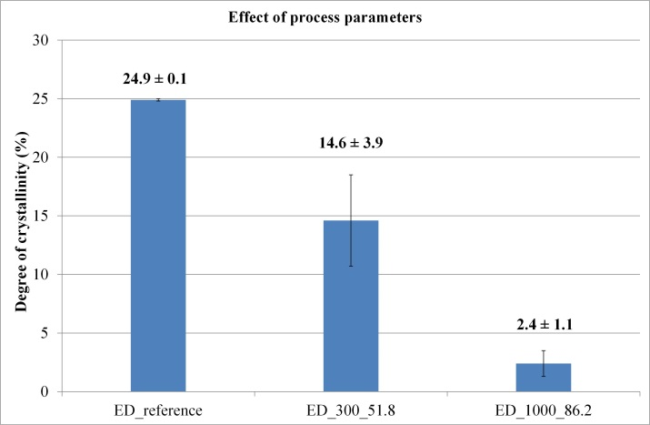

Figure 4. Crystallinity degree of PPS ED films calculated from DSC measurements. ED_300_51.8 showed moderate crystallinity while ED_1000_86.2 was predominantly amorphous. Each crystallinity value is the average of three measurements.

XRD measurements on the three ED films are shown in Figure 5, which outlines the diffraction patterns of all three samples.

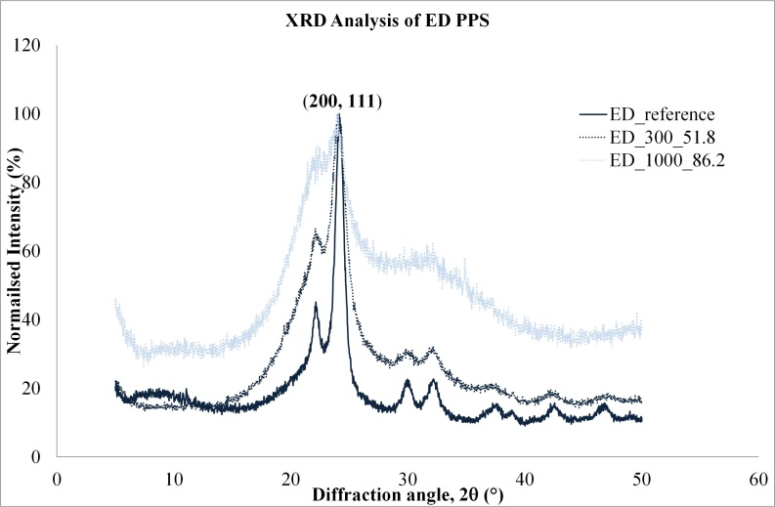

Figure 5. X-ray diffraction patterns showing the effect of the welding process parameters. Intensity was normalised with respect to the intensity of the main diffraction peak (200, 111).
The intensity was normalised with respect to the intensity of the major diffraction peak, (200, 111). ED_reference exhibited narrower diffraction peaks compared to the ED films removed from the welding interface, and ED_1000_86.2 exhibited the most significant peak broadening. The average crystallite size of the crystalline phase of PPS was estimated using equation (2), and it was found that the average crystallite size of ED_reference was 115.6 Å, of ED_300_51.8 was 41.3 Å and of ED_1000_86.2 was 25.6 Å.

4. Discussion

The results of this work are discussed with respect to the key research question as it was outlined in the introduction section, in particular, the influence of the process parameters on the crystallinity degree of PPS at the welding interface.

The cooling rate of ETC_300_51.8 was significantly lower than ETC_1000_86.2 and PPS experienced longer vibration times (ca. 1500 ms) for low force and low vibration amplitude compared to high force and high vibration amplitude (ca. 400 ms). The reason for the longer welding times of ETC_300_51.8 can be found in the lower heat generation:
Q̇ = ω*ε²*E´´/2 (3)

Where ε is the strain amplitude, ω is the frequency and E´´ is the loss modulus. Hence, the heat generation would be lower for lower vibration amplitude. Heat is dissipated through the composite substrates because of the high thermal conductivity of carbon fibres, therefore, the temperature in the composite substrates will increase as well. Consequently, longer vibration times would cause the substrates to remain warm for a longer time which, essentially, could result in a more gradual drop in temperature at the welding interface.

The DSC measurements on ED films removed from the welding interface, revealed that welding using 300 N and 51.8 μm can yield PPS of moderate crystallinity at the welding interface. On the contrary, 1000 N and 86.2 μm resulted in predominantly amorphous PPS at the welding interface as it was summarised in Figure 4. In principle, a lower cooling rate allows more time for the polymer chains to organise themselves and form crystalline domains, thus, at first glance it appears that a cooling rate of 38.1 °C/s is sufficient for PPS crystallisation. However, in recent studies it was shown that cooling rates of 20 °C/s [3] and 30 °C/s [4] were sufficient to suppress crystallisation and obtain an amorphous PPS structure. Therefore, a discrepancy was noted between the cooling rates calculated at the centre of the overlap and the crystallinity degree measured from the removed ED films of the welding interface. A few potential factors responsible for this disagreement are discussed below.

First, as it can be seen in Table 1, the cooling rate values showed large experimental errors. A possible reason could be that the thermocouples were not located precisely at the centre of the overlap for every measurement. Second, as mentioned in section 3.1, the decrease in temperature was not linear and the values provided in Table 1 are approximations based on a linear time-temperature relationship per temperature region. As it can be seen, between 280 °C and 250 °C the temperature decreases at a rate of 54 °C/s, and between 250 °C/s and 190 °C it decreases at a rate of 29 °C/s. On the contrary, the reported cooling rates of 20 °C/s and 30 °C/s [3, 4] were all constant, since these studies investigated the crystallisation of PPS under a constant decrease in temperature. In addition, the actual cooling rate at which the PPS which was used in this study becomes fully amorphous, is not known. Thus, further experiments are required in order to determine this, as the cooling rates might be different than the ones cited in this paper [3, 4]. Third, the removed ED films from the welding interface were not fully representative of an ED of a consolidated welded joint produced without the interference of Kapton films. Normally, the ED is in contact with the CF/PPS substrates while in our approach, the ED is in contact with the Kapton films which could, potentially, cause different heating. Although it is not anticipated that the presence of Kapton films will drastically alter the heat generation at the overlap, it is recommended to study the effect of Kapton films on the temperature evolution during ultrasonic welding by further temperature measurements.
In addition, a large experimental error on the crystallinity values of ED_300_51.8 was noted (Figure 4) which could be attributed to a non-uniform crystallisation of the ED film during cooling. Hence, one could expect that the actual crystallinity degree of ED_300_51.8 could be lower or higher than 14.6%. Still, the visual observation of the removed ED films (Figure 3) in conjunction with the larger average crystallite size of ED_300_51.8 compared to ED_1000_86.2, indicated that low force and low vibration amplitude have caused PPS to crystallise.

In accordance to these observations it is safe to conclude that by choosing the appropriate process parameters, PPS at the welding interface can crystallise, however, the question remains how this is possible. It is not clear whether the cooling rates involved during the ultrasonic welding process are low enough in order to achieve crystallisation of PPS at the welding interface, therefore, two factors that could potentially facilitate PPS crystallisation are discussed. One possible reason for the semi-crystalline structure of ED_300_51.8 could be the presence of remnant crystals in the melt. Although the temperature reached values much higher than the melting temperature of PPS (Figure 2), ensuring that the temperature is high enough to melt the crystals, the material cooled down rapidly from the melt. Hence, there is a possibility that some of the crystals which pre-existed in the initial state of the ED (as received from press consolidation) did not melt or melted partially and, therefore, acted as nucleation sites during cooling. Another possible reason for the crystallisation of PPS despite the high cooling rates, is the influence of shear that could potentially result in shear-induced crystallisation. The ultrasonic welding process involves vibration frequencies in the order of tens of kHz (20 – 40 kHz), thus, very high strain rates can be achieved instantaneously. Considering that shear can accelerate crystallisation of polymers [3, 13] and that the reported values of cooling rates at which crystallisation of PPS was suppressed [3, 4] were determined under quiescent conditions, it could be argued that the high strain rates during the ultrasonic welding process might have induced crystallisation. Furthermore, ED_1000_86.2 exhibited some small opaque areas and a crystallinity of 2.4% regardless the very high cooling rates (130.3 °C/s) which probably could also be explained in terms of shear-induced crystallisation.

5. Conclusions

The main objective of this study was to investigate the influence of the ultrasonic welding process parameters, namely the force and the vibration amplitude, on the crystallinity of PPS at the welding interface. The following conclusions can be drawn:

- Temperature measurements at the centre of the overlap of ultrasonically welded CF/PPS joints revealed that the cooling rate for low force and low vibration amplitude (300 N, 51.8 μm) was lower than the cooling rate for high force and high vibration amplitude (1000 N, 86.2 μm) The lower cooling rate for (300 N, 51.8 μm) was attributed to the longer vibration times which caused the composite substrates to remain warm for longer times

- A predominantly amorphous PPS structure at the welding interface of CF/PPS joints was obtained for high force and high vibration amplitude, exhibiting a crystallinity degree of 2.4% and an average crystallite size of 25.6 Å. Both values were significantly lower than the respective values (24.9% and 115.6 Å) of semi-crystalline PPS (initial state after press consolidation). Low force and low vibration amplitude resulted in PPS of moderate crystallinity (14.6%) and an average crystallite size of 41.3 Å, showing that it was possible to obtain a semi-crystalline welding interface by appropriately modifying the process parameters.

- The ability of PPS to crystallise despite the very high cooling rates at the welding interface, was attributed to two potential factors. The presence of remnant crystals, which did not melt or partially melted, as a result of the very fast cooling, might have acted as nucleation sites, and the very high strain rates involved in the ultrasonic welding process which could have resulted in shear-induced crystallisation. Further investigation is required in order to confirm the presence of remnant crystals in the melt and the effect of the very high strain rates on the crystallisation of PPS at the welding interface.

Acknowledgments

This study is part of the TAPAS2 project, financed by Netherlands Enterprise Agency of the Ministry of Economic Affairs. The authors gratefully acknowledge Ben Norder for his technical assistance and performing the XRD experiments.

References

[1] I. Fernandez Villegas. Strength development versus process data in ultrasonic welding of thermoplastic composites with flat energy directors and its application to the definition of optimum processing parameters. Composites: Part A, 65:27-37, 2014.
[2] D.G. Brady. The crystallinity of poly(phenylene sulfide) and its effect on polymer properties. Journal of Applied Polymer Science, 20:2541-2551, 1976.
[3] W.J.B. Grouve, G.V. Poel, L.L. Warnet, and R. Akkerman. On crystallisation and fracture toughness of poly(phenylene sulphide) under tape placement conditions. Plastics, Rubber and Composites, 42:282-288, 2013.
[4] Y. Furushima, M. Nakada, Y. Yoshida, and K. Okada. Crystallization/Melting Kinetics and Morphological Analysis of Polyphenylene Sulfide. Macromolecular Chemistry and Physics, 219, 2018.
[5] M.F. Talbott, G.S. Springer, and L.A. Berglund. The effects of crystallinity on the mechanical properties of PEEK polymer and graphite fiber reinforced PEEK. Journal of Composite Materials, 21:1056-1081, 1987.
[6] J.E. Spruiell, and C.J. Janke. A review on the measurement and development of crystallinity and its relation to properties in neat poly(phenylene sulfide) and its fiber reinforced composites. Report, Oak Ridge National Laboratory, 2004.
[7] S.L. Gao, and J.K. Kim. Cooling rate influences in carbon fibre/PEEK composites. Part 1. Crystallinity and interface adhesion. Composites: Part A, 31:517-530, 2000.
[8] E. Schulz, G. Kalinka, and W. Auersch. Effect of transcrystallization in carbon fiber reinforecd poly(p-phenylene sulfide) composites on the interfacial shear strength investigated with the single fiber pull-out test. Journal of Macromolecular Science, Part B, 35:3-4, 527-546, 1996.
[9] S.L. Gao, and J.K. Kim. Cooling rate influences in carbon fibre/PEEK composites. Part II: interlaminar fracture toughness. Composites: Part A, 32:763-774, 2001.
[10] F. Sacchetti. Interlaminar toughness of fusion bonded thermoplastic composites. PhD thesis, University of Twente, 2017.
[11] I. Fernandez Villegas. In situ monitoring of ultrasonic welding of thermoplastic composites through power and displacement data. Journal of Thermoplastic Composite Materials, 28:66-85, 2015.
[12] P. Huo, and P. Cebe. Effects of thermal history on the rigid amorphous phase in poly(phenylene sulfide). Colloid & Polymer Science, 270:840-852, 1992.
[13] R.C. Zhang, Y. Xu, A. Lu, K. Cheng, Y. Huang, and Z.M. Li. Shear-induced crystallization of poly(phenylene sulfide). Polymer, 49: 2604-2613, 2008.

