numerical simulation of two-dimensional crack propagation

Aida Cameselle-Molares¹, Anastasios P. Vassilopoulos¹, Jordi Renart², Albert Turon² and Thomas Keller¹

¹Composite Construction Laboratory (CCLab), École Polytechnique Fédérale de Lausanne (EPFL), Lausanne, Switzerland
Emails: aida.cameselle@epfl.ch, anastasios.vasilopoulos@epfl.ch, thomas.keller@epfl.ch
Web Page: http://cclab.epfl.ch
²AMADE, Mechanical Engineering and Industrial Construction Department, Universitat de Girona, Girona, Spain
Emails: jordi.renart@udg.edu, albert.turon@udg.edu
Web Page: amade.udg.edu

Keywords: 2D crack propagation, laminates, fiber-bridging, finite element analysis.

Abstract
A numerical investigation was carried out to simulate the experimental results previously obtained concerning two-dimensional in-plane crack propagation in laminated glass fiber-reinforced polymer (GFRP) plates. The plates were designed with an embedded circular pre-crack and subjected to quasi-static out-of-plane loads. In order to study the transition from standard fracture mechanics tests, where the crack propagates only in one dimension (1D), to two-dimension (2D) scenarios, additional double cantilever beam (DCB) experiments were carried out on the same material system. Three-dimensional finite element models were developed for the simulation of the experimental fracture responses and cohesive elements were used to take into account the fracture mechanisms acting on the fracture process zone. A much higher value of for the total strain energy release rate (SERR) was numerically obtained for the 2D plates (compared to 1D double cantilever beam (DCB) specimens), which was correlated to an increase in the fiber-bridging area due to additional stiffness mechanisms activated in the plate.

1. Introduction

Delamination in laminated structural components may lead to a reduction in the load-bearing capacity of the structure and thus, significant efforts have been devoted to investigate the delamination fracture behavior of laminated composites [1]. Pure and mixed-mode fracture behaviors in beam-like specimens have been widely investigated and standardized [2]. However, some of the conditions required by these types of experiments (e.g. constant crack width or single direction of propagation) may not correspond to the actual delamination damage growth that occurs in FRP structures where delamination damage may develop all around the contour of a defect. Furthermore, accurate determination of the strain energy release rate (SERR) is a key factor for damage-tolerant structural design and thus the development of new fracture experimental designs better able to represent realistic scenarios is needed.

The experimental fracture behavior of laminated FRP plates with an embedded circular pre-crack (i.e. 2D delamination) and subjected to quasi-static out-of-plane opening loads was investigated in [3]. The numerical investigation of the 2D in-plane crack propagation in two of these laminated plates is presented in this paper. The material system of the selected plates was glass/epoxy with a long continuous filament mat reinforcement. To compare and to understand the transition from standard 1D fracture experiments to 2D crack propagation scenarios, DCB specimens with different widths were further experimentally investigated. Finite element models were developed to simulate the experimental fracture responses of the plates and the DCBs using cohesive elements.
2. Experimental methods, results and discussion

2.1. Experimental investigation of laminated plates

The 2D delamination behavior of FRP laminated plates under quasi-static out-of-plane opening loading was experimentally investigated in [3]. The experimental program was conducted on twelve GFRP/epoxy plates comprising different glass reinforcements. The investigation presented here involves the two plates with six layers of long continuous glass filament mat reinforcement (CFM). The plates were fabricated using a vacuum infusion process with an embedded circular pre-crack in the center and at the midplane. The dimensions of the plates were 420-mm width and 420-mm height for both CFM plates with an average thickness of 7.50 mm and 6.99 mm for CFM.1 and CFM.2 respectively. An example of the experimental set-up for the CFM.2 plate is presented in Fig. 1(a, b). Likewise, the crack propagation pattern obtained for one of the plates is shown in Fig. 1(c). Further details concerning the experimental set-up and the measuring methodologies can be found in [3].

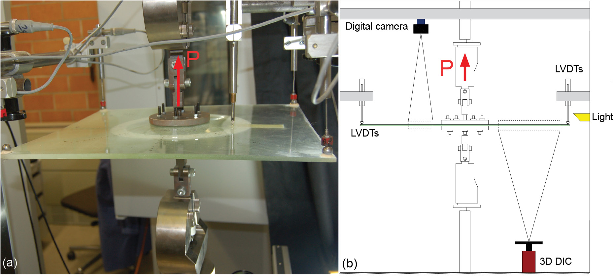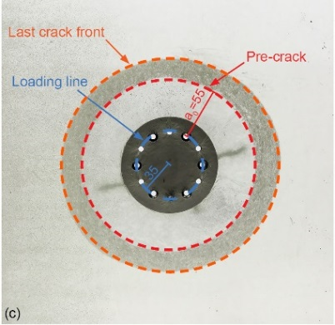

Figure 1. Experimental set-up; (a) experiment on CFM.2; (b) layout of set-up and (c) crack propagation pattern obtained in plate CFM.1. Units in mm.

The experimental results obtained for the two laminated plates under study in this investigation (CFM) are summarized in the following. In Fig. 2(a) the load vs displacement and average crack-length vs displacement curves are shown for both CFM plates. There, it can be observed that, even after crack initiation, a continuously increasing load-opening displacement behavior was obtained up to specimen failure due to the increase of the length of the crack front for each increment in the radial direction.

(a)
(b)

Figure 2. (a) Experimental load and crack length vs displacement curves and (b) Comparison of experimental and numerical crack area vs compliance of CFM plates.

The curves illustrating the crack area vs the compliance of the plates are shown in Fig. 2(b). Details describing the calculation of crack area can be found in [3]. Based on the compliances, two main different regions could be differentiated (A and B in Fig. 2(b)). In region A, a decreasing behavior of the compliance was observed (i.e. stiffening of the plate) down to a minimum value (transition point, TP). From the TP onwards (Region B), the compliance started to increase (i.e. softening of the plate). The changes in the stiffness were caused by three different mechanisms activated during the opening of the plates: stretching, fiber-bridging and crack propagation. The boundary conditions of the plates led to the radial and circumferential stretching of the out-of-plane deforming open part of the plates, while the fiber-bridging and the crack propagation were activated after crack initiation. The former contributing to the stiffening of the plate, whereas the latter causing the softening of the system. The stiffening mechanisms prevailed over the softening up to the TP. Beyond the TP, the softening was the dominant mechanism. Further discussion and details can be found in [3-4].

2.2. Experimental investigation of Mode I DCB specimens

Double cantilever beam specimens were used to determine the Mode I SERR. The same material system and lay-up as those of the previously studied plates were used. A Teflon film of 13-µm thickness was placed at the midplane to introduce the pre-cracks. Specimens of 250 mm length and of different widths (25, 40, 60 and 100 mm) were investigated to determine any possible influence of this parameter on the experimental SERR. The geometrical and elastic properties of the DCB specimens are presented in Table 1. The crack length was monitored with a digital camera placed above the specimens. To monitor the bridging length from the side of the specimens, a second digital camera was used. Further details concerning the set-up and the measuring methodologies can be found in [4].

Table 1. Geometrical and elastic properties of DCB specimens

 | Width  (mm) | Thickness  (mm) | Pre-crack (mm) | $E_{1}$=$E_{2}$ (GPa) | $E_{3}$ (GPa) | $G_{12}$ (GPa) | $G_{13}$= $G_{23}$ (GPa) | $$ν_{12}$$  (-) | $ν_{13}$= $ν_{23}$  (-)
DCB-25 #1-2 | 25 | 7.64 | 50 | 9.22 | 4.64 | 3.47 | 1.54 | 0.33 | 0.3
DCB-40 #1-2 | 40 | 7.64 | 50 | 9.22
DCB-40 #3-5 | 40 |  | 30
DCB-60 #1-3 | 60 | 6.80 | 50 | 10.03 | 4.90 | 3.77 | 1.57
DCB-100 #1-3 | 100 |  | 50

(a)
(b)

Figure 3. Results of DCB specimens; (a) comparison of experimental and numerical load-displacement curves; (b) experimental R-curves.

The experimental load-displacement responses of DCB specimens are presented in Fig. 3(a). For the calculation of the total SERR of the specimens, G_{tot}, the experimental compliance method (ECM) was used. The G_{tot} derived from the experiments is the sum of the SERR at the crack tip, G_{tip}, and the SERR due to the fiber-bridging, G_{br}. The R-curves obtained for all the DCB specimens are shown in Fig. 3(b). According to these curves, values of 400 J/m² and 2000 J/m² respectively were assigned to G_{tip} and G_{tot}. A value of ~10 mm for the fiber-bridging length was obtained along with a maximum crack opening displacement (COD), $δ_{f}$, of ~1.25 mm [4]. Likewise, as can be observed in Fig. 3(b), similar R-curves were obtained (considering the typical scatter observed in such experiments) regardless of the width.

3. Numerical methods, results and discussion

3.1. Cohesive zone modeling

The traction-separation law used to define the behavior of the cohesive elements is shown in Fig. 4(a). The first part of the law (in orange) is attributed to the initial damage and the area under this bilinear part equals the SERR at the crack tip, G_{tip}, corresponding to the energy required for crack initiation. The second part (in blue) corresponds to the SERR due to the fiber-bridging, G_{br}. The addition of these two SERR values equals the total area under the traction-separation law, which will be referred hereafter as G_{tot} (i.e. G_{tot} = G_{tip} + G_{br}). The bridging tractions are given by [5]:

$σ_{br}\left(δ\right)=e^{-γ\sqrt{δ-δ_{1}}}σ_{max}\left(1-\sqrt{\frac{δ-δ_{1}}{δ_{f}-δ_{1}}}\right), δ_{1}≤δ≤δ_{f}$ (1)
where $δ$ is the crack-opening displacement (COD),$σ_{max}$ and $δ_{1}$are the maximum bridging traction and the corresponding COD and $δ_{f}$is the COD corresponding to the fully developed bridging zone. Likewise, $γ$ is the parameter governing the bridging tractions’ profile. The overall traction-separation response is defined as:

$σ=\left(1-D\left(δ\right)\right)K_{0}δ$ (2)
$D\left(δ\right)=\left\{\begin{aligned}0 for 0≤δ≤δ_{c} \\ 1-\frac{αδ+β}{K_{0}δ} for δ_{c}≤δ≤δ_{1} \\ 1-\frac{σ_{br}}{K_{0}δ} for δ>δ_{1} \end{aligned}\right.$ (3)
where $σ$ is the general cohesive traction, $D$ is the damage, $K_{0}$is the initial cohesive stiffness and α and β are:
$α=\frac{σ_{c}-σ_{max}}{δ_{c}-δ_{1}}$ (4)
$β=σ_{c}-αδ_{c}$ (5)
where $σ_{c}$ and $δ_{c}$ are the corresponding values of the traction and COD for damage initiation.

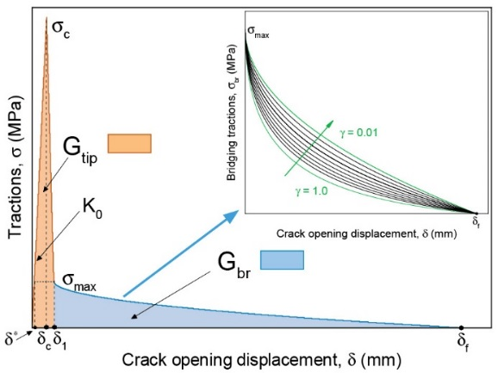
(a)
(b)

Figure 4. Traction-separation curves; (a) general description and (b) used in numerical models
The presented traction-separation law was implemented in the FE model by means of a user material subroutine (UMAT) written in FORTRAN programming language. The damage definition ($D\left(δ\right)$) was changed according to the formulation presented (Eq. 1-5). Details and theoretical background of the formulation of the original UMAT can be found in [6].

3.2. Numerical investigation of Mode I DCB specimens

A finite element (FE) model was developed to simulate the delamination behavior of the DCB experiments using the commercial finite element analysis (FEA) software ABAQUS 6.14.1. The two GFRP beams were modeled with 3D built-in continuum shell elements (CS8R) and a single zero-thickness layer of three-dimensional cohesive elements (Abaqus COH3D8) was implemented at the midplane in the un-cracked region. The engineering constants used to define the bulk material are listed in Table 1. One FE model for each of the DCB configurations presented in Table 1 was performed. Further details concerning this FE model can be found in [4].

The traction-separation law described in Section 3.1 was implemented in the cohesive elements of the model. The experimentally obtained SERR values of $G_{tip}$=400 J/m² and $G_{tot}$=2000 J/m² (i.e. $G_{br}$=1600 J/m²) and the maximum COD ($δ_{f}$=1.25 mm) were assigned. The maximum traction for damage initiation was assumed to be equal to 30% of the tensile strength of the matrix (84 MPa), i.e. $σ_{c}$=25.2 MPa. The initial cohesive stiffness, $K_{0}$, was taken as being equal to 100000 MPa/mm and the resulting value of $δ_{1}$was 0.027 mm. The values of the maximum bridging traction, $σ_{max}$, and the bridging traction decay ratio, $γ,$ were estimated iteratively to fit the experimental load-displacement responses. Corresponding values of $σ_{max}=$5 MPa and $γ=$0.46 were obtained. The same traction-separation law was used for all DCB specimens and is presented in Fig. 4(b). The numerical load-displacement curves obtained for the DCB specimens are shown in Fig. 3(a). As can be observed, the experimental curves are in good agreement with those numerically estimated.

A range of DCB specimen widths was selected in order to study the influence of the width on the SERR. The reinforcement is composed of long continuous glass filaments and a possible effect of the anchorage length (which increases with width) on the fiber-bridging behavior was considered. However, in view of the experimental R-curves in Fig. 3(b) and the validity of the same bridging parameters for all specimens (see numerical load-displacement curves in Fig. 3(a)), it can be concluded that the width of the DCB specimens has no influence on the fracture results, at least in the range investigated here.

3.3. Numerical investigation of laminated plates

For the numerical simulation of the CFM plates, the FEA software ABAQUS 6.14.1 was also employed. The dimensions of the model are presented in Fig. 5. The built-in continuum shell element of eight nodes (CS8R) from Abaqus/Standard was used to mesh the bulk material. Two through-thickness elements were assigned to each of the halves of the plate. As for the models of the DCB specimens, a single zero-thickness layer of 3D cohesive elements of eight nodes (Abaqus COH3D8) was implemented at the midplane of the un-cracked region (Fig. 5). The engineering constants used to define the bulk material are presented in Table 2.

Table 2. Engineering constants used in the FE of laminated plate

$E_{1}$=$E_{2}$ (GPa) | $E_{3}$ (GPa) | $G_{12}$ (GPa) | $G_{13}$= $G_{23}$ (GPa) | $$ν_{12}$$ | $ν_{13}$= $ν_{23}$
8.64 | 4.68 | 3.25 | 1.54 | 0.33 | 0.30

Two symmetry planes (D1 and D2) coincident with the diagonals of the plates were considered and therefore corresponding symmetric boundary conditions were applied (see Fig. 5). The steel inserts and external loading blocks [3] were not explicitly modeled. Instead, the nodes of the inner faces of the loading areas were tied by means of a rigid body condition to reference points (indicated in Fig. 5) where the boundary conditions were applied. An out-of-plane displacement condition (in-plane displacements constrained) was applied to the upper reference point and a pinned condition (all displacements constrained) to the bottom reference point. Further details of the FE model can be found in [4].

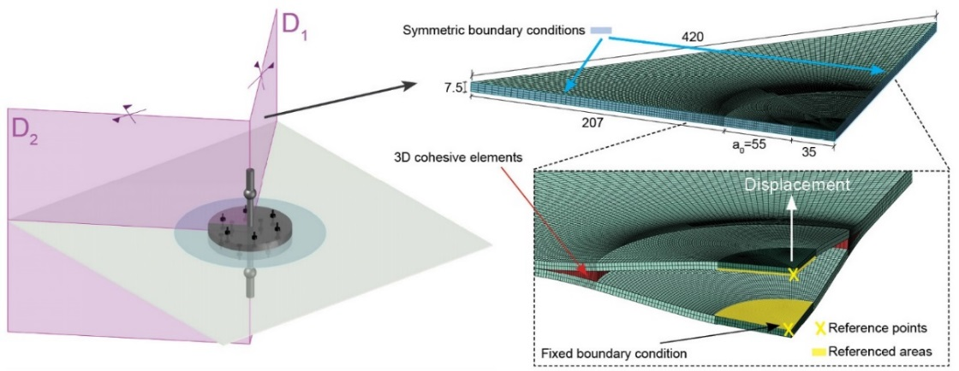

Figure 5. Description of finite element model of laminated plate

The same type of traction-separation law was implemented in the cohesive elements of the FE model of the plates. Initially, the same traction-separation law obtained for the DCB specimens was used (see Fig. 4(b)), the total value of the SERR being therefore equal to G_{tot}=2000 J/m². However, the numerical load-displacement response obtained with these values did not correspond to the experimental curves, leading to an underestimation of the experimental load, as shown in Fig. 6(a).

(a)
(b)

Figure 6. Comparison of experimental and numerical results of CFM plates; (a) load-displacement curves using cohesive parameters and total SERR obtained from DCBs and (b) load and crack length vs opening displacement curves with the adjusted parameters

To better approach the experimental behavior, a fitting process was carried out. The values of $K_{0}$, G_{tip}, $σ_{c}$ and $σ_{max}$ (typically matrix-dominated values) were kept constant and the same as those obtained from the DCB specimens. The adjustment of the law was accomplished by fitting the value of $G_{br}$ and therefore modifying the values of $γ$ and $δ_{f}$. The selected values that allowed the FE model to predict the experimental behavior were $γ$=0.01 and $δ_{f}$=1.58 mm which lead to a $G_{br}$ value of 2600 J/m² and therefore to a G_{tot} value of 3000 J/m². The obtained traction-separation law is presented in Fig. 5(b). The revised numerical load-displacement and crack length-displacement curves are shown in Fig. 6(b). A very good agreement with the experimental results was obtained. The numerically determined initiation of the crack (see Fig. 6(b)) was taken as the point where the first cohesive element reached a COD equal to $δ_{1}$= 0.027 mm (see Fig. 4) and therefore the point where the SERR equaled G_{tip}. It can be observed that the numerical initiation value was between the experimental initiation values of the two plates, proving that the initial part of the traction-separation law (up to $δ_{1}$ in Fig. 4(a)) is independent of any size or geometry change. The second part of the law (from $δ_{1}$ to $δ_{f}$ in Fig. 4(a)) was however the varying part, proving that the fiber-bridging is not a material property and is likely to vary under different configurations of the same material system. In Fig. 2(b) the numerical compliance vs crack area is shown, also presenting good agreement with the trend of the experimental curves. The TP (see Section 2.1) is indicated in both the experimental and numerical curves. As for the initiation value, the numerical TP was between the two experimental results, also obtaining a good agreement with the latter (Fig 6(b)).

The numerically derived R-curve for the plates is shown in Fig. 7(a). The numerical value of the crack area at the TP in Fig. 2(b) coincides with the numerical value of the fully developed bridging area in the numerical R-curve. Consequently, with the value of the area at the TP obtained from the compliance vs crack area curve, the value of the bridging area of the plate can be directly obtained. The numerically estimated value of this propagated area was ~29600 mm² which corresponded to a propagated radial length measured from the front of the pre-crack of ~13.2 mm. As described in Section 2.1, the TP corresponds to the change in behavior of the compliance when the general softening due to the propagation of the crack dominated over the stiffening mechanisms (stretching and fiber-bridging). Therefore, as a result of the identification of the fully developed bridging area with the TP, any decrease or increase in the bridging area would lead the compliance vs crack area curve moving to the left or right respectively (Fig. 7(b)). The initiation point, proved to be a material property, would not change.

(a)
(b)

Figure 7. (a) Numerical R-curve of laminated plate; (b) description of general behavior of crack area vs compliance curves

The total value of the SERR obtained from the FEM of the plates was 50% higher than the total SERR derived from the DCB specimens, increasing from 2000 J/m² to 3000 J/m². This increase in the G_{tot}, and thus in the R-curve, was directly related to the difference in stiffness between the DCB specimens and the plates. In terms of flexural stiffness, the plate was several times stiffer than any of the investigated DCB specimens. Furthermore, the biaxial stretching of the deformed part of the plate (radially and circumferentially) resulted in a biaxial “stress stiffening” effect. Consequently, more fiber-bridging than in the DCB specimens developed in the plates. The fiber-bridging length and $δ_{f}$ were higher in the plates than in the DCB specimens (13.2 vs 10 mm and 1.58 vs 1.25 mm respectively). The rate of decay of the bridging tractions, γ, was considerably smaller in the plates (0.01 vs 0.46 in the DCB specimens) and became the main parameter responsible for the increase of the $G_{br}$ and thus of the G_{tot}.

4. Conclusions

A numerical investigation of the 2D in-plane crack propagation in laminated plates was carried out to simulate the fracture behavior of the same plates that were previously experimentally investigated [3]. Additional DCB experiments were performed to study the transition from 1D to 2D crack propagation scenarios. Three-dimensional FE models were developed to simulate the exhibited experimental fracture behaviors in both experimental configurations. The following conclusions can be drawn from this work:
- The selected shape of the traction-separation law was able to model the fracture behavior of the plates, reproducing the trend in the behavior shown in the experimental load vs displacement and compliance vs crack area curves.
- The stress stiffening of the plates together with the increase in the flexural stiffness, led to an increase of the developed fiber-bridging area, causing a 50% increase of the total SERR compared to the total SERR obtained from the DCB specimens.
- The stiffness variations were reflected in the compliance vs crack area curves, which first decreased down to a minimum (transition point) after which it started to increase. This point represented the threshold between the stiffening and softening mechanism predominance.
- The fully developed fiber-bridging area in the plates was correlated to the crack area at the transition point of the compliance vs crack area curves.

Acknowledgments

The authors wish to acknowledge the support and funding of this research by the Swiss National Science Foundation (Grant No. 200021_156647/1) and by the Mobility PhD Award granted by the doctoral program in Civil and Environmental Engineering (EDCE) of the École Polytechnique Fédérale de Lausanne (EPFL).

References

[1] A.J. Brunner. Experimental aspects of Mode I and Mode II fracture toughness testing of fiber-reinforced polymer-matrix composites. Comput. Methods Appl. Mech. Eng., 2000; 185(2-4): 161-172.
[2] ASTM D5528-13: Standard test method for mode I interlaminar fracture toughness for unidirectional fiber-reinforced polymer matrix composites, in Annual book of ATM standards: adhesive section 15.03.
[3] A. Cameselle-Molares, A.P. Vassilopoulos, T. Keller. Experimental investigation of two-dimensional delamination in GFRP laminates. Eng. Fract. Mechs., 2018; in press; doi:10.1016/j.engfracmech.2018.05.015.
[4] A. Cameselle-Molares, A.P. Vassilopoulos, J. Renart, A. Turon, T. Keller. Numerical simulation of two-dimensional in-plane crack propagation in FRP laminates. Comp. Struc., 2018; 200; 396-407.
[5] G. Frossard, J. Cugnoni, T. Gmür, J. Botsis. Mode I interlaminar fracture of carbon epoxy laminates: effects of ply thickness. Composites: Part A, 2016; 91; 1-8.
[6] A. Turon, P.P. Camanho, J. Costa, C.G. Dávila. A damage model for the simulation of delamination in advanced composites under variable-mode loading. Mechanics of Materials, 2006; 38(11): 1072–1089.

