**ANALYSIS AND INTERRELATION BETWEEN SWELLING BEHAVIOR AND SURFACE ROUGHNESS OF GLASS REINFORCED CYANATE ESTER COMPOSITES**

Panagiota Kelverkloglou1, Evgenia Kollia 2, Stavros Tsantzalis 3 and Vassilis Kostopoulos 4

1 Mechanical Engineering & Aeronautics Department, University of Patras, Greece,

Email: kelverkl@mech.upatras.gr, Web Page: www.aml.mech.upatras.gr

2 Mechanical Engineering & Aeronautics Department, University of Patras, Greece,

Email: kollia@mech.upatras.gr, Web Page: www.aml.mech.upatras.gr

3 Mechanical Engineering & Aeronautics Department, University of Patras, Greece,

Email: tsantzal@mech.upatras.gr, Web Page: www.aml.mech.upatras.gr

4 Mechanical Engineering & Aeronautics Department, University of Patras, Greece,

Email: kostopoulos@ upatras.gr, Web Page: www.aml.mech.upatras.gr

**Keywords:** Swelling, Cyanate ester composites, Roughness, Hydrothermal coefficients

**Abstract**

The water absorption behaviour of composites and especially of woven glass reinforced cyanate-ester polymers, the swelling properties and the resulted surface roughness have been studied in this work. The swelling behaviour was investigated via absorption tests in distilled water at four different temperatures: 40°C, 60°C, 75°C, and 90°C. The progress of mass absorption is described analytically. Measurements of thicknesses and elongations at these three different temperatures lead to estimation of swelling behaviour of the material. A model describing swelling behaviour is examined, based on empirical approach. Temperature has significant effect on the hygroscopic thickness swelling rate with a trend of increase. The estimation of hydrothermal coefficients is necessary for the calculation of hydrothermal strains and stresses. The changes of the coefficients α and β with temperatures were significant. The surface of the materials can be affected directly from these exposures in extreme environments. Measurement of specimens’ surface roughness exposed on the three different temperatures showed that this characteristic can undertook significant changes due to the increase of temperature. This work creates the path for a modelling approach that could provide the prediction of swelling thickness percentages and surface roughness for any other exposure temperature and duration of time.

1. Introduction

The range of applications that the composite materials can be used is wide due to their mechanical advantages. The environment and the duration of the exposure play a significant role in the estimation of changes that can affect the service life of the structure [1]. Some of the potential changes can be reversible if they are consequences of physical ageing or can be irreversible, provoked by chemical ageing. Hydrothermal ageing is a very usual condition that provokes both of the aforementioned phenomena. Moisture absorption in combination with temperature is a really aggressive synergistic mechanism that activates the acceleration of the ageing processes. There is a need for a deeper understanding of the degradation of composite properties during given operating ageing so as to predict dimensional instabilities and changes in surface morphology [2]. The most representative dimensional instability during ageing procedures is thickness swelling. The recognition is crucial for the stress field of the structure. The next important change belongs to surface morphology and engineering section and is the surface roughness. Its existence can change the behaviour of the structure and especially in applications that are for example related with fluids flow. Concerning thickness swelling a quick review in the available bibliography shows that the interest of this phenomenon is being increased mainly for biocomposites. However, there are studies that can enhance the effort to develop methodologies for this matter. From 2006 to 2012 , many scientists like, Shi S. Q. Gardner D. and Bharath K. N. studied the hygroscopic thickness swelling behaviour of many different materials under various conditions of exposure [4], [5], [6], [7], [8]. Regarding surface morphology and roughness, there are not many sources available as well. The connection of extreme exposure environment with changes on the surface of composite is an area that is being investigated lately. From 2010 to 2012 reserachers like Song W., Loomans B. A. C, Mendes A. P. K. F. had proposed an approach on effect of roughness on the surface of the composite [9], [10].

The objectives of this study are to create procedures and methodologies of thickness swelling percentage estimation according to exposure time and temperature. The interrelation also of surface roughness due to the extreme corrosive environment and thickness due to swelling behaviour and the estimation of hygrothermal coefficient (necessary for the calculation of hygrothermal strains and stresses) can be neglected on specific applications and could be taken into account as tolerances in the design procedure. On the other hand, on other applications the functionality of the structure can be affected in a deep level by changing for example the accuracy of a whole fluid flow model. Knowing how the surface and the dimensions like thickness of a component exposed in hydrothermally ageing conditions can change, it is easier to estimate the normal and safe functionality of the component structure mode out by these materials [8], [9], [10].

2. Materials and methods

2.1. Materials and structure

The experimental data used in this study comes from the work of Kollia et al. [11] have been used. The authors investigated the effect of hydrothermal ageing on the mechanical, thermo-mechanical properties, dimensional stability and changes in surface morphology. The experimental procedure followed is analytically described in. The cyanate ester matrix composites have been increasingly used for applications in operational environments of high temperature in combination with moisture presence. [11]. The composite materials system used in the current study is the commercial prepreg system of PN901-G201-45 obtained by Gurit (Switzerland). It has a reinforcement phase of woven fabric of E-glass filament yarn 390 g/m2, 2/2 twill pre-impregnated with phenylene (C6H4) cyanate ester resin PN901. The glass reinforced cyanate esters were prepared in-house using autoclave technique. The curing cycle followed is the one suggested by the manufacturer and a post curing treatment of the plates for 24h at 120°C was also applied. Each plate has an average thickness of 2.56mm and it is made out of 8 plies stacked in a symmetric way having such orientation that the plate’s length direction coincided with the weft direction of the 2/2 twill weave. ASTM D5229/2004 was used for the moisture absorption tests. The test plan of ageing processes is presented in Table 1. The experimental data for moisture absorption are based on the specimen dimension given in Table 2.

**Table 1.** Groups of ageing processes (AC), conditions, and durations [11]

|  |  |  |  |  |
| --- | --- | --- | --- | --- |
| No of Group | Group | Type of Specimen | Conditions | Duration |
| 1 | AP1 | Tensile | 40°C | 61days |
| 2 | AP2 | 60°C |
| 3 | AP3 | 75°C |
| 4 | AP4 | 90°C |

**Table 2.** Dimensions of specimens used in moisture absorption measurements [11]

|  |  |  |  |  |  |
| --- | --- | --- | --- | --- | --- |
| Specimen | Length (mm) | Width (mm) | Thickness (mm) | No of layers | Volume fraction |
| Moisture absorption measurements | 250 | 25 | 2.56 | 8 | 54.1% |
| Thickness & roughness measurements | 50 | 10 | 2.56 | 8 | 54.1% |

2.2. Methodology

The method used in the current study is based on two distinguished steps. First step is the analytical calculation of the percentage of swelling thickness of the tested specimens (Tst%) at given operation environment, based on the experimental data. This procedure is being followed by the prediction of swelling for another exposure temperature and time, via the calculation of swelling rate. The estimation also of hydrothermal coefficients, necessary for stress analysis is a high importance Second step is the presentation of the surface metrology procedures for surface roughness via according to the calculated moisture absorption and the results of different mechanical tests.

3. Swelling analysis

3.1. Thickness swelling percentage %

In the present study, for the four experimental temperatures, four diffusion coefficients *D1*, *D2*, *D3*, *D4* and four moisture absorption saturation values *M∞1*, *M∞2*, *M∞3* and *M∞4* can be calculated. This theoretical approach is based on Fickian diffusion model [11, 12]. The basic equation for calculating the moisture absorption percentage via gravimetric analysis results is the equation (Eq. 1) below:

|  |  |
| --- | --- |
| $$M_{t}\%=\frac{\left(w_{i}-w\right)}{w}100$$ | (1) |

Where:

$M_{t}$: is percentage of moisture gain at time t

$w$: Dry weight of the specimen

$w_{i }$: Weight of specimen after immersion in water at time t

It is crucial to understand the swelling of tested composite specimens as a direct reversible effect of the hydrothermal ageing. Thickness measurements were extracted at different times during the long-time immersion. Thickness effects may be expected because of enhanced diffusion at edges, stress effects on diffusion coefficients and surface concentrations and time dependent slow relaxation processes [1]. The equation (Eq.2) below is necessary for the calculation of thickness swelling percentage based on the measured thickness of the sample during the hydrothermal ageing procedure.

|  |  |
| --- | --- |
| $${Ts}_{t}\%=\frac{\left(T_{i}-T\right)}{T}100$$ | (2) |

Where:

${Ts}_{t}$: is percentage of moisture gain at time t

$T$: Dry thickness of the specimen

$T_{i }$: Thickness of specimen after immersion in water at time t

Figure 1 provides the moisture/water absorption versus time at different exposure temperature for E-glass/cyanate ester laminates. and the thickness swelling percentages for the 4 exposure temperatures. The calculated values of diffusion coefficients and moisture absorption percentages at saturation are given in Table 3. In the case of diffusion coefficients the appropriate edge effect correction has been already incorporated in the results of *Dz* given previous Table. Obviously, both the diffusion coefficients and the moisture absorption percentages at saturation are increased with the temperature, something that is expected according to moisture absorption kinetics theory [3]. The thickness swelling of glass reinforced polymer composite that is tested is increased with exposure temperature and time. The equilibrium thickness swelling percentage is also dependent from temperature with the significant increase.

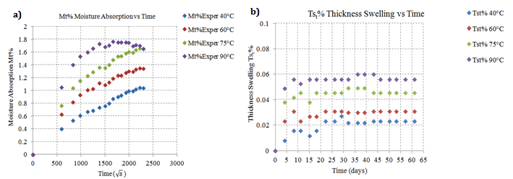

**Figure 1:** a) Experimental moisture absorption percentages *Mt%* and b) thickness swelling percentages *Tst%* [12]

**Table 3:** Diffusion coefficients and mass absorption % at saturation [12]

|  |  |  |  |  |  |
| --- | --- | --- | --- | --- | --- |
| Temperatures | | T1* | T2* | T3* | T4* |
| 40°C | 60°C | 75°C | 90°C |
| Diffusion Coefficients | *D* (*m2/s*) | 5.26E-13 | 7.67E-13 | 8.09E-13 | 1.45E-12 |
| Corrected Diffusion Coefficients | *Dz*(*m2/s*) | 4.25E-13 | 6.20E-13 | 6.53E-13 | 1.17E-12 |
| Moist. Absorption % at Saturation | *Moo%* | 1.05 | 1.35 | 1.66 | 1.68 |

3.2 Swelling rate and modelling

The thickness swelling percentage *Tst%*is an important property that represents the stability performance of composites. Generally, the swelling rates for polymer matrix composites are low during the initial stages of moisture absorption due to the viscoelasticity of the polymer matrix. In addition, any pores or voids that are present after fabrication enhance these procedures. Based on these considerations, the thickness swelling of the composite panel has been determined by the following equation (Eq. 3) as proposed by Shi and Gardner [5]:

|  |  |
| --- | --- |
| $${Ts}_{t}\%=\left(\frac{h_{∞}}{h_{0}+(h_{∞}-h_{0})e^{{-K}_{sr}t}}-1\right)$$ | (3) |

Where:

$h_{0}$: Initial composite panel thickness at *t=0*

$h_{∞}$: The ultimate thickness of the panel at equilibrium

$K_{sr}$: The intrinsic relative swelling rate parameter

The value of $K_{sr}$ in equation (Eq. 3) depends on how fast the composite swell and reach the ultimate thickness swelling at equilibrium. Figure 2 below illustrates the values for the aforementioned experimental thickness swelling percentages and the theoretically calculated from the equation (3). Table 4 includes the calculated $K_{sr}$ for the four different temperatures. The comparison of the predicted ${Ts}_{t}\%$ with the experimental data via the estimated error in each case gives an estimated error of 19.74% in the beggining of the experiment and 3.08% almost at the end.

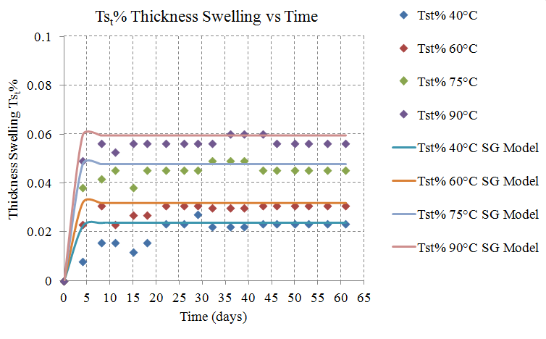

**Figure 2:** Experimental thickness swelling percentages *Tst%* and theoretical calculated via Shi and Gardner model

**Table 4:** The evolution of swelling rate parameter

|  |  |  |  |
| --- | --- | --- | --- |
| *Ksr* (1/hour) | | | |
| 40°C | 60°C | 75°C | 90°C |
| 0.693147 | 1.932838 | 1.654558 | 2.933857 |

The general behaviour of the swelling rate exhibits dependence of temperature. A model that could describe this behaviour via the activation energy is the Arrhenius model. Shi and Gardner in their work have supported also this approach [4]. It is found that the lower the swelling rate, the better the prediction obtained from the swelling model. Part of the explanation of this phenomenon could be that at a higher swelling rate, the specimens with a higher swelling rate would have more potential for a more inner debonding or damage, which will change the mode of moisture uptake. Therefore, it would change from a pure diffusion controlled swelling to a swelling including fracture inside the specimen which may induce errors in the swelling model prediction [4].

3.2 Coefficients of thermal and hygroscopic expansion

The dimensional instability that had been noticed in composites via mainly the organic matrix, must be totally correlated with the the hydrothermal behaviour of the material. The coefficient of thermal expansion (CTE) and the coefficient of hygroscopic expansion (CHE) are necessary for these procedures. The procedure that has been followed in this study for the calculations was to measure the appropriate elongation in the two directions of the specimens that were previously described for three different temperatures. The basic equation that is used for these procedures is the equation (Eq. 4) below:

|  |  |
| --- | --- |
| $$ε_{i}=a_{i}ΔΤ+b_{i}C$$ | (4) |

Where:

$ε_{i}$: Strain in the specific directioni

$α_{i}$: Thermal expansion coefficient in direction i *(1/Κ)*

*ΔΤ*: $T_{i}-T_{o}$ Temperature difference between the tested temperature and the maximum temperature of the cure cycle

*C:* Moisture concentration percentage

The procedure of elongation measurements lead to a system of 4 unknown variables that should be defined. It is important here to indicate that as long as the material has the same properties indirections 1 and 2, the CTE and CHE should have the same values in these two directions. Table 5 below includes all the calculated values for the three different temperatures tested. It is obvious that the coefficient tendency is to increase with temperature, something with is normal according to mechanisms of moisture diffusion, moisture kinetics and thermally activated procedures [6]. The Arrhenius model was used in order to express more accurately the dependence of temperature and to be able to calculate the CHE and CTE their values in any other temperature apart form the field of temperatures of the experiments for example here this temperature is 22°C. Table 5 includes the calculated values showing significant differences for the in-plane coefficients for different temperatures.

**Table 5:** CTE and CHE for experimental temperatures and for theoretical calculation for 22°C

|  |  |  |  |  |
| --- | --- | --- | --- | --- |
|  | Temperatures | | | |
| Coefficients | 20°C | 60°C | 75°C | 90°C |
| α1 (1/K) | 3.1E-07 | 8.8E-06 | 3.06E-05 | 7.69E-05 |
| β1 | 0.00775 | 0.110885 | 1.884876 | 0.835834 |
| α2 (1/K) | 2.74E-07 | 8.49E-06 | 2.92E-05 | 7.8E-05 |
| β2 | 0.006837 | 0.106971 | 1.796721 | 0.84822 |

4. Roughness analysis

4.1 Surface metrology and experimental results

Evaluating and predicting the mechanical surface quality of woven polymer composites is crucial. A parameter of great importance is surface roughness for many fundamental problems such as friction and tightness of contact joints etc. Surface roughness with respect to environmental conditions is a useful parameter to assess the level of the ageing. The increase of roughness for the four different aforementioned ageing processes (AP) was confirmed by surface roughness measurement with TESA-rugosurf 10, a portable roughness gauge. The resolution is 0.01μm/0.04μm. Surface roughness average *(Ra*) also known as arithmetic average (AA) is rated as the arithmetic average deviation of the surface valleys and peaks expressed in micro meters (μm). Figure 3 represents roughness *Ra* as a function of the ageing time (in days) at 40°C, 60°C, 75°C, and 90°C for GFRP samples.

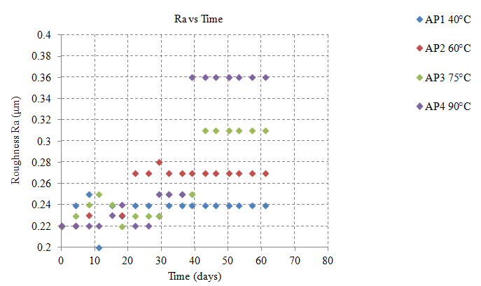

**Figure 3:** Roughness Ra as a function of the ageing time (in days) at 40°C, 60°C, 75°C and 90°C for GFRP samples

The approach with the appropriate trend lines of the experiments is linear. It is shown from the experimental results that the changes in surface morphology via roughness are more aggressive in higher temperatures exposure. Basic hydrolysis and leaching phenomena start to appear and in literally are irreversible. It must be noted also that the evolution of the phenomenon in each temperature reaches a "plateau", something that could be a path to correlate directly the surface roughness with the moisture absorption percentages and at saturation level in order to develop empirical models for predicting surface roughness at different temperatures in the long-run.

4.2 Optical microscopy of exposed surfaces

Optical microscopy (x100) was used in order to prove the evolution of surface roughness in the specimens tested. Figure 4 represents the appropriate section of the specimens so as to be able to distinct the roughness between the unaged and the aged specimens. Figure 4 indicates clearly that the surface roughness is totally related to the exposure temperatures.

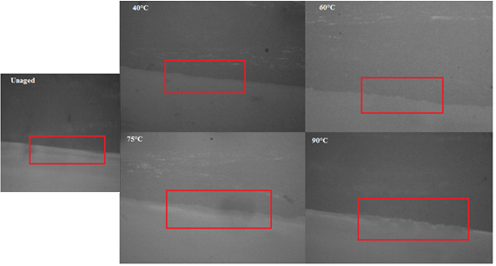

**Figure 4:** Roughness Ra evolution on the appropriate section of GFRP samples during the ageing time (in days) at 40°C, 60°C, 75°C and 90°C

5. Results and discussion

Glass fiber reinforced polymers are materials with hygroscopic and hydrophilic behaviour. They can absorb or desorb water depending on exposure environment. The polymer matrix is subjected to dimensional changes. This dimensional instability has great importance as long as it can create internal residual stresses and strains. Primarily, an exposure procedure has been designed in order to quantify via experimental results the thickness swelling percentages. It is pointed out that the evolution of the phenomenon is totally dependent from temperature. A model proposed by Shi and Gardner was applied to the experimental results, as long as the swelling had already been calculated. The model presents a good agreement with the experimental results, mainly in the regions where the swelling rate is being reduced. Regarding the CTE and CHE, the calculation of them is necessary for a more analytic and detailed strain and stress analysis of the materials and structures that are exposed to hydrothermal environments. In this study the in-plain coefficients of the material should be almost the same, something that has been proved by the calculations. The dependence of CTE and CHE from temperature is characteristic and the Arrhenius law was used in order to be able to predict the values of the coefficients for any other different temperatures. The surface roughness under the surface morphology investigation was measured. The scatter of the experimental results presents a tendency of increase with time and with temperature. This is quite reasonable as long as etching of the polymer surface is a very characteristics effect of accelerated ageing. Another important observation is that after a specific time the roughness evolution in each temperature reaches a "plateau". This can be a good evidence for the relationship that can be increased empirically between the moisture absorption percentages and surface roughness. The examination of the appropriate section of the unaged and aged specimens proved also the evolution of the surface roughness with temperature.

**6. Conlclusions**

This study is focused on the dimensional instabilities and changes of surface morphology of glass fiber reinforced polymers. On the exposure of specimens in hydrothermal environments, the diffusion analysis procedures are not enough in order to have more detailed behaviour of the material. The design procedures, including stress analysis demand the approach and the analysis of the thickness swelling procedures including CTE and CHE. Surface roughness is also a phenomenon that could be a proof for the evolution of irreversible changes on the material.

**Acknowledgements**

The support of the European Union and the JTI Clean Sky within the framework of ITD ECO-Design activity SPECIMEN is gratefully appreciated.

**References**

[1] ASM Handbook, *Composites*, ASM International, Vol. 21, The materials information company,.

[2] R. Martin, *Ageing of composites*, Woodhead Publishing Limited, UK, 2008.

[3] P. Kelverkloglou, E. Kollia, A. Vavouliotis, V. Kostopoulos, Description of anomalous water absorption behaviour of woven glass reinforced cyanate ester composites, *Plastic and Polymer Technology*, **4**, 2016 ( doi: 10.14355/papt.2016.04.009).

[4] S. Q. Shi, D. Gardner, Hygroscopic thickness swelling rate of compression molded wood fibreboard and wood fiber/polymer composites , *Composites Part A: Applied Science and Manufacturing* , 2006 ( doi: 10.1016/j.compositesa.2005.08.015).

[5] K. B. Adhikary, S. Pang, M. P. Staiger, Long-term moisture absorption and thickness swelling behavior of recycled thermoplastics reinforced with Pinus radiata sawdust, , *Chemical Engineering Journal* ,**142**, 2008, pp. 190-198 ( doi: 10.1016/j.cej.2007.11.024).

[6] M. H. Shirangi, B. Michel, Mechanisms of moisture diffusion, hygroscopic swelling and adhesion degradation in epoxy molding compounds, *Moisture of Plastic Packages of IC Devices*, *Micro- and Opto-Electronic Materials, Structures, and Systems*, **29.**

[7] B. Kord, Evaluation on the effect of wood flour and coupling agent content on the hygroscopic coupling agent content on the hygroscopic thickness swelling rate of polypropylene composites, *Bioresources*, **6**, 2011, pp. 3055-3065.

[8] C. Homkhiew, T. Ratanawilai, W. Thongruang , Long-term absorption and dimensional stability of composites from recycled polypropylene and rubberwood flour, *Journal of Thermoplastic Composite Materials*, 2014, pp. 1-18 (doi: 10.1177/0892705713518789).

[9] W. Song, A. Gu, G. Liang, L. Yuan , Effect of surface roughness on interfacial properties of carbon fibres epoxy resin composites, *Applied Surface Science*, **257,** 2011, pp. 4069-4074 (doi:10.1016/j.apsusc.2010.11.177).

[10] A. P. K. F. Mendes, M. De Oliveira Barceleiro, Changes in surface roughness and colour stability of two composites caused by different bleaching agents*, Braz Dent J*, **23,** 2012, pp. 659-666.

[11] E. Kollia, Th. Loutas, E. Fiamegkou, A. Vavouliotis, V. Kostopoulos, Degradation behavior of glass fiber reinforced cyanate ester composites under hydrothermal ageing, *Polymer Degradation and Stability*, **121,** 2015, pp. 200-207, (doi: 10.1016/j.polymdegradstab.2015.08.015).

[12] P. Kelverkloglou et al Models for combined diffusion and moduli degradation analysis of glass reinforced cyanate ester composites structures, *MOJ Polymer Science (On publishing process)*, 2017.