The Prospect of Using a Low Cost Ionic Liquid as a Delivery Medium for Thermally and Mechanically Stable Thermoset Resins

Nikzad. M^{1*}, Nisha. S. S^{2*}, Miller. J.A³ and Sbarski. I⁴

¹Swinburne University of Technology, FSET, Hawthorn campus, Australia
Email: mnikzad@swin.edu.au
²Swinburne University of Technology, FSET, Hawthorn campus, Australia
Email: snisha@swin.edu.au
³Swinburne University of Technology, FSET, Hawthorn campus, Australia
Email: jamiller@swin.edu.au
⁴Swinburne University of Technology, FSET, Hawthorn campus, Australia
Email: isbarski@swin.edu.au

Keywords: Epoxy resin, Ionic liquid, Curing, Thermal degradation, Toughness.

Abstract
Epoxy resins, the most important industrial reactive oligomers, are widely used in the composite materials production. Nevertheless, most often, modifications of epoxy networks are required to improve their performance or fine-tune for given applications. Recently, ionic liquids (ILs) have gained a lot of interest, as they could be considered potential alternatives to conventional additives in polymer matrices. The aim of this work is to study the possibility of using a low cost protic ionic liquid (Triethylammonium Hydrogen sulfate) as an additive for a fast curing DGEBA pre-polymer, a bisphenol A - based epoxy hardened with an anhydride based curing agent. Fourier Transformation Infrared spectroscopy (FTIR) was used to detect the chemical interactions of the IL and the anhydride functional groups within the epoxy resin. With increasing IL content (5% w); the appeared peaks at 1730.21 and 1148 cm⁻¹ established the interaction of IL with the epoxy resin. The degradation mechanisms and the influence of the ionic liquids on the thermal stability of IL- epoxy networks was demonstrated by thermogravimetric analysis (TGA), which showed a significant improvement of the thermal behaviour of the epoxy networks by increasing the degradation temperature by 30°C compared to the neat epoxy resin. The mechanical testing showed that the flexural toughness of the matrix was increased by 74%. There was, however, a detrimental effect on the elastic modulus as a result of IL addition.

1. Introduction

Epoxy resins belong to the most important industrial reactive oligomers in the thermosetting family. Like most thermo-setting plastics epoxy is hard, brittle and stiffer compared to thermoplastics. In contrast to traditional resins, epoxy resins have advantages such as less shrinkage after curing, chemical resistance, good electrical and mechanical properties, and a long shelf life. Their broad range of properties, as well as various curing possibilities, allow for a wide range of commercial applications [1]. Epoxy resins are widely applicable in the composite materials production. Nevertheless, in some cases, modifications of epoxy networks are required to improve their performances. Due to the high degree of chemical cross-linking, epoxy resins are intrinsically brittle, which is generally the case in most thermoset plastics [2]. This highlights the need to improve epoxy resins toughness as an interesting challenge for those niche applications.
Recently, ionic liquids (ILs) have gained a lot of interest, as they could be considered as excellent alternatives to conventional additives in polymer matrices of thermoplastics or thermosetting type. ILs show unique properties such as thermal, chemical, and electrochemical stability, low volatility, nonflammability, ionic conductance, catalytic activity, and recyclability [3]. They are often determined as “green solvents” and candidates for very broad practical applications. For instance, ILs can be used as media for performing polymerization processes, solvents or plasticizers for synthetic polymers as well as for polysaccharides (cellulose or lignocellulose biomass and starch), in separation techniques, polymer gel electrolytes, catalysts or even as efficient nanocarbon particle dispersants (carbon nanotubes, graphemes). In addition, thanks to their outstanding properties, low contents of ionic liquids can be considered in the epoxy networks delivered from copolymerization of epoxy prepolymer and amines or anhydrides in order to enhance their physical properties, such as thermomechanical behavior, ionic conductivity, and scratch resistance. Nevertheless, ILs could also substitute amines and anhydrides as hardeners of epoxy prepolymers [1, 4, 5].
Recently, ionic liquids have had a major impact on the development of new epoxy networks and composite materials by acting as a curing agent, plasticizer, and dispersants of nanoparticles. In literature, different routes have been investigated such as the use of ILs as additives of epoxy-amine or epoxy-anhydride systems, the synthesis of ionic epoxy monomer, and the use of ionic liquids as hardeners of the epoxy prepolymer. McDanel et al. have synthesized imidazolium ionic liquid functionalized with two epoxy groups in order to prepare epoxy-amine networks [6]. The increase of thermomechanical properties was also demonstrated and described by Nguyen et al. [7] and Xiao et al. [8] which have highlighted the influence of the chemical nature of the cation and the counter anion on the polymerization as well as on the final properties of the epoxy networks. For example, Maka et al. proposed a mechanism of epoxy prepolymer cross-linking with imidazolium cations. [1, 4]. Lyu et al. have produced high-performance graphene oxide/epoxy composites by introducing the imidazole ionic liquid [9]. Zheng et al. have studied that the incorporation of [C₆mim]FeCl₄ is a better way to improve the performance of room temperature curing epoxy resins [10]. In the field of networked epoxy systems, ILs have appeared as ionic additives to impart different properties to the material. Sanes et al. have investigated the synergy between single wall carbon nanotube and ionic liquid epoxy resin nanocomposites [11].
In the meantime, it is important to mention that despite a large amount of research related to the use of imidazolium-based IL in several areas of material science, they are somewhat expensive and present relatively low thermal stability. Therefore cost is one of the main impediments to ionic liquid (IL) utilization in the fabrication of polymer composites. With the view to manufacturing ILs from the relatively inexpensive feedstock of sulphuric acid and ammonia, low-cost ILs have been designed and synthesized to contain the [HSO4]⁻ anion and ammonium-based cations [12].
In this study, the effect of triethylammonium hydrogen sulfate ILs on the thermal and mechanical properties of epoxy networks was investigated. This particular ionic liquid is prepared from inexpensive triethyl ammonia and sulfuric acid following the protocol documented in the literature [12]. The motivation of this work was to find the potential of this hydrogen sulfate ammonium based IL in the epoxy networks for several unique applications. For this purpose, their thermal and the mechanical properties of high interest, which are the main scope of this work.

2. Experimental

2.1. Materials

The fast curing thermoset epoxy resin used as the composite matrix was Henkel Max 5, a proprietary prepolymer with an anhydride-based curing agent, which was provided by Henkel Chemical Company, Australia. Triethyl ammonia and Sulfuric acid were provided by Sigma Aldrich.

2.2. Preparation of IL-epoxy based composites

To prepare test specimens of the IL-epoxy composite IL were mixed with a Diglycidyl ether of bisphenol A prepolymer (Henkel Max 5) and an anhydride-based curing agent at 1%, 2%,3% and 5% w ratio by stirring at room temperature for 15 minutes. The final stoichiometric ratio of epoxy groups to anhydride groups was 1:1.03 for 1-3% w ratio. The neat epoxy resin was prepared following the same procedure as mentioned above. Then the mixture was sonicated for one hour and later degassed in fume cupboard for 15 minutes. Next, the mixture was poured into aluminium moulds and cured for half an hour at 130°C, followed by post curing for one hour at 180°C to achieve a fully cross-linked matrix. For 5% w ratio two set of IL-epoxy composites were prepared where the cure temperature was 140°C and 180°C and the stoichiometric ratio of epoxy groups to anhydride groups was 1.5:1. At least four samples for each composition were made to study the thermal and mechanical testing.

2.3 Characterisation

Thermogravimetric analysis (TGA) of IL-epoxy and the neat epoxy composites were performed on an Q 500 DSC-TGA instrument from TA Instruments. Approximately 5 mg of each sample was used to perform the test; the starting temperature was set to be 50 °C increasing with a rate of 10 °C per minute to a maximum of 600 °C using air as the gas.
Fourier transform infrared (FTIR) spectra were obtained using a Thermo Scientific Nicolet iS5 FT-IR Spectrometer, with 50 scans being performed per specimen at room temperature in the wavenumber range of 600−4000 cm⁻¹.
Flexural tests were performed on the produced resin samples on a Zwick Z010 universal testing machine. According to ASTM D790, the test speed and gauge length were set at 5mm/min and 50 mm, respectively. A slower test speed was used due to the brittleness of the samples.
Tensile tests were performed on the produced resin samples on a Zwick Z010 universal testing machine. According to ASTM D638, the test speed and gauge length were set at 100 mm and 5mm/min respectively. A slower test speed was used due to the brittleness of the thermoset samples. A minimum number of 4 test specimens were used for flexural and tensile tests to check for the reproducibility of the results.

3. Result and Discussions

3.1 Thermal properties of cured IL-epoxy based composites

The degradation mechanisms and the influence of the ionic liquids on the thermal stability of IL- epoxy networks have been highlighted by thermogravimetric analysis (TGA). The progression of the weight loss as a function of a temperature performed on IL and IL-Epoxy containing 1, 2, 3 and 5% w ratio are presented in Fig 1. Epoxy systems containing [Et₃NH][HSO₄] with different weight ratio begin to degrade at ~355°C. The degradation process can be divided into four stages. The first phase occurs from 40 °C to 340 °C and consists of thermal decomposition of the epoxy resin. The thermal decomposition is characterized by segmentation of random chains and terminal chains that lead to the loss of hydrogen atoms and other organic groups at a low molar mass. The second phase (from 340 °C to 370 °C) is ascribed to the acceleration of the thermal decomposition of the epoxy resin during which carbon chains begin to form. These byproducts of the epoxy resin are decomposed into gas and porous carbon chains. The third phase (between approximately 370 °C and 440 °C) consists of a thermal decomposition of the remaining epoxy resin. The fourth phase started at 440 °C and was due to oxidization of the carbon chain that formed during the combustion process of the epoxy resin.

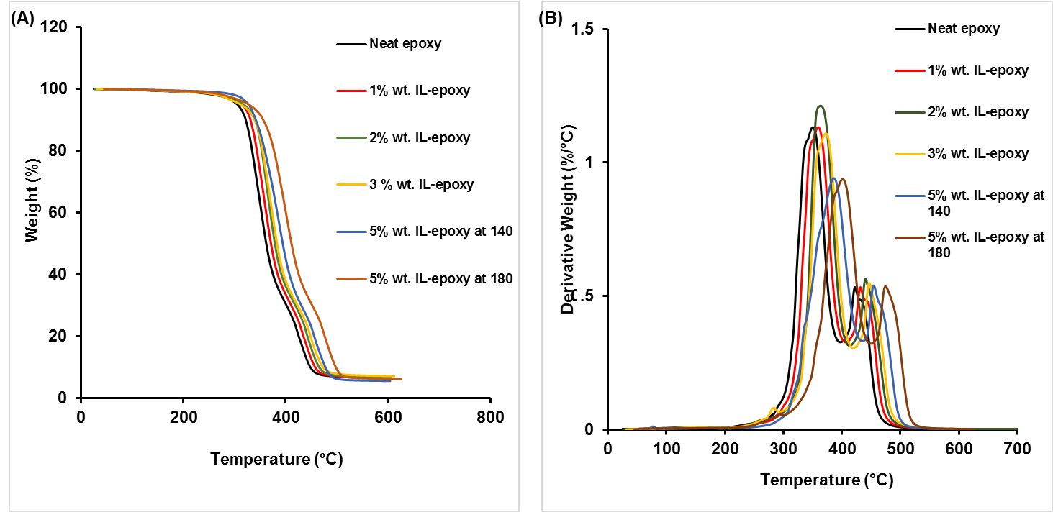

Figure 1.TGA (A) and DTG (B) curves of all composite samples at the heating rate of 10 °C/min.

The TGA analysis reveals an excellent thermal stability of the epoxy networks. In fact, the degradation temperature of the maximum of DTG peak is around 380 °C for 5% wt. IL-Epoxy composite. Compared to conventional epoxy systems based on DGEBA cured with an aliphatic monomer such as jeffamine (D230, D400) containing [C₆mim]FeCl₄, the use of triethylammonium hydrogen sulfate ionic liquid leads to a significant improvement of the thermal behavior of the epoxy networks (~40 to 50°C) [10]. Furthermore, these results demonstrate the presence of ionic liquid in the epoxy network from a high concentration of IL introduced (about 5% w) to the resin.
For further investigations, the interaction of IL in the composite was observed by FTIR spectroscopy. The FTIR spectroscopy of IL, anhydride, and IL with anhydride were also studied for comparing the results. Figure 2(A) shows the infrared spectra of cured neat epoxy resin, IL and a composite with 5% wt. IL. Some features were observed in all three spectra. The absorption at 3000-3500 cm⁻¹ was due to hydroxyl groups. The absorption at 2925 cm⁻¹ was due to C-H groups. The strong absorptions between 1000 and 1250 cm⁻¹ were assigned to C-O-C (ether) or C-O(H) in the epoxy composites [13]. Additionally, the absorption at 1469.10 cm⁻¹ observed in the spectra for IL is assigned to N-H bending for triethylammonium ion. In IL-epoxy composites, the epoxide group can react with the anhydride group of hardener or ammonium group from the ILL. If an epoxide group reacts with an anhydride group, the result will be an ester group. The 5% wt. composite shows clear pic at 1730.21 cm⁻¹ which is assigned to conjugated ester. The absorption peak at 1852.93 and 1769.49 cm⁻¹ represents the C=O groups of anhydride (Fig-2B). Additionally, monitoring of the epoxide group at 962 cm⁻¹ (fig 2B) indicates that the epoxide group reacted in both cured neat epoxy resin and composites, so the degree of cure attained in all of the samples was likely similar [14]. Moreover, the presence of a weak peak at 1148 cm⁻¹ is assigned to ethoxy group which may be formed during the partial bonding of IL and anhydride hardener. This may weaken the anhydride bonding and eases the path of crosslinking for epoxy resin. Therefore, the presence of this peak could provide evidence of IL as a crosslinking agent in the IL-epoxy resin composites.

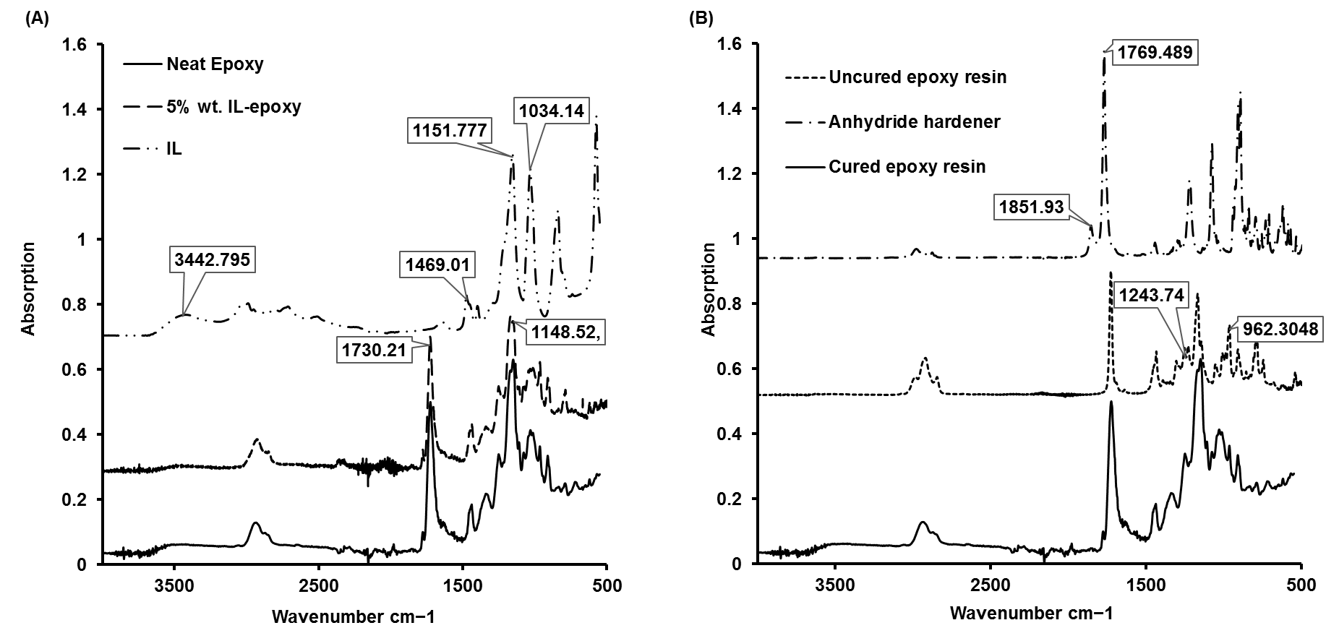
Figure 2. (A)FTIR data of ionic liquid, neat epoxy resin and 5% wt. ILL- epoxy composite (B) FTIR data of anhydride, cured and uncured epoxy resin.

To understand this phenomena, we ran the FT-IR analysis of higher ratio (25%) of IL with anhydride (fig 3A). For IL, the peak at 1150 cm⁻¹ corresponds to the C-N stretching in triethylammonium group. The stretching vibration of alkyl C-H group is located at 2968 cm⁻¹. In the FT-IR spectra of IL-Anhydride (fig 3B), a new peak at 1155 cm⁻¹ is seen which is absent in the FT-IR spectra of anhydride. This peak signifies the alkoxy C-O stretching, which indicates that ammonium ion partially attracted to the anhydride group and ethoxy group appeared by weakening the cyclic anhydride group. Moreover, the bands at 1253 and 1047 cm⁻¹, which are present in anhydride spectra, has been disappeared in the IL-anhydride spectra (fig 3B). These changes prove that IL react with anhydride and weakening the C-O bond that eases the cross-linking reaction path for epoxy resin. These observations indicate that the increasing ratio of ionic liquid lignin increases the crosslinking density. According to these results, it can be concluded that IL indeed is incorporated within the epoxy matrix and responsible for the improved thermal stability.

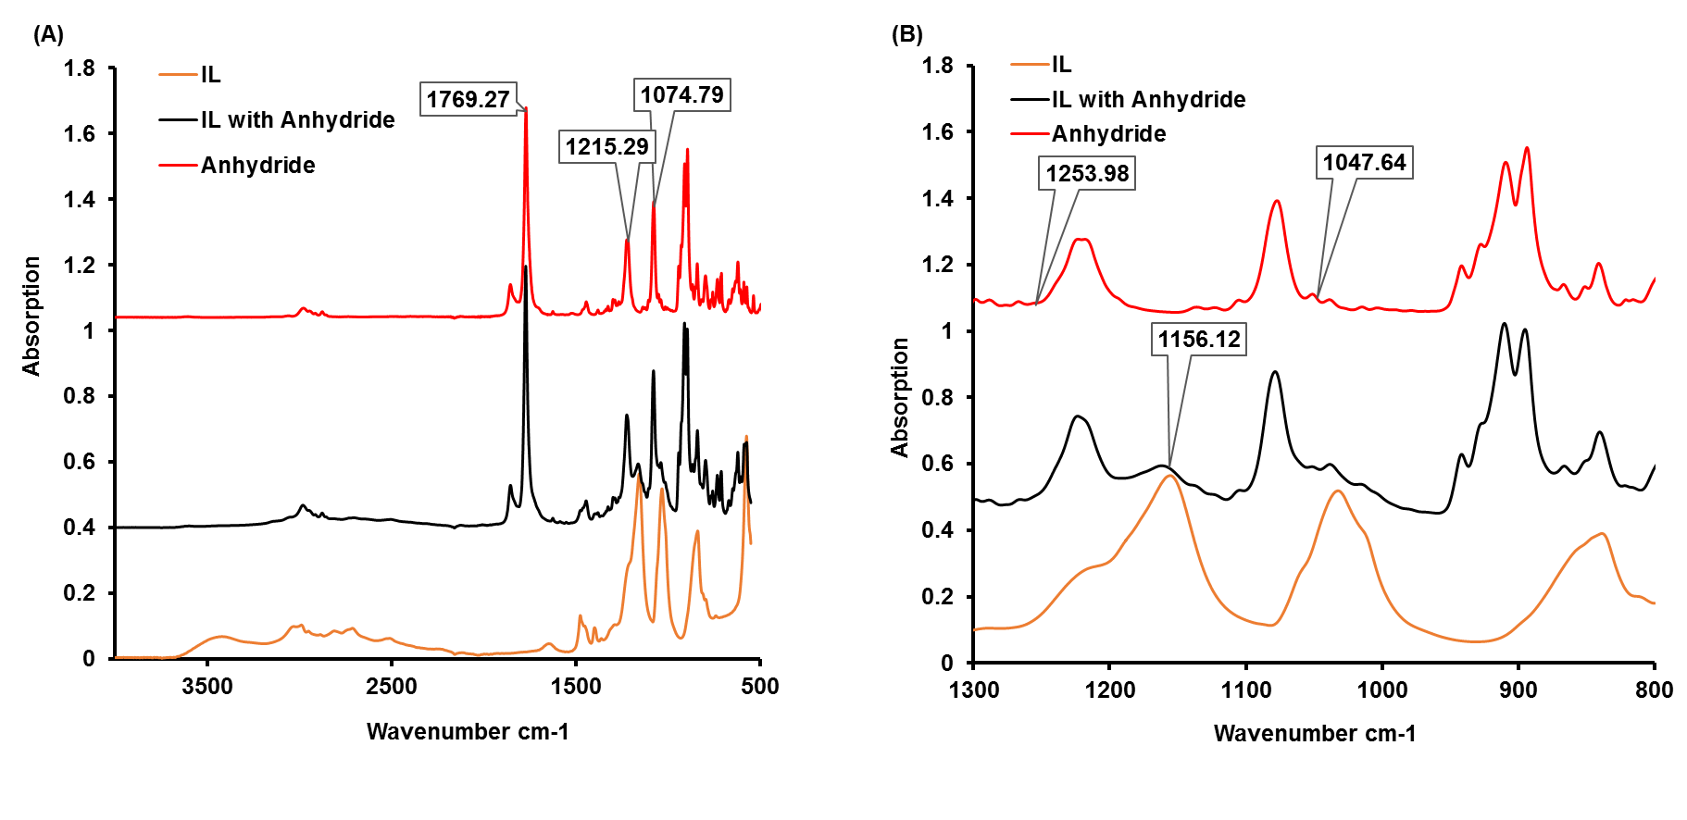
Figure 3. (A)FTIR data of ionic liquid, anhydride, and anhydride with 25% IL, (B) Medium broad spectram.

3.2 Mechanical properties

Three point bending flexural tests and tensile tests were instigated to determine the strengthening and toughening effects of the incorporated ionic liquid (IL). Flexural test results show that IL–epoxy composite sample are stiffer than neat epoxy resin in figure 4(A).

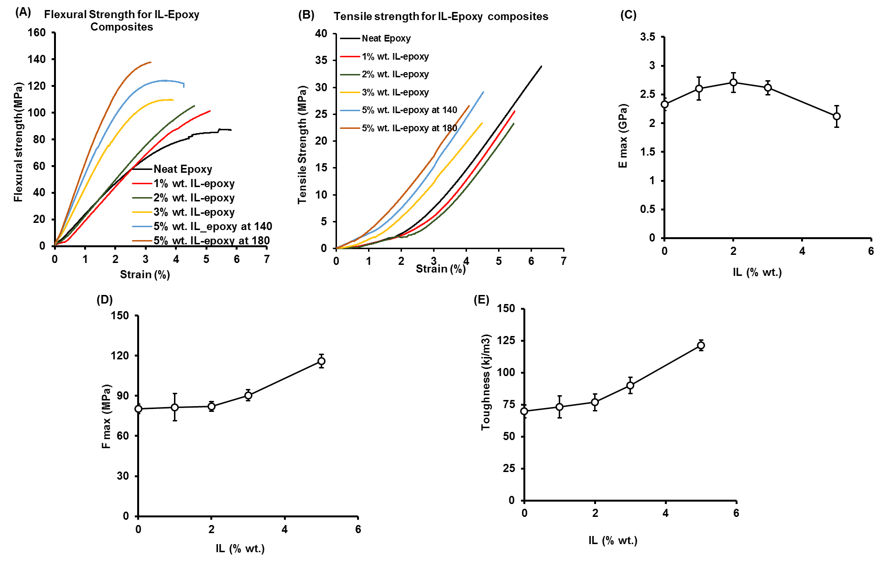

Figure 4. Flexural strength (A) and Tensile strength (B) with strain for neat epoxy resin and IL- epoxy resins, Variation of Elastic modulus (C), F_{max} (D), and toughness (E) with different concentration of IL-epoxy composite.

However, tensile test results in fig 4(B) show that 1% and 2% IL-epoxy composites are less stiffer than the neat epoxy resin but with increasing amount of IL composition (3% and 5% IL) their stiffness is higher compared to the neat epoxy resin. It also shows that elastic modulus increased with the increasing amount of ionic liquid upto 2% IL and then again decreased from 3% to 5% IL composition in fig 4(C). The sample with 2% wt. IL showed the elastic modulus of 2.70 ± 0.17 GPa, a slight improvement of about 16 % compared to the neat epoxy. The value of maximum force F_{max} increased with increasing amount of ionic liquid up to 5% wt. shown in Figure 4(D). The sample with 5% wt. of ionic liquid showed the utmost flexural strength value of 116.33 ± 4.11 MPa with 44.50 % increase compared to neat epoxy. The flexural toughness of these samples was calculated under the area of the flexural strength-strain curve and plotted against the IL concentration in Fig 4(E). The 5% wt. IL sample showed the maximum toughness value of 121.33 ± 4.21 KJ/m³ with 74% increase compared to the neat epoxy composite.

4. Conclusions

Ionic liquid was incorporated into a fast anhydride-cured epoxy resin to make IL-epoxy based composite. According to the TGA results, the degradation temperature of the 5% IL-epoxy composite increased by at least 30°C compared to the neat epoxy resin. This confirms that triethylammonium hydrogen sulphate protic ionic liquid components influence the degradation behaviour of epoxy resin. The FTIR measurements evaluated the evolution of the chemical structures during the curing process. The mechanical test analysis showed improvement in fracture toughness with 74% increase. These enhancements can be attributed to the functionality of IL and its interfacial interactions with the epoxy matrix. Consequently, this protic ionic liquid could be a promising delivery medium in fabrication of multifunctional reinforced epoxy based composite.

Acknowledgments

Authors would like to thank Brad Smith of Henkel Australia for providing base resin components for use during this project. Authors would also like to thank Tuan Nghiep Chiem for his assistance in running a part of experiments.

References

[1] Maka, H., T. Spychaj, and R. Pilawka, Epoxy Resin/Ionic Liquid Systems: The Influence of Imidazolium Cation Size and Anion Type on Reactivity and Thermomechanical Properties. Industrial & Engineering Chemistry Research, 2012. 51(14): p. 5197-5206.
[2] Bhuniya, S. and B. Adhikari, Toughening of epoxy resins by hydroxy-terminated, silicon-modified polyurethane oligomers. J. Appl. Polym. Sci., 2003. 90(6): p. 1497-1506.
[3] Silva, A.A., et al., New epoxy systems based on ionic liquid. Polymer, 2013. 54(8): p. 2123-2129.
[4] Maka, H., T. Spychaj, and K. Kowalczyk, Imidazolium and Deep Eutectic Ionic Liquids as Epoxy Resin Crosslinkers and Graphite Nanoplatelets Dispersants. Journal of Applied Polymer Science, 2014. 131(12): p. 7.
[5] Maka, H., T. Spychaj, and R. Pilawka, Epoxy resin/phosphonium ionic liquid/carbon nanofiller systems: Chemorheology and properties. Express Polymer Letters, 2014. 8(10): p. 723-732.
[6] McDanel, W.M., et al., Cross-linked ionic resins and gels from epoxide-functionalized imidazolium ionic liquid monomers (vol 55, pg 3305, 2014). Polymer, 2014. 55(23): p. 6195-6195.
[7] Nguyen, T.K.L., et al., Toughening of Epoxy/Ionic Liquid Networks with Thermoplastics Based on Poly(2,6-dimethy1-1,4-phenylene ether) (PPE). Acs Sustainable Chemistry & Engineering, 2017. 5(1): p. 1153-1164.
[8] Xiao, F., et al., An efficient phosphonate-based ionic liquid on flame retardancy and mechanical property of epoxy resin. Journal of Materials Science, 2017. 52(24): p. 13992-14003.
[9] Lyu, Q., et al., Imidazolium Ionic Liquid Modified Graphene Oxide: As a Reinforcing Filler and Catalyst in Epoxy Resin. Polymers, 2017. 9(9): p. 15.
[10] Zheng, C.M., et al., Kinetics and thermal properties of epoxy resins containing the ionic liquid C(6)mim FeCl4. Rsc Advances, 2016. 6(14): p. 11407-11411.
[11] Sanes, J., et al., Synergy between single-walled carbon nanotubes and ionic liquid in epoxy resin nanocomposites. Composites Part B-Engineering, 2016. 105: p. 149-159.
[12] Gschwend, F.J.V., et al., Pretreatment of Lignocellulosic Biomass with Low-cost Ionic Liquids. Jove-Journal of Visualized Experiments, 2016(114): p. 6.
[13] Xu, S.H., et al., Mechanical and thermal properties of waterborne epoxy composites containing cellulose nanocrystals. Polymer, 2013. 54(24): p. 6589-6598.
[14] Zhou, H.R., et al., Preparation of waterborne epoxy resin emulsion, in Progress in Environmental Science and Engineering, Pts 1-4, Q.J. Xu, Y.H. Ju, and H.H. Ge, Editors. 2013, Trans Tech Publications Ltd: Stafa-Zurich. p. 494-497.

