**MODIFIED HOMOGENIZATION METHOD WITH RELIEVED PERIODICITY IN ONE OR TWO DIRECTIONS**

Muhammad Ridlo Erdata Nasution1 and Naoyuki Watanabe2

1Department of Aerospace Engineering, Sekolah Tinggi Teknologi Adisutjipto, Jalan Janti Blok R, Yogyakarta 55198, Indonesia

Email: mrenasution@stta.ac.id, Web Page: http://www.stta.ac.id

2Department of Aerospace Engineering, Tokyo Metropolitan University, 6-6 Asahigaoka, Hino-shi, Tokyo 191-0065, Japan

Email: nwatana@tmu.ac.jp, Web Page: http://www.tmu.ac.jp

**Keywords:** homogenization, localization, relieved periodicity

**Abstract**

Since plain weave fabric or orthogonal interlock composites consists of a large amount of periodic microstructures and indicates very complicated deformations and stress distributions, homogenization method is usually adopted in the framework of finite element analysis. This method requires the employment of periodic boundary condition in three-dimension. As laminates are usually very thin compared to its in-plane dimensions, the periodic condition along its thickness direction should be omitted. Moreover, when tensile test specimen is investigated, the width of specimen is generally much smaller than its length. The simulation thus should consider that the periodicity only exists in longitudinal direction. Hence, the periodicity throughout both thickness and width directions are necessary to be relieved.Such modification consequently utilizes finite-thickness-and-width unit-cell model.In this paper, the modified formulation of 3-D homogenization method is reported and executed by including thermal expansion effects. Assessment of the results obtained from modified method is performed through the comparison with those obtained from homogenization-localization analysis with 2-D periodicity and standard finite element analysis.

1. Introduction

Advance composites (e.g. plain weave, 3-D orthogonal interlock composites) generally possess highly complicated microstructures. Such kind of microstructures will yield a very complex deformation and stress distribution. The periodic nature of composites microstructures attracts many researchers to employ asymptotic expansion homogenization analysis [1, 2]. This analysis is usually adopted in the framework of finite element method [2-4], and has been quite effective for analyzing microscopic architecture with periodicity in three-dimension. In this regard, the unit-cell can be modeled as an infinite model. As composite laminates are usually very thin compared to its in-plane directions, the periodicity throughout the thickness direction can be omitted. A homogenization and localization analysis implementing this technique had been proposed to analyze composites with only in-plane loading [5, 6]. The employed unit-cell was a finite-thickness model. This analysis was also performed to investigate thermal buckling of honeycomb sandwich composites, and concluded that relieving periodicity in the thickness direction does not only affect the obtained stresses but also the calculated buckling eigenvalues [7]. Moreover, investigation of tensile test specimen should consider that the width of specimen is generally much smaller than its length. The unit-cell can be modeled to possess finite dimension not only in the thickness direction but also correspond to its width direction (i.e. finite-thickness-and-width model). For sake of better understanding, Fig. 1 represents the so called infinite-thickness, finite-thickness, and finite-thickness-and-width models, in the case of 3-D orthogonal interlock composites. With regard to the finite-thickness-and-width model, the existing periodicity should only be considered in longitudinal direction. In addition, the surfaces of tensile test specimen normal to its width direction are not constrained. Such condition necessitates the application of free-boundary in simulation. In this regards, the periodic boundary condition in transverse directions (i.e. thickness and width directions) of the unit-cell should be relieved.

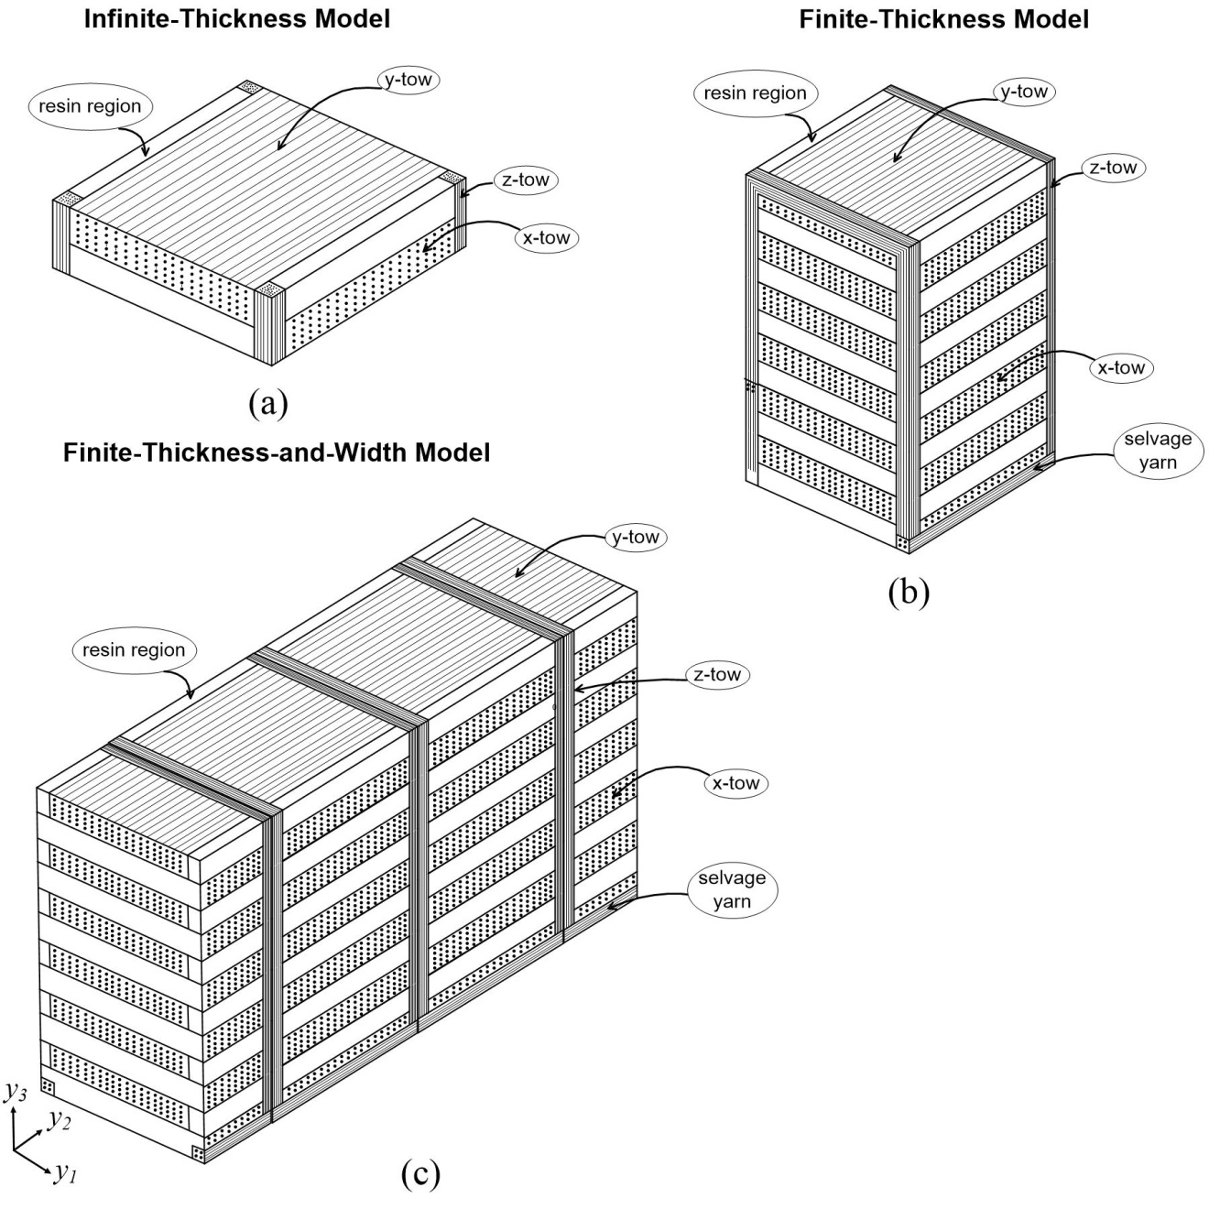

**Figure 1.** Schematic representation of unit-cell model of 3-D orthogonal interlock composites: (a) Infinite-thickness, (b) Finite-thickness, (c) Finite-thickness-and-width.

The rigorous formulation of 3-D homogenization method with relieved periodicity in the thickness direction had been presented in Ref. [5]. In this paper, the formulation of 3-D asymptotic expansion homogenization-localization method with relieved periodicity in the thickness and width directions is reported. This formulation includes the effects of thermal expansion, and is numerically implemented by an in-house code and applicable for general composites structures. The accuracy of this modified method are demonstrated and validated by a numerical case utilizing a finite-thickness-and-width unit-cell model of 3-D orthogonal interlock composites. The results are then compared to those of homogenization-localization analysis with 2-D periodicity as well as standard finite element analysis.

2. Method

2.1. General Concept

In Fig. 2(a), an elastic and heterogeneous macrostructure is viewed in macroscopic scale (*x*- coordinate system). Such kind of body consists of a large amount of heterogeneous and periodic macrostructures which can generally be represented through the use of a unit-cell model. In multi-scale analysis, the unit-cell can be viewed in microscopic scale (*y*- coordinate system) as shown in Fig. 2(b).

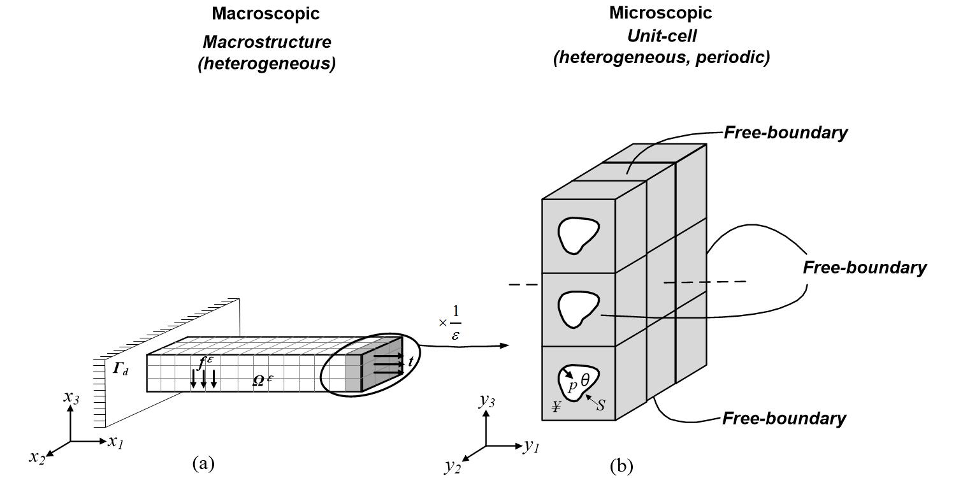

**Figure 2.** (a) Heterogeneous macrostructure, (b) Heterogeneous and periodic unit-cell.

Standard homogenization method employs periodic condition in three-dimension, which yields same characteristics deformation between each pair of surfaces of the unit-cell in in-plane and out-of-plane directions. Omitting periodicity in the thickness direction (i.e. for homogenization method with 2-D periodicity) consequently relieves periodic boundary condition on the surfaces of the unit-cell normal to out-of-plane direction. This yields that the top and bottom surfaces of the unit-cell are free-boundaries. The modified homogenization method presented in this paper considers that the periodicity exists only in longitudinal direction (direction -1). Accordingly, periodic boundary condition along the thickness and width directions should be omitted. Such condition is obtainable by applying free traction boundary not only on the surfaces normal to out-of-plane direction (direction -3) but also on the surfaces normal to width direction (direction -2) of the unit-cell as represented in Fig. 2(b).

2.2. Formulations

Brief formulation of homogenization method with relieved periodicity in the thickness and width directions is explained in this chapter. For detail formulation, readers are suggested to refer to the appendix section of Ref. [6]. Meanwhile, rigorous formulation of standard homogenization method with 3-D periodicity as well as the one with relieved periodicity in thickness direction can be seen in Refs. [3, 5, 6].

Standard homogenization method with periodicity in three directions implies the following periodic vector function

|  |  |
| --- | --- |
|  | (1) |

where *Y*1, *Y*2 and *Y*3 are unit-cell dimension in directions -1, -2 and -3, respectively.

In order to facilitate the periodicity that only exists in longitudinal direction (direction -1), periodic vector function is modified into the following

|  |  |
| --- | --- |
|  | (2) |

Due to consideration that *x*2 and *x*3 are now finite and very small as compared to *x*1, the following approximations are introduced as follows

|  |  |
| --- | --- |
|  | (3) |
|  | (4) |

where *ε* = **x**/**y** is used to correlate between macroscopic scale **x** and microscopic scale **y**. The periodic vector function utilized in the modified method with only longitudinal periodicity can be rewritten as follows

|  |  |
| --- | --- |
|  | (5) |

Derivatives of the modified function in Eq. 5 with respect to macroscopic coordinate **x** are as follows

|  |  |
| --- | --- |
|  | (6) |

Meanwhile, the limit of integration of Y-periodic function is now explicitly expressed as a one-dimensional macroscopic problem

|  |  |
| --- | --- |
|  | (7) |
|  | (8) |

where |*Y*| is the volume of unit-cell; *¥* denotes the solid part of unit-cell; *L* is the length of macroscopic body, **x** = *x*1; **y** = *y*1, *y*2, *y*3; and *dY* = *dy*1*dy*2*dy*3.

Application of derivatives and limit of integrations in Eqs. 6-8 to the weak-form of the principal of virtual work will yield three hierarchical equations. The equation of order of *ε*-2, after choosing **v** = **v**(**y**) and applying integration by parts as well as Gauss’ divergence theorem, is given as follows

|  |  |
| --- | --- |
|  | (9) |

where *C* denotes elastic constants tensor, while *u* and *v* are actual and virtual displacements, respectively. The third integral term within the square bracket of Eq. 9 will result in zero because the periodicity in direction -1 will cancel the results between the pair of opposite surfaces. Then, the fourth and fifth terms are zero due to free-traction boundaries on the surfaces normal to directions -2 and -3. By virtue of mathematical treatment in Ref. [2], the remaining equation will be satisfied by representing macroscopic displacement as follows

|  |  |
| --- | --- |
|  | (10) |

Eq. 10 asserts that the macroscopic problem is a one-dimensional problem. In comparison, for method with relieved periodicity in the thickness direction, the resulted zero terms due to the periodicity are found in the third and fourth terms of Eq. 9, while the fifth term is zero due to free-traction condition. Correspondingly, the remaining results that **u**0 = **u**0(**x**1, **x**2), which indicates that the macroscopic problem for method with relieved periodicity in the thickness direction is a two-dimensional case.

For order of *ε*-1, the obtained microscopic equilibrium equation can be developed to calculate elastic and thermal correctors (**χ***kl* and **ψ**) as follows

|  |  |
| --- | --- |
|  | (11) |
|  | (12) |

The following conditions are given to represent free boundary condition along directions -2 and -3 of the unit-cell model

|  |  |
| --- | --- |
|  | (13) |
|  | (14) |
|  | (15) |

It is noted that Eqs. 13-15 are also valid for thermal corrector by replacing **χ***kl* into **ψ**. In comparison to standard homogenization method, periodic boundary condition in three-dimension can be satisfied by replacing “≠” in Eqs. 14 and 15 into “=”. Meanwhile, homogenization method with relieved periodicity in the thickness direction only employs the inequality in Eq. 15. It is also important to note that, due to the existence of periodicity in only longitudinal direction, only one independent mode of elastic corrector exists, namely **χ**11, while homogenization method with 3-D and 2-D periodicity possess 6 sets (**χ**11, **χ**22, **χ**33, **χ**12, **χ**23, **χ**13) and 3 sets (**χ**11, **χ**22, **χ**12), respectively.

Evaluation of order of *ε*0 results in macroscopic equilibrium equation whereby the homogenized thermo-mechanical properties are then obtained through the following equations

|  |  |
| --- | --- |
|  | (16) |
|  | (17) |

where *C* and *S* denote elastic constants tensor and its inverse, *α* is coefficient of thermal expansion, and Δ*T* denotes temperature difference.

Stresses within unit-cell are calculated through the use of following equation

|  |  |
| --- | --- |
|  | (18) |

The following indexes are employed in Eq. 18: *i*, *j*, *p*, *q* = 1, 2, 3; *k*, *l* = 1. It is noteworthy that the microscopic displacement has three components and there are six components of strain and stress obtained by localization analysis.

3. Results and Discussion

Homogenization and localization analyses performed in this research utilize finite-thickness-and-width unit-cell model of 3-D orthogonal interlock composites whereby the properties of fiber tows, selvage yarn and resin-rich region are given in Refs. [5, 6]. Three kinds of numerical analysis are carried out. The first analysis implements periodic boundary condition in three-dimension (NR), while the other two analyses employ relieving periodicity in thickness direction (RP1D) as well as relieving periodicity in thickness and width directions (RP2D). The schematic representation of finite-thickness-and-width model used in the analyses is represented in Fig. 1(c).

Homogenization analysis with relieved periodicity in two directions (RP2D) consequently results in only longitudinal homogenized thermo-mechanical properties. Those homogenized properties (i.e. longitudinal Young’s modulus (*E*1) and coefficient of thermal expansion (*α*1)) are listed in Table 1. The results of NR and RP1D are also given. It is shown that, in the case of 3-D orthogonal interlock composites, the differences between the homogenized results of NR and RP1D are more significant than those between RP1D and RP2D. This indicates that the RP1D analysis may provide similar accuracy with RP2D in terms of longitudinal homogenized properties.

**Table 1.** Homogenized properties.

|  |  |  |  |
| --- | --- | --- | --- |
| Properties | NR | RP1D | RP2D |
| *E*1 (GPa) | 57.76 | 57.46 | 57.44 |
| *α*1 (/°C) | 4.11×10-6 | 4.05×10-6 | 4.02×10-6 |

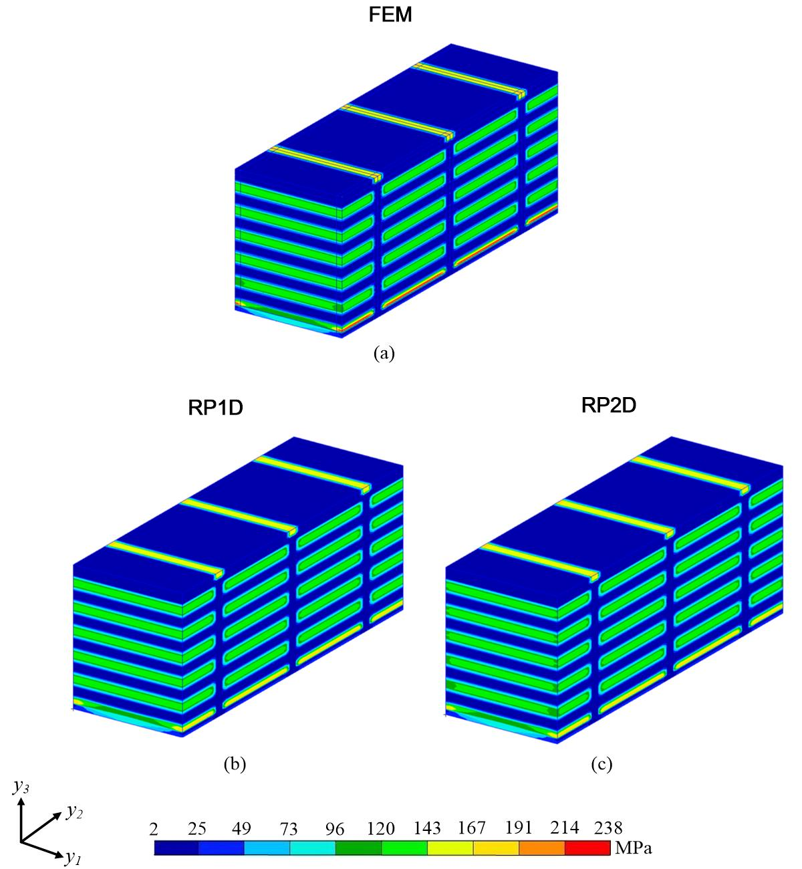

**Figure 3.** Stress distribution of *σ*11: (a) FEM, (b) RP1D, (c) RP2D.

Localization analysis is carried out to investigate the influence of relieving periodicity in one and two directions to the stresses distribution within the unit-cell. A mechanical loading case given by a macroscopic strain in longitudinal direction of 10-3 is employed. This represents tensile loading along longitudinal direction (direction -1) of the unit-cell. For the sake of validation, a comparable finite element model subjected by tensile loading is also built and analyzed. It is important to note that, due to the fact that the surfaces of tensile test specimen normal to its thickness and width directions are not constrained, finite element analysis employs free-traction boundaries on the top and bottom surfaces and surfaces normal to width direction (i.e. direction -2) of the model.

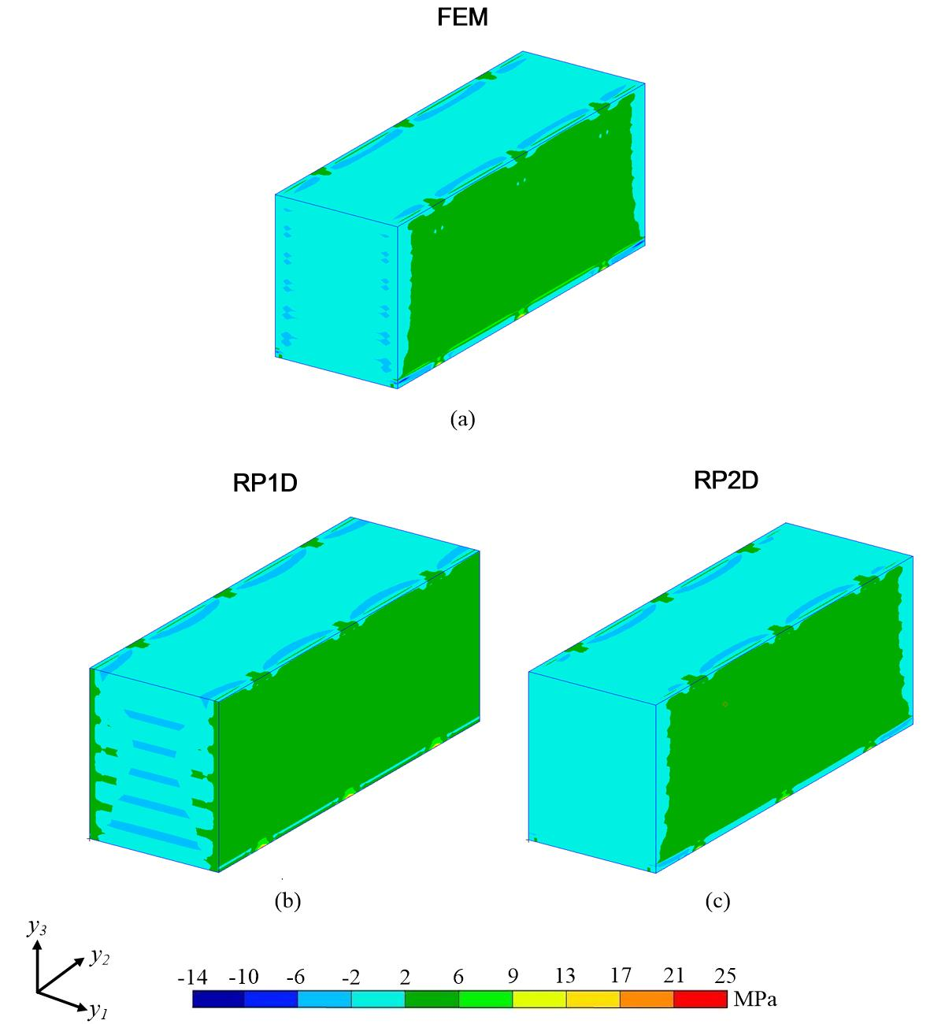

**Figure 4.** Stress distribution of *σ*22: (a) FEM, (b) RP1D, (c) RP2D.

Figs. 3 and 4 show the stresses distribution of *σ*11 and *σ*22, respectively. In the figures, the FEM results are obtained by analyzing a long plate and picking up that of the center cell. It is again noteworthy that the results of RP1D denote that the unit-cell is still under periodic boundary condition on the surfaces normal to width direction, while those of RP2D are based on a unit-cell with free-boundaries on the both pair surfaces normal to thickness and width directions.

Fig. 3 elucidates that the relieving periodic boundary condition in width direction does not show significant influence to the result of *σ*11. This fact is shown by relatively same stresses distribution between the results of RP1D in Fig. 3(b) and RP2D in Fig. 3(c). In Fig. 4, analyses of FEM and RP2D do not produce completely identical results. The differences are due to the fact that the FEM model has a finite length while RP2D assumes that the unit-cell is infinitely repeated in longitudinal direction. However, the influences of relieving periodicity in width direction are clearly emerged in the results of stresses distribution *σ*22 along direction -2. In this figure, FEM result shows a better approximation to the result of RP2D as compared to that of RP1D. This indicates that, in the case of tensile loading simulation, relieving periodicity only in the thickness direction of unit-cell is not able to effectively and accurately simulate the real condition. Hence, additional relieved periodic boundary condition throughout width direction is imperative to obtain more appropriate solution. The aforementioned facts show the importance and implication of relieving periodicity in the thickness and width directions in obtaining stresses results under tensile loading condition.

4. Conclusions

Modified homogenization and localization analyses are carried out by relieving periodicity in one direction (thickness direction) as well as two directions (thickness and width directions). The modified methods consequently alter the macroscopic problem into 2-D and 1-D problem, respectively. Meanwhile, the obtained stress and deformation under modified localization analyses are a 3-D problem. The numerical results implementing a unit-cell of 3-D orthogonal interlock composites show that the analysis with relieved periodicity in thickness and width directions (RP2D) may provide similar outcomes with those of only thickness direction (RP1D), in terms of longitudinal homogenized properties. Nevertheless, the relieving periodic boundary condition in thickness and width directions (RP2D) plays a significant role particularly for the results of stresses in the transverse direction. This fact asserts that relieving periodic boundary condition throughout both aforementioned directions is necessary, and may affect the stress analysis of composite structures under tensile loading.

References

[1] A. Bensoussan, J.L. Lion, and G. Papanicolaou. *Asymptotic analysis for periodic structures.* North-Holland Pub. Co., 1978.

[2] J.M. Guedes and N. Kikuchi. Preprocessing and postprocessing for materials based on the homogenization method with adaptive finite element methods. *Computer Methods in Applied Mechanics and Engineering*, 83:143–198, 1990.

[3] M.R.E. Nasution, N. Watanabe, A. Kondo, and A. Yudhanto. Thermomechanical properties and stress analysis of 3-D textile composites by asymptotic expansion homogenization method. *Composites: Part B*, 60:378–391, 2014.

[4] P.W. Chung, K.K. Tamma, and R.R. Namburu. Asymptotic expansion homogenization for heterogeneous media: computational issues and applications. *Composites: Part A*, 32:1291–1301, 2001.

[5] M.R.E. Nasution, N. Watanabe, A. Kondo, A. Yudhanto. A novel asymptotic expansion homogenization analysis for 3-D composite with relieved periodicity in the thickness direction. *Composites Science and Technology*, 97:63–73, 2014.

[6] M.R.E. Nasution. *Homogenization and localization for composite structures with relieved periodicity in the thickness direction*. PhD Thesis, Tokyo Metropolitan University, 2015.

[7] M.R.E. Nasution, N. Watanabe, and A. Kondo. Numerical study on thermal buckling of CFRP–Al honeycomb sandwich composites based on homogenization–localization analysis. *Composites Structures*, 132:709-719, 2015.