analysis of novel hybrid joints for composite struts

Jordan Jones¹, Luiz F.Kawashita², Byung Chul Kim³ and Stephen R.Hallett⁴

¹Advanced Composites Collaboration for Innovation and Science (ACCIS), University of Bristol, Queen’s Building, University Walk, Bristol, BS8 1TR, United Kingdom
Email: Jordan.Jones@bristol.ac.uk,
Web Page: http://www.bristol.ac.uk/engineering/people/jordan-l-jones
²Advanced Composites Collaboration for Innovation and Science (ACCIS), University of Bristol, UK
Email: Luiz.Kawashita@bristol.ac.uk,
Web Page: http://www.bristol.ac.uk/engineering/people/person/luiz-f-kawashita
³Advanced Composites Collaboration for Innovation and Science (ACCIS), University of Bristol, UK
Email: B.C.Eric.Kim@bristol.ac.uk,
Web Page: http://www.bristol.ac.uk/engineering/people/person/byung-chul-c-kim
⁴Advanced Composites Collaboration for Innovation and Science (ACCIS), University of Bristol, UK
Email: Stephen.Hallett@bristol.ac.uk,
Web Page: http://www.bristol.ac.uk/engineering/people/person/stephen-r-hallett

Keywords: Hybrid Structures, Digital Elements, Lagrangian Multiplier Method

Abstract

This paper considers a novel joining solution for a composite-metal hybrid strut component that
predominately experiences axial loads (tension and compression). The hybrid interface proposed may achieve high structural integrity through a mechanical interaction between filament wound fibre-tows and surface features (pins) sculpted onto the metal in the joint region.

A methodology to evaluate the proposed joining mechanism is presented through use of a two stage
explicit Finite Element Analysis (FEA). Firstly, individual carbon fibre tows were modelled as a chain
of one-dimensional beam elements with constant circular cross-section. This allowed for the prediction of the as-manufactured path of the tows on the structure. The fibre-tow beam elements were then converted to continuum elements for the tow cross section. A cylindrical casing of matrix material was then independently meshed. The non-coincident meshes were coupled using the Lagrange Multiplier Method.

Joint configurations comprising of different layup sequences were tested virtually. Firstly, to determine if expected tow-matrix interactions were captured through use of Lagrangian constraints and to further provide an indication of their relative performance ranking. Finally, the mechanical performance of the metal-composite hybrid structure was assessed.

1. Introduction

A key requirement for aircraft structures is the minimisation of component weight. This can be
achieved through the inclusion of composite materials in the design of hybrid structures. However, current metal-composite joining methods such as mechanical fastening and adhesive bonding are typically inefficient.

With mechanically fastened joints, bolt-hole drilling causes destruction of the fibre reinforcement,
peeling of the surface plies and stress concentrations at the hole boundary. This damage can initiate
fatigue cracks and reduce structural strength. Adhesively bonded joints exhibit sudden failure with high scatter in joint strength, thus tending to unreliability. Additionally, failure modes which initiate at the bondline, such as cohesive failure, are difficult to inspect visually.

However, primarily, both joining methods fail to account for the unique anisotropy inherent with
composite materials. The joining mechanism should aim to improve load transfer by directly coupling
the metallic component and the composite material’s fibre reinforcement, which acts as the predominate load-carrying constituent. Joining should be considered as a primary process where composite manufacture and composite-metal integration are achieved simultaneously.

One promising metal-composite joining technique is surface sculpting (or structuring). This describes
the process of manufacturing physical features onto the surface of metal in the joint region.
Composite fabrics and pre-preg laminates can then be compressed onto these features to integrate the two components. Several techniques exist for the manufacture of these metallic "pins" or "proggles",
including Additive Layer Manufacturing (ALM or 3D-Printing), TheWelding Institute (TWI) developed Surfi-Sculpt TM technology [1] and Cold Metal Transfer (CMT) [2].

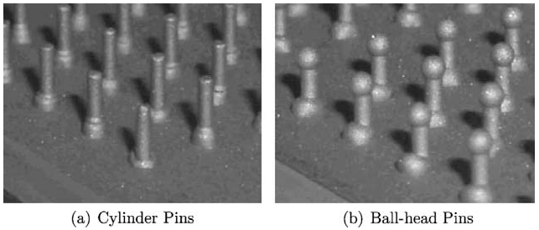

Figure 1. Cylindrical and ball-head shaped metallic pins [3]

Ucsnik et al. [3] proposed a CFRP-steel joining technology based on the sculptured surface approach.
An experimental investigation was conducted to assess the effect of pin shape on joint strength,
energy absorption capacity and failure behaviour for the case of double lap shear metal-composite joints undergoing static tensile-shear tests. A comparison between cylindrical and ball-head shaped pins, (see figure 1), was made alongside a reference case in which no modification of the metal’s surface took place and the joint connection was established solely by adhesive forces from resin usage. Improvements in the ultimate load and energy absorption capacity were observed for the surface structured joints against the reference case. The form fit between the pins and the composite part improved delamination resistance, with the pins maintaining load transfer post adhesive failure. Final failure occurred via pin shear and bending deformation of the pins.

TEUFELBERGER Ges.m.b.H [4] and its T-IGEL® connection technology use braiding to integrate
a fibre framework with a pin-structured metallic body for applications to hybrid cylindrical drive shafts. The ability to automatically vary the pin geometry and size allows for the possibility of tailoring these parameters to meet loading specifications.

Braiding achieves full coverage with a single pass of the mandrel and involves complex interactions
between the braid-yarns and braiding ring, whose frictional forces may cause significant deviation from the intended path (braiding angle). Therefore, this work considers a hybrid composite-metal joining solution using filament winding [5] to integrate carbon fibre composite with a pin structured metallic component. Filament winding allows for improved control of the tow path as each fibre-tow is placed individually. More precise positioning of the tow around the pins may then be possible. This will avoid puncturing of the fibre-tows by the pins, and thereby limit associated fibre breakage and strength degradation.
The component considered in this work is a tubular strut (predominately loaded axially). The central
part is substituted for carbon-fibre composite so that the strut would then comprise of two metallic endfittings connected via the mechanical form fit between the pins and filament wound tows. A cylindrical connector tube is situated between the two end-fittings in order to provide a winding surface during fabrication (see figure 2); this can either be removed post fabrication or maintained to improve strut properties in compression (beyond the scope of this work). For simplicity, in this discourse, this part is referred to as the "mandrel".

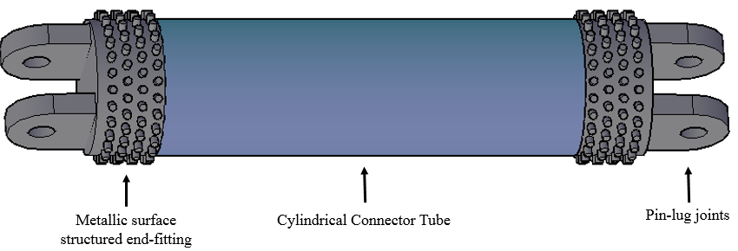

Figure 2. CAD representation of the hybrid strut without filaments (not to scale).
Pin-lug joints not included in model geometries.

A two-stage modelling approach was implemented in the explicit dynamics solver LS-DYNA® [6].
The fibre tow was first modelled in accordance with the Digital Element (DE) Method [7], to allow for prediction of the as-manufactured tow path (section 2). The DE method is used to capture yarn movement resulting from inter-yarn interactions occurring during textile production processes such as weaving and braiding. The virtual yarn is represented by a chain of beam elements (referred to as "digital elements") with a circular cross-section. The discretisation of the yarn length allows for realistic yarn flexural behaviour to be approximated, however, physical material properties are not conserved and therefore this method is unsuitable for mechanical analysis purposes.

Consequently, for the second stage of the modelling framework, the virtual tows were converted to
continuum elements for the tow cross-section. Matrix material was independently meshed, and the two constituents were coupled using Lagrangian constraints in order to improve computational efficiency through avoidance of over-meshing by non-concordance of nodes [8]. In this work, Lagrangian constraintswere implemented between tow and matrix parts through use of the LS-DYNA® keyword: *CONSTRAINED_LAGRANGE_IN_SOLID. Mechanical performance of the joint and strut under quasi-static tensile testing was then predicted at the meso-scale with characterisation of individual tows within the matrix.

2. Digital Element Model

2.1. Model Construction

The mandrel, end-fittings and pins were modelled using four-node rigid shell elements. It was sufficient to consider these parts as rigid bodies as they were employed only as a contact surface for the virtual tow(s), in order to simulate interactions between the physical carbon fibre and the metal during the filament winding process, and the effect these may have on tow path determination.

The pins were assumed to be cylindrical in shape and were distributed in a regular diamond pattern
(see figure 3 (a)). The pin array consisted of 31 pins around the end-fitting’s circumference, in 5 rows
up the end-fittings surface (see figure 3 (b)). The virtual tow was constructed from a chain of 2D (truss) beam elements with constant, circular cross-section. The diameter of the virtual tow was estimated for a 12k carbon fibre tow using the known diameter of a single carbon fibre and through treatment of the tow as a perfect fibre-bundle.

Table 1. Strut and part dimensions

Strut and component dimensions
End-fitting outer diameter | 60
End-fitting inner diameter | 40
End-fitting height | 35
Mandrel length | 200
Pin diameter | 3
Pin separation (array) | 3
Pin length | 7
Tow diameter | 0.77
All units (mm)

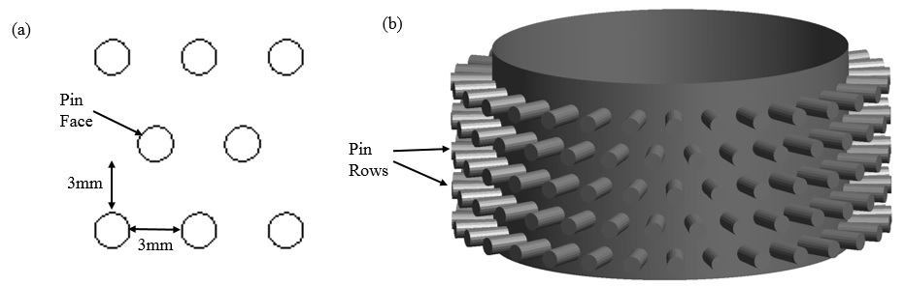

Figure 3. (a) 2D schematic of diamong patterned pin array. (b) Shell model of end-fitting.

2.2 Tow Path Determination

Previous work [9] attempted to replicate the physical winding process through use of the LS-DYNA® keyword *ELEMENT_BEAM_SOURCE. However, this approach proved to be computationally
inefficient for simulations involving multiple filament wound layers. Consequently, here an analytical
description of an initial route of the tow was used.

The winding pattern was subdivided into distinct regions on the structure. In the proximity of the
end-fitting and pins, the tow was determined to be wound around a single pin prior to reversing direction, (see figure 4). Each row of pins was wound sequentially starting with the pin row closest to the base of the end-fitting; the number of wind layers was therefore equivalent to the number of pin rows.

For the path of the tow on the mandrel, a winding angle was specified (this is the acute angle given
by the tow trajectory and the mandrel’s longitudinal axis). A given layup sequence then defines the
fibre orientation in this region for each filament wound layer. However, the ability to pre-determine the winding angle may be limited by the presence of the pins and the pre-condition established (section 1) to avoid tow puncturing. Therefore, the specified winding angle may have been adjusted to allow for a tow trajectory that passes through the pin array.

Each wind layer was made to form a closed-loop (equivalence of the first and last centre nodes of the
virtual tows) and each layer was independently placed in a sequential manner moving radially outwards away from the mandrel surface. Initial assignment of the tow path accounted for intra-layer tow crossing points only approximately through shifting of the centre-node positions of the (outer) virtual tows.

A subsequent FE simulation was then necessary to obtain a smooth, realistic tow path and to account
for tow-metal and inter-layer interactions such as nesting. This was achieved by creating a level of
pre-tension, or minimal strain, in the virtual tow structure through application of a negative temperature gradient and a coefficient of thermal expansion to the tows, (a similar approach was used in [10]). The effect observed was a reduction in excess tow length (figure 4(a) to (b)) and the tows were pulled closer to the struts surface to provide a more realistic radial tow density, (figure 4(c) to (d)).

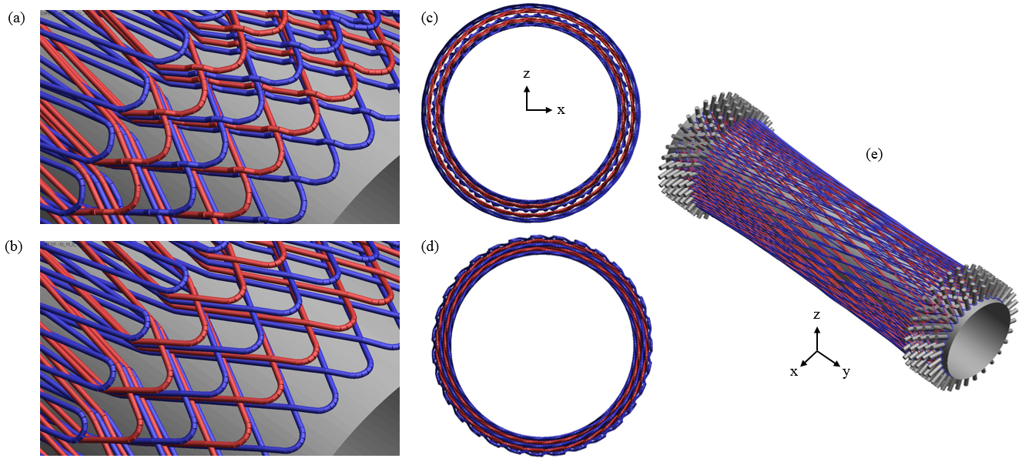

Figure 4. (a) Initial wavy tow path. (b) Final, smooth tow path (wind layers coloured alternately blue and red, pin surfaces removed for clarity). (c) Initial cross-section (x-z) view showing gaps between tow layers due to initial placement. (d) Final cross-section view with increased tow radial density.
(e) Final tow position on the full structure.

3. Solid Element Model

3.1 Path extraction and tow meshing

The centre nodes of the truss elements which comprise the virtual tows were then extracted post-process. These nodal coordinates were used to define a centreline path for the tows (figure 5(a)). The
virtual tows were then converted to 3D continuum elements. The mesh, as shown in figure 5(b), used
four 8-node solid elements to describe each cross-section. The element lengths along the tow direction were equal to the original beam element lengths utilised in the DE representation.

The tow elements were assigned the material card *MAT_COMPOSITE_DAMAGE. This is an
orthotropic material with optional brittle failure for composite materials. Properties (see table 2) were derived from [11] and the Chamis model [12], which provides engineering constants for a tow in terms of the fibre volume fraction and the elastic properties of the fibre and matrix. A constant 70% fibre volume fraction was assumed along the length of the tow.
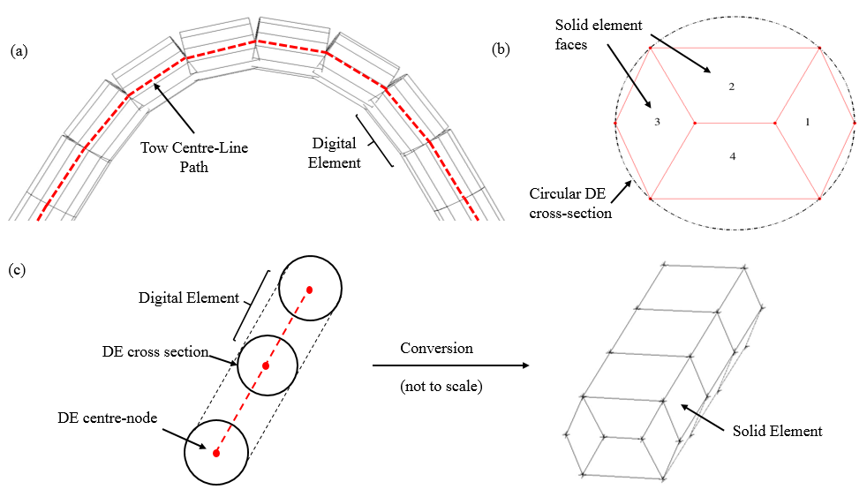

Figure 5. (a) Tow centre-line path. (b) Solid element cross-section mesh. (c) Tow conversion from DE to solid element representation.

Table 2. Material properties of physical fibre, virtual tow and matrix (resin)

 | E₁₁ (GPa) | E₂₂ (GPa) | n₁₂=n₁₃ | n₂₃ | G₁₂=G₁₃ (GPa) | G₂₃ (GPa)
Carbon fibre  (HTX40 F13 12k) | 238 | 13 | 0.20 | 0.25 | 13 | 6
Virtual tow | 168 | 8.54 | 0.245 | 0.177 | 5 | 3.6
Epoxy resin (MVR44) | 3.1 | 3.1 | 0.35 | 0.35 | 1.2 | 1.2

3.2 Matrix and End-fitting meshing

The matrix (resin) was meshed as a uniform, cylindrical tube using 8-node solid elements. It was assigned an elastic material type with the material properties of epoxy resin MVR44, as seen in table 2. For the end-fitting and pin geometries, (unlike previously for the DE model), it was important that the they were meshed as a single part, so that stresses can be transferred between pin and end-fitting in a realistic manner. The metallic parts (end-fittings and pins) were meshed using 4-node tetrahedral (prismatic) elements and assigned the material properties of the titanium alloy, Ti-6Al-4V (Grade 5) [12] (see table 3).

Non-physical mass was added to the model parts to achieve a larger critical time-step and thereby
reduce total computational expense. To achieve this, each model part was assigned a fictional material density of 0.1 tonne/mm³.

Table 3. Material properties of metallic elements: pins and end-fittings. G, K, ETAN denote the shear,
bulk and elastic (strain) hardening moduli respectively. s_{Y} denotes the yield stress.

 | G (GPa) | s_{Y} (GPa) | ETAN | K (GPa)
Ti-6Al-4V (Grade 5) | 43 | 1.1 | 0.20 | 0.25

4. Virtual Testing and Analysis

Quasi-static tensile tests were conducted virtually on three different joint configurations with layup
sequences as given in table 4. In all cases, the end-fitting and pin size were kept constant. Preliminary
tests were conducted using only tow and matrix (i.e. without end-fittings), as shown in figure 6(a). This was to determine if the Lagrangian constraints were able to capture expected fibre-matrix interactions (section 4.1). Later, a ranking was determined based on the struts performance requirements, and the layup which displayed improved mechanical behaviour was continued through to full structure analysis (section 4.2).

Table 4. Layup sequences for three different joint configurations

Model Number | Layup
1 | -10/10/0/10/-10
2 | 20/10/0/10/20
3 | 0/0/0/45/-45

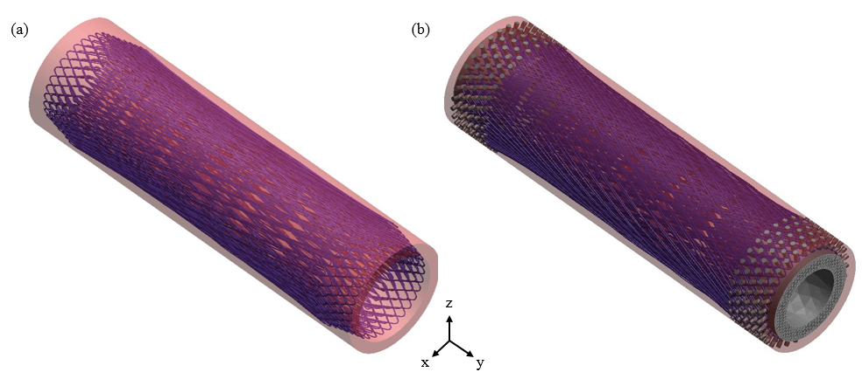

Figure 6. (a) Virtual tow (blue) and matrix (red) only, (matrix partially transparent) (b) With end-fittings

4.1 Tow-matrix interactions

In the Lagrangian coupling, the tows and matrix were designated as the slave and master parts respectively. A displacement of 1mm was applied to the nodes of the top and bottom surfaces of the matrix material, to simulate a total longitudinal (y direction) strain equivalent of 0:74%, over a time period of 10 seconds.

Figure 7 shows the local fibre-direction strain for the tow structure in the region of the end-fitting.
The maximum magnitude and distribution of strain was similar across all three cases. This was because tow orientation and tow-matrix density was identical in these localities across the three layups due to the constant end-fitting size, pin configuration and tow trajectory. Typically, higher strains were seen towards the strut ends, as tow density decreased. The tow structure also experienced negative strains as it was compressed onto the pins at the apex of the turn, (where the tow angle was 90 degrees to the strut’s longitudinal axis).

The local fibre-direction strain in the tow networks down the mandrel length are shown in figure
8 (a)-(c), for cases 1,2 and 3 respectively. The largest strains were observed in the layers that were
more closely aligned to the loading direction. This was most pronounced in configuration 3, where the inner layers comprising of near axial tows were significantly more highly stressed than the outer layers orientated at ±45. This conclusion was synchronous with the principles of composite materials and fibre-load alignment.

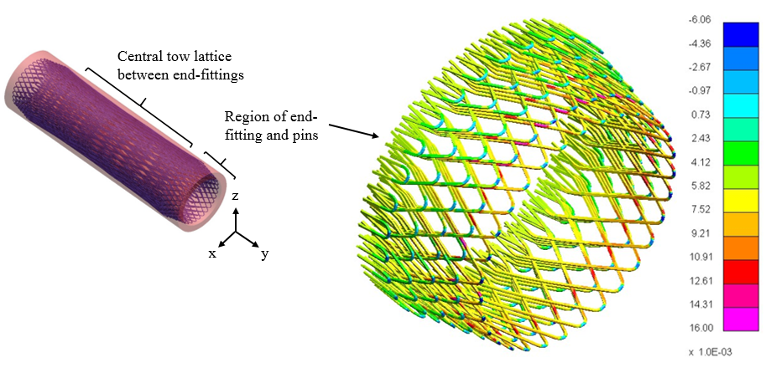

Figure 7. Local fibre direction strain for virtual tow in neighbourhood of end-fitting and pins

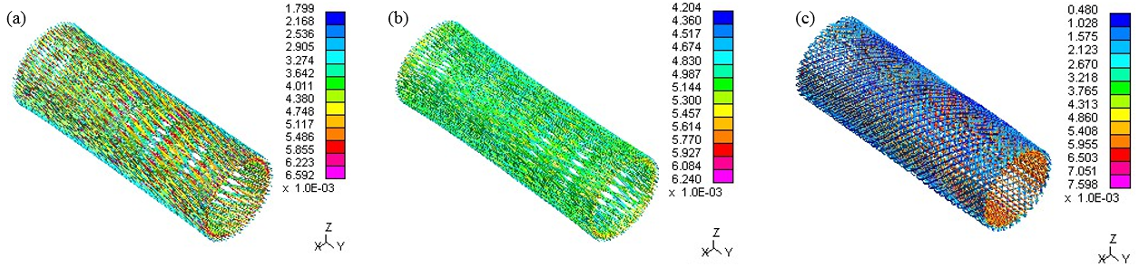

Figure 8. (a)-(c) Local fibre direction strain for tow lattice spanning the end-fittings

4.2 Performance ranking and hybrid joint analysis

For a strut which predominately experiences tension and compression, maximal axial properties are
desirable. However, use of filament wound layers with small fibre orientation angles may cause significant torsional effects. This should be minimised as it can induce additional stresses in the structure.

Figure 9 displays the force output from the model against simulation time, for each joint configuration. This was an indication of the work done to apply the prescribed displacement and strain equivalent. The largest force was transferred to strut with layup type 1, thus indicating that this layup provided the highest axial stiffness, compared to joints 2 and 3. This was expected due to the layup having more wind layers orientated with the loading (y) direction.

Figure 10 (a)-(c) displays the axial rotation (torsion) experienced in the full structure (matrix and tow(s)) for joint configurations 1 - 3. The highest torsional effects occurred in case 2, which displayed a magnitude of 9 and 21 times greater maximum radial displacement against strut types 1 and 3 respectively. This was expected due to the fact that the unbalanced layup induced extension-shear coupling under axial loading. Torsional effects were observed to be the least for case 3, which also displayed a more even distribution of rotation along the strut length. This was due to the presence of the ±45 degree fibre layers offering higher resistance to torsional forces.

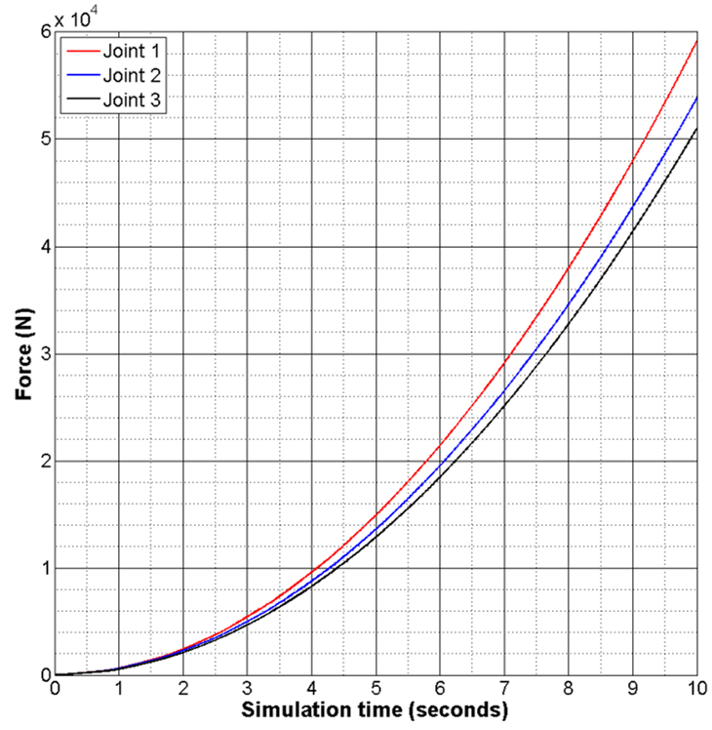
Figure 9. Global force transferred to tow-matrix structure

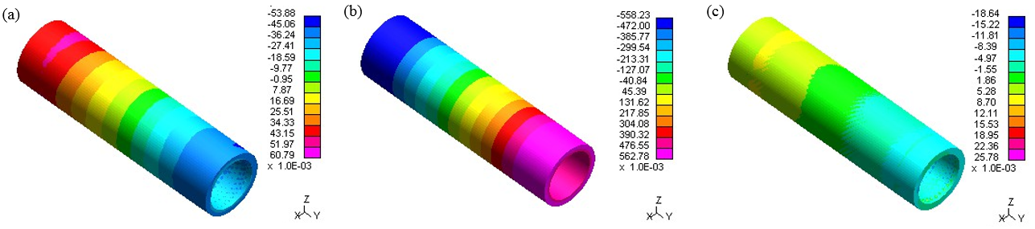

Figure 10. (a)-(c) Radial displacement (axial rotation) for joint layups 1, 2 and 3 respectively

From the results, joint type 1 was determined to offer improved mechanical behaviour over 2 and 3;
characterised by maximum axial stiffness and minimal torsional effects. Consequently, this joint configuration was continued through to the second stage of the virtual testing. Here, the full structure including the end-fittings was considered (see figure 6(b)).

The controlled displacement was this time applied to the metallic end-fittings. This should be more
representative of the physical structure, in which the end-fitting’s would be directly subjected to working forces that would be transferred to the composite part via the joining mechanism. The Lagrangian coupling between tow and matrix was maintained from section 4.1. Additionally, contact was introduced between the virtual tows, end-fittings and pins using type *CONTACT_AUTOMATIC_GENERAL.

Figure 11 shows the Von Mises stress distribution for a pin-structured metallic end-fitting. The largest stresses were observed around the base of the pins due to their mechanical interaction with the fibre-tows resulting in shear force and bending moments at their connections with the end-fitting’s surface. This would indicate that principle load transfer occurred directly between the pins and composite part. Furthermore, generally, loading of the pins was reduced further up the structure’s surface (i.e. for higher pin rows), as tow density decreased. Future work will aim to improve load sharing between pins in the array in order to maximise joint efficiency and avoid premature failure.

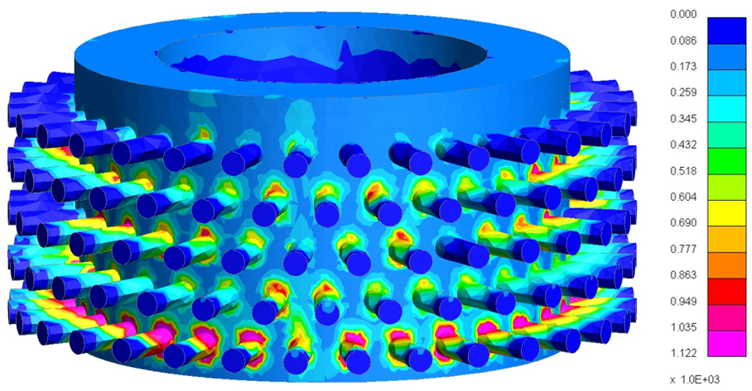

Figure 11. Von Mises stresses in a titanium alloy end-fitting

5. Conclusion

A two-stage modelling approach was conducted to investigate a novel hybrid composite-metal joining mechanism based on the principle of winding carbon-fibre filaments around a pin-structured metallic component in a tubular strut.

The virtual tow was first described as chain of truss elements in accordance with the Digital Element
Method. An initial, analytical path of the virtual tows on the structure was constructed and then subsequently refined through application of a temperature gradient. This approach had benefits in terms of computational efficiency, however, it was not a physical process simulation and therefore did not replicate the actual mechanisms of a filament winding machine. Consequently, it fails to capture manufacturing defects such as deviation from the prescribed winding angle due to tow slippage on the mandrel surface.

For mechanical analysis purposes, the tow geometry was then converted to 3D solid continuum
elements. Matrix material was then included and the two independently meshed constituents were then linked using Lagrangian constraints. This method captured expected interactions between the tow and matrix without significant computational cost. It further allowed for a comparison between different winding patterns to determine a relative performance ranking. Simulations of the full composite-metal hybrid structure were found to capture stress distribution in the surface-sculpted metallic end-fittings. Future work will consider joint parameters to improve load transfer between pins and the fibre-tows.

Acknowledgements

This work was supported by Airbus UK and the EPSRC through an iCASE studentship

References

[1] BGI Dance and AL Buxton. An introduction to surfi-sculpt technology–new opportunities, new
challenges. In Proceedings of the 7th International Conference on Beam Technology, pages 75–84,2007.
[2] A. Schierl. The cmt - process - a revolution in welding technology. 49(9):38, July 2005.
[3] S. Ucsnik, M. Scheerer, S. Zaremba, and D.H. Pahr. Experimental investigation of a novel hybrid
metal–composite joining technology. Composites Part A: Applied Science and Manufacturing,
41(3):369–374, March 2010.
[4] Teufelberger composite ges.m.b.h. vogelweiderstr. 50, 4600 wels, austria.
[5] M. Munro. Review of manufacturing of fiber composite components by filament winding.
Polymer Composites, 9(5):352–359, October 1988.
[6] Livermore Software Technology Corporation. Ls-dyna keyword user’s manual. 2015.
[7] YouqiWang and Xuekun Sun. Digital-element simulation of textile processes.
Composites Science and Technology, 61(2):311–319, February 2001.
[8] L Moutoussamy, G Herve, and F Barbier. Qualification of * Constrained _ Lagrange _ In _ Solid
command for steel / concrete interface modeling. 2011.
[9] J Jones, L.F. Kawashita, B.C. Kim, S.R.Hallett, Modelling of novel hybrid
composite- metal joints. Proceedings of the sixth ECCOMAS Thematic Conference on
the Mechanical Response of Composites, Joris J.C. Remmers and Albert Turon (Eds),
pages 72–81, Eindhoven University of Technology, 2017. ISBN: 978-90-386-4366-3
[10] Y. Mahadik and S.R. Hallett. Finite element modelling of tow geometry in 3D woven fabrics.
Composites Part A: Applied Science and Manufacturing, 41(9):1192–1200, September 2010.
[11] S.D. Green, M.Y. Matveev, a.C. Long, D. Ivanov, and S.R. Hallett. Mechanical modelling of 3D
woven composites considering realistic unit cell geometry. Composite Structures, 118:284–293,
December 2014.
[12] Chamis CC. Mechanics of composite materials: past, present, and future. J Compos Technol Res
ASTM 1989;11:3–14.
[13] http://www.matweb.com/search/datasheet.aspx?matguid=a0655d261898456b958e5f825ae85390.

