Polymer Nanocomposites Reinforced with
Porous Single-walled Carbon Nanotube Preforms

Youngseok Oh ^{1*}, Moon Kwang Um¹ and Mohammad F. Islam²
¹Composites Division, Korea Institute of Materials Science (KIMS),
797 Changwon-daero, Seongsan-gu, Changwon, Gyeongnam 51508, Republic of Korea,
(* E-mail: youngsoh@kims.re.kr)
² Department of Materials Science and Engineering, Carnegie Mellon University, Pittsburgh, PA 15213, US

Keywords: SWCNT, Aerogels, Nanocomposites
Abstract
Since single walled carbon nanotubes (SWCNTs) exhibit exceptionally high Young`s modulus and tensile strength, they have been considered an ideal additive for the reinforcement of the polymer composites. However, most polymer composites reinforced with carbon nanotube have shown limited mechanical improvement which is far below the level of the theoretical performance in consideration of the potentials of CNTs. The poor enhancement of mechanical properties of the composites is ascribed to the fact that the SWCNTs are easily bundled by strong van der Waals interactions induced by their small diameter. We report giant enhancement of polymer composites in mechanical properties by using the pre-fabricated, porous three dimensional SWCNT architecture which was built with individually dispersed SWCNTs. The isotropic SWCNT network acts as 3D pre-rebar system in the thermoplastic urethane (TPU). The TPU/SWCNT composites show giant enhancements of 40,000% and 9,700 % in tensile modulus and strength compared to those of the pristine SWCNT aerogel and bare TPU control sample regardless of the tensile direction.

Since single walled carbon nanotubes (SWCNTs) exhibit exceptionally high Young`s modulus (~ 1TPa) and tensile strength (~ 200 GPa), they have been considered a promising candidate for the reinforcement of the polymer composites . However, since discovery of carbon nanotube in 1991, most polymer composites reinforced with carbon nanotube have shown limited mechanical improvement which is far below the level of the expected performance in consideration of the potentials of CNTs. The poor enhancement of mechanical properties of the composites is ascribed to the fact that the SWCNTs are easily bundled by strong van der Waals interactions induced by their small diameter (0.8 ~ 1.2 nm). In that regard, the composites lack in dispersibility of SWCNTs in the matrix, and thus, the resultant CNT bundles give rise to reduced bending moduli due to their extremely low friction coefficient leading to low reinforcement efficiencies .

The continuous fiber structure has advantages in transferring the loads from the matrix over discontinuous fibers in the matrix. The vertically aligned carbon nanotubes as a filler in the elastomeric polymer matrix contributed to the large improvement (~3300%) in the compressive modulus and high loadings of the aligned millimeter-long multi-walled carbon nanotube sheets shows about 107 % enhancement in tensile modulus . However, in the transverse direction, their mechanical properties revealed very low mechanical strength compared to longitudinal direction. Reticulated CNTs structure acted as continuous reinforcements in the matrix, resulting in only 230 % and 100 % improved tensile strength and strength compared to that of neat fiber .

Here, we report giant enhancement of polymer composites in mechanical properties by using the pre-fabricated three dimensional SWCNT structures which was built with individually dispersed SWCNTs. The isotropic SWCNT network acts as 3D pre-rebar system in the thermoplastic urethane (TPU). The TPU/SWCNT composites show giant enhancements of 40,000% and 9,700 % in tensile modulus compared to those of the pristine SWCNT aerogel and bare TPU control sample regardless of the tensile direction.

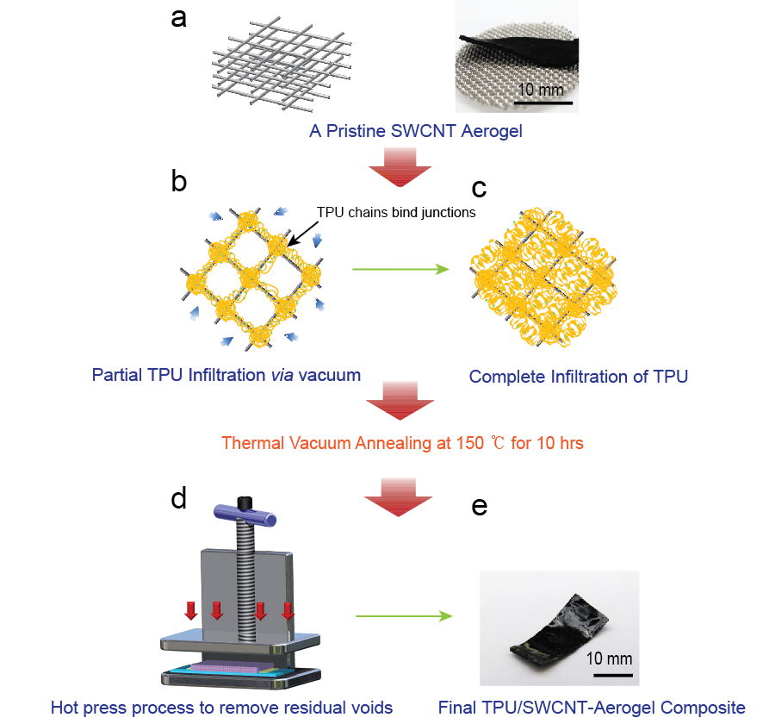

Figure 1. Schematic of synthesis of TPU/SWCNT Aerogel composites. a. Pristine SWCNT aerogel in a rectangular shape. The 3D aerogel network is built with individually dispersed SWCNTs. b. Vacuum infiltration of TPU solution (15 wt%). The SWCNT junctions formed by weak van der Waals interactions are secured with TPU molecules. Even though the vacuum infiltration process is carried out, there are still residual pores in the SWCNT 3D network. c. The 2nd infiltration process in which we soak the samples in TPU solution (10 wt%) for 12 hrs at 50 ℃. d. Hot-press process for 2 min at 120 ℃. The final thickness of the composite is controlled with the spacer.

Figure 1 shows the schematic of the preparation of SWCNT aerogel reinforced thermoplastic urethane (TPU, Bayer Materials) composites (TPU/SWCNT composites), and detailed procedures are described in methods. In brief, wet SWCNT gels were prepared by individually dispersing SWCNTs in water using 1 wt% sodium dodecylbenzene sulfonic acid (NaDDBS) and evaporating water off to the final SWCNT concentration of 0.375 wt%. We then broke the gels to transfer to the mold. The gels in the final shape were soaked in 1M nitric acid (HNO₃) to remove the residual surfactant effectively and in water to neutralize the samples. After the solvent exchange with anhydrous ethanol (EtOH), EtOH in the SWCNT wet gels was removed via critical-point-drying (CPD) as shown in Fig. 1a in order to preserve three dimensional (3D) network structures without mechanically deteriorated deformation . The SWCNTs are held each other by strong van der Waals force, which helps build a 3D pre-rebar system to reinforce the polymer matrix. TPU dissolved in Tetrahydrofuran (THF, Acros) solution (15 wt%) was infiltrated in the vacuum chamber.(See Supporting Information) After evaporating THF to cure the TPU molecules, it was found that the infiltrated TPU molecules dominantly covered the junctions between SWCNTs (Figure 1b), and thus, the structure had some robustness. The SWCNT junctions formed with the aid of van der Waals interactions could be secured tightly by the wrapping TPU molecules. In the following processes, the pre-TPU/SWCNT composite block was soaked in 10 wt % TPU/THF solution with low viscosity for uniform impregnation of TPU molecules into the pores (Figure 1c). Finally the composite was hot-pressed smoothly at 130 ℃ for 2min as shown in Figure 1d after vacuum thermal annealing process at 150 ℃ for 10 hrs. The average thickness of the composites was 200 μm (Figure 1e). The hot-press process at such temperature could fill the thermoplastic polymer molecules in nano-scaled SWCNT aerogel pores homogenously and achieve the densification of the composite resulting in removal of residual porosities in the system .
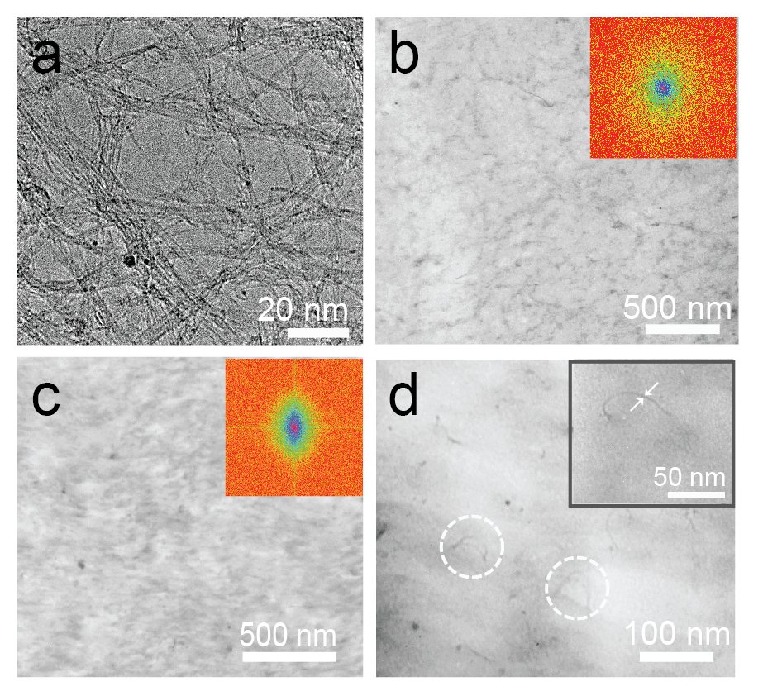

Figure 2. Transmission Electron Microscope (TEM) measurement of TPU/SWCNT aerogel composites. a. HR-TEM image of SWCNT aerogel (8 mg/ml). The pore size of SWCNTs is 10 ~ 30 nm. Even though the aerogel was crashed in the ethanol (99.9%) by tip-sonication (100 W) for 3 sec for the TEM sampling, the SWCNT network was maintained well without large bundling. b. TPU/SWCNT aerogel composites at 0% strain. The isotropic SWCNT networks embedded in TPU matrix was observed clearly. The inset shows the fast fourier transform of the TEM image. c. The TEM image of TPU/SWCNT aerogel composites after tensile test. The TEM image and their FFT support that 3D SWCNT network was aligned along the direction of tensile strain. d. Magnified TEM image of SWCNT/TPU aerogel. The small diameter (1.5 nm) indicates that the 3D network was built with individually dispersed SWCNTs as shown in the inset.

Figure 2a shows the high-resolution transmission electron microscopy (HR-TEM) of typical prefabricated SWCNT aerogel with density of 8.0 mg/ml which was prepared by tip-sonication (100 W, 3 sec) in ethanol (Acros, 99.9%). Although the 3D nanotube structure was under ultrasonically induced strong cavitation, the isotropic structure still remained reasonably undamaged without significant aggregation of SWCNTs due to such a short sonication time. The pre-fabricated 3D network of our aerogel could support 5,000 times of their own weight without any reinforcements . According to our previous research, the isotropic 3D network secured with van der Waals interactions has ultra-high surface area of 1291m²/g, which is closed to the theoretical value 1315 m²/g indicating strongly that the aerogel was built with individually dispersed SWCNTs . The important point to be noted is that the high surface area of the prefabricated SWCNT gel could provide extremely large interfacial area to grab the matrix.
Figure 2b and 2C are the TEM images of small piece of TPU/SWCNT aerogel composites (a-TPU/SWCNTs, 10.12 wt%) prepared with a micro-tome before and after tensile strain of 40%. The homogeneous carbon nanotube network was preserved well and no observation of pore reflects that TPU molecules are homogeneously interpenetrated into the pre-fabricated SWCNT aerogel. We determined the alignment of the CNT network within the composites under tensile strain by calculating the orientational order parameter (S) via fast Fourier transform (FFT) of the TEM images as shown in insets of Fig. 2b and 2c. The two Poisson`s ratio of the a-TPU/SWCNTs was experimentally measured in the direction of the thickness and width (ν_{w}: 0.19, ν_{t}: 0.18). The values of SWCNT/TPU composites is significant lower than that of TPU control block (ν_{w}: 0.44, ν_{t}: 0.36). This indicates that the SWCNT pre-rebar system play a significant role in the structural sustenance under external strain due to their finite volume and high resistance to deformation. The high elasticity of the composite resulted in recovery of the partial residual strain even though the permanent deformation occurred after fracture of the specimen during tensile test. Figure 2D shows the magnified surface morphology of a-TPU/SWCNTs composite after tensile test. The SWCNTs, clearly exposed during the sample preparation processes including cuttings of the samples by a precision blade, shows the bending with large curvature induced by the residual strain of the composite. Additionally, the small diameter of the bent SWCNTs (d≈1.5 nm) supports the fact that the individual SWCNTs of preformed aerogel are strongly held by excellent interfacial bonding with the TPU molecules as shown in inset of Fig. 2d.

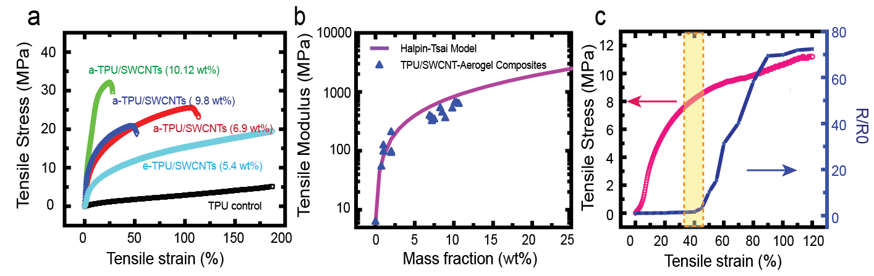

Figure 3. Mechanical and electrical characterizations of TPU/SWCNT composites. a. Tensile stress (σ)-Strain (ε) curves of SWCNT/TPU composites as a function of concentration of SWCNTs. The tensile moduli of the samples prepared with SWCNT aerogel with 6.9, 9.8, 10.12 mg/ml and pure TPU are 389.54, 650.53, 517.34 and 6.63 MPa, respectively. The TPU/SWCNT elastic gel composite (e-TPU/SWCNT composite) shows 132.0 MPa of tensile modulus. b. The tensile moduli of TPU/SWCNT aerogel composites as a function of concentration of SWCNT. Blue closed triangles and purple curved line appeared the experimental results and theoretically calculated value with modified Halpin-Tai equation. c. The comparison of the σ - ε curve (pink) and the change of electrical resistance as a function of tensile strain (Dark blue). The electrical resistance was significantly increased around the end of elastic region (yellow rectangular area).

The pore size and loading concentration of the preformed structure could be controlled with their density. TPU/SWCNT composites were prepared from pre-fabricated SWCNT aerogel with 6.9, 9.8, 10.12 wt% of SWCNT loadings respectively. Figure 3a shows the mechanical properties of the composites in tensile test. The TPU composite reinforced with SWCNT aerogel with 10.12 wt% of mass fraction shows extremely improved tensile modulus (650.53 MPa) which is 9706 % higher than that of pure TPU block (6.6 MPa). On the other hand, the composites reinforced with an elastic gel (e-TPU/SWCNT composite) with 5.4 wt% SWCNTs shows lower improvement compared to a-TPU/SWCNTs in tensile modulus. While the specific tensile modulus of e-TPU/SWCNTs, tensile modulus/weight fraction of SWCNTs, was 2.45 GPa, the a-TPU/SWCNT composite revealed maximum 6.43GPa. This means that the CNT junctions in the e-TPU composites are not solid due to the TPU molecules in between SWCNTs. A material`s resilience represents physically the ability of the material to absorb energy without any permanent damage to the material . The a-TPU/SWCNTs (60.10KJ/m³) have 1184 % larger resilience compared to that of the TPU control (4.78KJ/m³).
The theoretical elastic moduli of the composites as a function of SWCNT mass fraction have been fitted with modified Halpin-Tsai equation as shown in Figure 3b . The Halpin-Tai model was developed for the composites reinforced with randomly oriented continuous fibre composites . A detailed derivation is provided in the supplementary information. Individual, homogeneous dispersion of carbon nanotubes in the matrix is the most critical key for achieving the ultimate mechanical property from the composite via exceptional high Young`s modulus of carbon nanotubes. Interestingly, the theoretical prediction (Red line) could describe the experimental data (Blue closed triangles) well, although it overestimated the values in the range of high concentration. This indicates that the pre-fabricated aerogel built with individually dispersed carbon nanotubes supports the matrix efficiently under external force. The 3D SWCNT network also accompanied the enhancement of the tensile strength by 180% simultaneously with the improved tensile modulus. Detailed mechanical properties of the composites from the tensile test are in the Supplementary information. Additionally, the mechanical characterization on the pristine aerogel with 9.1 mg/ml of density has been performed. The pristine aerogel with density of 9.1 mg/ml revealed 0.2 MPa of tensile modulus, while compressive modulus of the aerogel with 10.0 mg/ml is 0.21 MPa (see Supplementary information). This supports that the SWCNT-aerogel could enhance the mechanical property of the polymer composites regardless of the direction of external force due to their isotropic structure. In addition, the composite reinforced with the SWCNT aerogel (6.9 wt%) appeared significant enhancement of 194,670 % compared to that of pristine aerogel in the tensile modulus.
We also measured electrical conductivity of the TPU/SWCNT composites. The maximum conductivity 3.9 S/cm was observed with 50 mg/ml of SWCNT aerogel (See Supplementary information), while the e-TPU/SWCNT composites shows only 0.01 S/cm which can be correlated to the low mechanical improvement due to the high electrical contact resistance induced by the TPU molecules intervening adjacent nanotubes. The high conductivity indicates that the interfacial contacts between adjacent nanotubes are maintained well during the polymer infiltration process. This conductivity is more than factor of 5 magnitudes higher than that of the previously reported conductivity of elastomeric composites which were synthesized without adding of specific chemical, metal agents and millimeter-long CNTs for enhancement of the electrical properties. Figure 3d shows the change of the electrical resistance as a function of a-TPU/SWCNT composites with 1 wt% SWCNT loading. The composite with 1 w% of SWCNTs shows the large tensile strain of 130 % as shown in the inset. Interestingly, the normalized resistance (R/R₀) was significantly increased from 40 % of tensile strain interestingly where the linear elastic region ends. This result indicates that the physical contacts between nanotubes in the 3D networks have been kept well in the elastic region. Additionally, we could expect that the junctions of nanotubes secured with TPU molecules endure against the external force and the bending modulus of SWCNTs dominates the mechanical properties of the composites in the elastic region consistent with the theoretical results as shown in Fig 3b. After elastic region, the debonding of the CNT junction was accompanied with increase of the inter-particle distance, inducing the large electrical resistance.

Conclusions

We integrated preformed hydrogels and aerogels of individually dispersed nanotubes with polymer to increase elastic modulus of composites according to Halpin_Tsai model up to at least 10 wt % of nanotube loadings without covalently liking the nanotubes to each other and to the polymer. The nanotubes also increased strength and toughness of the polymer, and added electrical conductivity. Our solution-based fabrication method did not depend on the polymer type, and is similar to current methods used in industry, making our approach suitable for rapid implementation.

Acknowlegement
This research was supported by a Global Research Lab Program and Basic Science Research Program through the National Research Foundation (NRF) of Korea funded by the Ministry of Science, ICT & Future Planning (NRF-2015R1C1A02037139), and the Principal Research Program in the Korea Institute of Materials Science (KIMS).

References

[1] Kis, A., et al. Reinforcement of single-walled carbon nanotube bundles by intertube bridging. Nature Materials 3, 153-157 (2004).

[2] Iijima, S. Helical Microtubules of Graphitic Carbon. Nature 354, 56-58 (1991).

[3] Salvetat, J. P., et al. Elastic and shear moduli of single-walled carbon nanotube ropes. Physical Review Letters 82, 944-947 (1999).

[4] Ci, L., et al. Continuous carbon nanotube reinforced composites. Nano Letters 8, 2762-2766 (2008).

[5] Cheng, Q. F., et al. Functionalized Carbon-Nanotube Sheet/Bismaleimide Nanocomposites: Mechanical and Electrical Performance Beyond Carbon-Fiber Composites. Small 6, 763-767 (2010).

[6] Ma, W. J., et al. Directly synthesized strong, highly conducting, transparent single-walled carbon nanotube films. Nano Letters 7, 2307-2311 (2007).

[7] Yodh, A. G., et al. Carbon nanotube aerogels. Advanced Materials 19, 661-664 (2007).

[8] Vaisman, L., et al. The role of surfactants in dispersion of carbon nanotubes. Advances in Colloid and Interface Science 128, 37-46 (2006).

[9] Chun, K. Y., et al. Highly conductive, printable and stretchable composite films of carbon nanotubes and silver. Nature Nanotechnology 5, 853-857 (2010).

[10] Morimoto, Y., et al. Mechanical Process of Dynamic Powder Compaction. Institute of Physics Conference Series 427-434 (1984).

[11] Kyu Hun Kim, Youngseok Oh. M. F. Islam Carbon Nanotube Aerogel with Ultra-High Surface Area. Advanced Functional Materials under revision, (2011).

[12] Hibbeler, R. C. Mechanics of Materials (Prentice Hall, Inc., Upper Saddle Riber, New Jersey, 2000).

[13] Coleman, J. N., et al. Small but strong: A review of the mechanical properties of carbon nanotube-polymer composites. Carbon 44, 1624-1652 (2006).

