OPTICAL FIBER SENSOR BASED IN-PROCESS MONITORING AND QUALITY ASSURANCE OF RECENT AEROSPACE COMPOSITES

Nobuo Takeda, Shu Minakuchi and Akira Hamamoto

Graduate School of Frontier Sciences, The University of Tokyo
5-1-5 Kashiwanoha, Kashiwa-shi, Chiba 277-8561, JAPAN
Email: takeda@smart.k.u-tokyo.ac.jp

Keywords: optical fiber sensor, CFRP, process monitoring, quality assurance

Abstract

SIP (Cross-ministerial Strategic Innovation Promotion Program) - SM⁴I (Structural Materials for Innovation) [1] was established by the Council for Science, Technology and Innovation (CSTI) of the Japanese Cabinet Office, as one of the national R&D subjects to realize scientific and technological innovation strategically under its initiative. Under this SIP - SM⁴I, our project, "Innovative Aircraft Polymer Matrix Composites (iAPMC)" started in November 2014 as a five-year project. The main purpose of this project is to develop high-rate production aircraft PMC products and quality assurance technology for next-generation CFRP aircraft structures. This project consists of five research units, (1) OoA CFRP (Airframe) Unit, (2) Low-cost Autoclave CFRP (Airframe) Unit, (3) CFRTP (Engine) Unit, (4) High-Temperature CFRP (Engine) Unit, and (5) Academic Support and Material Evaluation Unit.

This presentation provides a summary of recent results in this project. Especially, optical fiber sensor based in-process process/life cycle monitoring methodology is presented with some successful examples [2, 3] which cannot be provided by conventional material characterization methods (Fig. 1).
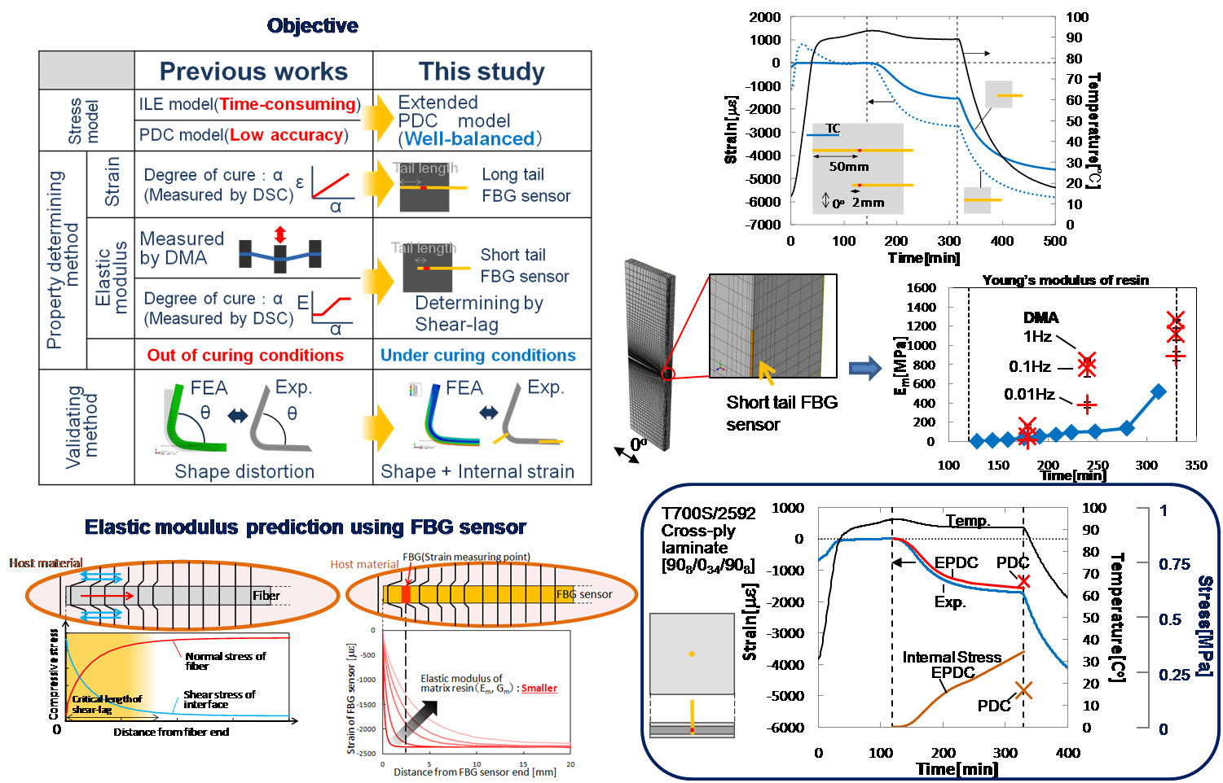

Figure 1: High accuracy cure process simulation of composites based on in-situ measurement of internal strain

REFERENCES

[1]http://www.jst.go.jp/sip/k03.html
[2] Minakuchi, S., T. Umehara, K. Takagaki, Y. Ito and N. Takeda. 2013. "Life cycle monitoring and advanced quality assurance of L-shaped composite corner part using embedded fiber-optic sensor," Composites Part A, 48: 153-161.
[3] Minakuchi, S., S. Niwa, K. Takagaki and N. Takeda. 2016. "Composites cure simulation scheme fully integrating internal strain measurement," Composites Part A, 84: 53-63.

