Compressive behavior of composite laminate with delamination and a quick mechanical repair

Su Yuru¹, Wang Xin¹, Li Zengshan¹, Guan Weishi², Huang Yongjie¹, Fan Rongtao¹, Guan Zhidong¹

¹School of Aeronautic Science and Engineering, Beihang University, Beijing, China
²Faculty of Aerospace Engineering, Shenyang Aerospace University, Liaoning Shenyang, China
Email: 645241457@qq.com, 451123986@qq.com, 09512@buaa.edu.cn, guanweishi1994@outlook.com, 443826354@qq.com, fanrongtao@buaa.edu.cn, 07434@buaa.edu.cn

Keywords: compressive, composite laminate, delamination, sub-laminate buckling, mechanical repair

Abstract
In this paper, the compressive behavior of the ZT7H/QY9611 composite laminates containing single delamination and a corresponding quick mechanical repair method for field repairing have been investigated both experimentally and by numerical calculation method. After the conduct of the test, the buckling mode and load as well as the failure mode and load were obtained. A parametric analysis was implemented using the finite element method (FEM) models. The results show that the delamination size and though thickness position have an influence on the buckling load and mode, and a mixed buckling mode composed of sub-laminate buckling and global buckling occurs with a delamination size of Ф60mm located in the 1/4 thickness position. It is concluded that the buckling load decreases with the increase of the delamination size and the decrease of the delamination position in the thickness direction, and the quick mechanical repair method has an obvious restraining effect on the sub-laminate buckling.

1. Introduction

Carbon Fibre Reinforced Plastic has been increasingly used as a significant material of the latest generation of aircraft, owing to its fairly high ratio of stiffness and strength to weight. Currently, resin based composite materials, applied in the primary force-taking components of aircraft, are mainly composite laminates and laminated structures. Delamination is one of the most serious failure modes in laminated composite materials. According to statistics, delamination damage of composite laminates accounts for more than 50% of the defective parts generated in the process of production, assembly and use [1]. Existing inside the structures, it is not easy to detect the damage just according to the surface condition. The stiffness of damaged structures will be lowered and in addition, once local buckling occurs under compressive load, delamination might grow and further decrease the load-carrying capacity of the structures [2].

Replacing the damaged structures is not an economical choice, considering the expensive cost of composite structures and integration trend of its design. Therefore, the technology of composite structures repair is becoming important. For the primary force-taking structures, transferred load is so high that mechanical connection repair should be the top-priority method. The mechanical connection repair has good antistripping performance and little environmental impact, besides, it has no residual stress like adhesive bonding repair during curing [3].

Therefore, the two key points of this paper are delamination damage of composite laminates and a corresponding mechanical repair method.

Composite laminates containing delaminations can buckle at a lower level of compressive load and this level is influenced by the delamination size and ﬁber orientation [4]. Many researchers have studied the effect of delamination on the compressive behavior of composite laminates experimentally, analytically and numerically using finite element method. Rajendran and Song [5] carried the buckling analysis of composite panels with embedded circular delaminations using ANSYS. They found that whenever the delamination is located at the mid-plane of laminate, the panel exhibits only global buckling, i.e. there is no local buckling of delaminated region. On the other hand, whenever the delamination is close to the surface, the buckling mode is predominantly local. Aslan and Sahin [6] studied the effects of the delaminations size on the critical buckling load of composite laminates with multiple large delaminations both by experimental and numerical way. It is concluded that the longest and near-surface delamination size inﬂuences the buckling load, however, the size of beneath delaminations has no signiﬁcant effect. The similar results were found by Hwang and Liu [7] and Hwang and Huang [8]. Cappello and Tumino [9] adopted two finite elements methods to examin the buckling behaviour of unidirectional and cross-ply composite laminated plates with multiple delaminations, a linear buckling model, based on the solution of the eigen-values problem, and a non-linear one, based on an incremental-iterative method. Fu and Zhang [10] investigated the distribution of delamination sizes and though thickness positions in the composite laminates. The statistical data show that most of delaminations can be classified into small ones and concentrate on the 1/4, 1/3 and 1/2 of thickness. Andrew et al. [11] focused on the effect of the interaction of local and global buckling on panel buckling and delamination propagation strains. An anti-buckling guide to restrain the panel against global buckling was adopted in the experiment and more novelly, the authors derive an integrated model of analytical Strip model and a Shanley model.

The mechanical repair method used in this research was to put a rivet in the delamination region, which functioned like a stapler to resume load-carrying capacity and restrain local sub-laminate buckling. Mechanical joint and mechanical connection repair of composite materials have been researched by many scholars using FEM methods. And three-dimensional solid element was most adopted to simulate the metal connectors. Nie et al. [12] investigated the tensile performances of mechanically fastened repairs of composite laminates. Bolt and nut were modeled as a whole using solid element C3D8R. Zhao Chuang and Guo Xia [13] built the models of intact stiffened composite panel and the mechanical repaired ones. The general contact with a 0.3 friction coefficient in tangential attribute and rigid contact in normal was defined through commercial finite element software ABAQUS.

In this paper, the compressive behavior of ZT7H/QY9611 composite laminates, which contained single delamination with unrestrained laterals, was studied both experimentally and by numerical method. Also, a quick mechanical repair method for field repairing was investigated. The buckling mode and load as well as the failure mode and load were obtained experimentally. The influence of the delamination size and though thickness position on the buckling load and mode were studied using the finite element method (FEM) models. The results show that a mixed buckling mode composed of sub-laminate buckling and global buckling occurs with a delamination size of Ф60mm located in the 1/4 thickness region, and the quick mechanical repair method has an obvious restraining effect on the sub-laminate buckling.

2. Experimental study

2.1. Specimens and test procedures

The laminates for experiment were manufactured from fiber/ bismaleimide preimpregnated tapes of 0.125 mm in thickness. The prepreg tapes, named by ZT7H/QY9611, were made of T700 continuous high tensile strength carbon fibers preimpregnated with QY9611 toughened bismaleimide resin made in China. As shown in Fig. 1, the specimens were made up of two identical 200*100 plates, being bonded by J-299 adhesive with a thickness of 0.2 mm. Each plate used the stacking sequences of [45/90/-45/0/45/-45/90/0]_{S}. The 25*100 dimensioned strengthening plates, made of glass fiber reinforced plastics, were bonded to the two ends of the 200*100 laminates to avoid end cracking. All the nine laminates were divided into three sets, the intact, the damaged and the repaired. The damaged specimens were artificially delaminated by inserting a non-stick material (circle of 20mm in diameter) in adhesive layer centrally, as the C scan image shows in Fig. 2. The mechanical connectors of repaired specimens were titanium alloy rivets of the brand CR7774S-05-l with a 5 mm nominal diameter. The rivets were positioned in the center of the specimens. The actual stereogram of the repaired specimens is shown in Fig. 3.

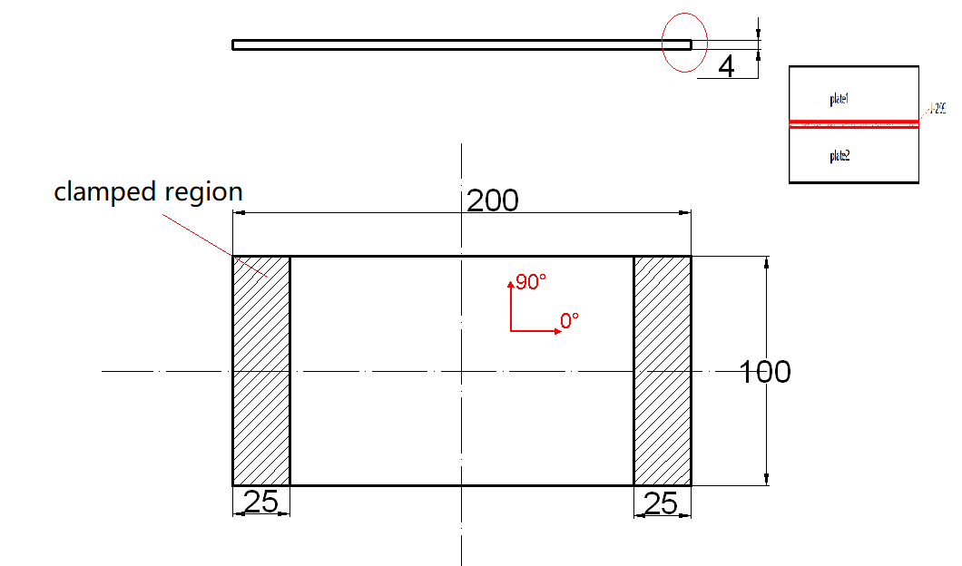

Figure 1. Specimen size.

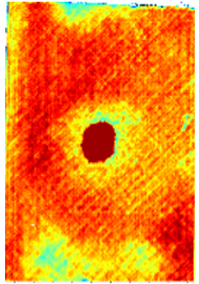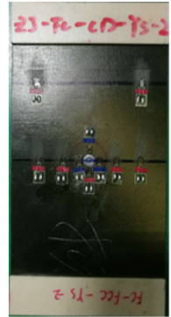

Figure 2. C scan image of the damaged sepcimens. Figure 3. Stereogram of the repaired specimens.

Strain gauges were pasted on the surface of each specimen to obtain the strain response during the compression process. The back-to-back distribution of the strain gauges is shown in Fig. 4. The strain gauges on the same side were marked as Ai(i = 1–10) while on the opposite side were marked as Bi. No.6, 7 and 8 strain gauges of the damaged specimens, located inside the delamination area, were used to monitor the occurrence of sub-laminate buckling. Close to the rivet, No.7, 8, 9 and 10 strain gauges of the repaired specimens were used to measure stress concentration.

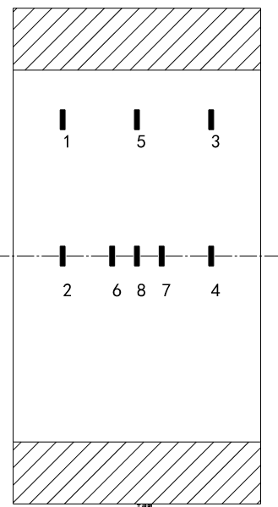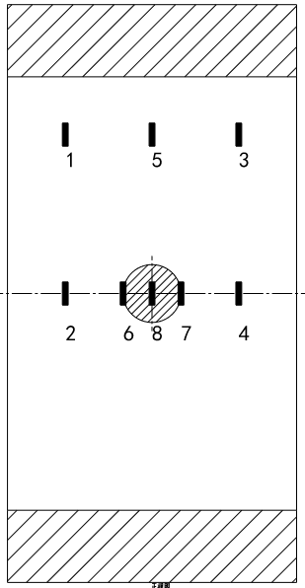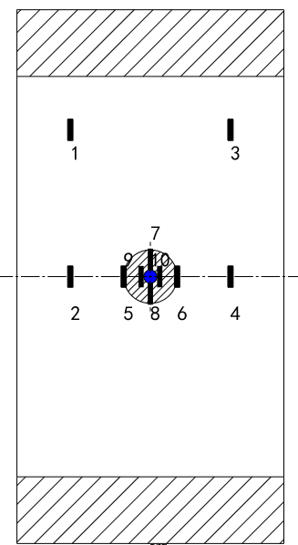

- The intact (b) The damaged (c) The repaired

Figure 4. The locations and numbers of the strain gauges.

The specimens were clamped on the upper and lower ends by a pair of U-slots, while free in the left and right sides. The compression tests were carried out on MTS material testing machine, of which the maximum load is ±200 kN. The fixed loading rate was 1.0mm/min during the test, and the load and displacement curve was automatically recorded by the testing machine.

2.2. Test results and analysis

2.2.1. Load and displacement curves

The compressive load vs displacement curves of the typical intact, damaged and repaired specimens are shown in Fig. 5. It is clear that the load increases linearly with displacement initially. The stiffness of the repaired is highest due to the rivet. Then the load remains unchanged or decreases after the buckling. For the intact and the damaged, the load slowly increases in the final phase before failure.
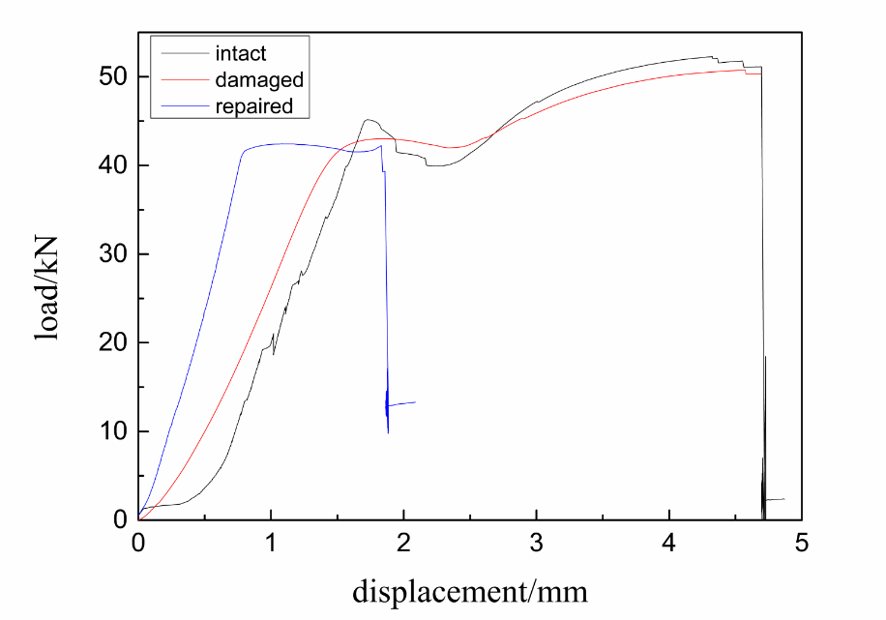

Figure 5. The compressive load vs displacement curves.

2.2.2. Strain and buckling modes

The strain data of the intact, the damaged and the repaired are respectively shown in Fig. 6. The strain initially increases linearly with the compressive load and a substantial superposition can be observed among different measuring points. The strain curves of Ai and corresponding Bi bifurcate at a certain load, which is considered as the buckling load of a global buckling mode. The variation trends of strain data after buckling are opposite at the measuring points near the clamped region and in the middle of the specimen. As shown in Fig. 6(c), the compressive strain of A1 and A2 increase, while compressive strain at middle points decrease and even develop to tensile strain. The buckling mode of all specimens were global buckling. The local sub-laminate buckling did not occur due to the deep location of the delamination in thickness direction (1/2) and the small delamination size.

(a) The intact (b) The damaged (c) The repaired

Figure 6. The strain vs compressive load curves of the sepecimens.

2.2.3. Failure mode

The failure mode of the intact and the damaged specimens is same, as shown in Fig. 7. Delamination in multiply interface can be observed from the side view. Fiber splitting and matrix cracking occur in the concave side (relative compression), while fiber breaking and matrix cracking in the convex side (relative tension). The failure mode of the repaired specimens is shown in Fig. 8. Interlayer delamination occurs in shallow layers close to the countersunk head of the rivet, meanwhile, fiber breaking and matrix cracking can be observed.

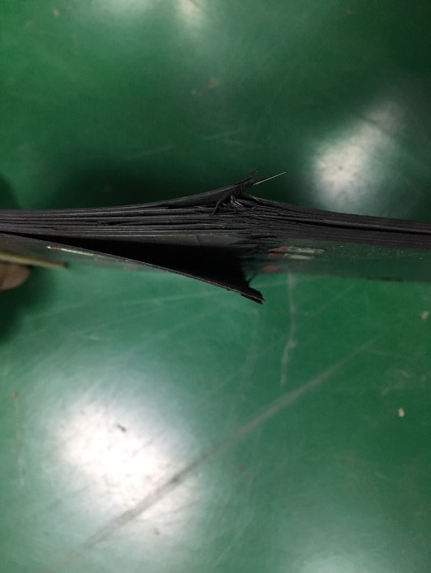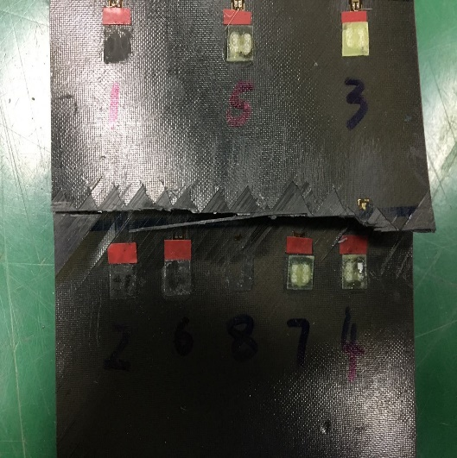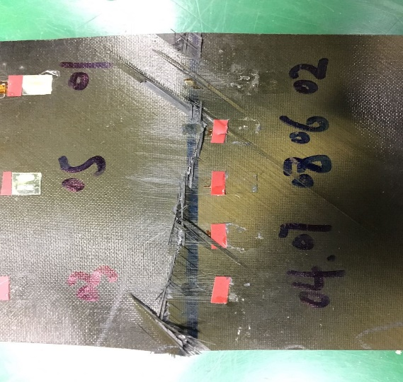

Figure 7. Failure mode of the intact and the damaged specimens.

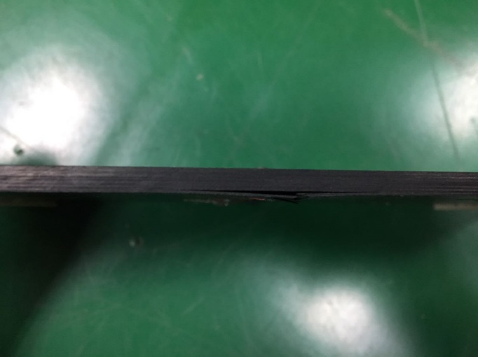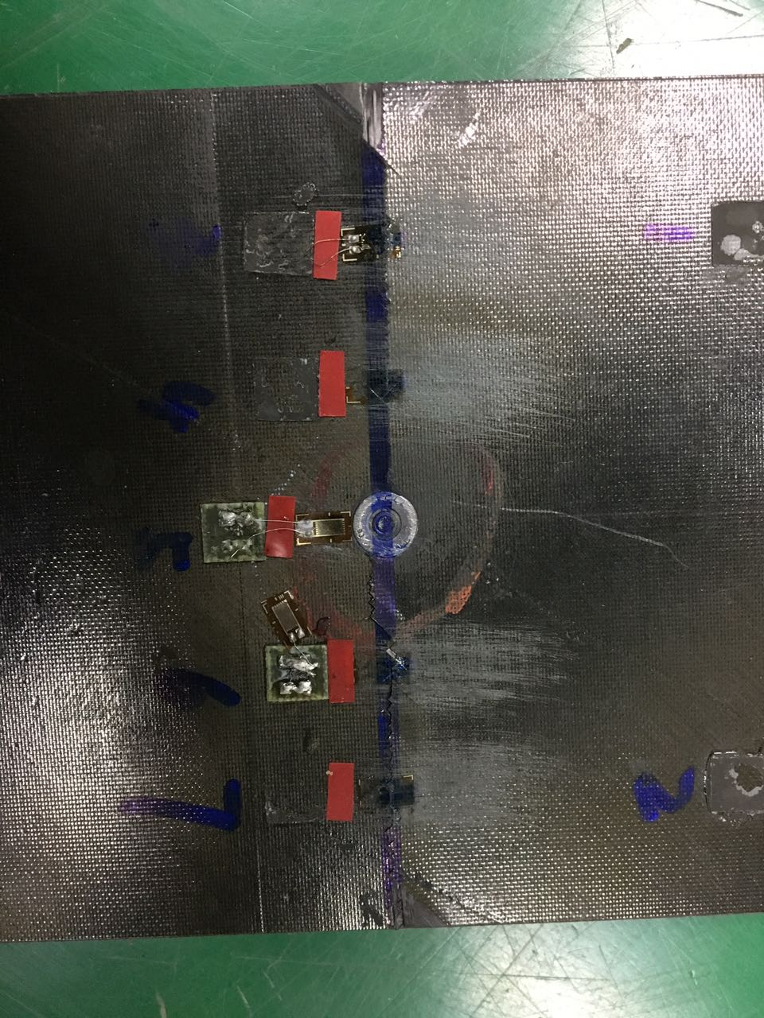

Figure 8. Failure mode of the repaired specimens.

2.2.4. Buckling and failure load

The average buckling load and failure load of three sets of test specimens are as shown in Table 1. The average buckling load of repaired specimens is slightly lower than that of intact specimens, but slightly higher than the damaged specimens. Other damage was introduced into the repaired specimens due to the rivet, so the average ultimate load is lower than the damaged.

Table 1. The average buckling and ultimate loads obtained from experiment.

Test specimens | Average buckling load (kN) | Average ultimate loads (kN)
Intact specimens | 41.42 | 51.22
Damaged specimens | 40.71 | 49.94
Repaired specimens | 41.26 | 45.03

3. FEM numerical simulation

3.1. Linear buckling model

According to the experimental results, the stiffness of specimens after buckling is greatly reduced, and the ultimate loads are no more than 20% higher than the buckling loads. Therefore, FEM was only used for linear buckling analysis. Linear perturbation technique was applied to obtain the buckling load and buckling mode, only requiring the elastic property of the materials. The elastic properties of the ZT7H/QY9611 unidirectional lamina are shown in Table 2. The composite laminate was modeled using SC8R element, the J-299 adhesive layer was modeled by COH3D8 element, and the rivet was modeled by C3D8R element.

Table 2. Elastic properties of the ZT7H/QY9611 unidirectional lamina.

E₁  (GPa) | E₂  (GPa) | ν₁₂ | G₁₂  (GPa) | G₁₃  (GPa) | G₂₃  (GPa)
146 | 10.4 | 0.277 | 6.45 | 6.45 | 6.45

3.2. Simulation results and analysis

Table 3. The buckling load obtained by the simulation results.

- The buckling loads of 1/2 delamination location models

Delamination size | buckling load of damaged mode | buckling load of repaired mode | recovery rate
Ф20mm | 45.822 | 46.017 | 0.423%
Ф40mm | 45.736 | 45.943 | 0.449%
Ф60mm | 44.863 | 45.107 | 0.529%

- The buckling loads of 1/4 delamination location models

Delamination size | buckling load of damaged mode | buckling load of repaired mode | recovery rate
Ф20mm | 45.786 | 45.975 | 0.410%
Ф40mm | 45.682 | 45.920 | 0.516%
Ф60mm | 43.379 | 45.503 | 4.6%

The modeling parameters included two types of delamination locations in the thickness direction(1/2 and 1/4) and three delamination sizes(Ф20mm，Ф40mm and Ф60mm). The buckling loads are shown in Table 3. The errors are within 15%, comparing the calculated buckling loads with the test results. According to the results, the buckling load decreases with the increase of the delamination size and decrease of the delamination locations in the thickness direction.

The buckling load of the repaired is higher than the damaged. Except for Ф60mm delamination located in the 1/4 thickness region, the buckling mode were all global buckling partly due to the unrestrained lateral [14]. As the most serious damage in consideration, the special set had a mixed buckling mode composed of sub-laminate buckling and global buckling as shown in Fig. 9 (a). And the buckling mode of the repaired for corresponding damage parameters is shown in Fig. 9 (b), which indicates that the quick mechanical repair method has an obvious restraining effect on the sub-laminate buckling.

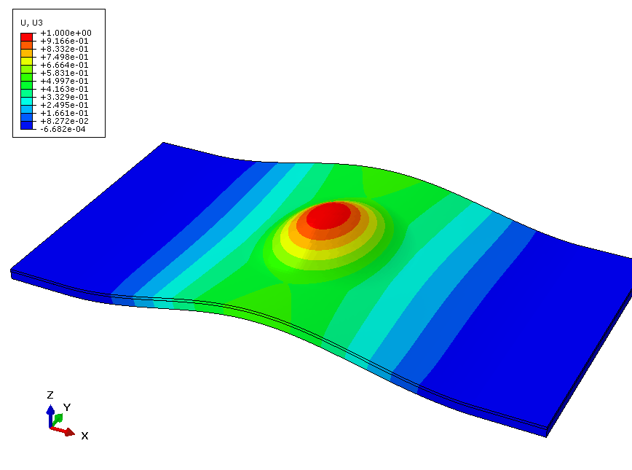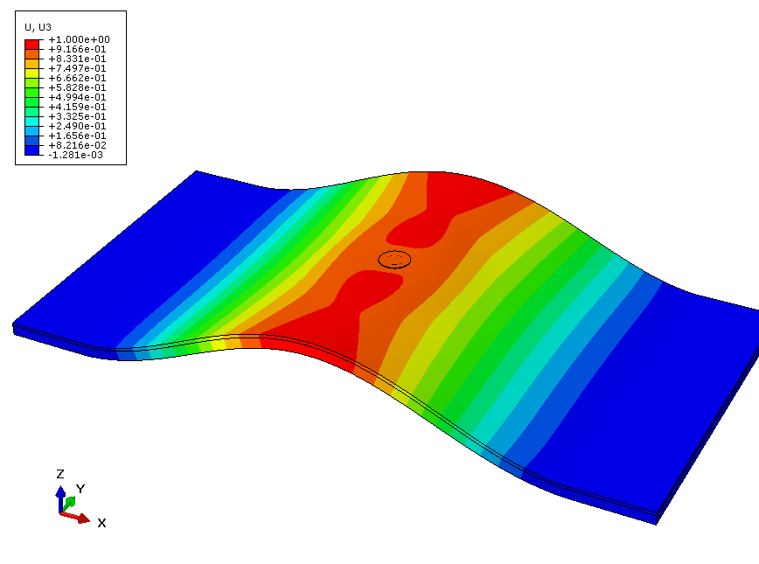

(a) The damaged model (b) The repaired model

Figure 9. The buckling mode of models with Ф60mm delamination located in the 1/4 thickness position.

4. Conclusions
In this paper, the compressive behavior of the delaminated composite laminates and a corresponding quick mechanical repair method have been investigated both experimentally and by numerical calculation method. The results show that the delamination size and though thickness position have an influence on the buckling load and mode and the quick mechanical repair method has an obvious restraining effect on the sub-laminate buckling. The conclusions are summarized as follow.
- The experimental and numerical results show that the buckling load of the repaired specimens is slightly lower than that of the intact specimens, but slightly higher than the damaged specimens.
- With the increase of the delamination size and the decrease of the delamination position in the thickness direction, the buckling load decreases and a mixted buckling mode is easier to occur. For the laminate investigated in this paper, a mixted buckling mode occurs with a delamination size of Ф60mm located in the 1/4 thickness position.
- The recovery rate is highest when a mixted buckling mode occurs for the damaged, and the quick mechanical repair method has an obvious restraining effect on the sub-laminate buckling according to the buckling mode change. The repairing efficiency is neglectable when a global buckling mode occurs for the damaged, of which the delamination is small and deep.

References

[1] Wang XM, Xie FY, Li M, Wang F, and Zhang ZG. Factor Analysis of Delamination in Composite Components Produced By Autoclave Process. National Conference on Composite Materials NCCM-15, Heilongjiang, China, July 24-26 2008.
[2] S. Abrate. Impact on composite structures. Cambridge University Press, 1998.
[3] Zhang AY, Xu HM, and Chen H. Residual strengthevaluation of composite laminates repaired by riveted metal patch. Journal of Mechanical Strength, 38(1):105-109, 2016.
[4] Y. Arman, M. Zor, and S. Aksoy. Determination of critical delamination diameter of laminated composite plates under buckling loads. Compos Sci Technol, 66:2945–2953, 2006.
[5] S. Rajendran, and D. Q. Song. Finite element modelling of delamination buckling of composite panel using Ansys. Proceedings of 2nd Asian ANSYS User Conference, Singapore, Nov 11-13 1998.
[6] Z. Aslan, and M. Sahin. Buckling behavior and compressive failure of composite laminates containing multiple large delaminations. Compos Struct, 89:382–390, 2009.
[7] S. F. Hwang, and G. H. Liu. Buckling behavior of composite laminates with multiple delaminations under uniaxial compression. Compos Struct, 53:235–243, 2001.
[8] S. F. Hwang, and S. M. Huang. Postbuckling behavior of composite laminates with two delaminations under uniaxial compression. Compos Struct, 68:157–165, 2005.
[9] F. Cappello, and D. Tumino. Numerical analysis of composite plates with multiple delaminations subjected to uniaxial buckling load. Compos Sci Technol, 66:264-272, 2006.
[10] Fu HM, and Zhang YB. On the Distribution of Delamination in Composite Structures and Compressive Strength Prediction for Laminates with Embedded Delaminations. Applied Composite Materials, 18(3):253-269, 2011.
[11] Andrew T. Rhead, Richard Butler, and Giles W. Hunt. Compressive strength of composite laminates with delamination-induced interaction of panel and sublaminate buckling modes. Composite Structures, 171:326-334, 2017.
[12] Nie HC, Tan RM, Guo X, and Guan ZD. Tensile performances of mechanically fastened repairs of composite laminates. Journal of Beijing University of Aeronautics and Astronautics, 42(2):319-327, 2016.
[13] Zhao C, and Guo X. Analysis for Compression Performance of Mechanical Connection Repaired Stiffened Composite Panel. Annual Conference of the 15th China Association for Science and Technology, Guizhou, China, May 25-28 2013.
[14] Deng J, Zhou GM, Stephane P. A. Bordas, Xiang C, Cai DA. Numerical evaluation of buckling behavior induced by compression on patch-repaired composites. Composite Structures, 168:582-596, 2017.

