A strategy towards synergy by combining long vertically-aligned carbon nanotubes and graphene in epoxy nanocomposites

Sandeep Kumar ¹, John Owen¹, Stephen C. Hawkins ^{1,2} Brian G. Falzon ¹

¹ School of Mechanical and Aerospace Engineering, Advanced Composite Research Group, Queen’s University Belfast, Ashby Building, Belfast BT9 5AH, UK
² Department of Materials Science and Engineering, Monash University, Clayton,
Victoria 3800, Australia
Email:
sandeep.kumar@qub.ac.uk
J.owens17@qub.ac.uk
stephen.hawkins@qub.ac.uk
b.falzon@qub.ac.uk

Keywords: Carbon nanotubes, Graphene, Dielectric constant and Dynamic mechanical properties

Abstract
In this work, we report the remarkable synergy achieved by combining in-house CNTs, which are grown as highly-aligned ‘forests’ (aspect ratio ~30,000), and are highly dispersible, with graphene, in randomly dispersed epoxy nanocomposites, at low combined wt%. The hybrid CNTs/graphene/epoxy nanocomposites resulted in a significant enhancement in dielectric and mechanical properties. For example, the dielectric constant of the composite with 0.5 wt% hybrid nanofiller (50:50) is 35 times higher than that of the pure epoxy, about 1.8 times higher than that of the epoxy filled with either 0.5wt% graphene or 0.5wt% CNTs separately. In hybrid samples, CNTs bridge graphene particles creating a continuous co-supported network. At such low loadings, these CNTs and CNT-graphene materials become economically feasible for large volume production of nanocomposites. The reported strategy provides an effective route for the development of high-performance multifunctional polymer-based composite materials

1. Introduction

Due to the miniaturization of electronics devices, the demand for polymer nanocomposite materials, with enhanced electrical and thermal properties, has attracted significant interest. Graphene and carbon nanotubes (CNT) have emerged as promising nanostructured fillers for polymer nanocomposites owing to their superior electrical, thermal, optical and mechanical properties. Over the past two decades, most of the work has focused on nanocomposites fabricated by the incorporation of either CNTs or graphene. Recently, the idea of using a hybrid of CNTs and graphene has been explored and it has been demonstrated that a hybrid composition outperforms composites utilizing these nanoparticles separately [1-2]. To date, existing experimental studies have been limited to hybrids of commercially available short length randomly-oriented CNTs ((~20 µm) and graphene or graphene nanoplatelets (GNPs). However, the dispersion and aggregate formation has been identified as a key bottleneck for randomly-oriented CNTs. More importantly, it is often observed that the length of randomly-oriented CNTs reduces to even <500 nm after certain dispersion operations, which may greatly reduce their bridging capability and consequently, potential synergy [3].

We present here the effect of long vertically-aligned mutli-walled carbon nanotubes (V-MWCNTs) /graphene hybrid structure on the dielectric and mechanical performance of the resulting nanocomposite . It was postulated that the addition of highly-aligned CNTs (each individual CNTs dia. ~10 nm and length~ 300 microns) in graphene/epoxy composites may yield continuous conductive pathways and effective stress transfer at relatively low nanoparticle loading.

2. eXPERIMENTAL

2.1. Materials
High performance two component ultra-low viscosity epoxy resin based on diglycidyl ether of bisphenol A (DGEBA) and poly(oxypropylene) diamine was provided by Easy Composites, UK. Graphene, with an average thickness ≤1nm and diameter 0.25-1μm, was obtained from FGV Cambridge Nano-systems, UK. High specification vertically aligned multiwalled-carbon nanotubes (V-MWCNTs) with diameter of 10 nm and a length of 300 microns were produced in-house using a chemical vapour deposition process.
2.2. Epoxy nanocomposites preparation

Epoxy monomer was mechanically stirred in a beaker under ambient conditions using an IKA Eurostar 40 mixer (Turbine blades diameter 30 mm) at a speed of 500 rpm. The appropriate amount of graphene/V-MWCNTs was added, and the mixture stirred over night at a speed of 1000 rpm. The mixture was subsequently subjected to sonication for 5 min (using a Soniprep 150, tapered tip dia. 3mm and amplitude 15 microns) and during sonication the temperature was maintained below 50˚C. The mixture was cooled to 20˚C and the hardener was added and mechanically mixed for about 2-3 mins at 500 rpm followed by degassing to remove the air bubbles. Pure epoxy samples and epoxy nanocomposites filled with different graphene/V-MWCNTs contents and ratios were prepared in a similar manner.

The homogeneous cured samples of desired shapes were obtained by casting the epoxy and epoxy nanocomposites mixtures into customized telfon moulds. The curing profile involves keeping the samples at 25°C for 24 hr followed by 6 hr curing at 60°C. The samples were subsequently demoulded, and kept in air-tight polyethylene bags for further testing’s.

3. Characterization

Dielectric properties were measured with a 4294A Precision Impedance Analyzer (Agilent Technologies Co. Ltd.). Gold electrodes with a diameter of 2 mm and a thickness of 30 nm were sputtered on both sides of the nanocomposite for the electrical measurements. Dynamic mechanical thermal analysis was used to determine the stiffness of samples under a dynamic load, using a Q 800 DMA from TA instruments, in tension mode. The samples were subjected to vibrations, of amplitude 15 μm at a frequency of 1 Hz. The measurements were taken at a heating rate of 5ºC/min at temperatures ranging from 25ºC to 180ºC. Morphological analysis was conducted using a JEOL JSM6500. Cryo-fractured surfaces, were gold coated to observe the extent of dispersion and formation of CNT/graphene hybrid within the epoxy matrix.

4. Results and Discussion

Figure1 shows the plot of dielectric constant for epoxy and epoxy nanocomposites with graphene, V-MWCNT only and V-MWCNTs/graphene hybrids. At a concentration of 0.5 wt.%, the graphene/epoxy and V-MWCNTs/epoxy nanocomposites show a dielectric constant of 118 and 169, respectively, which is an increase of almost 19 and 28 times compared to the epoxy (6.0). These results confirm that CNT and graphene are excellent conductive fillers for epoxy composites at low concentration loadings. The V-MWCNT/graphene/epoxy nanocomposites exhibit even better performance with a dielectric constant of 215, an increase of 35 times over the neat epoxy. This is attributed to the increased specific surface area of the CNT/graphene hybrid filler, which results in an increase in interfacial polarization density between the hybrid filler and the epoxy matrix.

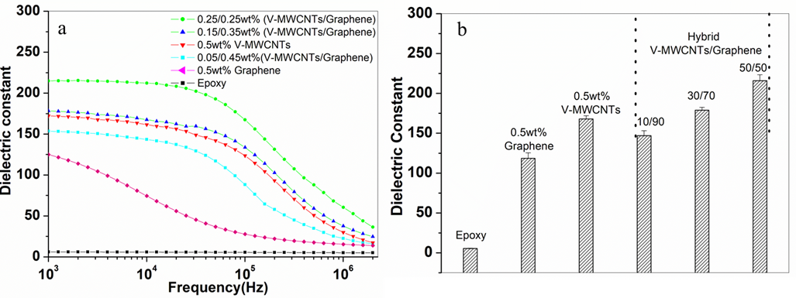

Figure 1. (a) Spectra of dielectric constant of epoxy and epoxy nanocomposites as function of applied frequency (b) dielectric constant average values with standard deviation

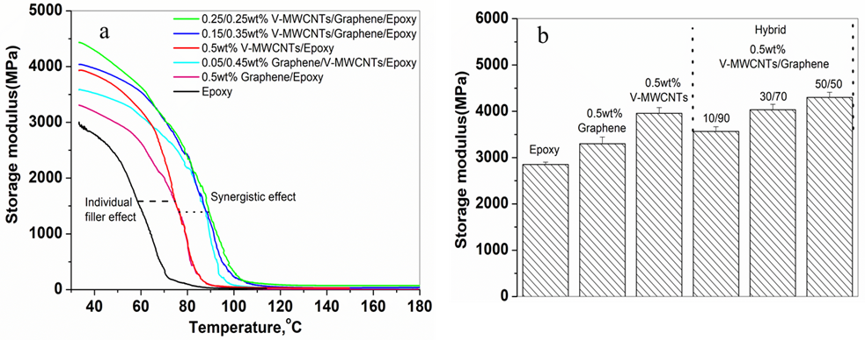

Figure 2: (a) Dynamic mechanical analysis of epoxy composites prepared with single and hybrid fillers and (b) storage modulus average values with standard deviation

The effect of temperature on the storage modulus, E', of epoxy, graphene/epoxy, V-MWCNTs/epoxy and V-MWCNTs/Graphene/epoxy composites at different loadings is depicted in Figure 2. As can be seen, epoxy composites containing graphene (0.5 wt%) and V-MWCNTs (0.5 wt%) alone showed 15.7% and 38% improvement, respectively, as compared to that of epoxy, but the composite containing hybrid fillers, V-MWCNT/graphene (0.25/0.25 wt%), showed a 50% improvement compared to the epoxy. This synergistic increase in storage modulus further suggests an interaction between graphene and CNTs, which results in good dispersion of graphene and CNTs in the presence of one another.
.
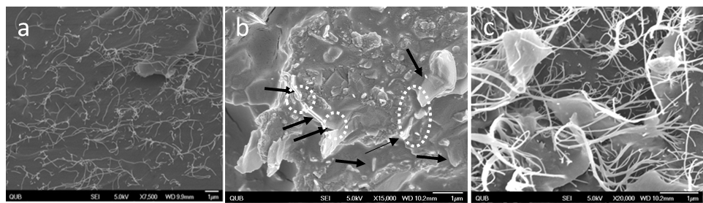

Figure 3. SEM image of epoxy nanocomposites at 0.5 wt% loading of (a) V-MWCNTs, (b) graphene and (c) V-MWCNTs/graphene hybrid (0.25/0.25wt% (50:50) )

Figure 3(a&b) clearly reflects that CNTs and graphene are well dispersed and formed well connected network within the epoxy. For the hybrid epoxy nanocomposites, it can be seen from Figure 3(c) that CNTs formed conducting channels between graphene, thus reducing the gap between graphene to facilitate the electrical and thermal transport.

5. Conclusion

Composite films,composed of graphene/epoxy, V-MWCNTs/epoxy and V MWCNTs/graphene/epoxy were fabricated and their dielectric and mechanical performance was investigated. Compared with the binary composites, the dielectric constant and storage modulus acheived for the hybrid filler (V-MWCNTs/graphene)/epoxy composites was significantly higher.

Acknowledgments
This work was supported by the UK Engineering and Physical Sciences Research Council (EPRSC) grant EP/N007190/1.

References
- A.Yu, P.Ramesh, X.Sun, E.Bekyarova, M.E. Itkis, and R.C. Haddon, Enhanced Thermal Conductivity in a Hybrid Graphite Nanoplatelet– Carbon Nanotube Filler for Epoxy Composites. Adv. Mater.20: 4740–4744,2008
- S. Chatterjee, F. Nafezarefi , N.H. Tai , L. Schlagenhauf, F.A. Nuesch ,B.T.T. Chu.Size and synergy effects of nanofiller hybrids including graphene nanoplatelets and carbon nanotubes in mechanical properties of epoxy composites. Carbon, 50:5380,2012
- M.Safdari, M.S. Al-Haik. Synergistic electrical and thermal transport properties of hybrid polymeric nanocomposites based on carbon nanotubes and graphite nanoplatelets. Carbon, 64:111-121,2013

