PREDICTION OF STATISTICAL CREEP FAILURE TIME FOR UNIDIRECTIONAL CFRP

Yasushi Miyano¹ and Masayuki Nakada²

^{1,2}Materials System Research Laboratory, Kanazawa Institute of Technology
3-1 Yatsukaho Hakusan 924-0838, Japan
¹Email: miyano@neptune.kanazawa-it.ac.jp, ²Email: nakada@neptune.kanazawa-it.ac.jp,
^{1,2}Web Page: http://wwwr.kanazawa-it.ac.jp/MSRL/

Keywords: CFRP, Bending load, Creep failure time, Life prediction, Viscoelasticity

Abstract
This paper is concerned with the statistical prediction of flexural creep failure time in the longitudinal direction of unidirectional CFRP based on the viscoelasticity of matrix resin. The flexural creep failure time of unidirectional CFRP was predicted statistically using the flexural static strengths measured at various temperatures and viscoelastic behavior of matrix resin. Then the flexural creep failure times of unidirectional CFRP at a constant load and temperature were measured experimentally for comparison with the predicted ones. Furthermore, the characteristics of statistical flexural creep failure time of unidirectional CFRP were compared with that of statistical tensile creep failure time of unidirectional CFRP which were already obtained in the previous paper.

1. Introduction

Carbon fiber reinforced plastics (CFRP) has been used for the primary structures of airplanes, ships, automobiles and others, in which the high reliability should be kept during the long-term operation. Therefore, it is strongly expected that the accelerated testing methodology for the long-term life prediction of CFRP structures exposed under the actual environmental temperature, water and others will be established.

The mechanical behavior of matrix resin of CFRP exhibits time and temperature dependence, called viscoelastic behavior, not only above the glass transition temperature T_{g} but also below T_{g}. Thus, it can be presumed that the mechanical behavior of CFRP significantly depends on time and temperature [1-6]. We have proposed the formulation for the statistical static strength of CFRP based on the viscoelasticity of matrix resin in our previous papers [7, 8].

The tensile strength along the longitudinal direction of unidirectional CFRP constitutes important and basic data for the reliable design of CFRP structures. Our most recent study undertook the prediction of statistical creep failure time under tension loading along the longitudinal direction of unidirectional CFRP. The statistical creep failure time of unidirectional CFRP at a constant load and temperature was predicted using the statistical results of tensile static strengths of unidirectional CFRP measured at various temperatures and the viscoelastic behavior of matrix resin. The predicted results quantitatively agree well with the experimentally obtained results measured using creep tests for unidirectional CFRP [9].

This paper is concerned with the statistical prediction of flexural creep failure time in the longitudinal direction of unidirectional CFRP laminates based on the viscoelasticity of matrix resin. The flexural creep failure time of unidirectional CFRP laminates is predicted statistically using the flexural static strengths measured at various temperatures and viscoelastic behavior of matrix resin. Then the flexural creep failure times of unidirectional CFRP laminates at a constant load and temperature are measured experimentally and statistically using CFRP laminates for comparison with the predicted ones.

2. Statistical Prediction of Creep Failure Time of Unidirectional CFRP

We have proposed the formulation for the statistical static strength _{s} of CFRP based on the viscoelasticity of matrix resin as shown in the following equation in our previous paper [8],
$$\text{log}σ_{s}(P_{f},t,T)=\text{log}σ_{0}(t_{0},T_{0})+\frac{1}{α}\text{log}[−\text{ln}(1−P_{f})]−n_{R}\text{log}\left[\frac{D^{}(t,T)}{D_{c}(t_{0},T_{0})}\right]$$ | (1)
where, P_{f} is the failure probability, t is the failure time, t₀ is the reference time, T is the temperature, T₀ is the reference temperature, σ₀ and α are the scale parameter and the shape parameter on Weibull distribution of static strength, n_{R} is the viscoelastic parameter determined through the relationship between the static strengths of CFRP and the viscoelastic compliance D* of matrix resin at the same time and temperature. The viscoelastic compliance D* of matrix resin to be defined by the compliance for a constant strain rate is shown by the following equation for the creep compliance D_{c} of matrix resin.
$$D∗\left(t,T\right)=D_{c}(t/2,T)$$ | (2)
The statistical creep strength σ_{c} can be determined by shifting the master curve of static strength with log A based on Christensen’s theory for viscoelastic crack kinetics [10]. Therefore, the master curve of creep strength can be shown by the following equation,
$$\text{log}σ_{c}(P_{f},t,T)=\text{log}σ_{0}(t_{0},T_{0})+\frac{1}{α}\text{log}[−\text{ln}(1−P_{f})]−n_{R}\text{log}\left[\frac{D^{}(\text{At},T)}{D_{c}(t_{0},T_{0})}\right]$$ | (3)
where the shifting amount log A determined by the slope of the static strength–failure time curve is shown by the following equation.
$\text{log}A=\text{log}(1+1/{k_{R}})$ $k_{R}=n_{R}m_{R}$ | (4)
where m_{R} is the slope of creep compliance of matrix resin against time. The failure probability of CFRP under creep load with a constant stress can be shown by the following equation from Eq.3.
$P_{f}=1−\text{exp}\left(−F\right)$, $\text{log}F=α\text{log}\left[\frac{σ_{c}}{σ_{0}}\right]+{αn}_{R}\text{log}\left[\frac{D_{c}({\text{At}}/2,T_{0})}{D_{c}(t_{0},T_{0})}\right]$ | (5)

3. Experimental Procedures

Unidirectional CFRP laminates which consists of T800-12000 (Toray Industries Inc.) and a general purpose epoxy resin jER828 (Mitsubishi Chemical Corp.) was molded by the filament winding using flat plate mandrel and resin transfer molding method. The fiber volume fraction V_{f} of CFRP laminates is approximately 55%. Molding condition of CFRP laminates is shown in Table 1. The glass transition temperature T_{g} is 130ºC for the epoxy resin used.

The static and creep tests for the fiber direction of unidirectional CFRP laminates were conducted by three point bending according with ISO14125. In the test, cushion material made of aluminum foil is used to prevent localized destruction due to stress concentration at the loading point. Three point bending test method for static and creep tests is shown in Fig.1.

For the static bending tests, the test temperatures were 25°C, 120°C and 135°C, and cross-head speed was 2mm/min. For the creep failure tests, the test temperature was 120 ºC, and the applied creep stress was 791MPa which is 41% of the static strength at 25ºC. The fiber volume fraction V_{f} and the glass transition temperature T_{g} of CFRP laminates were scattered. Then both of the flexural static strengths and the flexural creep failure times measured experimentally were corrected for the influences of V_{f} and T_{g}.

Table 1. Composition and cure schedule of CFRP laminates.
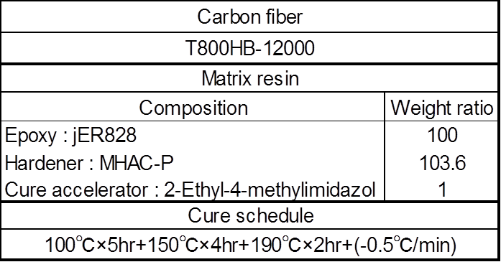

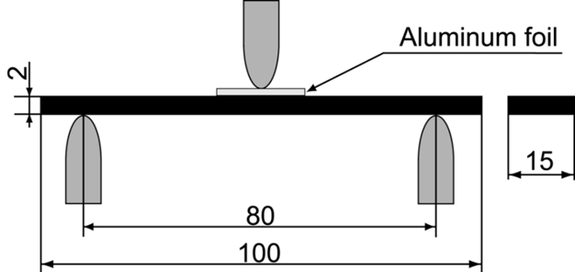
Figure 1. Specimen configuration and three point bending static and creep tests.

4. Results and Discussion

4.1. Creep Compliance of Matrix Resin

Non dimensional creep compliance of matrix resin at 120ºC is shown in Fig.2. T_{g} is 130ºC for matrix resin. The creep compliance of matrix resin D_{c} was measured at various temperatures as shown by the left side of this figure and the smooth master curve of creep compliance at T = 120ºC is determined by shifting horizontally these curves at various temperatures based on the time-temperature superposition principle as shown by the right side of this figure. The viscoelastic compliance D* under a constant strain rate loading can be obtained by shifting D_{c} horizontally in the amount of log 2 from Eq.2. The slope of creep compliance of matrix resin m_{R} can be obtained as shown in this figure.
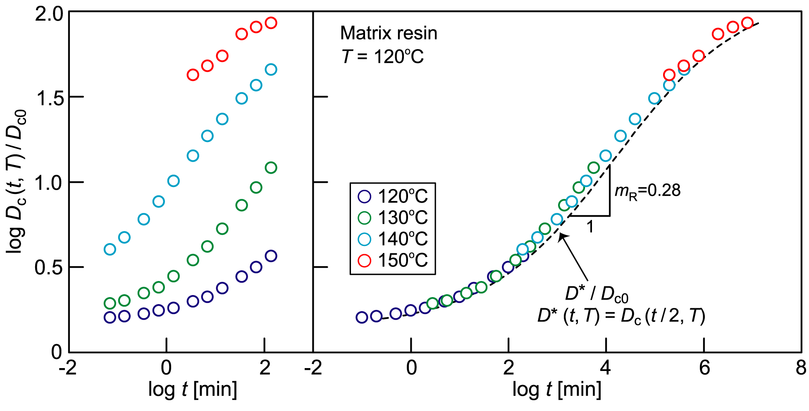
Figure 2. Dimensionless creep compliance of matrix resin at T=120°C.

4.2. Flexural Static Strengths of CFRP Laminates

The flexural static strengths of CFRP laminates measured at various temperatures are shown in Fig.3. The flexural static strength decreases remarkably with increasing temperature. The Weibull distributions of the static strength of CFRP laminates at four temperatures are shown in Fig.4. The shape parameter α_{s} and the scale parameter β_{s} on Weibull distribution of static strength are shown in the table in this figure. It is cleared from this figure that the shape parameter keeps almost a constant for different temperatures and the scale parameter decreases remarkably with increasing temperature.

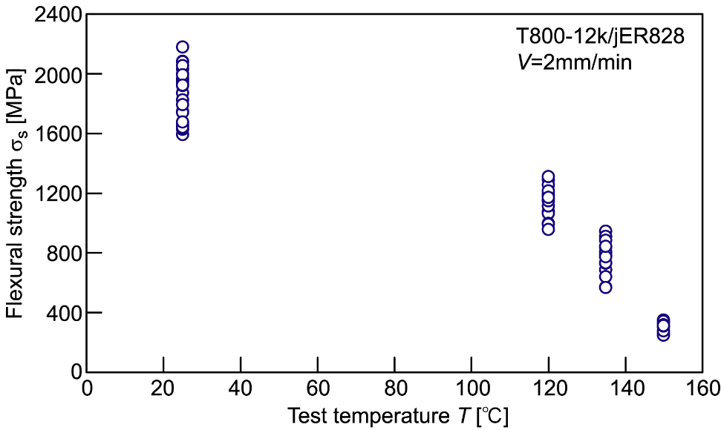

Figure 3. Flexural static strengths of unidirectional CFRP laminates versus temperature.

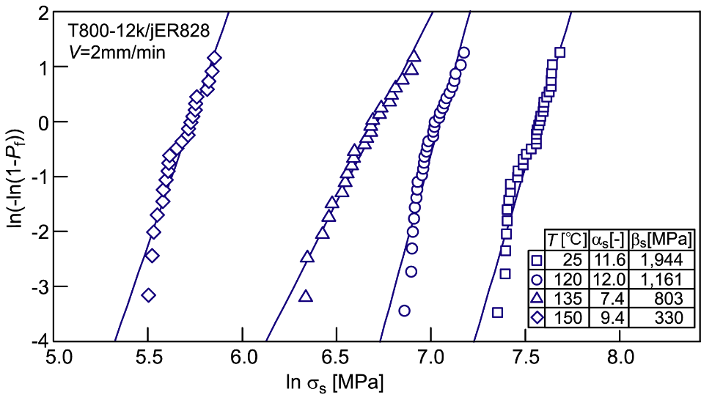

Figure 4. Weibull distributions of flexural static strengths of

unidirectional CFRP laminates at various temperatures.

4.3. Flexural Strength of CFRP Laminates versus Viscoelastic Compliance of Matrix Resin

The static strength of CFRP σ_{s}/σ₀ versus the viscoelastic compliance of matrix resin D*/D_{c0} at the corresponding same condition of time and temperature is shown in Fig.5. The static strength of CFRP laminates decreases linearly with increasing the viscoelastic compliance of matrix resin below 135ºC. The viscoelastic parameter n_{R} can be determined by least square fitting. The slope of fitting line n_{R}=0.652, which is the viscoelastic parameter in Eq.1.

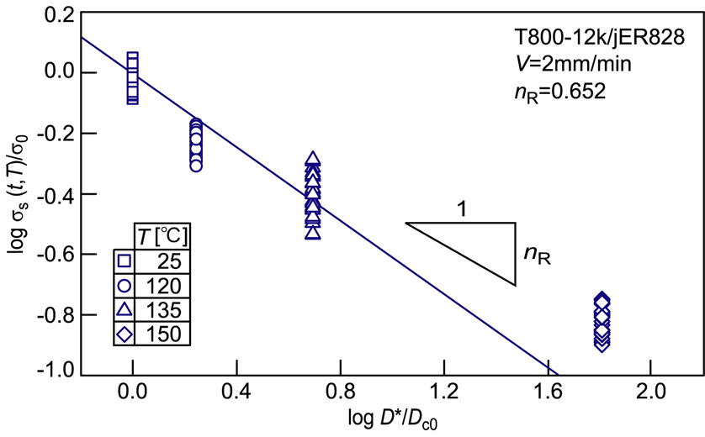
Figure 5. Statistical static strength of CFRP laminates against
viscoelastic compliance of matrix resin.

4.4. Statistical Creep Failure Time of CFRP Laminates

The upper and lower sides of Fig.6 shows the experimental and predicted results for the flexural creep strength and failure probability against creep failure time, respectively. The predicted statistical creep failure time agrees well with the experimental data with the exception of long time range. Figure 7 shows the results for the tensile creep failure time obtained by our previous paper [9]. From Figs.6 and 7, it is cleared that the statistical creep failure time of unidirectional CFRP under bending load as well as the tension load can be predicted by substituting the statistical static strength of CFRP measured at various temperatures and the viscoelastic compliance of matrix resin into Eqs.3 and 5.

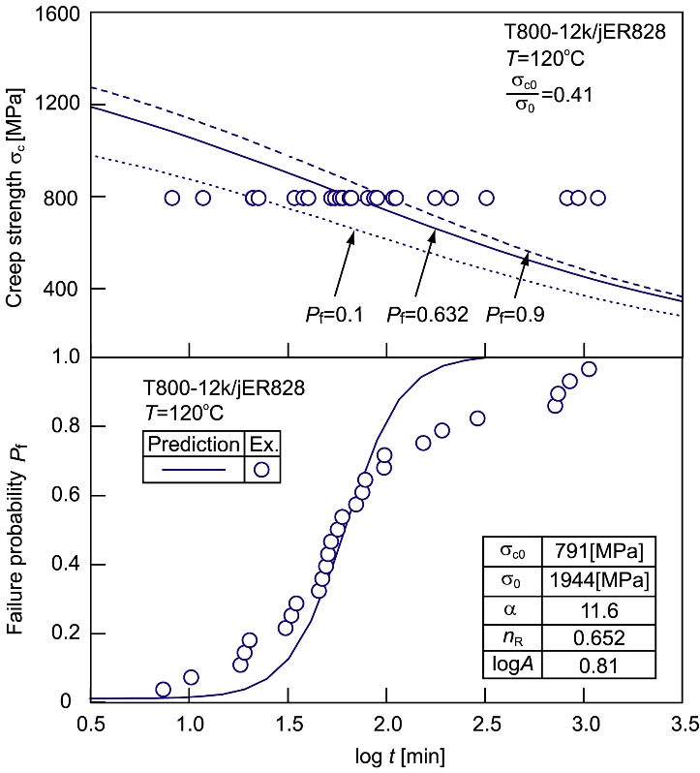
Figure 6. Flexural creep strength and failure probability against creep failure time.

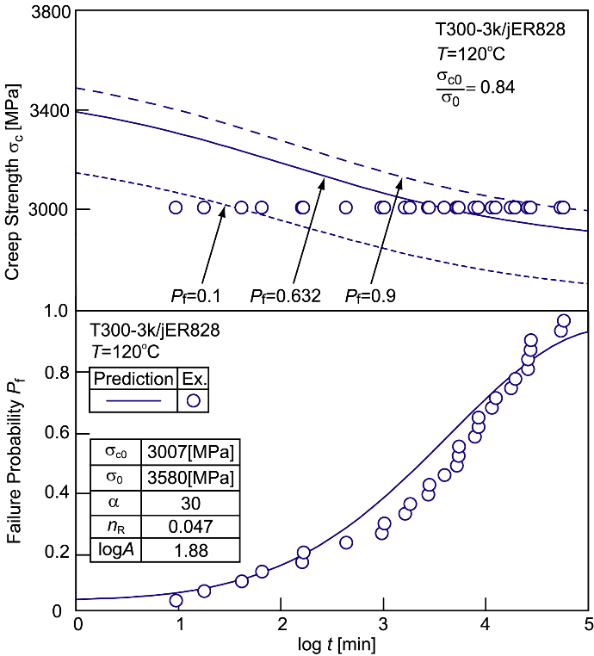
Figure 7. Tensile creep strength and failure probability against creep failure time.

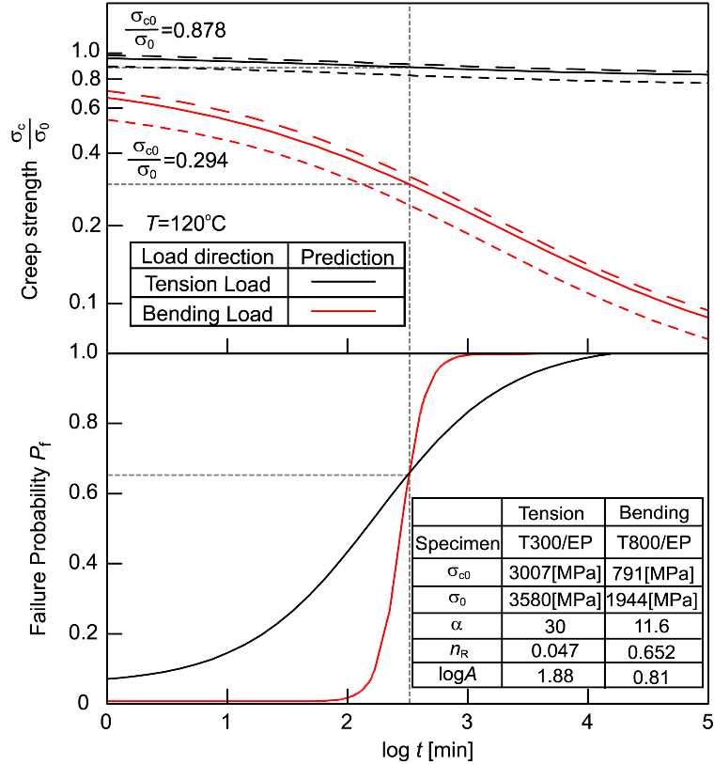
Figure 8. Comparison of two master curves for flexural and tensile creep strengths
against creep failure time.

The upper side of Fig.8 shows the comparison of two master curves for the flexural and tensile creep strengths against creep failure time and the lower side of this figure shows the comparison of two probabilities against creep failure time under tension and bending loads, respectively. It is cleared from this figure that the scale parameter of tensile creep strength σ_{c} at t = 10^{2.5}min (=316min =5.3hour) at T = 120ºC keeps 87.8% of that at the reference time t = 1min at the reference temperature T = 25 ºC and that the scale parameter of flexural creep strength σ_{c} at the same condition decreases drastically to 29.4% of that at the reference time and temperature. On the other hand, the scatter of creep failure time under the tension load is clearly larger than that under bending load, although the scatter for the tensile strength is smaller than that for the flexural strength because the shape parameter α for the tensile strength is larger than that for the flexural strength. The reason why is the tensile creep strength decreases scarcely with increasing time and the flexural creep strength decreases remakably with increasing time.

5. Conclusions

The creep failure times of unidirectional CFRP laminates under a constant bending load and temperature were predicted based on our proposed methodology using the statistical flexural static strength for CFRP laminates measured at various temperatures and the viscoelasticity for matrix resin and compared with the experimental data measured by creep tests. As results, the predicted ones agree well with the experimental data. Therefore, the long term flexural creep failure time can be statistically predicted by using the statistical flexural static strengths at various temperatures based on the viscoelasticity of matrix resin. Futheremore, it is cleared that the flexural creep strength decreases drastically with increasing time and temperature comparing with the tensile creep strength.

Acknowledgements

This work was supported by Office of Naval Research (ONR) and US Air Force Office of Scientific Research (AFOSR) / Asian Office of Aerospace R & D (AOARD). The authors thank Dr. Yapa Rajapakse (ONR), Dr. Ming-Jeng Pan (ONR), Dr. Scott Robertson (AOARD) and Dr. Jeremy Knopp (AOARD). The authors thank Professor Richard Christensen of Stanford University as a consultant on ONR project.

References

[1] J. Aboudi and G. Cederbaum. Analysis of Viscoelastic Laminated Composite Plates. Composite Structures, 12:243–256, 1989.
[2] T. Gates. Experimental Characterization of Nonlinear, Rate Dependent Behavior in Advanced Polymer Matrix Composites. Experimental Mechanics, 32:68–73, 1992.
[3] Y. Miyano, M. Kanemitsu, T. Kunio and H. Kuhn. Role of Matrix Resin on Fracture Strengths of Unidirectional CFRP. Journal of Composite Materials, 20:520–538, 1986.
[4] Y. Miyano, M. K. McMurray, J. Enyama and M. Nakada. Loading Rate and Temperature Dependence on Flexural Fatigue Behavior of a Satin Woven CFRP laminate. Journal of Composite Materials, 28:1250–1260, 1994.
[5] Y. Miyano, M. Nakada, M. K. McMurray and R. Muki. Prediction of Flexural Fatigue Strength of CFRP Composites under Arbitrary Frequency, Stress Ratio and Temperature. Journal of Composite Materials, 31:619–638, 1997.
[6] J. Sullivan. Creep and Physical Aging of Composites. Composite Science and Technology, 39:207–232, 1990.
[7] Y. Miyano, M. Nakada and H. Cai. Formulation of Long-term Creep and Fatigue Strengths of Polymer Composites Based on Accelerated Testing Methodology. Journal of Composite Materials, 42:1897-1919, 2008.
[8] M. Nakada and Y. Miyano. Advanced Accelerated Testing Methodology for Long-Term Life Prediction of CFRP Laminates. Journal of Composite Materials, 49:163-175, 2015.
[9] M. Nakada and Y. Miyano. Statistical Creep Failure Time of Unidirectional CFRP. Experimental Mechanic, 56:653-658, 2016.
[10] R. Christensen and Y. Miyano. Stress Intensity Controlled Kinetic Crack Growth and Stress History Dependent Life Prediction with Statistical Variability. International Journal of Fracture, 137:77-87, 2006.

