Short fibre reinforced thermoplastics – a novel standard to determine material parameters under tension, pressure, shear and mixed loadings

Kim Kose¹, Matthias DeMonte², Dominik Spancken³, Volker Trappe⁴ and Andreas Zeiser⁵

¹inpro, Steinplatz 2, 10623 Berlin, Germany
Email: kim.kose@inpro.de, Web Page: www.inpro.de
²Robert Bosch GmbH, Robert-Bosch-Campus 1, 71272 Renningen, Germany
Email: matthias.demonte@de.bosch.com, Web Page: www.bosch.com
³Fraunhofer LBF, Bartningstr. 47, 64289 Darmstadt, Germany
Email: dominik.spancken@lbf.fraunhofer.de, Web Page: www.lbf.fraunhofer.de
⁴Bundesanstalt für Materialforschung und -prüfung (BAM), Unter den Eichen 87, 12205 Berlin, Germany, Email: volker.trappe@inpro.de, Web Page: www.bam.de
²Hochschule für Technik und Wirtschaft (HTW) Berlin, Wilhelminenhofstr. 75 A, 12459 Berlin, Germany, Email: andreas.zeiser@htw-berlin.de, Web Page: www.htw-berlin.com

Keywords: short fibre reinforced polymer, testing, fatigue, strength, fracture

Abstract
Short fibre reinforced plastics (SFRP) show anisotropic material behavior depending on the manufacturing process. Test specimens which make a combination of tensile, compressive and shear loads feasible can provide a big improvement in determining the elasticities, strengths and fatigue stiffness needed for material models. Tubular specimens have the advantage of high geometric stability under compression and torsional load, so that characteristic values can also be determined without buckling supports. With these test specimens a shear load is realized with a torsional deformation. In addition, these test specimens are well-suited for measuring the fatigue strength under uniaxial as well as combined bi-axial stress for all technically relevant load conditions. However, up until now there is no comprehensive standard for tubular test specimens, their form, and the tests to be performed with them with respect to material parameters. The new DIN SPEC 16457 "Short fiber reinforced thermoplastics — tensile-compression shear testing on tubular test specimens with alternating load", which is to be released in 2018, builds on the results of different prior research projects. This paper discusses the features and stress results of the test specimens described in the DIN SPEC 16457.

1. Introduction

SFRPs provide excellent possibilities to combine lightweight with functional integration. This is especially important for the in the cost sensitive car industry. However, with a wider use of this class of materials even for semi-structural purposes the need for reliable material data and a common understanding how to obtain them arises. Among the basic values needed are stiffness and fatigue strengths for tension, shear and compression. Currently only the DIN EN ISO 527 “Plastics - Determination of tensile properties” covers material data for general injection molding polymers. Additionally, fatigue properties have been historically only a concern for infinite i.e. long fibre reinforced polymers used in the aircraft industry. In the automotive industry the main interest is on polymer applications for complex shaped parts often in combination with complex load paths. Different to metals SFRPs are not isotropic and their behaviour under tensional loading differs to compression. The DIN SPEC 16457 "Short fiber reinforced thermoplastics — tensile-compression shear testing on tubular test specimens with alternating load" which is due to be published in 2018 and will be made available free of charge closes this gap for fatigue and strength test in tensile, shear and compression including the definition of test specimens, test procedures and evaluation methods.

2. Tubular Test Specimens

Tubular specimens can come in a variety of forms. Here two fundamentally different forms are discussed. One is a test specimen with constant radius and constant wall thickness in the measuring section (here called type inpro) and the other a specimen with a double-curved surface outside the clamping region (here called type Bosch), see Figure 1.

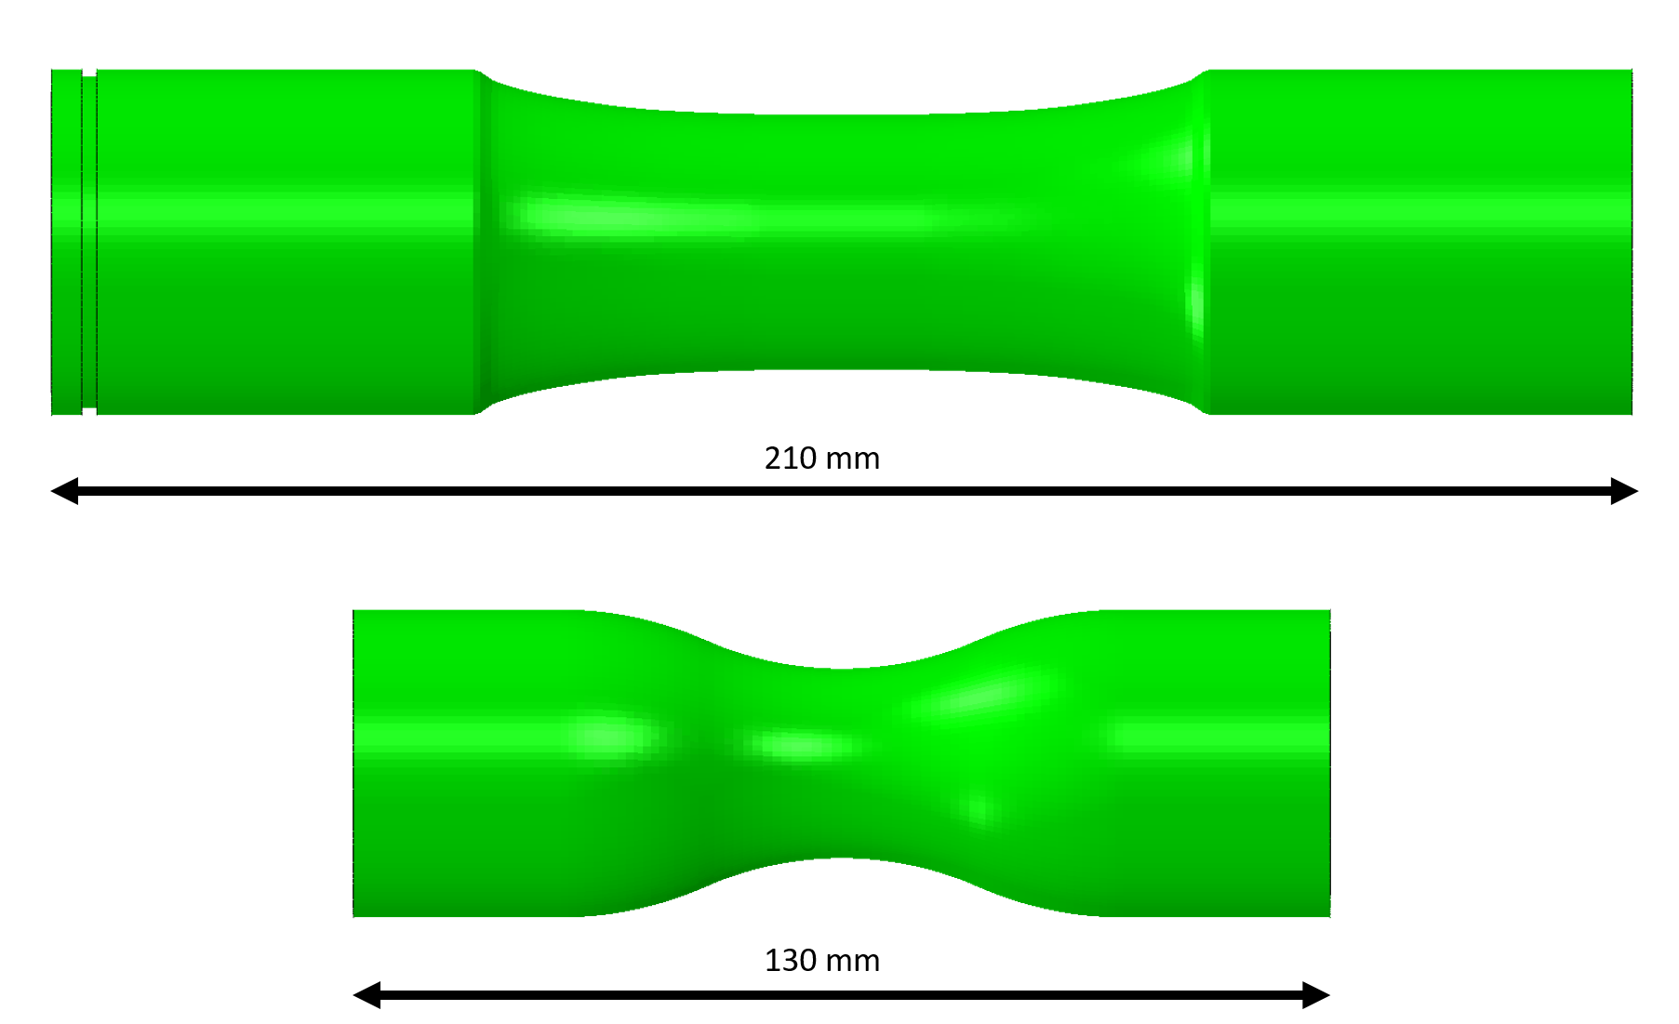

Figure 1. Two different tubular test specimens for determining material parameters of SFRPs, type inpro (upper) and type Bosch (lower).

Both designs are suited for material tests such as strength, fatigue or creep under tensile, compression and shear stress, the latter being applied via torsion of the samples. In addition, any combination of these loads can be used.

The design for the tubular test specimen of type inpro was guided by a high fibre orientation in the measuring section making it comparable to flat tensile tests specimens while retaining a high buckling strength. Additionally, the measuring section is designed to be the section where the first failure occurs. The design for the tubular test specimen type Bosch was guided by maximum geometric stability thus making the specimen also useful for tests with pressure loadings, constant wall thickness and manufacturability.

2.1. Stress Patterns

Both types show distinct stress patterns even if isotropic material properties are assumed. When evaluating measurement results these stress patterns are to be taken into consideration. Characteristic for tubular specimens, under every load the stress on the outside is lower than on the inner side of the specimens, this is in part due to the difference of the circumferential length. Assuming an isotropic material with E=6650 MPa and υ= 0.3 the stress difference is less than 3% for the type inpro and about 8% for the type Bosch test specimen, see Figure 2.

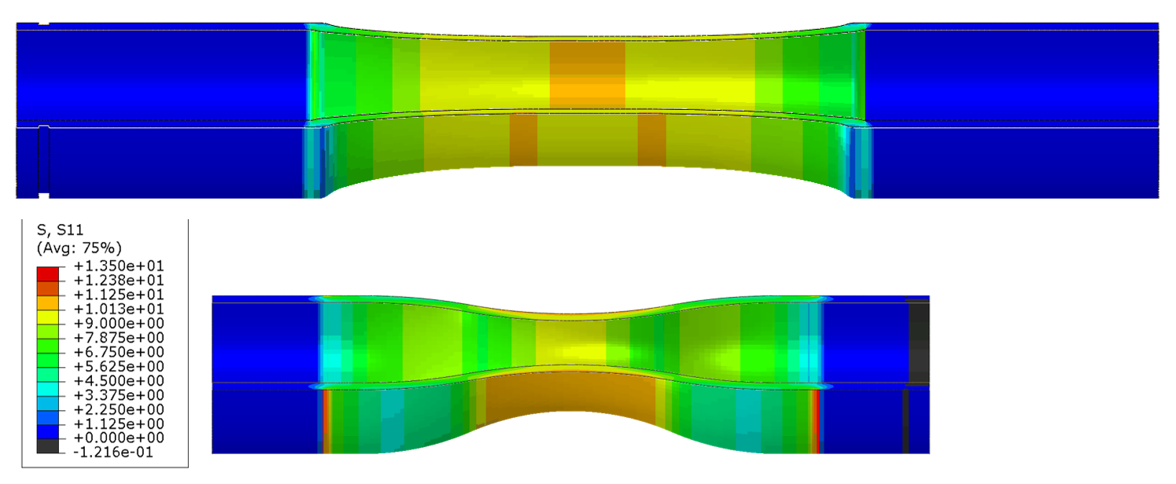

Figure 2. Stress results in longitudinal direction under 10 MPa longitudinal load in smallest diameter, type inpro (upper) and type Bosch (lower).

Figure 3 shows the S22 stresses resulting from the same longitudinal load. These are up to 3 MPa for the type Bosch specimen and nil for the Type inpro specimen. For the specimen type Bosch this is since it is double curved everywhere. All other stresses are insignificant under torsional loading.

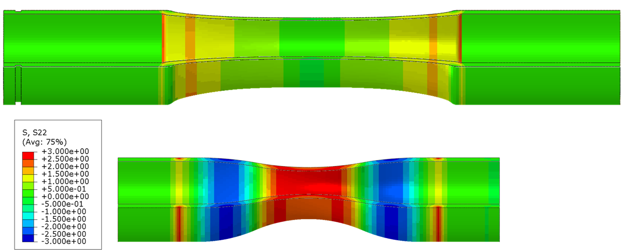

Figure 3. Stress results in S22 direction (hoop stress) under 10 MPa longitudinal load in smallest diameter, type inpro (upper) and type Bosch (lower).

In the case of torsional loading on the tubular specimens S12 shear stresses in material ensue. In this case there are no interfering stresses in both specimen types. The errors are plenty.

2.2. Fatigue and Fracture

While the test specimens according to DIN SPEC 16457 are also suitable for static tests, the standard focuses on fatigue tests. Collapse through fracture in semi static tests is very close to first failure through buckling for both types, Figure 4 shows exemplarily PA6GF30 inpro specimens under tension and compression loads with first cracks appearing in the measuring section. Together the combined slopes give a continuous curve, with failure at nearly the same load amount (27,5 kN under tension vs. 31,7 kN under compression).

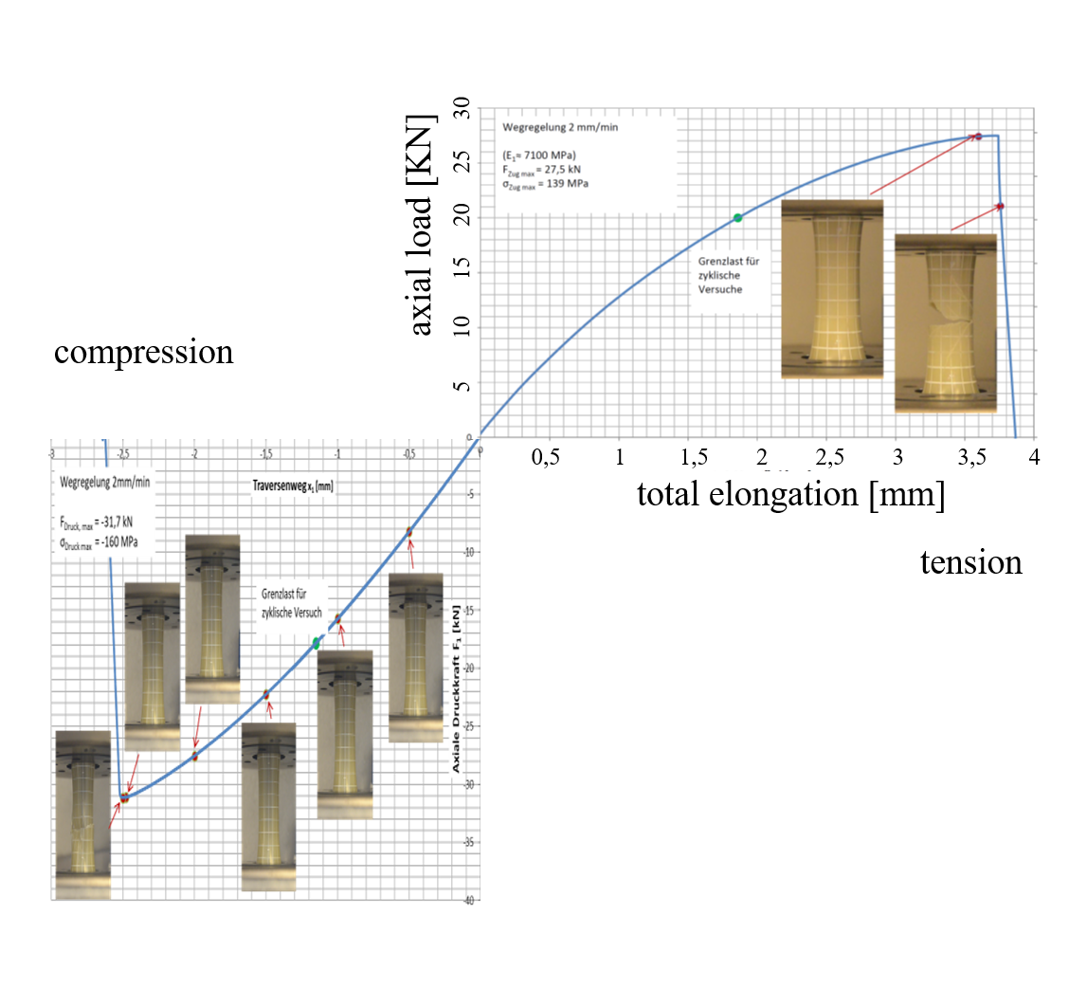

Figure 4. Tension and compression loads on specimen type inpro.

Although both specimen types differ considerably in between them their failure modes and locations are the same. Cracks always start in the middle sections.

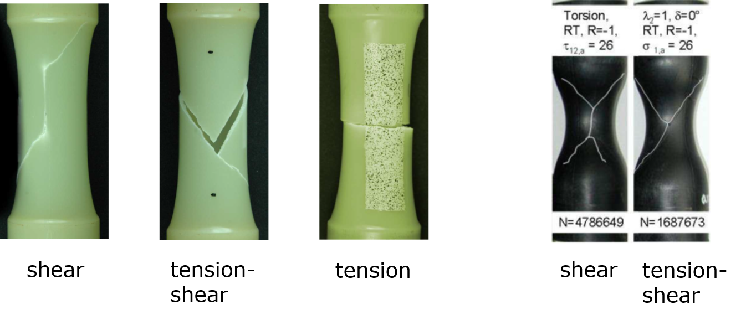

Figure 5. Failure modes in fatigue tests.

These cracks are shown in Figure 5 for various loads with R=-1. The left samples are made of PA6GF30 the black right ones of PA66GF35 material.

2.3. DIN SPEC 16457 - Scope and Content

The new norm not only covers the description of the test specimens but also the test equipment needed and how to perform tests with them properly. The latter point is extremely important for meaningful results as most thermoplastics are quite sensitive to humidity and temperature. In addition to this the inspection of the tests specimens prior to testing is described because the results must be interpreted with taking the fibre orientation into account. Finally, a big part of the norm is on the statistics needed to produce a correct S/N-curve.

3. Conclusions

In the upcoming DIN SPEC 16547 two significantly different tubular test specimens for fatigue and strength tests of short fibre reinforced thermoplastics are described. They are suitable for testing of strengths and fatigue properties under tensile, compressive and shear loads and fulfill longstanding needs for testing any combination between these loads. It has been shown that both types provide reliable data useful for industrial applications.

Acknowledgments

The authors would like to thank the DIN and especially Ms. Dr. Stoelzel.

References

[1] K. Metzkes, V. Trappe: „ Short Fibre Polyamide Under Combined Shear and Tensile Loading: A Non-Destructive Evaluation of Micro Damage Evolution”, Proceedings of the 20th International Conference on Composite Materials ICCM-20, Copenhagen, Denmark, July 19-24, 2015
[2] M. De Monte, E. Moosbrugger, K. Jaschek, M. Quaresimin, “Multiaxial fatigue of a short glass fibre reinforced polyamide 6.6 – fatigue and fracture behaviour”, Int. J. Fatigue, 2010, 32(1): 17-28
[3] K. Kose, A. Zeiser, „On the Problem of Generating Reliable Material Data of SFRPs for Structural Simulations”, Proceedings of the 15th European Conference on Composite Materials ECCM-15, Venice, Italy, 24-28 June 2012

