Instabilities due to Strain-Softening Solved using the SPH Method

Nenad Djordjevic¹, Rade Vignjevic¹, Tom De Vuyst¹, Simone Gemkow²

¹Dynamic Response Group, Structural Integrity Theme, Brunel University London, Kingston Lane Uxbridge, UB8 3PH, United Kingdom
Email: nenad.djordjevic@brunel.ac.uk
² Cranfield University, Cranfield, Bedfordshire MK43 0AL, United Kingdom

Keywords: nonlocal regularisation, continuum damage models, composites, SPH

Abstract

The local continuum damage models used with the quasi brittle materials can lead to strain softening and an ill-posed boundary value problem, when the character of governing partial differtial equations changes locally, leading to a mesh sensitive numerical instability. This work primarily considered the strain softening effects in the SPH spatial discretization, combined with a local continuum damage model, which had been observed to lead to the instabilities in the classic FEM [1]. Simulation programme presented in here conists of analysis of an one dimensional wave propagation problem that was analytically solved by Bažant in [2] and a cube high velocity impact on a flat quasi brittle panel. The first set of results demonstrate that width of the strain softening region in the SPH is controlled by the smoothing length rather than discretisation density, which means that the SPH method is inherently non-local and suggests that the SPH smoothing length should be linked to the material characteristic length scale in solid mechanics simulations. The second set of results demonstrates that the SPH provides stable and satisfactory solutions for a high velocity impact case, which will be used for further validation of the numerical tools developed within the project EXTREME.

1. Introduction

When mechanical properties degradation due to damage in a quasi brittle material is implemented in a numerical code as a local continuum damage mechanics (CDM) model, it can result in strain softening behaviour and lead to an ill posed boundary value problem. A typical example is a local CDM model implemented in a FEM solver, where the local governing hyperbolic differential equations, that describe a dynamic problem become elliptic, and cannot interact with the remaining of the material, leading to numerical instability. This instability is mesh-sensitive and manifests itself as non-physical deformation of the softening continuum (due to deformation localisation, infinite number of bifurcated branches and post-bifurcation mesh dependency issues). This problem is typically addressed in the FEM using a nonlocal approach, with a characteristic length scale added to CDM models, which maintains the character of the governing equations in the material softening deformation regime. The characteristic length scale can be defined either in the form of spatial gradients or integral nonlocal terms.

The purpose of this investigation was to establish if Smoothed Particle Hydrodynamics (SPH) is by nature a nonlocal method capable of overcoming difficulties related to material softening without any additional regularisation measures. The SPH [3]-[6] is a meshless particle method which does not require a structured grid. The motion of the continuum is approximated by motion of discrete material points (particles) with no fixed connectivity. Interaction of particles is defined by a weighting (smoothing) function, where the smoothing length (size of the smoothing function domain) defines the range of influence of an individual particle.

This paper consists of four sections. Following the introduction, local and nonlocal analytical solutions for dynamic strain softening problem are outlined in Section 2. The SPH method and simulation results are described in Section 3, with the summary of the ongoing work presented in Section 4.

2. Analytic Solution for Dynamic Strain Softening Problem

One dimensional stress wave propagation problem solved by Bažant and Belytschko [2] is shown in Figure 1. The problem is long bar, symmetrically loaded at both ends with a constant velocity . In the original paper, material behaviour of the bar was determined by stress strain relationship illustrated in Figure 1b), where the softening zone between Point P and Point F, is characterised with a negative slope and elastic unloading/reloading law. The loading defined in Figure 1 generates two tensile step stress waves, which propagate towards the midsection of the bar (), where they are superposed at time . Superposition of the strain waves in the midsection of the bar instantaneously doubles the strain at that point, which can result in strain softening regime.

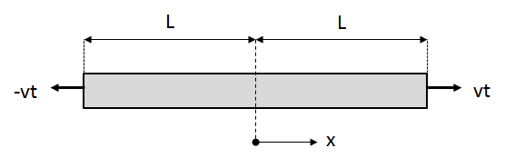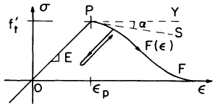
Figure 1 a) Geometry and loading of softening bar; b) stress strain law [2]
The local and nonlocal analytical solutions for displacement, strain, stress and internal energy in the strain softening problem, at the response time t=3L/2c, are shown in Figure 2. The key difference between the nonlocal and the local solution is discontinuity in the displacements and development of the standing strain wave in the midsection of the bar, which occurred as a result of superposition of the waves propagating from the bar ends. The obtained discontinuity could not propagate away from the localisation zone, so that material unloads outside of the localisation zone. In other words, the softening zone acts as a free boundary.

a)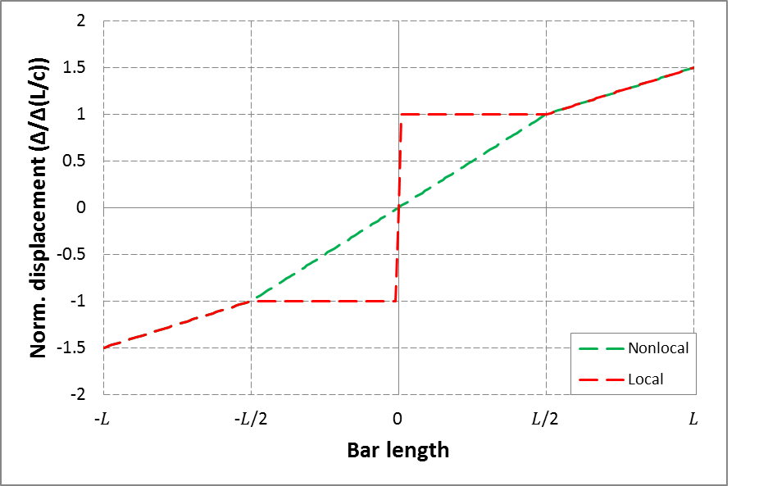b)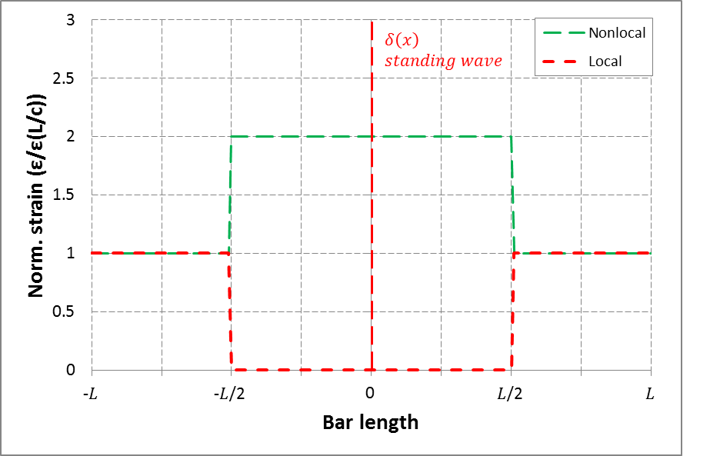

c)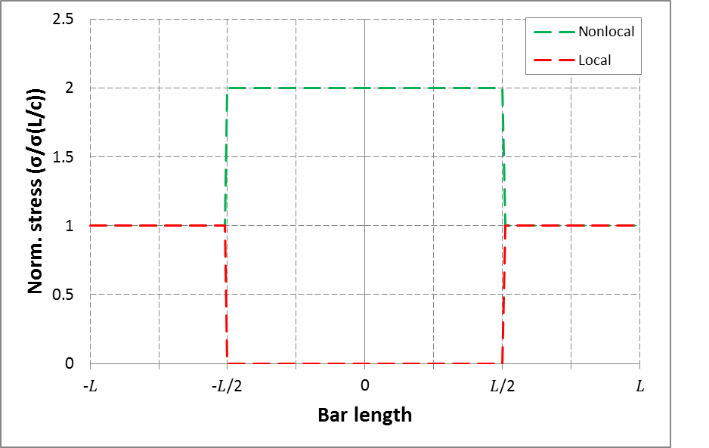d)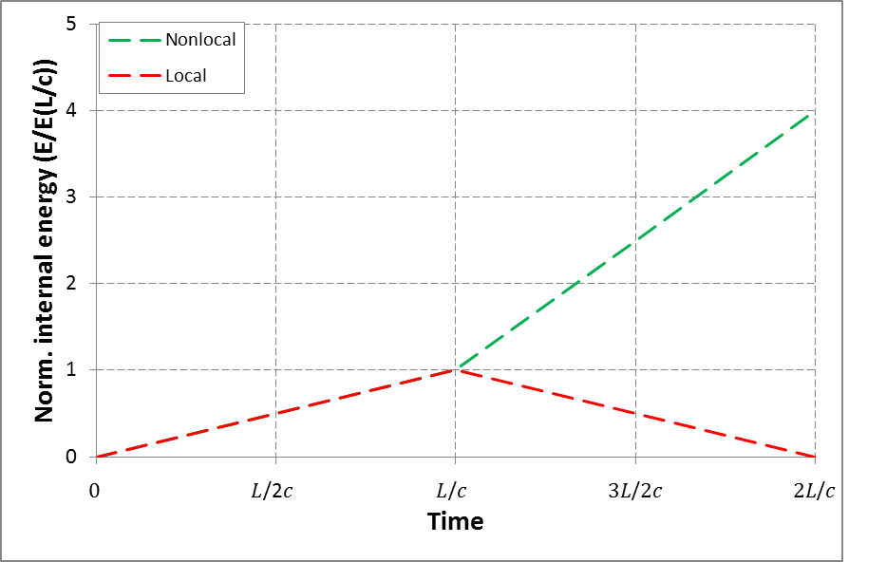
Figure 2 Elastic local and nonlocal solutions at the time instance t=3L/2c for : a) normalised displacement; b) normalised strain; c) normalised stress; d) normalised internal energy;

3. Simulation Results for Dynamic Strain Softening Problem and Impact Problems

3.1. Smooth Particle Hydrodynamics Method

The dynamic strain softening problem described in the previous section was modelled by using in house developed SPH code [5]-[6], with the material behaviour described as a bilinear constitutive law, with isotropic material properties, given in Figure 4. Generalisation to the three dimensional problem and orthotropic material behaviour is straightforward.

The SPH [3]-[6] is a meshless particle method which does not require a structured grid. The motion of the continuum is approximated by motion of discrete material points (particles) with no fixed connectivity. Interaction of particles is defined by a weighting (smoothing) function, where the smoothing length (size of the smoothing function domain) defines the range of influence of an individual particle. For instance, an estimate value of the function at the location is given as a continuous integral function in the following form:
(1)
where the angled brackets denote kernel approximation, is a weighting function, is a new independent variable and denotes smoothing length, i.e. size of the kernel support. The smoothing length is illustrated in Figure 3 and calculated from inter-particle distance, , as:
(2)
A discrete form of the kernel approximation, where the function is known at finite number of points , is given in terms of a sum:
(3)
with the corresponding gradient equal to:
(4)
The purpose of this investigation was to establish if SPH is by nature a nonlocal method capable of overcoming difficulties related to material softening without any additional regularisation measures.
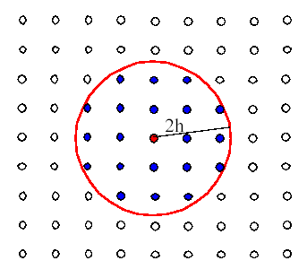
Figure 3 Definition of neighbourhood in SPH discretisation method.

Damage in the constitutive model given in Figure 4 was mathematically expressed with a single damage parameter , using a local continuum damage mechanics approach. The strain softening and the damage evolution developed when strain was in a range between and . The effective stress , given in terms of true stress , damage variable and tangent stiffness, i.e. of the stress stain curve at the material state determined by , were respectively calculated as:
(5)
(6)
(7)
Figure 4 Bilinear law implemented in the SPH codes using a damage parameter and classic CDM approach.

3.2. SPH results for for Dynamic Strain Softening Problem

The SPH simulations of the dynamic wave propagation problem were run with three discretisation densities shown in Figure 5. The influence of the smoothing domain on the numerical results was analysed in terms of each parameter that constitute the smoothing length. Consequently, three sets of numerical tests were run with three discretisation densities for analysis the influence of: 1) inter-particle distance ; 2) parameter ; and 3) smoothing length, . It was observed that the SPH method was inherently nonlocal and that the results were sensitive to the changes of the smoothing length. However, when the smoothing length was kept constant between the three models with different discretisation densities (interparticle distance ), the numerical results for displacement, strain, stress and damage remained the same as illustrated in Figure 6. The damage distribution obtained with three models with the fixed smoothing lenght shown in Figure 7 is independent of the interparticle distance ; instead the damage zone within the three models was constant and equal to , which suggests that the smoothing length should be considered as a material property.

Figure 5 Particle discretisation in SPH of strain-softening bar.

a)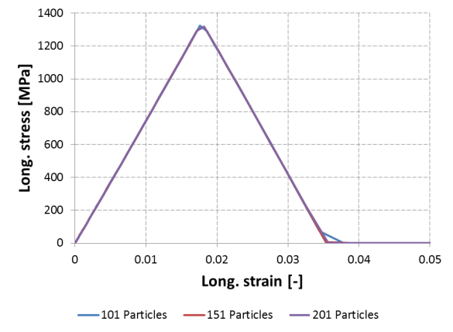b)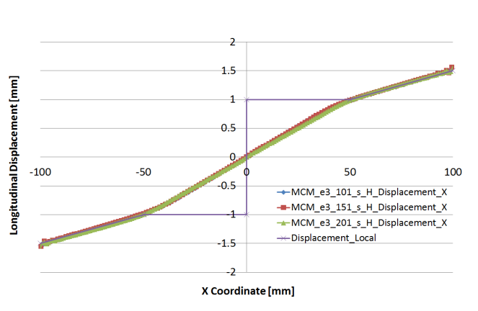
c)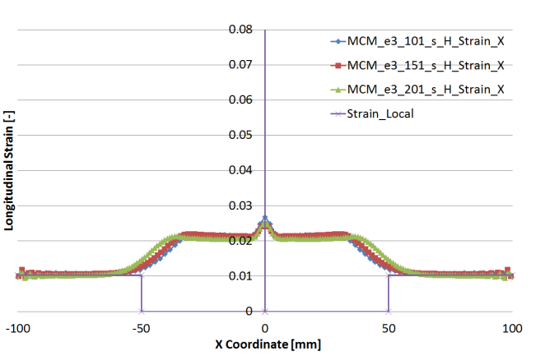d)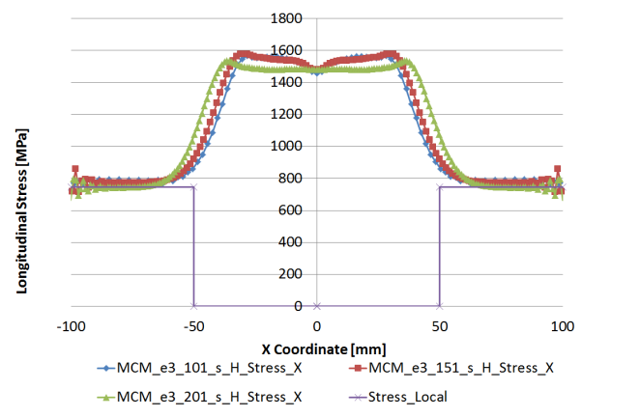
e)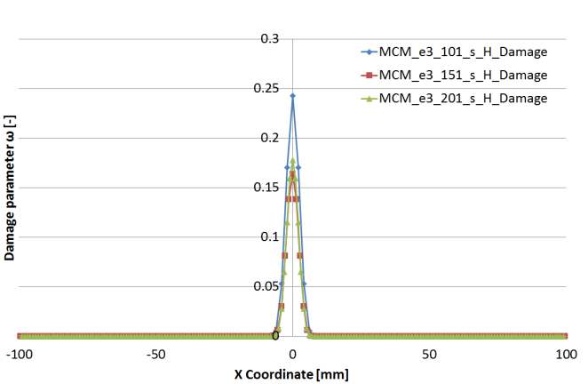f)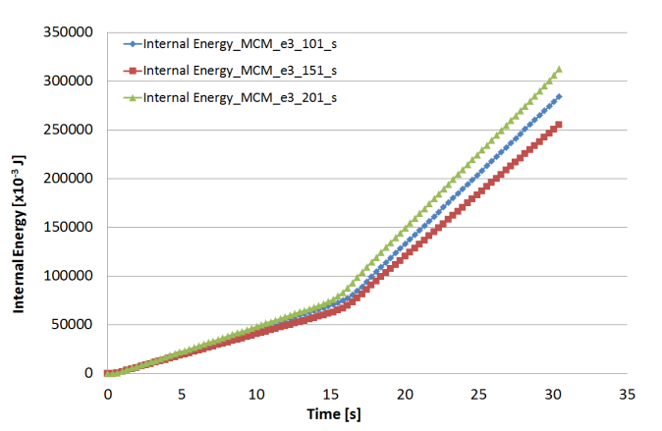

Figure 6 SPH solutions of dynamic strain softening problem at the time instance t=3L/2c for: a) constitutive law obtained in the middle of the bar; b) Longitudinal displacement; c) Longitudinal strain; d) Longitudinal stress; e) Damage distribution; f) Internal Energy history.
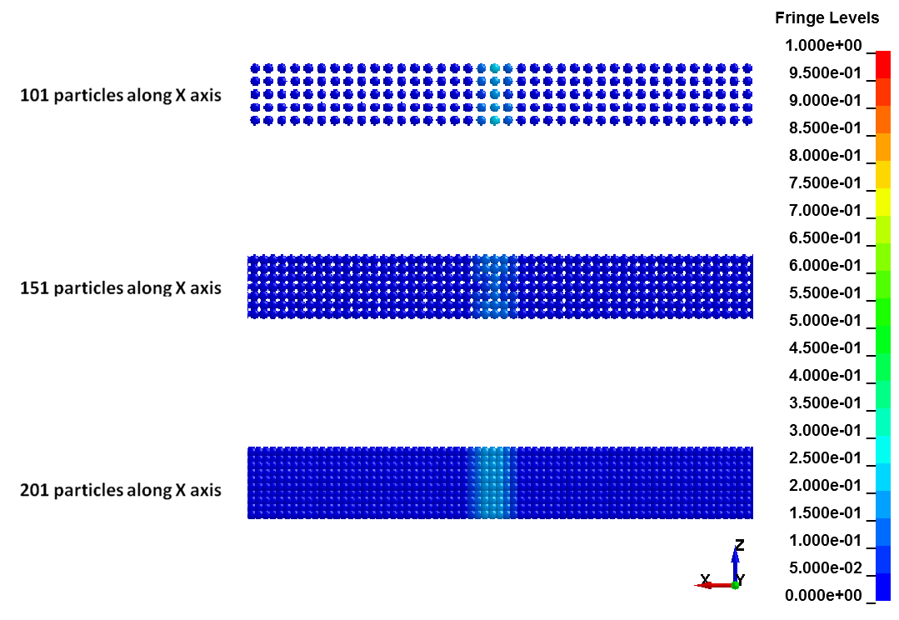
Figure 7 Damage distribution within a finite 4h wide zone (h=2.5mm) around the bar symmetry plane at response time t=3L/2c.

3.3. Modelling of cube impact

Performance of the SPH code with the consitututive model given in Figure 4 was tested in a problem of a flat faced projectile impact on a 3.175mm target plate. The impact velocity was 240m/s, which is 10% above the ballistic limit of the target panel [7]. Due to two symmetry planes, only a quarter of the problem was modelled as shown in Figure 8. Material properties used in this simulation, including the smoothing length, were the same as in the simulation of wave propagation problem.

The numerical results obtained for damage distribution within the target plate at several time instances until the total penetration are showin in Figure 9. The numerical model captured the damage and failure of the target plate well, with the crater shape and flug formation similar to those observed experimentally in [4]. Residual velocity of the projectile was within 10% of the experimentally observed velocity.
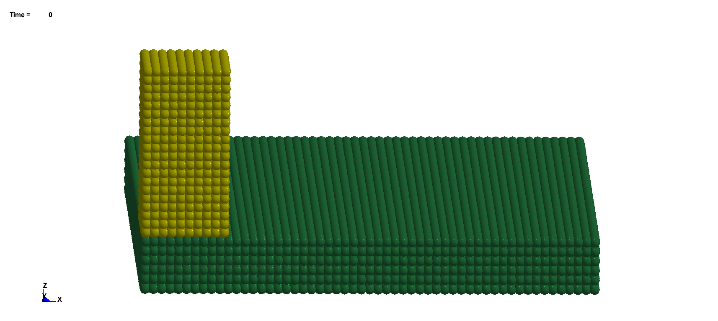
Figure 8 SPH model for cube impact test.
a)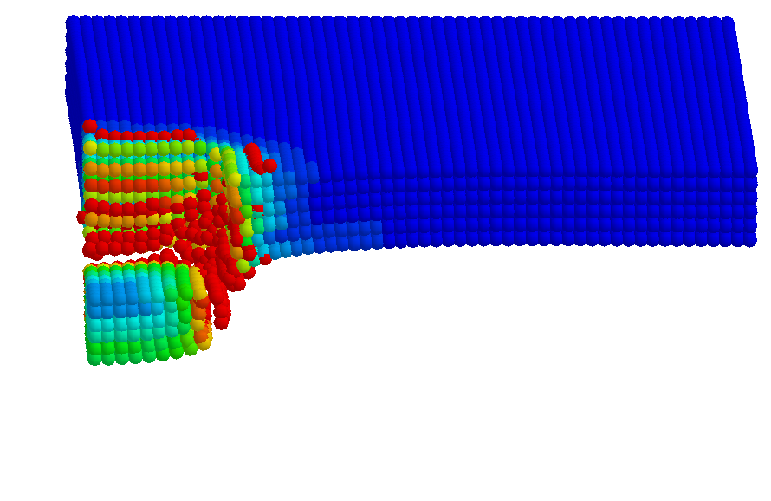b)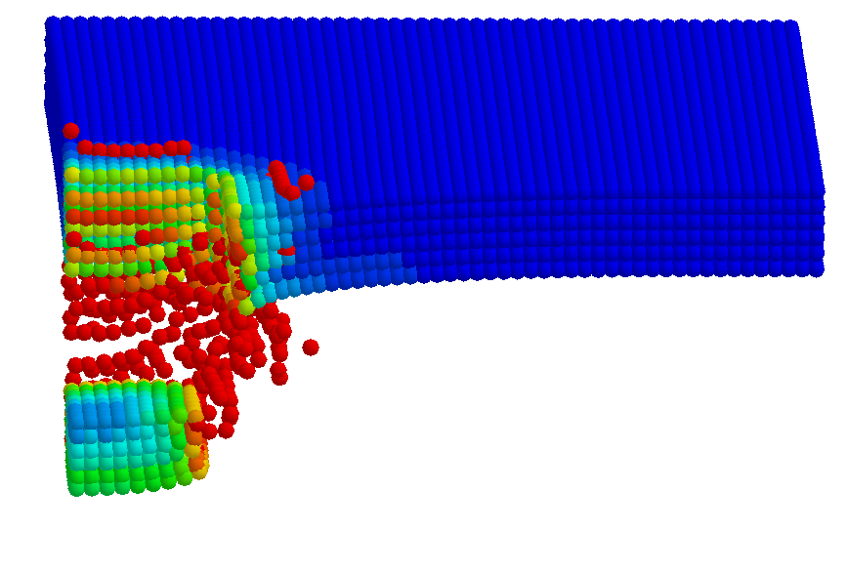
c)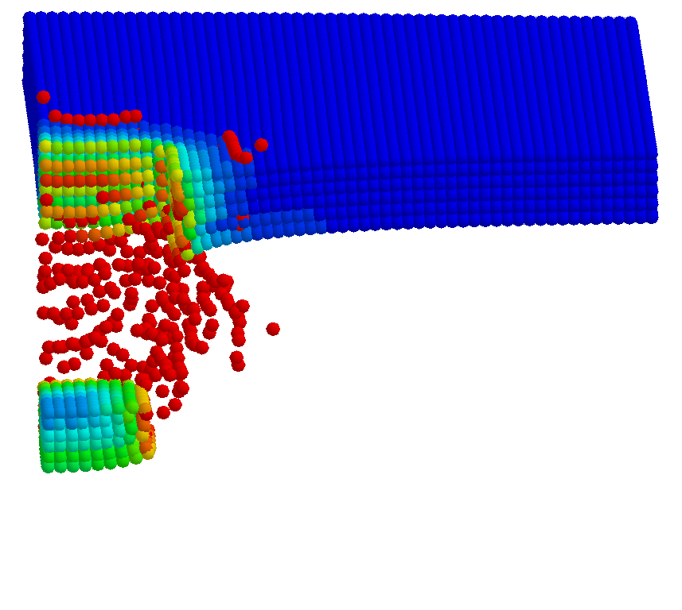d)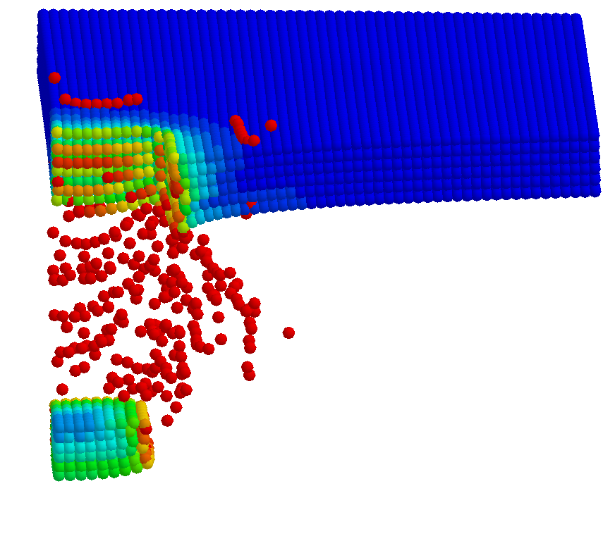
e)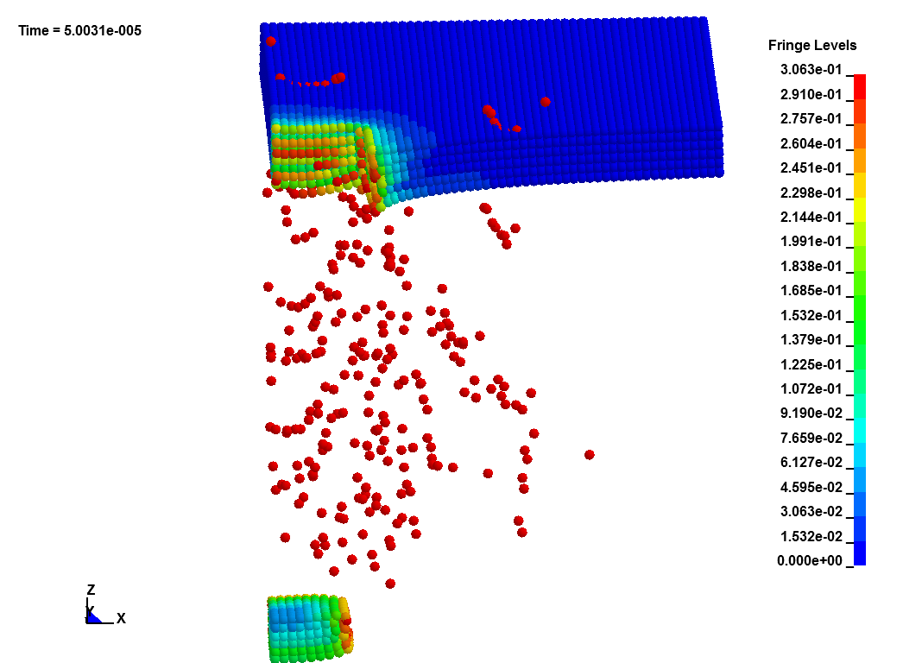
Figure 9 SPH results for damage distribution at time instance: a) ; b) ; c) d) ; e) ;

4. Conclusions

A series of numerical experiments conducted with the SPH demonstrated that the width of the strain softening region is controlled by the smoothing length rather than the inter-particle distance, which is analogous to the element size in the FEM. This means that the SPH method is inherently non-local and suggests that the SPH smoothing length should be linked to the material characteristic length scale in solid mechanics simulations. Simulation results for the cube impact on the flat panel demonstrate that the SPH provides stable solutions for the target impact response, capturing well the crater shape, flug formation and residual velocity of the projectile. The impact case considered will be further used for validation of the numerical tools developed within the project EXTREME.

Acknowledgments

The project leading to this publication has received funding from the European Union’s Horizon 2020 research and innovation programme under grant agreement No 636549.

References

- R. Vignjevic, N. Djordjevic, T. De Vuyst and S. Gemkow. Modelling of strain softening materials based on equivalent damage force. Computer Methods in Applied Mechanics and Engineering, 335: 52–68, 2018.
- Z. P. Bažant and T.B. Belytschko. Wave propagation in a strain-softening bar: exact solution. Journal of Engineering Mechanics 111 (3): 381-389, 1985
- R.A. Gingold and J.J. Monaghan. Smoothed particle hydrodynamics, Theory and application to non-spherical stars, Monthly Notices of the Royal Astronomical Society. 181: 375-389, 1977.
- L.D. Libersky and A.G. Petschek. Smooth particle hydrodynamics with strength of materials. In: Trease HE, Fritts MJ and Crowley WP, editors. Advances in the Free-Lagrange Method Including Contributions on Adaptive Gridding and the Smooth Particle Hydrodynamics Method. USA, Springer, 248-257, 1991.
- R. Vignjevic, J.R. Reveles, and J. Campbell. SPH in a Total Lagrangian Formalism. CMES: Computer Modeling in Engineering & Sciences, 14(3): 181-198, 2006.
- R. Vignjevic, J. Campbell, J. Jaric and S. Powell. Derivation of SPH Equations in a Moving Referential Coordinate System. Computer Methods in Applied Mechanics and Engineering, 198: 2403–2411, 2009
- T. De Vuyst, R. Vignjevic, A.A. Albero, K. Hughes, J. Campbell and N. Djordjevic. The effect of the orientation of cubical projectiles on the ballistic limit and failure mode of AA2024-T351 sheets. International Journal of Impact Engineering, 104: 21-37, 2017

