Alignment of magnetite-graphene nanoplatelets in epoxy matrices using low magnetic fields.

Kyriaki Gkaliou¹, Jeremy Hall¹, Philip R. Davies², Samuel Pattisson² , Christopher Dyer¹ and Mark J. Eaton¹

¹Cardiff School of Engineering, Cardiff University, Cardiff, CF24 3AA, UK
Email: gkaliouk@cardiff.ac.uk
¹Cardiff School of Engineering, Cardiff University, Cardiff, CF24 3AA, UK
Email: halljp@cardiff.ac.uk, Web Page: https://www.cardiff.ac.uk/people/view/364378-hall-jeremy
²Cardiff School of Chemistry, Cardiff University, Cardiff, CF10 3AT, UK
Email: daviespr@cardiff.ac.uk, Web Page: https://www.cardiff.ac.uk/people/view/38531-davies-philip
²Cardiff School of Chemistry, Cardiff University, Cardiff, CF10 3AT, UK
Email: pattisonsd@cardiff.ac.uk, Web Page: https://www.cardiff.ac.uk/people/view/117613-pattisson-samuel
¹Cardiff School of Engineering, Cardiff University, Cardiff, CF24 3AA, UK
Email: dyerc8@cardiff.ac.uk
¹Cardiff School of Engineering, Cardiff University, Cardiff, CF24 3AA, UK
Email: eatonm@cardiff.ac.uk, Web Page: https://www.cardiff.ac.uk/people/view/364361-eaton-mark

Keywords: GNPs, magnetic alignment, epoxy nanocomposites, magnetic nanoparticles

Abstract
Graphene nanoplatelets (GNPs) are an attractive nano-filler due to remarkable mechanical, electrical and thermal properties. Their high anisotropy has inspired researchers to focus on their alignment in polymer matrices. Such polymer composites would present interesting and desirable anisotropic behavior. Alignment methods for nanoparticles in polymers include direct mixing, integration as micro-components, self-assembly and active assembly. Active assembly using magnetic fields has attracted attention as it allows control of the alignment direction, is inexpensive, non-dectructive, scalable and allows organization of the fillers by inter-particle motions. To enhance the alignment of carbon nano-fillers and reduce the required field strength (<1T), researchers have decorated CNTs with magnetic nanoparticles. This work presents the alignment of GNPs coated by iron oxide nanoparticles (GNPs@MNP’s) in epoxy resin using low magnetic fields. The morphology of the magnetic nanohybrids was studied by Scanning Electron Microscope (SEM) and Transmission Electron Microscope (TEM). Assembly of GNPs@MNP’s using a static magnetic field of 100 mT was examined by an automated image capture and magnetic control system, confirming a strong alignment effect. Knowledge obtained in this study is expected to lead to a better understanding of nanoparticle alignment with the goal of scalable polymer composites containing oriented nanoparticle structures.

1. Introduction

Polymer composites consisting of carbon nanofillers and thermoset polymers are of great interest because of their excellent mechanical properties and their multi-functional thermal and electric properties. These exciting combinations of properties have great potential for use in a range of key industry sectors such as aerospace, automotive, medical, electrical and other consumer products [1]-[2]. Graphene nanoplatelets (GNPs) have been used recently as a nano-filler due to their remarkable mechanical, electrical and thermal properties, along with lower production costs compared with that of carbon nanotubes (CNTs) [3].
However, the industrial application of these materials is limited by three factors. Firstly, they tend to agglomerate due to the strong van der Waals interactions and π-π interactions and as a result it is very difficult to achieve a homogeneous dispersion in a polymer matrix, leading to degraded mechanical and electrical properties. Secondly, their naturally inert surface results in poor interfacial adhesion with the polymer matrix and gives a low loading rate of nanomaterials [4]. Finally, the carbon nano-filler dispersion tends to be random and as a result does not harness the full material properties in any given direction. The degree of the alignment has a significant effect providing conductive pathways for electrons and phonons which improve electrical and thermal properties [5]. Therefore, achieving nano-carbon alignment has the potential to enhance, control and tune material properties for a range of applications and requirements.
A number of studies have produced polymer based composites with oriented or structured nanocarbon fillers [6]-[8]. Among them, active assembly using magnetic fields is a promising technique since it is allows the bulk processing of nanocomposites whilst, controlling nano-carbon orientation and maintaining a homogeneous microstructure [9]. The fabrication of aligned-nanofiller-based composites is driven by the ability to create anisotropy at the molecular level and transfer the interesting electrical, mechanical, and thermal properties to the polymer [10]. Recently, due to the low magnetic susceptibility of the carbon nanomaterials, researchers have focused on the magnetization of nano-carbons in order to avoid the use of high magnetic fields (15-25T) requiring national facilities [11-13].
This paper reports the effects of the different parameters (filler loading, curing time and magnetic field strength) on the alignment of GNPs coated by iron oxide nanoparticles in epoxy resin. Plasma functionalized GNPs (Haydale Ltd, HDPlas®GNPs) were utilized to ensure uniform distribution of iron oxide particles in the graphene sheets. The GNPs were coated with magnetite nanoparticles using a facile co-precipitation method as proposed by S. Wu et al [14]. Subsequently, the magnetic GNPs (GNPs@MNP’s) were introduced into an epoxy matrix and aligned by the application of a weak magnetic field (100 mT), forming composites with an aligned filler phase which has been observed by Optical Microscope. It is expected that these composites would exhibit anisotropic electrical and thermal and mechanical properties, in accordance with the parallel and the perpendicular direction to the magnetic field, giving the potential for applications in aerospace, electronic devices and barrier coatings.

2. Experimental Section

2.1. Materials

Graphene nanoplatelets (GNPs) used in the present work have been plasma treated by Haydale Ltd (HDPlas®GNPs). The surface area of the GNPs is measured to ~ 20 m²/g and also, their planar size is in the range of 0.3-5 µm with thickness <50 nm. The GNPs were plasma processed in a COOH atmosphere, functionalizing them with carboxylic chemical groups (GNPs-COOH). For the deposition of iron oxide particles, the following materials were used: Iron (II) sulfate heptahydrate (Fe₃SO₄∙7H₂O), anhydrous iron chloride (FeCI₃) and ammonium hydroxide (NH4OH, 28.0-30.0 % NH3 basis) were sourced from Sigma – Aldrich, UK.
For the alignment procedure of the magnetic nanohybrids, the following materials were used: IN2 epoxy infusion resin, provided by the Easy Composites Ltd. The epoxy resin was catalyzed using a fast hardener (AT30) which has a pot-life of 9-14mins, a gelation time of 2-4hrs and is de-mouldable in around 6 hrs.

2.2. Synthesis of iron oxide- GNPs hybrid materials (GNPs@MNP’s)

The GNPs were coated with iron oxide nanoparticles using a simple wet co-precipitation method as proposed by S. Wu et al [14].

2.3. Characterization of the iron oxide- GNPs hybrid materials (GNPs@MNP’s)

The morphological analysis of the magnetic nano-hybrids (GNPs@MNP’s) was investigated by Scanning Electron Microscopy (SEM) analysis using a Zeiss Sigma HD Field Emission Gun Analytical SEM. To avoid charging during electron irradiation, the samples have been sputter coated with ~20nm overlayer of Au-Pd alloy. Secondary electron images were acquired at 5 kV with an in-lens detector. Transmission electron microscope (TEM) analyses of the samples was conducted using a Jeol JEM-2100 LaB6 Transmission Electron Microscope fitted with Oxford Instruments X-MaxN 80 EDS analyser. The samples were dispersed in ethanol using an ultra-sonic bath for 2-3 mins and then transferred to 300 Mesh Copper grids (AGS147-3) covered with Holey Carbon Film. This procedure allowed the better separation of agglomerations in individual particles for easier observation and size quantification of them. The analysis of the TEM images for measuring the size distribution of the nanoparticles was proceeded by software ImageJ. To gain reliable results, the particle size distribution was evaluated by measuring the length of 100 nanoparticles from different TEM images.

2.3. Alignment study of GNPs@MNP’s in epoxy matrix

Epoxy nanocomposites containing GNPs@MNP’s were prepared as described below. The GNPs@MNP’s were dispersed in IN2 epoxy infusion resin, using a high speed mixer (DAC 800.1 FVZ) for 10 min with a speed of 1950 rpm/min at 0.5, 0.8, w.t. %. Subsequently, the resin dispersions were catalyzed (AT30) by the use of the high speed mixer for 5 min with a speed of 1950 rpm/min and then with the use of a pipette added and cured on a microscope slide (3 x 1 in.) to a magnetic field parallel to the short edge of the slide for 6hrs. A steel C-core electromagnet with an air gap of 30 mm between faces of 30 mm x 30 mm was used to apply the magnetic field to the specimen. The uncured epoxy was held in position between the magnetic poles on a 3D printed plastic bracket designed to locate both the C-core and the slide. The electromagnet was energized by a software controlled Power Supply Unit (PSU) that would allow the user to define the required magnetic field strength through the LabVIEW VI. The current was supplied by a KEPCO Bipolar power supply (400W, ±36V, ±12A) and the magnetic field was measured using a LakeShore 450 gaussmeter.
Real-time images of the alignment behavior of the GNPs@MNP’s (0.5 wt. %, 0.8wt. %, 1 wt. %) in the epoxy matrix were captured using an optical microscope with 20x magnification (Leitz Wetzlar, Germany, Nikon DSLR camera) throughout the curing process, Figure 1. Microscope image capture was controlled by the LabVIEW software at a rate of one image per minute during the curing process. This allows examination of the alignment process at any point during the curing process. From the images the length of the magnetic chains and their configurations were calculated using the ‘ImageJ’ processing software.

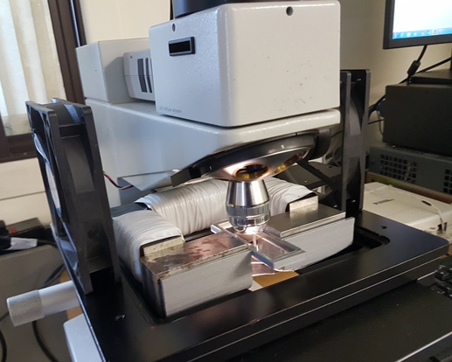
Figure 1. Experimental set-up of the magnetization system comprising the plastic former, electromagnet and specimen slide holder located beneath the microscope objective.

3. Results

3.1. Characterization of the magnetic nanohybrids (GNPs@MNP’s)

The surface morphology of the plasma treated GNPs, and iron oxide coated GNPs (GNPs@MNP’s) was studied using Scanning Electron Microscopy (SEM) and Transmission Electron Microscope (TEM). Figure 2 (a) shows the morphology of GNP-COOH.The graphene sheets are randomly oriented, giving rise to petal-like shaped agglomerates. Figure 2 (b) shows the attachment of iron oxide nanoparticles on the GNP surface. The majority of the magnetic nanoparticles are uniformly distributed on the GNPs although some clustering of the nanoparticles has been observed. This phenomenon is due to strong magnetic dipole–dipole attractions between particles combined with van der Waals force and high surface energy [15]-[16].

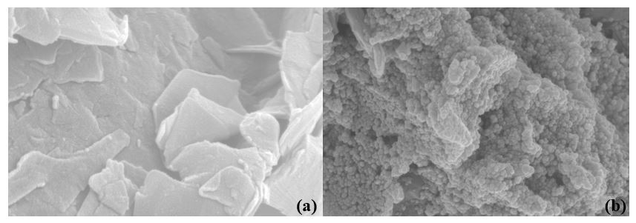
Figure 2. SEM images of GNP-COOH (a), GNPs@MNP’s (b).

To study the attachment of the magnetic nanoparticles in more detail, TEM images were taken and are shown in Figure 3. The iron oxide nanoparticles grew on the surface of GNPs (Figure 3 (a), (b)) with diameters mainly below 50 nm (Figure 3 (c)). The distribution of the magnetic nanoparticles on the GNPs surface is uniform with only a small amount of local agglomeration evident, as observed also by SEM images. [17].
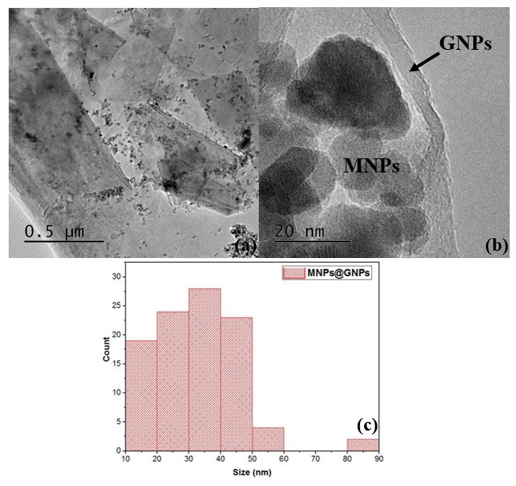
Figure 3. Typical TEM image of GNPs@MNP’s (a), (b), the size distribution of GNPs@MNP’s (c)

3.2. Alignment of GNPs@MNP’s in the epoxy nanocomposites

Figure 4 a-d (I) shows the alignment behavior of the magnetic nanoparticles at 0.5 wt. % in the presence of the 100 mT magnetic field. Figure 4 a shows the random distribution of the magnetic prior to the application of the magnetic field. Some larger agglomerates can been seen, most likely due to the interaction between the single magnetic NPs with the polymeric chains [17]. After the second minute (Figure 4 c), it is a horizontal alignment and assembly can been seen clearly as the nanoparticles form longer-chain like clusters.
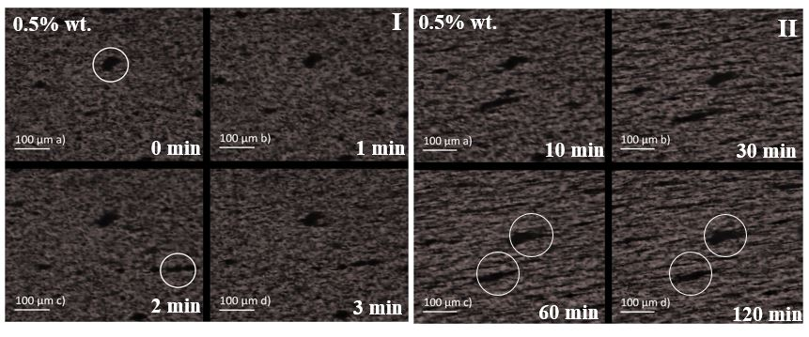
Figure 4. (I) Optical microscope images of the alignment of 0.5 wt. % GNPs@MNP’s to the epoxy matrix under the applied magnetic field (100 mT) after a time of 0 min (a), 1 min (b), 2 min (c), 3 min (d). (II) Optical microscope images of the alignment of 0.5 wt. % GNPs@MNP’s to the epoxy matrix under the applied magnetic field (100 mT) after a time of 10 min (a), 30 min (b), 60 min (c), 120 min (d).

Within a very short time (30 min), significant alignment is observed (Figure 4b) (II) in the field direction. However, there is little difference between the images after 30 min, 60 min and 120 min (Figure 4 b, c, d) (II), indicating that most alignment occurs within 30 min with any changes during the remaining time negligible.

Increasing the concentration of the magnetic nanoparticles to 0.8 wt. %, initial signs of alignment can be observed after only 10 seconds (Figure 5 a). After ten minutes (Figure 6 a), the GNPs@MNP’s have formed to thin magnetic clusters with an average length of 60 μm.

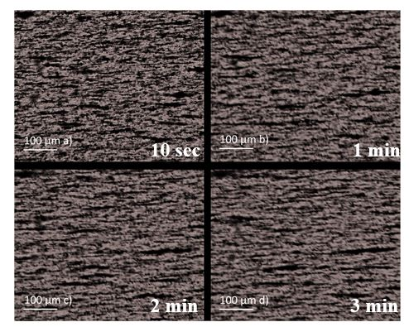
Figure 5. Optical microscope images of the alignment of 0.8 wt. % GNPs@MNP’s to the epoxy matrix under the applied magnetic field (100 mT) after a time of 10 sec (a), 1 min (b), 2 min (c), 3 min (d).

After two hours (Figure 6 d), most of the GNPs@MNP’s have been aligned with cluster lengths, reaching mostly the length of 200-250 μm (Figure 7 e) and very few random distributions observed. Similar results were observed for the 1 wt. % concentration of GNPs@MNP’s.
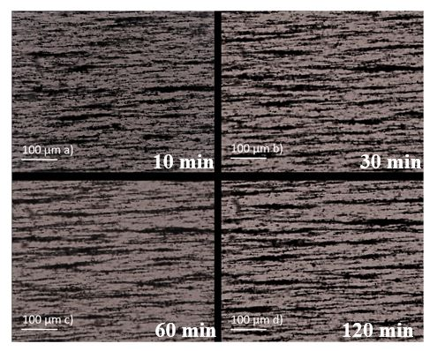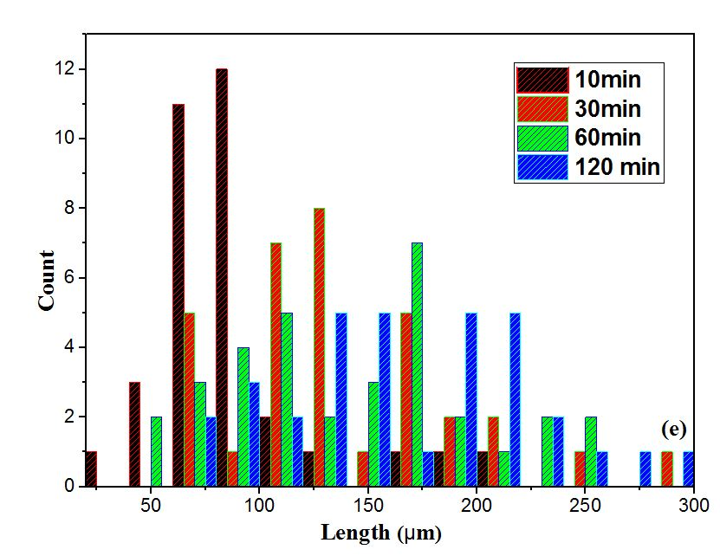
Figure 6. Optical microscope images of the alignment of 1wt. % GNPs@MNP’s into the epoxy matrix under the applied magnetic field (100 mT) after a time of 10 min (a), 30 min (b), 60 min (c), 120 min (d), length distribution of the magnetic clusters during the curing time (e).

4. Conclusions

Magnetic-responsive nanohybrids of GNPs@MNP’s have been synthesized by a simple co-precipitation method. The morphology of these magnetic nanoparticles was studied by Scanning Electron Microscope (SEM) and Transmission Electron Microscope (TEM). In detail, iron oxide nanoparticles were attached uniformly on the graphene sheets with some observed local agglomerations. These hybrids were mixed at different concentrations (0.2 wt. % , 0.8 wt. %, 1wt. %) with an epoxy resin and their alignment under the application of a low magnetic field (100 mT) was investigated using an optical microscope. It has been established that the magnetic nanohybrids can be aligned in the liquid epoxy resin, creating thin clusters up to 250 µm and this alignment is maintained after the epoxy is cured. Capturing images during the curing process, provided more information about the time which is required for the magnetic clusters to be aligned. This allows us to decrease the experimental time from 6 hrs to 2 hrs, providing a non-time-consuming manufacturing process. Future work will focus on the use of a different mixing method (for instance, three-roll miller) between the epoxy and the graphene nanofillers in order to investigate the dispersion aspects of the magnetic graphene sheets into the polymer matrix. Additionally, different directions of the magnetic field will be used in order to be examined the anisotropic thermal and electrical behavior of the epoxy composites reinforced by aligned GNPs.

Acknowledgments

We would like to thank Dr Thomas Davies for his help with the Cardiff University electron microscopy facility for the transmission (TEM) and scanning electron microscopy (SEM) and Dr Duncan Muir for his help with SEM at the School of Earth and Ocean Sciences, Cardiff University. Also, Haydale Ltd. which provides us the plasma-functionalized GNPs (GNPs-COOH).

References

[1] Haibat, Jatin, et al. "Preliminary demonstration of energy-efficient fabrication of aligned CNT-polymer nanocomposites using magnetic fields." Composites Science and Technology 152 (2017): 27-35.
[2] Saleem, Haleema, et al. "Mechanical and Thermal Properties of Thermoset–Graphene Nanocomposites." Macromolecular Materials and Engineering 301.3 (2016): 231-259.
[3] Prolongo, S. G., et al. "Advantages and disadvantages of the addition of graphene nanoplatelets to epoxy resins." European Polymer Journal 61 (2014): 206-214.
[4] Chen, Zhiqiang, et al. "Improving the mechanical properties of epoxy using multiwalled carbon nanotubes functionalized by a novel plasma treatment." Composites Part A: Applied Science and Manufacturing 45 (2013): 145-152.
[5] Park, Jin Gyu, et al. "Thermal conductivity of MWCNT/epoxy composites: the effects of length, alignment and functionalization." Carbon 50.6 (2012): 2083-2090.
[6] Grzelczak, Marek, et al. "Directed self-assembly of nanoparticles." ACS nano 4.7 (2010): 3591-3605.
[7] Xie, Xiao-Lin, Yiu-Wing Mai, and Xing-Ping Zhou. "Dispersion and alignment of carbon nanotubes in polymer matrix: a review." Materials Science and Engineering: R: Reports 49.4 (2005): 89-112.
[8] Erb RMet al 2012 Composites reinforced in three-dimensions by using low magnetic fields Science 335 199–204.
[9] Spencer, Mychal P., David Gao, and Namiko Yamamoto. "Scalable Manufacturing of Thermoset Nanocomposites Consisting of Ferrimagnetic Nanoparticles using Static Magnetic Fields." 2018 AIAA/ASCE/AHS/ASC Structures, Structural Dynamics, and Materials Conference. 2018.
[10] Garmestani, Hamid, et al. "Polymer‐Mediated Alignment of Carbon Nanotubes under High Magnetic Fields." Advanced Materials 15.22 (2003): 1918-1921.
[11] Yamamoto, Namiko, Harish Manohara, and Ellen Platzman. "Magnetically anisotropic additive for scalable manufacturing of polymer nanocomposite: iron-coated carbon nanotubes." Materials Research Express 3.2 (2016): 025004.
[12] Jia, Xiaolong, et al. "Numerical characterization of magnetically aligned multiwalled carbon nanotube–Fe3O4 nanoparticle complex." ACS applied materials & interfaces 7.5 (2015): 3170-3179.
[13] Shen, Jianfeng, et al. "One step synthesis of graphene oxide− magnetic nanoparticle composite." The Journal of Physical Chemistry C 114.3 (2010): 1498-1503.
[14] Wu, Shuying, et al. "Epoxy nanocomposites containing magnetite-carbon nanofibers aligned using a weak magnetic field." Polymer 68 (2015): 25-34.
[15] Xia T, Wang J, Wu C, et al. “Novel complex-co precipitation route to form high quality triethanolamine-coated Fe3O4 nanocrystals: their high saturation magnetizations and excellent water treatment properties.” CrystEngComm. 2012; 14(18):5741–5744.
[16] Lalatonne, Y., J. Richardi, and M. P. Pileni. "Van der Waals versus dipolar forces controlling mesoscopic organizations of magnetic nanocrystals." Nature materials 3.2 (2004): 121.
[17] Lorenzo, Daniela, et al. "Formation and magnetic manipulation of periodically aligned microchains in thin plastic membranes." Journal of Applied Physics 112.8 (2012): 083927.

