International Benchmark Exercises on Textile Permeability and Compressibility Characterization

D. May¹, A. Aktas² and A. Yong²

¹Institut für Verbundwerkstoffe GmbH, Erwin-Schrödinger-Str., Geb. 58, 67663 Kaiserslautern, Germany
Email: david.may@ivw.uni-kl.de, Web Page: http://www.ivw.uni-kl.de
² National Physical Laboratory, Hampton Road, Teddington, Middlesex, TW11 0LW, UK
Email: aktasalpr@yahoo.co.uk, Email: ana.yong@npl.co.uk, Web Page: http://www.npl.co.uk

Keywords: Permeability, compressibility, resin injection, resin flow, process monitoring

Abstract
Efficient process design for Liquid Composite Moulding (LCM) requires knowledge about textile permeability and compressibility, but existing textile characterization methods have not yet been standardized. In 2016 it was decided to launch benchmark exercises on textile in-plane and out-of-plane permeability as well as compressibility measurements. The same two textiles (non-crimp and woven fabric) were characterised in all benchmarks.
For in-plane permeability a characterization procedure was predefined and only the radial injection method was allowed. Excluding outliers (3 of 20), the average coefficient of variation (cv) between the participants’ data was 38%. If only data from systems with cavity deformation < 2% (rel. to target value) are considered, the average cv reduces to 29%.
The first out-of-plane permeability benchmark exercise allowed participants to use their own method. No test procedure was prescribed, but the participants were asked to measure the permeability at defined nominal fibre volume fraction values. The scatter was between 44% and 100%.
The purpose of the compressibility benchmark was to compare the existing experimental approaches and reproducibility of test results using a displacement controlled procedure. Dry and wet compaction tests were performed. The average of the cv value for the thicknesses at 1 bar pressure was around 1%.

1. Introduction

Efficient process design for Liquid Composite Moulding requires knowledge about material properties. The permeability, which quantifies textile conductance for liquid flow, is particularly important as it determines the flow velocity. Yet, existing textile characterization methods have not yet been standardized, although good progress was made by two international benchmark exercises on in-plane permeability including a guideline for a measurement procedure based on linear flow [1-3]. In this context, a recent survey [4] identified the need for further benchmark exercises to compare results obtained from the existing techniques and develop the methods for standardization. Hence, in 2016 at the FPCM 13 in Kyoto, it was decided by the scientific community to launch benchmark exercises on textile in-plane and out-of-plane permeability as well as textile compressibility measurements.

The in-plane permeability benchmark was organized by the Institute for Composite Materials and the out-of-plane permeability and compressibility benchmark exercises were organized by the National Physical Laboratory (NPL). The organizers are supported by University of Nottingham, University of Delaware, Montanuniversität Leoben, KU Leuven, National Composites Centre, Polytechnique Montreal, and ETH Zurich as members of a steering committee.

Thirty-two organizations (see Table 1) participated in one, two or all three of the benchmarks.

Table 1. List of participants
Institution | Country | 2D  In-Plane Permeability | Out-of-plane  Permeability | Preform  Compressibility
Brigham Young  University | USA | Yes | Yes | Yes
École centrale de Nantes | France | No | Yes | Yes
École des Mines d’Albi | France | Yes | No | Yes
École Polytechnique de Montréal | Canada | No | Yes | Yes
École Polytechnique Fédérale de Lausanne | Switzerland | No | Yes | Yes
ETH Zurich | Switzerland | Yes | Yes | Yes
FHNW, University of Applied Sciences and Arts Northwestern Switzerland | Switzerland | No | Yes | Yes
Fraunhofer IGCV | Germany | No | Yes | Yes
IMT Lille Douai | France | Yes | No | No
INEGI | Portugal | Yes | No | No
Institut für Verbundwerkstoffe GmbH (Institute for Composite Materials) | Germany | Yes | Yes | Yes
Institute des Soudere Composite Platform | France | Yes | Yes | Yes
INTEMA | Argentina | Yes | No | No
ITAINNOVA | Spain | Yes | Yes | Yes
Khalifa University | UAE | Yes | Yes | Yes
Koc University | Turkey | Yes | Yes | No
KU Leuven | Belgium | Yes | No | Yes
McGill | Canada | No | Yes | Yes
Montanuniversität Leoben | Austria | Yes | Yes | Yes
National Physical Laboratory | UK | Yes | Yes | Yes
Nottingham University | UK | Yes | Yes | Yes
Purdue University | USA | Yes | Yes | Yes
Skolkovo Institute of Science and Technology | Russia | Yes | Yes | Yes
Technical University Munich | Germany | Yes | Yes | Yes
TENSYL | France | No | Yes | Yes
TU Clausthal | Germany | Yes | Yes | Yes
Université de Technologie de Compiègne | France | Yes | Yes | No
Université d'Orléans | France | No | No | Yes
University of Auckland | New Zealand | Yes | Yes | Yes
University of Stuttgart | Germany | Yes | Yes | Yes
University Politechnique of Valencia | Spain | Yes | Yes | No
Wuhan University of Technology | China | No | Yes | Yes

2. Materials

For all three benchmarks the same textiles were tested:
- a biaxial (±45°) glass fibre non-crimp fabric (NCF) from Saertex (X-E-444g/m²) with an areal weight of 444 g/m² (217 g/m² for the ±45° layers, 2 g/m² for 0° and 90° stabilization yarns, 6 g/m² for the polyester stitching yarn with 76 dtex). The stitching shows a warp pattern with a stitch length of 2.6 mm and a gauge of 5 mm.
- a twill (2/2) glass fibre woven fabric (WF) from Hexcel (01102) with an areal weight of 295 g/m² equally distributed in weft and warp direction. Nominal construction in yarns/cm is 7 for both, weft and warp direction.
Each material was from a single sample batch in order to reduce the influence of manufacturing variations on the benchmark results. Figure 1 shows images of both materials.

Figure 1. Images of the textiles characterized in the benchmark studies (AA for biaxial 45° fabric; BB for twill (2/2) fabric.

The permeability measurements were all undertaken using silicone oil XIAMETER® PMX-200 SILICONE FLUID 100CS from Dow Corning, which provides a viscosity of about 100 mPas at room temperature. In order to minimize possible variations induced by fluid viscosity, the silicone oil was procured batch-wise and measured centrally for each batch at TU Munich in a temperature range from 15 to 40 °C using an Anton Paar MCR 302 rheometer.

For the complete programme 1389 kg of textile (equals to >3600 m²) and more than 700 kg of fluid were procured for this benchmark.

3. Methods

3.1. International benchmark exercise on in-plane permeability characterization based on radial flow experiments

In the first international benchmark exercise on in-plane permeability measurement [1] no specifications were made regarding the measurement method, resulting in a scatter of the measured permeability values of more than one order of magnitude. The subsequent second international benchmark required application of an unsaturated linear injection and also the measurement procedure was clearly defined. In this way strongly improved reproducibility was obtained [3]. In-plane permeability characterization based on radial flow experiments, compared to the linear injection method, provides unique advantages, i.e. only one test is required for full textile characterization including K1 and K2 (highest and lowest in-plane permeability) and the orientation angle of K1 relative to the textiles production direction. Hence, the presented benchmark focused on unsaturated in-plane permeability characterization based on radial flow. Taking into account the guidelines of the successful 2nd international benchmark on in-plane permeability characterization based on linear flow technique [2], detailed requirements for the system and the measurement procedure were specified, the most important ones (see Figure 2 for illustration) are explained in the following:
- stack of textile layers compressed between two rigid molding surfaces with constant gap
- central point injection of test fluid into a circular flow channel (punched with a diameter of 12 mm), resulting in two-dimensional flow pattern (ellipse)unsaturated measurement principle: Tracking of flow front progression

Figure 2. Schematic illustration of the radial injection set-up and measurements.

All of the 19 participants were asked to measure the permeability of both textiles at a defined cavity height (3.00 mm) and stack, with three different number of layers (NCF: 8, 9 and 10; WF: 12, 13 and 14) resulting in three levels of nominal fibre volume content (NCF: 0.466, 0.522, 0.580; WF: 0.463, 0.501, 0.540). Within each stack of material, all layers showed uniform orientation. Per fibre volume content five measurements were performed for statistical analysis. Each sample stack was weighed. The measured permeability values were accounted to a fibre volume content calculated based on the areal weight averaged over all five sample stacks used for measurement at one fibre volume content. For each material and fiber volume content (fvc) an injection pressure was pre-specified (1, 2 and 4 bar for smallest, intermediate and highest fvc for both textiles). Twenty data sets were analyzed (1 participant provided data from two systems) in total.
The experimental tests were complemented by an extensive questionnaire on system characteristics (geometry, materials etc.), available sensors (for pressure, temperature and flow front monitoring), and analysis methods. The participants were also asked to measure the cavity height with and without textile in the cavity and at five points using plasticine. Also a numerical simulation on the deformation behaviour was requested.

3.2. Out-of-Plane Permeability Benchmark Exercise
This has been the first international benchmark exercise on the out-of-plane permeability characterization of textiles with 26 participants. No test procedure or guideline was prescribed. This study allowed participants to use their own method (e.g. unsaturated, saturated, constant flow, constant injection pressure).
All participants were asked to perform 5 measurements at nominal fvc levels of 0.46, 0.50 and 0.54 using the textiles and the test fluid mentioned in Section 2. The number of fabric layers in specimens and specimen thicknesses were not specified. Each test specimen’s weight was used for the actual fvc calculations. Participants provided information on their test setups and methods, which will be useful for drafting the requirements for the next benchmark exercise.

3.3. Compressibility Benchmark Exercise
Compressibility characterization of textiles is as important as the in–plane and out-of-plane permeability characterizations, but there has been no benchmark study or test standard developed to date. In this first compressibility benchmark study undertaken by 27 participants, a simple displacement controlled test procedure representing the Resin Transfer Moulding process was used, which asked participants to compress the textile specimens (14 layers of woven fabric and 10 layers of non-crimp material) from 10 mm to a final thickness of 3 mm, between the upper and lower platens, and report the corrected thicknesses based on their compliance, or the thicknesses based on their direct measurement. The compaction speed was 1 mm/min. The final compaction was followed by a 30-minute dwell period to allow the textile specimens to relax. Both wet and dry compaction tests were performed using 5 (round and square) specimens for each case. For the wet compaction tests, the specimens were placed in a silicone oil bath for 15 minutes and then left on a rack to drain off excess oil.

4. Results

4.1. In-Plane Permeability Benchmark Exercise

The main point of interest is the reproducibility of permeability characterization. Figure 3 exemplarily shows the results of major in-plane permeability K1 of each participant measured at each of the three fvc for the non-crimp fabric. The data points represent the arithmetic average of each data set and the error bars show the standard deviation for permeability and fvc (resulting from areal weight variations), respectively. For the fvc the batch-wise averaged areal weight was considered and a cavity height of 3 mm was used. Cavity deformation was not considered. For each comparable set of data a cluster group is marked by a frame. The clusters cover a range of 2 fvc percentage points (pp) max. and the coefficient of variation (cv) between the permeability values of the different data sets is stated in the diagrams. Three of the 20 data points are excluded from the clusters, whereby these data points always origin from the same participants and always show the same relative position to the cluster: these are considered to be outliers, where a systematic deviation can be presumed. The outlier beneath the cluster reported identification of a unit conversion error in their calculation procedure after the deadline. This error explains the deviation from the cluster group. The two outliers above the cluster show high mold deflection. The results for the minor in-plane permeability K2 of the non-crimp fabric (NCF) as well as those for the woven fabric (WF) are similar but not shown here due to space limitations. For the remaining 17 data sets in the cluster, the cv between the data sets averaged over all fvc and both textiles is 38%. For comparison the average cv can be calculated for each single participant`s data set, which then gives an impression on the reproducibility for measurements on a single system. Averaged over all participants this cv is 8%. This is by far smaller than the cv of 38% between the participants. Hence, a large amount of variation is expected to be due to differences between the measurement systems.

Figure 3. In-plane permeability: average values for each participant for the highest in-plane permeability of the NCF at three different target fibre volume contents (the error bars correspond to standard deviation).

The most dominant source of variation is the deformation of the tool. Experimental tests revealed that only 9 of the 20 systems show less than 2% deviation from the target cavity height, when a textile is placed in the cavity (original participation requirement). If only these 9 systems are considered, the average cv between the data sets reduces to 23%, with a maximum of 26%. These results are quite similar to those achieved in benchmark II for the linear flow approach [3]. For the single data sets the fitting of the correlation from permeability and fvc with an exponential function showed mostly good results. However, some data sets deviated from this finding, again indicating increasing deformation with increasing fvc and injection pressure, respectively.
The third important value is the orientation angle, defined as the angle between the direction of K1 and the production direction of the textile. For the NCF the calculated orientation angle varies strongly, and covers a range from -42° to 41° (min. to max.). For the WF the range is smaller and covers angles from -14° to 14°. This difference results from the higher anisotropy of the WF compared to the NCF (0.19 to 0.77), which reduces variation in the orientation of the ellipses fitted to the elliptical data. Further sources of variation were identified by the questionnaire: pressure is monitored at different points (mostly in the feeding line) which can lead to injection-pressure variations induced by throttle effects. Sample size varied from 7,700 mm² to 216,000 mm² and also analytical methods were not consistent. In addition, viscosity and areal weight variations contribute to the overall variation. The identified sources of variation are potential starting points for further unification and improvement of each measurement system.

4.2. Out-of-Plane Permeability Benchmark Exercise
In this study, 20 organisations performed saturated tests, 4 organisations performed unsaturated tests and 2 organisations performed both tests based on the Darcy’s law for the out-of-plane permeability characterization of the woven and non-crimp textiles. The specimen geometry varied between organisations. 20 organisations used round samples, 5 organisations used square samples and 1 organisation used elliptical samples. Sample sizes varied between 1134 mm² and 49087 mm². Sample thicknesses in the test rigs varied between 1.2 mm and 10 mm. There were 22 constant injection pressure measurements and 4 constant flow rate measurements.

The nominal fvc values were 0.46, 0.50 and 0.54. The calculated fvc values varied from 0.44 to 0.58 and from 0.45 to 0.59 for the woven and the non-crimp fabric, respectively. From the permeability versus fvc graphs, the permeability values corresponding to the nominal fvc values were calculated. The results are exemplarily plotted for the non-crimp fabric in Figure 4.

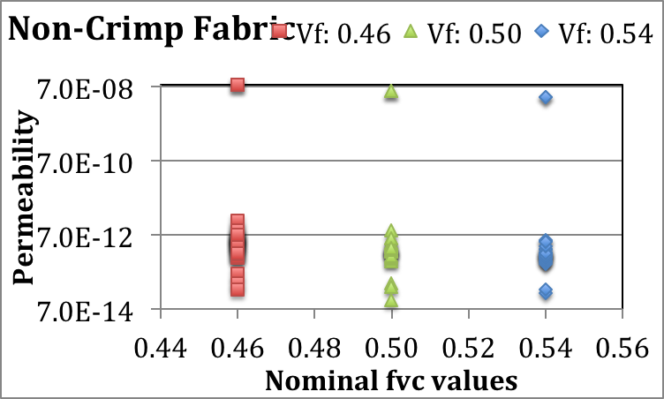
Outliers
Figure 4. Out-of-plane permeability results for the non-crimp fabric

After excluding the two sets of results that are different from the majority, the average permeability cv values are 92%, 83%, 73%, and 40% for the woven-saturated, woven-unsaturated, non-crimp saturated and non-crimp unsaturated cases, respectively.
The sources of variations could be caused by several reasons, such as the test methods, test setups, cavity deformation, race tracking and viscosity values calculated from the functions fitted to the measured viscosity values. This study showed how the out-of-plane permeability is currently measured and how large the scatter is due to the differences.

4.3. Compressibility Benchmark Exercise
As described in Section 3.2, a simple test procedure was prescribed for all participants to follow. This required compaction of the textile specimens down to 3 mm from a 10-mm reference point. There were 3 test groups: i) sample area < press area, ii) sample area > press and iii) sample area = press area.
Due to the test setups and the compliance factors, the maximum pressure levels were achieved at slightly different thicknesses. Some representative pressure versus thickness curves are shown in Figure 5, exemplarily for the tests with the dry non-crimp fabric.

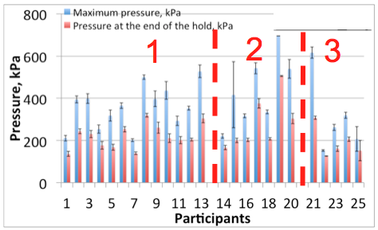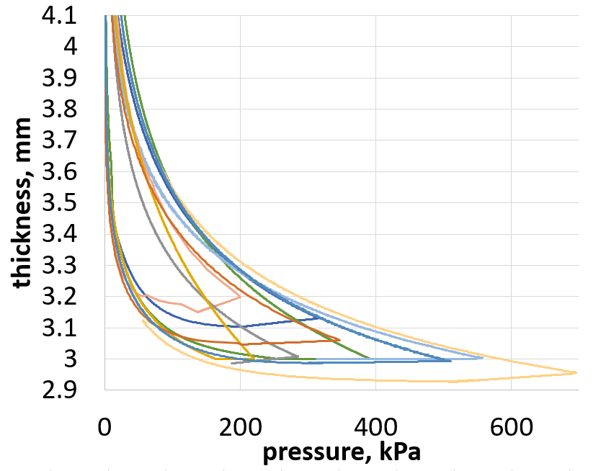
a) Non-crimp dry b) Non-crimp dry graphs
Figure 5. Maximum pressure vs. maximum thickness for dry non-crimp fabric

Figure 6 exemplarily shows the thickness values at 1 bar pressure for the non-crimp fabric. The red lines in the graphs in Figure 6 are representing the average values. The average of the cv values for the thicknesses are 0.93%, 1.06%, 0.81% and 1.17% for the woven-dry, woven-wet, non-crimp-dry and non-crimp-wet, respectively.

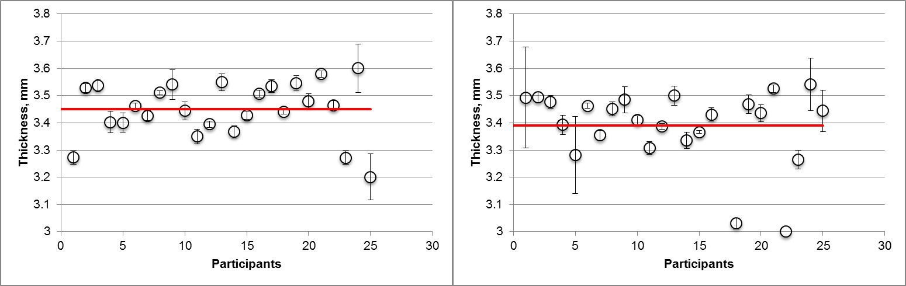
a) Non-crimp dry b) Non-crimp wet
Figure 6. Thickness values at 1 bar pressure for the non-crimp fabric

5. Conclusions

The benchmark studies revealed several sources of variation and will support institutions in improving their setups and methods. Further, another step towards standardization was made. At the FPCM14 held in Luleå (Sweden), the results of all three benchmarks were discussed and further programme of work was drafted.
Concerning the in-plane radial permeability, the next step will be to derive from the benchmark results minimum requirements for measurement systems and guidelines for performing the measurements: subsequently, following these guidelines and with few systems that meet all requirements, some last open questions, i.e. on the comparability of linear and radial injection method-based values, will be answered by a series of smaller topic-focused benchmarks.
For out-of-plane permeability and compressibility the benchmarks delivered an extensive technology review and will allow the derivation of stricter requirements and guidelines for subsequent benchmark studies. This approach follows the successful strategy of the in-plane permeability benchmarks.
Additionally, a “virtual permeability” benchmark study will be launched, focusing on numerical simulation of permeability characteristics.
In the near future the results of all three benchmarks will be published in detail in three separate, peer-reviewed papers.

Acknowledgements

First of all we thank all participants (listed in Table 1) for their pleasant cooperation and patience.
Furthermore, it is kindly acknowledged that the textile manufacturing companies Saertex GmbH and Hexcel supported the benchmark by supplying the materials free of charge.
It is also kindly acknowledged that the benchmark organization was strongly supported by the members of the steering committees: Prof. Peter Mitschang from the Institute for Composite Materials (IVW), Dr. Ewald Fauster from the Montanuniversität Leoben, Prof. Andy Long and Dr. Andreas Endruweit from the University of Nottingham, Prof. Suresh Advani from the University of Delaware, Prof. Stepan Lomov from the KU Leuven, Dr. Christian Lira from the National Composites Center, Prof. Francois Trochu from the Polytechnique Montreal and Prof. Paolo Ermanni and Mario Danzi from the ETH Zürich.
We also thank Kalle Kind from TU Munich for performing all viscosity measurements and David C. Berg from TU Clausthal for the kind support during the fluid procurement phase.

References

[1] R. Arbter et al. Experimental determination of the permeability of textiles: A benchmark exercise. Composites Part A: Applied Science and Manufacturing. Volume 42, Issue 9, September 2011, Pages 1157–1168.
[2] Alms, JB et al. Experimental procedures to run longitudinal injections to measure unsaturated permeability of LCM reinforcements. FPCM 2010.
[3] Vernet, E. et al. Experimental determination of the permeability of engineering textiles: Benchmark II. Composites Part A: Applied Science and Manufacturing. Vol-ume 61, June 2014, Pages 172–184.
[4] Aktas, A. et al. Survey of procedures in use for permeability measurements in Liquid Composite Moulding processes. NPL Report MAT 82, ISSN 1754-2979, May 2016.

