On the selection of alternative Out-of-autoclave manufacturing methods for composite aircraft components

M.Bodaghi¹, R. Gomes¹, J.Silva¹, R.Costa¹ and N. Correia¹

¹Country INEGI-Institute of Science and Innovation in Mechanical and Industrial Engineering, Campus FEUP, Porto, Portugal
Email: mbodaghi@inegi.up.pt, Web Page: http:// www.inegi.pt

Keywords: Void, Controlled atmospheric infusion, VAP membreane, Double bag

Abstract

Given the increasing use of continuous fibre polymer composites (CFPC), the working hypothesis of this article is that substituting AC with Out-of-autoclave (OoA) manufacturing methods, in particular those that deliver autoclave-quality components, will become a major industry driver of composite materials. Liquid Composite Moulding (LCM) is one of the most relevant OoA technology families and experience with this technology has shown that it is possible to manufacture autoclave-quality components. A considerable collection of variants for LCM composite process can be both found in literature as well as in industry. Each manufacturing process provides different benefits that must be carefully taken into account depending on the final application of the desired composite. For the fabrication of composite panels using dry carbon fabric and epoxy resin as base constituents, the chosen manufacturing techniques are Double Vacuum-Bag Infusion (DVBI), Controlled Atmospheric Pressure Resin Infusion (CAPRI), Vacuum Assisted Processing (VAP). After manufacturing, the achieved properties and performance of panels from each processing method are assessed by determining the final thickness, void content, and fibre/resin content.

1. Introduction

Due to the cost of hard tooling as well as design difficulties, Vacuum Assisted Resin Transfer Molding (VARTM) has been developed as a variant of the traditional Resin Transfer Moulding (RTM) process. In VARTM, the upper side is a flexible mould made from silicon or a polymer film such as nylon, with no need of a two-side rigid mould as in the RTM process.
To achieve a reliable, reproducible and qualitatively robust infusion processes, several parameters have to be appropriately adjusted. Increasing efforts have been made in the infusion process techniques. In this context, both process development and process handling are not trivial.
In a vacuum bagged process, one need to deal with the complex compaction stage to prevent some possible processing defects such as voids and inherent thickness gradiant. Several variations of resin infusion processes have been developed and patented in order to address these requirements. These can be divided in three main variants: (i) successive bulking and debulking prior to resin infusion [1], (ii) debulking after resin infusion[2], [3], and (iii) nano-porous membranes[4]. Two first variants was developed to improve uniformity on the thickness of final composite part and increase fibre volume fraction. The later variant is the integration of a porous membranes as a surface layer, cleaning out gases and volatiles from the complete part exterior[5]. The fine control over the alternative manufacturing processes, with the potential to reduce voids, is crucial to obtain composite components with high fibre volume fraction with low thickness tolerances. However, there is little evidence to support the effects of such variants and their implementation whether meet the required criteria of aerospace industry. Furthermore, there is no comparison among these alternative manufacturing processes and it is not clear how much good even the best infusion process could improve the quality of composite parts over autoclave process.
This paper aims to combine both void content and fibre volume fraction assessment and apply them to composite panels produced with the different variants of infusion processes. The work also aims to identify the best infusion variant based on a comparison of final performances that each of the process offer. The materials considered for this comparative study are carbon fabric and a PRISM® EP2400 resin system.

2. Materials and characterization method

Two types of fabrics are used for these comparative manufacturing trials. A stain woven carbon fabric and a non-crimp carbon fabric (NCF) plus a PRISM® EP2400 resin system are used depending on the fabrication conditions performed for each of the cases.

Taguchi’s Orthogonal Arrays (OA) is applied to combine three parameters including fabric architecture, number of plies, and pressure gradient between the vent and the inlet (resin front) affecting the process and the two levels at which they should be varied; this experiment desing allows for the collection of the necessary data to determine which factors most affect product quality with a minimum amount of experimentation (Table.1).

Table 1. Write Experimental design using orthogonal array.

Treatment name | Fabric architecture | Number of layers | Pressure gradient (bar)
Run I | Woven | 6 | 600
Run II | Woven | 10 | 950
Run III | NCF | 6 | 950
Run IIII | NCF | 10 | 600

The fibre fraction and resin content of cured composite plates are determined based on the burning matrix technique as described in ASTM D 2734.

3. Results and discussion

2.1. Fibre volume fraction

As observed from Figure.1, CAPRI and DVBI for the case of woven fabric resulted in relatively high fibre volume fraction (55%). While with VAP for different scnarios is not possible to arrive more than 50%. This means that the VAP cannot provide efficient compaction force to compact the reinforcement to the desired thickness even though that membrane can provide unified thickness. But the story with NCF is completely different. All manufacturing process are not able to deliver a laminate with fibre volume fraction more than 50% on average. This may be due to two fundamental reasons: the first is due to the structure of NCF which is less compressible than woven fabric and hence the strategy of compaction in the current fashions would not be able to high fibre volume fraction. Additional the veil is another conclusion. The veil is a barrier for the compressibility and a well defined conditions by temperature is necessary to compact the veil. Overall , one can produce high quality if one can correlate the process variables with the geometric characteristics of fabrics.

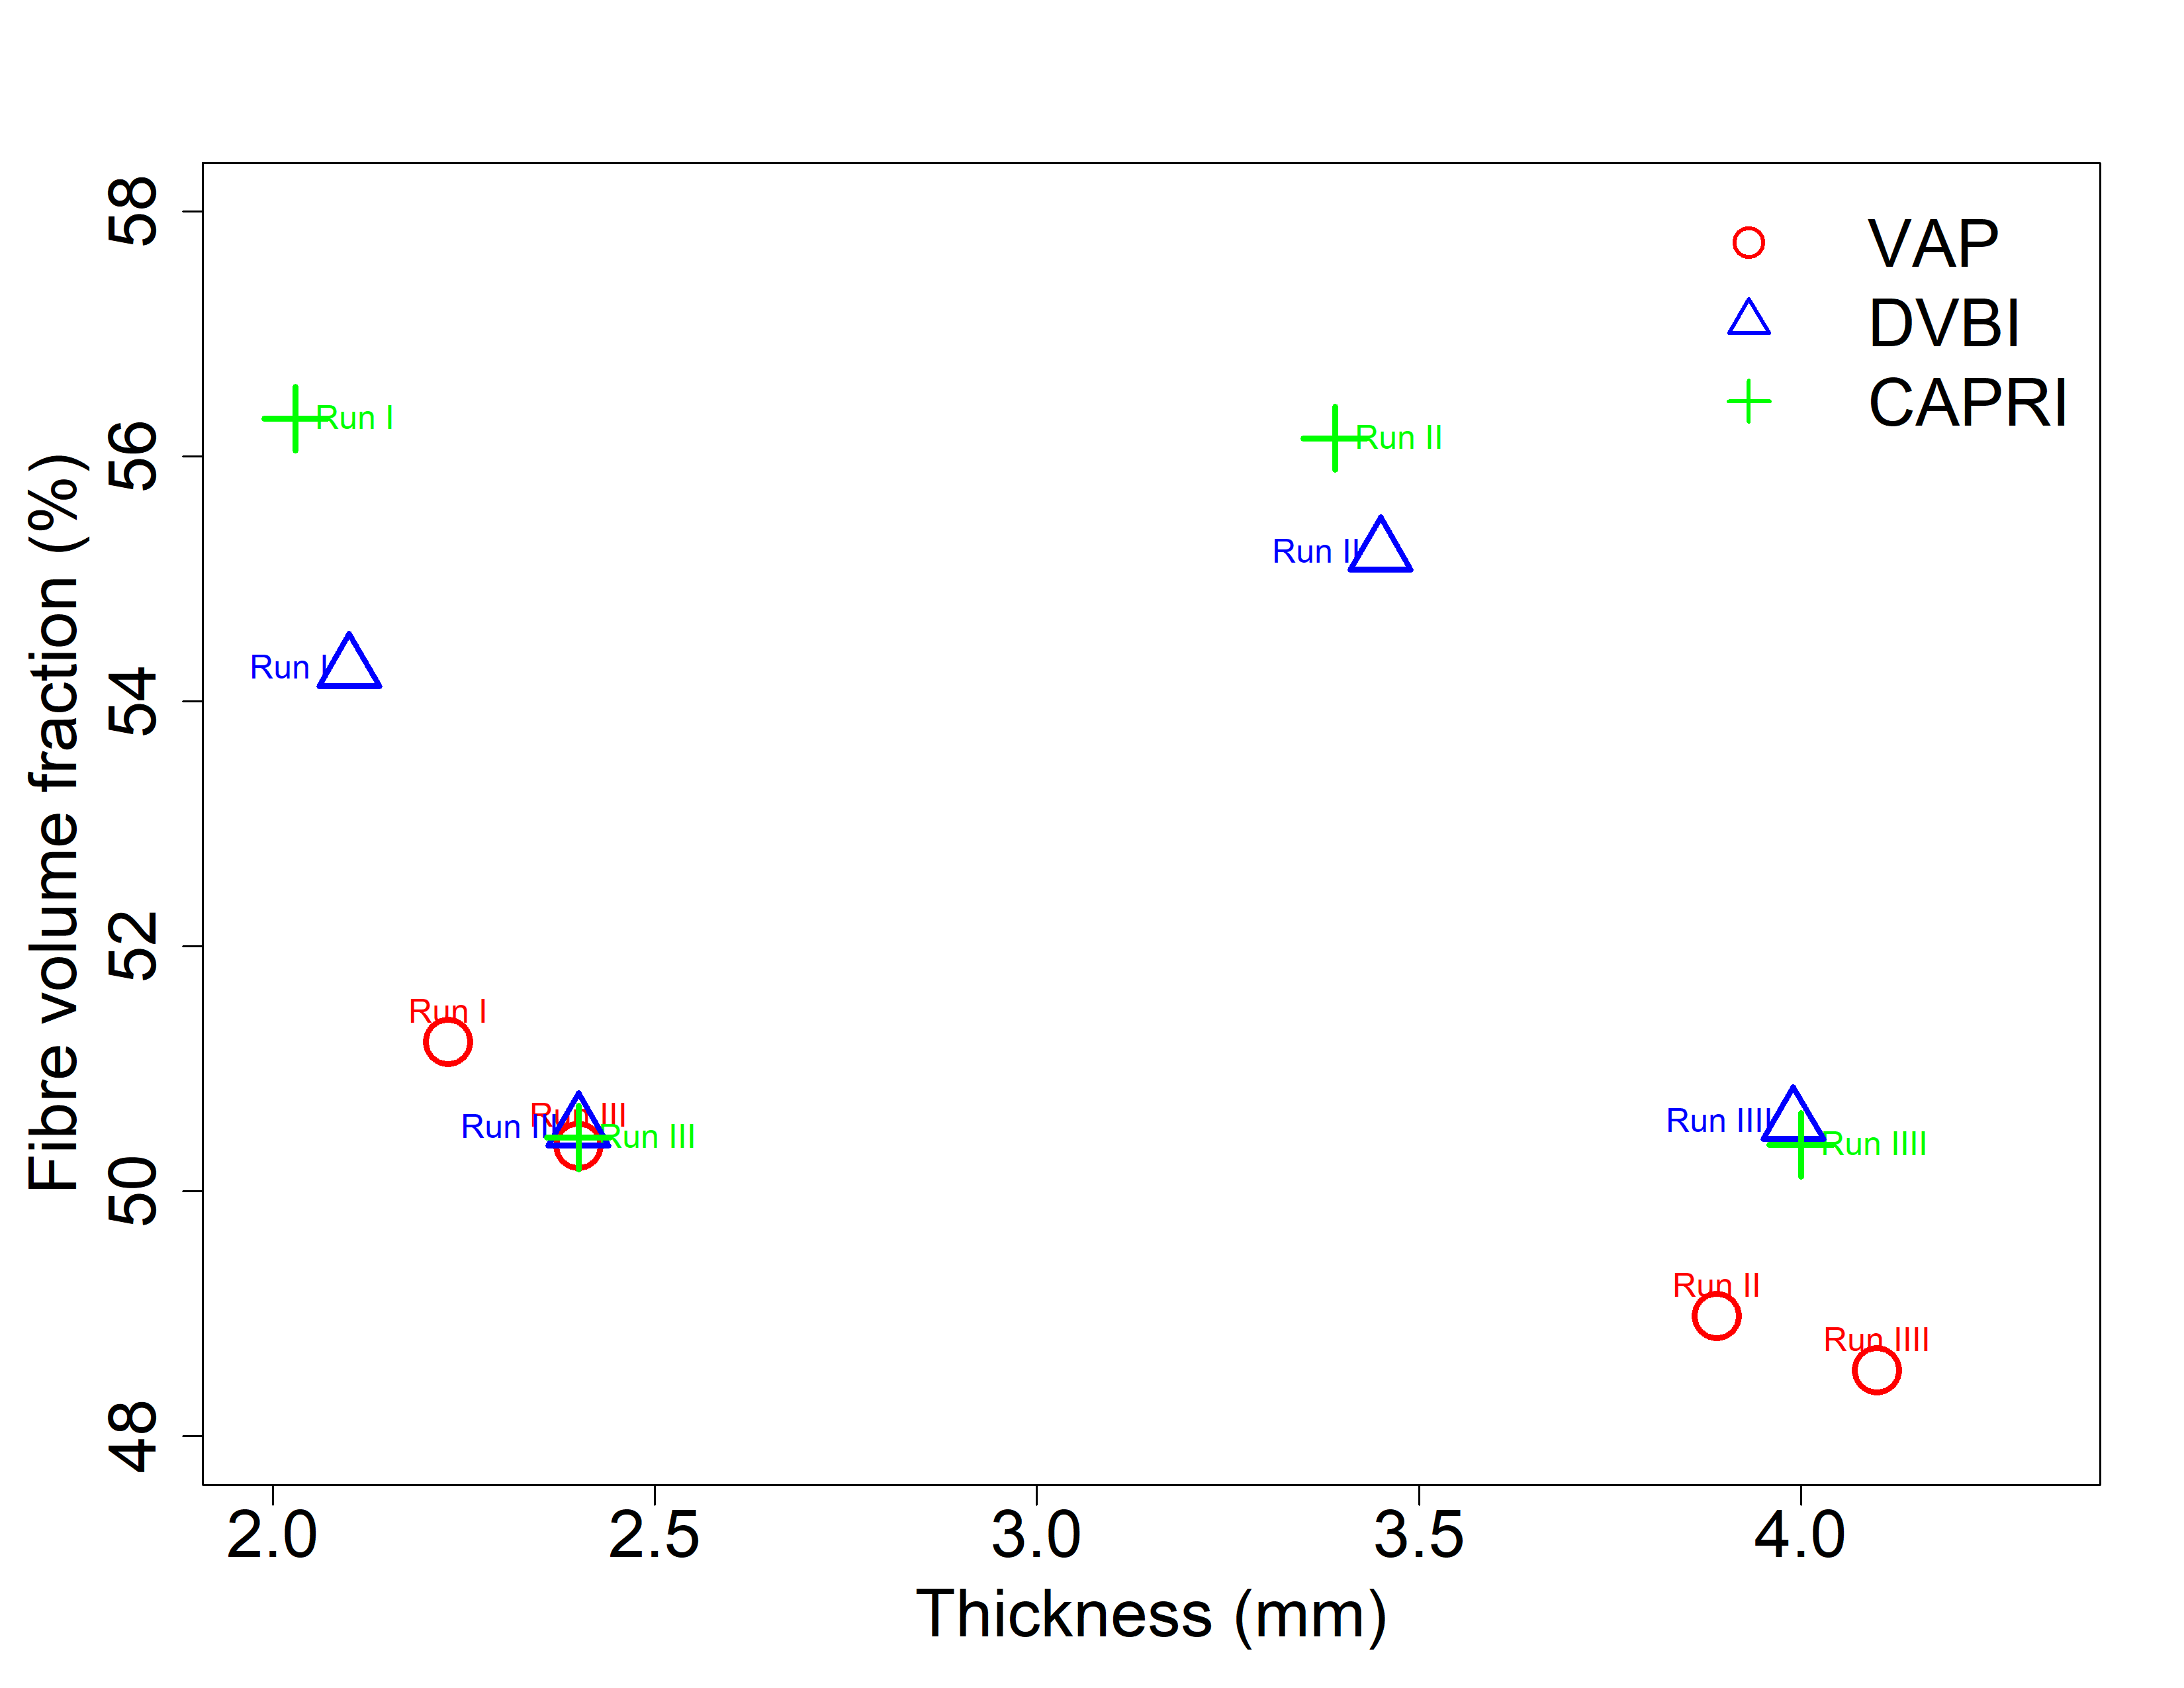
Figure 1. Fibre volume fraction for different manufacturing configurations.

2.1. Void content

The void content was evaluated for each bagging arrangement. The bar charts of results are given in Figure.2. The results correlate well with the variation of thickness. More variation in thickness over laminate resulted in more void content. This means that the variation of thickness leads more spatial variation of reinforcement geometry and hence flow will locally change , leading to more probability of void formation. One the other hand, the process with less variability in thickness would provide better control over fluid flow inside the fibrous media and hence the probability of void formation would be less because of less lead lag. As reported by the Figure.1, CAPPRI as well as VAP leads to less void content while the DBVI yielded the highest void content. One obvious different between two first processes with the early one is the no presence of second breather. Because this breather prevented providing an effective compaction on the laminate during consolidation step.
Furthermore, it is observed that one cannot take a clear conclusion on the influence of the type fabric on the magnitude of void content. But for same compaction force, the laminates constructed with the woven fabric leads to less void content compared to non-crimp fabric. This may attribute to the geometric construction of fabrics. At high compaction pressure, the woven fabric can easily nested to each other due to longer float while the stitches prevent the NCF from free movement. But this compressibility property can significantly contribute to thickness reduction as well as fibre volume fraction.
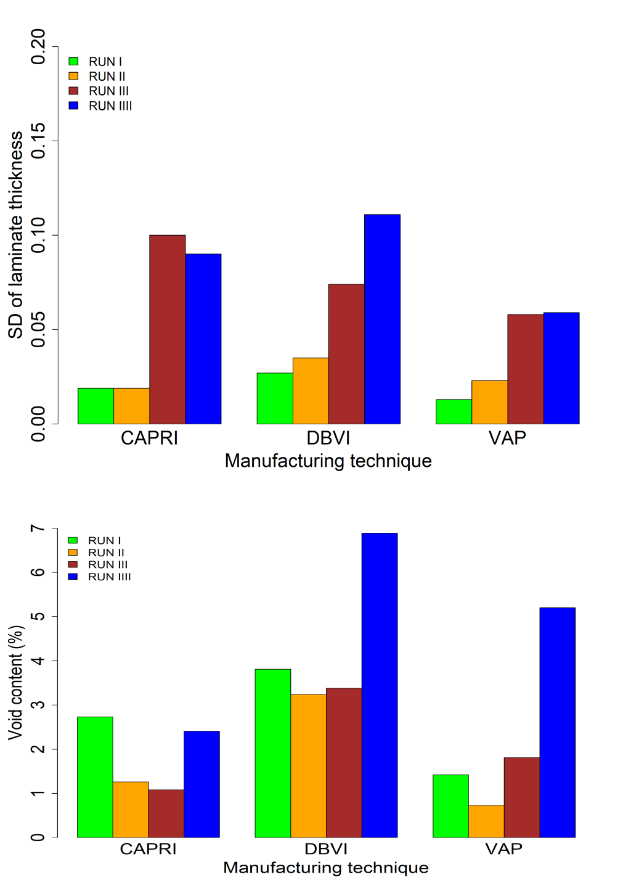
Figure.2: The average variation of thickness(top ) and average void content (bottom) for the different tested configurations

4. Conclusion
In the current work, the team examined the different variants of Vacuum Assisted Resin Transfer Molding and compared their potential for manufacturing plates with low void content (<1%) and high fibre volume fraction (60%>). A series of experiments was carried out, and these showed that non of these process variants alone could provide a laminate with low void content as well as high fibre volume fraction . To deliver a laminate with the high quality, these alternative out-of-autoclave manufacturing process require further optimisation among process parameters. These challenges continue to be explored in INGEI’s task.

Acknowledgments

The authors gratefully acknowledge the funding of Project NORTE-01-0145-FEDER-000022 - SciTech - Science and Technology for Competitive and Sustainable Industries, cofinanced by Programa Operacional Regional do Norte (NORTE2020), through Fundo Europeu de Desenvolvimento Regional (FEDER).

References

[1] C. Niggemann, Y. S. Song, J. W. Gillespie, and D. Heider, “Experimental investigation of the Controlled Atmospheric Pressure Resin (CAPRI) process,” J. Compos. Mater., vol. 42, no. 11, pp. 1049–1061, 2008.
[2] L. A. Khan, A. H. Mahmood, S. Ahmed, and R. J. Day, “Effect of Double Vacuum Bagging ( DVB ) in Quickstep Processing on the Properties of 977-2A Carbon = Epoxy Composites,” Polym. Compos., vol. 34, no. 6, pp. 942–952, 2013.
[3] H. M. Chong et al., “Out-of-autoclave scarf repair of interlayer toughened carbon fibre composites using double vacuum debulking of patch,” Compos. Part A, vol. 107, pp. 224–234, 2018.
[4] J. Filsinger, T. Lorenz, F. Stadler, and S. Utecht, “Method and device for producing fiber-reinforced components using an injection method,” 2003.
[5] T. H. Hou and B. J. Jensen, “Evaluation of Double-Vacuum-Bag Process For Composite Fabrication,” in SAMPE, 2004.

