Embedding miniaturized flexible sensors for online monitoring of fibre composite production

Martina Hübner¹, Michael Koerdt², Elisabeth Hardi², Axel Siegfried Herrmann² and Walter Lang^{1,3}

¹Institute for Microsensors,-actuators and-systems (IMSAS), University Bremen, Otto-Hahn-Allee 1,28359 Bremen, Germany
Email: mhuebner@imsas.uni-bremen.de, Web Page: http://www.imsas.uni-bremen.de
²Faserinstitut Bremen e.V., Am Biologischen Garten 2, 28359 Bremen, Germany
Email: mkoerdt@Faserinstitut.de, hardi@Faserinstitut.de, herrmann@Faserinstitut.de, Web Page: http://www.faserinstitut.de
³Microsystems Center Bremen, University Bremen, Otto-Hahn-Allee 1, 28359 Bremen, Germany
Email: wlang@imsas.uni-bremen.de, Web Page: http://www.mcb.uni-bremen.de/

Keywords: material integrated sensor, online monitoring, miniaturized dielectric sensor, mechanical evaluation

Abstract
Online monitoring of the production of carbon fibre reinforced polymers (CFRPs) is an enabling technology for fast and reliable manufacturing of CFRP parts. Especially for complex shaped parts, sensors embedded inside the CFRP part, not only in the mould, are necessary for successful monitoring. As the embedded sensors remain inside the part also during the whole lifetime, it is necessary that they do not influence the structural integrity of the CFRP part. Therefore, we embedded different types of inlays representing sensors to evaluate the influence of the inlay on the mechanical properties of the CFRP part. With the fabricated specimens three-point bending tests and interlaminar shear tests were performed. A polyimide foil with holes showed the minimum influence while a silicon inlay showed a significant reduction of the mechanical stability. A miniaturized flexible dielectric sensor, which has a polyimide substrate with holes, was fabricated. With this sensor a successful cure monitoring inside the CFRP is possible.

1. Introduction

Fibre reinforced polymers (FRPs) are used in a huge range of application areas, like aerospace and automotive, due to their lightweight potential. In addition they offer excellent mechanical properties which can be designed adapted to the created structure [1]. Monitoring of the production of FRPs becomes more and more important to improve the quality and reduce the cost of the production. Especially online monitoring which allows receiving information about the process in real time enables the fabrication of complex shaped parts as the measured values can also be used for the direct control of the process. During the production the curing degree of the polymer matrix is an important factor to be monitored. A standard method for cure monitoring is the dielectric analysis [2], [3]. The used sensors can be located outside the FRP, for example in the mould. However, the curing process can be inhomogeneous over the complex fabricated part not only in complex parts. Therefore, sensors should be also placed inside the material. Sensors that are embedded inside the material have to fulfil several requirements: First, they have to be able to withstand the fabrication process without losing their functionality. Depending on the material process, high temperatures and pressure can appear. Secondly they should not influence the production process of the FRP. Thirdly the fabricated part should not be influenced by the sensor. The embedded sensor always creates a wound in the material but the structural integrity should be harmed as little as possible by the sensor. If the sensor is embedded successfully inside the FRP it can be used during the whole lifecycle of the produced part, for example for structural health monitoring.
Here we focus on the effect of the sensor on the mechanical integrity of the produced FRP part. Therefore, we produce different types of inlays which replace the sensor in a first instance. The inlays differ in material and shape. These inlays are embedded in a unidirectional carbon fibre reinforced polymer plate. Mechanical test are performed with samples with inlays and compared to samples without inlays.
In addition we fabricate a miniaturized interdigital sensor based on the results of the mechanical test. This sensor is embedded inside the CFRP and the curing degree is measured.

2. Mechanical evaluation

2.1 Material and Methods

The developed sensor should remain inside the fabricated CFRP parts. Therefore, the influence of the sensor on the mechanical integrity of the fabricated material should be minimal. The main influence of the sensor can be expected from the substrate material. We expect that a thick and non-flexible substrate has a higher impact on the mechanical properties of the composite than a smaller, more flexible one [4]. Hence, we choose polyimide (PI) as a substrate material. It can be fabricated in a thickness which is in the range of the diameter of the fiber, is flexible and mechanical stable. In addition it is compatible with the microfabrication process used for the manufacturing of the sensor. Furthermore it is able to withstand the processing of the CRFP part at 180 °C. To evaluate the influence of the substrate on the mechanical properties of the CFRP part a three-point bending test and an interlaminar shear test are performed. In the test three different types of polyimide substrates are compared with a silicon (Si) inlay and reference specimens with no inlay. Silicon is chosen here because it is the typical substrate material of microsensors. In table 1 the geometrical properties of the four types of inlays are described. The PI inlays are fabricated using a precursor from UBE which can be spin coated on a silicon wafer and cured. Afterwards the PI is structured in a dry etching process and the PI film is released from the Si handling wafer. This results in 5 µm thick PI inlays. For the Si inlays a double side polished 380 µm thick Si wafer is diced with a wafer saw in the required specimen size.

Table 1. Specification of the inlays.

Inlay type | Width (mm) | Length (mm) | Height (µm) | Specimens per Three-Point Bending Test | Specimens per Interlaminar Shear Test
Silicon | 6 | 6 | 380 | 11 | 5
Long Polyimide | 6 | 12 | 5 | 11 | 10
Polyimide | 6 | 6 | 5 | 12 | 10
Polyimide with holes | 6 | 6 | 5 | 12 | 5

The inlays were embedded in unidirectional laminates made of prepreg plies containing Cytec 977-2 epoxy resin and carbon fibres of type HTS40. Plates of a total size of 600 mm x 600 mm are fabricated using eight layers, which results in approximate thickness of 2 mm. The laminate layers were placed on a metal plate. In between a Teflon foil is used to be able to separate the CFRP plate from the metal plate. For the three-point bending test the inlays were placed between layer 7 and 8 while for the interlaminar shear test the inlays were placed between layer 4 and 5. On top, another Teflon foil and metal plate are placed. This setup is placed in a press where a pressure of 8 bar and a temperature of 180 °C are applied. After four hours the press is switched off. The plate remains inside the press for another 12 hours to cool down. After demolding the plate is sawed in small plates of sizes 100 mm x 100 mm. From these plates the specimens are diced with a wafer saw. For the three-point bending test the specimen size is 10 mm x 15 mm according to DIN EN ISO 14125 and for the interlaminar shear test it is 20 mm x 10 mm according to DIN EN 2563. In figure 1 the three-point bending specimens are shown. The inlays are always located in the middle of the specimen, as illustrated. For the three-point bending test at least 10 specimens were tested, for the interlaminar shear test at least 5 specimens are used, see table 1. The three-point bending test was performed on a mechanical testing machine from the company DYNA-MESS.

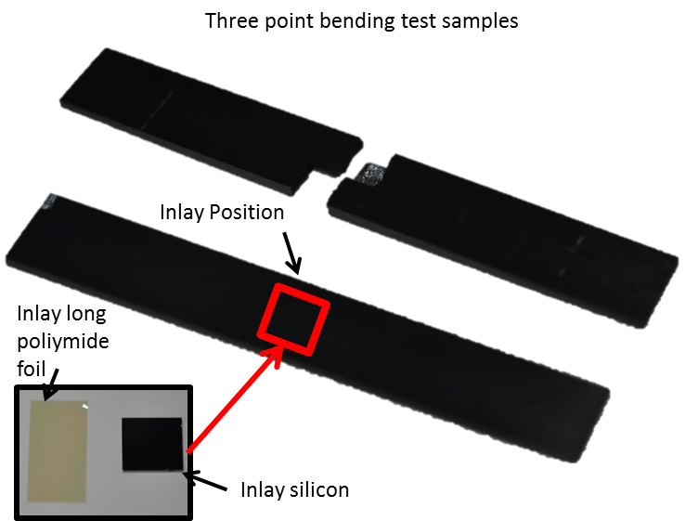

Figure 1. Three-point bending test specimens. Inlay type long polyimide foil and silicon are shown on the left side. Broken three-point bending test specimen is shown on the right.

2.2 Results and Discussion

The results of the mechanical tests are shown in figure 2. The average breaking force of the three-point bending test is in the same range for the samples with the polyimide inlay and without an inlay while the maximum breaking force for the ones with the silicon inlay is much smaller. This was expected as the silicon specimens had the largest geometrical dimensions and the mechanical material parameters are quite different to the ones of the CFRP. The silicon inlay is very stiff compared to the rest of the material which causes breaking at comparably low forces. Looking at the values for the reference sample it can be seen that the standard deviation is in the range of the other samples. Therefore, it can be expected that the deviation results from defects in the material itself for example pores. In case of the foil with holes the standard deviation is slightly higher. During the embedding in some cases the foils buckle because they are very flexible. This can create some further deviation. Looking at the mean values of the breaking forces, the specimens break in the expected order. The most stable one compared to the reference is the one with the holes in the polyimide foil followed by the one without holes but in the same sizes and the one which has double the sizes of the other. The breaking force of the sample with the inlay with holes is only reduced by 2.7% while the silicon inlay reduces the breaking force by 29.8%. Using a polyimide foil with holes instead of a common silicon chip reduces the influence on the CRFP part in a three-point bending test by a factor of 10.
Comparing the results of the interlaminar shear test with the three-point bending test, it can be seen that the standard deviation for the interlaminar shear test is a bit smaller. The samples for the two different tests are not from the same plate. Therefore, these are also the deviation between two plates. In case of the long polyimide foil inlay the standard deviation is higher. This inlay already uses 36% of the area of the whole specimen. The inlays can move slightly during the production. This can cause the observed differences here. Looking at the mean breaking forces it can be clearly seen that the silicon inlay reduces the interlaminar shear strength as it was also expected from the three-point bending test. The mean breaking force of all other sample types is in the same range. The highest mean breaking force can be observed for the long polyimide foil. Looking at the measurements in detail it can be seen that in case of the specimens with inlay precracks happen. These are not considered in the evaluation but they represent a kind of weakening of the material. In figure 3 a force-way-diagram with two representative curves of a reference specimen and a sample with long polyimide foil are shown. At a force of 830 N the first precrack can be seen for the specimen with a long polyimide foil.
In general it can be stated from the interlaminar shear test that the silicon inlay significantly influences the mechanical stability of the CFRP part while no difference of the polyimide inlays can be observed.

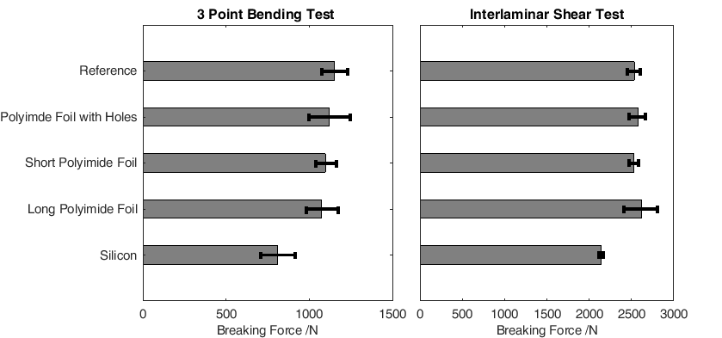

Figure 2. Mean value and standard deviation of the maximum breaking force for a (a) three-point bending test and (b) a interlaminar shear test.

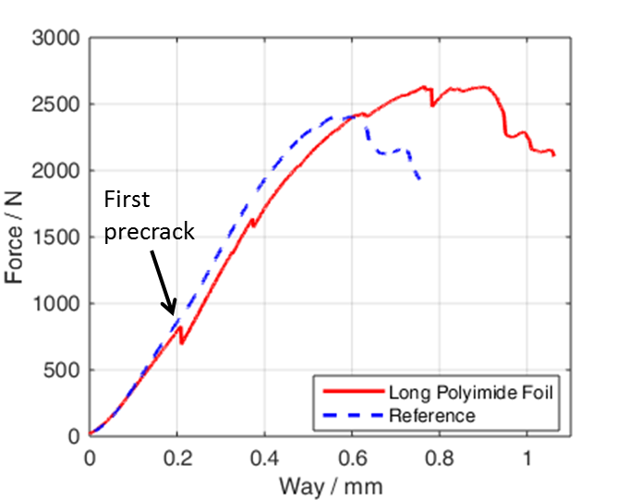

Figure 3. Force way diagram of a representative specimen with a long polyimide foil inlay and a reference specimen without any inlay during the interlaminar shear test.

3. Sensor fabrication

As demonstrated comparing polyimide foil and silicon substrates the polyimide foil is favourable. Therefore, we fabricate our sensor based on a polyimide substrate. The first step is the spin-coating of the polyimide precursor on a silicon wafer, which only acts as a handling device. After curing this results in a 5 µm thick polyimide. On top a 300 nm thick gold layer is sputtered and wet-chemically structured in an interdigital structure [5]. As carbon fibres are conductive an insulating top layer is needed. Here we use a thin polyimide layer of about 500 nm which is again spin-coated. Finally holes are etched in the polyimide and the sensor is released from the wafer. The fabricated sensor is embedded in the CFRP laminate in the same manner described above for the inlays.

4. Cure monitoring

In figure 4 the absolute value of the impedance is shown over time at a frequency of 32.6 Hz. The impedance can be directly correlated to the curing degree. After a temperature of 180 °C is applied the impedance drops. During this time the viscosity of the matrix resin drops. Therefore, the free charges inside the resin can move in the electric field causing the impedance drop. After a certain time the cross-linking of the polymer starts resulting in a raising viscosity. Hence the impedance starts to rise again. After roughly 4 hours the impedance stays at a constant level indicating that no further curing will happen under the given conditions. The matrix resin is cured.
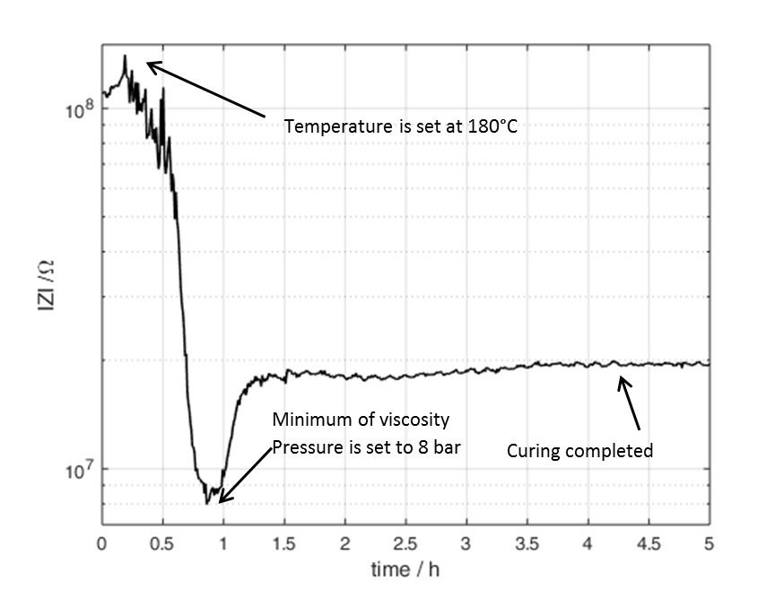

Figure 4. Absolute value of the impedance over time of an embedded miniaturized dielectric sensor during the curing process of a CFRP part at 180 °C and a pressure of 8 bar. The shown measurement was recorded at 32.6 Hz.

6. Conclusion

We fabricated different types of polyimide inlays, as well as a silicon inlay and embedded them in a unidirectional prepreg carbon fibre laminate. With specimens with embedded inlays, we realized three-point bending tests and interlaminar shear tests. Both mechanical tests confirmed that the silicon inlay weakens the CFRP part. All types of polyimide inlays show a significantly lower influence on the mechanical properties than the silicon inlay. From the three-point bending test it can be assumed that a polyimide foil with holes is the least invasive inlay. Therefore, we used such a substrate for our miniaturized dielectric sensor which was embedded inside the CFRP part and used for online monitoring of the curing degree of the matrix resin. We demonstrated that cure monitoring is possible with an embedded miniaturized sensor. This sensor is realized on the basis of a 5 µm thick polyimide substrate. We verified that this substrate does not harm the structural integrity compared to a silicon substrate.

Acknowledgments

The work is funded by the German Research Foundation (DFG) within the project “Kammsensor: Integration flexibler kapazitiver Sensoren in Polymere zur Überwachung von Polymerisations- und Degradationsprozessen “ (LA 1471/17-1 and HE 2574/31-1).

References

[1] D. H. Kim, D. H. Choi, and H. S. Kim, “Design optimization of a carbon fiber reinforced composite automotive lower arm,” Composites Part B: Engineering, vol. 58, pp. 400–407, 2014.
[2] M. C. Kazilas and I. K. Partridge, “Exploring equivalence of information from dielectric and calorimetric measurements of thermoset cure-a model for the relationship between curing temperature, degree of cure and electrical impedance,” Polymer, vol. 46, no. 16, pp. 5868–5878, 2005.
[3] Y. Yang, G. Chiesura, G. Luyckx, T. Vervust, F. Bossuyt, M. Kaufmann, J. Degrieck, and J. Vanfleteren, “Development of a Dielectric Sensor System for the On-line Cure Monitoring of Composites,” Procedia Technology, vol. 15, pp. 632–638, 2014.
[4] G. Dumstorff, S. Paul, and W. Lang, “Integration without disruption: The basic challenge of sensor integration,” IEEE Sensors Journal, vol. 14, no. 7, pp. 2102–2111, 2014.
[5] M. Hübner, G. Dumstorff, and M. K. Moghaddam, “Online monitoring of the curing of adhesives with a miniaturised interdigital sensor using impedance spectroscopy,” Journal of Adhesion Science and Technology, vol. 4243, no. November, pp. 1–15, 2017.

