Numerical Simulation and Analysis of Curing Deformation of Stiffened Composite Structure

Jiang Ting1, Li Shengzhe1, Wang Qian¹, Liu Xiaodong¹, Guan Zhidong¹

¹ School of Aeronautic Science and Engineering, Beihang University, Beijing, China
Email: BY1505175@buaa.edu.cn, lishengzhe@buaa.edu.cn, rualpapaya@126.com, liudongdong@buaa.edu.cn, zdguan@buaa.edu.cn

Keywords: Composite, Spring-in, Stiffened Structure, Influencing Factor, Finite Element Method

Abstract
A non-liner elastic finite element analysis method for predicting the curing deformation of composite structures was established in this paper. The method simulated the entire curing process of composite materials and simplified resin during the curing process into two states: rubbery state and glassy state. Two different material properties were used in different states by updating the Jacobian matrix of materials using finite element method. The influence of thermal shrinkage, chemical shrinkage of resin, mold, interlaminar stresses and modulus on the curing deformation of the composite structure was considered. By using the established FEM, the spring-in of L-shaped composite structures made of T700/5429 was predicted and compared with the experiment results to verify the validity and accuracy of the method. The verified method was used to simulate the curing deformation of the stiffened composite structure. The results indicate that the spring-in of skin increases with the length and thickness of stiffener, but the increasing trend does not appeal to be linear. Skin length and stiffener radius exhibit an inhibitory effect. A linear relationship exists between stiffener radius and spring-in, while the relationship between skin length and spring-in is non-linear. Stiffener height and shape hardly have influence on spring-in.

1. Introduction

Stiffened composite structures are becoming widely used in aerospace field, of which the molding process usually includes co-curing, co-bonding and secondary bonding. The co-curing process indicates that the uncured skins and the stiffeners are put into the autoclave for curing at the same time. The co-bonding process refers to the curing of the stiffeners alone first, and then the uncured skins and cured stiffeners curing together. In the secondary bonding process skins and stiffeners are cured separately, then clued and cured in the autoclave.

Spring-in is the main component of curing deformation of composite structures with corners, caused by many factors, including anisotropic thermal shrinkage, the chemical shrinkage of the resin and the difference of thermal expansion coefficient between the composite material and the mold ^{[1-2]}. Many scholars have used the linear elastic model to simulate and study the curing deformation of composites ^{[3-4]}. But non-linear elastic method is becoming a trend of study because of its better applicability ^{[5-6]}.

At present, the deformation of L-shaped structure has been studied a lot while the deformation of T-shape structure is barely studied, and most of the studies use the linear elastic model. Also, there is no research on the effects of individual structural parameters. Therefore, the curing deformation of T-shaped structure still needs further studies.

In this paper, the skin structure with T-shaped stiffeners is taken as the research object and a three-dimensional finite element model is established to simulate the whole curing process of the composite T700/5429. The model can simulate the stress distribution and deformation accumulation process before the glass transition temperature and predict the spring-in of stiffeners and warpage of skins after curing. At the same time, the effects of different structural parameters on curing deformation are analyzed, including the height, thickness, length, shape, corner radius of stiffeners and the length of skins.

2. Finite Element Method of Curing Process Simulation

2.1. Analysis and simplification of curing process

The curing process of T700/5429 is divided into five stages according to the physical and chemical changes of the resin, as shown in Fig. 1.

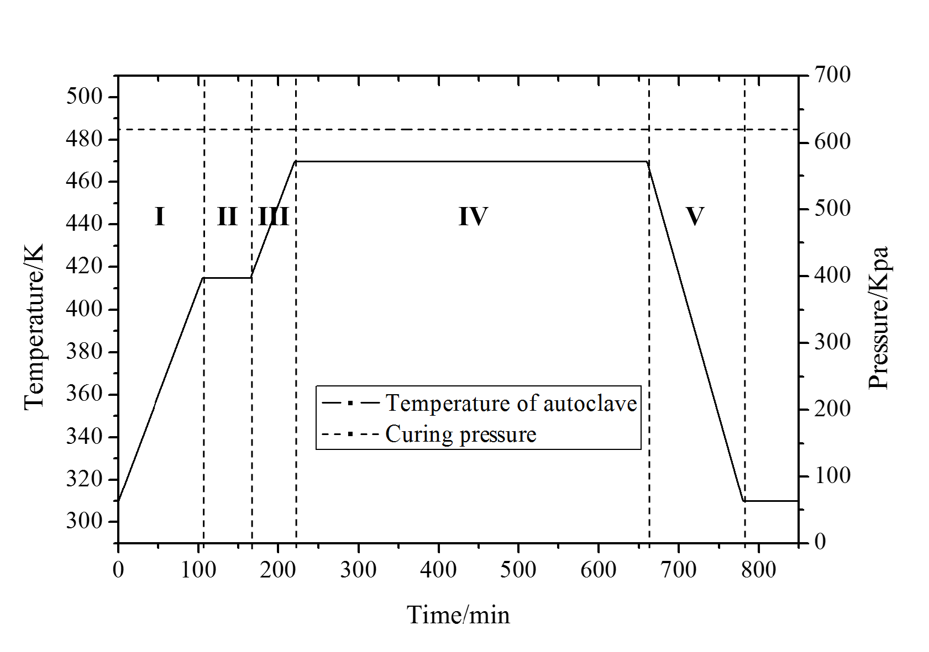

Figure 1. The curves of the cure cycle of T700/5429.

In the first heating stage (stage I), a cross-linking reaction of resin occurs and the viscosity of resin gradually decreases. With the pressure in the autoclave increasing to 0.62 MPa, the internal stress in the composite structure began to appear.

In the first thermostatic stage (stage II), the cross-linking reaction continues, viscosity of resin reaches a minimum and most of the stress is taken by the fiber-net structure. The chemical shrinkage of the resin will lead to the internal stress, which will affect the curing deformation of structure.

In the second heating stage (stage III), the resin begins to gel and reaches its glass transition temperature with its viscosity gradually increasing. At this stage, the influence of stress, mold and interlaminar stress on the deformation still exists. The chemical shrinkage of the resin reaches its maximum, and its effect on the curing deformation is also maximized. At this stage, the modulus of the resin increases by several orders of magnitude. The stresses and deformations generated in the first three stages accumulate inside the composite structure, affecting the final deformation.

In the second thermostatic stage (stage IV), the modulus of materials increases and tends to be stable with the reaction finished. At this stage, the chemical shrinkage and modulus of the resin will have an effect on the cure deformation of the composite.

The last stage is the cooling process (stage V), the composite structure is cooled down to be released from the mold. The thermal shrinkage at this stage is the main reason that causes the deformation.

After the analysis of the physical and chemical changes during the processing, the curing deformation influencing factors are summarized into: mold, interlaminar stress, thermal expansion coefficient, resin shrinkage and material modulus, as shown in Table 1. According to this, the curing process can be simplified into two parts, corresponding to two different states of resin: rubbery state and glassy state. In the first part, the cross-linking reaction occurs, the chemical shrinkage of resin and mold play a major role on the influence on curing deformation. In the second part, the composites are cooled down and released from the mold while the thermal shrinkage of the composite plays a main role on influencing curing deformation.

Table 1. The factors on curing deformation in cure process

Factors | I | II | III | IV | V
Mold | * | * | *
Interlaminar stress | * | * | *
Thermal expansion | * |  | *
Resin shrinkage | * | * | * | *
Thermal shrinkage |  |  |  |  | *
Modulus | * | * | * | *

2.2. The realization of the model in Abaqus

A two-step model is established to simulate the curing process using finite element analysis software Abaqus and its subroutine UMAT. In the first step, the properties of rubbery state are given to the materials. The procedure of temperature and pressure, a contact between the mold and the composite structure and the set of chemical shrinkage of resin are created. In the second step, the properties of resin are replaced with the glassy one. To simplify the conversion process, the thermodynamic properties are converted instantaneously in stage IV. Cooling, pressure relief and demolding set are completed in the step.

The material properties of resin in rubbery state are usually obtained by quoting similar materials ^{[7]} , while material properties of resin in glassy state are obtained by experiments. The chemical shrinkage of resin is estimated empirically and converted to line shrinkage ε of single layer of composites in three directions ^{[8]}, as listed in Table 2.

Table 2. The material properties of T700/5429
Properties | E(GPa) |  |  | ν |  |  | G(GPa) |  |  | α(με/℃) |  | ε
State | E₁ | E₂ | E₃ | ν₁₂ | ν₁₃ | ν₂₃ | G₁₂ | G₁₃ | G₂₃ | α₁ | α₂, α₃ | ε₁ | ε₂，ε₃
Rubbery | 140 | 0.16 | 0.16 | 0.3 | 0.3 | 0.95 | 0.05 | 0.05 | 0.04 | - | - | 0 | 0.42%
Glassy | 144 | 9.0 | 9.0 | 0.3 | 0.3 | 0.4 | 5.9 | 5.9 | 3.2 | 0.2 | 48.9 | - | -

2.3. Experiment and verification of FEM

To verify the accuracy of the curing deformation prediction model, L-shaped specimens with 60° and 90° corners are designed and cured in the same process shown in Fig. 1. After the curing, the specimens are cleaned, cut into the same size and measured accurately. The measurement results and the comparison with the FEM prediction results are shown in Fig. 2 and Table 3. The simulation results are very close to the experimental ones, and the maximum error does not exceed 10%, which proves the validity and accuracy of the finite element method for predicting composite curing deformation.

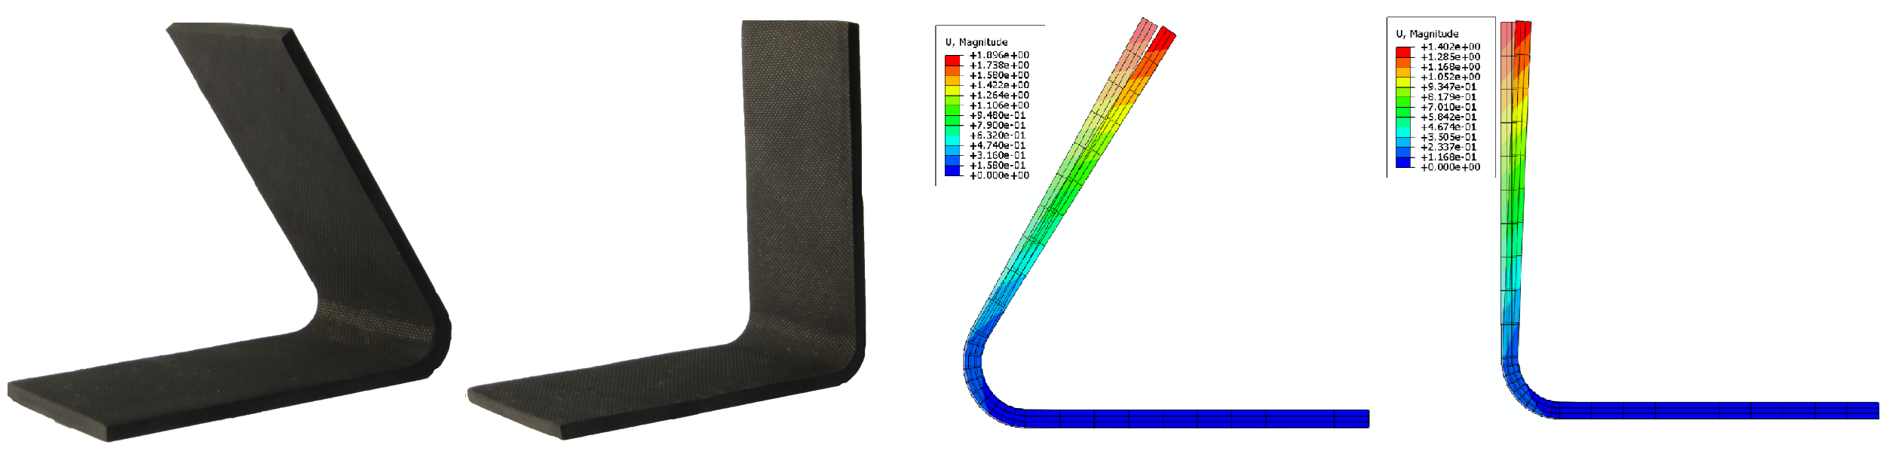
(a)
(b)
(c)
(d)

Figure 2. L-shaped specimens and their curing deformation prediction
(a) L-shaped specimen with 60° corner, (b) L-shaped specimen with 90° corner, (c) FEM simulation result of 60°-corner specimen, (d) FEM simulation result of 90°-corner specimen

Table 3. Comparison of experiment and simulation results

Part number | Corner (°) | Spring-in (°) |  |  | Error (%)
Part number | Corner (°) | Experiment | Average | Model | Error (%)
1-A | 60 | 1.60 | 1.64 | 1.614 | 1.5
1-B | 60 | 1.63 | 1.64 | 1.614 | 1.5
1-C | 60 | 1.70 | 1.64 | 1.614 | 1.5
2-A | 90 | 1.10 | 1.07 | 1.174 | 9.7
2-B | 90 | 1.03 | 1.07 | 1.174 | 9.7
2-C | 90 | 1.07 | 1.07 | 1.174 | 9.7

3. Stiffened Structure Curing Deformation Prediction and Influence of Parameters Analysis

3.1. Stiffened structure curing deformation prediction model

The verified finite element method was used to predict the curing deformation of T-shaped stiffened structure and study the influence of several structure parameters, including stiffener height, thickness, length, shape, corner radius and skin length. The stiffened structure simulated in this chapter was cured in a co-curing process with the uncured skin and stiffeners put into the autoclave together. The structure and structure parameters are shown in Fig. 3, in which L_{skin}=500mm；t_{skin}=3mm；L_{stiff}=100mm；H=100mm；R=8mm；t=3mm.

The structure is consisted of one skin and two stiffeners, both of which the composite layup is [45/90/-45/0]_{3s.} The filling material between resin and stiffeners is twists made of single layers and was given the material properties of 90° layer in Abaqus. The temperature and pressure procedure stayed the same with the L-shaped structures. The expected curing deformation is the warpage of the whole structure, so the boundary condition was set at one edge of the skin, in order to restrict the rigid body displacements of the T-shaped structure.

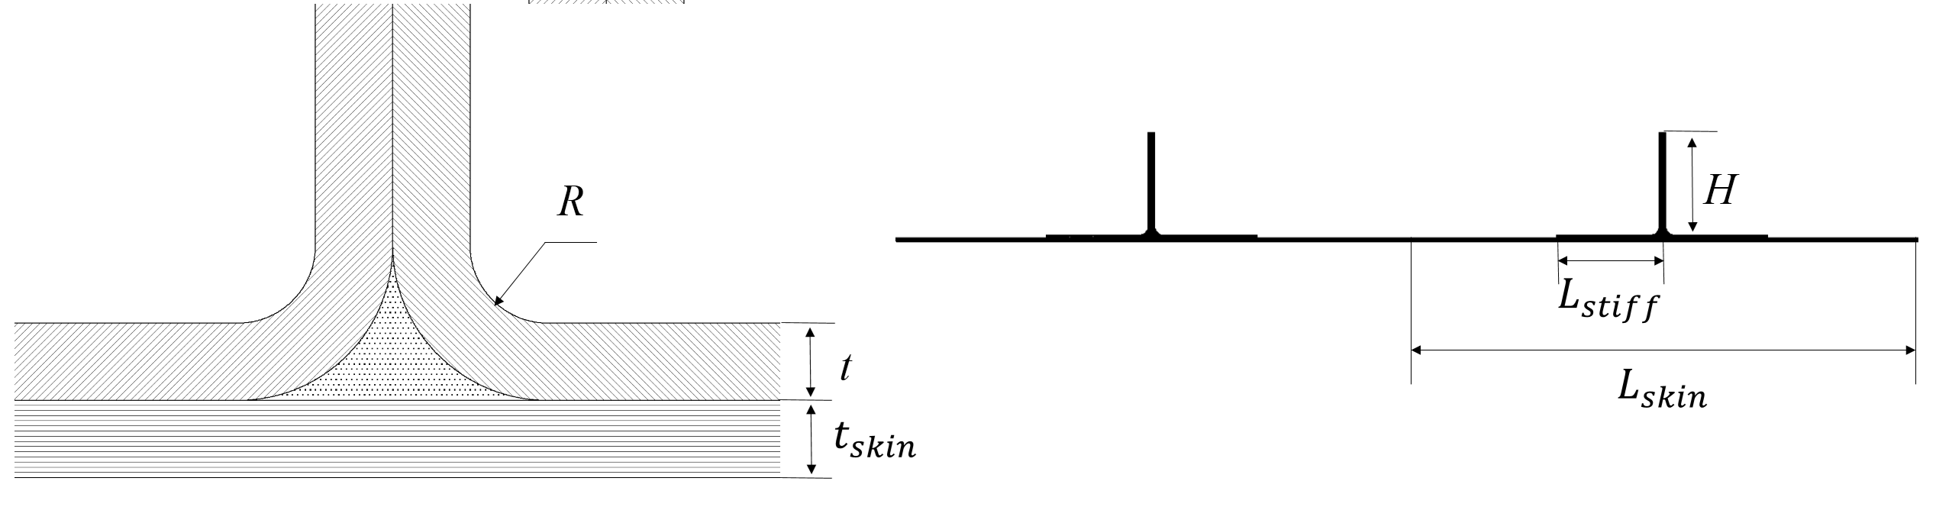

Figure 3. Schematic of size of T-shaped stiffened structure

3.2. Stiffened structure curing deformation prediction results

The prediction results using the verified FEM are shown in Fig. 4, the maximum warpage of the T-shaped structure was 8.19mm. The warpage was thought to be the associated results of the spring-in of the four L-shaped stiffener. The focus here is the relationship between the spring-in of every single L-shaped stiffener and the warpage of the whole structure.

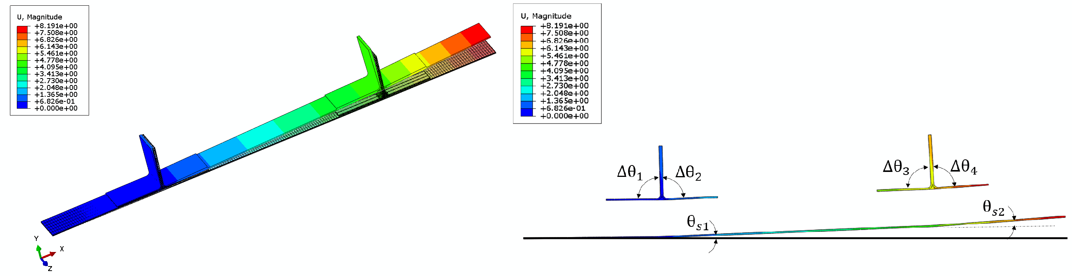

Figure 4. Warpage and spring-in of T-shaped stiffened structure

The four spring-in of L-shaped corners and two spring-in of the whole stiffened structure at two specified places were measured directly in Abaqus, as can be seen in Fig. 4. It turned out that the four spring-in of the L-shaped corner were almost the same, the spring-in of the stiffened structure can be the simple superposition of spring-in of stiffeners. The measurement results and their relationships are expressed in Eq. 1. We can use to describe the curing deformation of a stiffened structure, and the spring-in of the stiffened structure in the next section are all referred to .
(1)

3.3. Influence of Parameters Analysis

The simulation results of spring-in of stiffened structures with different structure parameters are listed in Table 4. The structure parameters of the study mainly include stiffener height, stiffener thickness, stiffener length, corner radius, stiffener shape and the skin length.

Table 4. The prediction results of spring-in of composite stiffened structure

Number | H(mm) | L_{stiff}(mm) | t(mm) | R(mm) | shape | L_{skin}(mm) | θ_{s1}(°)
1 | 50 | 100 | 3 | 8 | T | 500 | 0.3784
2 | 100 | 100 | 3 | 8 | T | 500 | 0.3780
3 | 150 | 100 | 3 | 8 | T | 500 | 0.3782
4 | 200 | 100 | 3 | 8 | T | 500 | 0.3784
5 | 100 | 50 | 3 | 8 | T | 500 | 0.3539
6 | 100 | 150 | 3 | 8 | T | 500 | 0.3837
7 | 100 | 200 | 3 | 8 | T | 500 | 0.3958
8 | 100 | 100 | 1 | 8 | T | 500 | 0.2199
9 | 100 | 100 | 2 | 8 | T | 500 | 0.2794
10 | 100 | 100 | 4 | 8 | T | 500 | 0.4697
11 | 100 | 100 | 3 | 4 | T | 500 | 0.4434
12 | 100 | 100 | 3 | 12 | T | 500 | 0.3131
13 | 100 | 100 | 3 | 16 | T | 500 | 0.2530
14 | 100 | 100 | 3 | 8 | T | 300 | 0.4192
15 | 100 | 100 | 3 | 8 | T | 700 | 0.3573
16 | 100 | 100 | 3 | 8 | T | 900 | 0.3455
17 | 100 | 100 | 3 | 8 | J | 500 | 0.3784
18 | 100 | 100 | 3 | 8 | I | 500 | 0.3783

The figures of specified parameter vs spring-in are drawn in Fig. 5. The analysis of the effect of structure parameters on the spring-in are summarized as follows.

Stiffener height barely has any influence on the spring-in, as can be seen from the simulation results of stiffened structures with four different stiffener heights: 50mm, 100mm, 150mm and 200mm, shown in Fig. 5 (a). The conclusion corresponds with the results known that length of straight edge has no effects on spring-in of L-shaped structures.

Stiffener length is an important factor influencing the curing deformation of stiffened structure, as shown in Fig. 5 (b), the spring-in of skin increases non-linearly with stiffener length increasing. That’s mainly because the area of stress affected by skin increases with the stiffener length increasing.

Stiffener thickness has a similar influence on curing deformation with stiffener length, but the shape of curve is different, as can be seen in Fig. 5 (c). The main reason of the non-linearity is that the bending stiffness of the structure increases with the thickness increasing, but the bending stiffness is proportional to the moment of inertia, which is proportional to the third power of the thickness.

The Fig. 5 (e) shows that the spring-in varies inversely with the radius of stiffener corner. It was found in the stress analysis that the in-plane normal stress between the stiffeners and the skin remained unchanged in the four different models. Therefore, with the increase of the corner radius, the bending moment generated by the forementioned in-plane normal stress increases linearly, which has an inhibiting effect on spring-in, resulting in a linear reduction of spring-in .

The Fig. 5 (f) shows that the spring-in decreases with the skin length increasing, but the influence is limited. When the length exceeds 700mm, the reducing rate becomes small, and the spring-in finally tends to be stable.

Three stiffened structures with different shape of stiffeners are modelled and the results are compared in Fig. 5 (g). The dimensions of the T-shaped, J-shaped and I-shaped stiffener remain the same, and the results show no difference. This is mainly due to the fact that for any shape of stiffener, the curing deformation of the corners connected to skin is the same. Therefore, the stiffener shape has no effect on the warpage of the composite stiffened structure. This conclusion is only applicable to the stiffened structures with transverse stiffeners forementioned in this paper. A stiffener in opposite direction will greatly increase the bending stiffness of the structure and inhibit the curing deformation.

(a)
(b)
(c)
(d)
(e)
(f)

Figure 5. The influence of structurer parameters on spring-in of skin
- Stiffener height, (b) stiffener length, (c) stiffener thickness, (d) stiffener corner radius, (e) skin length, (f) stiffener shape

4. Conclusions

- A non-liner elastic finite element analysis method simplifying resin during the curing process into two states was established for predicting the curing deformation of composite structures in this paper. The influence of thermal shrinkage, chemical shrinkage of resin, mold, interlaminar stresses and modulus on the curing deformation of the composite structure was considered. The method was used to predict the spring-in of L-shaped structures made of composite material T700/5429 and it turned out that the simulation results fitted well with the experiment ones.

- The verified FEM was used to simulate the curing deformation of the stiffened composite structure and study the influence of structure parameters. The results show that the spring-in of stiffener is the main factor leading to the warpage of the whole structure. The results indicate that the stiffener length and thickness have a non-linear positive effect on the spring-in of stiffened structure, while the skin length and stiffener corner radius have a negative one, and the stiffener height and shape hardly have any influence on spring-in.

- In conclusion, when designing the composite structure with transverse stiffeners like those in this paper in practical engineering, under the premise of meeting the mechanical performance requirements, properly reducing the thickness of the stiffener and increasing its corner radius will be helpful to reduce the curing deformation of stiffened structure and to improve the molding accuracy. However, the conclusion is only fitful for the structure with transverse stiffeners, a longitudinal stiffener will greatly improve the structure bending stiffness and suppress the curing deformation effectively. The detailed influence is still wait to be studied.

Acknowledgments

My professor Guan Zhidong and Dr. Wang Qian has devoted a lot to this work, I would like to show my deepest gratitude to them.

References

- Kappel E, Stefaniak D, Spröwitz T, et al. A semi-analytical simulation strategy and its application to warpage of autoclave-processed CFRP parts[J]. Composites Part A: Applied Science and Manufacturing, 2011, 42(12): 1985-1994.
- Wisnom M R, Potter K D, Ersoy N. Shear-lag analysis of the effect of thickness on spring-in of curved composites[J]. Journal of composite materials, 2007, 41(11): 1311-1324.
- Fernlund G, Floyd A, McKay S. Process analysis and tool compensation for curved composite L-angles[C]//The 6th Canadian international composites conference p. 2007: 14-17.
- Kappel E, Stefaniak D, Hühne C. Process distortions in prepreg manufacturing–An experimental study on CFRP L-profiles[J]. Composite Structures, 2013, 106: 615-625.
- Mezeix L, Seman A, Nasir M N M, et al. Spring-back simulation of unidirectional carbon/epoxy flat laminate composite manufactured through autoclave process[J]. Composite Structures, 2015, 124: 196-205.
- Li J, Yao X F, Liu Y H, et al. Thermo-viscoelastic analysis of the integrated T-shaped composite structures[J]. Composites Science & Technology, 2010, 70(10):1497-1503.
- Ersoy N, Garstka T, Potter K, et al. Development of the properties of a carbon fibre reinforced thermosetting composite through cure[J]. Composites Part A: Applied Science and Manufacturing, 2010, 41(3): 401-409.
- Albert C, Fernlund G. Spring-in and warpage of angled composite laminates[J]. Composites Science and Technology, 2002, 62(14): 1895-1912.
- Zhang Jikui, Guan Zhidong, Li Zhengneng. Three-dimensional finite element analysis for the temperature field of thermoset composites during cure process [J]. Acta Ma-teriae Compositae Sinica, 2006, 23(2): 175-179. (in chinese)

