SELF-WARNING HYBRID COMPOSITE PATCHES FOR REPAIRING CRACKED ALUMINIUM PANELS

Meisam Jalalvand^{1,2}, Hon Wing Michael Lok Wu², Fariborz Sheibanian³, Mohamad Fotouhi^{4,2}, Michael R Wisnom²

¹Department of Mechanical and Aerospace Engineering, University of Strathclyde, Glasgow, UK
M.Jalalvand@strath.ac.uk, https://www.strath.ac.uk/
²Bristol Composites Institute (ACCIS), University of Bristol, UK
³ Department of Aerospace Engineering, Amirkabir University of Technology, Tehran, Iran
⁴ Department of Design and Mathematics, University of the West of England, Bristol, UK

Keywords: Overload sensor, thin-ply hybrid composite, visible damage, fatigue crack propagation

Abstract

In this paper, a new concept for health-monitoring of bonded patch repairs is presented. Aerospace structures using aluminium panels occasionally crack and bonded composite patches are one of the repair methods available to maintain the integrity of the structure. Further damage beneath the repair patch cannot be monitored from simple visual inspection alone with standard repair techniques. The new proposed health-monitoring technique is based on the novel concept of overload sensors using hybrid composites, and has great potential for monitoring crack propagation in the main aluminium substrate, allowing passive, reliable and easy structural inspection to be achieved.

1. Introduction

Cyclic loading causes crack propagation in structures, particularly metallic ones, which may lead to a catastrophic failure, and thus have devastating consequences. It is essential for any cracks to be detected early and to allow repairs to be carried out before it is too late. Cracked aluminium panels can be repaired using mechanically fastened or bonded composite patches. Traditional mechanically fastened patches used to repair cracked aluminium panels require extra fastener holes, which increases the number of stress concentrations and changes the stress distribution within the structure. Elevated stresses can reduce the structure’s fatigue life because the stress concentrations encourage crack propagation and also provide sites under the patch for corrosion[1]. Bonded composite repair patches address this issue as they do not require fastener holes and prevent crevice corrosion underneath the patch because the adhesive interface is sealed. Mechanically fastened repairs and bonded composite repairs were compared in several works [1–3] and it was concluded that bonded composite repair patches provided higher patching efficiency as well as minimal stress concentrations, corrosion issues and damage to the parent structure [4].

The main aim of this paper is to demonstrate the feasibility of the new concept of self-warning hybrid composite patches for repairing cracked aluminium panels. Thin-ply hybrid composites have been shown to provide pseudo-ductility and changes of appearance under certain load cases [5]. These properties can be exploited when hybrid patches are bonded onto the artificially cracked aluminium panel.

2. The concept – Overload sensors

The idea of overload sensors originated in the Univeristy of Bristol during experimental tests on pseudo-ductile hybrid composites [5,6]. In addition to acheiving gradual failure due to ply fragmentation, well designed hybrids change appearance which was found to be consistent with the fibre failure strain of the lower strain material in the hybrid combination.

A unidirectional hybrid composite sensor is comprised of glass/epoxy layers with a higher failure strain and carbon epoxy layers with lower failure strain [7]. The sensor is attached to a substrate/component, and the originally intact carbon layers absorb the incident light passing through the translucent glass layer, exhibiting a dark appearance as illustrated in Figure 1 (a). After exceeding the failure strain of the ‘sensing’ carbon layer, the incident light is reflected from the locally damaged glass/carbon interface resulting in the appearance of light stripes around the cracks in the carbon layer as seen in Figure 1 (b).

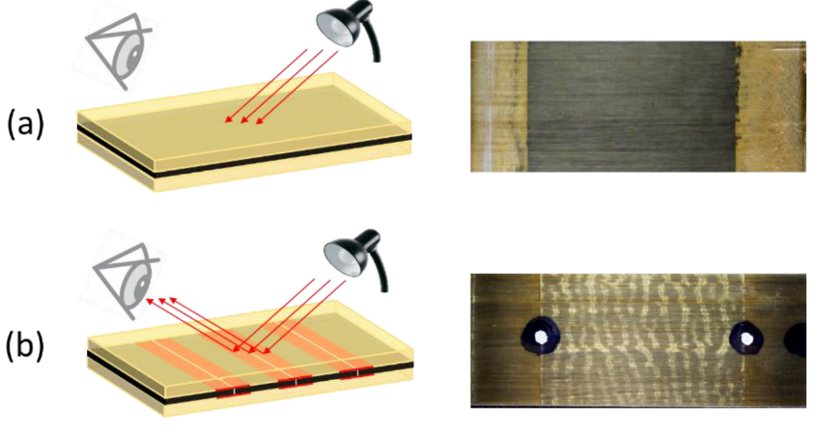
Figure 1- Schematic describing the overload sensor mechanism: (a) intact carbon layers absorbing light at glass/carbon interface (b) change of appearance (striped pattern) due to light being reflected from the locally damaged glass/carbon interface [7].

3. Patch design

In this paper, the mechanism for change of appeareance in overload sensors is used to demonstrate a composite repair patch that can indicate critical situations e.g. an overload or crack extension in the substrate. The hybrid overload sensor(s) are generally designed to have the least possible stiffness so that the sensor does not change the local strain distribution. However, for a repair patch, it is important to have enough stiffness in the patch so that the load in the damaged area of the substrate is significantly reduced and carried instead by the patch.

The size and design of the test specimen shown in Figure 2 were based on specimens used in [8] , and were modified to be compatible with the Instron 250kN test machine. A trade-off study between critical stress and having a noticeable crack propagation was carried out to find the suitable initial crack length in the cracked aluminium panel. The critical stress (σ_{c}) was calculated using Equations 1-3, where the shape factor Y is given in Equation 2 for a centrally cracked panel. The critical stress is the stress that would cause rapid crack propagation in a plate for a given crack length. For the 7075-T6 cracked panel, the critical stress was calculated to be 136MPa using a fracture toughness (K_{IC}) and initial crack length of 25MPa.m^{1/2} and 20mm respectively.

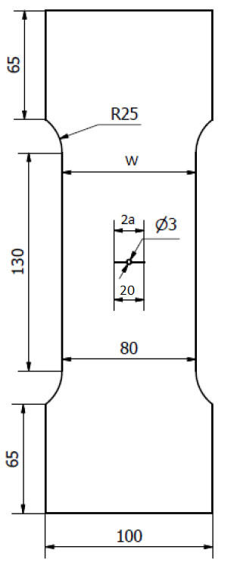
Initial crack
Figure 2- The aluminium specimen with initial 20 mm central crack used for the quasi-static tensile and fatigue testing

()

 | 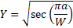 | ()

 | 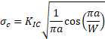 | ()

An R-ratio (σ_{max}/σ_{min}) of 0.09 was used in the fatigue loading cycles where the maximum stress (σ_{max}) was 110MPa, which was approximately 80% of the critical stress, and the minimum stress (σ_{min}) was 10MPa. The critical crack length (a_{c}) at this maximum stress was determined by using the bisection method from the rearrangement of Equation 3 to form Equation 4, this yielded a result of 14.0mm. Hence, the total critical crack length became 28.0mm, significantly above the initial crack length of 20 mm.
 | 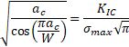 | ()

ABAQUS was used to create a linear elastic FE model and calculate the Stress Intensity Factor (SIF) at the crack tip of the test specimen before and after a repair had been made. Symmetric boundary conditions were applied at the two planes of symmetry to enable a quarter model to be representative of the structure. The Seam Crack technique built into ABAQUS, was assigned to the model to define the site of crack initiation and crack front direction. A fixed boundary condition was assigned to the bottom surface of the aluminium specimen and a mean applied stress of 60MPa was applied to the upper surface of the cracked specimen. Quadratic 20-noded C3D20 solid elements were used in the analysis to evaluate solutions at more nodes and full integration was used to prevent the ‘hourglass effect’ that could be caused by using reduced integration. Initially, FEA was performed for an unrepaired specimen to find the SIFs at the crack tip using the built-in J-integral function of the software, and the results were found to be consistent and close to the analytical results.

The hybrid composite parts were then created and connected using ‘ties’ to the aluminium panel. This model was used to find the SIF for the repaired panel. A loop was created to automate the calculation of several SIFs for a range of different configurations. SIFs for a range of cracked lengths, glass and carbon layer thicknesses were stored in an output file. The first five J-integral contours that were close to the tip of the crack were considered for each node at the crack tip alongside the though-thickness SIFs and were both averaged together to determine representative results. These averaged SIFs were used to derive the shape factor function (Y) for this specific configuration (repaired panel with central crack) that was substituted into Equation 5. Four elements through the thickness were used to capture the stresses within the aluminium specimen A refined mesh was created in the section enclosing the crack and this was transferred to the patch to avoid incongruent meshes that can result in inaccurate results for SIFs and displacements. Figure 3 (a) and (b) indicate the distribution of stress in the aluminium panel without and with the patch respectively at similar applied far field stress.

()

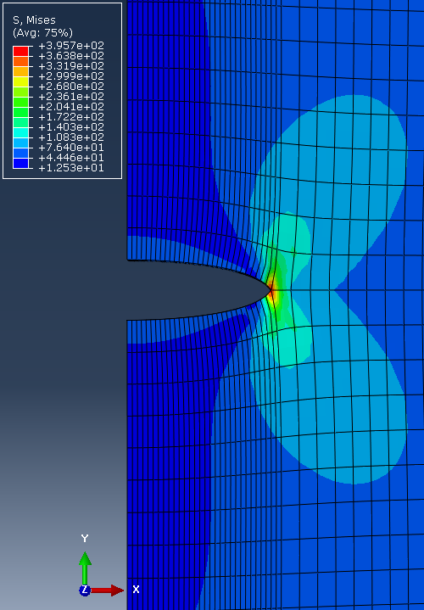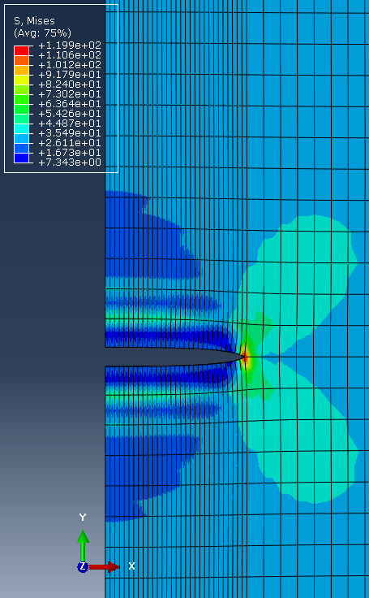
(a)
(b)
Figure 3- Stress distribution in (a) unrepaired aluminium panel; (b) repaired aluminium panel

The patch’s materials were selected in a way that the low strain layers do not fail due to ultimate loading conditions but overloads cause fibre failure in the low strain material and accordingly a change of appeareance. Additionally, higher patch moduli will ensure a better and quicker load transfer from the cracked panel to the composite patch. The patch was intended as a proof of concept, and so detailed calculations of the repair efficiency were not performed at this stage. This resulted in the selection of the YSH-70 fibre prepreg as the low strain material using the technique developed for hybrid composite materials [9]. These fibres have a considerable longitudinal prepreg modulus of 430 GPa with a fibre failure strain of 0.5%. S-glass prepregs are used for the high strain material. This is a strong and stiff glass fibre with prepreg longitudinal modulus of 45.6 GPa and a failure strain of over 4%. Thin-ply hybrid composites were therefore selected where high modulus carbon fibre plies (YSH70) were sandwiched between the compliant S-glass fibre layers

4. Experiments

The initial aluminium specimens were made using a water-jet cutting machine to cut the outline of the test specimen. A wire-cutting electrical discharge machine was used to introduce an initial 18mm crack into the specimen, with a width of 0.25mm caused by the diameter of the wire. The desired 20mm initial crack length with a sharp tip was achieved by applying subsequent fatigue cycles on the specimen. The layup configuration for the hybrid composite is illustrated in Figure 4. To avoid sudden change of thickness for glass and carbon layers, plies were dropped gradually to spread the shear stress concentration. The top glass layer is the largest layer covering all other layers.

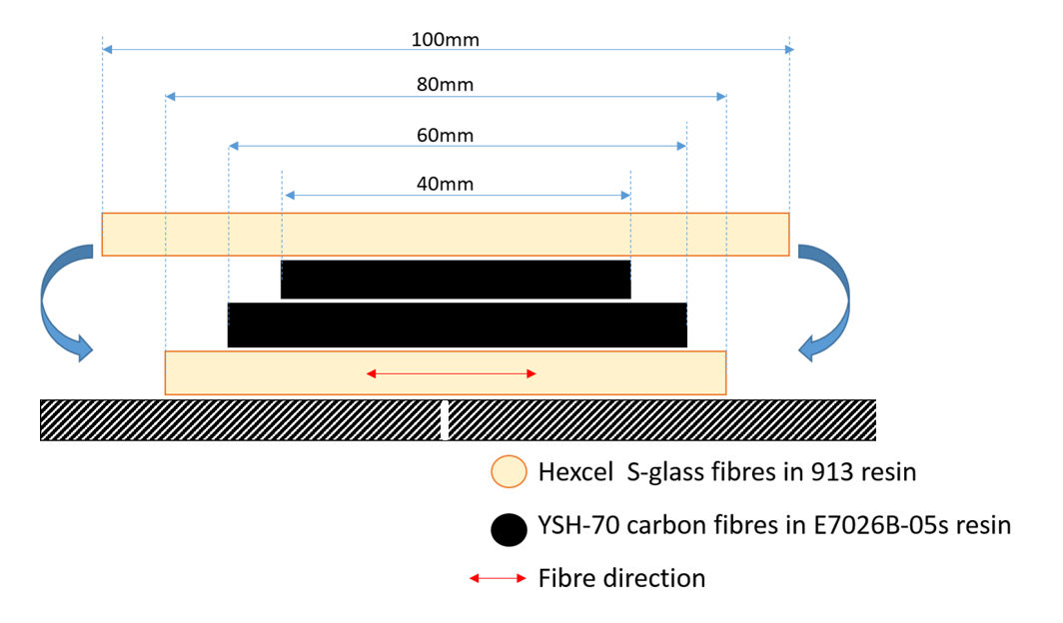
Aluminium panel
Crack in the aluminium panel
Figure 4- Layup sequences of hybrid composite repair patch

Araldite 2014-1 two-part epoxy resin adhesive was used to bond the cured hybrid composites onto the cracked aluminium specimens in an oven. This adhesive was chosen for its high shear strength and is commonly used in the aerospace industry. Maximum shear strength was achieved by curing the bonded specimens for three hours under atmospheric pressure at a temperature of 70°C. Hand clamps were used with additional aluminium plates to maintain the position of the repair patches during oven curing.

An Instron MJ6274 250kN test machine was used to apply the quasi-static tensile load and fatigue loads on the specimens using 100mm wide grips with a clamping pressure of 120 psi. Extensions of the specimens were measured using an Imetrum video gauge system by tracking white dots on a black background defined at specific gauge lengths and recording by means of data acquisition software. . A digital single-lens reflex (DSLR) camera captured images of crack propagation throughout the fatigue test and a cold-light lamp was used to change the brightness and contrast in the images. The configuration of the set-up is shown in Figure 5.

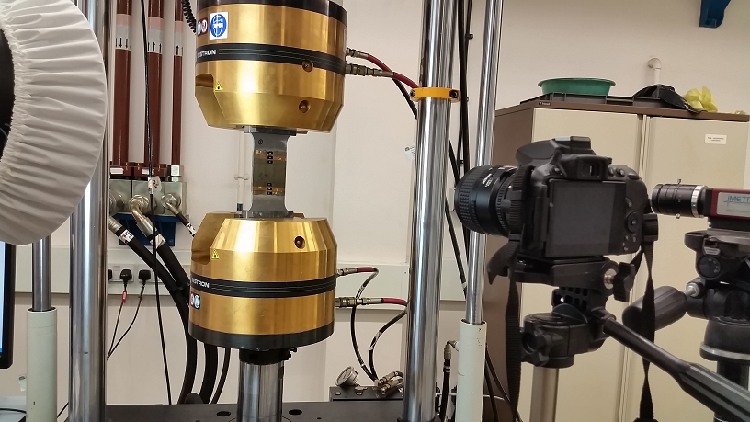
Figure 5- Set-up of quasi-static tensile and fatigue tests using the Instron 250kN test machine, Imetrum video gauge system and DSLR camera

5. Results

The 20mm central crack in these specimens reduced the ultimate tensile strength (UTS) to 213MPa which was about a third of the original value in the stock material of 566MPa [10]. Repairing these specimens through bonding hybrid composite patches increased the strength by approximately 60% as shown in Table 1. It did not reach the original UTS, but that was not a requirement for this proof of concept demonstrator. The combined stiffness of the hybrid composite patch was greater than the aluminium specimen alone, therefore it increased the stiffness of the repaired specimens compared to the unrepaired specimen as illustrated in Table 1.

Table 1 – Summary of specimen strength, normalised modulus and stiffness

Specimen Name | Strength (MPa) | Stiffness (kNmm⁻¹)
Stock Material | 566 | 192.6
Unrepaired specimen | 215 | 161.4
Repaired specimen | 341 | 204.2

Changes of appearance on the repaired specimen shown in Figure 6 were noticeable above the threshold load in the quasi-static tensile test at different applied stresses. This showed the progression of crack propagation underneath the repair patch and occurred when the specimen was overloaded. Figure 6 shows the change of appearance due to delamination induced by central fractured carbon layers and successfully demonstrates the self-warning ability of the repair patch.

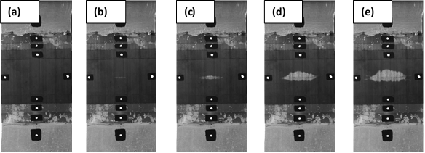
Figure 6 – Self-warning features apparent from overloading the specimen at increasing loads: (a) 195MPa; (b) 197MPa; (c) 304MPa; (d) 336MPa; (e) 340MPa (99% failure load)
Fatigue tests were also performed on the specimens and 2153 fatigue failure cycles for the unrepaird specimen was significantly improved to 84891 cycles for the repaired one. The failed specimen showed evidences of changed of apareance in the hybrid repair patch. but unfortunately the planned photo capturing algorithm failed due to technical issues so no photo was recorded in the fatigue crack propagation phase of the failure process.

6. Conclusion

A novel idea to achieve a new functionality in bonded composite repair patches is presented. The patch successfully increased both the strength of a cracked aluminium panel whilst indicating the critical state of crack extension. This maintained structural integrity and could be used as a warning to the end-users about crack propagation or overload in highly loaded components. This is useful as the structural health can be determined from a simple visual inspection which is economical and quick to carry out.

Acknowledgements

This work was funded under the UK Engineering and Physical Sciences Research Council (EPSRC) Programme Grant EP/I02946X/1 on High Performance Ductile Composite Technology in collaboration with Imperial College, London.

References

[1] Baker AA. Repair of cracked or defective metallic aircraft components with advanced fibre composites—an overview of Australian work. Compos Struct 1984;2:153–81. doi:http://dx.doi.org/10.1016/0263-8223(84)90025-4
[2] Baker AA. A summary of work on applications of advanced fibre composites at the Aeronautical Research Laboratories, Australia. Composites 1978:11–6.
[3] Baker AA. Fibre composite repair of cracked metallic aircraft components - practical and basic aspects. Composites 1987;18:293–308. doi:10.1016/0010-4361(87)90293-X.
[4] Baker A. Bonded composite repair of fatigue-cracked primary aircraft structure. Compos Struct 1999;47:431–43. doi:10.1016/S0263-8223(00)00011-8.
[5] Czél G, Jalalvand M, Wisnom MR. Design and characterisation of advanced pseudo-ductile unidirectional thin-ply carbon/epoxy–glass/epoxy hybrid composites. Compos Struct 2016;143:362–70. doi:10.1016/j.compstruct.2016.02.010.
[6] Czél G, Jalalvand M, Wisnom MR. Demonstration of pseudo-ductility in unidirectional hybrid composites made of discontinuous carbon/epoxy and continuous glass/epoxy plies. Compos Part A Appl Sci Manuf 2015;72:75–84. doi:http://dx.doi.org/10.1016/j.compositesa.2015.01.019.
[7] Rev T, Czél G, Jalalvand M, Wisnom MR. Unidirectional hybrid composite overload sensors – robust tools for visual overload indication, Xi’An: ICCM21; 2017.
[8] Jian-Bin H, Xu-Dong L, Zhi-Tao M. Fatigue behavior of thick center cracked aluminum plates repaired by two-sided composite patching. Mater Des 2015;88:331–5. doi:https://doi.org/10.1016/j.matdes.2015.09.011.
[9] Jalalvand M, Czél G, Wisnom MR. Damage analysis of pseudo-ductile thin-ply UD hybrid composites - a new analytical method. Compos Part A Appl Sci Manuf 2015;69:83–93. doi:10.1016/j.compositesa.2014.11.006.
[10] BIKAR-METALLE. Aluminium 7075 Quality Certificate EN10204. 2016.

