Evaluation of Cure cycle interruption on thermoset epoxy polymer matrices

Ana Amate-Illescas¹, Zulima Martín-Moreno², Jose Sánchez-Gómez³

¹Airbus Operations, Material, Processes&Tests - Bonding specialist, P^{so} John Lennon, Getafe (Madrid), Spain
Email: Ana.a.amate-illescas@airbus.com
² Airbus Operations, Material, Processes&Tests – Composite Senior Expert, P^{so} John Lennon Getafe (Madrid), Spain
Email: zulima.martin@airbus.com
³ Airbus Operations, Material, Processes&Tests – Composite Senior Expert, P^{so} John Lennon Getafe (Madrid), Spain
Email: Jose.g.sanchez@airbus.com

Keywords: Epoxy prepreg, epoxy adhesive, degree of cure, cure cycle interruption

Abstract
Most of epoxy resin composite matrices used in the Aerospace Industry cure by the presence of high temperature, to start the polymerization reaction and create the crosslinks of the molecular network responsible of the final material properties. Vacuum and Pressure are also necessary to get enough level of compaction and forcing out volatiles to achieve the right quality on the composite part.
This leads into long and complex autoclave processing cure cycles that sometimes due to unavoidable malfunction of the autoclave or complexity of the vacuum bag construction used on the part, interruption at any stage during curing process can occur.
Therefore, there is a need to understand the influence of cure cycle interruptions on a critical stage and analyse the final material performances and the final quality obtained on the composite part. A typical two steps cure cycle was the basis of this study, analysing the influence of the cycle interruption on the epoxy thermoset prepreg and the epoxy adhesive film material properties by means of physical-chemical tests (degree of cure, DMA) and mechanical tests (Interlaminar Shear Strength, Single Lap Shear, Double cantilever beam-G_{IC}).
Additionally, composite part demonstrator will be used to confirm the inner quality of the part by means of optical microscopy and physical-chemical and mechanical coupons extracted directly from the demonstrator.

1. Introduction

Epoxy composite materials are more and more used in Aerospace Industry to manufacture Aircraft Primary Structures based on the excellent mechanical, chemical and heat resistance properties in addition to the high strength/stiffness-to-weight ratio they provide in comparison with metallic materials. Epoxy thermoset curing processes are based on complex exothermic chemical reactions, in which the epoxide base group react by polyaddition with a curing agent, normally a diamine, creating the final three-dimensional (3D) cross-linked molecular network of the resin which is responsible of the excellent material performances.
There are different types of epoxy systems depending on the chemical formulation. For one-component materials, the hardener is premixed on the resin formulation but inactive, so that, the curing reaction is initiated by an external means (pressure, high temperature, UV light. air, humidity…). However, for two-component materials, epoxide base and hardener are separated and once both components are mixed during the application of the product, the cure reaction is initiated.
Most of thermoset epoxy resins used on Aerospace Industry to manufacture primary structures elements are one-component systems, in which high temperature curing process are necessary to start the reaction and get the final 3D molecular network on the material. Based on this, most of epoxy thermoset materials need to be storage at cold temperatures (-18ºC) to avoid the advancement of the curing reaction.
Figure 1 shows the complexity of a typical epoxy thermoset curing process and the different molecular stages for which the resin is passing while temperature is increasing and until the final 3D molecular network of the material is completely formed.
From a rheological point of view, the resin is passing from a liquid-phase to a rubbery stage as long as temperature is increased. Initially, an increase on the temperature initiates the curing reaction producing the rupture of some molecular bonds. The resin is entering in the liquid phase (“minimum viscosity point”) due to the freedom of the molecular chains to move. As soon as temperature keep increasing, the cure reaction continues advancing and the number of connections between the molecular chains is increasing limiting the movement of the polymeric chains. This state is named as “gel point” and from this moment the resin will not be longer a liquid and lost the ability to flow. After this point the resin continue the reaction until the final three-dimensional network structure is formed and the final material properties are achieved. As it is shown on Figure 1, degree of cure is a good indicator of the chemical state of the resin on every stage during the curing process.
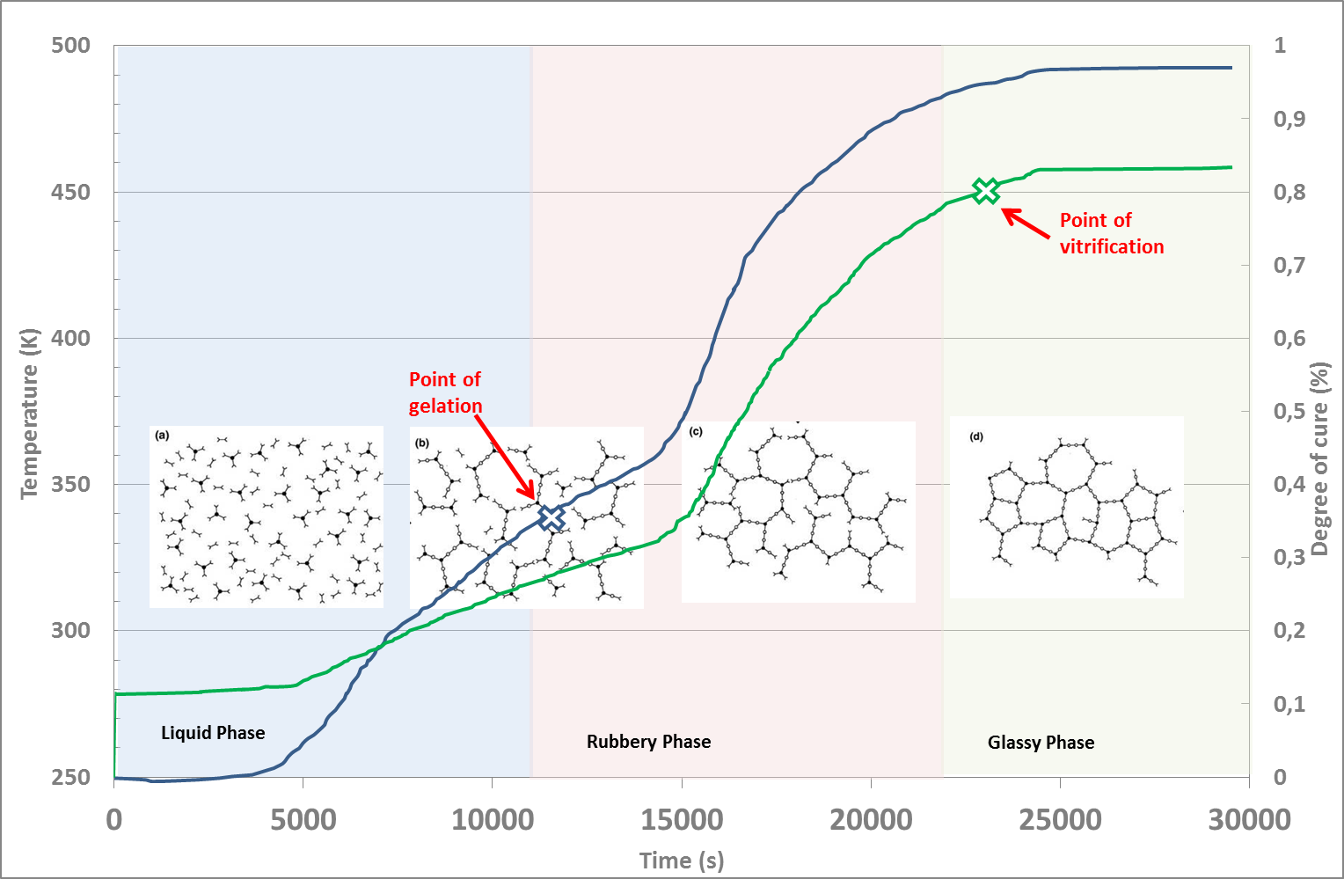
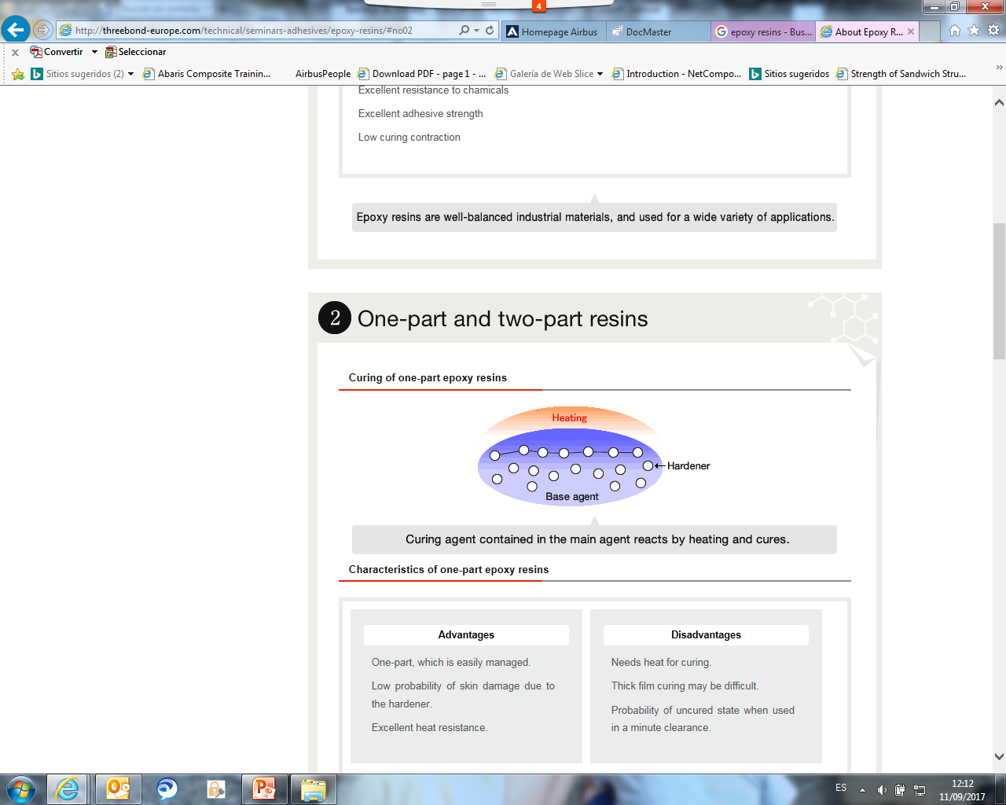
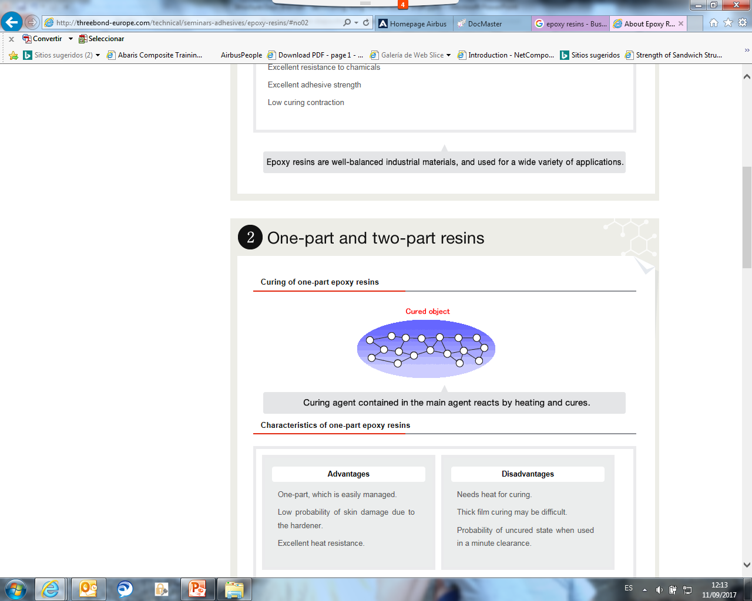
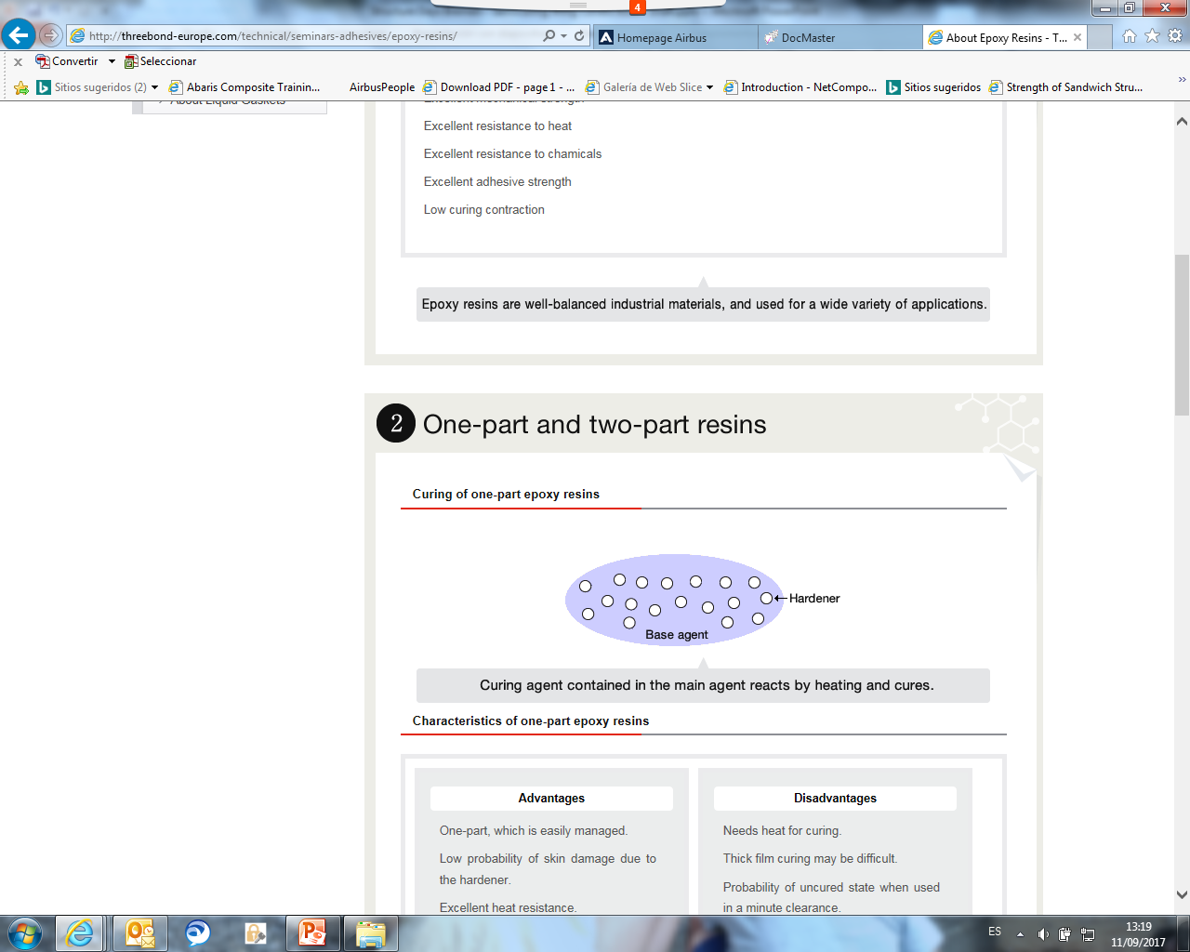

Figure 1. Typical cure cycle for thermoset resins

The state of the art to manufacture thermoset composite parts is the use of autoclaves, where by means of pressure, high temperature and vacuum, high quality composite structures can be manufactured. The definition of the cure cycle parameters, temperature, time and pressure, will definitely influence the final performances of the composite thermoset material and the quality of the part.
Sometimes, unavoidable failure on the autoclave systems during cure cycle occur, interrupting the curing reaction of the thermoset resin matrix. The exothermic chemical reaction of epoxy resins and the different degree of cure gradients during the curing process, need to be considered on cure cycle interruptions because non-uniform curing processes can lead to incomplete degree of cure, entrapped volatiles causing porosity on the part and as a consequence reduction in the overall quality and performances of the component.
Therefore, it is important to understand and analyse the influence of cure cycle interruptions on the final material properties and the inner quality of the part.

This study will consider the influence of cure cycle interruption not only on the carbon fibre thermoset prepreg but on the epoxy adhesive material and the associated bonded joint performances of the component.

2. Materials

For this study, a typical 180ºC cure epoxy prepreg-adhesive system was evaluated.

Prepreg material used was an epoxy unidirectional carbon fibre preimpregnated tape prepreg 268g/m² grade. As an adhesive film, epoxy adhesive film with knitted polyester carrier, 250g/m² grade B, was used.

Nominal cure cycle for the co-bonding step of the selected epoxy system is shown in Figure 2. It is a two-steps cure cycle with one dwell at 135ºC and a second one at 180ºC to get the final performances of the epoxy materials.
Interruption step was defined considering the manufacturing constrains on the plant, historical cure cycle interruption cases and also the worst case scenario for the epoxy system under evaluation. As seen on Figure 2, interruption was done after 35min on the first dwell step and considering the upper limit on the temperature range of the first dwell step (140ºC).
Time between cure cycle interruption and reinitiating of the nominal cure cycle need to be also limited, controlled and included as an important variable of the test matrix. For this study, 4 hours were considered for the evaluation.

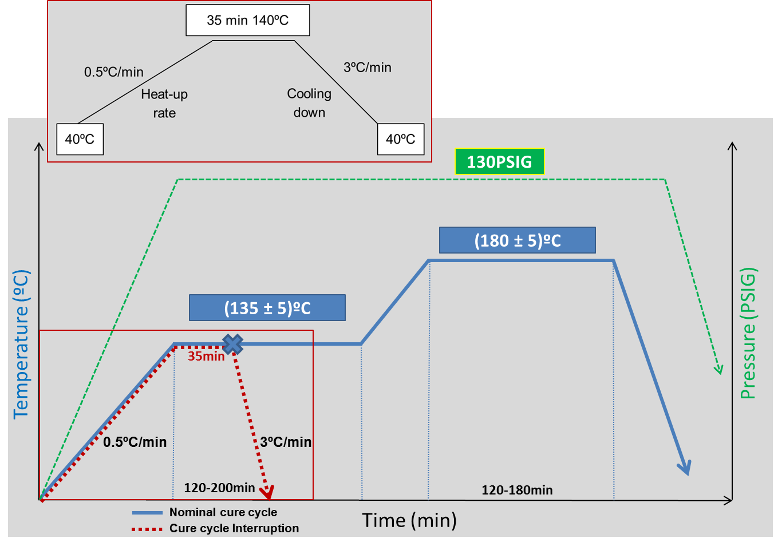
Figure 2: Nominal cure cycle and cure cycle interruption definition

2. Experimental test matrix

Evaluation of cure cycle interruption effect on the epoxy prepreg/adhesive system was done in two different streams, real component and standard test coupons.
As mentioned in the introduction, considering the chemical behaviour of thermoset prepreg, the inner quality of the part can be affected when a running cure cycle is interrupted. So that, some of the test specimens will be extracted from a representative component to analyse if cure cycle interruption defined on Figure 2 has an impact on the inner quality of the demonstrator.
Additionally, standard coupons will be also necessary to evaluate the influence of cure cycle interruption on the physical and mechanical performances of the epoxy system under study considering a “worst case” scenario.

2.1 Part Demonstrator

The part demonstrator used for this study is shown in Figure 3. It was manufactured using a precured skin co-bonded with two fresh T-stringers by means of a preimpregnated peel-ply as surface treatment.
The cure cycle interruption simulated on this part demonstrator was as defined on Figure 2. The interruption was performed only on the co-bonded cycle to evaluate the influence over the epoxy prepreg/adhesive system material properties and the bonding performances.

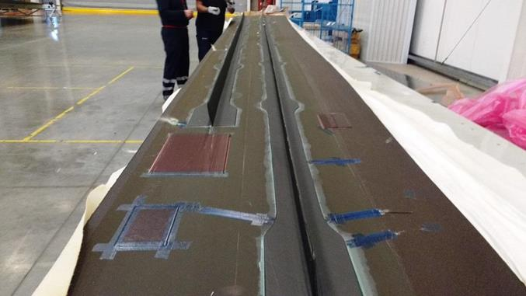
Strg 3
Strg 3
Strg 3
Strg 2
Figure 3: Representative test part

For that purpose, optical microscopy analysis was made by mean of cut-out coupons extracted directly from the part on different locations as shown in Figure 4. Main focus was to check the inner quality of the part covering bondline thickness distribution, resin pooling effect, failure mode, squeeze out formation.
Thermoset prepreg molecular structure was also analysed my means of Dynamic Mechanical Analysis tests (DMA) extracted from the stringer web on different locations.
Additionally, some single lap shear test specimens were extracted from the demonstrator to collect preliminary information about the bonding performances of real components.

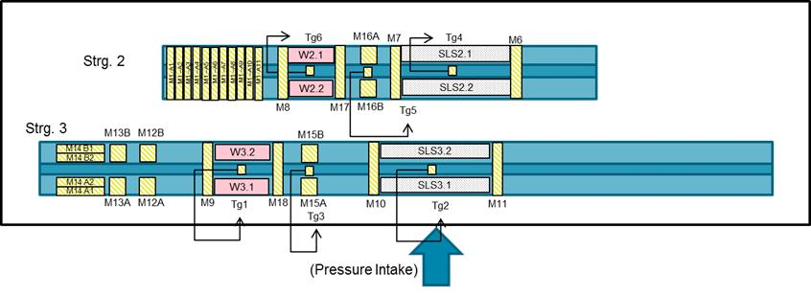
Figure 4: Specimen extraction scheme on Part Demonstrator

2.2 Standard test panels

Additionally to the specimens extracted from the part demonstrator, standard panels will be manufactured with the same history of the part they represent and considering the “worst case” material conditioning scenario.
Figure 5 summarises the material history cycle to be applied during the manufacturing process of the test panels and considered on this evaluation.

Figure 5: Material history cycle

The following considerations were taken into account on this test evaluation as critical variables to cover the “worst case” material conditioning scenario:

  - Storage life: Storage life of thermoset materials is defined as the period of time during which the material storage under specific conditions (-18ºC) is capable to maintain the initial performances. (See Fig. 6)
  - Work life: Work life of thermoset materials is defined as the accumulated time between the material is taken out from the specific storage conditions (-18ºC) and curing cycle is started. During all this time the material shall keep as well the initial performances. (See Fig. 6)
  - Hot forming cycle: Hot forming process is applied on the fresh stringers of the representative part to get the appropriate T-shape. This step shall be also included as a variable inside the material history cycle of the test panels.
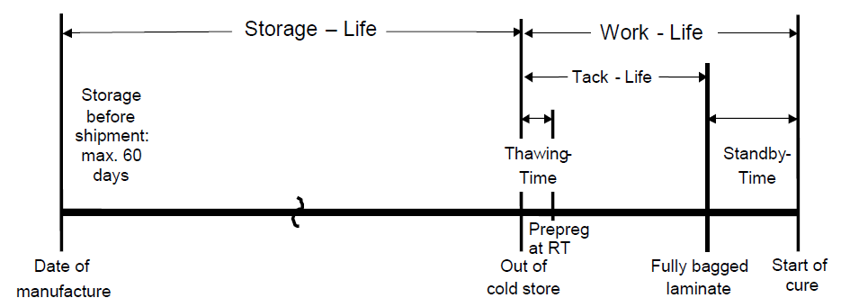
Figure 6: Storage/Work life definitions
Evaluation of cure cycle interruption will be made by means of different physical-chemical and mechanical tests.
Table 1 defines the physical-chemical tests which are focused on studying the viscosity profile of the epoxy prepreg/adhesive system and the degree of cure achieved on the moment of the cure cycle interruption.
Table 1. Physical-chemical tests

Material | Test Method | Test Standard
Adhesive film | Viscosity  (µ_{min}, T_{min}, t_{min},  µ_{gel}, T_{gel}, t_{gel}) | AITM 3-0004  (0.5ºC/min)
Prepreg resin |  | AITM 3-0004  (0.5ºC/min)
Adhesive film | Extent of cure  (%) | AITM 3.0008  (MDSC  ASTM E 2602  Method A)
Prepreg resin | Extent of cure  (%) | AITM 3.0008  (MDSC  ASTM E 2602  Method A)

Table 2 and Table 3 define the mechanical tests to be performed on the prepreg and adhesive materials. For this study, reference panels will be manufactured with the nominal cure cycle (Fig. 2).
Dynamic Mechanical Analysis (DMA) tests will give an indication of the final 3D molecular network obtained on the material and if the cure cycle interruption has any effect on it by comparison with reference panels cured with the nominal cure cycle.
Additionally, Interlaminar shear strength (ILSS) and Optical Microscopy coupons will provide additional information about the mechanical performances of the laminate and the inner quality of it.

Table 2. Mechanical test for prepreg material

Panel ID |  | Test Method | Panel Lay-up Configuration | Test  Temperature | Test  Conditioning
Reference | RP1 | DMA  AITM 1.0003 | (0)₈ | - | Dry  (120ºC eq.)
Reference | RP2 | DMA  AITM 1.0003 | (0)₈ | - | Wet  (70ºC/85%R.H eq.)
Reference | RP3 | Optical  Microscopy  AITM 4.0005 | (0)₈ | - | -
Reference | RP4 | ILSS  EN2563 | (0)₈ | RT | AR
Reference | RP5 | ILSS  EN2563 | (0)₈ | 120ºC | AR
Test Panel | TP7 | DMA  AITM 1.0003 | (0)₈ | - | Dry  (120ºC eq.)
Test Panel | TP8 | DMA  AITM 1.0003 | (0)₈ | - | Wet  (70ºC/85%R.H eq.)
Test Panel | TP9 | Optical  Microscopy  AITM 4.0005 | (0)₈ | - | -
Test Panel | TP10 | ILSS  EN2563 | (0)₈ | RT | AR
Test Panel | TP11 | ILSS  EN2563 | (0)₈ | 120ºC | AR

Table 3. Mechanical test for adhesive material

Panel ID |  | Test Method | Panel Lay-up  Configuration | Test Conditioning
Reference | RA1 | DMA  AITM 1.0003 | (0)₁₀ | Dry  (120ºC eq.)
Reference | RA 2 | DMA  AITM 1.0003 | (0)₁₀ | Wet  (70ºC/85%R.H eq.)
Test Panel | TA 1 | DMA  AITM 1.0003 | (0)₁₀ | Dry  (120ºC eq.)
Test Panel | TA 2 | DMA  AITM 1.0003 | (0)₁₀ | Wet  (70ºC/85%R.H eq.)

Table 4. Test specimens for co-bonded panels

Panel ID |  | Test⁽²⁾ | Panel lay-up configuration | Test  Temperature | Test  Conditioning
Reference | RA 3 | GIC  AITM 1.0053 | (0)₆ precured  / adhesive /  (0)₆ fresh | -55ºC | AR
Reference | RA 4 | GIC  AITM 1.0053 | (0)₆ precured  / adhesive /  (0)₆ fresh | RT | AR
Reference | RA 5 | GIC  AITM 1.0053 | (0)₆ precured  / adhesive /  (0)₆ fresh | RT | Wet⁽¹⁾
Reference | RA 6 | Single Lap Shear  ATIM1.0019 | (0)₈ precured  / adhesive /  (0)₈ fresh | RT | AR
Reference | RA 7 | Single Lap Shear  ATIM1.0019 | (0)₈ precured  / adhesive /  (0)₈ fresh | 90ºC | AR
Reference | RA 8 | Single Lap Shear  ATIM1.0019 | (0)₈ precured  / adhesive /  (0)₈ fresh | 90ºC | Wet⁽¹⁾
Test Panel | TA 3 | GIC  AITM 1.0053 | (0)₆ precured  / adhesive /  (0)₆ fresh | -55ºC | AR
Test Panel | TA 4 | GIC  AITM 1.0053 | (0)₆ precured  / adhesive /  (0)₆ fresh | RT | AR
Test Panel | TA 5 | GIC  AITM 1.0053 | (0)₆ precured  / adhesive /  (0)₆ fresh | RT | Wet⁽¹⁾
Test Panel | TA 6 | Single Lap Shear  ATIM1.0019 | (0)₈ precured  / adhesive /  (0)₈ fresh | RT | AR
Test Panel | TA 7 | Single Lap Shear  ATIM1.0019 | (0)₈ precured  / adhesive /  (0)₈ fresh | 90ºC | AR
Test Panel | TA 8 | Single Lap Shear  ATIM1.0019 | (0)₈ precured  / adhesive /  (0)₈ fresh | 90ºC | Wet⁽¹⁾
Notes:
- “Wet” means 70ºC/85% RH equilibrium.
- In all cases, co-bonding panel configuration will be used. Detail conditioning specified in Fig. 5 will be applied on adhesive film and prepreg material used to manufacture these panels.

3. Results & Conclusions

Part of the results and conclusions obtained during this investigation will be shown during the ECCM18 oral presentation.

References

[1] K. Vijaya Kumar, A.S Nagaraja. Influence of curing process interrupt on ILSS of thin carbon epoxy laminates. International Journal of Research in Engineering and Technology, Vol. 04 Issue 06, June 2015.
[2] J. Zhang, Y.C. Xu, P. Huang. Effect of cure cycle on curing process and hardness for epoxy resin eXPRESS Polymer Letters. Vol.3 Nº.9 June 2009.
[3] K. Suzuki, Y. Miyano and T. Kunio. Change of Viscoelastic Properties of Epoxy Resin in the
Curing Process. Journal of Applied Polymer Science. 21:3367–3379, 1977.
[4] M. T. Aronhime and J. K. Gillham. Time-Temperature Transformation (TTT) Cure Diagram of
Thermosetting Polymeric Systems, in Epoxy Resins and Composites III. Karel Dusek, editor, pp.
83–113. Springer-Verlag, 1986.
[5] W. I. Lee, A. C. Loos and G. S. Springer, “Heat of Reaction, Degree of Cure, and Viscosity of Hercules 3501-6 Resin, Journal of Composite Materials, Vol. 16, pp. 510-520, 1982.
[6] S. Alavi-Soltani, S. Sabzevari, H. Koushyar and B. Minaie. Thermal, rheological, and mechanical properties of a polymer composite cured at different isothermal cure temperatures. Journal of Composite Materials. 575-587, 2011.
[7] Liva Pupure, Sibin Saseendran, Janis Varna and Margherita Basso. Effect of degree of cure on viscoplastic shear strain development in layers of [45/-45]s glass fibre/epoxy resin composites. Journal of Composite Materials. 1-12, 2018.
[8] A. C. Loos and G.S. Springer. Curing of Epoxy Matrix Composites. Department of Mechanical Engineering and Applied Mechanics. University of Michigan. 1982.
[9] J.H. Chois, D.G. Lee. Expert Cure System for the Carbon Fiber Epoxy Composite Materials. Dept. of Precision Engineering and Mechatronics. Korea Advanced Institute of Science and Technology. 1994.

