**Experimental analysis of the failure of a 3D woven composite belted lug**

C. Garcia1,2,3, A. Hurmane1, F.-X. Irisarri1, F. Laurin1, S. Leclercq2, R. Desmorat3

1ONERA, DMAS, Université Paris-Saclay F-92320 Châtillon, France

Email: cecile.garcia@onera.fr, Web Page: https://www.onera.fr/

2Safran Landing Systems, Landing gear department, Inovel Parc Sud 78140 Vélizy-Villacoublay, France

3LMT, ENS Cachan, Université Paris-Saclay, CNRS, 61 avenue du president Wilson 94230 Cachan, France

**Keywords:** Failure, 3D woven composites, Lug

**Abstract**

The study focuses on the failure of landing gear lugs. To delay the failure by shear-out that is classical for such parts, Safran Landing Systems suggested an innovant concept of belted lug. The aim of the paper is to analyze the experimental failure of the belted lug. To that end, an experimental set-up was designed to test the sample in tension with high-level loads. The test was performed using an hydraulic machine with a maximum capacity of 1 500 kN. Thanks to a rich test instrumentation (3 stereo-DIC systems, 2 acoustic emission sensors), a damage scenario could be settled. The sample failure mode is, as expected, net tension (fibres failure in a plane perpendicular to the loading). The failure load is however overestimated due to a structure effect, the decolonnage, on the one hand and to the sample machining on the other hand.

1. Introduction

A system of struts in landing gears enables axial load coming from the wheels to be transmitted to the airplane structure. The struts of a Boeing 787 landing gear are shown in **Figure 1**. Safran Landing Systems (SLS) deals with the mass reduction of these components. To that end, composite materials are seen as part of the solution insofar as they are lighter than metallic materials and simultaneously present excellent mechanical properties. To deal with impact issues such as bird or stone strikes on the landing strip, 3D-woven composites with polymeric matrix are considered. The 3D-woven architecture indeed provides better residual performances after impact than classical laminates made of unidirectional plies.

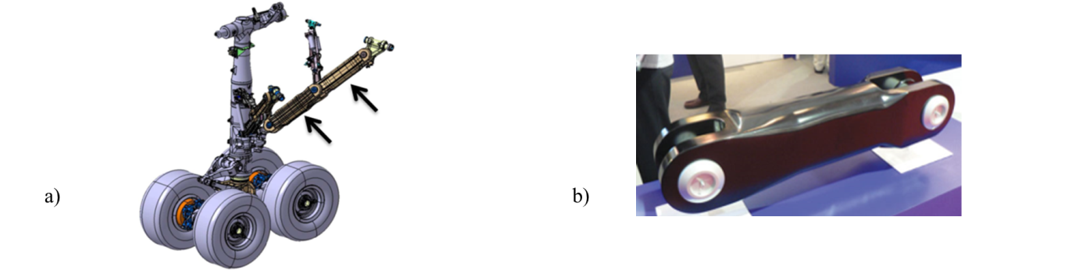

**Figure 1.** a) Landing gear of a Boeing 787. The struts are indicated by means of arrows. b) An example of landing gear strut made of composite material (SLS).

Loads are introduced in the struts by means of lugs. This study focuses on the failure of the lugs. Depending on the lug geometry and the material orientation, there are four common failure modes in competition in such structures, namely shear-out, net tension, cleavage and bearing [1], which are illustrated in **Figure 2**. Shear-out appears for lugs with short end distance in the loading direction and low out-of-axis material reinforcements. Indeed, high in-plane shear stress concentrations on the loaded boundary of the hole generate material damage along two bands on both sides of the hole, in the loading direction. The shorter the end distance, the earlier the failure happens by shear-out of the nose of the lug along the shear bands. For classical panel assemblies, there is usually enough design freedom to avoid shear-out failure by increasing the end distance and choosing appropriate laminates. Conversely, in the case of lugs made of 3D woven composite material, this failure mode is critical since the end-distance has to be minimized to reduce the mass of the structure. Net tension consists in the failure of the lug ligament in tension. Thus, it is directly linked to the width of the lug ligament and the proportion of carbon fiber reinforcement in the loading direction.

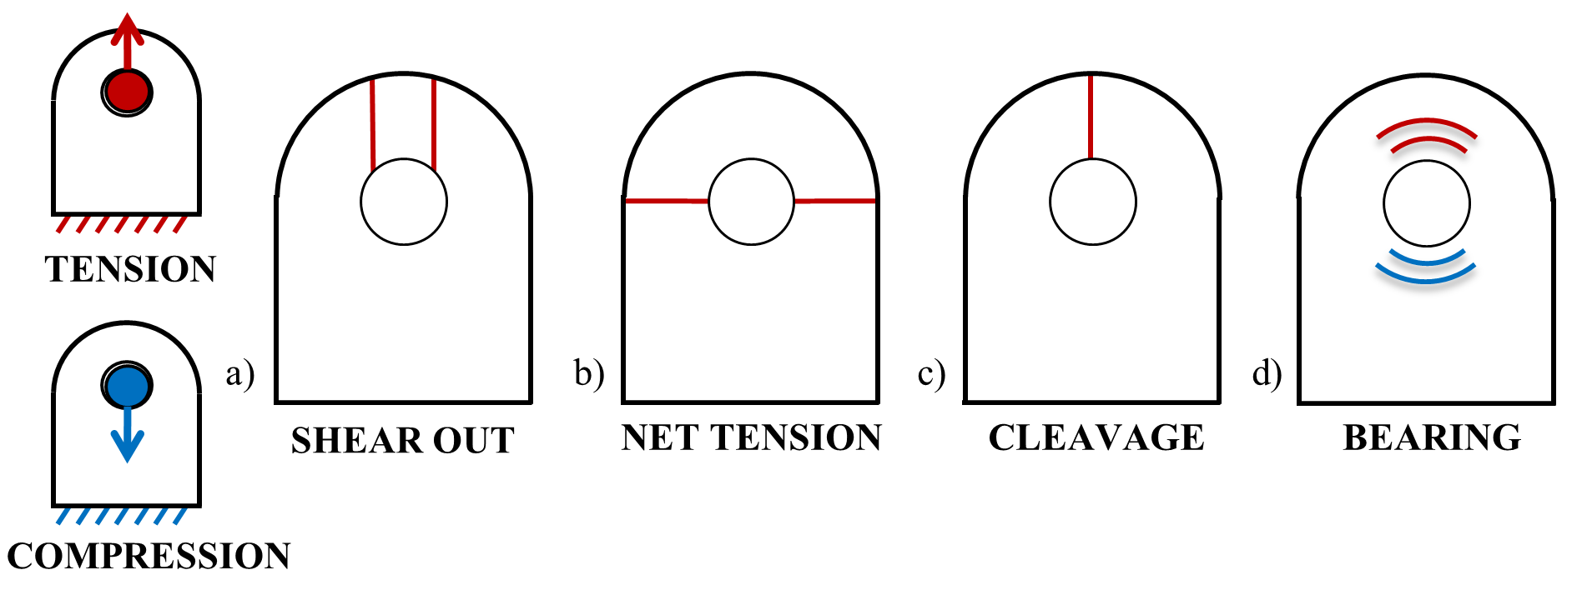

**Figure 2.** Failure modes that are in competition in a lug solicited in tension: shear-out, net tension, cleavage and bearing. Bearing is the only failure mode observed in compression.

Both shear-out and net tension are structural failure modes whose occurrence can be controlled through the sizing of the joint. With high end-distance to diameter and width to diameter ratios appears the bearing failure mode, which can be considered as an intrinsic material macroscopic property. At the macroscopic level, bearing corresponds to the elongation of the hole, due to the crushing of the material by the pin in the loading direction [2]. Bearing failure is stable and progressive in the case of 3D-woven composite materials [3]. Thus, bearing is the failure mode that enables to take full advantage of the material potential, hence the intent to design structure for that failure mode. However, the lug geometry is not flexible because of integration constraints. A lug with a standard geometry tends to fail by shear-out. In order to increase the first damage emergence and the failure load of the lug, SLS proposed an innovative concept of belted lug whose material orientation spatially varies in the structure, thus taking benefit of the material anisotropy both in stiffness and strength. The belted lug design is presented in **Figure 3**. A 3D-woven preform (represented in red in **Figure 3**) is belted by another preform (in blue) whose out-of-plane material orientation is radial around the hole. The belt increases the resistance to shear-out since its warp yarns are circumferential around the hole. Moreover, this concept enables to take benefit of the sufficient out-of-plane material compressive resistance. Therefore, the belted lug could be subjected to different triaxial loading (*i.e.* in-plane tension associated with out-of-plane shear stresses, or out-of-plane compression depending the angular position around the pin) which have not been considered previously at our knowledge for such material.

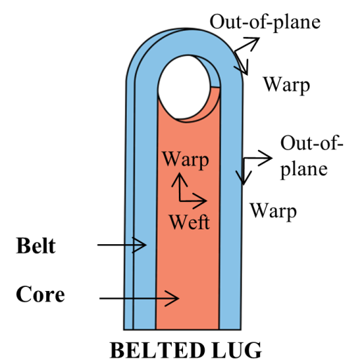

**Figure 3.** Concept of belted lug.

The challenge of this research is to perform the experimental characterization of the belted lug in tension, inducing locally complex 3D state of stresses. For that purpose, a technological test has been set up. Section 2 describes the experimental set-up design. Test results are provided and discussed in Section 3. Finally, concluding remarks are proposed.

2. Experimental set-up design

A single belt without the core is tested. The sample was manufactured from an existing belted lug. It is assumed that both parts of the structure – the belt and the core – have independent behaviors. Their interface is not within the scope of the present study. The choice was made to test the whole belt in order to capture the structure effects. Moreover, it is the only way to have a constitutive material that is representative of the real component. As a matter of fact, local phenomena due to the manufacturing process or shaping can appear and cannot be seen on flat coupons. For instance, the winding around the axis of the belt, which is a thick preform, introduces an offset of the different plies according to the shaping angle: the so-called “decolonnage”.

FE simulations of the belt in tension were performed with the damage and failure model ODM-CMO [4]. Although the model had not been identified on this exact material, this approach enables to estimate both failure mode and failure load. The sample was estimated to fail by tensile failure at a high level load requiring the use of a 1500 kN testing machine.

An experimental set-up was designed to test the sample under high load levels. In order to be as representative as possible of the real loading, the structure is loaded by means of a part representative of an axis. The main challenge here was to fasten the belt to the fixed part of the experimental set-up. Mechanical fastening using bolts was first considered. However, this solution had to be discarded since the width of the belt was too small to design a joint that would not fail either by tension or bearing long before the failure of the belt itself. Thus, another option was adopted that consists in tightening the sample arms within clamping jaws. The clamping pressure value is based on the abacus of an hydraulic testing machine. For the present material, it is possible to apply high pressure because of its sufficient out-of-plane compressive strength. It is applied in the experimental set-up with a torque wrench. The experimental set-up is represented in **Figure 4**. During the design process a particular attention was paid to the visibility of the sample in order to allow observation of the belt using Digital Image Correlation (DIC). This enables (i) to be able to introduce in the FE simulation the real boundary conditions and (ii) to monitor the different damages occuring during the test.

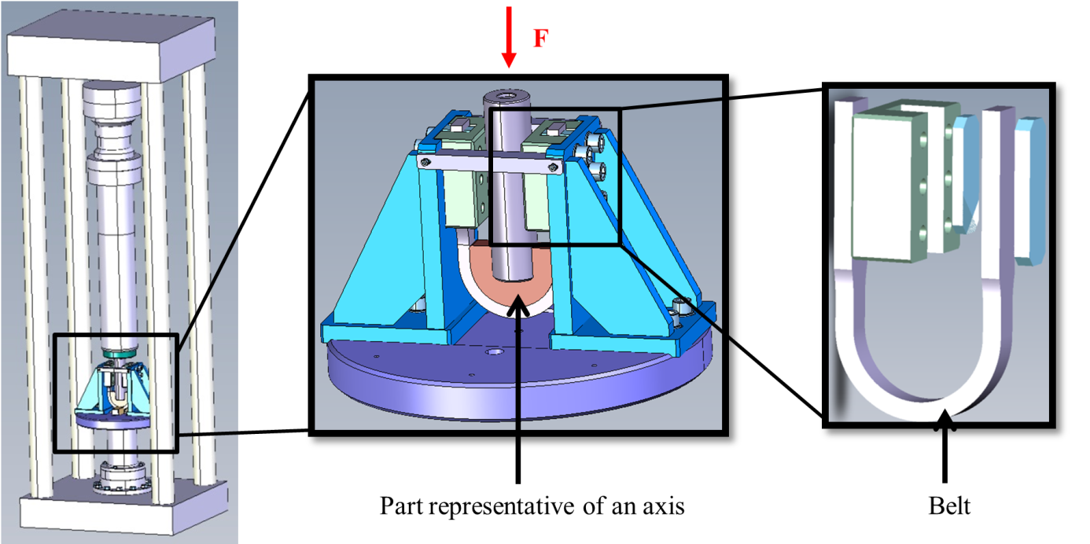

**Figure 4.** Experimental set-up that enables to load the sample in tension. The belt is fastened using clamping jaws. Clamping pressure is ensured using a bolted system.

Elastic analyses of the whole set-up were carried out in order to check the global rigidity. The set-up dimensions were adjusted in order to minimize the deformation of test set-up. Numerical simulations were performed with the commercial FE code Abaqus/Standard. The vertical displacement U3 over the final configuration can be seen in **Figure 5**. For the sake of simplicity, the interactions between the different parts have been considered as perfect contact (*Tie* condition in Abaqus). However, contact was implemented between the part representative of the axis and the belt with a coefficient friction of 0.3. Another contact was established between the plates (in blue on the right picture in **Figure 5**) and mobile jaws (in green in the same picture) in order to account for an eventual slipping between these parts. The friction coefficient was set to 0.15.

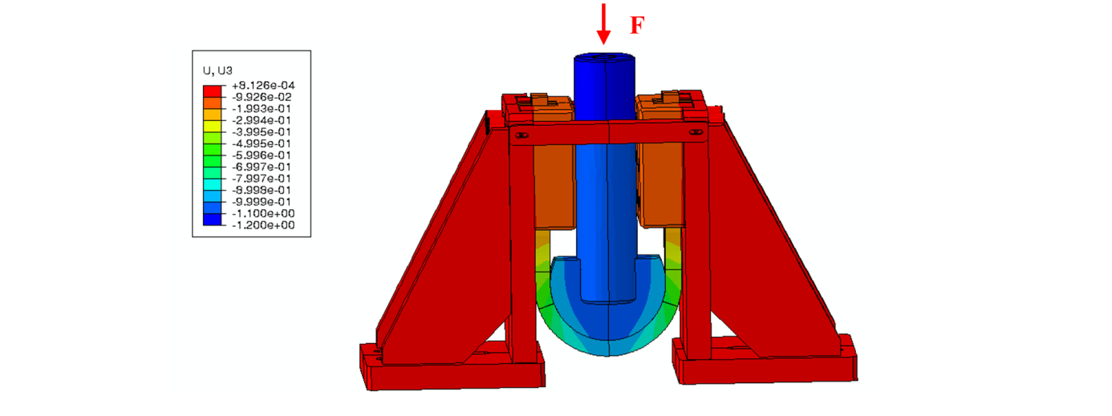

**Figure 5.** Finite Elements Simulation (Abaqus/Standard) of the whole experimental set-up.

The numerical simulations have also been used to design the sample in order to guarantee that it will not break because of unwanted stress concentrations due to the proposed fastening system. To this end two different approaches were performed to localize the critical sections in the belt: a local FE stress state analysis and an analysis of the cohesive torsor (load result and momentum, one torsor per cross-section). These post-processing are performed from a simulation of the whole experimental device so that the set-up flexibility is taken into account. The examination of the relevant components of the cohesive torsor is outlined in **Figure 6**. The torsor is calculated along the belt at the barycenter of each section. The analysis highlights two critical areas where both force and moment are extremum: the hole border (Section 1 in **Figure 6**) and the beginning of the clamping jaw (Section 2). The high load levels at the beginning of the clamping jaw are due to the fastening system. To avoid an unwanted failure in this area, the section of the belt has been reduced in the curved nose of the belt which can be seen in the (XZ) view of **Figure 6a**. By doing so, the stress distribution in the section near the clamping jaw is unchanged, whereas the average stress in the section near the belt nose gets higher, thus making tensile failure in that region the critical failure mode for the test.

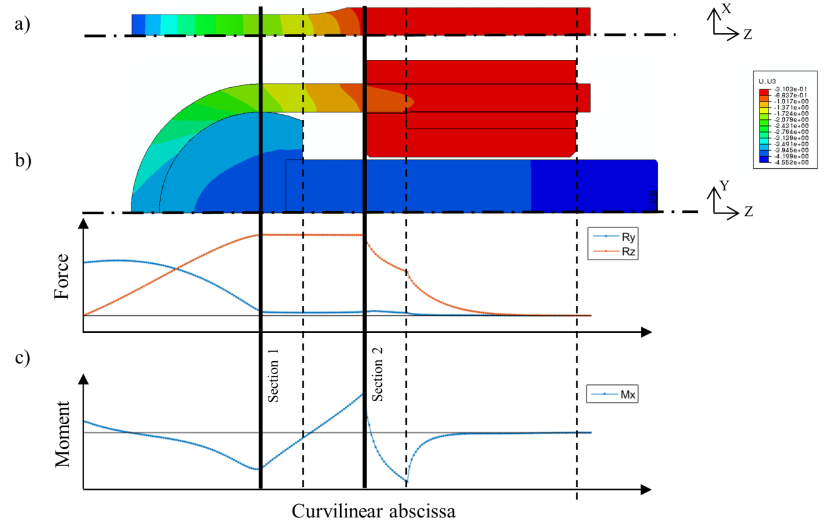

**Figure 6.** a) View in the (XZ) plane of the out-of-plane displacement Uz of a half belt. The section is reduced on the top of the sample. b) View in the (YZ) plane of a half belt. c) Evolution of the cohesive torsor components Ry, Rz and Mx computed at the section barycenters of the belt with its curvilinear abscissa. The simulation is performed for the whole experimental set-up.

3. Analysis of the test results and discussion

The test is performed on a hydraulic Schenck machine with a maximum capacity of 1500 kN. It is displacement-controlled with a low rate (0.1 mm.min-1). The test is monitored by means of three stereo-DIC systems. One system furnishes the global displacement of the whole belt nose. The others two systems disposed on the opposite side of the sample give more accurate displacements at the hole border where the failure is expected. Information is processed by Vic3D acquisition software. Two Acoustic Emission (AE) sensors are positioned inside each arm of the belt in order to follow the damage process during the loading. These data must be carefully analyzed since noise can also come from the belt sliding in the clamping jaws. AE information is treated by the commercial software AEWin of EuroPhysicalAcoustics. The whole experimental set-up with its instrumentation is illustrated in **Figure 7**.

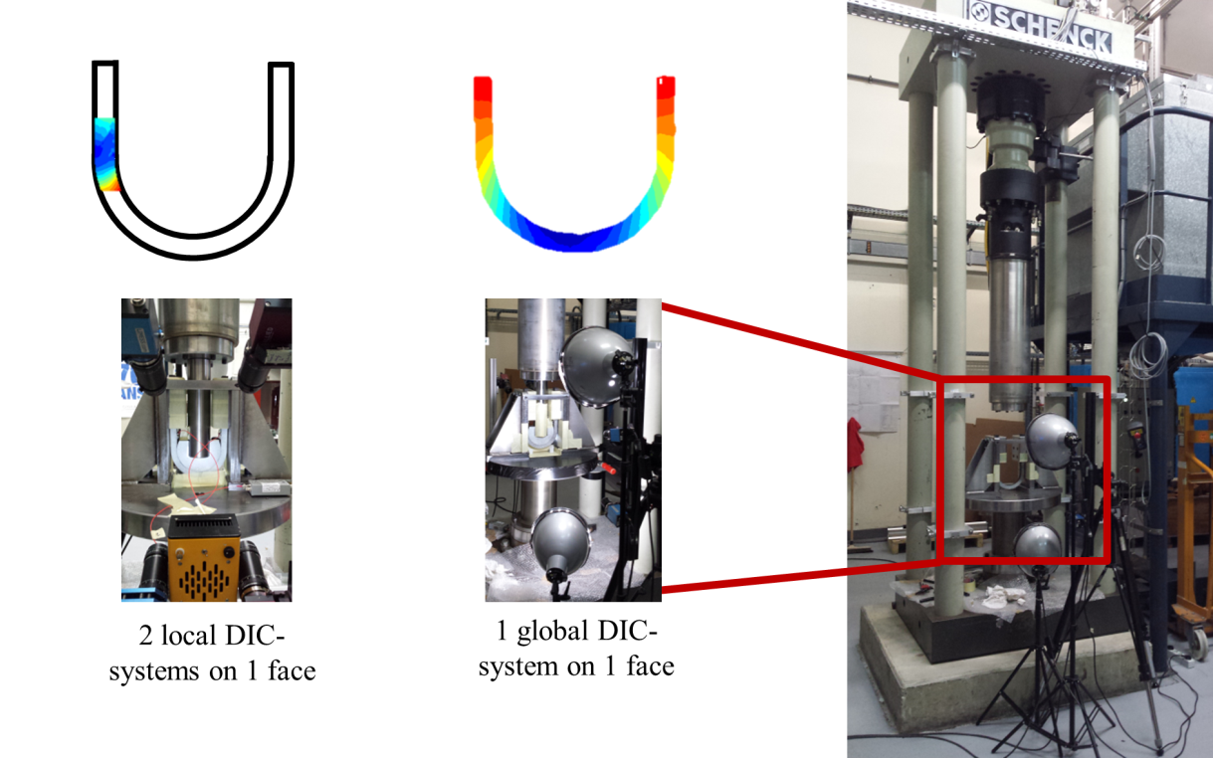

**Figure 7.** Experimental set-up with its instrumentation: one DIC-system on one face in order to have a global view of the nose of the lug, and two DIC-systems on the other face focused on each arm of the belt where failure is planned.

The global load-time curve is exposed in **Figure 8**. It exhibits a first stage of load establishment during which clearances are cancelled. The behavior during the whole loading is nearly linear. Cumulative energy obtained with EA is plotted on the same figure. The first cracks visible on the sample appear simultaneously at the hole border and at the place where the section is reduced. The reduction of section actually generates high in-plane shear stresses at the transition radius. The cracks are oriented by the microstructure and in the present case the observed angle is due to the decolonnage induced during the manufacturing process. These cracks in the matrix lead to yarn fibres failure. At high load levels, the two cracks collapse, leading to the global failure of the sample. The belt failure is due to the failure of one of the two arms. The failure of the first arm troggers a bending phenomenon in the other arm. The failure pattern is shown in **Figure 9**.

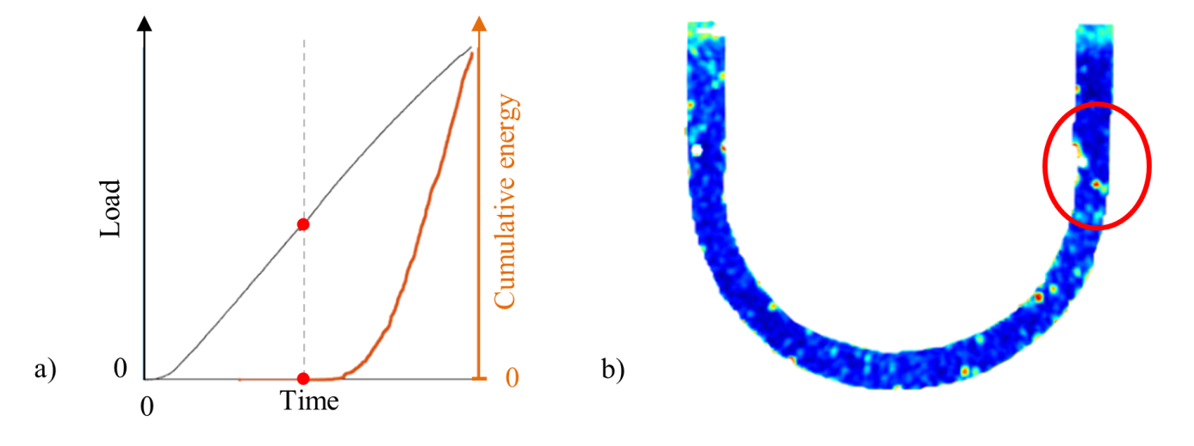

**Figure 8.** a)Global force-time curve (in black) and cumulative energy obtained with acoustic emission (in orange), b) DIC error furnished by Vic3D when crack is emerging (represented by red points in a)).

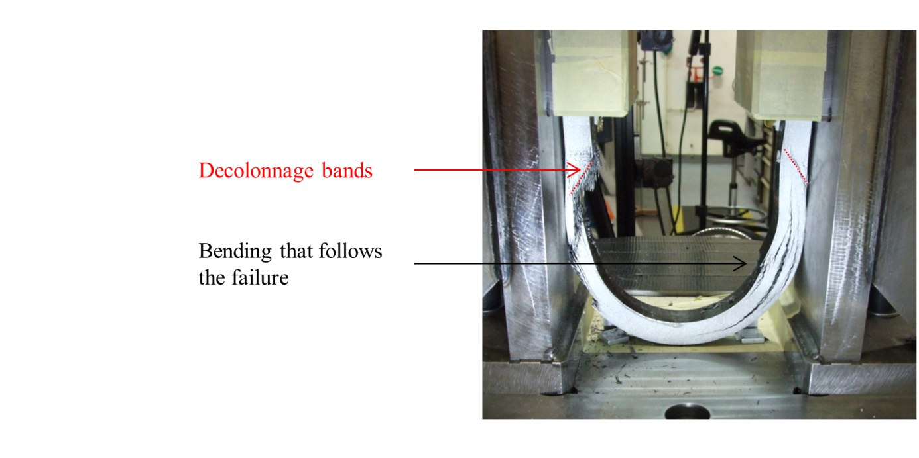

**Figure 9.** Failure pattern of the tested belt. Cracks emanating from the section reduction are guided along decolonnage bands. They collapse with cracks emerging from the hole border leading the the belt failure (left arm on the picture). The failure is followed by the bending of the sample on the other arm.

4. Conclusions

The test has proved that the concept of belted lug enables, in comparison with a classical design of lug, to delay the failure load level and to switch from a failure mode of shear-out to one in net tension. As a result, the load levels reached are higher insofar as the warp yarns are loaded in tension. Two more samples are planed to be tested, in order to confirm these results. To limit the stress interactions emerging from the thinned section and the hole border resulting in a early failure, the thinned section ratio will be higher. Simulations will be performed with the damage and failure model ODM-CMO.

References

[1] P. P. Camanho and F. L. Matthews, “Stress analysis and strength prediction of mechanically fastened joints in FRP: a review,” *Compos. Part Appl. Sci. Manuf.*, vol. 28, no. 6, pp. 529–547, 1997.

[2] R. Mounien, C. Fagiano, P. Paulmier, B. Tranquart, and F.-X. Irisarri, “Experimental characterization of the bearing behavior of 3D woven composites,” *Compos. Part B Eng.*, vol. 116, pp. 369–376, 2017.

[3] M. McClain and N. Timoshchuk, “Bearing behavior of 3D woven composites,” proceeding of the international conference ICCM19, Montreal Canada, 28 July-2 August 2013.

[4] R. Mounien, “Analyse expérimentale et modélisation du comportement en matage de composites à matrice organique tissés interlocks”, Doctorate thesis of the University of Bretagne Occidentale, 2016.