Modelling the Tensile Behaviour of Hybrid Fibre Architectures of Randomly Oriented strand composites

Swaroop B. Visweswaraiah, Vincent Cadran, Larry Lessard, and Pascal Hubert

Department of Mechanical Engineering, McGill University
817, Rue Sherbrooke Ouest, #270, Montréal, QC H3A 0C3, Canada
Corresponding author: larry.lessard@mcgill.ca

Keywords: Randomly oriented strands, Hybrid fibre architectures, Compression moulding, Cohesive elements

Abstract

Hybrid fibre architectures of randomly oriented strand composites (ROS) and laminate groups represent trade-off solutions of formability and mechanical performance for composite structures. The focus of this work is the proposition of a simplistic meso-structure model that generates the absolute and relative behaviour of ROS and ROS-hybrids under tensile loading. The current work utilizes semi-empirical and stochastic 2D and 3D finite element modelling approaches with progressive damage to simulate the tensile behaviour of 30% cross-ply/70% ROS hybrid configuration. The stochastic 3D FE modelling utilizes three important stages: the use of a strand placement and generation procedure representative of the heterogeneous meso-structure; intralaminar progressive failure analysis using hashin failure criteria for damage initiation and fracture energy based linear softening law for damage propagation; and the use of traction-separation laws for the cohesive elements to model interlaminar behaviour. The 2D model utilizes the first two stages and excludes the interlaminar progressive behaviour. Effects of hybridization on the stress-strain behaviour, failure characteristics, and the variability are quantified and compared with the experimental results.

1. Introduction

Continuous fibre (CF) preforms exhibiting excellent mechanical performance are limited in use due to the low formability characteristics and are confined to simple shell-like geometries with minimal curvature and thickness variations. On the other hand, long discontinuous fibre preforms such as randomly oriented strand composites (ROS or R), characterized by finite chips/strands of unidirectional or woven fabric prepregs (Figure 1.a), offer high processability and formability but exhibit lower mechanical performance [1]. A trade-off solution, as suggested by various authors [2-9], is to use a ‘hybrid architecture’ that integrates the formability of ROS and performance of CF (Figure 1.b). By controlling the contents, position and arrangement of the individual phases, adequate formability and better mechanical performance can be achieved. Compression moulding that involves preheating a composite preform above its melting temperature and consolidating by the direct action of the mould has been recognized as a versatile and low cost manufacturing method for ROS thermoplastics [1].

Co-moulded hybrid fibre architectures of ROS composites and laminate groups was studied by varying the thickness of the laminate group relative to that of ROS phase, stacking sequence of the architectures within a hybrid specimen, and the ply stacking sequences within the laminates [10]. Significant improvements in the tensile properties of the base ROS composites or a ‘reinforcement effect’ was observed with small proportions of laminate groups in the specimen in addition to exhibiting a positive synergy or a positive deviation from the rule-of-mixtures in the overall stiffness and strength behaviour when stacked in specific configurations. The current work proposes a modelling method capable of predicting the tensile behaviour of hybrid fibre architectures of ROS and laminates. The non-linear finite element (FE) model based on stochastic strand placement procedures has been demonstrated using hybrid fibre architectures of ROS and cross-ply laminates and compared with the experimental results.
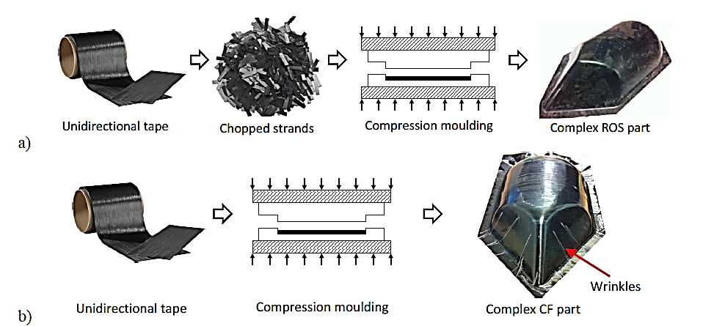
a)
b)

Figure 1: a) Randomly oriented strands or chips of prepreg tapes; b) Performance vs. processing [10]

2. Experimental work

Carbon/PEEK strands of size 25 mm x 12 mm were chosen and placed in small batches into a steel mould and shuffled back-and-forth each time to minimize their out-of-plane orientation. The picture frame mould was placed into a press and minimal pressure was applied to close it. The processing pressures and temperatures were fixed at 60 bars and 400°C, respectively, based on processing studies [11]. Once the processing temperature of 400°C was reached, full pressure of 60 bars was applied. Following a 20-min dwell, the mould was cooled down at an average cooling rate of 10°C/min. The panel was then de-moulded and trimmed into test specimens for the tensile tests. ROS and cross-ply laminate were chosen for hybridization with a thickness ratio of 30/70 (t_{tape}/t_{ROS}) in the hybrid specimen. Three hybrid stacking configurations were chosen: T-R-T, R-T-R and T-R (Figure 2) and tested as per ASTM D3039 [12]. Details of the processing parameters, resulting part qualities and experimental results are discussed in [10, 13].

Figure 2: Hybrid fibre architectures of ROS and cross-ply laminate, with the stacking configurations

3. Modelling work

The stochastic 3D FE modelling utilizes three important stages: the use of a strand placement and generation procedure representative of the heterogeneous meso-structure; intralaminar progressive failure analysis using Hashin failure criteria for damage initiation and fracture energy based linear softening law for damage propagation; and the use of traction-separation laws for the cohesive elements to model interlaminar behaviour.

3.1. Strand placement and Laminate analogy
The strand generation procedure generated in Matlab is illustrated pictorially in Figure 3, while a detailed description of the randomization algorithm is given in [13].
Figure 3: Strand generation procedure (with a partition size of 1.25 mm x 1.25 mm)

3.2. Intralaminar progressive failure analysis
The in-plane strand behaviour is modelled using the progressive analysis [14-16] comprising of three aspects: failure initiation in the specimen at Hashin’s failure criteria, damage propagation modelled by linear softening law based on fracture energy dissipation and damage stabilization by viscous regularization scheme. Damage initiation or the onset of damage is governed by Hashin’s failure criteria [17] that accounts for the combined effect of various stress components on each failure mode while differentiating the fibre and matrix failure modes and are available in ABAQUS. Damage propagation is modelled by linearly softening the material based on the concept of fracture energy dissipation [18] and the equivalent stress-displacement curve.

3.3. Interlaminar progressive failure analysis
Simulating the interlaminar behaviour is crucial since strand delamination was shown to be one of the primary failure modes [19]. The interaction between the in-plane layers is defined through surface-based cohesive elements with negligible thickness and linear elastic traction-separation interaction behaviour prior to damage. The initial uncoupled cohesive contact stiffness is defined by the normal and tangential stiffness components. Quadratic stress criterion is used as the damage initiation criteria. The damage evolution or the progressive degradation of the cohesive stiffness for the surface-based cohesive elements is characterized by energy-based damage evolution criteria as a function of mixed mode using Benzeggagh-Kenane (B-K) analytical forms. Figure 4 depicts the flowchart of the progressive damage analysis while the values are listed in [20].
Figure 4: Flowchart of the progressive damage analysis of the ABAQUS FE model

3.4. Implementation through finite element modelling
The strand placement procedure in Matlab was interfaced with ABAQUS FE software through custom Python language scripts resulting in a fully automated procedure for creating two-dimensional (2D) or three-dimensional (3D) FE models or virtual specimens of ROS and ROS-hybrids. The FE modelling introduces three characteristic parameters: partition size, mesh size and virtual specimen size or RVE size. Partition is the smallest area within an in-plane layer with a distinct ply orientation. Thus, smaller partition sizes define the strand geometries better. Smaller mesh sizes produce accurate results with a compromise on the computational time while larger mesh sizes would increase the resin volume fraction within the specimen. For the virtual specimens, a mesh and partition size of 1.0 mm x 1.0 mm was chosen as a trade-off between the accuracy, total resin rich area and the computational time. Excluding the matrix demarcation, the total resin rich area in the virtual specimens with 1.25 mm mesh size was ~8-9% while the mesh size of 1.0 mm produced a resin rich area of ~3-4% typically as measured from the micrographs. The size of the virtual specimen was chosen to be 25 mm (same as test specimen width) while the length was chosen to be twice the length of the strand (50 mm) to be able to distinguish a strand aligned at zero and a zero-degree tape in the laminate group.

Two types of FE models were used to simulate the virtual specimens: a) 2D FE model: utilizing the randomization algorithm and the intralaminar progressive failure method; b) 3D FE model: utilizing the randomization algorithm, intralaminar and interlaminar progressive failure methods. Both 2D and 3D models use the same partition size, layup, and virtual specimen sizes. A comparison between the 2D and 3D models are made to emphasize the importance of the interlaminar progressive failures for the strand sizes chosen. The 2D model is meshed using general-purpose reduced integration conventional shell element (S4R). The 3D FE model is meshed using 8-noded hexahedron element continuum shell element (SC8R) for the in-plane layers while the interfaces are modelled with surface-based cohesive behaviour. For the boundary conditions, a constant displacement is applied along one edge, and the opposite edge is restrained in the longitudinal direction. The other degrees-of-freedom (dof) are such that the rigid body rotations of the model are restrained, while the model can expand or contract laterally in the width direction and in the through-thickness directions, as shown in Figure 5.

Face ABCD constrained in X dof
Points A and B constrained in Y dof
Point P constrained in Z dof
Face EFGH subjected to an X displacement
Points E and F constrained in Y dof
Point Q constrained in Z dof
A
B
C
D
E
F
G
H
P
Q
X
Y
Z

Figure 5: Boundary conditions imposed on the virtual tensile specimen

4. Results and Discussion

4.1 Stress-strain curves
a) | b)
Figure 6: a) Experimental stress vs. strain curves of ROS specimens and representative stress vs. strain curves of 2D and 3D virtual specimens; b) Experimental stress vs. strain curves of 30/70 T-R-T hybrid specimens and representative stress vs. strain curves of 2D and 3D virtual specimens (all the curves are normalized with reference to ROS mean properties)

The experimental and model (2D and 3D) stress vs. strain curves for ROS and 30/70 hybrid configuration are depicted in Figure 6. The typical behaviour of the stress-strain curve for ROS is mostly linear except for the last 10-15% of the strain when the curves usually tend to be non-linear. The rapid progression of failure in the specimens causes such a behaviour. The 2D and 3D virtual models did demonstrate slight non-linearity, and local load drops with the progression of the load. The macro stiffness and the strengths are well predicted by both 2D and 3D models. Thus, the methodology using the in-plane layer of strands with dilation and matrix demarcation results in an improvement over the other 2D in-plane model proposed in literature. For example, the researchers [15] had showed discrepancies of ~30% for the stiffness and ~39% for strength in ROS specimens for the same strand and process parameters as this study, while this study shows a mismatch of ~25% in strength compared to the experiments. The modelling approach also demonstrated that thicker virtual specimens exhibited slightly higher stiffness and strength compared to thinner ROS specimens, as observed by several researchers [10, 19, 21, 22].

ROS and ROS-hybrid specimens, due to the heterogenous meso-structure, are influenced by tension-bending and tension-twist couplings resulting in unique deformed shapes from specimen to specimen [20]. Further bending and twisting reactive moments are generated in the specimens due to the couplings. Thus, the final failure of the specimens is due to a combined stress state that is caused by the moments and the axial loading. While the magnitude of these moments is unique from specimen to specimen, in a general sense, T-R-T results in a higher resultant moment due to the higher resistance offered by the tape layers placed on either side of the ROS group. The experimental curves and the virtual specimen curves match well as for the 30/70 hybrid configurations as the behaviour of laminate dominant groups are well established and predicted by FE models.

4.2 Stiffness and Strength comparisons
The normalized longitudinal stiffness and longitudinal strengths of all the experimental and virtual (2D and 3D) specimens are shown in Figure 7. The stiffness of both 2D and 3D models are ~10-12% lower than the experimental results. While precise explanations for such differences are unknown, reasons such as the exclusion of the strand waviness behaviour and inclusion of the matrix demarcation is believed to primarily contribute to these differences. The model and the experimental results match well with the inclusion of the tapes. Overall, for all the 30/70 hybrid configurations, the stiffness predictions of the 3D virtual specimens are within ~8-12% of the experimental values, signifying that the predictability of the behaviour increases with the inclusion of the laminate groups. The model predictions for the T-R-T and the R-T-R configurations are similar. The experimental values are slightly lower for the R-T-R configuration owing to the waviness in the centrally placed laminate group. The 3D models outperform the prediction capabilities of the 2D models, due to the inclusion of the cohesive behaviour.

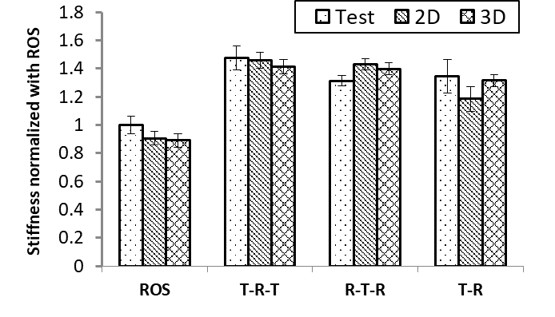 | 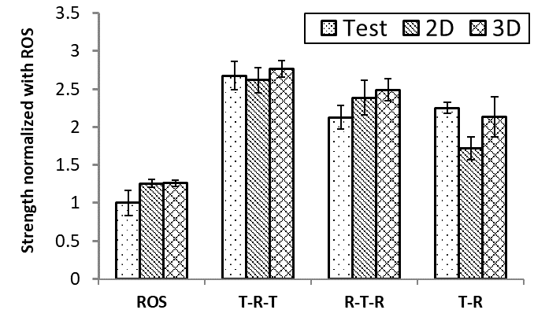
a) | b)
Figure 7: a) Stiffness comparison; b) Strength comparison (all the properties are normalized with reference to ROS mean properties)
The strength predictions of the 2D and 3D models are ~25% higher than the experimental values for the ROS specimens. ROS specimens of 2 mm thickness demonstrate high strand waviness, which are not factored into the strength calculations of the virtual specimens. Among the hybrid configurations, the strengths for the T-R-T configurations are predicted with a greater accuracy than that of ROS specimen predictions. In the T-R-T configuration, the strand waviness is minimized by the tape layers on either side of a centrally placed ROS group. The 2D and 3D models over predict the strength of R-T-R configuration by ~8% and ~15% respectively. These differences could be attributed to the waviness in the laminate group and the strand waviness in the ROS groups. The variability in the virtual specimens is primarily due to the in-plane strand orientations while the variability in the experimental specimens is due to the strand waviness, residual stresses, and strand orientations. Overall, the scatter in the models is similar to those of the experiments. It is to be noted that the relative differences in the stiffness and strength values between the virtual specimens are very close to that of the relative differences in the stiffness and strength values of the experiments. Such relative differences are important to quantify the relative effect of configurations in terms of a standard laminate, without extensive testing efforts. Another important aspect is that both 2D and 3D models predict the positive synergistic behaviour in the T-R-T configuration with reasonable accuracies.

4.3 Failure characteristics
In general, for the strand sizes chosen, the failure in ROS specimens displayed a combination of fibre failures, multiple matrix failures and multiple delaminations. These multiple failures were either in the form of fibre or matrix failures in an in-plane layer or due to cohesive failures in the interfaces of any two in-plane layers. Irrespective of the nature of failures, the weakest regions form a cluster leading to the final failure of the specimen. In the T-R-T specimens, the axial load is distributed in the architectures proportional to their extensional stiffness. With the failure of one of the phases in a hybrid specimen, the load is transferred to the other remaining material until the complete specimen failure. In the chosen hybrid configuration, (i.e. 30/70), the ratio of the extensional stiffness of the laminate group to the extensional stiffness of ROS is 55:45. Extensive matrix dominated failures was observed in the ROS specimens at the highest load while the final failure was caused in the tape layers of the laminate group. The R-T-R configurations demonstrated similar behaviour to that of T-R-T except that the R-T-R configurations involved much more extensive matrix failures at the interfaces with the laminate groups. Among the hybrid stacking configurations, T-R-T demonstrated the highest properties, despite all the configurations possessing similar axial properties theoretically. A more detailed account of the failure characteristics of the models and the experiments are discussed in [10, 20].

5. Conclusions

Simplistic stochastic finite element models (2D and 3D) have been proposed to generate the absolute and relative behaviour of hybrid fibre architectures of ROS and cross-ply laminates. The tensile behaviour of 30% cross-ply and 70% ROS composites in hybrid specimens are simulated and compared with the experiments. The 2D model utilizes two of the following three stages: the use of a strand placement and generation procedure and empirical parameters to replicate the processing, intralaminar progressive failure analysis using Hashin failure criteria for damage initiation and fracture energy based linear softening law for damage propagation, and the use of traction-separation cohesive element laws to model the interlaminar progressive analysis. The 3D model utilizes both intralaminar and interlaminar progressive prediction methods. Overall, both the modelling approaches match the trends observed during experiments, predicts the tensile stiffness and strength of the specimens, and provides preliminary insights into the hybridization aspects. The modelling method certainly demonstrates improvements over other 2D models in literature for ROS, while the 3D modelling is first of its kind proposed and adapted for a hybrid fibre architecture of ROS with laminate groups.

Acknowledgements

We would like to acknowledge the financial support of Bell Helicopter Textron Canada Limited, and Mitacs Accelerate Internship program.

References

1. Chang, I.Y. and J.F. Pratte, LDF thermoplastic composite technology. Journal of Thermoplastic Composite Materials, 1991. 4: p. 227-252.
2. Wakeman, M.D., et al., Compression moulding of glass and polypropylene composites for optimised macro- and micro-mechanical properties. 4: Technology demonstrator - a door cassette structure. Composites Science and Technology, 2000. 60: p. 1901-1918.
3. Wakeman, M., et al., Stamp forming of carbon fibre/PA12 composites – A comparison of a reactive impregnation process and a commingled yarn system. Composites Science and Technology, 2006. 66(1): p. 19-35.
4. Bourban, P.E., et al., Integrated processing of thermoplastic composites. Composite Science and Technology, 1998. 58(5): p. 633-637.
5. Bourban, P.-E., et al., Material phenomena controlling rapid processing of thermoplastic composites. Composites Part A, 2001. 32(8): p. 1045-1057.
6. Bernet, N., et al., Commingled yarn composites for rapid processing of complex shapes. Composites Part A: Applied Science and Manufacturing, 2001. 32(11): p. 1613-1626.
7. Bernet, N., et al., An integrated cost and consolidation model for commingled yarn based composites. Composites Part A: Applied Science and Manufacturing, 2002. 33(4): p. 495-506.
8. Jansson, N., et al., Finite element modelling and testing of an injection moulded generic tow reinforced structure. Composites Part B: Engineering, 2005. 36(6–7): p. 487-495.
9. Jansson, N., M.D. Wakeman, and J.A.E. Månson, Optimization of hybrid thermoplastic composite structures using surrogate models and genetic algorithms. Composite Structures, 2007. 80(1): p. 21-31.
10. Visweswaraiah, S.B., L. Lessard, and P. Hubert, Tensile Behaviour of Hybrid Fibre Architectures of Randomly Oriented Strands combined with Laminate groups. Journal of Composite Materials, 2016. (Under review).
11. Landry, B., Experimental study and numerical simulation of defect formation during compression moulding of discontinuous long fibre carbon/PEEK composites, in Mechanical Engineering. 2016, McGill University: Montreal.
12. International, A., ASTM D3039 / D3039M-14: Standard Test Method for Tensile Properties of Polymer Matrix Composite Materials. 2014, ASTM International: West Conshohocken, PA.
13. Visweswaraiah, S.B., L. Lessard, and P. Hubert, Interlaminar Shear Behaviour of Hybrid Fibre Architectures of Randomly Oriented Strands Combined with Laminate Groups. Composite Structures, 2017.
14. Lapczyk, I. and J.A. Hurtado, Progressive damage modelling in fibre-reinforced materials. Composites Part A: Applied Science and Manufacturing, 2007. 38(11): p. 2333-2341.
15. Selezneva, M., et al., Modelling of mechanical properties of randomly oriented strand thermoplastic composites. Journal of Composite Materials, 2017. 51(6): p. 831-845.
16. Naderi, M., Stochastic analysis of inter- and intra-laminar damage in notched PEEK laminates. eXPRESS Polymer Letters, 2013. 7(4): p. 383-395.
17. 21.3.2 Damage initiation for fibre-reinforced composites, in Abaqus/Standard v. 6.10. Abaqus Analysis User's Manual
18. 21.3.3 Damage evolution and element removal for fibre-reinforced composites, in Abaqus/Standard v. 6.10. Abaqus Analysis User's Manual
19. Selezneva, M. and L. Lessard, Characterization of mechanical properties of randomly oriented strand thermoplastic composites. Journal of Composite Materials, 2015.
20. Visweswaraiah, S.B., Mechanical Characterization and Modelling of Hybrid Fibre Architectures of Randomly Oriented Strand Composites, in Mechanical Engineering. 2018, McGil lUniversity: Montreal.
21. Feraboli, P., et al., Characterization of Prepreg-Based Discontinuous Carbon Fibre/Epoxy Systems. Journal of Reinforced Plastics and Composites, 2008. 28(10): p. 1191-1214.
22. Kravchenko, S.G., Failure Analysis in Platelet Molded Composite Systems, in Department of Aeronautics and Astronautics. 2017, Purdue University: West Lafayette, Indiana. p. 341.

