**On quantifying the effect of noise in radial basis function based stochastic free vibration analysis of laminated composite beam**

S. Naskar**[1]**, S. Sriramula

*LRF Centre for Safety & Reliability Engineering,**School of Engineering, University of Aberdeen, Aberdeen, UK*

**Abstract**

This paper presents the effect of noise on Radial basis function (RBF) based stochastic natural frequency analysis of thin-walled laminated composite beams. The RBF based method is built up on the basis of information acquired regarding the behaviour of the response quantity throughout the entire design space utilizing few algorithmically chosen design points The crucial issue of expensive computation involved in uncertainty quantification of composite structures and the development of radial basis function based uncertainty quantification algorithm to mitigate this lacuna. On the other hand, noise is an inevitable factor in every real life design methods and structural response monitoring for any practical systems. In this paper, a novel algorithm is developed to explore the effect of noise in surrogate based uncertainty quantification methods. The probability distributions for higher modes of natural frequencies (first eight) corresponding to the bending modes has been calculated. The study reveals that stochasticity/ system irregularity in structural and material attributes influences the system performance remarkably. To ensure robustness, safety and sustainability of the structure, it is very crucial to consider such forms of uncertainties during the analysis. The proposed method for quantifying the effect of noise for the proposed computationally efficient RBF based framework in this paper is general in nature and therefore, it can be further extended to explore other surrogate based approach of uncertainty quantification under the influence of noise.

**Keywords**: stochastic representative volume element (SRVE); uncertainty quantification; radial basis function; stochastic natural frequency; sensitivity analysis

**Introduction**

Laminated composites have gained huge popularity because of their weight sensitivity, high-strength and stiffness to weight ratios and long-term cost effectiveness. Such structures are extensively used in aerospace, marine, construction and other industries due to their application specific tailorable material properties. It is widely known that thin walled composite beams are used broadly in various applications of structural engineering, such as helicopter blades, wings, trusses in space structures, submarine hulls, cooling tower shafts, medical tubing, connecting shafts, transmission poles, tail boom of helicopter and tube like structures in missiles. Because of their inherent complexity, a laminated composite beam is difficult to manufacture accurately according to its exact design specifications, resulting in undesirable uncertain responses due to random material and geometric properties. Generally uncertainties are broadly classified into three divisions, namely aleatoric (because of variability in the structural system parameters), epistemic (because of lack of information of the structural system) and prejudicial (because of the absence of variability characterization) [1-4]. The performances of composite structures are influenced by the quality control processes, operating conditions and environmental effects. It can be observed that there are uncertainties in input forces, system descriptions, computation as well as model calibration. The production of composite laminates is subjected to large variability because of unavoidable fabricating imperfections, operational factors, inaccurate experimental data, lack of experience etc. Furthermore, because of various forms of damages and defects, effective material properties may vary substantially from the specified values. As a cumulative effect, the vibration characteristics of such composite structures show significant variability from the deterministic values. Therefore, the structural performance is subjected to a significant element of risk from safety and serviceability point of view. Moreover, uncertainties in input parameters can propagate through different modelling scales and influence other parameters and the final system output can have a substantial cascading effect because of the accumulation of the risk [5, 6]. Such variability can result in significant deviations from the expected outputs (deterministic design values). Hence, it is of prime importance to characterize the probability distribution of the response parameters of interest (such as natural frequencies) by accounting for the variability in stochastic input parameters [7, 8].

Since late eighties, research activities are dedicated towards the development of appropriate analysis for thin-walled composite beams [9, 10]. Bauld and Tseng [11] studied the static structural behavior of a thin-walled composite orthotropic member under various load patterns. Bauchau [12] studied thin walled composite beam models with effects of shear deformability. Cortínez and Piovan reported vibration and buckling analysis of thin-walled composite beams with shear deformability [13]. Various other studies on composite beams are found to be concentrated on deterministic analysis concerning statics and dynamic responses including aero-elastic effects [14, 15]. An extensive review of literature on laminated composites reveals that most of the studies carried out so far are based on a deterministic framework, in spite of the possibility of significant probabilistic variability in the responses of such structures due to inevitable stochasticity in material and geometric parameters. Recently attempts have been made to carry out stochastic analysis for different responses of composite plates and shells [16]. The treatment of uncertainties to quantify the same for thin walled circular composite beam has received little attention. Of late, Piovan *et al.* have investigated the effects of parametric uncertainty on dynamics of thin-walled laminated composite beams [17]. However, most of the recent research follows a random variable based approach that neglects the spatially random variation of material properties. Consideration of random fields for modelling uncertainty in composite structures is practically more relevant. Moreover, consideration of spatially varying damage that often develops in the operational environments has not been accounted in scientific literature yet.

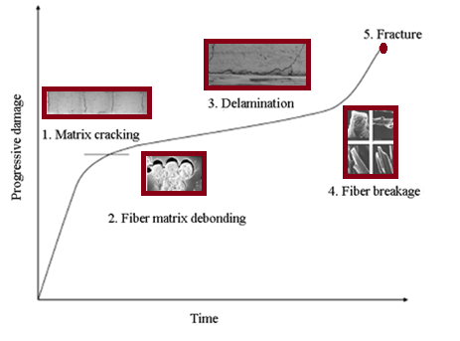

**Figure 1:** Occurrence of progressive damage in composites

This paper presents a realistic analysis on stochastic natural frequency of thin-walled laminated composite beams with spatially varying matrix cracking damage in a multi-scale framework. A typical schematic description of damage development in composite laminates is depicted in Figure 1, where the five identifiable damage mechanisms are indicated in the order of their occurrence [18]. In the early stages of damage accumulation, multiple matrix cracking dominates in the layers which have fibres aligned transverse to the applied load direction. Static tensile tests on cross-ply laminates have shown that the transverse matrix cracks can initiate as early as at about 0.4-0.5% applied strain depending upon the laminate configuration. Thus in the present investigation, spatially random distribution of matrix cracking is considered along with other stochastic input parameters to characterize the natural frequencies of thin-walled composite beams. The crucial issue of expensive computation involved in uncertainty quantification of composite structures and the development of radial basis function based uncertainty quantification algorithm to mitigate this lacuna is discussed in the following paragraph. One of the most prominent approaches followed for uncertainty quantification in composite structures is the Monte Carlo simulation (MCS) based approach. MCS is a computerized mathematical technique which allows to account for risk in quantitative analysis and decision making. This technique is mainly utilized to generate the uncertain variable output frequency using large number of samples. MCS technique can be broadly used to quantify the uncertainty of laminated composites in which thousands of FEM simulations are required to be carried out. Therefore, this technique has limited practical use because of its computational intensiveness unless some form of efficient modelling technique is applied to mitigate this lacuna. Moreover, due to consideration of matrix cracking damage in the present analysis, the entire process of obtaining natural frequency for a particular realization of Monte Carlo sample becomes a multi-step procedure making it even more time consuming. An efficient radial basis function [19, 20] based uncertainty quantification approach is developed in this article to quantify the probabilistic variability in free vibration responses of the structure due to spatially random stochasticity in the micro-mechanical and geometric properties along with matrix-cracking damage. In the present approach, the effect of uncertainty is accounted in the elementary micro-level first and then these effects are disseminated towards the global responses via surrogates of the actual FEM models. To the best of authors’ knowledge, this work is the first attempt of its kind for assessing any surrogate based uncertainty propagation algorithm under the effect of noise. The results presented for different levels of noise have been compared by using probability density function to provide a comprehensive idea about stochastic structural responses under influence of simulated noise, this article presents the effect of inevitable noise in RBF based uncertainty quantification algorithm to simulate the uncertainties associated with the actual field condition.

**RBF based algorithm for stochastic analysis of thin-walled composite beam**

The stochasticity in material properties of laminated composite circular thin walled beams, such as longitudinal elastic modulus, transverse elastic modulus, shear modulus, Possoin’s ratio, mass density and geometric properties such as ply-orientation angle are considered as input parameters for analysis of natural frequencies. It is presumed that the distribution of randomness of input parameters exists within a certain band of tolerance following random uniform distribution with the central determinstic mean values. A variation of  from deterministic value for material properties and fibre orientation angle is assumed for the purpose of analyses following industry standards, unless otherwise mentioned. The percentage variation is regarded as the degree of stochasticity (). In the present study, two separate analyses have been carried out considering the stochasticity in micro-mechanical properties and the stochaticity in macro-mechanical properties to understand the cascading effect of stochasticity on a comparative basis.

To achieve computational efficiency, an RBF based uncertainty quantification algorithm has been developed as presented in figure 4. For constructing the RBF surrogate model, both Latin hypercube sampling [25] and Sobol sequence [26] have been studied to assess their comparative performance. In this surrogate based approach, first the surrogate model (RBF) is formed on the basis of few optimally chosen design points. Thus same number (number of design points) of finite element simulation/ experiments is needed to be carried out at this stage. The RBF model effectively replaces the actual expensive finite element model by an efficient mathematical model. Once the surrogate model is formed, thousands of virtual simulations can be carried out for different random combinations of input parameters using the computationally efficient RBF model.

**Effect of noise on RBF based stochastic analysis algorithm**

The effect of noise on the proposed RBF based stochastic analysis algorithm is accounted by incorporating different levels of Gaussian noise. A Gaussian white noise with a specific factor () is introduced in the set of output responses, which is used subsequently for the RBF model formation, as

|  |  |
| --- | --- |
|  | (1) |

Here,  represents natural frequency and the subscript  and  denote frequency number and sample number respectively; is a function which generates random numbers with normal distribution having zero mean and unit standard deviation and  ** (noise level) in the equation (1) basically represents the standard deviation corresponding to the noise level. The subscript is used here to indicate the noisy frequency.

Thus the simulated noisy set of data (i.e. the sampling matrix for RBF model formation) is constructed by incorporating pseudo random noise in the responses (natural frequencies), while the input design points are allowed to remain unaltered. Subsequently for each of the datasets, RBF based Monte Carlo simulation is performed to quantify uncertainty in the thin walled composite beam. Effect of noise has been analysed following a deterministic approach in several other studies [23-24]. Assessment of the effect of noise on RBF based uncertainty propagation algorithm is investigated for the first time in this study. Such simulated noise can be considered as accounting other sources of uncertainty such as error in computer modelling, error in measurement and various other forms epistemic uncertainties inherently involved with the structural system. Thus the present approach of considering noise in uncertainty analysis will provide a comprehensive idea regarding the robustness of RBF based algorithm under noisy data.

**Results and discussion**

For the purpose of obtaining numerical results, a long circular cross section of a composite beam is considered in the present analysis having a length of 18, outer diameter of the circular cross section as 600 and the beam wall cross-section as 11 [28]. The configuration of laminate is considered for the analyses similar to Nuismer and Tan [21]. The deterministic micromechanical material properties (E-glass Gevetex/ epoxy) of the composite beam are presented in Table 1 [57]. Using Halpin- Tsai

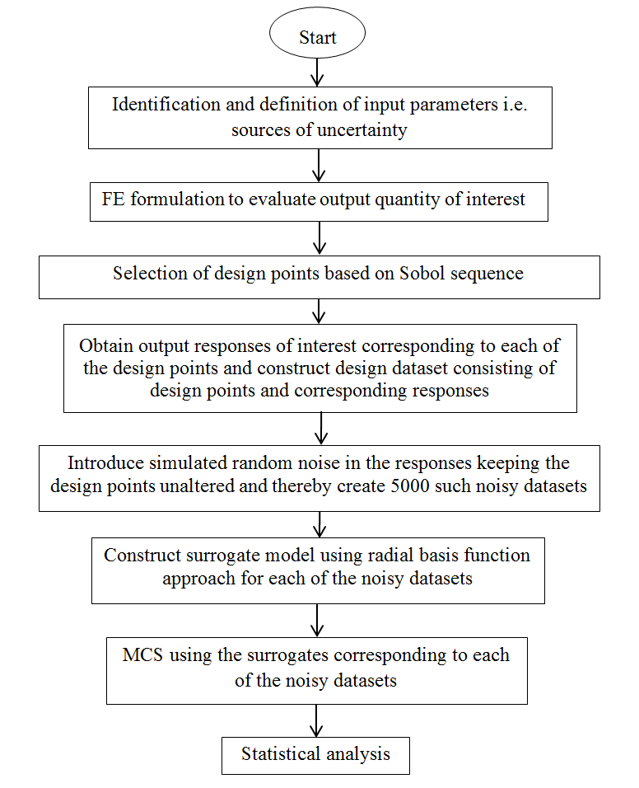

**Figure 3:** Flowchart for analyzing the effect of noise on uncertainty quantification algorithm based on RBF model

principle [33] the deterministic macromechanical properties are calculated by considering a volume fraction () of 0.61 and presented in Table 2.

**Table 1:** Deterministic micromechanical properties of composite [27]

|  |  |
| --- | --- |
| Property | Value |
| Longitudinal modulus for fibre () | 80 GPa |
| Transverse modulus for fibre () | 80 GPa |
| Poisson's ratio for fibre () | 0.2 |
| Shear modulus for matrix () | 33.33 GPa |
| Mass density for fibre () | 2.55 gm/cc |
| Mass density for matrix () | 1.265 gm/cc |
| Elastic modulus of matrix () | 4.2 GPa |
| Shear modulus for matrix () | 1.567 GPa |
| Poisson's ratio for matrix () | 0.34 |
| Fibre volume fraction () | 0.61 |

**Table 2:** Deterministic macro-mechanical properties for = 0.61

|  |  |
| --- | --- |
| Property | Value |
| Longitudinal modulus () | 48 GPa |
| Transverse modulus () | 13.3 GPa |
| Poisson's ratio () | 0.235 |
| In-plane shear modulus () | 5.17 GPa |
| Mass density () | 1.94 gm/cc |
| Shear modulus () | 5.17 GPa |
| Transverse shear modulus () | 4.12 GPa |

It is worthy to mention here that by adopting the surrogate based approach, significant computational efficiency is achieved. Although same sampling size as in direct MCS (with sample size of 10,000) is considered in the present RBF based approach, the number of actual FE analysis is much less compared to original MCS and is equal to the number of representative samples required to construct the RBF meta-model. Hence, the computational time and effort expressed in terms of FE simulations is reduced significantly compared to full-scale direct MCS.

Figure 4-5 show the effect of noise on RBF based uncertainty quantification algorithm for the thin-walled laminated composite beam. The scatter plot for fundamental natural frequency in figure 4 show that the prediction capability of RBF gets increasingly affected by increasing level of noise (), while figure 5 presents the effect of noise on probabilistic description of first three natural frequencies. The fundamental natural frequency is identified to be the most noise sensitive among the first three modes of vibration.

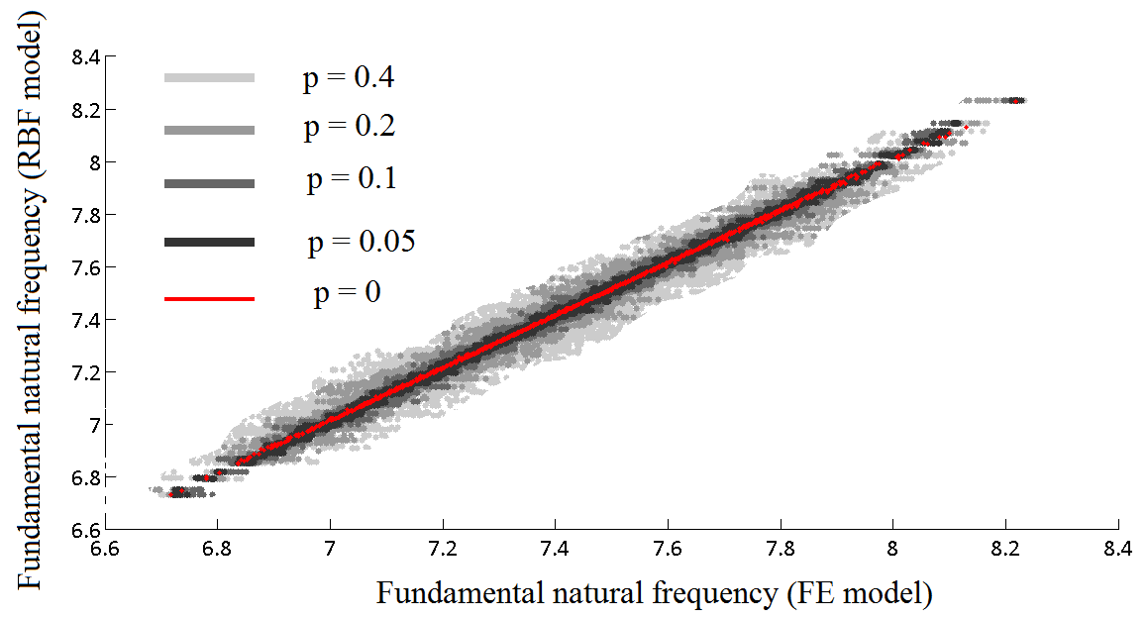

**Figure 4:** Scatter plots depicting the effect of noise on RBF based uncertainty quantification for first three natural frequencies

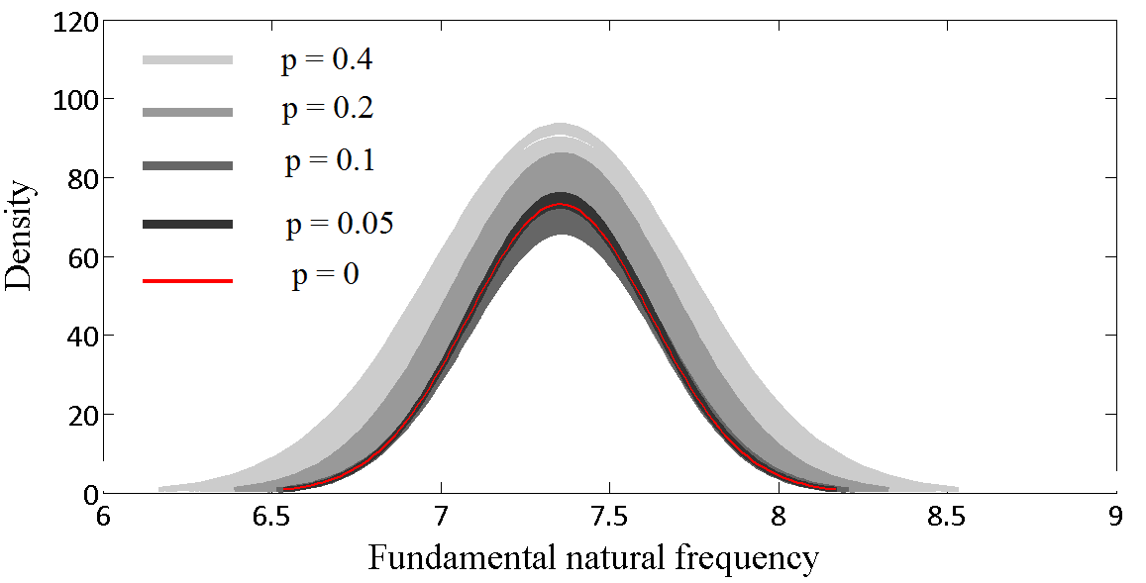

**Figure 5:** Probability density function plots depicting the effect of noise on RBF based uncertainty quantification for first three natural frequencies

**Conclusions**

In this paper, another prospective source of uncertainty has been identified in the surrogate based uncertainty propagation approaches besides the conventionally considered uncertainties and the effect of same has been analyzed through introducing simulated noise in the system. A novel algorithm for quantifying the effect of noise on surrogate based uncertainty propagation approach has been developed. The effect of such simulated noise can be regarded as inclusion of other sources of uncertainty beside the conventionally considered stochastic material and geometric parameters, such as error in measurement of responses, error in modeling and computer simulation and various other epistemic uncertainties involved with the system. The kind of analysis presented in this paper provides a brief insight on the stochastic responses under investigation. The representative results have been presented for thin walled laminated composite beams based on RBF based approach considering different levels of noise, wherein it is noticed that the fundamental natural frequency is most affected by such simulated noise. Consideration of the effect of such noise is thus an important criterion for robust and comprehensive analysis of stochastic systems. Though we have concentrated on RBF based analysis of spherical composite beams only, the proposed algorithm for quantifying effect of noise in stochastic analysis is general in nature. Thus it can be extended to other structures and to analyze other surrogates in future.

**Acknowledgements**

The authors are grateful for the support provided through the Lloyd’s Register Foundation Centre. The Foundation helps to protect life and property by supporting engineering-related education, public engagement and the application of research.

**References**

1. Sriramula S, [Chryssanthopoulos](http://www.sciencedirect.com/science/article/pii/S1359835X09002577) K M, Quantification of uncertainty modelling in stochastic analysis of FRP composites, [*Composites Part A: Applied Science and Manufacturing*](http://www.sciencedirect.com/science/journal/1359835X)*,* 40 1673-1684, 2009
2. Naskar, S., Mukhopadhyay, T., Sriramula, S. & Adhikari, S. (2017a). 'Stochastic natural frequency analysis of damaged thin-walled laminated composite beams with uncertainty in micromechanical properties'. Composite Structures, vol 160, pp. 312-334
3. Naskar, S. & Sriramula, S. (2017a). 'Random Field Based Approach for Quantifying the Spatial Variability in Composite Laminates'. Paper presented at 20th International Conference on Composite Structures (ICCS20), paris, France, 4/09/17 - 7/09/17
4. Naskar, S. & Sriramula, S. (2017b). 'Vibration analysis of hollow circular laminated composite beams - A stochastic approach'. Paper presented at 12th International Conference on Structural Safety & Reliability, Vienna, Austria, 6/08/17 - 10/08/17
5. Shaw A, Sriramula S, Gosling P D, Chryssanthopoulos M K, A critical reliability evaluation of fibre reinforced composite materials based on probabilistic micro and macro-mechanical analysis, *Composites Part B: Engineering*, 41 6 446-453, 2010
6. Mukhopadhyay, T., T.K. Dey, S. Dey and A. Chakrabarti. 2015a. Optimization of fiber reinforced polymer web core bridge deck—a hybrid approach. *Structural Engineering International* 25(2): 173–183.
7. Dey, S., T. Mukhopadhyay and S. Adhikari. 2015a. Stochastic free vibration analysis of angle-ply composite plates—a RS-HDMR approach. *Composite Structures* 122: 526–536.
8. Naskar, S., Mukhopadhyay, T. & Sriramula, S. (2018). A comparative assessment of ANN and PNN model for low-frequency stochastic free vibration analysis of composite plates. in Handbook of Probabilistic Models for Engineers and Scientists. Elsevier
9. Bank L C, Bednarczyk P J, A Beam Theory for Thin-walled Composite Beams, *Composites Science and Technology,* 32 265-277, 1988
10. Chandra R, Stemple A D, Chopra I, Thin-walled composite beams under bending, torsional, and extensional loads, *Journal of Aircraft*, 27 (7) 619-626, 1990
11. Bauld N, Tzeng L. A Vlasov, Theory for fiber-reinforced beams with thin-walled open cross sections, *International Journal of Solids and Structures*, 20(3) 277–297, 1984
12. Bauchau O, A beam theory for anisotropic materials, *Journal of Applied Mechanics*, 52(2) 416–22, 1985.
13. Cortínez VH, Piovan Mt, Vibration and buckling of composite thin-walled beams with shear deformability, *Journal of Sound and Vibration*, 258(4) 701–23, 2002
14. Chakrabarti A, Sheikh A. H., Griffith M., Oehlers D. J., Dynamic Response of composite beams with partial shear interactions using a higher order beam theory. *Journal of Structural Engineering*, 139 (1), 47-56, 2013
15. Chakrabarti A, Chalak H D, Iqbal M A and Sheikh A H, A new FE model based on higher order zigzag theory for the analysis of laminated sandwich beam with soft core. Composite Structures, 93(2), 271-279, 2011
16. Dey S, Mukhopadhyay T, Spickenheuer A, Gohs U, Adhikari S, Uncertainty quantification in natural frequency of composite plates - An Artificial neural network based approach, *Advanced Composites Letters*, 25(2) 43–48, 2016a.
17. Piovan M T, Ramirez J M, Sampaio R, Dynamics of thin-walled composite beams: Analysis of parametric uncertainties, *Composite Structures,* 105 14–28, 2013
18. Singh C V, Multiscale modeling of damage in multidirectional composite laminates, PhD Thesis, Texas A&M University, 2008
19. Hardy R L, Theory and applications of the multiquadric-biharmonic method, *Comput. Math. Appl,* 29 163{208}, 1990
20. Powell M J D, Radial basis functions for multivariable interpolation: a review, *Algorithms for Approximation*, Mason J.C., Cox M.G. (eds.), London, Oxford University Press, 1987
21. Nuismer, R. J., Tan, S. C., Constitutive relations of a cracked composite lamina, *J Compos Mater,* 22, 306–321, 1988
22. Jones R M, Mechanics of *Composite structures*, *Taylor & Francis*, Philadelphia, PA, 1999
23. Mukhopadhyay T., Naskar S., Dey S., Adhikari S., On quantifying the effect of noise in surrogate based stochastic free vibration analysis of laminated composite shallow shells, Composite Structures, 140 798–805, 2016
24. Mukhopadhyay T., Chakraborty S., Dey S., Adhikari S., Chowdhury R., A critical assessment of Kriging model variants for high-fidelity uncertainty quantification in dynamics of composite shells, *Archives of Computational Methods in Engineering*, DOI: 10.1007/s11831-016-9178-z
25. McKay MD, Beckman RJ, Conover WJ. A comparison of three methods for selecting values of input variables in the analysis of output from a computer code. *Technometrics*, 42(1) 55–61, 2000
26. Sobol’ IM. On the distribution of points in a cube and the approximate evaluation of integrals, *USSR Comput Math Math Phys*, 7 86–112, 1967
27. Soden P D, Hinton M J, Kaddour A S, Lamina properties, lay-up configurations and loading conditions for a range of fibre reinforced composite laminates, *Compos. Sci. Technol.*, 58 (7) 1011-1022, 1998 //51
28. Polyzois D., Raftoyiannis G., Ibrahim S., Finite Elements for the Dynamic Analysis of Tapered Composite Poles, *Composite Structures*, 43 25–34, 1998.

1. *Corresponding author: Susmita Naskar*

   *E-mail: r01sn15@abdn.ac.uk (S. Naskar)*