Finite Element Analysis of Damage Properties of Carbon Nanocoil / Epoxy Composites

K. Sanada and S. Okada

Department of Mechanical Systems Engineering, Faculty of Engineering, Toyama Prefectural University, 5180 Kurokawa, Imizu-shi, Toyama 939-0398, Japan
Email:sanada@pu-toyama.ac.jp, Web Page: http://www.pu-toyama.ac.jp

Keywords: Damage mechanics, Finite element method, Carbon nanocoil, Composite material, Effective properties

Abstract
The damage properties of carbon nanocoil (CNC) /epoxy composites have been investigated numerically. To predict the damage evolution in CNC/epoxy composites, the finite element analyses were performed using a three-dimensional unit cell model of the composites with aligned straight CNCs. The form of this unit cell model is based on the assumption of a square array of unidirectionally oriented CNCs in an infinite epoxy matrix. To simplify the geometry we treat the tube geometry as a solid element of circular cross-sectional area. Matrix microcracking was detected by the von Mises criterion. The effect of helical geometry of CNCs on the damage properties of CNC/epoxy composites are examined. Similar calculations were also made for carbon nanotube (CNT) /polymer composites. The results for CNC/polymer composites were compared with those for CNT/polymer composites.

1. Introduction

Carbon nanocoils (CNCs) are considered as potentially useful reinforcements for high performance polymer composites [1]. CNCs exhibit excellent mechanical properties because of the combination of coil morphology and properties of carbon nanotubes (CNTs). If CNCs were used in polymer composites, their shape would favor a better load transfer between CNCs and matrix than that in the case of CNTs. Sanada et al. evaluated numerically the stiffness and damping characteristics of CNC/polymer composites [2] and performed cryogenic tensile tests with flat tensile specimens and single edge notched tensile specimens of CNC/polymer composites [3]. The microstructures determine the failure properties of the composites through their influence on the initiation and evolution of the damages. To assess the performance of CNC/polymer composites, it is important to understand the effects of the helical geometries of CNCs on the damage properties. The scope of this study is to investigate the damage properties of CNC/epoxy composites numerically.

2. Modeling and Simulation

The finite element analysis in this study is performed using ANSYS. The 3D unit cell model shown in Fig. 1 is used to predict the damage properties of the composites with aligned straight CNCs. A rectangular Cartesian coordinate system (, , ) is used. This unit cell model contains a single CNC at the center. The form of this unit cell model is based on the assumption of a square array of unidirectionally oriented CNCs in an infinite epoxy matrix. To simplify the geometry we treat the tube geometry as a solid element of circular cross-sectional area. In the case of the unit cell model for the composites with aligned straight CNCs, the CNC volume fraction is given by

(1)

where is the length of the unit cell, is the cross-sectional area of the unit cell, is the number of coil turns, is the coil radius and is the tube radius. The coil pitch of the CNC is . To obtain the converged values of the effective properties, the CNCs with [2] are considered.

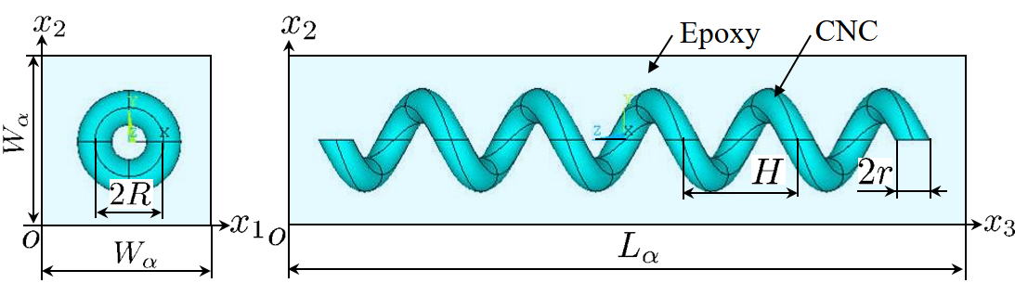

Figure 1. 3D unit cell model for the composites with CNCs.

Symmetry conditions are applied to the boundary surfaces , , , and . The surface is subject to a uniform displacement in the direction. Thus, the applied global strain of the unit cell model is defined as . The effective Young's modulus in the direction, , can be found by applying the above boundary conditions to the model.

Under incrementally applied loading, stress analyses were carried out and used to identify the damage location according to a failure criterion. To consider the interaction between the stress components, the von Mises criterion was selected as the criterion for microcracking of the matrix. The von Mises criterion is a special case of a general form of quadratic interaction criteria. Variations of the general criteria such as Tsai-Wu, Hoffman and Hashin criteria have been used to predict brittle failure in orthotropic materials. Zhao et al. used the von Mises criterion to predict failure in the polymer matrix of woven composites. Once damage occurs, stiffness reduction is applied for further stress analysis. The following von Mises criterion was selected as the criterion for matrix microcracking [4].

where, , , , and are the stress components, is the measured tensile strength of epoxy and the subscripts 1, 2, and 3 are related to the three axes of the coordinate system. When the stress state in an element satisfied the von Mises criterion, all of the stiffness terms of the element are reduced to a near zero value and the damaged element is marked to distinguish it from the undamaged elements. Sequential plots of the damaged elements can be used to indicate the damage growth pattern.

The individual phase materials are modeled as linear elastic and isotropic solids, and a perfect bonding between the phases is assumed. For the epoxy matrix, the Young's modulus, the Poisson's ratio and the tensile strength are taken to be 3.48GPa, 0.35 [2] and 90MPa [5], respectively. The Young's modulus and the Poisson's ratio of the CNC are assumed to be 100GPa [6] and 0.3, respectively.

Similar calculations were conducted for the composites with CNTs. The 3D unit cell model shown in Fig. 2, which contains a single wavy CNT at the center, is created and solved with appropriate boundary conditions to compare with the results of the 3D unit cell model for the composites with CNCs.

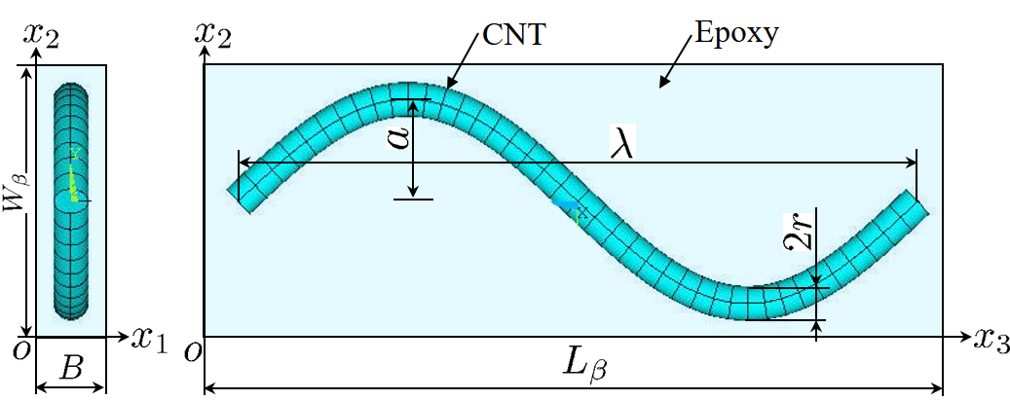

Figure 2. 3D unit cell model for the composites with CNTs.

In the case of the unit cell model for the composites with aligned wavy CNTs, it is assume that the tube radius of the CNT is equal to that of the CNC and the centerline path of the CNT is sinusoidal in the - plane at. The material properties of the CNT is assumed to be same with the material properties of the CNC. The CNT volume fraction is obtained as [7]

(2)

(3)

(4)

where is the length of the unit cell, is the cross-sectional area of the unit cell and and are the wavelength and amplitude of the CNT waviness, respectively.

3. Results and Discussion

The geometric parameters of CNCs as measured in the scanning electron microscope are =195nm, =390nm and =1330nm, and the CNCs with =5 are considered [2]. The waviness ratio of the CNTs is taken to be 0.15 and 0.2 [8]. Calculations were carried out assuming =0.05.

Fig. 3 presents the predicted damage progression in the unit cell model of the CNC/epoxy composites at the applied global strain value of 1.2%. In this figure, dark parts indicate the matrix microcracking. The matrix microcracking initiated from the edges of the CNC and propagated along the CNC/matrix interface toward the center of CNC. Same trends were observed for the unit cell model of the CNT/epoxy composites.
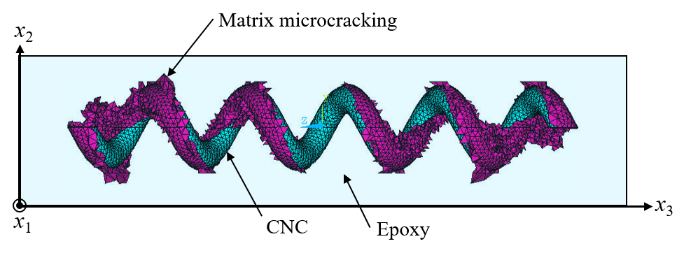
Figure 3. Predicted damage growth in the unit cell models of the CNC/epoxy composites.

Fig.4 shows the effective Young's modulus of the composites, , versus the applied global strain. The value is affected by matrix microcracking. When the matrix microcracking initiated and propagated, the value decreased. The matrix microcracking in the unit cell model of the CNC/epoxy composites occurred at higher strain than that of the CNT/epoxy composites. This due to the difference of stiffness between the CNT and the CNC. Moreover, the value of the CNC/epoxy composite decreased gently compared with the CNT/epoxy composite. This trend could be caused by the coil geometry of the CNC. Thus, the failure strain of the CNC/epoxy composite is higher than that of the CNT/epoxy composite.

Figure 4. Effect of damage on the effective Young's modulus of the composites.

4. Conclusions

The damage properties of CNC/epoxy composites have been investigated numerically. The finite element analyses were performed using the three-dimensional unit cell model of the composites. The results indicated that the matrix microcraking initiated from the edges of the CNC and propagated along the interface between the CNC and matrix. Moreover, the matrix microcracking in the unit cell model of the CNC/epoxy composites occurred at higher strain than that of the CNT/epoxy composites. Thus, the damage properties of the CNC/epoxy composite was affected by the coil geometry of the CNC.

References

[1] K.T. Lau, M. Lu and D. Hui. Coiled carbon nanotubes: Synthesis and their potential applications in advanced composite structures, Composites:Part B, 37: 437-448, 2006.
[2] K. Sanada, Y. Takada, S. Yamamoto and Y. Shindo. Analytical and experimental characterization of stiffness and damping in carbon nanocoil reinforced polymer composites, JSME Journal of Solid Mechanics and Materials Engineering, 2(12):1517-1527, 2008.
[3] K. Sanada, H. Sanga and Y. Shindo, Effect of ultrasonication on the cryogenic tensile properties of carbon nanocoil/poly-dicyclopentadiene composites, Composites Part A, 43:1895-1900, 2012.
[4] L.G. Zhao, N.A. Warrior and A.C. Long. Finite element modeling of damage progression in non-crimp fabric reinforced composites, Composites Science and Technology, 66: 36-50, 2006.
[5] C. Li and T.W. Chou. Modeling of damage sensing in fiber composites using carbon nanotube networks, Composites Science and Technology, 68: 3373-3379, 2008.
[6] T. Hayashida, L. Pan, Y. Nakayama, Mechanical and electrical properties of carbon tubule nanocoils, Physica B, 323: 352-353, 2002.
[7] T.-W. Chou and K. Takahashi, Non-linear elastic behaviour of flexible fibre composites, Composites, 18(1): 25-34, 1987.
[8] F.T. Fisher, R.D. Bradshaw and L.C. Brinson, Fiber waviness in nanotube-reinforced polymer composites - I:Modulus predictions using effective nanotube properties, Composites Science and Technology, 63:1689-1703, 2003.

