EXPERIMENTAL INVESTIGATION OF THE EFFECTS OF PRE-PREG GAPS FOR THE AUTOMATED PRODUCTION OF FIBER METAL LAMINATES

D. Nardi¹, M. Abouhamzeh¹ , R. Leonard², J. Sinke¹

¹Structural Integrity & Composites, Department of Aerospace Structures and Materials, Delft University of Technology, Kluyverweg 1, Delft, The Netherlands
Email: d.nardi@tudelft.nl
Email: m.abouhamzeh@tudelft.nl
Email: j.sinke@tudelft.nl

²Fibre Metal Laminates Centre of Competence, Kluyverweg 1, Delft, The Netherlands
Email: r.a.leonard@tudelft.nl

Keywords: automated manufacturing, fiber metal laminates, gaps, non destructive evaluation, mechanical properties

Abstract
Gaps in pre-preg plies, in a case when adjacent plies do not align perfectly, may represent a significant issue in an automated fibre placement manufacturing process and can be detrimental to the properties of the final laminates. In order to tackle the consequences of gaps in the composite material, a comprehensive research has to be performed. Starting from existing manufacturing processes, the effects of gaps were investigated in different ways, including the first indication of their impact on the mechanical properties. The focus of this paper is to extend the state of the art in gaps in composite materials to hybrid composite materials such as Glare, a member of Fibre Metal Laminates (FMLs). The investigation started with the manufacturing of Glare specimens having gaps with different widths, followed by a non-destructive ultrasonic inspection. Also, an optical evaluation of the gaps was performed by microscope image analysis of the cross sections of the specimens. Results from the ultrasonic inspections revealed the presence of areas corresponding to the gaps areas. The optical evaluations supported the ultrasonic results and showed the presence of fibre waviness and delaminations. Finally, the ultimate tensile strength of comparable specimens was determined, proving the detrimental effect of gaps on the strength of the final laminate.

1. Introduction

Fiber-metal laminates (FMLs) represent an effective hybrid alternative solution for monolithic alluminium alloys in primary aircraft structures. The better behavior of the laminates, e.g. in terms of fatigue crack initiation and growth, may offer weight savings in aircraft structures along with cost saving in production [1].

Glare, a member of the FML family, consists of aluminium sheets and unidirectional S2-glass fibres embedded in an FM 94 adhesive. The pre-preg can be laid-up in different orientations with respect to the aluminium sheet, providing different Glare grades for different purposes, such as fatigue, impact, and off-axis properties. For an overview of the different grades, refer to [2]. After the manufacturing process, flaws can be found in the final laminate, leading to a degradation of the mechanical properties of the structural component.
The production of Glare panels has traditionally considered many manual steps, such as trimming, pre-treatment and primer application of the metal sheets, followed by layup into the mold with pre-preg plies. However, in order to increase the rate of production the automation of the process has to be developed, at least for the stacking operation. In this aspect, similarities can be found with the automated manufacturing of fully composite laminates, such as carbon fiber reinforced plastic (CFRP).

The degree of automation in CFRP manufacturing is not very high, and considerable knowledge has still to be gained before achieving a consistent, robust and reliable manufacturing chain [3]. Automated fibre placement (AFP) process is one of the main technologies used to automate the pre-preg layup. It consists of a computer-controlled robotic arm with a placement head that lays tape or pre-preg strips into a mold for the build up of the product. Due to the relatively narrow width of the strips, gaps and overlaps parallel to the fibre direction can be generated between adjacent plies [4]. The effect of gaps and overlaps due to AFP in composite laminates has been investigated in [5]. The results gave a general overview of the influence of defects on laminate behavior under different loadings and laminate configurations.

In order to extend the current state of the art of the effects of AFP induced defects to FMLs, the present study proposes an experimental investigation of the effects of pre-preg gaps in Glare.

This work reports the results obtained in [6] and in addition shows the effect of the presence of gaps with respect to the laminate ultimate tensile strength.

Laminates with different gap widths have been manufactured and then subjected to non-destructive ultrasonic inspection. Microscope optical evaluation has been performed on the laminate cross sections in order to correlate the ultrasonic inspection with the geometrical features of the presence of gaps. Lastly, the ultimate tensile strength of the samples with and without gaps has been experimentally evaluated, and a correlation with an analytical predictive model has been included. The obtained results of the gap investigation will be used to extend the effect of gaps into other mechanical properties, both static such as compression and interlaminar shear strength, and fatigue, and to evaluate the effectiveness of the proposed analytical method for different Glare layups.

2. Manufacturing

Specimens of Glare 3-2/1 have been manufactured manually, consisting of 2 aluminium sheets with 0.4 mm of thickness, and 0°/90° cross-ply pre-preg in between, with a nominal thickness of 0.125 mm. Gaps with widths of 2, 3, 4, and 5 mm have been left in the 0° ply only. Table 1 and Figure 1 show the features of the manufactured laminates.

Table 1. Overview of the first batch of Glare laminates specimens for the gaps investigation.

Laminates  dimension  [mm] | Glare  features | Gaps  width  [mm]
1400 x 320 | 3-2/1-0.4 | 2
1400 x 320 | 3-2/1-0.4 | 3
1400 x 320 | 3-2/1-0.4 | 4
1400 x 320 | 3-2/1-0.4 | 5

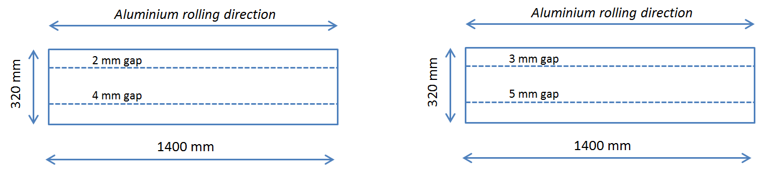
Figure 2. Sketches of the manufactured Glare 3-2/1-0.3 laminates with gaps [6].

The cured laminates reveal the presence of the gaps by light reflection due to the local thickness variation induced by the gaps. However, if wider laminates are considered, or if the length of the gaps is shorter, a non-destructive detection based on light contrast will lack reliability.

3. Non-destructive ultrasonic inspection

The Glare laminates with gaps have been subjected to an ultrasonic non-destructive analysis by means of C-Scan inspection. The inspection is based on sending ultrasound signal through the laminate where its attenuation is measured over the surface of the component. The measured signal attenuation is displayed as a greyscale or color image [7]. For the details of the performed ultrasonic inspection refer to [6].

Figure 3 displays the outcome of the C-Scan analysis on the Glare specimens with 5 and 3 mm gaps (top) and 4 and 2 mm gaps (bottom).
Red lines, corresponding to the presence of the gaps, reveal the higher attenuation level with respect to the other flawless areas of the laminates. Moreover, the picture shows that the gaps do not keep a constant width along the laminate, showing the tendency of the pre-preg from the adjacent material to fill the gaps due to the autoclave pressure.

In addition, gaps width and attenuation have been measured considering six random points along the length of the laminates. The obtained results are reported in Table 2 and 3. In particular, the higher attenuation level noticed for wider gap widths can be related to the local thickness variation induced by the gaps.

In conclusion, the C-Scan-based inspection has proven to be effective for both gap detection and severity assessment, based on the measured values of the width and attenuation level.

4. Optical evaluation

In order to better understand the results obtained from the ultrasonic inspection, a microscope-based investigation of the presence of the gaps in the laminate is performed. For each specimen, five fragments have been cut out along the length in correspondence of the gaps location, as shown in Figure 4. The fragments have been placed in a resin and polished. Only gaps of 2 and 4 mm have been considered for the sake of simplicity.

The figure obtained from the microscope shows the presence of the gap area, which is filled by the epoxy resin without fibers (see Figure 4). This implies that the absence of fibers can affect the mechanical properties of the Glare laminate depending in the first instance on the width of the gap. Furthermore, an out-of-ply waviness is visible, mainly due to the pressure that pushes the pristine ply below into the opens space left by the gap.
For more information about the variation of the thickness of the laminate due to the presence of gaps, the interested reader is referred to [6].

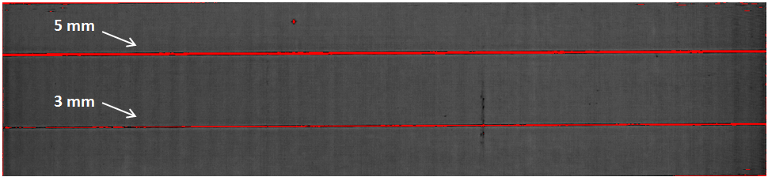
(a)
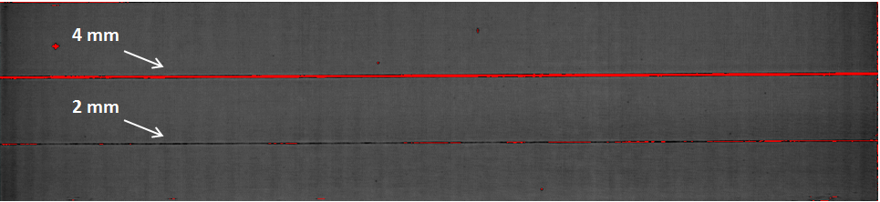
(b)
Figure 3. C-Scan of the Glare laminates with gaps: 5 and 3 mm gap widths (a), 4 and 2 mm gap widths (b) [6].

Table 2. Overview of the first batch of Glare laminates specimens for the gaps investigation [6].

Gap width [mm]  -manufactured- | Gap width [mm]  -measured (max value)-
5 | 4
4 | 3
3 | 2
2 | 2

Table 3. Average attenuation levels of the Glare specimens [6].

Gap width [mm]  -manufactured- | Average attenuation level [dB] | Standard deviation [dB]
0  (reference) | 28.33 | 0.51
5 | 75.83 | 9.72
4 | 70.16 | 11.56
3 | 45.83 | 9.66
2 | 38.83 | 3.65

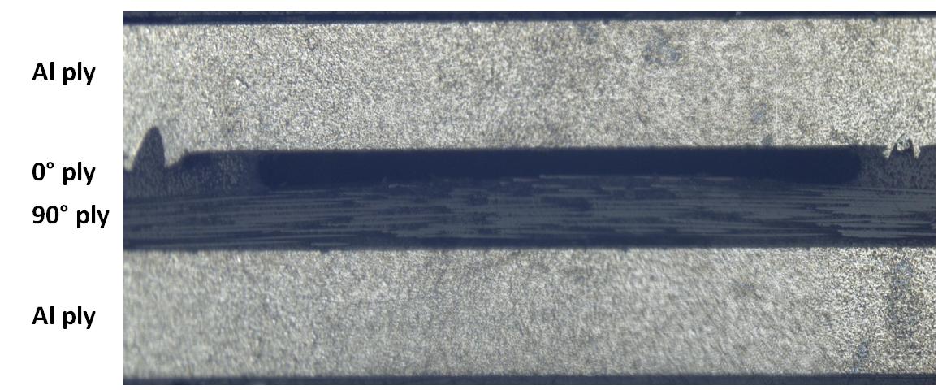
Figure 4. Cross section cut-outs [6] (left), and miscroscope picture of the cut-out with gap on the top ply [6].

.

5. Ultimate tensile strength

The Glare laminates have been subjected to the tensile test in order to evaluate the effect of gaps on the ultimate tensile strength (UTS) property. Tensile specimens (three for each gap width) have been realized according to the test procedure for fiber metal laminates [8], as shown in Figure 5a, with the gap placed in the centre line of the specimen and parallel to its length. One specimen with a gap width of 4 mm has not been properly tested, therefore for this configuration only two samples have been considered. Figure 5b shows a Glare sample after failure.

Table 4 summarizes the details of the performed tests with the UTS values. It is evident that, although the number of samples may not be enough for a proper evaluation of the UTS values, the standard deviation is limited, and the results can be considered as indicative for future tests.
The average UTS values are plotted in Figure 6, showing an almost linear, decreasing trend of the UTS as a function of the gap width increment. The presented results are width-dependent, meaning that, for the same gap width, a sample width increment will result in smaller UTS reduction. The same conclusion can be formulated for specimens with a higher number of pre-preg layers.

In order to predict the UTS values for specimens of different gap width or Glare layups, an analytical model is developed based on the presented experimental data.

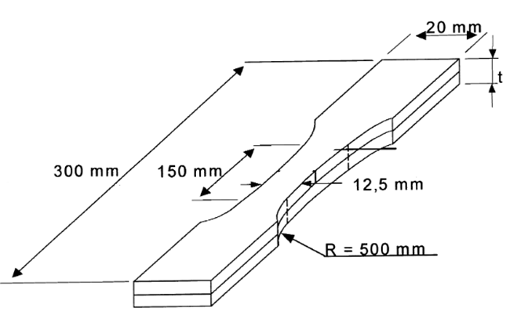 | 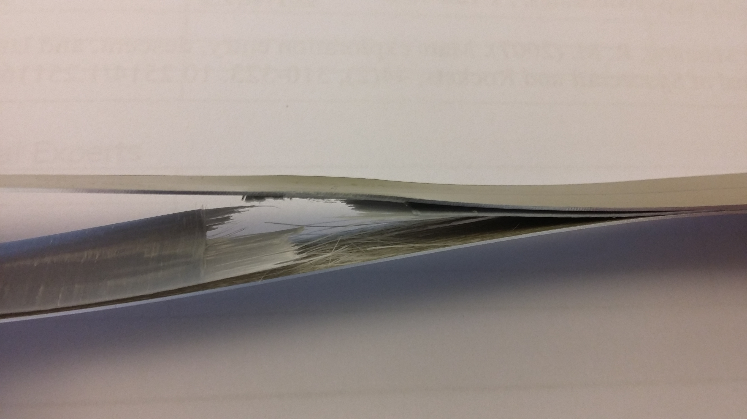
(a) | (b)
Figure 5. Glare dogbone specimen (a) [9], and after the tensile test (b).

Table 4. Details of the experimental investigation for UTS property evaluation.

Gap width [mm]  -manufactured- | Average UTS [MPa] | Standard deviation [Mpa] | Variation from the reference (%)
0  (reference) | 599.63 | 12.98 | /
2 | 564.33 | 2.12 | -5.89
3 | 528.50 | 2.95 | -11.86
4 | 498.65 | 0.49 | -16.84
5 | 471.80 | 3.75 | -21.32

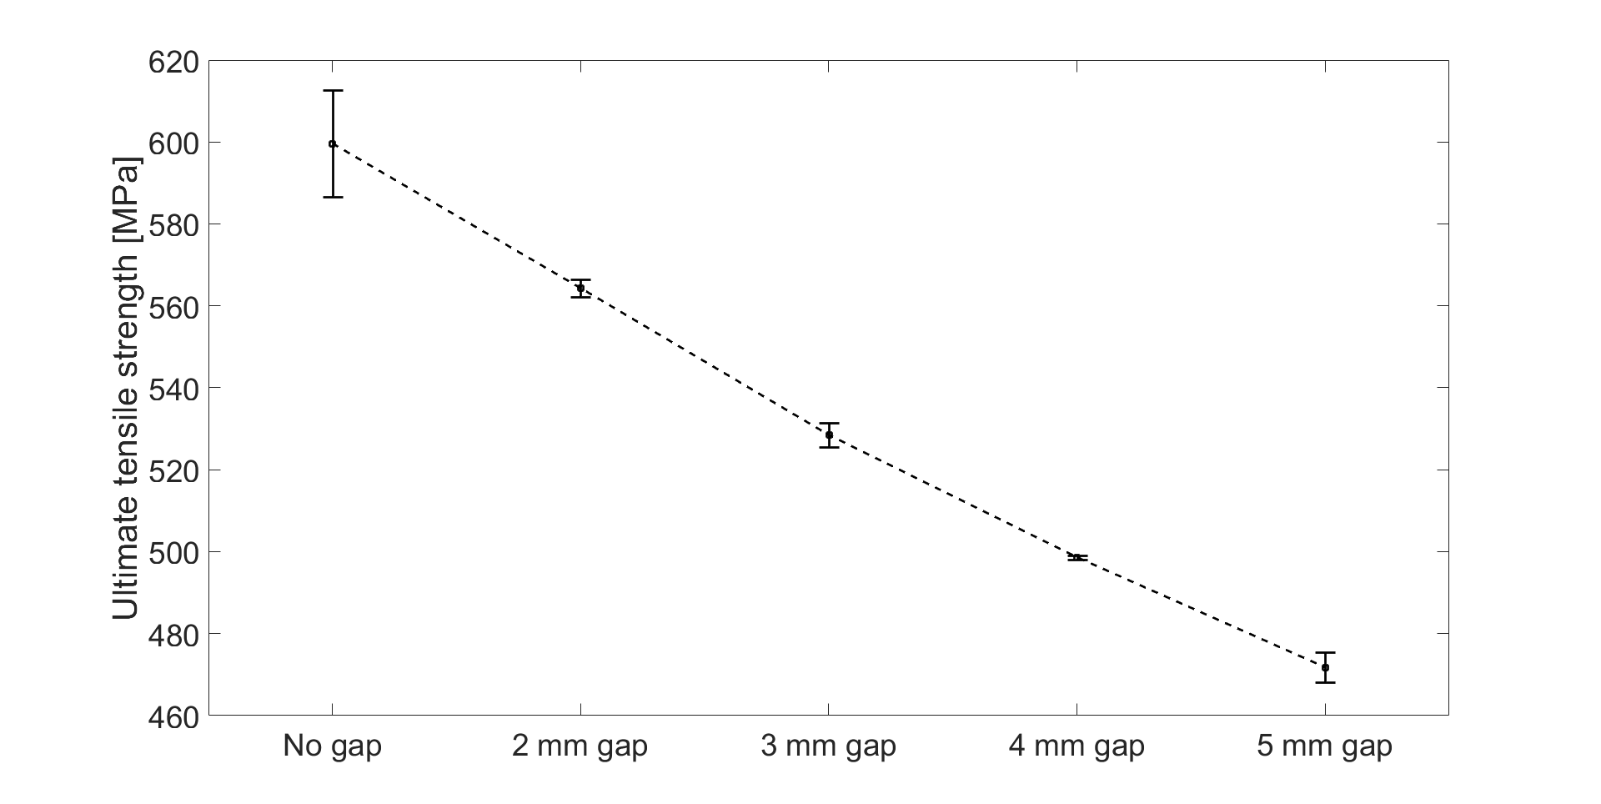
Figure 6. Average UTS values.
Considering the different contributions to the UTS of the three Glare constituents, we have

(1)

where the contributions of the aluminium and the pre-preg orientations to the UTS are reported with the proper subscript.

If there is no gap, (1) can be written as:

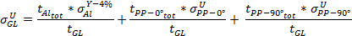 | (2)

since = 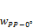 = 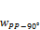 = .

If a gap of a certain width is introduced in the 0° pre-preg ply, then , such that

(3)

Figure 7 shows the comparison between the UTS values obtained with the analytical model with the ones obtained by the experimental test campaign. The results of the comparison can be split into two regions, the first from the reference samples (no gap) to the 2 mm gap samples, and the second for the other samples with gaps.

In the first region, the trend provided by the analytical model is in agreement with the experiment. The difference is due to the stress reference values of the Glare components considered in the analytical solution [10], [11].

In the second region, the slope of the analytical trend is lower (in absolute value) than the trend obtained by the tests. The reason can be found in not having considered the local thickness variation in the laminate due to the presence of the gaps. Hence, more tests and a more comprehensive analytical formulation is required.

6. Conclusions

In this work, the effects of the presence of pre-preg gaps in Glare have been investigated. Different gap widths have been manufactured in order to evaluate the influence in terms of (i) non-destructive evaluation, (ii) microscope optical evaluation of post-curing appearance, and (iii) ultimate tensile strength of the final laminate.

C-scan ultrasonic inspection has proved the effectiveness of the gaps detection showing a higher level of attenuation compared to undamaged areas. Microscope optical evaluation has shown the tendency of gap width reduction due to the cure of the laminate. In terms of the impact on the mechanical properties, the laminates with gaps have shown a linear decrement of the value of the ultimate tensile strength which has also been represented by an analytical model.

Future works will address the effect of gaps in different Glare grades and layup and the influence of other laminate mechanical properties, both static and fatigue.

Acknowledgments

The research was carried out under project number T11.6.14523 in the framework of the Research Program of the Materials innovation institute (M2i) (www.m2i.nl) and Fokker Aerostructures.

(3)

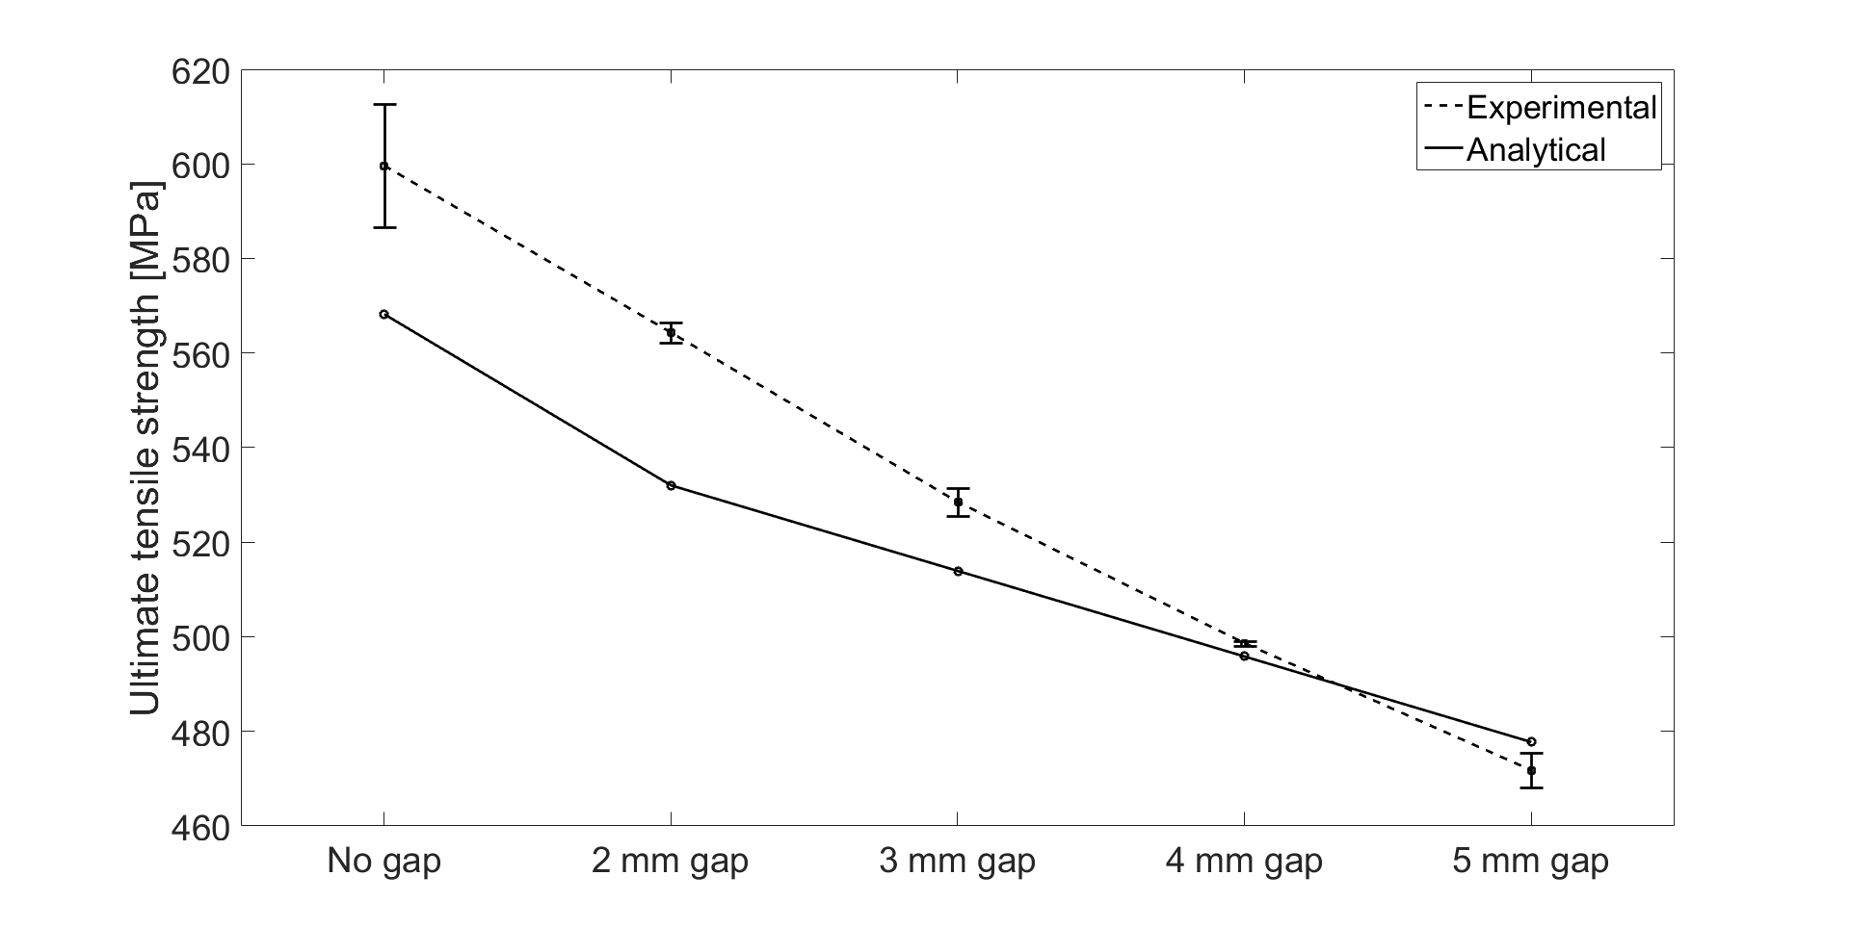

Figure 7. Comparison of the UTS values from the analytical model and experimental tests.

References

[1] G.H.J.J. Roebroeks. Fibre-metal laminates. Recent developments and applications. International journal of fatigue, 16: 33–42, 1994
[2] A. Vlot, and J. W. Gunnink. Fibre Metal Laminates an introduction. Kluwer Academic Publishers, 2001.
[3] M. Perner, S. Algermissen, R. Keimer, and H.P. Monner. Avoiding defects in manufacturing processes: A review for automated CFRP production. Robotics and Computer-Integrated Manufacturing, 38: 82-92, 2016.
[4] X. Li, S.R. Hallet, and M.R. Wisnom. Modelling the effect of gaps and overlaps in automated fibre placement (AFP)-manufactured laminates. Science and Engineering of Composite Materials, 22 (2): 115-129, 2015.
[5] K. Croft, L. Lessard, D. Pasini, M. Hojjati, J. Chen, and A. Yousefpour. Experimental study of the effect of automated fiber placement induced defects on performance of composite laminates. Science and Engineering of Composite Materials, 22 (2): 115-129, 2015.
[6] D. Nardi, M. Abouhamzeh, R. Leonard, and J. Sinke. Detection and Evaluation of Pre-Preg Gaps and Overlaps in Glare Laminates. Applied Composite Materials, https://doi.org/10.1007/s10443-018-9679-z, 2018.
[7] R. A. M. Coenen. Design of a Quality Assurance System for Structural Laminates. Ph.D. dissertation, Delft University of Technology, 1998.
[8] A. Mattousch. Test Procedures for Fibre Metal Laminates. Reoprt: TD-R-93-003, Structural Laminates Company, 1993.
[9] T. J. de Vries, A. Vlot, and F. Hashagen. Delamination behavior of spliced Fiber Metal Laminates. Part 1. Experimental results. Composite Structures, 46: 131-145, 1999.
[10]I. Lapczyk, and J. A. Hurtado. Progressive damage modelling in fibre-reinforced materials. Composite: Part A, 38: 2333-2341, 2007.
[11]A. S. Yaghoubi, and B. Liaw. Experimental and Numerical Approaches on Behavior of GLARE 5 beams: Influences of Thickness and Stacking Sequence. Topics in Modal Analysis II, Volume 6, Springer, 2002.

