CENTRIFUGE TESTING OF PRE-BOND CONTAMINATED COMPOSITE-TO-METAL ADHESIVELY BONDED JOINTS

K. Tserpes¹, M. Hoffmann², E. Moutsompegka¹, M. Schlag² and K. Brune²

¹Laboratory of Technology & Strength of Materials, Department of Mechanical Engineering & Aeronautics, University of Patras, Patras 26500, Greece
Email: kitserpes@upatras.gr, mucobega@mech.upatras.gr, Web Page: http://ltsm.mead.upatras.gr/
²Fraunhofer Institute for Manufacturing Technologies and Advanced Materials
Wiener Str. 12 28359 Bremen, Germany
Emails: michael.hoffmann@ifam.fraunhofer.de, mareike.schlag@ifam.fraunhofer.de, kai.brune@ifam.fraunhofer.de, Web Page: https://www.ifam.fraunhofer.de/en.html

Keywords: Composite bonded joints, Pre-bond contamination, Centrifuge testing, Adhesion strength, Kissing bonds

Abstract
In the present work, the effect of pre-bond contamination scenarios related to production and repair processes on the adhesion strength of composite-to-metal joints is investigated by means of the novel centrifuge testing technology. The composite substrates have been subjected to contamination with release agent, moisture, fingerprint, thermal degradation and de-icing fluid before being bonded on the metallic stamp. Different contamination levels have been considered for each scenario. The standard deviation of adhesion strength values differs for each sample category and in some cases, is relatively high. The experimental results show a considerable decrease of adhesion strength for all contamination scenarios. The evaluation of the adhesion strength values is assisted by the characterization of the failure modes. In most cases, the transition between the failure modes explains the variation of adhesion strength.

1. Introduction

In aerostructures, adhesive bonding is applied in metal-to-metal joints, composite-to-composite joints and composite-to-metal joints both for assembling parts and for patch-repairing. However, application of adhesive bonding in aerostructures is limited for the moment to secondary structural parts that are not load-critical [1,2] due to certification reasons. In the certification requirements for primary composite aircraft structures, it is stated that for bonded joints repeatable and reliable non-destructive inspection techniques (NDI) must be established that ensure the strength of each joint [3]. Repeatable and reliable NDI techniques for ensuring strength of bonded joints are required for both the installation phase to check the physicochemical conditions of the bonded surfaces and the in-service phase to monitor the integrity of the joints and support structural health monitoring systems.

The most effective and frequently used method for providing quantitative results in terms of normal force per area is the standardized pull-off test which quantifies adhesion strength by means of tension [4]. The standardized conventional adhesion tests are characterized by a series of drawbacks: they are single-sample tests and time-consuming, a two-sided clamping of the samples is required [5,6] and shear stresses are also developed due to sample misalignment [7]. In the last few years, a novel test method, based on the principle of the centrifuge force, has been proposed for measuring adhesion strength of adhesive joints. The centrifuge test is a multi-sample, single-lap fast test. The application of the centrifuge test on adhesive joints is still very new and under evaluation. Only three works have been reported in the area [4, 8-9].
In the present work, a study has been conducted using centrifuge tests in order from one hand to evaluate this novel testing method for CFRP-to-metal adhesive joints and on the other hand to evaluate the effect of contamination on the adhesion (pull-out) strength of the joints. The production-related pre-bond contamination scenarios considered are the release agent, the moisture and the fingerprint and the repair-related scenarios are the fingerprint, the thermal degradation and the de-icing fluid.

2. The centrifuge testing principle

The centrifuge test is based on the physical law of inertia of a body [8]. Due to rotation, a progressively increasing radial centrifugal force is applied to the specimen being tested. The load increase is adjusted by the variation of the rotor’s rotational speed. The centrifuge testing principle for the bonded joints is illustrated in the schematic of Fig. 1a. The specimen comprises a composite plate (adherend) bonded to a metallic cylindrical stamp (Fig 1b). The axial centrifugal force acts as a normal tensile force in the bondline. If the applied load exceeds the tensile strength of the joint, rupture occurs, and the test stamp changes its position within the guiding sleeve. The detachment of the test stamp from the CFRP adherend at the time of rupture is automatically detected and a position-coded signal is sent out of the turning rotor transmitting the current rotor speed as well as rupture time [10].

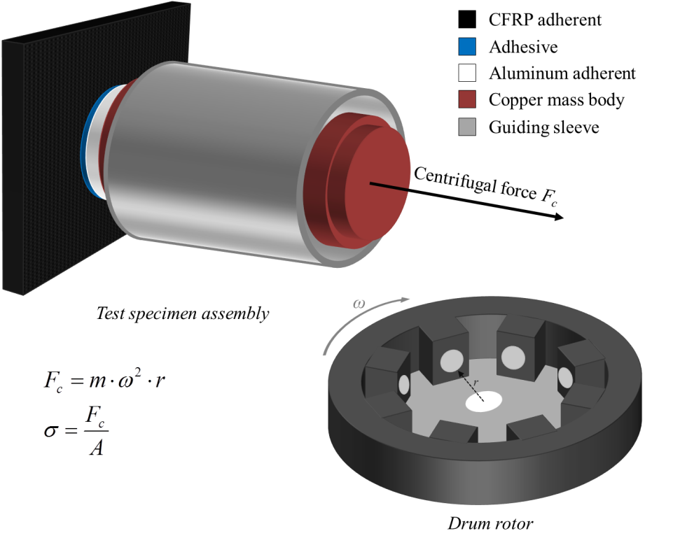(a) | 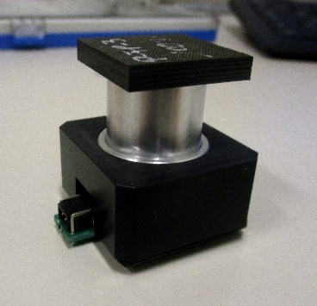 (b)

Figure 1. (a) Measurement principle of the centrifuge test, (b) the stamp-to-plate specimen used in the centrifuge tests.

The centrifugal force F_{c} (N) is derived from where m (kg) is the mass of the stamp, r (m) is the distance of the test stamp to the rotational axis and ω (rad/s) is the angular velocity related to frequency v by . Dividing the centrifugal force F_{c} by the area of the bondline A (mm²), the tensile adhesion strength σ (MPa) is derived .

4. Experimental

4.1 Materials and specimen preparation

The specimens used in the centrifuge tests had a stamp-to-plate configuration (Fig. 1). The CFRP adherends were manufactured from the M21E/IMA prepreg material. The lay-up sequence of the panels was [(0/90/45/-45)₃]_{s}. The lay-up of the plies was applied by an automated tape laying equipment. The final dimensions of the CFRP adherends are 25 mm × 25 mm × 4.4 mm.

The modular test stamps bonded to the CFRP adherends consist of the aluminum (EN AW-2007) adherend screwed onto a mass body made of copper (see Fig. 1). The test stamps had a diameter of 10 mm on the bonding face and were anodized in phosphoric-sulfuric acid (PSA, 120 g/l H₃PO₄/ 80 g/l H₂SO₄).

For the bonding of the samples, the film adhesive was hole-punched to a diameter of 10 mm and then deposited onto the test stamp (cleaned by sonication for 5 min in isopropanol) which was then placed onto the CFRP sample. The production samples bonded with the FM300K adhesive were cured in an autoclave using a custom-made curing device at 3 bars and 175°C for 60 min (heat up to 175°C in 60 min, cool down to room temperature in 60 min). The repair samples bonded with FM300-2 adhesive were cured at 2 bars and 121°C for 90 min (heat up to 121°C in 30 min, cool down to room temperature in 60 min).

All contaminations were applied to cleaned surfaces. The concentration of each contaminant is presented in tables 1 and 2 for the production- and repair-related cases respectively. The release agent (RA) FREKOTE 700NC was dissolved and diluted in heptane (1, 2, and 4 vol% solutions) and applied to the adherends by dip coating. Moisture (MO) contamination was applied by first drying the samples in an oven at 80ºC and then exposing them to humidity conditions at 70ºC for two weeks. In the production-related scenario, fingerprint (FP) contamination was applied using a standardized salty fingerprint solution (artificial hand perspiration solution) according to the DIN ISO 9022-12 [11] standard. The solution contained sodium chloride, urea, ammonium chloride, lactic acid, acetic acid, pyruvic acid and butyric acid in demineralized water. Samples were prepared by applying this solution with the size of a fingerprint to the samples. Different degrees of contamination were achieved by using different dilutions of the FP solution (10, 50 and 100 vol% solutions).

Table 1. Labeling of the production-related contaminated samples (letter P refers to Production).

Sample category | Si, at%
P-RA-1 | 3.2 ± 1.0
P-RA-2 | 5.1 ± 0.7
P-RA-3 | 6.2 ± 0.3
Sample category | Humidity conditions
P-MO-1 | 30% RH
P-MO-2 | 75% RH
P-MO-3 | 98% RH
Sample category | Contamination solution
 | at% Na | at% Cl
P-FP-1 | 0.2 ± 0.1 | 0.5 ± 0.3
P-FP-2 | 0.5 ± 0.1 | 0.9 ± 0.0
P-FP-3 | 0.7 ± 0.1 | 1.1 ± 0.2

In the repair-related scenario, fingerprint (FP) contamination was applied using the Skydrol 500B-4 hydraulic-oil from Eastman. Skydrol fingerprints were applied to the surfaces using a plastic finger and different concentrations of Skydrol in heptane. Thermal degradation (TD) was carried out in an oven with air circulation. The de-icer (DI) used was the SAFEWAY KF from CLARIANT. It was diluted with demineralized water to obtain solutions (2, 7, and 10 vol% DI) with different concentrations of potassium. The de-icer was applied on the surfaces by dip coating (aqueous solution) and then dried in the oven for 2h at 40°C. Then, acclimatization at room temperature was allowed for at least for 24h.

4.2 Centrifuge tests

The centrifuge tests were carried out using a LUMiFrac desktop adhesion analyzer equipped with a LSFR-ST: 200.42 drum rotor of up to eight testing units. The fully loaded rotor allows for a maximum rotational speed ω of 13,000 rpm corresponding to a centrifugal acceleration of 13,715 g [10]. Six specimens per contamination scenario were tested. The duration of each testing was from 6-20 sec on average depending on the contamination scenario. The rupture event was detected on-line outside the drum rotor using a position-coded and rpm-correlated data transmission from the inside of the testing units mounted in the drum rotor. The current rotor speed and rupture time are transmitted and the centrifugal force F_{c} (N) is calculated.

Table 2. Labeling of the repair-related contaminated samples (letter R refers to Repair).

Sample category | Contamination solution
R-FP-1 | 20% Skydrol in heptane
R-FP-2 | 50% Skydrol in heptane
R-FP-3 | 100% Skydrol (no dilution)
Sample category | Applied temperature
R-TD-1 | 220ºC
R-TD-2 | 260ºC
R-TD-3 | 280ºC
Sample category | K, at%
R-DI-1 | 6.4 ± 1.8
R-DI-2 | 10.9 ± 2.3
R-DI-3 | 12.0 ± 1.4

4.3 Failure characterization

After testing, high resolution microscope images of the failure surfaces of both the CFRP adherend and the test stamp side were taken and examined aiming to characterize the failure patterns. The main failure modes observed are described in the following. Adhesive (ADH) failure occurs when the separation takes place at the adhesive/adherend interface, cohesive (CO) failure when the separation takes place within the adhesive, fiber-tear (FT) failure when the failure occurs exclusively within the matrix resulting in the appearance of fibers on both ruptured surfaces and light-fiber-tear (LFT) failure when failure occurs within the adherend, near the interface characterized by a thin layer of the matrix on the surface with few or no fibers transferred from the substrate to the adhesive and thin-layer cohesive (TLC) failure when the separation takes place within the adhesive but not at the mid-thickness. The classification, identification and characterization of the failure modes of the joints were conducted according to the ASTM D5573 [12] standard.

5 Results and Discussion

Fig. 2 displays the average adhesion strength values, for the production-related and the repair-related samples. In the bar-charts, the average adhesion strength values of the respective reference samples and the standard deviation ranges for each case are also included.

Fig. 3 depicts representative microscope photos of the different failure modes from various samples while Figs. 4 and 5 display the average surface percentages of the failure modes for the production- and repair-related contamination scenarios, respectively. The reference specimens for both categories (production and repair) failed in ADH and LFT failure modes. The adhesive mainly remained on the metallic stamp which is an indication for a stronger bond between the metallic stamp and the adhesive. This stands for all cases of adhesive failure. On the other hand, the considerable percentage of LFT failure mode is also an indication of a strong bond between the CFRP and the adhesive. The P-REF samples showed a much higher (almost double) adhesion strength than the R-REF samples which is due to the different type of adhesive used and the different curing conditions applied.

(a)
(b)

Figure 2. Average adhesion strength values for the (a) production-related and (b) repair-related sample categories.

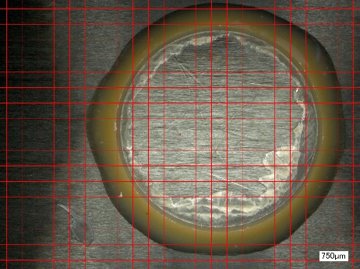 (a) | 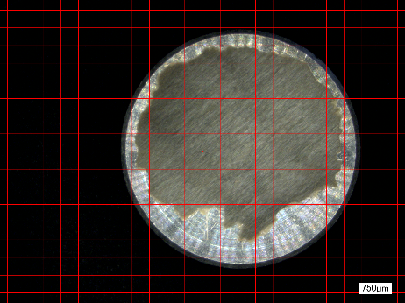 (b)
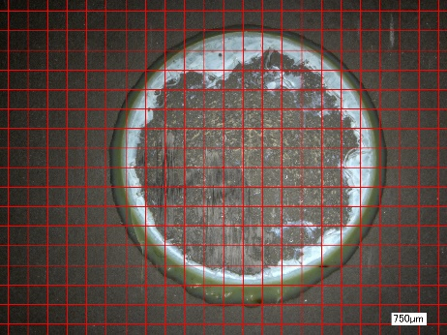 (c) | 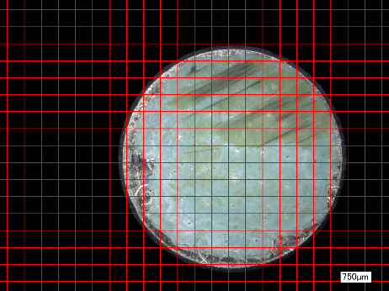 (d)
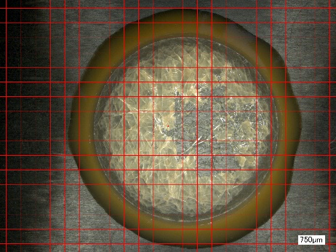 (e) | 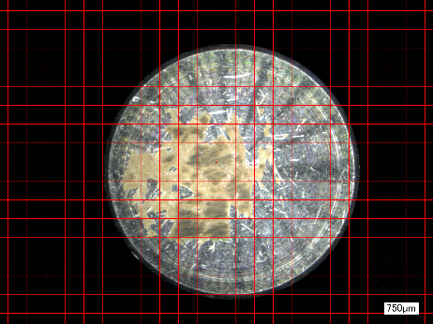 (f)

Figure 3. Representative microscope photos of the different failure modes: (a) ADH+FT for R-TD sample (CFRP’s side), (b) ADH+FT for R-TD sample (stamp’s side), (c) ADH+LFT for P-MO sample (CFRP’s side), (d) ADH+LFT for P-MO sample (stamp’s side), (e) ADH+FT+TLC for R-DI sample (CFRP’s side), (f) ADH+FT+TLC for R-DI sample (stamp’s side).

For the P-RA scenario, the presence of release agent leads to the decrease of adhesion strength at the same level for P-RA-1 and P-RA-2 cases and at a lower level for the P-RA-3 case. This finding agrees with the findings of [1]. Regarding the failure modes (Fig. 4a), there is an increase of ADH failure and a decrease of LFT failure. This transition is due to the weakening of the adherend/adhesive bond. However, a safe conclusion about the effect of contamination level on the failure modes cannot be drawn from the variation of the average percentages of the failure mode.

(a) | (b)
(c)

Figure 4. Average surface percentage of the different failure modes for production-related samples: (a) RE scenario, (b) MO scenario and (c) FP scenario.

For the P-MO scenario, the results show that the moisture absorption by the CFRP adherend causes a decrease of adhesion strength at the same level for P-MO-1 and P-MO-2 and at a lower level for P-MO-3. Observation of Fig. 4b reveals that moisture absorption leads to the increase of ADH failure and to the decrease of LFT failure mode. This is an indication for the weakening of the CFRP/adhesive bond due to presence of moisture on the CFRP’s surface.

Similar conclusions are drawn for the P-FP scenario for both the adhesion strength and the type and percentage of the failure modes (Fig. 4c). However, the large deviation of the P-FP-1 and P-FP-2 cases, which lies within the limits of the P-REF values, hinders the indication of a definite conclusion regarding these contamination levels. The only difference between the P-MO and the P-FP scenarios is that the decrease of adhesion strength is smaller for the P-FP scenario.

For the Skydrol-based R-FP scenario, there seems to be an increase of adhesion strength for the R-FP-1 case, a no variation of adhesion strength for the R-FP-2 case and a decrease of adhesion strength for the R-FP-3 case. However, a safe conclusion for the R-FP1-1 and R-FP-2 cases cannot be drawn due to the very high standard deviation of the results for these two cases and the R-REF case. For the R-FP-3 case, there is a considerable decrease of adhesion strength. On the other hand, the percentage of the failure modes in Fig. 5a reveals a similar failure behavior for the R-FP-1 case and for the R-FP-2 and the R-FP-3 cases, a decrease of LFT failure and an increase of ADH and TLC failure modes. The increase of the ADH failure mode in the R-FP-3 case agrees with the considerable decrease of the adhesion strength of the R-FP-3 specimens, as ADH failure mode is an indication of a weak bond. The fact that three failure modes occur in the R-FP scenario is closely related to the large standard deviation of the adhesion strength values and makes it very difficult to clearly evaluate the effect of the different FP contamination concentrations. The large standard deviation of the results of the R-FP scenario could be attributed to the use of Skydrol for the application of FP contamination. The use of a dip coating contamination might lead to a smaller standard deviation.

(a) | (b)
(c)

Figure 5. Average surface percentage of the different failure modes for repair-related samples: (a) FP scenario, (b) TD scenario and (c) DI scenario.

For the R-TD scenario, the R-TD-1 case presents a similar behavior both in terms of adhesion strength and failure modes (ADH and LFT and TLC, see Fig. 5b) with the R-REF case. However, there is evidence of adhesion strength improvement for the case of the low temperature. Thermal degradation results in the thermo-oxidation of the resin [13, 14]. Depending on the temperature level applied, this may either lead to the improvement of the resin performance due to the presence of carboxyl bonds or cause the development of an oxidized layer which hinders the adhesion at the surface of the CFRP substrate [13]. On the contrary, the R-TD-2 and R-TD-3 cases present a lower adhesion strength and different failure modes (ADH and FT, see Fig. 5b). In the latter cases, the decrease of adhesion strength is attributed to the degradation of the polymer matrix in the first layer of the CFRP adherend because of the increased temperature, which causes a FT failure mode. Indeed, as shown in Fig. 5b, FT failure increases drastically as the temperature increases.

Finally, for the R-DI scenario, there is a detrimental effect of the presence of de-icer on the adhesion strength of the joint. The failure modes percentages (Fig. 5c) show that the increase of the DI concentration causes an increase of ADH failure mode, due to the formation of thin layer by the de-icer which acts as a barrier in the bonding of the adhesive and the CFRP adherend. However, in contrast with the adhesion strength, there is not a clear differentiation regarding the failure mode percentages between the different de-icer concentrations.

6. Conclusions

From the evaluation of the experimental results, the following conclusions can be drawn:
- The production related contamination scenarios tend to decrease the adhesion strength with the high level of contamination being the most detrimental for all the cases. The lower adhesion strength has been measured for the P-MO-3 case (98% RH). The standard deviation is also considerable but within acceptable limits.
- The values of adhesion strength for the R-REF samples present a high standard deviation which is due to the different adhesive used and the different curing conditions applied. In all repair-related contamination scenarios, except for the R-FP-1 and R-TD-1, there is a decrease of the adhesion strength. The lower adhesion strength for this set of scenarios has been measured for the P-TD-3 case (280^{ο}C).
From the experimental process, it can be concluded that the centrifuge testing technology shows a great potential to be established as a test method for the characterization of pristine and defected bonded joints as it is a fast testing process which generates repeatable tests capable of describing the strength of the joints.

Acknowledgements
The research leading to these results has received funding from the European Union’s Horizon 2020 research and innovation program under grant agreement no 636494 (Project ComBoNDT: Quality Assurance Concepts for Adhesive Bonding of Aircraft Composite Structures by Extended NDT).

References

- D.N. Markatos, K.I.Tserpes, E. Rau ,K. Brune, Sp. Pantelakis. The Journal of Adhesion, 90:156–73, 2014. doi:10.1080/00218464.2013.770720.
- E. Moutsompegka, K.I. Tserpes, P. Polydoropoulou, et al. Fatigue & Fracture of Engineering Materials & Structures, 40:1581–91, 2017. doi:10.1111/ffe.12660.
- Code of Federal Regulations, Federal Aviation Administration, 14 C.F.R § 23.573 Damage tolerance and fatigue evaluation of structure, 2011.
- U. Beck, S. Hielscher, M. Weise, R. Mix, D. Lerche, U. Rietz. PSE 2012 - 13th Int. Conf. plasma Surf. Eng., Garmisch-Partenkirchen, Germany: 2012, p. 169–72.
- DIN EN 15870: 2009-08, Adhesives - Determination of the tensile strength of stump adhesives, German Institute for Standardization, 2009.
- ISO 4624:2002, Paints and varnishes -- Pull-off test for adhesion, International Organization for Standardization, 2002.
- U. Beck, S. Hielscher, R. Mix, M. Weise, D. Lerche, U. Rietz. IKV - Institute of Plastics Processing in Industry and the Skilled Crafts at RWTH Aachen University, 2012.
- Rietz U, Lerche D, Hielscher S, Beck U. Centrifugal Adhesion Testing Technology (CATT) - A Valuable Tool for Strength Determination. J Adhes Soc Japan 2015;51:293–7. doi:10.11618/adhesion.51.293.
- U. Beck, G. Reiners, D. Lerche, U. Rietz, H. Niederwald. Surface and Coatings Technology, 205:S182–6, 2011. doi:10.1016/j.surfcoat.2010.07.045.
- LUM GmbH, Technical specification of Adhesion Analyser LUMiFrac, Available at: http://www.lumifrac.com
- DIN ISO 9022-12, Optics and photonics -- Environmental test methods -- Part 12: Contamination, International Organization for Standardization, 2012
- ASTM D5573-99(2005), Standard Practice for Classifying Failure Modes in Fiber-Reinforced-Plastic (FRP) Joints, ASTM International, West Conshohocken, PA, 2005, www.astm.org
- D.N. Markatos, K.I.Tserpes, E. Rau, S. Markus, B. Ehrhart, S.Pantelakis. Composites Part B Engineering, 45:556–64, 2013. doi:10.1016/j.compositesb.2012.05.052.
- K.I. Tserpes, D.N. Markatos, K. Brune, M. Hoffmann, E. Rau, Sp. Pantelakis. Journal of Adhesion Science and Technology, 28:1865–80, 2014. doi:10.1080/01694243.2014.925387.

