Fracture toughness and mechanical characterization of epoxy nanocomposites based on different hyperbranched polymers typologies

A. Zotti, S. Zuppolini, M. Zarrelli and A. Borriello

Institute for Polymers, Composites and Biomaterials, National Research Council of Italy, P.le Fermi, 1, 80055 Portici, Naples, Italy

Keywords: Thermosetting resin, Polymer-matrix composites (PMCs), Fracture toughness, Hyperbranched Polymers.

Abstract
Two different hyperbranched polymers (HBPs) were synthesized as tougheners for an aeronautical graded epoxy matrix. The first, labelled HBPG (HBP Glassy) is a glassy polyester characterized by a glass transition temperature (Tg) higher then room temperature (~90°C): this system was synthesized by means of bulk poly-condensation reaction starting from 4,4-bis(p-hydroxyphenyl) pentanoic acid as polymer precursor. The second HBP typology, identified as HBPR (HBP Rubbery) is a polyamide ester with a Tg lower then room temperature (~20°C), thus in rubbery state at testing temperature. The HBPR filler was obtained by bulk poly-condensation of succinic anhydride and diethylamine. In both cases, DSC was employed to measure polymer-based filler glass transition temperature.
HBP/epoxy systems were prepared at two filler concentrations, i.e. 0.1 and 5wt%, and later tested by using different experimental techniques in order to assess effects of the filler nature on rheological, mechanical and fracture performances.
Final rheological results have demonstrated that HBPG induces an higher increase of the viscosity compared to that associated to HBPR (at same weight contents). Nevertheless the glassy HBP provides the best results in term of thermo-mechanical and fracture performances, with a lower loss of glass transition temperature and an higher increase of K_{IC} and G_{IC} values.

- Introduction

Thanks to their high tensile and adhesive strength, excellent chemical and solvent resistance and good thermal and electrical properties, epoxy resins are widely employed in different applicative fields such as aerospace [1], electronic [2] and structure [3-5] (e.g. anti-corrosive coatings and structural adhesives). However the commercially used epoxy resins are characterized by a few drawbacks such as brittleness, low toughness and poor impact resistance which limit their use in various advanced applications in which high toughness is necessary, such as adhesives and fiber-reinforced composites [6,7]. To overcome these drawbacks, generally thermosetting resins are loaded with different filler typologies such as rubber [8,9], inorganic nanoparticles [10] and hyperbranched polymers [11,12]. All these filler categories can increase toughness of epoxy resins, but the strength, including tensile strength and flexural strength, will decrease to different extend.
Hyperbranched polymers (HBPs) have attracted the attention of the scientific community because their unique structure, thanks to which they exhibit lower melt and solution viscosities, high peripheral functionality, and small molecular dimensions compared to linear polymers of the same molar mass. These properties make HBPs particularly suitable as novel and high potential tougheners for epoxy resins: in fact, HBPs can increase fracture and impact resistance of the hosting matrix without remarkable loss in thermo-mechanical properties, as opposed to their linear counterpart [13].
As reported by Boogh et al. [14], the addition of 5wt% of a polyester-based HBP to an epoxy matrix results in an increase of the critical strain energy release rate, G_{IC}, of about 500%. In this work, no remarkable loss in thermo-mechanical properties (elastic modulus and Tg) were reported, and this feature is attributable to the strong mechanical interaction between epoxy matrix and the reactive epoxy groups grafted onto the HBPs. Xu et al. [15] have studied the improvements on impact strength and critical stress intensity factor obtained adding HBPE-OH (hyperbranched polyester with hydroxyl end groups) to a commercial epoxy resin. Results have shown a 19% increase of the impact strength with the addition of 15wt% of HBPE-OH and the K_{IC} value was approximatively doubled compared to pure epoxy resin when HBPE-OH content reaches the 20 wt%. Also the curing behavior was affected by the polymer presence, with a strong increase of curing rate associated to the catalytic effect of hydroxyl groups in HBPE-OH. Zang et al [16] have realized blends of a tetrafunctional epoxy resin and a hydroxyl-functionalized hyperbranched polymer, whose morphology depends by the blends composition. It was demonstrated that because matrix and HBPs are immiscible a particulate morphology is obtained, and the particles size distribution depends by the HBP concentration. Moreover, according to mechanical measurements, at a HBP concentration of 30 phr the fracture toughness is almost doubled compared to the unmodified epoxy resin.
In this work two different HBPs have been synthesized, an aromatic hyperbranched polyester, characterized by a glass transition temperature higher then room temperature, and an aliphatic hyperbranched poly amide ester, with a Tg lower then room temperature. The effect of these two different HBPs on the rheological, thermo-mechanical and fracture performances of an aeronautical grade epoxy resin were studied.

- Experimental Section

2.1 Materials
The epoxy resin system used was RTM6 supplied by Hexcel Composites (Duxford, UK). RTM6 is a pre-mixed epoxy-amine system developed for the resin liquid molding processes (RTM, VARTM, Vacuum Infusion). For the synthesis of HBPG, diphenolic acid and tin(II) octoate were employed as polymer precursor and catalyst, respectively. Sebacic acid and diisopropanolamine were used in the HBPR synthesis. All chemicals were purchased from Sigma-Aldrich and used as received.

2.2 Manufacturing of RTM6/HBPs nanocomposites
A modified procedure reported in literature [17] was employed for HBPG synthesis. Diphenolic acid and tin(II) octaoate (molar ratio 1:0.01) were magnetic stirred @190°C under nitrogen atmosphere. To ensure the homogeneity of the mixture, the system was stirred for 3 hours and then temperature was raised up to 225°C; HBPG was obtained after another 3 hours of mixing and then dissolved in THF. This solution was poured in a large amount of water in order to precipitate HBPG and separate it by unreacted monomers. The precipitate was filtered, washed and finally dried in oven under vacuum @80°C for a night. The so synthesized HBPG was dissolved in few mL of tetrahydrofuran (THF), mixed with epoxy resin and poured in an aluminum mould: the system mixing and the solvent evaporation were performed in a single step with rotovapor set @80°C. The loaded resins were cured according RTM6 standard temperature profile, i.e. 90 mins @160°C followed by 120 mins @180°C.
HBPR synthesis was performed according a modified procedure reported in literature [18]. Equal moles of diisopropanolamine and sebacic acid were mixed @140°C for 10 mins in order to obtain an homogeneous mixture; tin(II) octaoate (~0.20% mol) was added in the reaction flask and the system was placed in the oven under vacuum @185°C for 4 hours. The crude product was washed with methanol and finally dried in oven under vacuum @80°C for a night. The synthesized HBPR was dissolved in dimethylformamide (DMF) and the solution added to the resin; DMF was removed by the HBPR/RTM6 systems using rotovapor set @80°C. The employed cure profile is the same of the HBPG/RTM6 systems.
During nanocomposites manufacturing for each HBP typology two different concentrations were used, i.e. 0.1wt% and 5wt% and both characterized along with neat resin. The manufacturing process is schematized in fig. 1.

2.3 Characterization
Thermal Analysis (DSC) tests were performed by a Q1000 DSC (TA Instruments) under nitrogen atmosphere (50 mL/min) and a heating ramp of 10°C/min. The rheological characterization of the HBPs/RTM6 suspensions was carried out by MRC-301 rheometer (Anton Paar) in temperature ramp mode, using parallel plates PP25 (25 mm diameter) with a 1 mm gap. The heating rate was set to 2 °C/min from ambient temperature at frequency (1 Hz) and deformation (γ = 0.5%).
Dynamic Mechanical Analysis (DMA) was performed by Q800 DMA (TA Instruments) at fixed frequency of 1 Hz and heating ramp of 3 °C/min. The testing configuration was the double cantilever mode. Flexural (ASTM D790) specimens were tested at a crosshead speed of 1 mm/min with an Instron 4301 tensile tester.
Mode-I fracture tests were conducted using single edge notched beam (SENB) specimen. The test specimen was chosen according to the ASTM D5045-99 standard test method for plane strain fracture toughness and strain energy release rate of plastic materials.

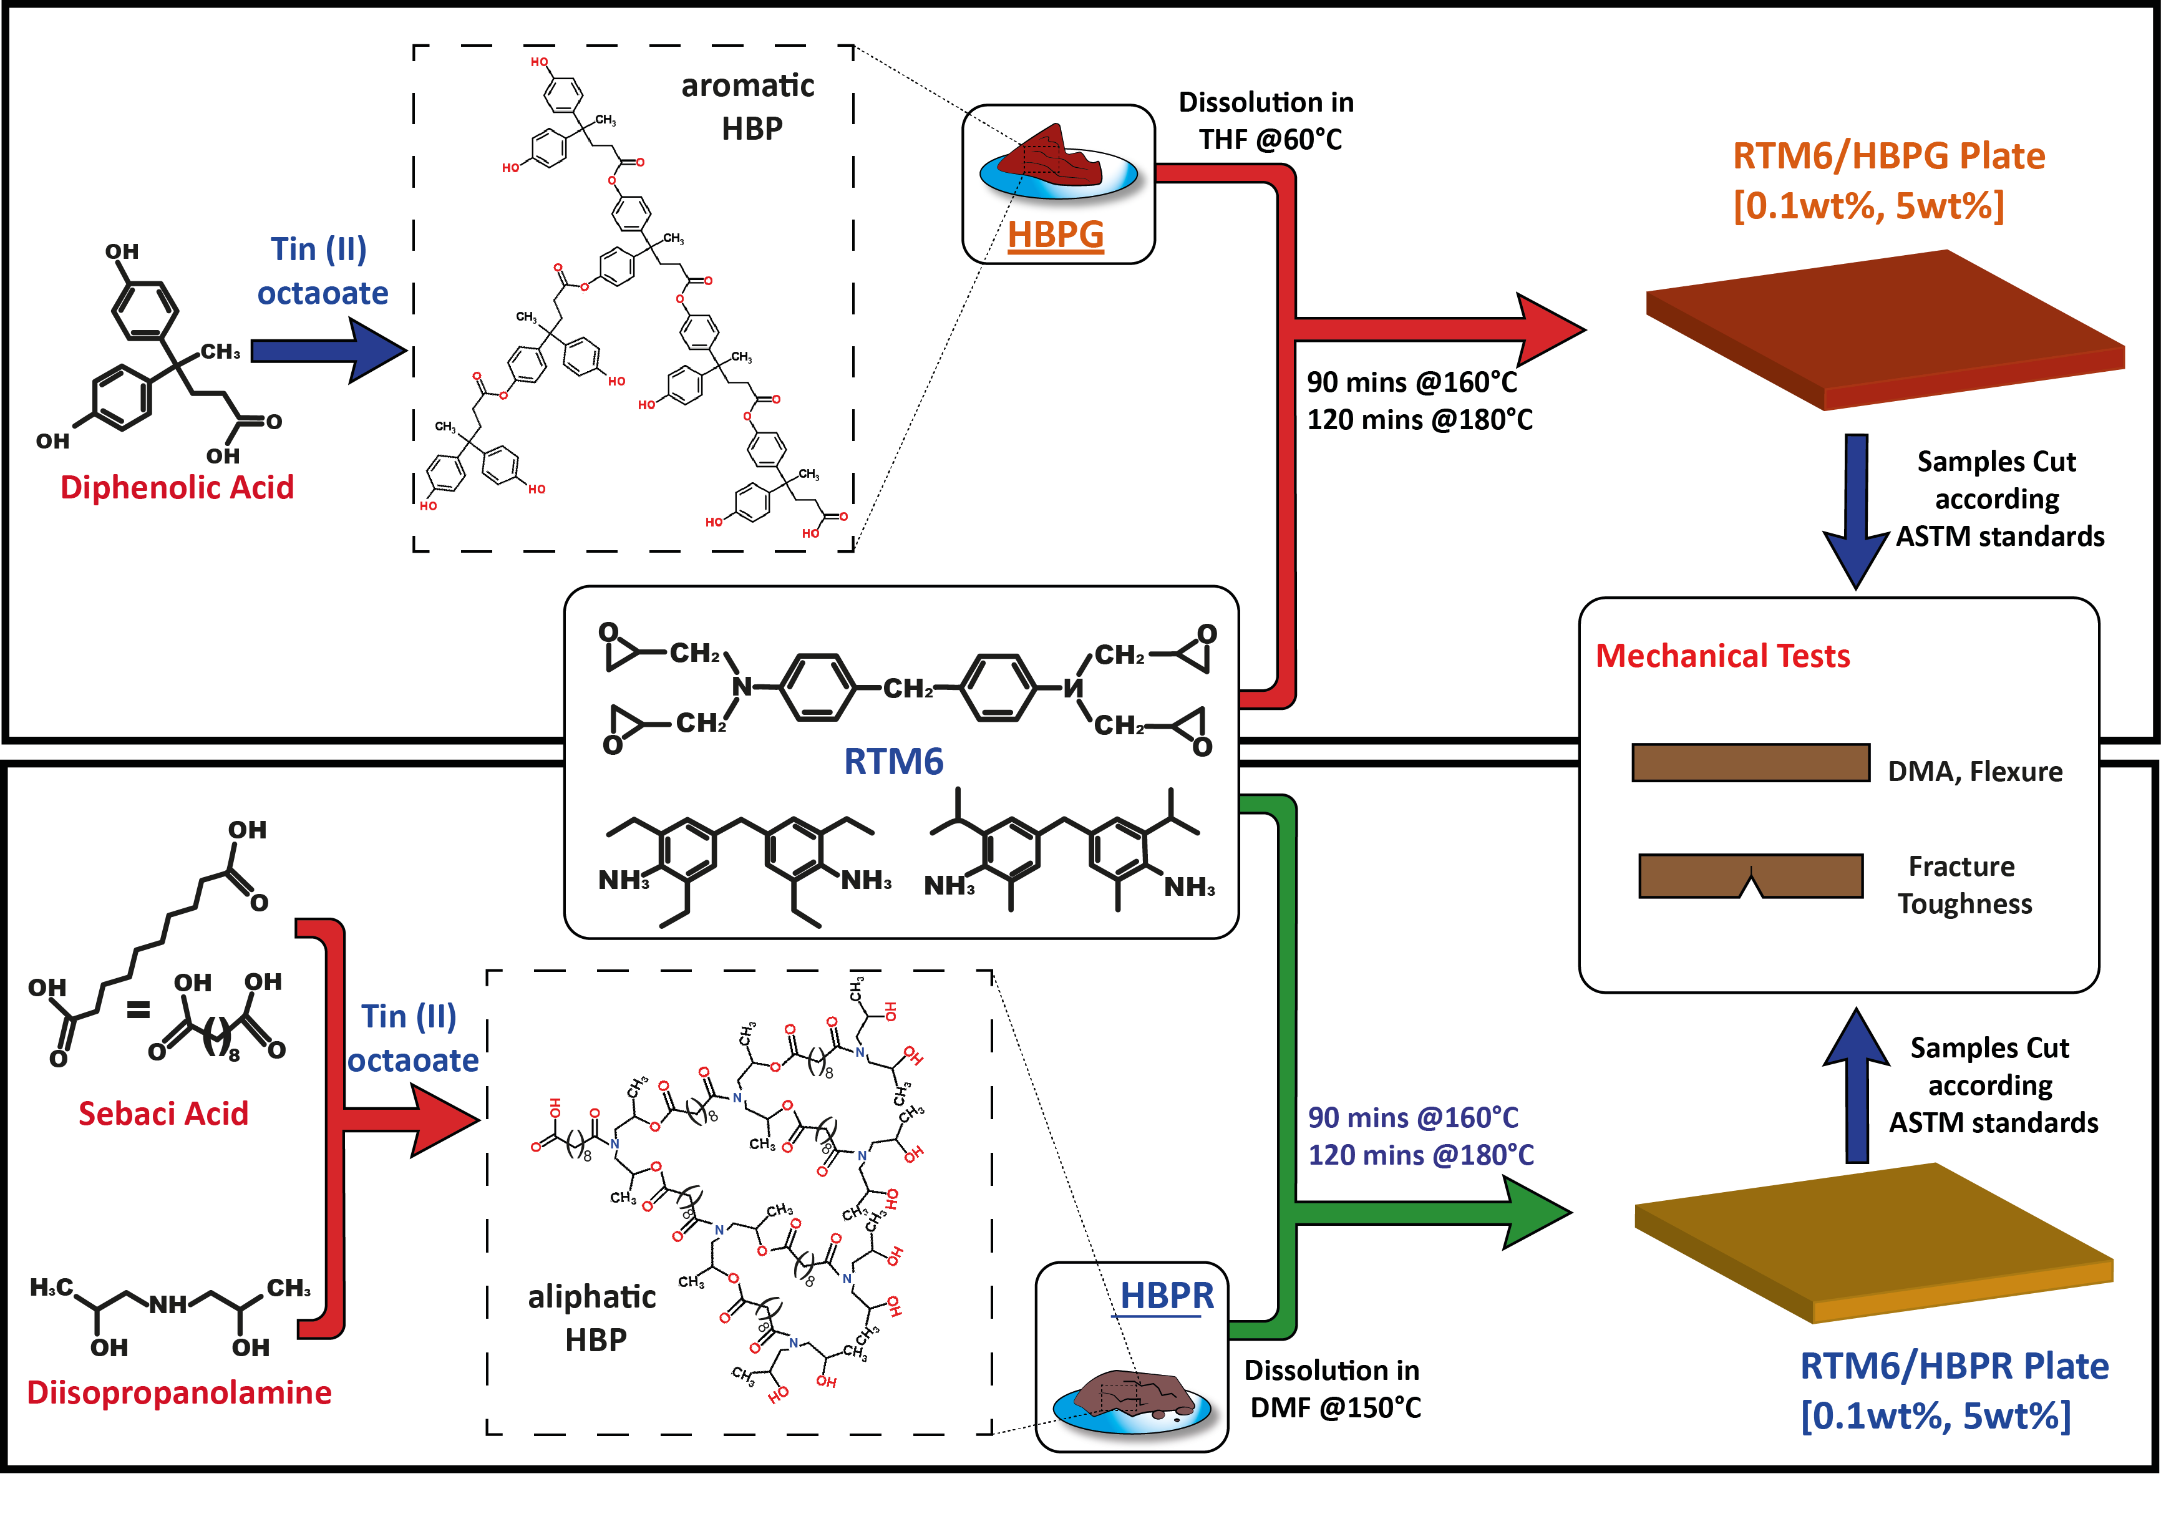
Figure 1. The manufacturing procedure of RTM6/HBP nanocomposites.

- Results And Discussion

The synthesized HBPs were characterized using DSC test to evaluate their glass transition temperature. As reported in fig. 3.a, HBPG is characterized by a Tg of 88.7°C; this high Tg value is associated to the stiffness of the aromatic segments in the macromolecular chains. DSC tests performed on HBPR have revealed a Tg much lower compared to the HBPG, i.e. 20.5°C and this behavior is attributable to the aliphatic nature of this polymer. For HBPR, the long linear segments obtained by the sebacic acid poly-condensation allow to move freely also at room temperature, justifying the low glass transition temperature and thus the rubbery state at room temperature.
Fig. 3 reports the flow curves for neat epoxy and suspensions containing different percentages of HBPs: a Newtonian behavior is recorded for both polymers. Unlike linear polymers, the unique HBPs architecture allows to increase the molecular mass without remarkable increasing of particles sizes and preserving a spherical geometry. Thus from the rheological point of view, HBPs macromolecules can be assumed as small spherical particles in a dilute suspension and therefore no remarkable variation of viscosity are reported with the increase of the angular frequency [19]. The recorded level of viscosity strongly depends on the typology of HBPs loaded: in fact, it is evident that viscosity dramatically raises of one order of magnitude with the addition of 5wt% of HBPG, i.e. from 120 Pa*s to 1290 Pa*s. In contrast, with 5wt% of HBPR the viscosity is doubled, reaching 292 Pa*s. This effect could be associated to the different chemical nature of the hyperbranched polymers: due to steric effect, the aromatic nature of HBPG reasonably causes the formation of hyperbranched particles smaller than that of the HBPR; moreover the presence of long aliphatic chains in the HBPR limits the surface functionality of macromolecules (-OH and –NH groups), which consequently interact very weakly with the epoxy monomers. The smaller dimensions and the higher surface functionality of HBPG nanoparticles could be reasonably the explanation of the significant increase of the viscosity for the HBPG/RTM6 system compared to that associated to HBPR filler.

a) | 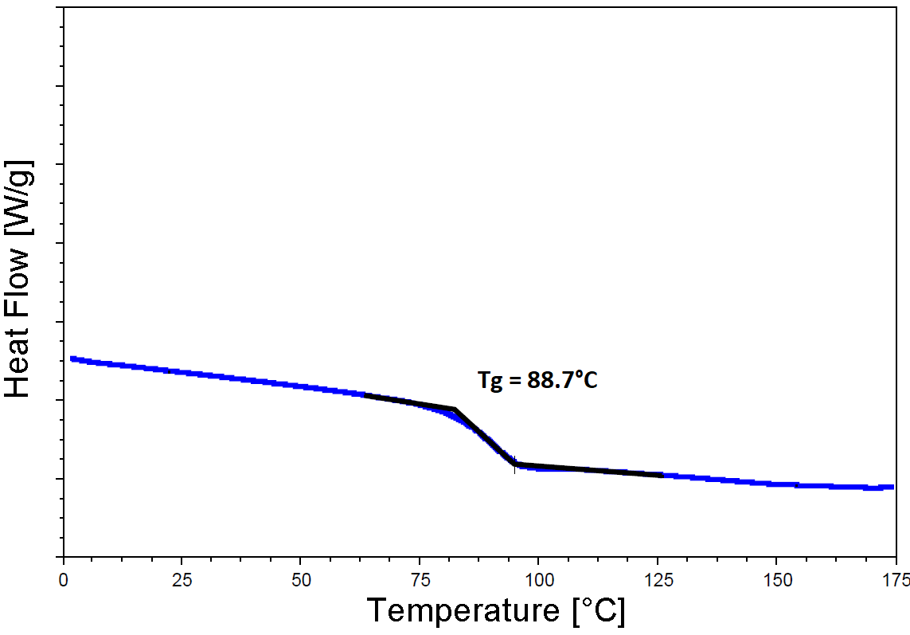 | b) | 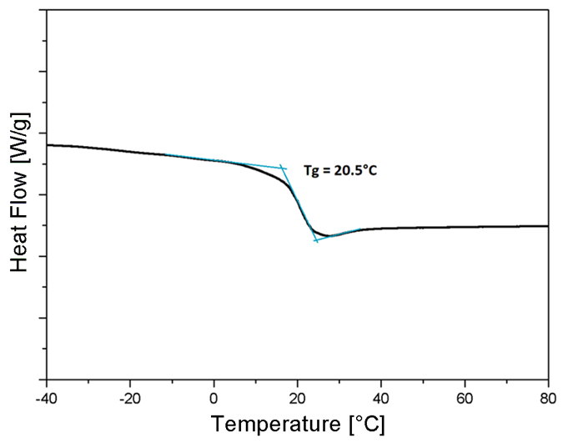
Figure 2. DSC curves of a) neat HBPG and b) neat HBPR

a) | b)
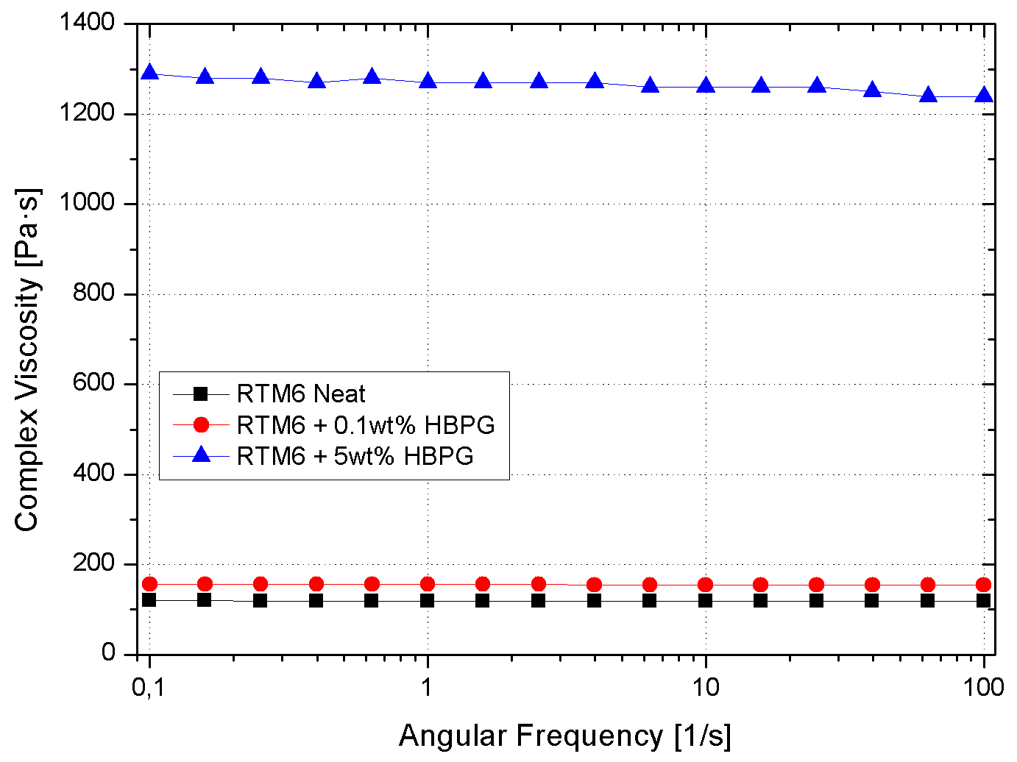 | 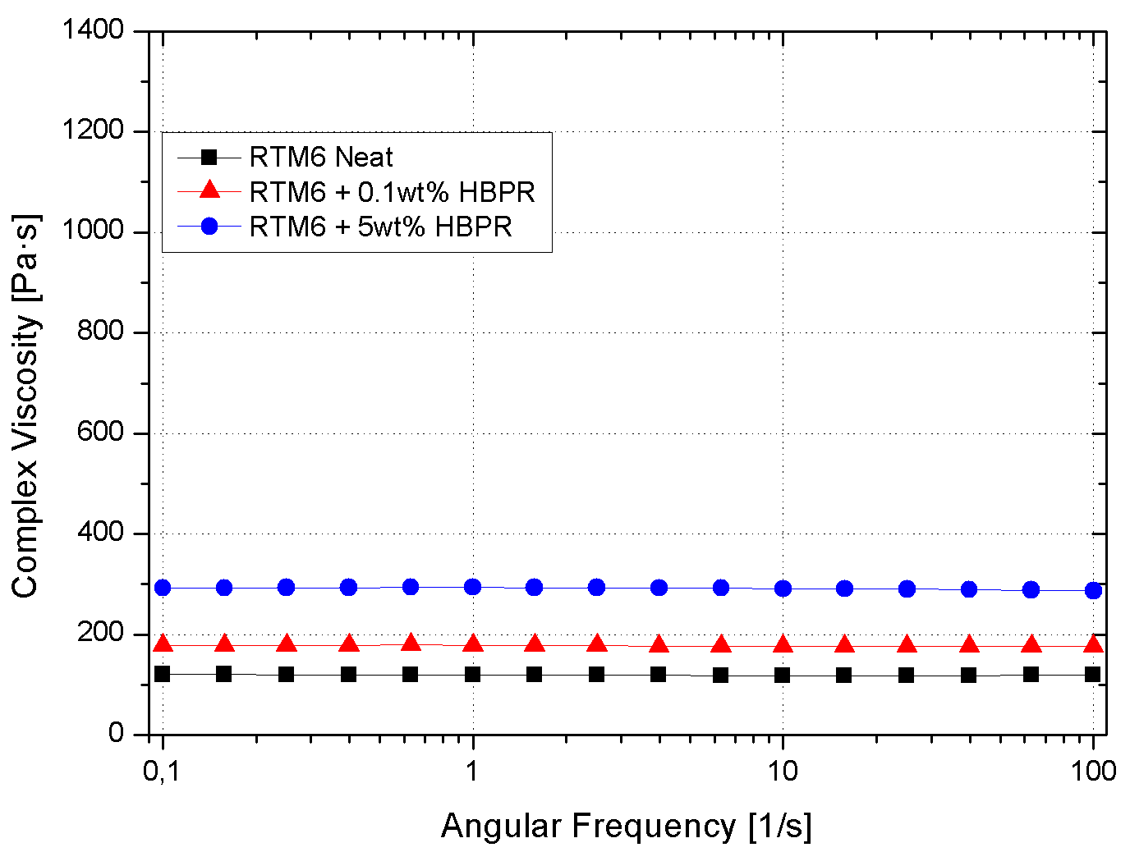
Figure 3. Complex viscosity vs. frequency for the neat and HBPR/epoxy uncured systems: (A) HBPG and (B) HBPR.

a) | b)
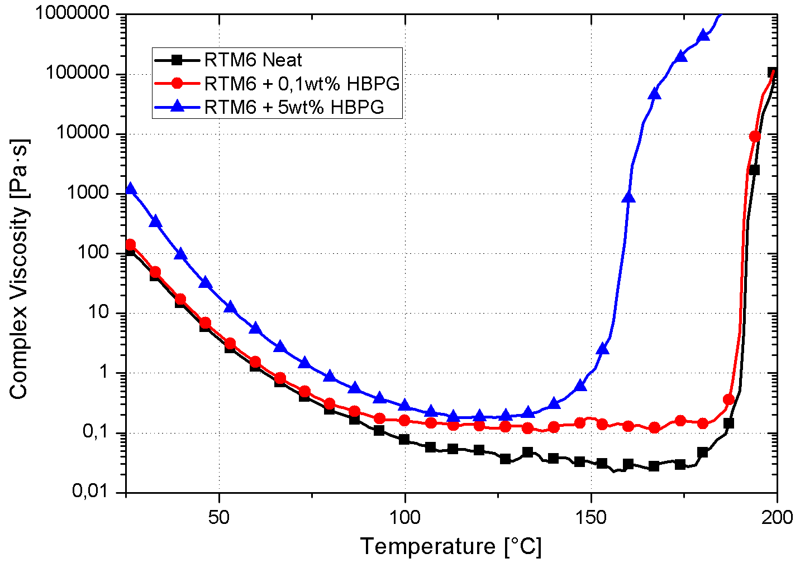 | 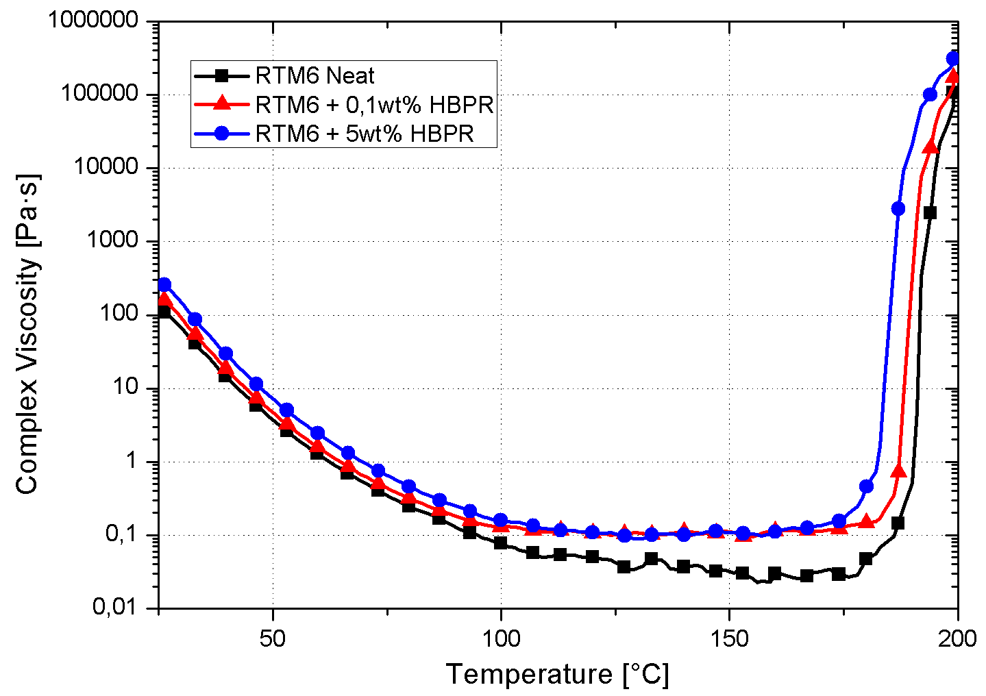
Figure 4. Complex viscosity vs. temperature for the neat and HBPR/epoxy uncured systems: (A) HBPG and (B) HBPR.

The complex viscosity curves vs temperature, reported in fig. 4, for neat and HBPS filled uncured system also support the assumption of higher surface functionality related to the HBPG compared to HBPR. The 5wt% content of glassy hyper-branched polymer, in fact, will determine a significant enhancement of the polymerization rate due to the catalytic effect of hydroxyl groups [15] on the HBPG surface. Although also the rubbery HBP induces in the epoxy matrix a slight reduction of the temperature corresponding to the viscosity arising, this effect is remarkably lower then corresponding HBPG behavior, indicating a lower concentration of reacting groups onto the nanoparticles surface.
Since the large mismatch between the matrix and the fillers in term of glass transition temperature, the addition of HBPs to the epoxy resin obviously will lower the Tg of the corresponding nanocomposite. This is observable by analyzing the DMA results, shown in fig. 5, as the addition of HBPR remarkably reduces the glass transition temperature of the hosting matrix (up to 38°C for the HBPR filled sample at 5wt%). HBPG nanoparticles, as characterized by higher glass transition temperature compared to HBPR, do not induce any remarkable drop in Tg (fig. 5.a). Storage modulus, E’, shows a similar trend: no remarkable variations in the samples filled with HBPG whereas a more pronounced detrimental effect is measured in the case of HBPR. DMA results are listed in table 1.

a) | b)
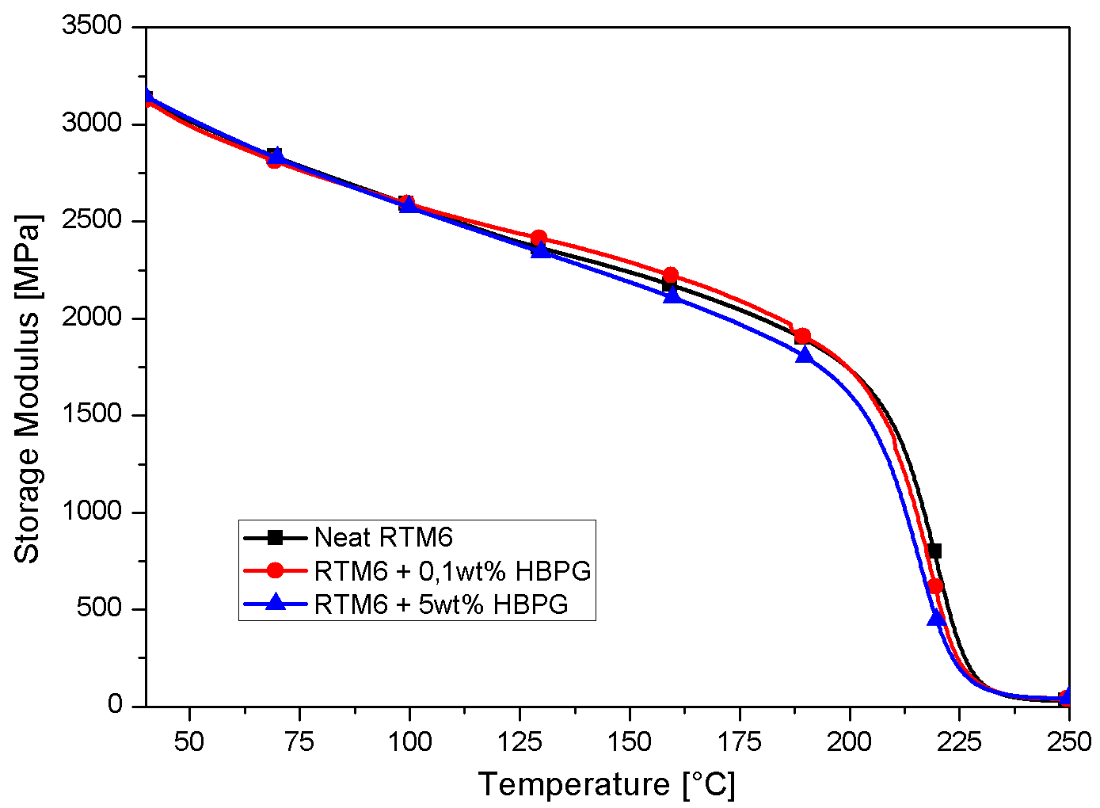 | 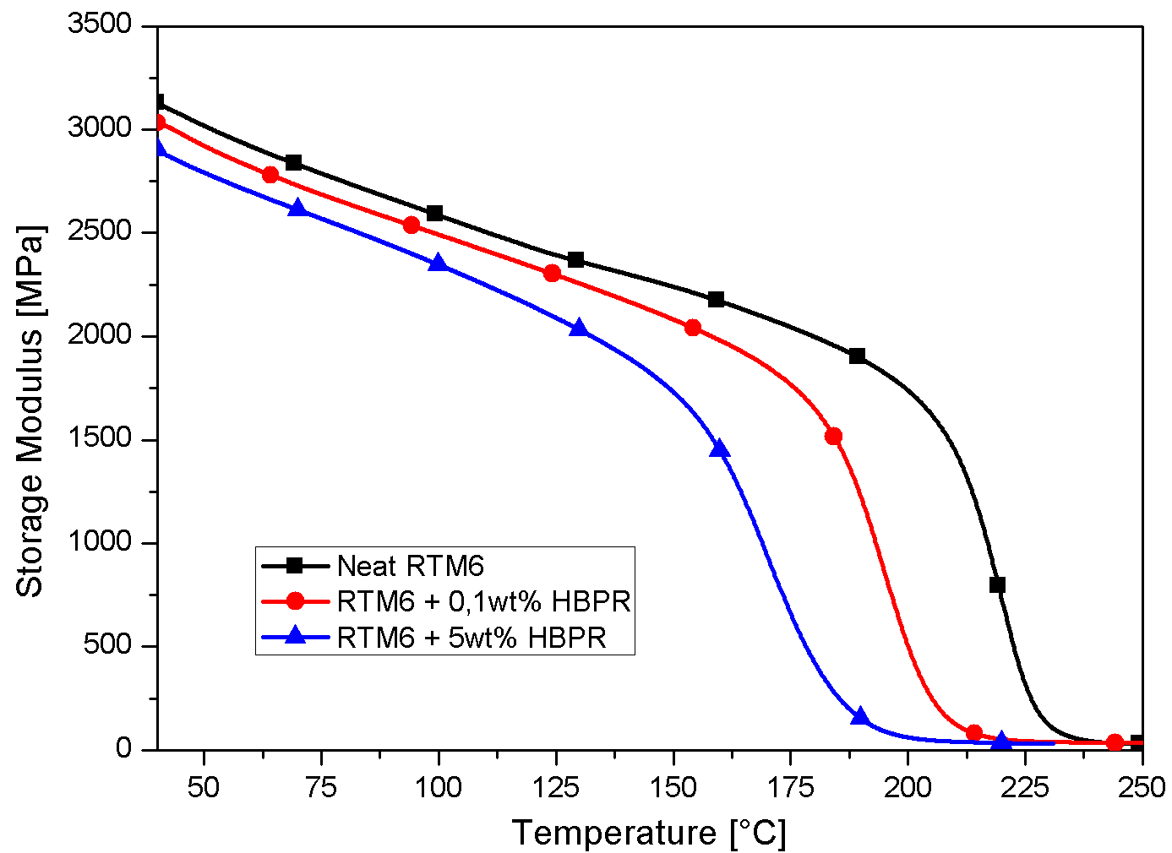
Figure 5. Storage modulus vs. temperature for neat, 0.1 and 5wt% HBP/RTM6 systems: (a) HBPG and (b) HBPR.

Table 1. DMA and mechanical results.
Sample ID | Tg [°C] | E’@40°C [MPa] | Bending Strength [MPa] | K_{IC} [MPa m^{1/2}] | G_{IC} [KJ m⁻²]
RTM6 Neat | 228 | 3128 | 128 | 0.62 | 0.114
RTM6 + 0.1wt%HBPG | 226 | 3127 | 131 | 0.76 | 0.17
RTM6 + 5wt%HBPG | 225 | 3150 | 127 | 0.86 | 0.209
RTM6 + 0.1wt%HBPR | 208 | 3036 | 129 | 0.73 | 0.151
RTM6 + 5wt%HBPR | 191 | 2907 | 129 | 0.78 | 0.191

a) | 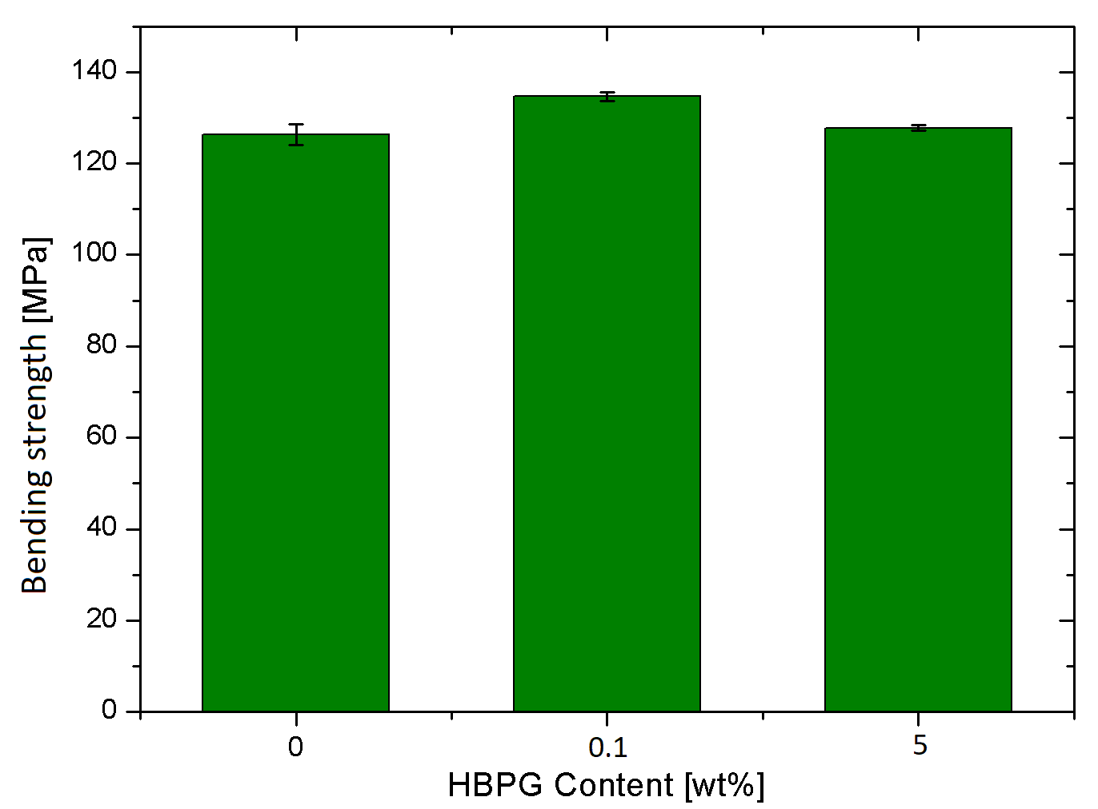 | b) | 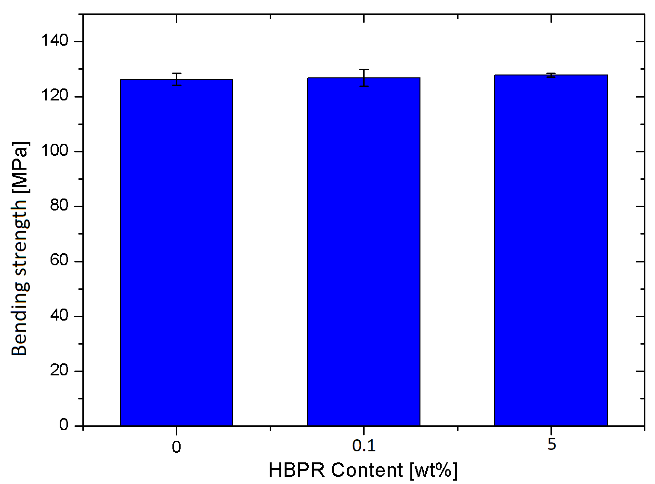
Figure 6. Effect of the content of a) HBPG and b) HBPR on the bending strength.

The effect of the HBPs content on the bending strength of the cured resins is shown in Figure 6. The data clearly reveal that both HBP typologies does not affect bending strengths. Conversely, fracture toughness of HBPs/RTM6 systems, in term of K_{IC} and G_{IC} values, is remarkably affected by either the filler content and typology. Stress intensity factor, K_{IC}, represents the stress amplification factor near the edge of a crack (at damage propagation) and it is representative of the material fracture toughness. Strain energy release rate, G_{IC}, represents the energy available for an unit increase of crack length. Figures 7 and 8 shows the K_{IC} and G_{IC} values for neat and filled systems. For samples 5wt% HBPR filled samples, the increasing of K_{IC} and G_{IC} values are 25% and 68%, respectively. HBPG induces higher fracture toughness improvement achieving 39% and 83% respectively for K_{IC} and G_{IC}.
In conclusions both HBP nanoparticles lead to enhancement of the fracture toughness behavior of the corresponding nanocomposites, thus limiting the crack propagation through plastic deformation. The higher efficiency of the glassy polymer could be reasonable related to the higher filler dispersion within the hosting matrix, promoted by the affinity among the aromatic groups in the epoxy resin and in the HBPG.

a) | 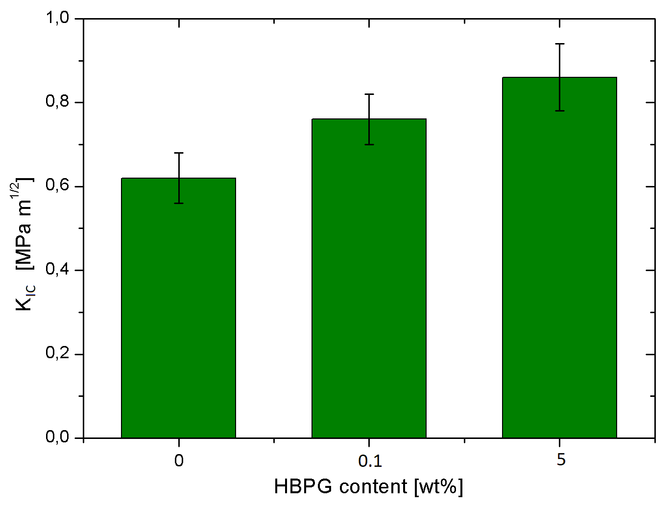 | b) | 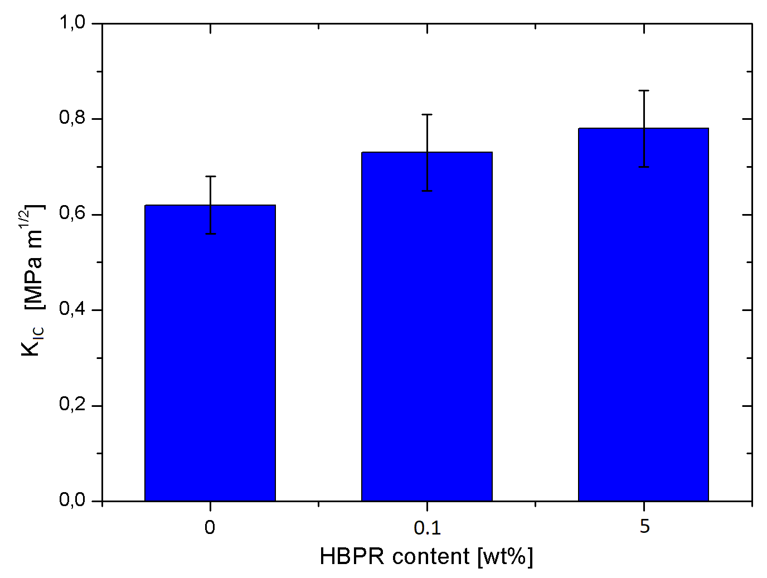
Figure 7. Effect of the content of a) HBPG and b) HBPR on K_{IC}.

a) | 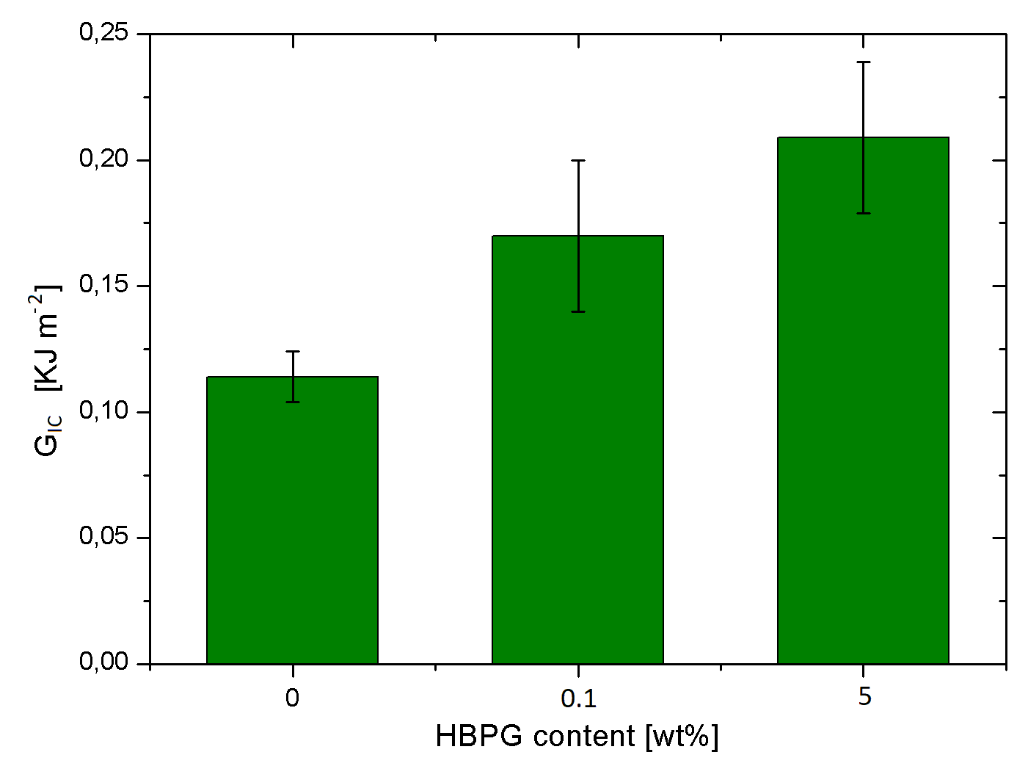 | b) | 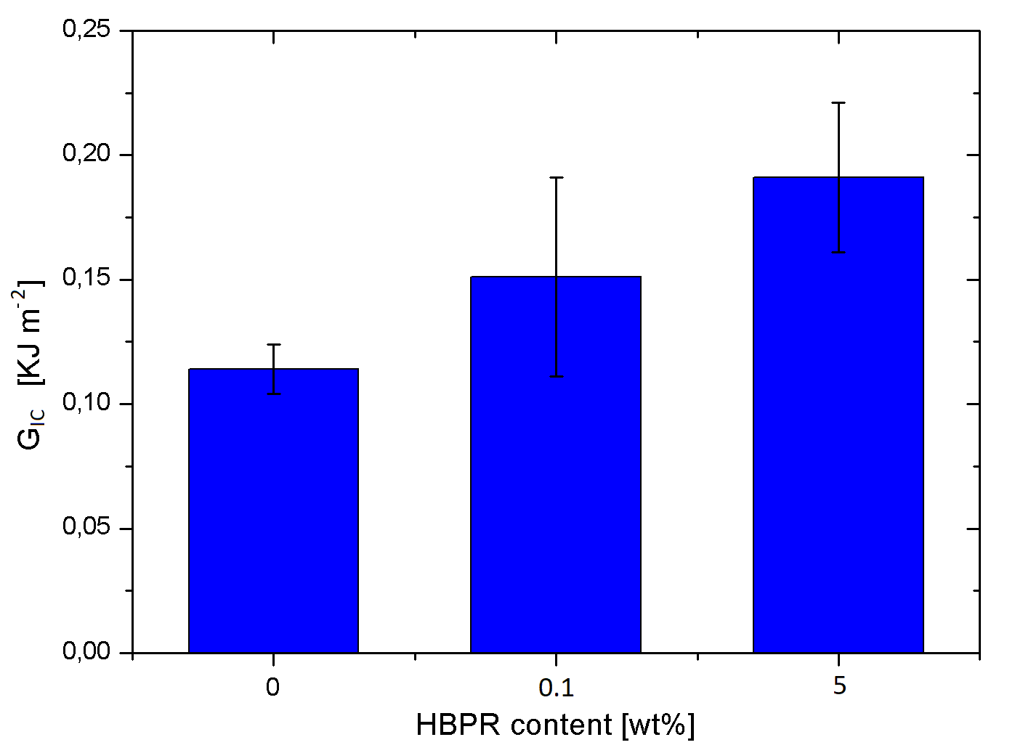
Figure 8. Effect of the content of a) HBPG and b) HBPR on G_{IC}.

- Conclusions

The effects of two different typologies of hyperbranched polymers on thermal and thermomechanical performances of a commercial epoxy resin has been studied. The synthesized polymers are an aromatic polyester (HBPG), characterized by a Tg~90°C, and an aliphatic polyamide ester (HBPR), characterized by a Tg~20°C. Two filler concentrations have been considered for each HBPs typology, i.e. 0.1wt% and 5wt%. The following remarks were achieved:
- from a rheological point of view, both HBPG/RTM6 and HBPR/RTM6 systems show a Newtonian behavior;
- HBPG induces an higher increase of viscosity compared to that determined by HBPR;
- the higher surface functionality of HBPG compared to HBPR causes a remarkable increase of curing rate;
- HBPR fillers, due to the low glass transition temperature, lead to a remarkable drop of the Tg for the corresponding nanocomposites; whereas a negligible Tg variation is determined by the HBPG content;
- Bending strength is not affected by the HBPs percentage;
- The higher increase of fracture toughness is associated to the sample loaded with 5wt% of HBPG filler, with an increase of K_{IC} and G_{IC} of 39% and 83%, respectively.

Acknowledgments

This study was financially supported from European Project: EXTREME dynamic loading-pushing the boundaries of aerospace composite material structures - GA 636549

References

[1] J.P. Pascault, H. Sautereau, J. Verdu, R.J.J. Williams. Thermosetting polymers. Marcel Dekker, 2002.
[2] F.L. Jin, X. Li, S.J. Park. Synthesis and application of epoxy resins: A review. Journal of Industrial and Engineering Chemistry, 29:1-11, 2015.
[3] A. J. Kinloch. Interfacial Fracture Mechanical Aspects of Adhesive Bonded Joints-A Review. The Journal of Adhesion, 10:193-219, 1967.
[4] A.J. Kinloch, S.J. Shaw. The Fracture Resistance of a Toughened Epoxy Adhesive. The Journal of Adhesion, 12:59-77, 1981.
[5] A. Zotti, S. Zuppolini, M. Zarrelli, A. Borriello. Fracture Toughening Mechanisms in Epoxy Adhesives, Adhesives Anna Rudawska, 2016.
[6] A. J. Kinloch. Toughening Epoxy Adhesives to Meet Today's Challenges. MRS Bulletin, 28:445-448, 2003.
[7] H.Y. Ma, G.S. Wei, Y.Q. Liu, X.H. Zhang, J.M. Gao, F. Huang, B.H. Tan, Z.H. Song, J.L. Qiao. Effect of elastomeric nanoparticles on properties of phenolic resin. Polymer, 46:10568-10573, 2005.
[8] R.A. Pearson, A.F. Yee. Influence of particle size and particle size distribution on toughening mechanisms in rubber-modified epoxies. Journal of Materials Science, 26:3828-3844, 1990.
[9] R. Bagheri, B.T. Marouf, R.A. Pearson. Rubber-Toughened Epoxies: A Critical Review. Polymer Reviews, 49:201-225, 2009.
[10] J. Ma, M.S. Mo, X.S. Du, P. Rosso, K. Friedrich, H.C. Kuan. Effect of inorganic nanoparticles on mechanical property, fracture toughness and toughening mechanism of two epoxy systems. Polymer, 49:3510-3523, 2008.
[11] R.J. Varley, W. Tian. Toughening of an epoxy anhydride resin system using an epoxidized hyperbranched polymer. Polymer International, 53:69-77, 2004.
[12] R. Mezzenga, L. Boogh, J.A.E. Månson. A review of dendritic hyperbranched polymer as modifiers in epoxy composites. Composites Science and Technology, 61:787-795, 2001.
[13] A.C. Garg. Failure mechanisms in toughened epoxy resins-A review. Composites Science and Technology, 31:179-223, 1988.
[14] L. Boogh, B. Pettersson, J.A.E. Manson. Dendritic hyperbranched polymers as tougheners for epoxy resins, Polymer, 40:2249–2261, 1999.
[15] G. Xu, W. Shi, M. Gong, F. Yu, J. Feng. Curing behavior and toughening performance of epoxy resins containing hyperbranched polyester. Polymers For Advanced Technologies, 15:639-644, 2004.
[16] J. Zhang, Q. Guo, B. Fox. Thermal and Mechanical Properties of a Dendritic Hydroxyl-Functional Hyperbranched Polymer and Tetrafunctional Epoxy Resin Blends. Journal of Polymer Science: Part B: Polymer Physics, 48:417-424, 2010.
[17] F.W. Billmeyer. Textbook of Polymer Science, 3th edition. Wiley, 1984.
[18] G.G. Buonocore, L. Schiavo, I. Attianese, A. Borriello. Hyperbranched polymers as modifiers of epoxy adhesives. Composites: Part B, 53:187-192, 2013.
[19] C.M. Nunez, B.S. Chiou, A.L. Andrady, S.A. Khan. Solution Rheology of Hyperbranched Polyesters and Their Blends with Linear Polymers. Macromolecules, 33(5):1720–1726, 2000.

