Cellulose metal sulfide based nanocomposite thin films

Michael Weißl¹, David Reishofer¹, Bruno Alonso², Emmanuel Belamie², Heinz Amenitsch³, Armin Zankel⁵, Thomas Rath⁴, Josef Innerlohinger⁶, Harald Plank⁵, Gregor Trimmel⁴ and Stefan Spirk¹

¹Institute for Paper, Pulp and Fibre Technology, Graz University of Technology,
Inffeldgasse 23, 8010 Graz, Austria
²Institut Charles Gerhardt Montpellier, UMR 5253 CNRS/UM/ENSCM, ENSCM-8, rue de l′Ecole Normale, 34296 Montpellier Cedex, France
³Institute for Inorganic Chemistry, Graz University of Technology, Stremayrgasse 9,
8010 Graz, Austria
⁴Institute for Chemistry and Technology of Materials, Graz University of Technology,
Stremayrgasse 9, 8010 Graz, Austria
⁵Institute for Electron Microscopy and Nanoanalysis, NAWI Graz, Graz University of Technology and Centre for Electron Microscopy, Steyrergasse 17, 8010 Graz, Austria
⁶Lenzing AG, Werkstraße 2, 4860 Lenzing, Austria

Keywords: cellulose, thin films, layer- by- layer, CuInS₂

Abstract
Here, we present different strategies to realize cellulose based nanocomposite thin films by spin coating, having metal sulfides as active component. Two strategies are described, namely to create an interpenetrated network of metal sulfide nanoparticles in a cellulose based thin film as well as to prepare sandwich type structures where the metal sulfides are deposited in between the cellulose layers. In both cases, metal xanthates are used as precursors which are either added to the spin coating solution or to deposit these onto the cellulose thin films by spin coating. After a heating step, the xanthates decompose, accompanied by the formation of volatile by-products and metal sulfides in or on a cellulose based thin film are formed.

1. Introduction

Cellulose, a major biopolymer on earth, exhibits interesting properties and in the past years significant efforts have been performed to increase the value of cellulose based materials.[1] Particularly, the use of nanoscale cellulosic materials such as nanofibrillated and nanocrystalline cellulose as well as the introduction of concepts from polymer thin film technology offers a wide range of opportunities to exploit cellulose in advanced applications such as optoelectronic devices, transistors and solar cells.[2, 3] Among renewable energy resources, photovoltaics are one of the main pillars. One currently followed research area is the use of nanocrystals and nanocomposites in solar cells.[4, 5] In order to overcome environmental concerns, alternatives to toxic coumpounds like PbS or Cd have been thoroughly investigated, among which CuInS₂ seem to be a promising, nontoxic alternative.[6, 7]
In this contribution we want to present two, solvent based, layer- by- layer approaches which combine the properties of cellulose as source for polymer thin films and CuInS₂ as semiconductive material.
In the first example we demonstrate a simple process for development of Cellulose CuInS₂ multilayer systems, the second approach describes a biopolymer / CuInS₂ nanocomponent based solar cell.[2]

2.1. Cellulose/CuInS2 nanocomponent based solar cell

A nanocrystal solar cell based on CuInS₂ and TMSC is designed. In order to realize this goal, different requirements must be met, namely, (i) solvent compatibility between the xanthate precursors and TMSC, (ii) formation of homogeneous precursor films by spin-coating these solutions onto PEDOT:PSS/ITO, (iii) conversion of metal xanthates to metal sulfide nanoparticles in the TMSC matrix, (iv) final assembly of the device, and finally, (v) determination of the photoelectric activity of the assembled solar cells. In all these steps, comprehensive characterization techniques are employed to investigate the underlying processes.

Figure 1 Schematic representation of manufacturing steps of CuInS₂/TMSC nanocomposite films and a multilayer

To demonstrate the suitability of the TMSC/CuInS₂ films for the application in optoelectronic devices, solar cells with a simple architecture are prepared, by sandwitching the Cellulose/CuInS₂ layers ITO/PEDOT:PSS and aluminum electrodes.
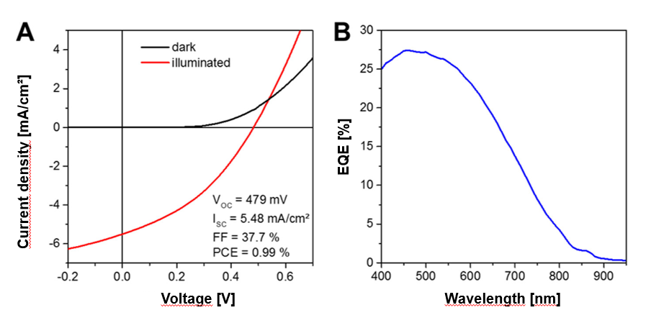

Figure 2. (A) I/V curves measured in the dark and under 100 mW/cm2 illumination. (B) EQE spectrum of a CuInS₂/TMSC solar cell.

2.2. Cellulose/CuInS₂ multilayer thin films

Cellulose layers are developed through spin coating of cellulose xanthate and further regeneration of the cellulose xanthate in a trifluoroacetic acid atmosphere. The cellulose builds up the bottom, intermediate and top layer in the system. Between the cellulose layers CuInS₂ layers are deposited through spin coating a Cu-, In-xanthate solution onto the cellulose. Heating the system to 170°C initiates a Tschugaev reaction and thereby the development of CuInS₂ crystals from the xanthate precursors.

Infrared spectroscopy, contact angle measurements, profilometry, atomic force microscopy, broad ion beam slope cut scanning electron microscopy, UV-VIS spectroscy and conductivity measurements are employed to fully characterize the multilayer systems.

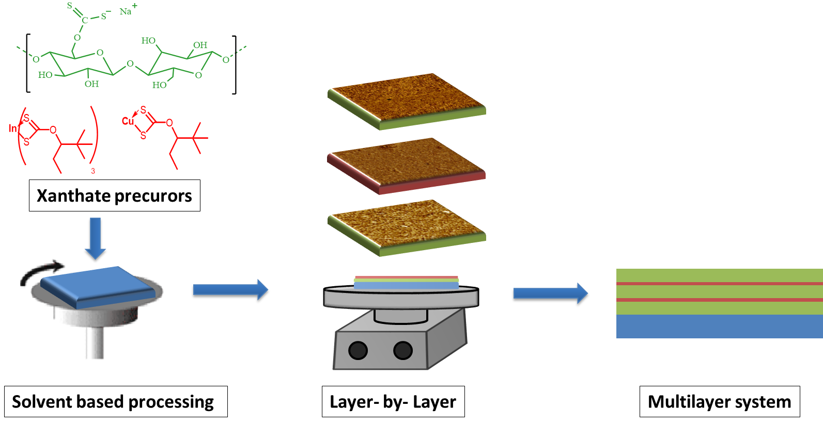
Figure 3. Schematic describtion of the Cellulose/CuInS₂ multilayer production

The combination of all the methods used, gives the possibility to present detailed information on the structure, the cross section and the surface properties of the multilayer system on the one hand, and the optoelectronic behavior on the other hand.

3. Conclusions

With the two examples presented in this contribution, we demonstrate that the combination of cellulose as green, manifold applicable polymer and CuInS₂ as optoelectronic material is a powerful and promising tool for developing electro active hybrid materials, even in the nanoscale. Easy soluble, widely available and cheap cellulose derivatives offer the possibility to form cellulose matrices with well adjustable film properties.
The employed xanthate precoursors generated semiconductive CuInS₂ nanoparticles through a mild thermal treatment, which offers a great possibility to overcome the use of toxic Pb or Cd based materials.

References

1. Klemm, D., et al., Cellulose: Fascinating Biopolymer and Sustainable Raw Material. Angewandte Chemie International Edition, 2005. 44(22): p. 3358-3393.
2. Reishofer, D., et al., Biobased Cellulosic–CuInS2 Nanocomposites for Optoelectronic Applications. ACS Sustainable Chemistry & Engineering, 2017. 5(4): p. 3115-3122.
3. Weißl, M., et al., Homogeneous cellulose thin films by regeneration of cellulose xanthate: properties and characterization. Cellulose, 2018. 25(1): p. 711-721.
4. Yang, J., et al., CdSeTe/CdS Type-I Core/Shell Quantum Dot Sensitized Solar Cells with Efficiency over 9%. The Journal of Physical Chemistry C, 2015. 119(52): p. 28800-28808.
5. Chuang, C.-H.M., et al., Improved performance and stability in quantum dot solar cells through band alignment engineering. Nature Materials, 2014. 13: p. 796.
6. So, D., S. Pradhan, and G. Konstantatos, Solid-state colloidal CuInS2 quantum dot solar cells enabled by bulk heterojunctions. Nanoscale, 2016. 8(37): p. 16776-16785.
7. Rath, T., et al., A Direct Route Towards Polymer/Copper Indium Sulfide Nanocomposite Solar Cells. Advanced Energy Materials, 2011. 1(6): p. 1046-1050.

