EFFECT OF SUPERHEATED STEAM ON THE ADHESION PROPERTIES OF RECYCLED CARBON FIBER

Guangbin Cai¹*, Masashi Wada², Isamu Ohsawa¹, Satoshi Kitaoka² and Jun Takahashi¹

¹School of Engineering, The University of Tokyo, Tokyo, Japan
²Japan Fine Ceramics Center, Nagoya, Japan
*Corresponding author (cai-guangbin@cfrtp.t.u-tokyo.ac.jp)

Keywords: Superheated steam, Carbon fiber, Interfacial shear strength, CFRP recycling

Abstract
The interfacial adhesion properties of recycled carbon fibers subjected to 1 hour superheated steam (SHS) treatment at 650 °C were evaluated by performing micro-droplet tests on the single fibers. The virgin carbon fiber with sizing agent was selected as the reference material; maleic anhydride (0.5 wt%) grafted polypropylene and non-treated polypropylene were used as polymer matrixes for the evaluation. The interfacial shear strength (IFSS) was calculated on the basis of experimental results. It has been observed that SHS promotes desirable adhesion properties of the resultant fibers by comparing the IFSS with that of corresponding ones. The surface morphology of the recovered fibers revealed that the SHS will not induce specific degradation during the recycling. The thermal residual stress and surface chemical states were studied to elucidate the experimental results.

1. Introduction

Carbon fiber reinforced plastics (CFRP) have been attracted extensive attention, and widespread application have found in the various segments [1,2]. The total demand for CFRP is expected to increase in the next few years, primarily owing to their high specific strength and high specific stiffness [3,4]. At the same time, CFRP waste has also increased, raising concerns about environmental issues. Currently, recycling is the most efficient way for managing CFRP waste. The conventional recycling can be surmised as the decomposition of polymer matrix and the recovery of the carbon fibers, since it is difficult to recycle fiber and matrix simultaneously from the waste. Recently, treatment with superheated steam (SHS) has considered as a potential technique for CFRP recycling, because of its specific advantages over the hot air, which is used in the conventional processes. The SHS exhibits high thermal capacity and heat transfer coefficient, which are the essential parameters in determining the efficiency of thermal decomposition [5,6].

Generally, virgin fibers are coated with a polymeric-sized layer on the surface to enhance the interfacial adhesion to the polymer matrix whereas recycled carbon fibers (RCF) are not, since the sizing agent could be decomposed simultaneously with the polymer matrix during the recycling. Thus, an additional surface treatment is necessary for re-use of the RCF[7]. This is due to that the interfacial adhesion contributes considerably to the mechanical properties of CFRP. A recent study has reported that SHS treatment has high potential in surface modification when the fiber bundles were exposed to SHS [8]. If the treatment with SHS could ensure the desirable carbon fiber recovery with complete decomposition of polymer matrix, as well as simultaneous increase in the adhesion properties, then the extensive RCF re-using could be expected due to the lowering of cost and manufacturing cycle time.

In this study, the effect of SHS on the carbon fiber adhesion properties was assessed toward the development of SHS treatment for CFRP recycling. The interfacial adhesion of resultant RCF was measured through performing micro-droplet test on the single fibers. The influence of thermal residual stress on the evaluation of interfacial adhesion was discussed. Furthermore, the effect of SHS on RCF surface chemical states was studied by X-ray photoelectron spectroscopy (XPS).

2. Experimental

2.1. Materials

Virgin carbon fibers (PYROFIL TR-50S, Mitsubishi Chemical Co., Ltd., Japan) as-treated with sizing agent were used as reference material. To demonstrate the influence of sizing agent on the adhesion properties, cleaning of the as-received virgin fibers was performed sequentially by using acetone, ethanol and pure water. These fibers are labeled the “sized” and “desized”, respectively. Unidirectional carbon fiber reinforced (UD) sheets in an average volume fraction of 55% were provided by the Industrial Technology Center of Fukui Prefecture, Japan for this study. These UD sheets were manufactured by impregnating as-spread TR-50S tow to the both sides of polyamide 6 resin film. Maleic anhydride (0.5 wt%) grafted polypropylene (MAPP) and non-treated polypropylene (PP) (Toyobo Co., Ltd., Japan) were used as polymer matrixes for the experiments.

2.2. SHS treatment

Treatment facility consists of an SHS-generating system and a processing chamber that is equipped with an assistant heater to provide a relatively constant temperature during the treatment. Currently, the permissible dimensions of the sample for SHS treatment are regarded as 250 × 250 × 250 mm (length × width × thickness). The treatment with SHS was performed on UD sheets with dimensions of 240 × 180 × 0.044 mm (length × width × thickness) at the Japan Fine Ceramics Center, Japan. The treatment temperature was 650 °C, and the treatment time was 1 hour. The selection of treatment condition is on the basis of the results of our previous study, since it had been observed that carbon fibers were recovered with complete decomposition of resin after the SHS treatment for 1 hour at temperatures higher than 650 °C. The results of thermogravimetry and differential scanning calorimetry (TG-DSC) also indicated that SHS treatment at 650 °C was sufficient for complete resin decomposition, as shown in Figure 1 [9]. The RCF subjected to the SHS treatment is labelled based on the temperature in the rest of this paper.

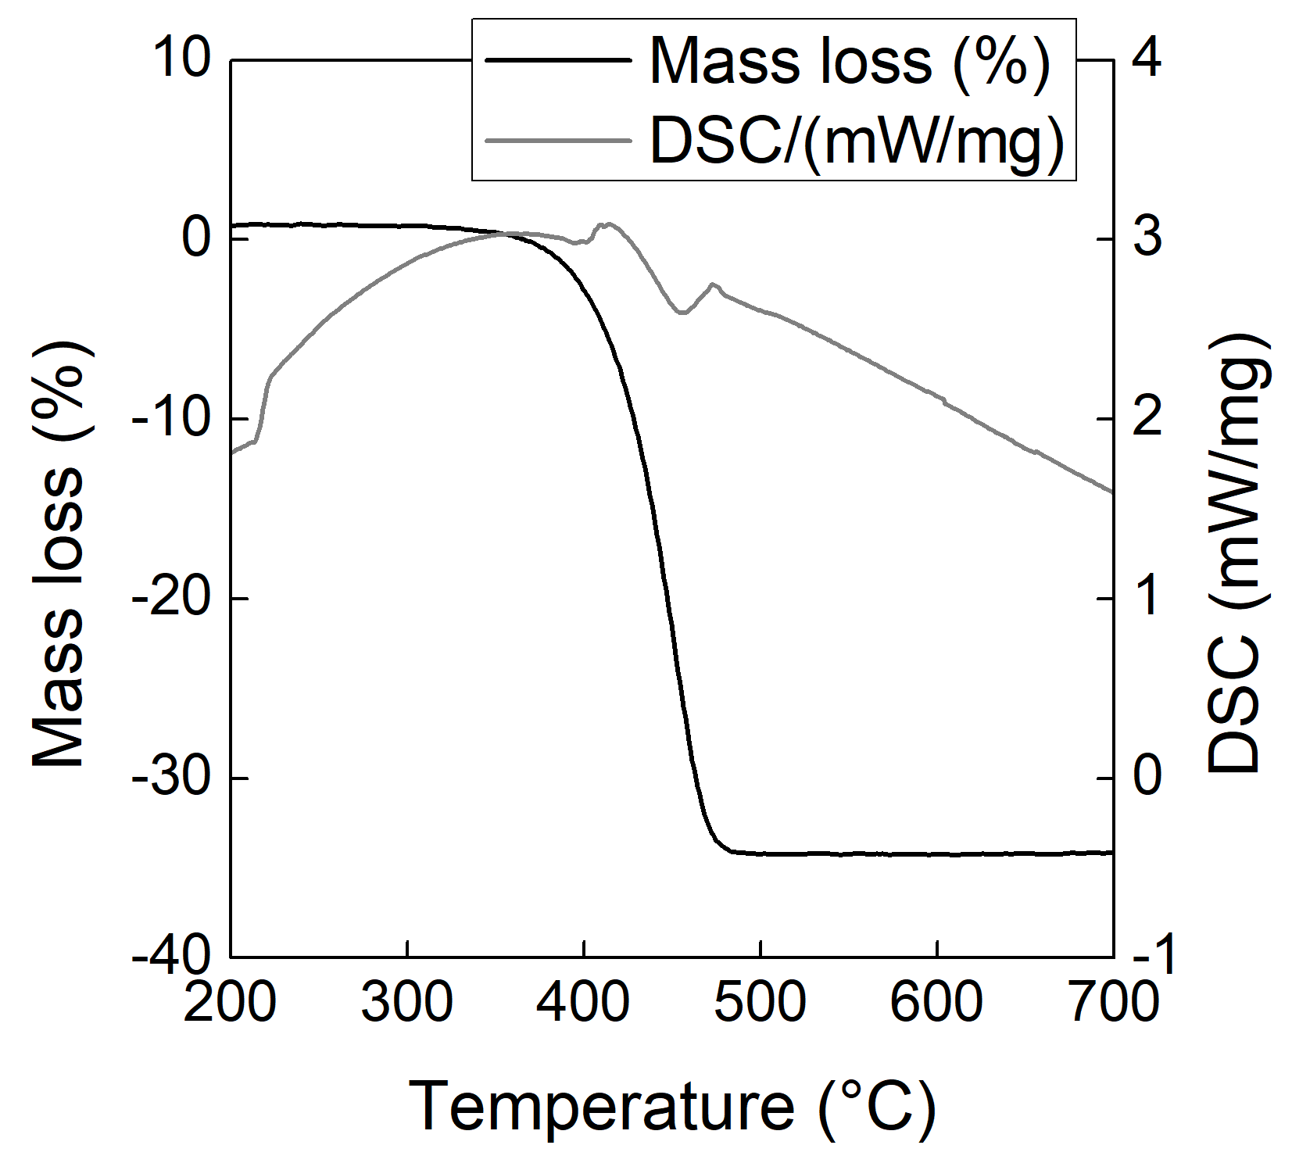

Figure 1. TG-DSC curves of UD sheet in SHS-like atmosphere. Adapted from [9].

2.3. Characterization

The surface morphologies of sized, desized, and RCF subjected to 1 hour SHS treatment at 650 °C (SHS650) were observed using a scanning electron microscopy (SEM) system (JSM-IT300LV, JEOL, Ltd., Japan).

The effect of the SHS on the interfacial adhesion properties of carbon fibers were evaluated by single fiber micro-droplet tests. To prepare the specimens for the test, single carbon fibers were selected randomly from the bundle of sized and desized carbon fiber, and from the as-treated UD sheets, respectively. A single carbon fiber was placed at the aluminum mounting and then firmly bonded to the mounting using a drop of polyester adhesive (NP-50B, Tokyo Sokki Kenkyujo Co., Ltd., Japan). A micro-droplet testing system (HM410, Tohei Sangyo Co., Ltd., Japan) was employed to the measurement. The droplets were fabricated within the temperature range of 155 – 160 °C. Subsequently, the droplets were solidified to the room temperature with a gradual cooling in order to promote sufficient crystallization of resin.

After preparation, a droplet was loaded between two blades. Then the embedded length was measured through a two-dimensional measurement software (AR-U120P3MF, ARTRAY Co., Ltd., Japan). The force was then recorded during a unidirectional pulling process at a displacement rate of 0.12 mm/min until interface debonding. We measured 40 valid data points at 25 °C with embedded lengths ranged from 60 to 110 micro-meters.

The interfacial shear strength (τ_{i}) (IFSS) can be calculated by the following Eq. (1):
τ_{i} = F_{max} / π D_{f} L_{e} | (1)
where F_{max} is the force at the moment of interface debonding, D_{f} is the fiber diameter, and L_{e} is corresponding to the embedded length of individual droplet. This method assumes a uniform shear lag model where shear stresses are uniformly distributed along the interface. Considering the fact that shear stress distributions vary along the interface, the IFSS can be derived from the following Eq. (2):
τ_{d} = dF_{max} / π D_{f} dL_{e} | (2)
There are two methods to evaluate the IFSS value from the experimental results. One is the mean of the values calculated from the Eq. (1); the other is the method of utilizing the slope of linear regression of F_{max} as a function of L_{e}, as shown in Eq. (2).

The surface chemical states of the carbon fibers used in this study were analyzed by X-ray photoelectron spectroscopy (XPS; ESCA 180MC, Ulvac-Phi., Chigasaki, Japan). The high resolution spectras of C_{1s}, O_{1s}, and N_{1s} were studied.

3. Results and discussion

3.1. Morphology of carbon fiber surface

The morphology of SHS650 surfaces were observed by SEM. The micrographs of the sized and desized virgin fibers are shown for comparison. As shown in Figure 2 (a), sizing agent was present on the as-received virgin fibers. It can be noticed that the cleaning process has removed sizing on the fiber surfaces (Figure 2 (b)). Figure 2 (c) indicates the carbon fibers could be recovered with complete decomposition of resin after treatment at 650 °C for 1 hour. Additionally, it can be observed that the SHS treatment will not induce the specific degradation of the carbon fibers during the recycling of CFRP.
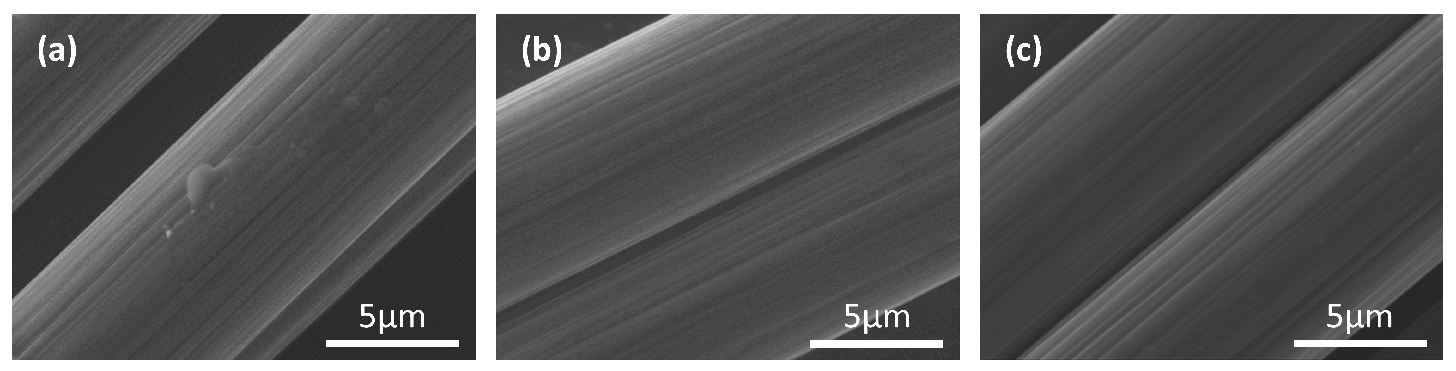

Figure 2. Carbon fiber surface morphology: (a) sized, (b) desized and (c) SHS650.

3.2. Interfacial shear strength

Figure 3 shows mean IFSS calculated from Eq. (1); the error bar indicates standard deviation of 40 valid data points. The mean IFSS of SHS650/MAPP is 27.29 MPa, which value was approximately 30% higher than that of desized/MAPP. It can be seen that the IFSS of SHS650/MAPP is slightly lower than that of sized/MAPP (29.87 MPa), although the mean of former is within the error range of latter. IFSS of sized/MAPP is higher than that of desized/MAPP, which is considered to be the contribution of sizing agent. On the other hand, IFSS values of sized, desized, SHS650 to PP are close to each other. These can be explained in terms of chemical structure of PP molecular, since the PP resin cannot involve chemical bonding to the functional groups on the fiber surface. Thus, it can be surmised that the interface debonding of PP could be primarily determined by the thermal residual stress.

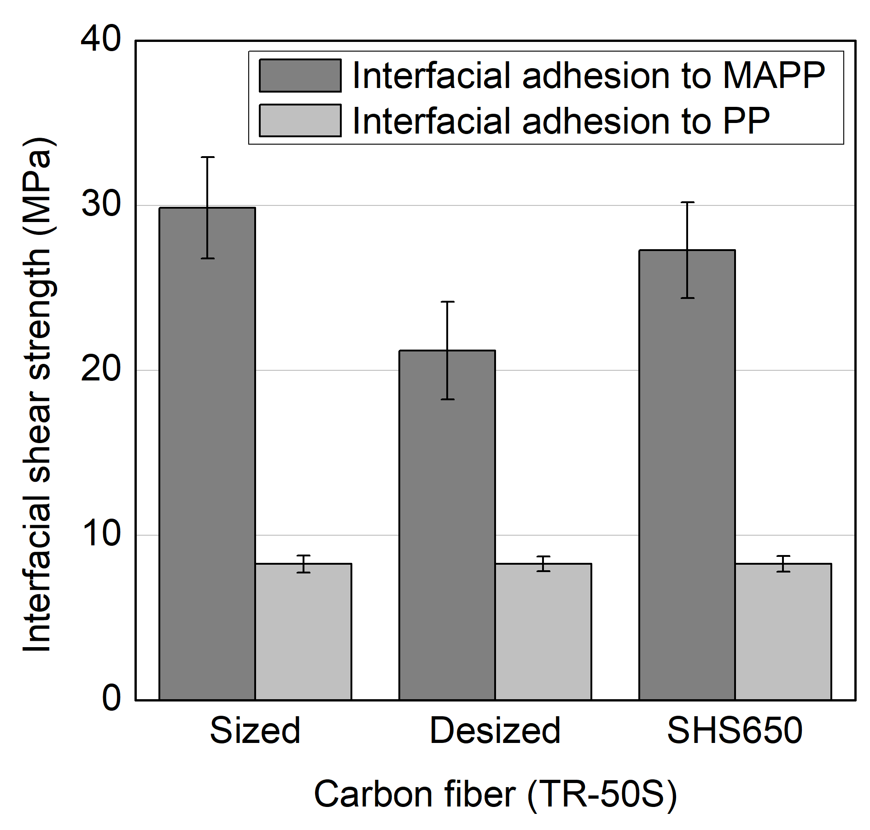

Figure 3. IFSS of sized, desized and SHS650 to PP and MAPP.

A least-square linear regression was established in order to identify the correlation between the force for interface debonding and embedded length, as shown in Figure 4. The results show clearly that maximum force for debonding MAPP is higher than that for PP. However, the scatter in the force data for MAPP is relatively higher than that in the data for the PP. The parameters of linear regression are shown in Table 1, and the mean IFSS are shown for comparison. It is obvious that the SHS promotes desirable interfacial adhesion between the fiber and MAPP resin. Furthermore, the IFSS derived by the Eq. (2) are higher than the mean IFSS calculated on the basis of Eq. (1).

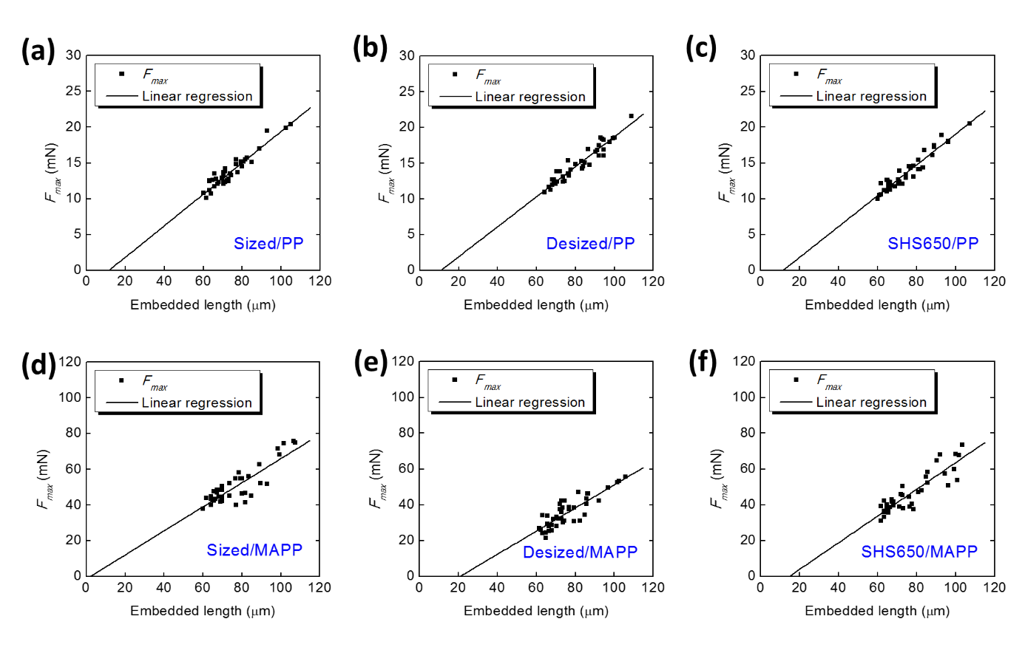

Figure 4. Experimental results obtained by micro-droplet test: (a) sized/PP, (b) desized/PP, (c) SHS650/PP, (d) sized/MAPP, (e) desized/MAPP, and (f) SHS650/MAPP.

Table 1. Parameters of least-square linear regression in Figure 4.

Carbon fiber | Sized |  | Desized |  | SHS650
Polymer | PP | MAPP | PP | MAPP | PP | MAPP
Slope (mN/μm) | 0.22 | 0.67 | 0.21 | 0.65 | 0.22 | 0.75
Intercept (mN) | -2.55 | -1.27 | -2.25 | -13.41 | -2.46 | -10.87
τ_{d} (MPa) | 10.00 | 30.61 | 9.55 | 29.40 | 9.79 | 33.90
τ_{i} (MPa) | 8.42 | 29.87 | 8.27 | 21.20 | 8.27 | 27.29

It can also be noticed that the linear regressions are not meet the origin, which results can be explained by the presence of residual stress in fiber axial direction [10]. The intercepts of linear regression for fiber and PP are almost close to each other, however these are vary from one to another for MAPP. This could be explained by the surface chemical states of fibers due to all of the specimens were fabricated in the identical conditions. Thus, the debonding should be influenced by the similar degree of residual stress. However, the droplets with higher embedded length could result in a higher probability of chemical interaction between fiber and matrix. In that case, the slope of linear regression will be steeper when the probability of surface functional group is low or the surface chemical states are not uniform. It is worth to note that the sized fibers had been used for this study as treated with a sizing agent during the manufacturing process; the surface chemical states of desized and SHS650 could be influenced by the desizing and SHS treatment, respectively. Thus, it would not be reasonable to compare the negative intercept from one to another or define the value as the axial residual force.

3.3. Thermal residual stress

The thermal induced residual stress arises during the polymer solidification. Considering the thermal shrinkage mismatch between fiber and matrix, the presence of residual stress could influence the characterization of interfacial adhesion properties [11]. The residual stress in fiber axial direction can be calculated from the following equations by assuming the isotropic matrix deformation [10,12],
σ_{A} = (E_{f} ∆T (α_{m} - α_{f})) / (1 - 2kv_{f}) | (3)
k = θv_{f} / (θ (1+v_{f}) +1+ v_{m}) | (4)
θ = E_{m} / E_{f} | (5)
where E_{f} is the elastic modulus of carbon fiber, ∆T is temperature change, α_{m} and α_{f} is the coefficient of thermal expansion of fiber and matrix, respectively. At the same time, thermal residual stress in fiber radial direction can be calculated from the following Eq. (6),
σ_{R} = (E_{m} ∆T (α_{m} - α_{f})) / (θ (1 - v_{f}) +1+ v_{m} + 2γ) | (6)
where E_{m} is the elastic modulus of polymer matrix, γ is defined as the ratio between fiber and matrix cylinder cross sections. v_{f} and v_{m} are the Poisson’s ratio of carbon fiber and matrix, respectively.

Table 2. Material constants for calculating thermal residual stress.

Material | E  (GPa) | v | α  (µm/m∙°C)
Carbon fiber | 206 | 0.28 | 5.6
PP | 2.43 | 0.42 | 60
MAPP | 1.61 | 0.42 | 63

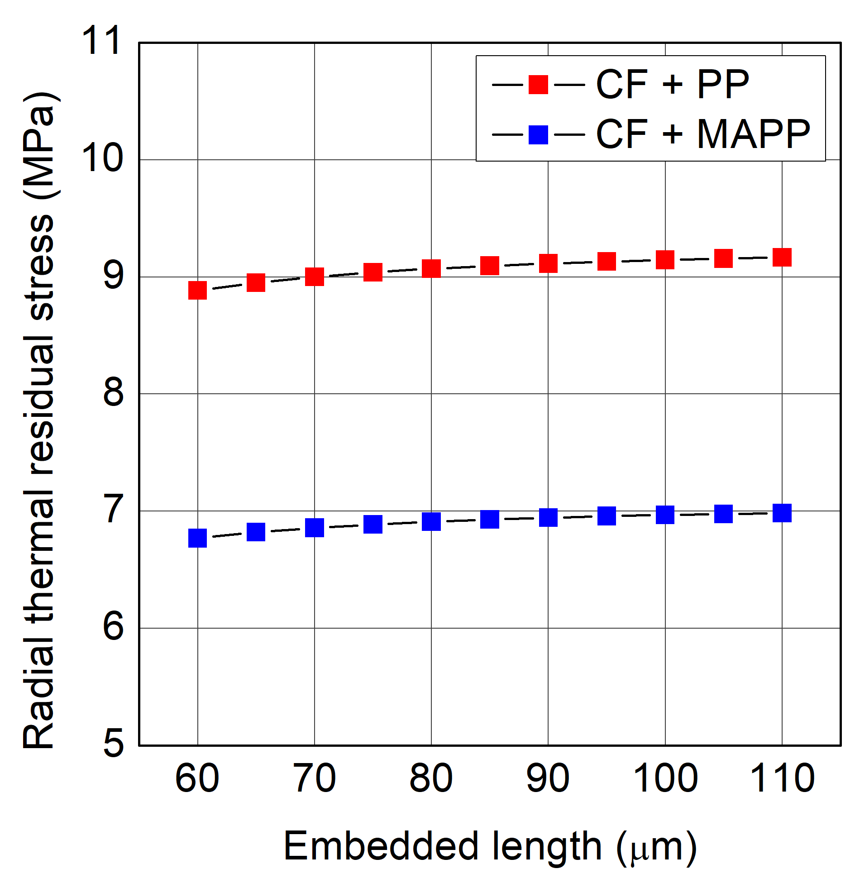

Figure 5. Thermal residual stress in the fiber radial direction.

Figure 5 shows the radial residual stress which values are calculated on the basis of the material constants in Table 2. The results show that radial stress increases with the growth of embedded length, primarily owing to the variance of droplet cylinder diameter along the increase of embedded length. The residual stress in PP solidification (Eq. (6)) is within the range of IFSS calculated from Eq. (1) and (2). Furthermore, the IFSS (PP) value obtained from the experimental results will not be influenced by the surface chemical states. On the other hand, the gradual cooling may contributes to the release of residual stress [10]. Thus, it can be speculated that the interfacial adhesion to PP could be primarily determined by the thermal residual stress. Although the interfacial shear strength of carbon fiber to PP is lower than that to MAPP, the residual stress induced by PP is higher than that by MAPP in the fiber radial direction, as shown in Figure 5. This is considered to be related to effect of the surface chemical states on the interface adhesion due to the fact that MAPP can involve chemical interaction to the functional groups on the fibers. Hence, it is necessary to assess the effect of surface chemical states of fibers on the adhesion properties.

3.4. Surface chemical states of carbon fiber

The high resolution spectra of C_{1s} region indicates the intensity of phenol or ether groups (C-OH, C-O-C; 285.5 eV) in desized fibers is slightly lower than that in sized virgin fibers. This may be responsible for the decrease of interfacial adhesion between desized fibers and MAPP, since these oxygen-containing groups can involve chemical bonding to the MAPP [13]. The O_{1s}/C_{1s} ratio for RCF is even lower than that for desized fiber, though IFSS values indicated that SHS650 show desirable adhesion properties to MAPP resin. Furthermore, the N_{1s} spectra of SHS650 varies from those of sized and desized fibers. A new peak over 398.5 eV in the N_{1s} spectra of SHS650 is noticed. Thus, it could be the appearance of nitrogen-containing extrinsic functional groups on the RCFs that contributed to the observed increase in the IFSS, as it is likely that these functionalities were produced during the SHS treatment, given the atmosphere condition of the treatment and the high processing temperatreus for resin decomposition.

4. Conclusion

CFRP recycling and RCF re-use are known as the pressing issues for both environmental and economic aspects. The SHS treatment is regarded as a potential approach for recycling CFRP. Thus, the influence of SHS on the carbon fiber was assessed by exposing UD sheets to such a treatment at 650 °C for 1 hour. It has been observed that carbon fibers were recovered with complete decomposition of polymer matrix. SEM micrographs indicated that the SHS will not induce any specific degradation on the fiber surface during recycling. The interfacial adhesion properties of RCF subjected to SHS treatment have been evaluated by performing single fiber micro-droplet test. The IFSS of fibers treated with SHS at 650 °C was comparable to that of sized virgin fibers when MAPP and PP were used as the polymer matrix. The XPS results showed that the appearance of extrinsic functional groups, which may contributes to the desirable adhesion properties of the fibers subjected to SHS treatment. Conclusively, SHS treatment shows great potential for the CFRP recycling and simultaneous surface modification of the recovered fibers.

Acknowlegdements

Part of this study belongs to Japanese METI project “the Future Pioneering Projects/Innovative Structural Materials Project” since 2013fy. The authors express sincere appreciation to the project members who have provided valuable information and support. In addition, the authors would appreciate the Industrial Technology Center of Fukui Prefecture and Toyobo Co., Ltd. for providing materials for this study.

References

[1] Seabubbles A, Infugreen G, Seine R. Improved carbon fiber structure for automotive. Reinf Plast 2018;62:4–5. doi:10.1016/j.repl.2017.12.009.
[2] Carbon fiber for building. Reinf Plast 2017;61:263. doi:10.1016/j.repl.2017.07.065.
[3] Holmes M. Global carbon fibre market remains on upward trend. Reinf Plast 2014;58:38–45. doi:10.1016/S0034-3617(14)70251-6.
[4] Composites H, Asa N, Strassburger C, Asia JEC. Carbon fiber market growing at 8%. Reinf Plast 2017;61:71–2. doi:10.1016/j.repl.2017.01.033.
[5] Shi J, Bao L, Kobayashi R, Kato J, Kemmochi K. Reusing recycled fibers in high-value fiber-reinforced polymer composites : Improving bending strength by surface cleaning. Compos Sci Technol 2012;72:1298–303. doi:10.1016/j.compscitech.2012.05.003.
[6] Ye SY, Bounaceur A, Soudais Y, Barna R. Parameter Optimization of the Steam Thermolysis : A Process to Recover Carbon Fibers from Polymer-Matrix Composites. Waste Biomass Valor 2013;4:73–86. doi:10.1007/s12649-013-9220-4.
[7] Lee H, Ohsawa I, Takahashi J. Effect of plasma surface treatment of recycled carbon fiber on carbon fiber-reinforced plastics (CFRP) interfacial properties. Appl Surf Sci 2015;328:241–6. doi:10.1016/j.apsusc.2014.12.012.
[8] Wada M, Kawai K, Suzuki T, Hira H, Kitaoka S. Effect of superheated steam treatment of carbon fiber on interfacial adhesion to epoxy resin. Compos Part A Appl Sci Manuf 2016;85:156–62. doi:10.1016/j.compositesa.2016.03.024.
[9] Cai G, Wada M, Ohsawa I, Kitaoka S, Takahashi J. Influence of treatment with superheated steam on tensile properties of carbon fiber. Compos Part A Appl Sci Manuf 2018;107:555–60. doi:10.1016/j.compositesa.2018.02.002.
[10] Wang X, Xu D, Liu HY, Zhou H, Mai YW, Yang J, et al. Effects of thermal residual stress on interfacial properties of polyphenylene sulphide/carbon fibre (PPS/CF) composite by microbond test. J Mater Sci 2016;51:334–43. doi:10.1007/s10853-015-9251-2.
[11] Parlevliet PP, Bersee HEN, Beukers A. Residual stresses in thermoplastic composites - a study of the literature. Part III: Effects of thermal residual stresses. Compos Part A Appl Sci Manuf 2007;38:1581–96. doi:10.1016/j.compositesa.2006.12.005.
[12] Liu H, Mai Y, Ye L, Zhou L. Stress transfer in the fibre fragmentation test: Part III Effect of matrix cracking and interface debonding. J Mater Sci 1997;32:633–41. doi:10.1023/A:1018527516621.
[13] Li X, Bandyopadhyay P, Nguyen TT, Park O kyung, Lee JH. Fabrication of functionalized graphene oxide/maleic anhydride grafted polypropylene composite film with excellent gas barrier and anticorrosion properties. J Memb Sci 2018;547:80–92. doi:10.1016/j.memsci.2017.10.031.

