**Methodical approach for simulating the vibration of damaged fibre reinforced composite rotors under consideration of aerodynamic influences**

I. Koch1; B. Beirow2; A. Filippatos1; A. Kühhorn2 and M. Gude1

1 Institute of Lightweight Engineering and Polymer Technology, Faculty of Mechanical Science and Engineering, Technische Universität Dresden, Holbeinstraße 3, 01307 Dresden, Germany

2 BTU Cottbus-Senftenberg, Chair of Structural Mechanics and Vehicle Vibrational Technology, Siemens-Halske-Ring 14, 03046 Cottbus, Germany

Corresponding author: Email: [ilja.koch@tu-dresden](mailto:ilja.koch@tu-dresden), Web Page: <http://tu-dresden.de/mw/ilk>

**Keywords:** damage mechanics, aerodynamic influence coefficients, polar orthotropic disk rotor

**Abstract**

A numerical methodology for the aerodynamic damping analysis of fibre reinforced rotors under consideration of varying stiffness due to damage is proposed. Therefore continuum damage mechanics approaches for textile reinforced composites are applied to composite rotors for the description of anisotropic damage evolution resulting in locally varying stiffness and strength. In order to take account of aeroelastic coupling, the aerodynamic influence coefficients (AIC) technique has proved to be a well-suited and simple method for isotropic and homogeneous rotors but not yet fully developed for anisotropic and locally damaged composite rotors. To step further a first valuable combination of a simplified interaction model for vibrating structures and fluids and the modal analysis of polar orthotropic disk rotors is presented. Damping ratios are calculated in dependence on the acoustic impedance and therefore on fluid pressure and temperature and reasonable results are achieved.

1. Introduction

Bladed disk rotors for compression or acceleration of gases, such as fans in modern jet engines, applications of general mechanical engineering and process engineering, underlie extreme loadings of quasistatic and low cycle fatigue character (centripetal and thermal forces) but also vibration such as rotation harmonic vibrations in several vibration modes. Reducing the forced response and adjusting vibration frequency and therefore reducing fatigue and noise emission is mandatory. A reduced vibration level additionally leads to improved system efficiency.

Blade integrated disk (Blisks) rotors are known to provide excellent light weight potential but lack in material und structural damping (see Figure 1).

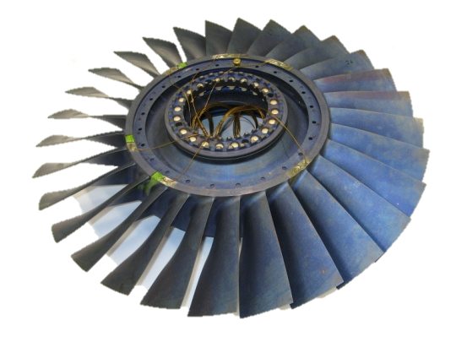

Figure 1: Titanium high pressure compressor blisk

For that reason the mode dependent aeroelastic interaction of blade and fluid is used to provide sufficient aerodynamic damping for save application. In case of metal blisks one to two orders of magnitude in damping are gained compared to the structural damping.

Fibre reinforced composite rotors, which are under investigation extensively, also provide a high lightweight potential and additionally comparable high material damping compared to conventional rotor concepts based on titan, nickel base alloys or steel [1]. Due to the extremely light design of fibre reinforced rotors a significant level of aerodynamic damping is never the less needed.

During service of rotors damage may be induced by the various loadings such as vibration or foreign object damage. For the case of composite rotors, by damage local stiffness degradation and change of damping over service time is induced [2, 3].

A combined methodology for the aerodynamic damping analysis of fibre reinforced rotors under consideration of local damage is proposed here. After short introduction to failure mode related damage models for quasistatic, highly dynamic and cyclic loading aeroelastic calculation procedures to account for aeroelastic coupling effects are highlighted. A first valuable combination of a simplified interaction model for vibrating structures and fluids and the modal analysis of polar orthotropic disk rotors is presented. Damping ratios are calculated in dependence on the acoustic impedance and therefore on fluid pressure and temperature.

1. Failure mode related damage models for composite materials

Reliable design tools for dynamically loaded composite structures require a realistic and physically based description of the damage evolution. Especially the mechanical representation of damage phenomena such as stiffness and strength degradation should be modelled in detail.

Composites reinforced by crimped fabrics, such as woven or braided fabrics, can be virtually broken down in a mechanical sense to bidirectional layers [3]. In the case of fabrics with straight fibre orientation and less fibre ondulation the mechanical response of the structure can very well be modelled based on idealised unidirectional (i-UD) layers [2]. By introducing the effective stress  in the damaged material with

|  |  |
| --- | --- |
|  | (1) |

where denote the damage parameters, the constitutive law for the damaged i-UD-layer can be given by

|  |  |
| --- | --- |
|  | (2) |

with the compliances  and  of the undamaged material and the damaged material respectively. Due to crack closure effects a separated formulation of the compliance matrix  for tension and compression states of stresses can be introduced.

Assuming

|  |  |
| --- | --- |
|  | (3) |

the effective compliance matrix can be written for plane tension (t) and compression (c) states of stresses according to

|  |  |
| --- | --- |
|  | (4) |

The damage parameter  has been introduced as a state variable and is therefore independent of the loading direction, however the stiffness degradation effect differs with the parameter *hi* (i = 1, 2)

A subsequent failure analysis using the fracture mode related failure conditions, which are based on the Failure Mode Concept (FMC) for fibre-reinforced materials under static loading by CUNTZE, provides the material effort  for every single fracture mode of the i-UD-layer (Fig. 2).

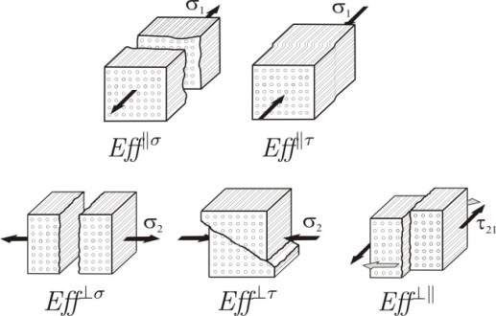

Figure 2: Fracture modes of the i-UD-Layer according to FMC by Cuntze [4]

In combination with damage growth functions $ϕ^{j}$ formulated in the fracture mode specific material efforts and the damage parameters $D_{ij}$ itself, the evolution of the anisotropic damage parameter is calculated according to

|  |  |
| --- | --- |
| 1. ; b) | () |

for the case of static (a) and, in the sense of a damage increment per cycle, for cyclic (b) loading. The summation is performed over the number of active failure modes $i$. The damage evolution equation for the cyclic case can be expanded for plane states of stresses to the form:

|  |  |
| --- | --- |
|  | () |

Following the concept of the effective stress, the anisotropic damage parameter influences the corresponding stiffness and strength of the constitutive layers. The influence of damage to the damping behavior is not yet included. By incorporating the described model approaches into FE valuable tools for the structural analysis of composite structures under consideration of damage are given [2].

1. Computation of Aerodynamic Influence Coefficients

In order to take account of aeroelastic coupling, the aerodynamic influence coefficients (AIC) technique [5-7] has proved to be a well-suited and simple method for that purpose. The method assumes small blade displacements and linear conditions, which is justified for forced response problems.

For reducing the degree of freedom number of a finite element blisk model from several millions down to the number of blades *N,* modal reduction techniques are applied. Indeed, those models are only valid for considering a particular blade mode but nevertheless without significant lack of accuracy. The equation of motion is appearing as follows:

|  |  |
| --- | --- |
| $$\left[\text{-}{\text{Ω}}^{\text{2}}\text{M }\text{+ }\text{j}\text{Ω}\text{D }\text{+ }\text{K}\right]\text{q}\text{=}{\text{f}}^{\text{F}}$$ | (8) |

**M**, **D** and **K** denote modal mass, modal structural damping and modal stiffness matrices of the tuned reference structure. **f***F* quantifies the vector of external modal forcing, $\text{Ω}$ denotes the angular exciting frequency and **q** represents the vector of modal displacements. Up to now, Eq. (8) just represents the pure structural description of the blisk.

The derivation of AIC starts with unidirectional coupled CFD-/FEM-calculation of the stationary flow, where identical rotor blades are assumed without any consideration of vanes. One blade of the cascade being subsequently denoted as reference blade (Blade ‘0’ in Figure ) is forced to vibrate in a particular blade mode ψ, which effects a disturbed flow field. Consequently, all blades are exposed to unsteady surface pressure distributions and hence, modal forces are acting upon each blade.

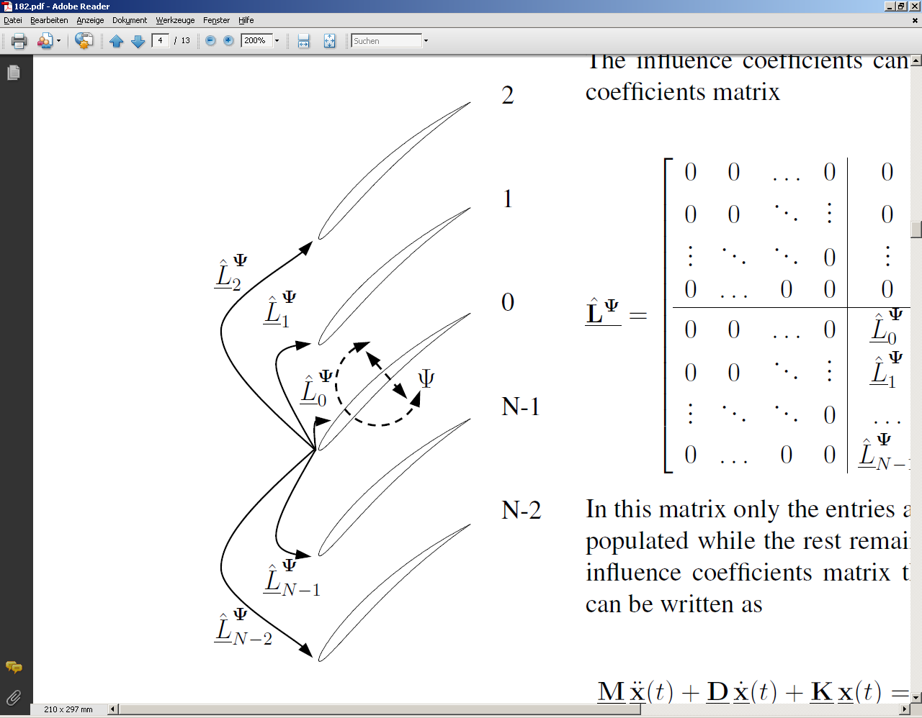

Figure 3: Graphic representation of Aerodynamic Influence Coefficients Technique. [8]

The AICs *Li* themselves are determined from a normalization of the blade individual modal forces $f_{i}^{i}$ with the modal displacement of the reference blade $q_{0}^{i}$ (index i: blade individual coordinates) according to

|  |  |
| --- | --- |
| $$L_{i}= \frac{f_{i}^{i}}{q_{0}^{i}}$$ | (9) |

and sorted to form the influence coefficient matrix **L** [9]. The influence coefficients matrix is a circular matrix, which reads as

|  |  |
| --- | --- |
| $$L=\left[\begin{matrix}L_{0} & L_{N-1} & L_{N-2} & ⋯ & L_{1} \\ L_{1} & L_{0} & L_{N-1} & ⋯ & L_{2} \\ ⋮ & ⋮ & ⋮ & ⋱ & ⋮ \\ L_{N-1} & L_{N-2} & L_{N-3} & ⋯ & L_{0}\end{matrix}\right]$$ | (10) |

AICs can be interpreted as complex stiffness term of the unit $N/mm$. Hence, if modal displacements $q_{i}^{i}$ of all blades are present the modal forcing $f_{i}^{i}$ acting on blade *i* is composed as following:

|  |  |
| --- | --- |
| $$f_{i}^{i}=L_{i}q_{0}^{i}+L_{i-1}q_{1}^{i}+⋯+L_{N-i}q_{i}^{i}+⋯+L_{i+1}q_{N}^{i}$$ | (11) |

For further details please refer to [9].

The magnitudes of AIC are dependent on the distance between the blades meaning that the largest influence occurs for the reference blade itself and the directly adjacent blades [9]. That is why typically only the reference blade itself and between 2 and 6 of its neighbors are considered (Figure 3, 4 neighbors). With increasing distance from the reference blade the magnitudes of modal forces usually strongly decrease. An additional transformation matrix **P** allows for transforming **L** blade individual coordinates into travelling wave coordinates $\text{Z}$ [9]:

|  |  |
| --- | --- |
| $$\text{Z} \text{= -}{\text{P}}^{\text{-1}}\text{LP}$$ | (12) |

The modal description of the tuned blisk considering the aerodynamic impedance matrix **Z** reads as

|  |  |
| --- | --- |
| $\left[\text{-}{\text{Ω}}^{\text{2}}\text{M }\text{+ }\text{j}\text{Ω}\text{D }\text{+ }\text{K}\text{ + }\text{Z}\right]\text{q}\text{=}{\text{f}}^{ \text{F}}$. | (13) |

Herein the expression

|  |  |
| --- | --- |
| $${\text{f}}^{ \text{M}}\text{= -}\text{Zq}$$ | (14) |

is representing the modal vector of motion induced forcing, which is shifted to the left hand side of Eq. (13).

If the external forcing as well as the extremely small structural damping part is neglected in Eq. (13) a homogeneous eigenvalue problem can be formulated

|  |  |
| --- | --- |
|  | (15) |

from which the aeroelastic eigenvalues can be evaluated:

|  |  |
| --- | --- |
| . | (16) |

λ*a,j* denote the aerodynamic eigenvalues containing the aerodynamic damping described by the decay rate δ*a,j*of the *j*th mode and the angular aerodynamic natural frequency ω*a,j*. The aeroelastic damping ratio of the *j*th mode is defined by

|  |  |
| --- | --- |
| $${\text{ζ}}_{\text{a,j}}\text{=}\frac{{\text{δ}}_{\text{a,j}}}{{\text{ω}}_{\text{0,}\text{j}}}$$ | (17) |

In case of metal blades angular aeroelastic eigenfrequencies hardly deviate from the corresponding structural natural frequencies. Contrary, it is expected that composite blades are prone to significant shifts of natural frequencies due to their low weight and consequently, a stronger impact of co-vibrating air mass.

If a mistuned blisk is considered from the structural point of view in terms of small stiffness variations $∆K$ and small variations in mass $∆M$, Eq. (13) is modified corresponding to

|  |  |
| --- | --- |
| $$\left[\text{-}{\text{Ω}}^{\text{2}}\text{(}\text{M}\text{+}\text{∆}\text{M}\text{)} \text{+ }\text{j}\text{Ω}\text{D }\text{+ }\text{(}\text{K}\text{+}\text{∆}\text{K}\text{)}\text{ + }\text{Z}\right]\text{q}\text{=}{\text{f}}^{\text{F}}$$ | (18) |

Please note that mistuning in case of reinforced composite blisks may be caused by manufacturing defects or defects and impact damage occurring during operation. In the strategy presented before it is assumed that mistuning will not cause changing blade mode shapes. Otherwise, the derivation of AIC from the tuned reference may no longer applied. The mistuned blisk has to be considered instead from the beginning, which will tremendously increase the computational effort.

1. Approximation of aerodynamic damping for polar orthotropic composite disks

As a first example a simple circular polar orthotropic fibre reinforced disk without blades is considered, which vibrates in a fluid environment at free boundary conditions. To get an idea of the magnitude of damping contributed by the fluid, a simplified approach according to [10] is employed, which has to be understood as an introduction to the problem. The method is based on the assumption that acoustic emission can be considered as main source of damping for lightweight structures [11]. It allows for computing the modal damping of the *m*th mode by applying the equation

|  |  |
| --- | --- |
|  | (19) |

The application of Eq. (19) requires that the *m*th mass-normalized mode shape **φ***m* as well as the dedicated undamped angular natural frequency ω0 are known quantities. In case of a disk in operation, fluid density ρ*i* and acoustic velocity *ci* acting on surface element *Ai* (Fig. 4) can be taken from the steady state solution. For disks at standstill conditions constant ambient state variables are plugged in Eq. (19). Attention regarding the area of application for bladed disks should be paid on a sufficiently large distance between adjacent blades and on sufficiently high blade natural frequencies. Commonly, the simplified method cannot be employed for damping calculations of fundamental blade modes. For further details with the complete derivation included please refer to [10].

As a first demonstration of this simplified approach two mode shapes of the non-rotating FRP disk are considered, which have been computed by means of finite element analysis (Figure 4). Mode shapes and natural frequencies are processed employing Eq. (19). The calculations have been computed at room conditions.

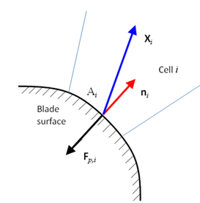 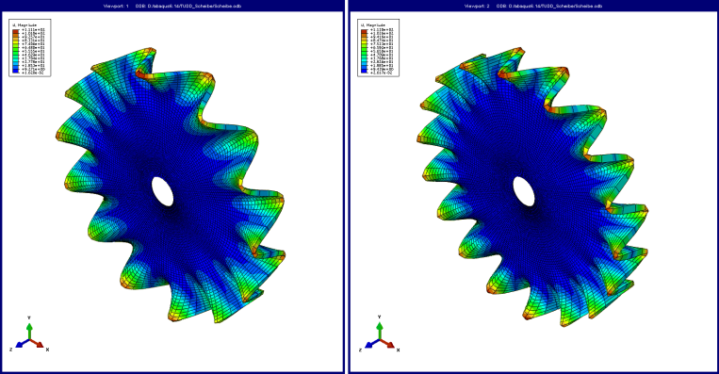

Figure 4: Acoustic pressure forcing and motion of disk surface according to [9] (left), Modes 59 (middle) and Mode 100 (right)

It is favorable to take into account the dependency of modal damping ratios on varying ambient fluid temperature and pressure by means of the dependence on the acoustic impedance *ZF* which reads as

|  |  |
| --- | --- |
| $Z_{F}= \frac{p}{R_{s}∙T}∙\sqrt{κ∙R_{s}∙T}$. | (20) |

*Rs* is denoting the specific gas constant and κ the ratio of specific heats. Assuming that the mode shapes and natural frequencies do not change, a linear dependence of modal damping ratios on the acoustic impedance is computed (Figure 5). Moreover, results of a steel disk of equal geometry are plotted in blue color in Fig. 5 for the purpose of comparison. These results are dedicated to the same mode shapes as found for the FRC-disk. Modes 59 and 100 are indicating modal fluid damping ratios which are about 6 to 7 times higher for the FRC structure, mainly driven by the about 4 times lower density of FRC compared to steel. It has to be mentioned that the linear dependence of fluid damping ratios on acoustic impedance has been also proven for metal blisks in several experimental analyses e.g. [10, 12]. However, comparable experiments for FRC blisks remain to be done.



Figure 5: Modal fluid damping ratios for Modes 59 and 100 dependent on acoustic impedance (structural damping contribution neglected)

In the following the same polar orthotropic composite disk is considered again with the objective to quantify the impact of possible local damages on fluid damping. In the sense of continuum damage mechanics and Eq. (2) the elastic modulus transverse to the fibre direction is lowered here for approximating the effect of foreign object damage. The damage position is highlighted in red in Figure 6a. Deviating from the first analyses fixed boundary conditions are chosen at the inner rim in order to achieve comparability with later experimental analyses.

The magnitudes of fluid damping ratios of the undamaged and the damaged disk given in Figure 7 are differing from each other only slightly apart from a few exceptions which are representing in-plane mode shapes with extraordinary low damping. A deeper analysis of the bending Mode 74 indicates that the modes themselves are very similar (Fig. 6b and c) and the change of natural frequencies remains moderate as well (0.7 %). Besides that structural mass does not change by incorporating damage. Consequently, the fluid damping ratios are approximately taking the same values (ζundamaged,74 = 0.1694 % and ζdamaged,74 = 0.1681 %).



**Figure 6:** a) Damaged region, Mode 74 b) undamaged disk and c) damaged disk



**Figure 7:** Change of fluid damping ratios due to inter fibre damage (*ZF* = 408.17 kg/m/s²)

1. **Summary**

Two fundamental possibilities have been presented to determine the aerodynamic damping of damaged composite disks. The first and more sophisticated considers the aeroelastic coupling and hence, the computation of aerodynamic damping by means of aerodynamic influence coefficients, which are incorporated into the system of differential equations. The second represents a simplified method of approximation, which is based on the assumption that acoustic emission into the free field of the surrounding fluid can be regarded as main source of fluid damping contribution. Due to its simplicity it is easy to be employed on circular composite plates and thus allows for a fast estimation of the mode dependent fluid damping in terms of the order of magnitude. Necessary input values are the natural frequency and mass-normalized mode shapes, which are computed by finite element analyses, and acoustic impedance of the surrounding fluid.

For the purpose of comparison, a polar orthotropic composite disk and an isotropic steel disk with identical geometry has been analysed. It could be found that fluid damping ratios computed for the composite disk are about 6 to 7 times greater than those computed for the steel reference, which is primarily caused by the lower density of the composite structure. Hence, the impact of co-vibrating fluid masses takes on greater significance in case of the lightweight structure.

The second focus of the work addresses the effect of typical composite damage on aerodynamic damping. The damage considered is typical for minor foreign object damage and includes local inter fibre failure reducing the transverse elastic modulus without material loss. Again employing the simplified method it could be shown that damage has already an influence on the aerodynamic damping just because of stiffness changes. For the given damage position near the clamping and damage extent in terms of reduced transverse modulus in a small proportion of the rotor, the damping ratios change only slightly for three reasons: 1) Mode shapes and 2) natural frequencies are only marginally changing, and 3) the structural mass remains unchanged.

With regard to future work, the extension of the presented analyses methods in terms of continuum damage models for fibre reinforced composite structures and aeroelastic interaction approaches for considering varying material damping is mandatory for a realistic in service performance analysis. Moreover experimental validation strategies for damaged composite rotors with fluid interaction are to be developed.

References

[1] Wollmann, T.; Modler, N.; Dannemann, M.; Langkamp, A.; Nitschke, S.; Filippatos, A. Design and testing of composite compressor blades with focus on the vibration behavior, *Composites Part A*, Volume 92, (2017), pp. 183-189, doi: 10.1016/j.compositesa.2016.06.012

[2] Koch, I.; Zscheyge, M.; Tittmann, K.; Gude, M. Numerical fatigue analysis of CFRP components; *Composite Structures* 168 (2017), pp. 392–401

[3] Böhm, R.; Gude, M.; Hufenbach, W. A phenomenologically based damage model for textile composites with crimped reinforcement. *Composites Science and Technology* 70 (2010), pp. 81-87

[4] Koch, I. Modellierung des Ermüdungsverhaltens textilverstärkter Kunststoffe, PhD thesis, TU Dresden, <http://nbn-resolving.de/urn:nbn:de:bsz:14-qucosa-233785>, 2010.

[5] Hanamura, Y, Tanaka, H. and Yamaguchi, K. A simplified method to measure unsteady forces acting on the vibrating blades in cascade. *Bulletin of JSME*, 23(180-12): 880–887, 1980.

[6] Kahl, G. Aeroelastic Effects of Mistuning and Coupling in Turbomachinery Bladings. Thèse N° 2629, École Polytechnique Fédérale de Lausanne, 2002.

[7] Crawley, E. F., Hall. K. C. Optimization and Mechanisms of Mistuning in Cascades. *Journal of Engineering for Gas Turbines and Power*, 107 (2), 418-426, 1985.

[8] Nipkau, J. Analysis of mistuned blisk vibrations using a surrogate lumped mass model with aerodynamic influences. PhD – Thesis, Brandenburg University of Technology Cottbus, 2010.

[9] Giersch, Hönisch, P., Beirow, B., Kühhorn, A. Forced Response Analysis of Mistuned Radial Inflow Turbines, *ASME Journal of Turbomachinery*, 135 (3), pp. 031034-1-9, 2013.

[10] Beirow, B., Maywald, T., Figaschewsky, F., Kühhorn, A., Heinrich, C.R., Giersch, T. Simplified Determination of Aerodynamic Damping for Bladed Rotors. Part 1: Experimental Validation at Rest. *Proceedings of ASME Turbo Expo 2016*, GT2016-56535, June 13-17, 2016, Seoul, South Korea.

[11] Clarkson, B. L., Brown, K. T. Acoustic Radiation Damping. *Journal of Vibration, Acoustics, Stress, and Reliability in Design*, 107, pp. 357-362, 1985.

[12] Zemp, A., Abhari, R. S., Ribi, B. Experimental Investigations of Forced Response Impeller Blade Vibration in Centrifugal Compressor with Variable Inlet Guide Vanes – Part 1: Blade Damping. *Proceedings of the ASME Turbo Expo 2011*: Paper GT2011-46289, Vancouver, June 6-11, 2011.