Thermal and electrical conductivity of epoxy-carbon fiber prepreg laminates filled with different sizes of graphite particles

Simon Bard ª*, Gökhan Bakis ª, Marius Radtke ª, Volker Altstädt ª
ª Department of Polymer Engineering, University of Bayreuth, Universitätsstr. 30, 95444 Bayreuth, Germany

Abstract

The conductivity of carbon-fiber reinforced polymers offers new application fields and has therefore became a focus of the research in recent years. A deeper understanding of the mechanisms of thermal and electrical conductivity and the interaction with of conductivity with fibers is necessary for further research and improvements.
An elaborative analysis of thermal and electrical conductivity and the mechanical properties of a graphite filled fiber reinforced composite has been performed. A formulation by two different sizes of graphite (with 3.4 µm and 18.6 µm) has been processed to a carbon fiber reinforced prepreg. The laminate quality has been analyzed by optical microscopy and ultrasound measurements.
The laminates produced from an unfilled matrix showed a conductivity of 0.35 W/mK, and the increase compared to neat resin (0.19 W/mK) can be attributed to the fibers. After adding 15 vol% of graphite into the matrix of the laminate, the thermal conductivity increased from 0.35 W/mK to 0.91 W/mK with small graphite particles and to 0.92 W/mK with bigger particles.
The neat resin showed an electrical conductivity of 6.6 * 10⁻¹⁴ S/m. The unfilled laminate already showed an electrical conductivity of 0.02 S/m, which was increased to 0.8 S/m with small and 1.4 S/m with big particles.

Introduction
Especially in the aerospace industry, where lightweight is an important topic to reduce the life-cycle costs of airplanes, metals are increasingly replaced by carbon fiber reinforced polymers (CFRP). [1] Functionalization thereby offers new application fields and has therefore became a focus of the research about CFRP in recent years. [2]
The most common approach to achieve conductivity in the polymer is by the incorporation of filler. carbon-based fillers (graphite [4], carbon nanotubes [5], carbon black [6], graphene [7]), metallic fillers (Ag, Cu [8], Al [9], TiO2), ceramic fillers (BN [10], AlN [11], Si[12] , ZrB2 [13]) and vegetal fibers [14] can be distinguished.
Electric conductivity is a very interesting topic, especially for the aircraft industry. [17] Mostly the research deals with lightning strike protection in aircrafts, at the same time, electromagnetic shielding and static discharge are of interest for this industry. [17] The theory behind electric conductivity is different from those of the thermal conductivity. While thermal conductivity increases almost linear with lower filler concentrations, a certain filler content in the composite will rapidly increase the electric conductivity, called percolation threshold. [6] In principle, the same types of fillers for thermal conductivity can be used to achieve electric conductivity, besides ceramic fillers, due to their insulating effect. As the mechanisms for electric and thermal conductivity differs, the effectiveness of the fillers also differs.
Only few researchers focused so far on the thermal conductivity of fiber reinforced laminates. Rolfes analyzed and simulated the thermal conductivity of CFRP with different fiber volume content. By a self-developed measurement method, which they called GHP, for the thermal conductivity and a high fiber volume contents of 64.3 vol.%, they reached a conductivity of 0.708 W/mK. With the transient hot strip (THS) method, which was used simultaneously, much higher conductivities of 1.029 W/mK at a fiber volume content of 61.8 vol.% has been measured. Rolfes simulated the thermal conductivity with different fiber morphologies, i.e. PAN and pitch based carbon fibers, but no experimental data can be found in their work. [18] In an elaborative literature research, only Han and Chung were identified to have used filler in the epoxy matrix to enhance the thermal conductivity. They used carbon black, CNT chopped carbon fiber as a filler material. However, the used filler content of 0.8 vol.% is rather small. They used a guarded hot plate method to measure and analyze the thermal conductivity and could increase the thermal conductivity from 1.091 W/mK to 1.453 W/mK, which is about 33 %, by the incorporation of 0.4 vol% CNT and a fiber volume content of 65 %. [19] Remarkably, the measured conductivity of the unfilled laminate differs from the experimental data of Rolfes, although the fiber volume content is at a comparable level.
Mostly literature focuses on either thermal, electrical or mechanical properties and or neglects at least one of these topics. The aim of this work is therefore to explain the influence of a graphitic filler on the thermal and electrical conductivity.

PRODUCTION AND CHARACTERIZATION METHODS

Materials
The resin Tetraglycidylmethylenedianiline (TGMDA) was supplied as EpikoteTM RESIN 496 by Hexion Inc. TGMDA is a four-functional epoxy resin with epoxy equivalent of 115 g/eq. Huntsman provided a liquid hardener with the trade name XB3473, consisting of 60-100 % Diethyltoluenediamine (DETDA) and 7-13 % 1,2-diaminocyclohexan. The hydrogen equivalent weight of the hardener is 43 g/eq. Graphite (Imerys Graphite & Carbon Switzerland Ltd.) with trade name Graphit Timrex® KS6 and KS44 was used as conductive filler. The filler is characterized by a platelet-shape and an average particle size of 3.6 μm (D50) and 18.4 µm (D50) with a density of 2.255 g/cm³. The particle size distribution was again measured in our laboratory and can be found in Figure 2. A PAN based fiber 12K A-49 (DowAksa, Atlanta, USA) with a tensile strength of around 4900 MPa and a Young’s modulus of 250 GPa has been used for the prepreg production.

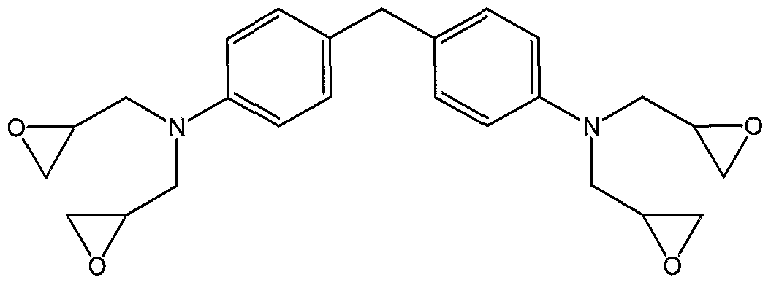 | 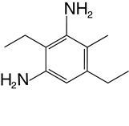
(a) | (b)
Figure 1: Chemical structures of resin TGMDA and hardener DETDA

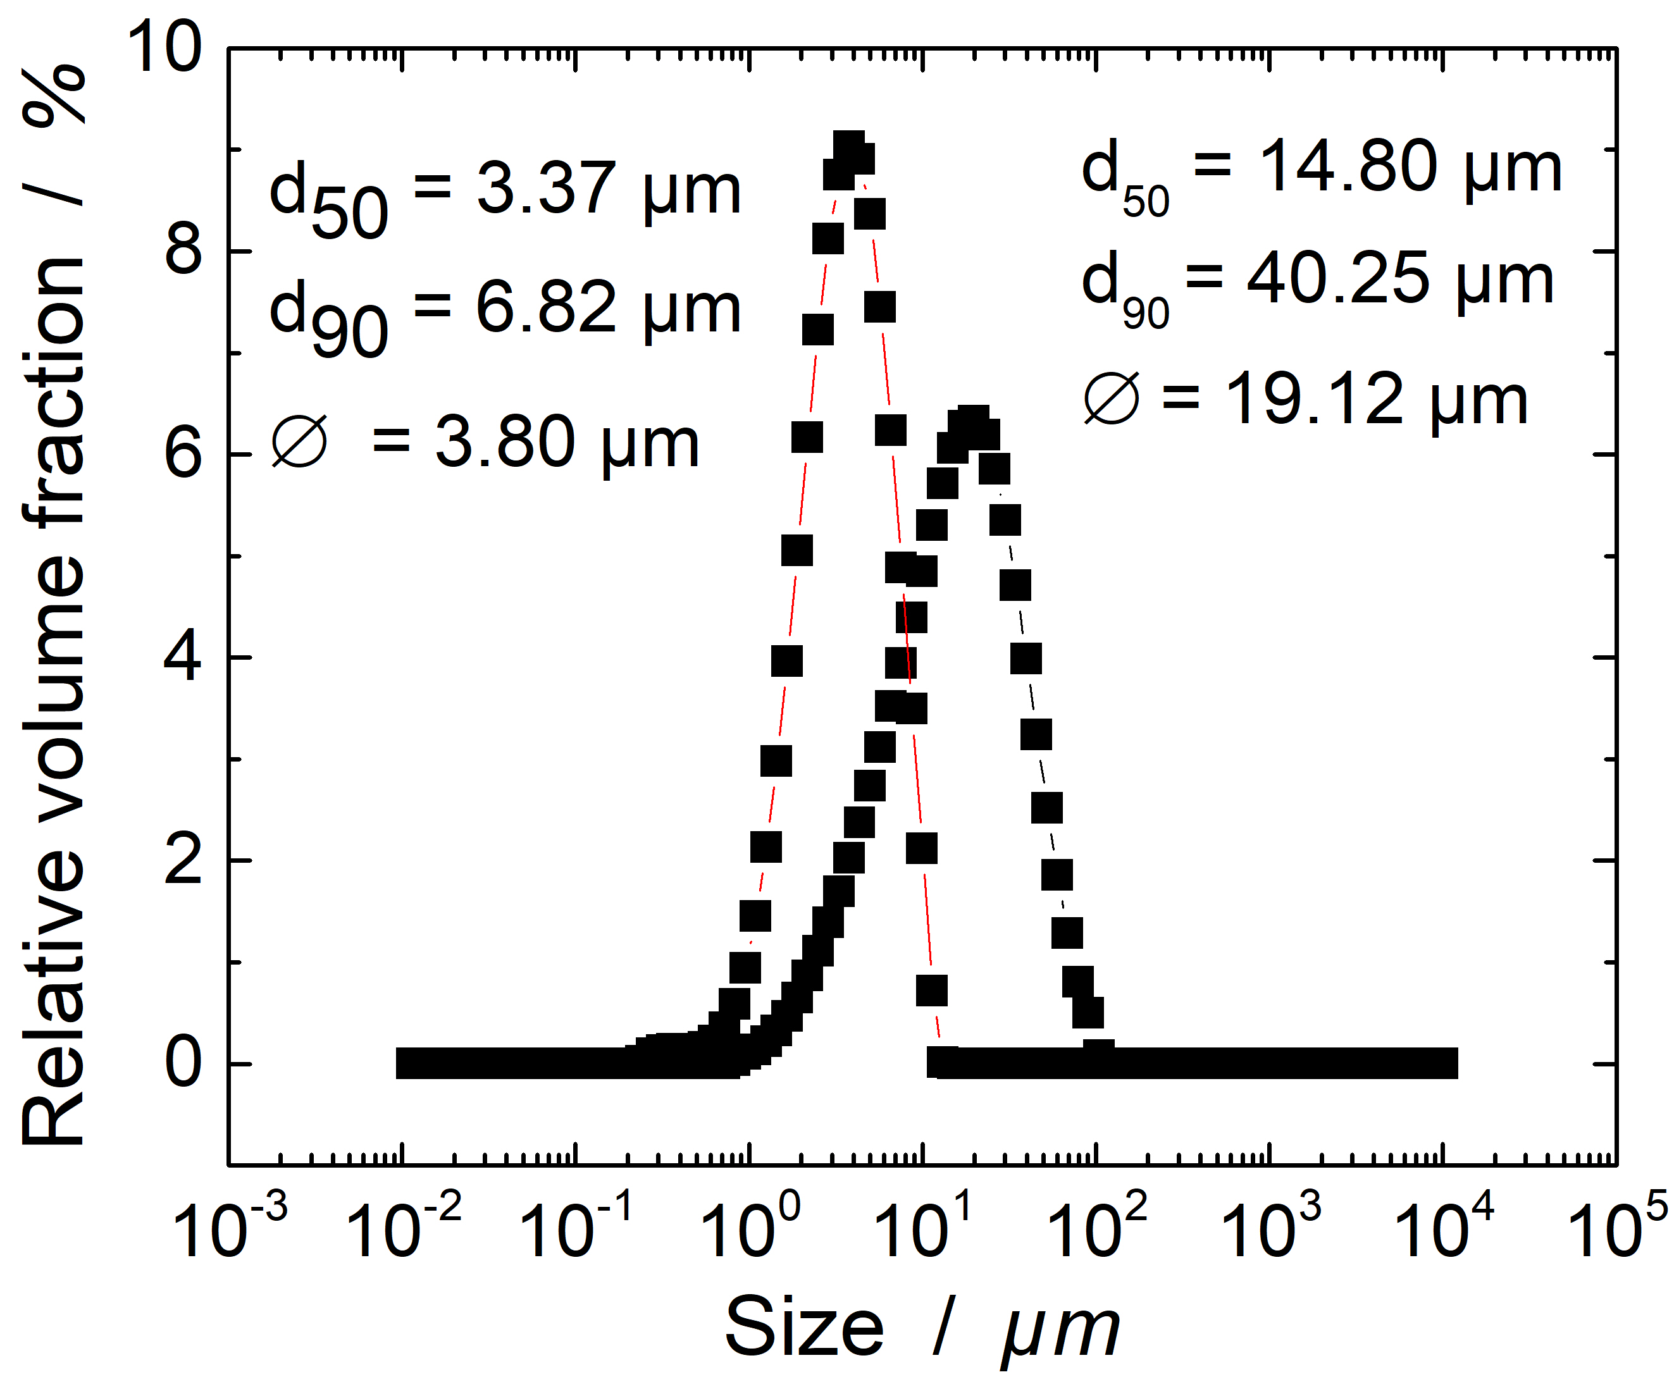
Figure 2: Particle size distribution of the used graphite types

Figure 3: SEM of small (3.6 µm) and big (18.4 µm) graphitic particles

Prepreg Production
The unidirectional prepregs were produced via hot-melt processing at the laboratory scale prepreg impregnation machinery of the University of Bayreuth.
First of all, the unidirectional rovings of 12K carbon fibers are pre-spreaded on the pre-spreading unit, as shown in Figure 4. Resin film was coated at 25 °C on a siliconized carrier paper in the coating unit of the prepreg machinery. Finally, resin film and pre-spreaded fibers were impregnated to the final prepreg with a heated calendar (25 °C). Produced prepregs were then hand-layed up to the final unidirectional prepreg laminates and cured with the same parameter as the neat and filled resin samples.

Thermal and electrical conductivity measurements
Resin and hardener were heated up separately at 25 °C and stirred in a stoichiometric ratio of 2.67:1. The mixture has been degassed at 10-20 mbar. The mass ratio of graphite is related to the volume of the whole mixture, i.e. to achieve 100 cm³ of the sample with 15 vol.% Graphit content, 85 cm³ resin/hardener and 15 cm³ Graphit have been mixed. A three-roll mill (EXAKT 120EH-450) was used to homogeneously disperse the filler in the matrix with opening gaps of 63 and 21 μm. The samples were cured under pressure in a laboratory press at 120, 160 and 200 °C, at each temperature for 1 h with a rate of heating of 10 K/min. A postcuring at 220 °C for 2 h followed before cooling down at a rate of 5 K/min.
The thermal conductivity was measured by the laser flash method (LFA) with LFA447 (Netzsch GmbH, Selb, Germany).
Electrical conductivity has been measured after ASTM D257. Thereby, the electrical resistivity was measured with Keithley 6517A for resistivity higher than 100 MΩ and for lower values Keithley 2100 (Keithley, USA).

RESULTS AND DISCUSSIONS

Thermal and electrical conductivity of the neat and filled resin
The thermal conductivity values of the composites versus filler content are shown in Figure 5. At lower filler concentrations up to 10 vol%, the increase in thermal conductivity is almost linear. At higher filler concentrations, the thermal conductivity increases exponentially. This behavior has already been described by several researchers. [3,20,21] At higher filler concentrations, a remarkable difference in the thermal conductivity can be found between the composites with small and bigger particles. In the literature, contradicting influences of the particle size on the thermal conductivity have been reported. Boudenne et al. reported higher thermal conductivities for small copper particles of 12 µm in average in a Polypropylene matrix than for bigger particles of 200 µm. [22] Zhu et al. reported contradictory results with Boron-Nitride of 70 nm and 7 µm in an epoxy matrix. [23] In both studies, it seems that the morphology and shape of the filler has not been taken into account. In this study, the shape of the particles is very similar, as it can be observed in Figure 3. The aspect ratio has been calculated from 60 measurements of the particles observed in SEM and is at 36 for the smaller and 32 for the bigger particles. The higher thermal conductivity for composites with bigger particles can be explained by a thermo-mechanical point of view. Heat is conducted by phonons in polymer composites. It seems that fundamental for the thermal conductivity are the interfaces between conducting parts of the composite. As elaborated by Burger et al., the phonons are scattered at the interfaces, which lowers the thermal conductivity. [3]

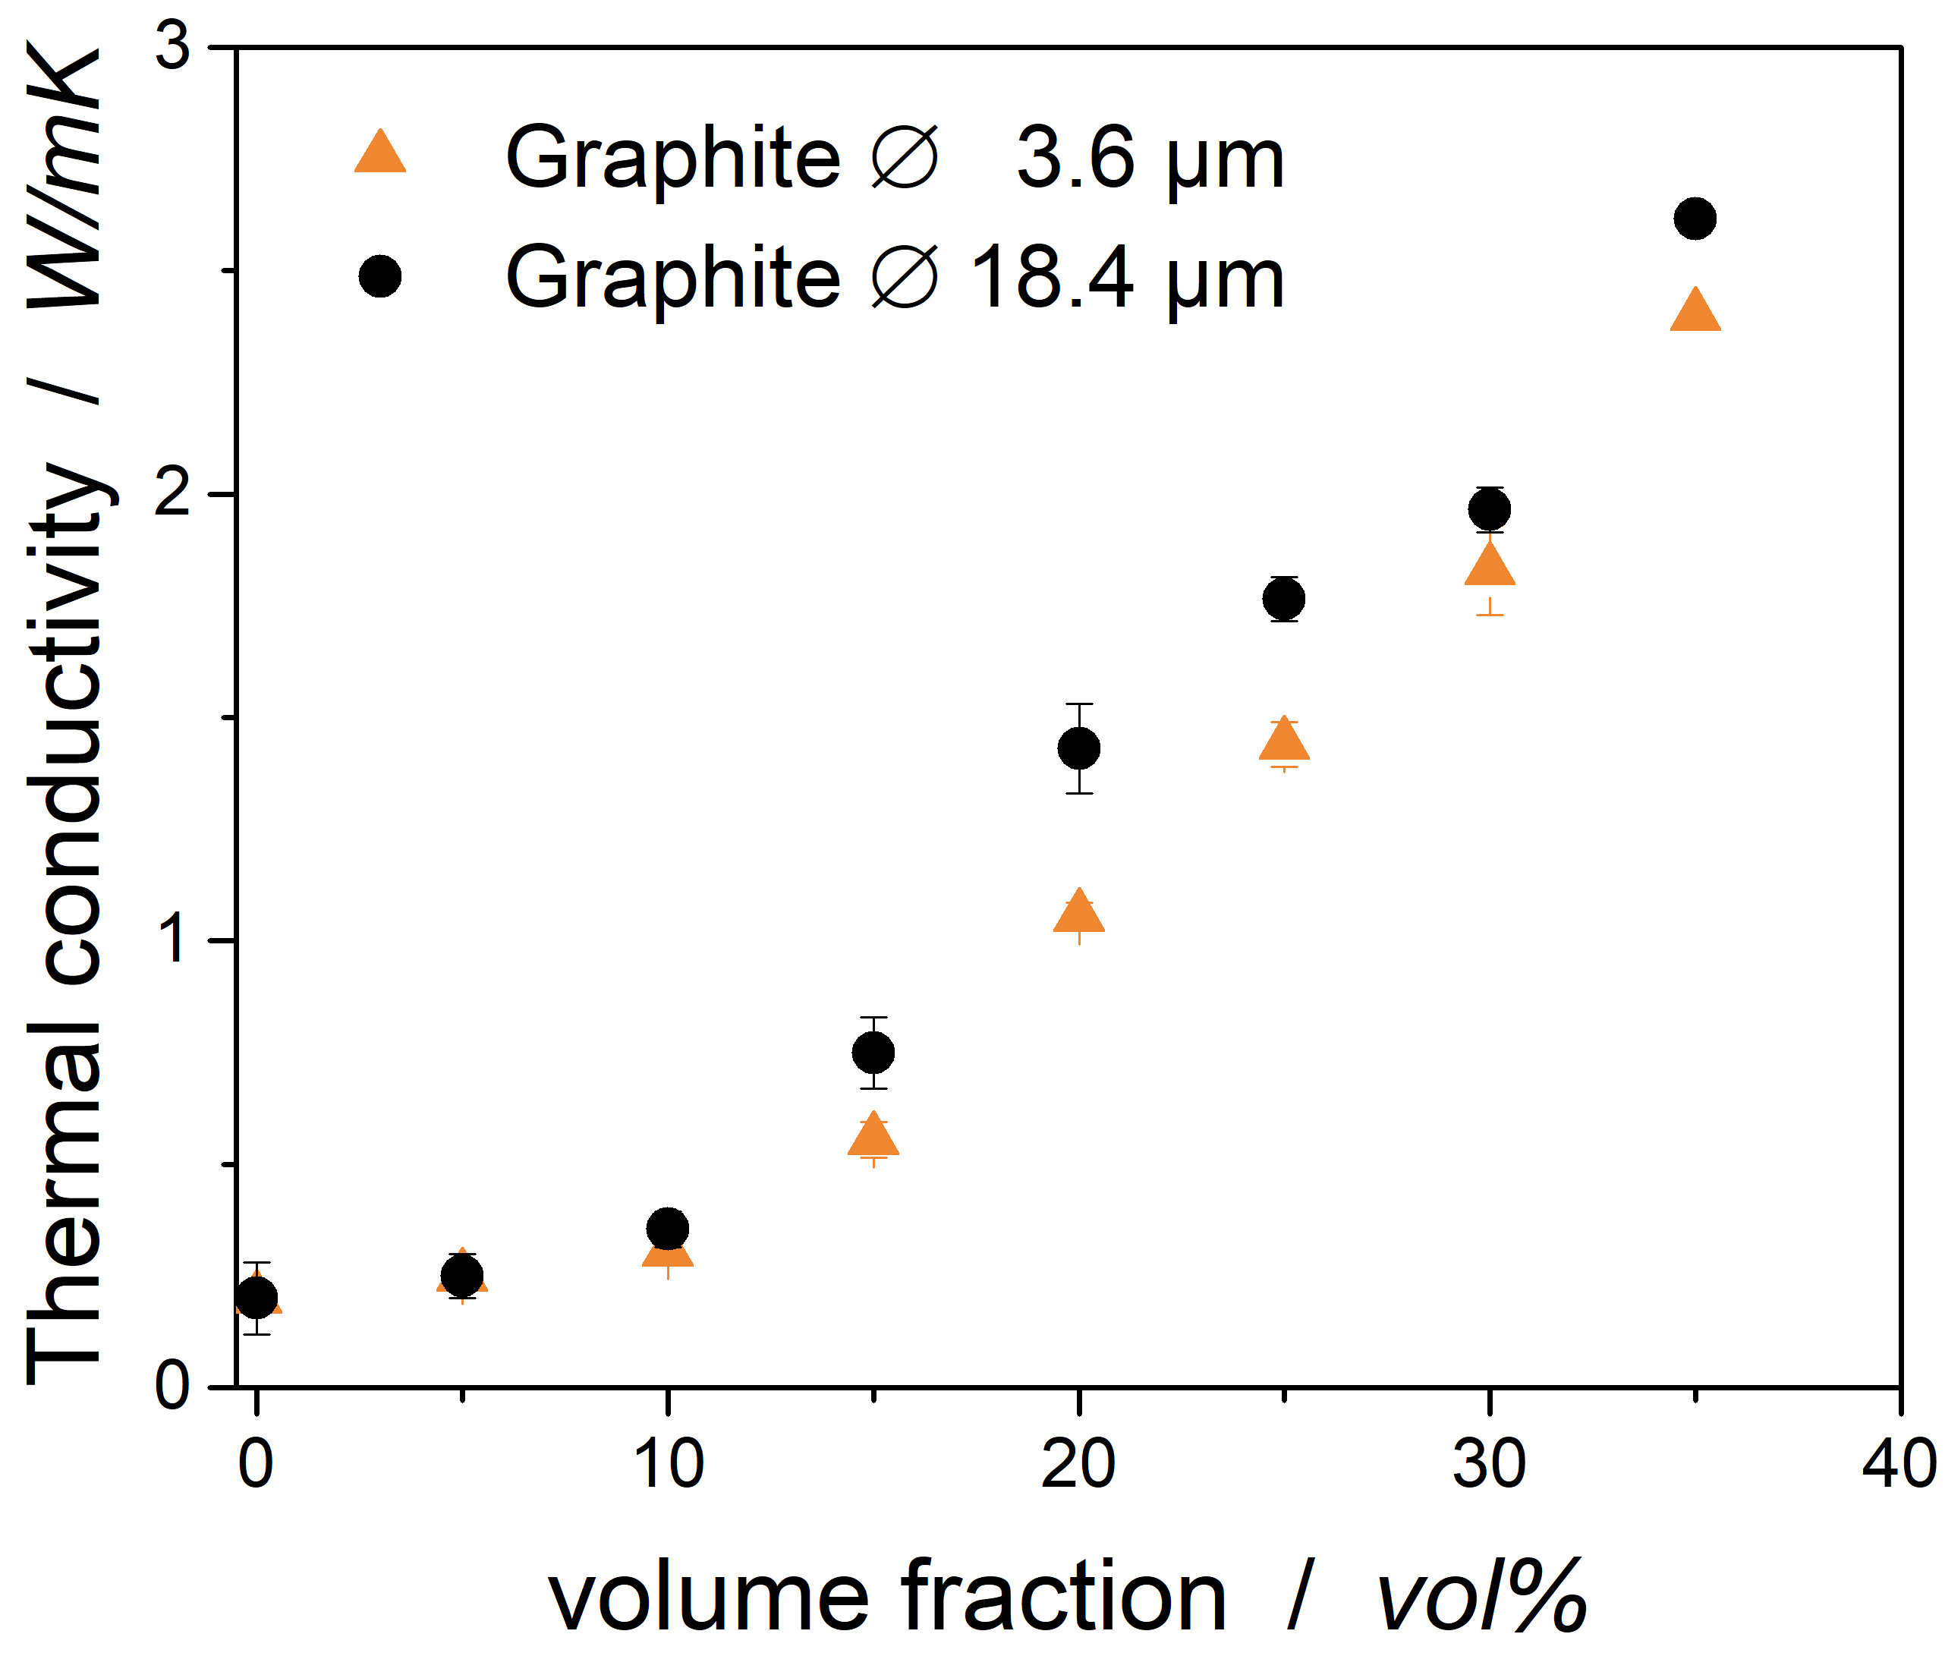 | 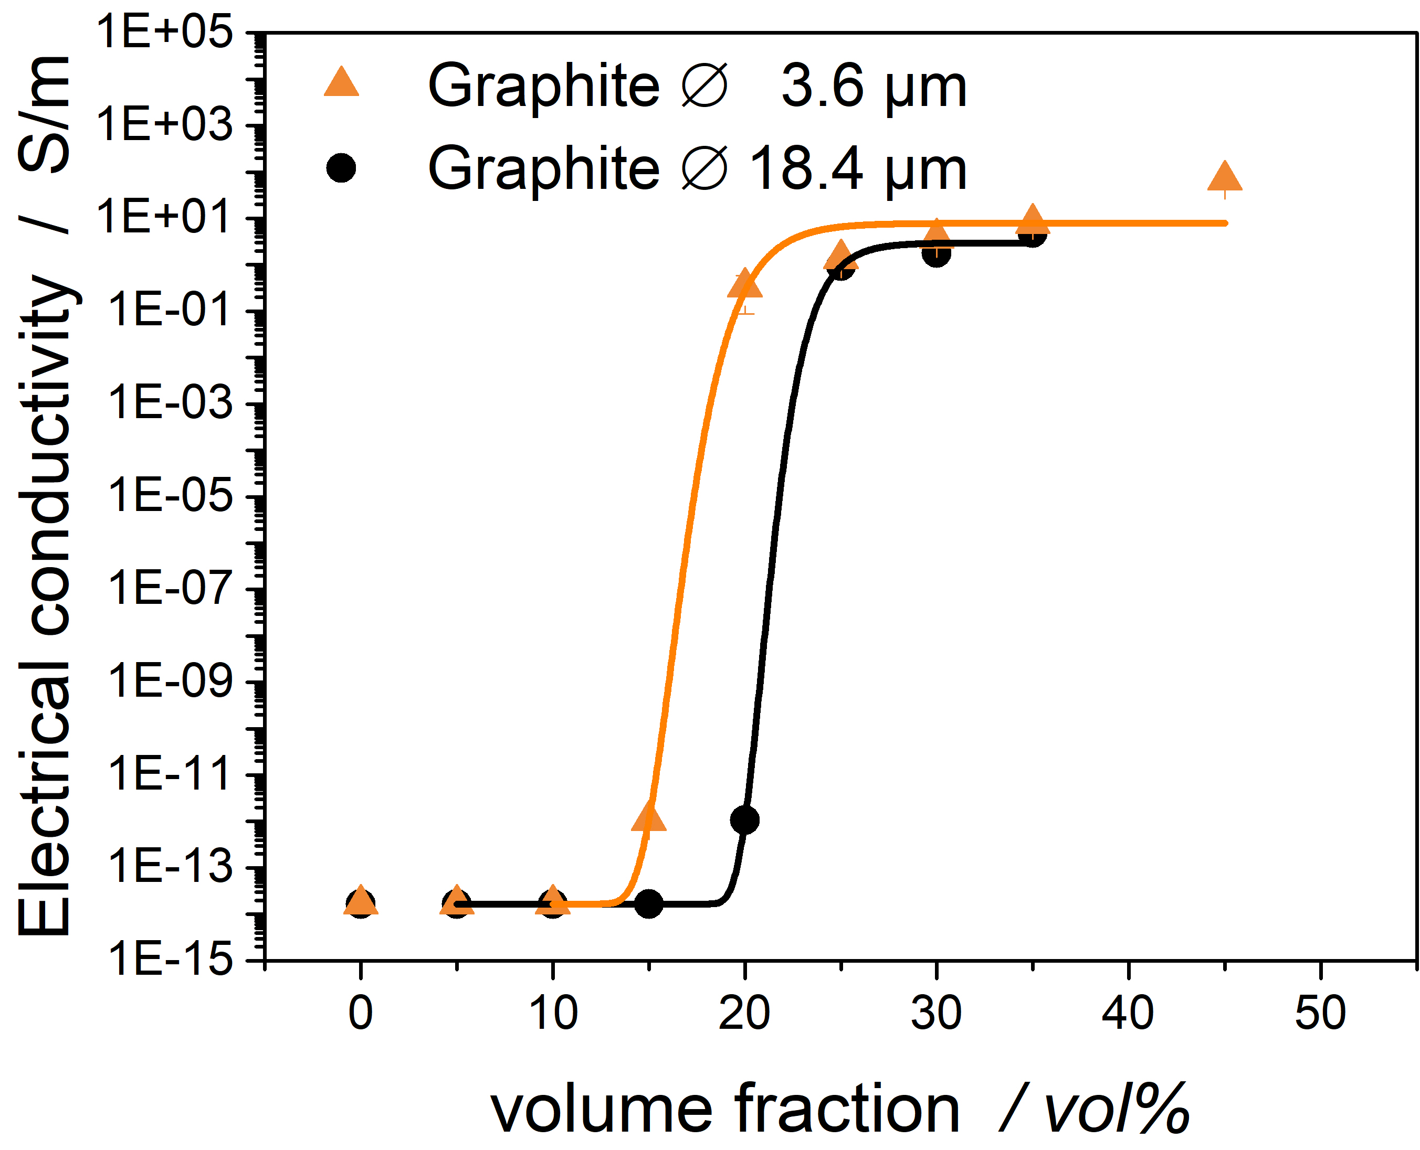
Figure 5: left Thermal conductivity in dependence of filler content, right Electrical conductivity, fitted with equations by Chodák-Krupa

The dependence of electrical conductivity of Graphite/Epoxy composites versus filler volume content is shown in Figure 5 right. A sudden increase could be found at the percolation threshold, where the electric conductivity is increased by several units. At the percolation threshold, an infinite conductive cluster is formed, which enables the electric conductivity of the composite. [22] The values have been fitted by an equation of Chodak and Krupa, as described in their publication. [24] The percolation threshold can be found between 15 and 20 vol% for the small and between 20 and 25 vol% for the bigger graphite particles. The exact percolation threshold calculated by the equations provided by Chodak and Krupa are 16.2 for the composites with small and 20.9 vol% for the composites with bigger particles. As expected, the composites with the smaller particles exhibit a lower percolation threshold. This can be attributed to the higher probability to form a conductive chain, as already described by several researchers. [22,25–28]

Prepreg laminate characterization
As shown by Rolfes, the fiber volume content has an influence on the thermal conductivity, though it remains weak when the conductivity of the fiber is low. [18] To verify the comparability of the samples, the fiber volume content has been measured and calculated by Thermogravimetry. The method is described and verified by Monkiewitsch. [29] As shown in Table 1, the fiber volume content varies only slightly between the samples, so we can expect them to be comparable.

Table 1: Fiber volume content of the produced laminates
Prepreg laminate | Fiber volume content
unfilled | 52 vol%
Graphite ø 18.4 - 10 vol% | 55 vol%
Graphite ø 18.4 - 15 vol% | 53 vol%
Graphite ø 18.4 - 20 vol% | 57 vol%
Graphite ø 3.6 - 15 vol% | 56 vol%

Thermal and electrical conductivity of prepreg laminates
Figure 7 shows the thermal conductivities of the prepreg laminates measured by LFA. The unfilled resin owns a thermal conductivity of 0.2 W/mK, which is increased to 0.36 W/mK by the incorporation of carbon fibers. When the conductive resin with a thermal conductivity of 0.7 W/mK is used for the prepreg production, the conductivity in the laminate increases to 0.91 W/mK for the big particles.

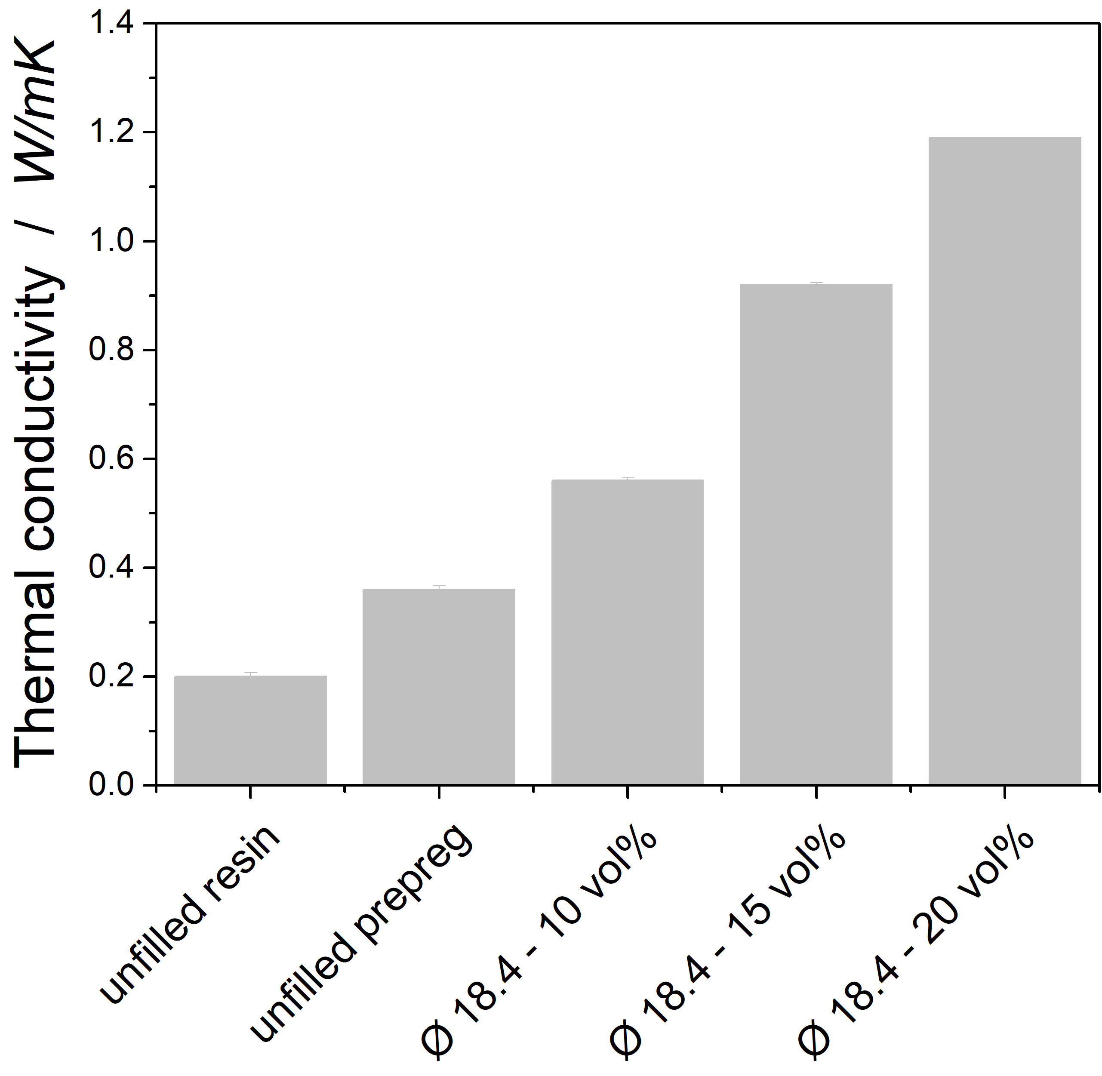 | 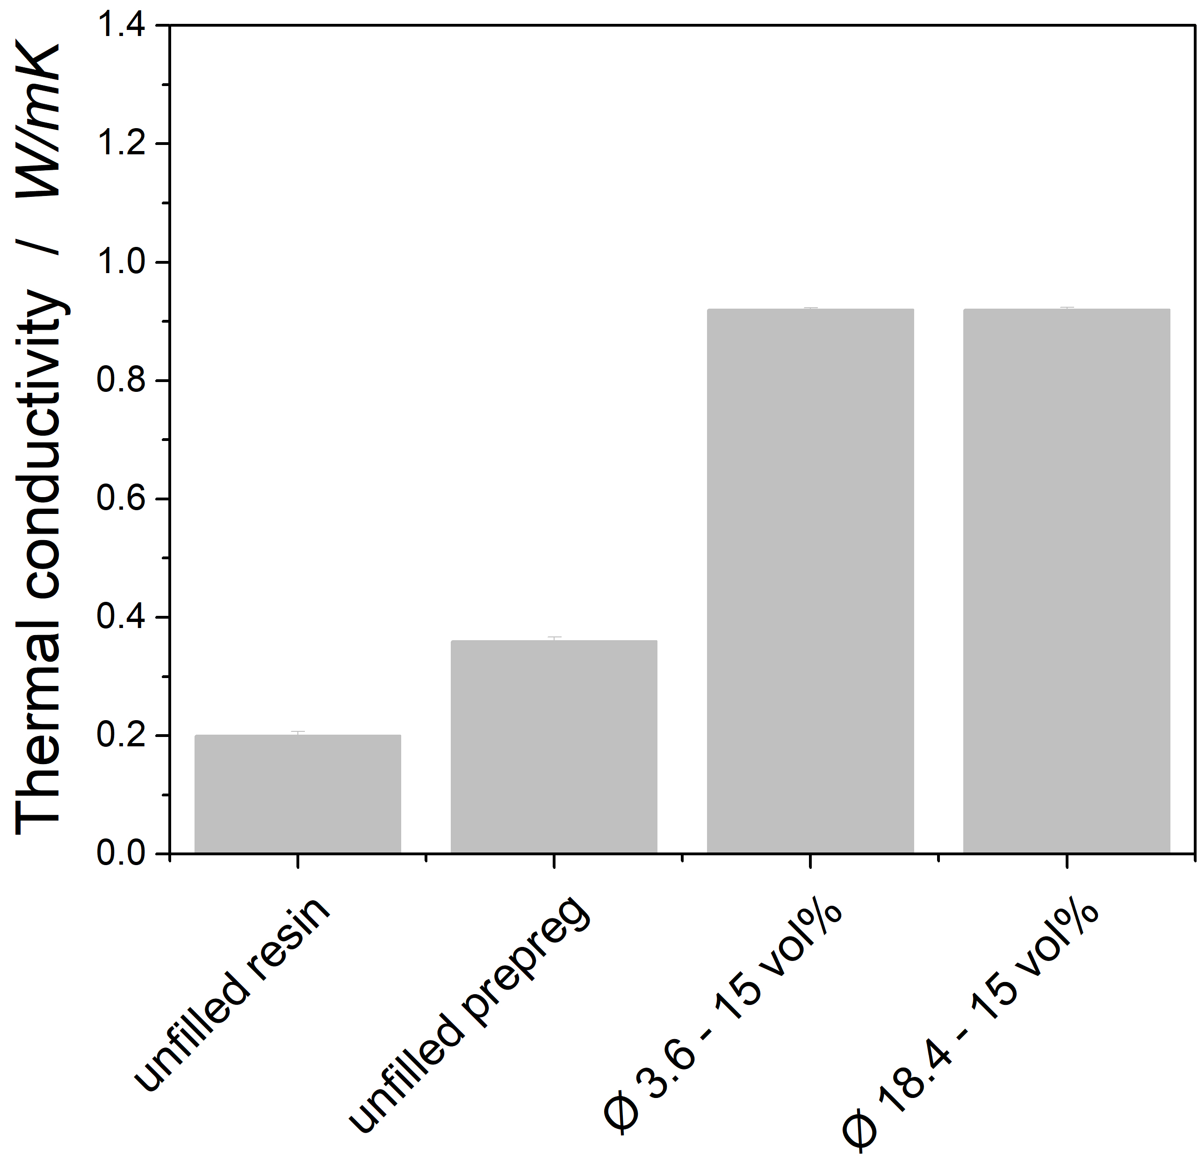
Figure 7: left Dependence of thermal conductivity and big particles, right influence of big and small particles

Although the results from the graphite filled resins without carbon fibers indicate that bigger particles lead to higher conductivities in the composite, the effect could not be repeated with carbon fiber reinforced composites. Figure 7 shows a strong effect of the filler volume content of the laminates on the thermal conductivity, as the conductivity of the laminate significantly increases when the filler content is varied from 10 to 15 and 20 vol%.
The thermal conductivity can be evaluated from a thermodynamical point of view. It is suggested to extend the model introduced by Han and Chung by a third component. It then hold that the thermal resistivity of the laminate $R_{L}$ can be calculated by the addition of the thermal resistivity of the fibers $R_{F},$ the resistivity of the resin $R_{R}$ and the contact resistivity of the interfaces between resin and fiber $R_{I}$:
$$R_{L}=R_{F}+R_{R}+R_{I}$$ | Equ. 1
The calculations of the thermal conductivity of the laminate with graphitic filler follow with the equations by Han and Chung and the thermal conductivity of the filled resin given. The thermal conductivity of the interfaces is then assumed as the differences between resistivity of the laminate and those of the resin and fiber. The results are summarized in Table 2. In the unfilled laminate, so the laminate without graphitic filler, the thermal resistivity has the strongest influence on the resistivity of the laminate. This is represented by a resistivity of 2.25 $*{{10}^{-3} m}^{2}KW^{-1}$, which is eight times higher than the thermal resistivity of the carbon fiber. The thermal resistivity of the resin decreases with higher load of the graphitic filler to 0.35 ${{*10}^{-3} m}^{2}KW^{-1}$ with 20 vol% of graphite. Hereby, the thermal resistivity is only slightly higher than those of the fiber. We can assume that higher filler contents will lead to a weaker increase, as the differences in thermal conductivity of fiber and matrix are then negligible. The resistivity of the interfaces $R_{I}$ can be assumed independent from the filler load. This holds true as the interface resistivity values are close to each other, the average over all $R_{I}$ is represented by 0.252 ± 0.0148 $*{{10}^{-3} m}^{2}KW^{-1}$. The small standard deviation underlines the validity of the thermodynamical considerations.

Table 2: Results from thermodynamical calculations
Prepreg laminate |  |  | $$R_{L}$$  $$m^{2}KW^{-1}$$ | $$R_{R}$$  $$m^{2}KW^{-1}$$ | $$R_{F}$$  $$m^{2}KW^{-1}$$ | $$R_{I}$$  $$m^{2}KW^{-1}$$
unfilled |  | 2.78 10⁻³ |  | 2.25 10⁻³ | 0.275 10⁻³ | 0.253 10⁻³
Graphite ø 18.4 - 10 vol% |  | 1.82 10⁻³ |  | 1.27 10⁻³ | 0.275 10⁻³ | 0.276 10⁻³
Graphite ø 18.4 - 15 vol% |  | 1.11 10⁻³ |  | 0.6 10⁻³ | 0.275 10⁻³ | 0.236 10⁻³
Graphite ø 18.4 - 20 vol% |  | 0.83 10⁻³ |  | 0.35 10⁻³ | 0.275 10⁻³ | 0.244 10⁻³

The electric conductivity of the laminates is shown in Figure 8. The unfilled resin can be characterized by a strong electric resistance, while the laminate without graphitic filler already exhibits an electric conductivity above the percolation threshold, of 0.02 S/m. The incorporation of filler increases the electric conductivity by roughly two units, to up to 1.4 S/m for the laminate with 15 vol% of the graphitic filler. As the conductivities are already well above the percolation threshold, the electric resistance seems to be mainly influenced by the contact resistance of the composites.

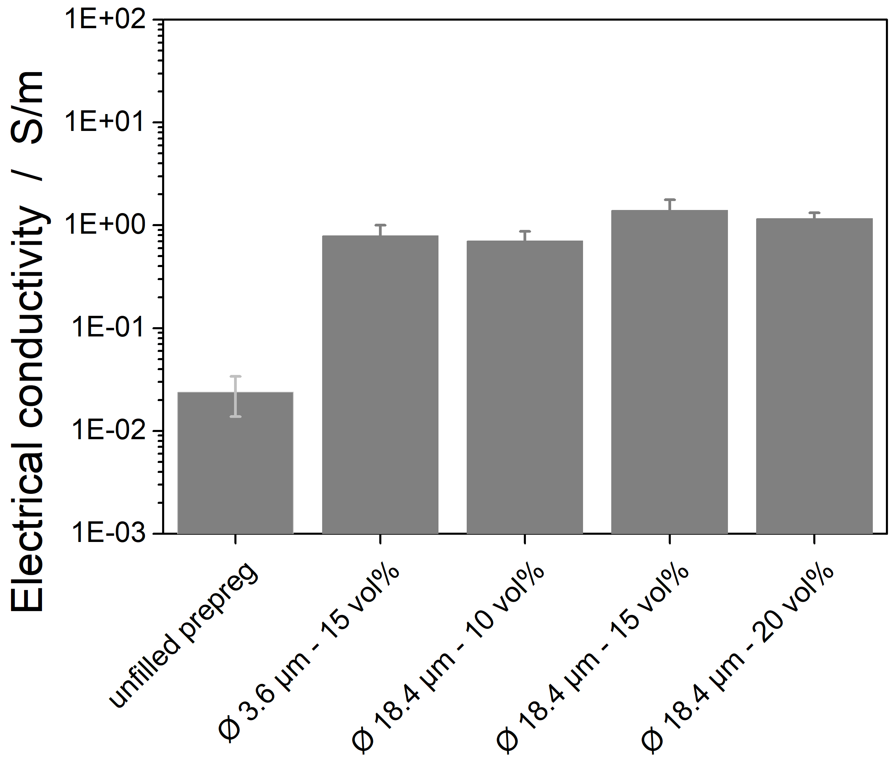
Figure 8: Electric conductivity of prepreg laminates

Conclusion
The aim of the underlying research is to show the influence of a conductive matrix on the thermal and electrical conductivity of carbon-fiber reinforced prepregs. A special focus was laid on the influence of small and big particles.
The following conclusions can be drawn from the analysis of the results:
- In an epoxy resin, bigger graphite particles of 18.4 µm lead to a higher increase in thermal conductivity as smaller particles of 3.6 µm, which could be explained by lower phonon scattering due to less interfaces.
- The epoxy samples with lower particle size lead exhibit smaller percolation threshold due to smaller distances between the particles. After the percolation threshold, no significant differences could be found between composites with small and big particles.
- In the carbon fiber reinforced composites, the thermal conductivity was enhanced by the factor 4 with 20 vol% of graphitic particles. The thermodynamic analysis showed a major influence of the resin matrix at lower filler contents, owing to a thermal resistivity which is five times higher than the resistivity of the carbon fibers. At higher filler load level, the thermal resistivity of resin (0.35 ${{*10}^{-3} m}^{2}KW^{-1}$ and fibers (0.275 ${{*10}^{-3} m}^{2}KW^{-1}$) are very close to each other.
- The graphitic filler enhanced the electric conductivity in the CFRP by two units with no significant influence of the filler content variation between 10 and 20 vol% or the size of the filler.
Further developments are needed to understand the influence of the fiber on the thermal conductivity. As stated above, no measurement method has been developed so far to measure the conductivity of carbon fibers. For a further increase in the thermal conductivity, conductive fibers might be used. Besides, a deeper understanding of the mechanical properties of CFRP is crucial for the application of the materials in the industry.

Acknowledgements
Authors kindly thank to the German Ministry of Economy and Energy (BMWi) for the foundation of the Lufo Project TELOS (FKZ 20Y1516D).

References
[1] Scelsi L, Bonner M, Hodzic A, Soutis C, Wilson C, Scaife R et al. Potential emissions savings of lightweight composite aircraft components evaluated through life cycle assessment. Express Polym. Lett. 2011;5(3):209–17.
[2] Tong XC. Advanced Materials for Thermal Management of Electronic Packaging. 1st ed. New York, NY: Springer Springer Science+Business Media LLC; 2011.
[3] Burger N, Laachachi A, Ferriol M, Lutz M, Toniazzo V, Ruch D. Review of thermal conductivity in composites: Mechanisms, parameters and theory. Progress in Polymer Science 2016;61:1–28.
[4] Goyal V, Balandin AA. Thermal properties of the hybrid graphene-metal nano-micro-composites: Applications in thermal interface materials. Appl. Phys. Lett. 2012;100(7):73113.
[5] Thostenson ET, Chou T-W. Processing-structure-multi-functional property relationship in carbon nanotube/epoxy composites. Carbon 2006;44(14):3022–9.
[6] Sumfleth J, Adroher XC, Schulte K. Synergistic effects in network formation and electrical properties of hybrid epoxy nanocomposites containing multi-wall carbon nanotubes and carbon black. J Mater Sci 2009;44(12):3241–7.
[7] Yu A, Itkis ME, Bekyarova E, Haddon RC. Effect of single-walled carbon nanotube purity on the thermal conductivity of carbon nanotube-based composites. Appl. Phys. Lett. 2006;89(13):133102.
[8] Tekce HS, Kumlutas D, Tavman IH. Effect of Particle Shape on Thermal Conductivity of Copper Reinforced Polymer Composites. Journal of Reinforced Plastics and Composites 2007;26(1):113–21.
[9] Hammerstroem DW, Burgers MA, Chung SW, Guliants EA, Bunker CE, Wentz KM et al. Aluminum nanoparticles capped by polymerization of alkyl-substituted epoxides: ratio-dependent stability and particle size. Inorganic chemistry 2011;50(11):5054–9.
[10] Ng HY, Lu X, Lau SK. Thermal conductivity of boron nitride-filled thermoplastics: Effect of filler characteristics and composite processing conditions. Polym. Compos. 2005;26(6):778–90.
[11] Hong J-P, Yoon S-W, Hwang T, Oh J-S, Hong S-C, Lee Y et al. High thermal conductivity epoxy composites with bimodal distribution of aluminum nitride and boron nitride fillers. Thermochimica Acta 2012;537:70–5.
[12] Bauhofer W, Kovacs JZ. A review and analysis of electrical percolation in carbon nanotube polymer composites. Composites Science and Technology 2009;69(10):1486–98.
[13] Wu Y, Yu Z. Thermal conductivity of in situ epoxy composites filled with ZrB2 particles. Composites Science and Technology 2015;107:61–6.
[14] Liu K, Takagi H, Osugi R, Yang Z. Effect of physicochemical structure of natural fiber on transverse thermal conductivity of unidirectional abaca/bamboo fiber composites. Composites Part A: Applied Science and Manufacturing 2012;43(8):1234–41.
[15] Hong, J. P., Yoon, S. W., Hwang, T. S., Lee, Y. K., Won, S. H., & Nam, J. D. Interphase control of boron nitride/epoxy composites for high thermal conductivity. Korea-Australia Rheology Journal 2010;22(4):259–64.
[16] Ding Y, Alias H, Wen D, Williams RA. Heat transfer of aqueous suspensions of carbon nanotubes (CNT nanofluids). International Journal of Heat and Mass Transfer 2006;49(1-2):240–50.
[17] McDermott V. Research acitivities on nano-materials and electromagnetic procection of composite aeronautical structures.
[18] Rolfes R. Transverse thermal conductivity of CFRP laminates: A numerical and experimental validation of approximation formulae. Composites Science and Technology 1995;54(1):45–54.
[19] Han S, Chung DDL. Increasing the through-thickness thermal conductivity of carbon fiber polymer matrix composite by curing pressure increase and filler incorporation. Composites Science and Technology 2011;71(16):1944–52.
[20] Agari Y, Tanaka, M., Nagai, S., Tanaka M, Nagai S, Uno T. Thermal conductivity of a polymer composite filled with mixtures of particles. J. Appl. Polym. Sci. 1987;34(4):1429–37.
[21] Garret KW, Rosenberg HM. The thermal conductivity of epoxy-resin /powder composite materials. Journal of Applied Phyics;1974.
[22] Boudenne A, Ibos L, Fois M, Majesté JC, Géhin E. Electrical and thermal behavior of polypropylene filled with copper particles. Composites Part A: Applied Science and Manufacturing 2005;36(11):1545–54.
[23] Zhu BL, Ma J, Wu J, Yung KC, Xie CS. Study on the properties of the epoxy-matrix composites filled with thermally conductive AlN and BN ceramic particles. J. Appl. Polym. Sci. 2010;118(5):2754–64.
[24] Chodak I, Krupa I. Percolation effect and mechanical behavior of carbon black filled polyethylene Polymer. Journal of Materials Science Letters 1999;18(18):1457–9.
[25] Mamunya YP, Davydenko VV, Pissis P, Lebedev EV. Electrical and thermal conductivity of polymers filled with metal powders. European Polymer Journal 2002;38(9):1887–97.
[26] Novák I, Krupa I. Electro-conductive resins filled with graphite for casting applications. European Polymer Journal 2004;40(7):1417–22.
[27] Novák I, Krupa I, Chodák I. Analysis of correlation between percolation concentration and elongation at break in filled electroconductive epoxy-based adhesives. European Polymer Journal 2003;39(3):585–92.
[28] Bigg DM. Thermal conductivity of heterophase polymer compositions;119:1–30.
[29] Monkiewitsch M. Faservolumengehaltsbestimmung mittels thermogravimetrischer Analyse (TGA); 2018.

