Elliptic Paraboloid Flow Front Modelling for
In-Plane Permeability Characterization of
Textile Fabrics by the Radial Flow Technique

E. Fauster¹, D. C. Berg², D. May³, A. Endruweit⁴, Y. Blößl¹, R. Schledjewski¹

¹Processing of Composites Group, Department Polymer Engineering and Science,
Montanuniversitaet Leoben, Leoben, Austria, ewald.fauster@unileoben.ac.at
²Department of Polymer Materials and Plastics Engineering,
Clausthal University of Technology, Clausthal-Zellerfeld, Germany
³Institut für Verbundwerkstoffe GmbH, Kaiserslautern, Germany
⁴University of Nottingham, Faculty of Engineering, Nottingham, UK

Keywords: Liquid Composite Moulding, In-Plane Permeability Characterization, Radial Flow Method, Geometry Model Fitting

Abstract
This work addresses a novel approach for modelling the temporally advancing fluid flow front in radial flow experiments. In particular, fitting of an elliptic paraboloid model is suggested to model the entirety of flow front sensor data collected throughout radial flow experiments in a single step approach. The shape of the fluid flow front at a specific point in time during the radial flow experiment is known to be elliptic as permeability is represented by a symmetric second order tensor. The dimensions of the temporally advancing flow front shows a parabolic nature as was empirically justified by the authors in a recent work. This leads to fitting an elliptic paraboloid model to the flow front data collected throughout the radial flow experiment. The newly proposed ‘elliptic paraboloid’ method allows for a direct computation of the in-plane degree of anisotropy, i.e. the ratio of minor and major principal in-plane permeability values, from the model parameters. This significantly simplifies the subsequent computation of anisotropic permeability data. In addition, the approach adds robustness to the analysis of temporally or spatially incomplete sets of flow front data. The applicability of the method is demonstrated on flow front data acquired with different types of sensors.

1. Introduction

In liquid composite moulding (LCM), dry preforms of reinforcing fabrics are placed in a mould and impregnated with a liquid polymer matrix material. Impregnation quality plays a key role as insufficiently saturated regions directly affect the mechanical properties of the finished composite part. The actual impregnation process involves flow of viscous fluids (the liquid polymer matrix) in porous media (the fibrous reinforcing structure), as well as fibre-liquid interactions such as fibre wetting or swelling [1–4]. Modelling of these aspects results in mathematically complex relations, which in general cannot be solved analytically. For a selection of geometrically simple flow problems though, specific analytic solutions exist. In the given context, the flow of viscous fluids in fibrous media can be described by means of Darcy’s law [5], which is commonly presented as a relation between the phase-averaged flow velocity $v$ and the driving pressure gradient$∇p$, which can be reproduced as:
$$v=-\frac{1}{η}K∇p,$$ | (1)
with the dynamic fluid viscosity $η$ as well as the permeability tensor $K$.
Neuman [6] reported a derivation of Darcy’s law from the Navier-Stokes equations involving the following set of assumptions: (i) incompressible and (ii) isothermal flow of a (iii) viscous fluid with Newtonian characteristics through (iv) saturated porous media with (v) homogeneous porosity in (vi) laminar flow regimes and (vii) neglecting the impact of gravity. Although assumptions (ii) and (iv) are quite often not met in LCM processes, reported observations suggest that Darcy’s law can still be applied with reasonable accuracy [7]. Despite its mathematical simplicity, this explains its popularity in the composite processing community.

For the characterization of unsaturated in-plane permeability of reinforcing materials, the channel flow and radial flow techniques are most prominent. The channel flow method is based on one-dimensional fluid flow through the reinforcing structure. It shows two major disadvantages:
- Race tracking [8] is very likely to appear in gaps along the side edges of the material, deteriorating the rectilinear flow front advancement. Thus, specific care needs to be taken when preparing the experiments, typically by sealing the preform material at the side walls of the characterization cell [9–11].
- Three experiments are required to fully characterize the in-plane permeability tensor. Thus, the number of experiments increases the testing effort compared to the radial flow method, even when ‘multi-cavity parallel flow cells’ are used [12–15].
In-plane permeability characterization by the radial flow technique is based on two-dimensional fluid flow through the reinforcing structure. It avoids race tracking issues by nature, allows to fully characterize the in-plane permeability tensor from a single experiment and basically involves three major aspects: (1) flow front tracking by acquisition of specific sensor data during the actual experiment, (2) flow front modelling by processing the sensor data to determine temporal characteristics of flow front advancement and (3) calculation of the permeability tensor entries according to specifically developed mathematical algorithms. The paper at hand concentrates on the aspect of modelling flow front data acquired during radial flow experiments. In a recent work published by the authors [16], it was shown empirically that the temporal advancement of the fluid flow front in radial flow experiments can be well approximated by means of a parabolic model. In combination with the knowledge about the elliptic characteristics [17] of the flow front shape in experiments on anisotropic materials, this allows to fit an elliptic paraboloid model to the flow front data in a combined time-space-coordinate system as shown in Figure 1.

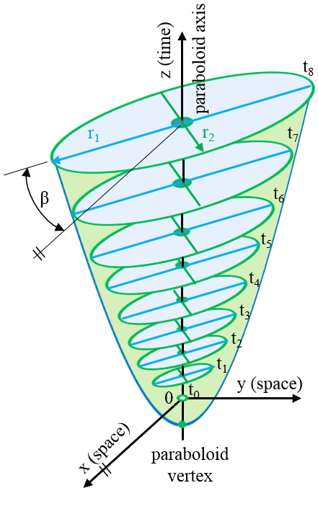
Figure 1: Schematic of an elliptic paraboloid fitted to the temporally advancing fluid flow front [16].

2. Experimental Work

The applicability of the method is demonstrated on flow front data acquired with different types of sensors mounted in permeability characterization cells of four European research institutions:
- quasi-continuous flow front data from sequence images evaluated by digital image processing techniques at the Processing of Composites Group (LVV) at Montanuniversität Leoben (Austria) and the Department of Polymer Materials and Plastics Engineering (PuK) at Clausthal University of Technology (Germany) as shown in Figure 2 and Figure 3, respectively,
- sensor saturation data of linear capacitive sensors in a permeameter of the Institut für Verbundwerkstoffe (IVW) in Kaiserslautern (Germany) as depicted in Figure 4 (left) and
- flow arrival times derived from pressure point sensors in a permeability characterization cell of the University of Nottingham (UK) as shown in Figure 4 (right).

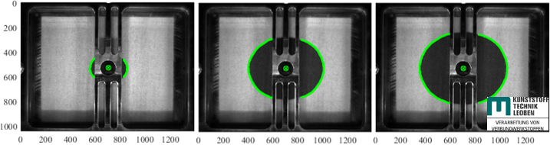

Figure 2: Measurement images and flow front data from the optical permeameter systems at LVV.

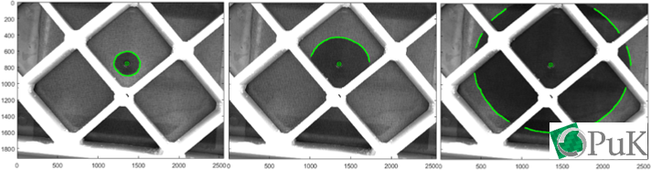

Figure 3: Measurement images and flow front data from the optical permeameter systems at PuK.
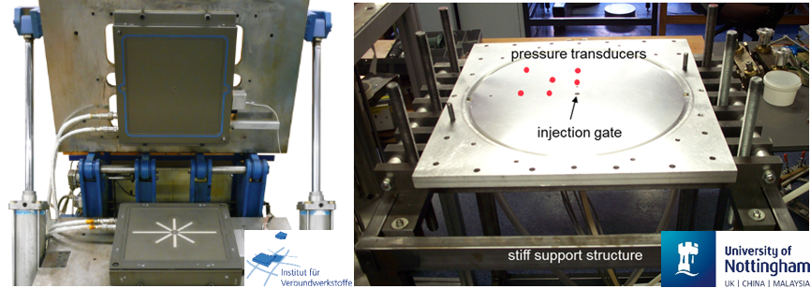

Figure 4: In- plane permeability characterization cells based on linear capacivite sensors (left) and pressure point sensors (right).

In the past, various algorithms have been developed for evaluating the acquired flow front data. They are applicable to specific sensing strategies and the corresponding data. The approach of Weitzenböck et al. [18,19] was introduced for evaluating flow arrival time data derived from pressure or electrical point sensors. The most prominent methods developed for characterization cells based on optical systems, such as those of Adams et al. [20], Chan and Hwang [21] as well as Carter et al. [22] are all based on a ‘step-wise ellipse fitting’ approach, where a set of data points along the flow front is modelled by an ellipse at each point of time during the experiment.

By contrast, the ‘elliptic paraboloid’ method proposed by the authors allows for the evaluation of all types of such data and thus, provides a uniform approach for evaluating flow front data acquired in radial flow experiments. Due to space limitations in this paper, the basic procedure of the method is just briefly revised here:
- in a combined time-space-coordinate frame as shown in Figure 1, a type-specific elliptic paraboloid model is fitted to the entirety of flow front data collected during the experiment,
- by application of principal component analysis, the orientation angle $β$ of the major axis of the cross-sectional ellipse with respect to the x-axis is determined,
- rotation of the paraboloid by the angle $β$ ensures alignment of the model with the coordinate frame and allows for the derivation of the major and minor intersecting parabolae,
- the in-plane degree of anisotropy can now be analytically computed from the parabolae parameters and
- the principal in-plane permeability values are finally computed following the method reported by Adams et al. [20].

3. Results and Discussion

Figure 5 shows elliptic paraboloid models fitted to flow front data from optically tracked radial flow experiments on two different, exemplarily chosen materials conducted at LVV and PuK, respectively.

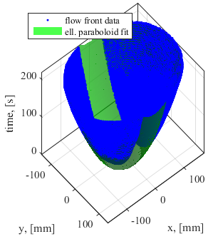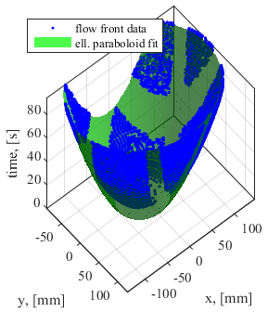

Figure 5: Elliptic paraboloid models fitted to flow front data from optically tracked radial flow experiments at LVV (left) and PuK (right).

Figure 6 (left) shows saturation data acquired with linear capacitive sensors in the characterization cell at IVW and Figure 6 (right) visualizes flow arrival time data captured with pressure point sensors in the cell at University of Nottingham. Both data sets were acquired on different materials and are shown together with the elliptic paraboloid models fitted to the data.

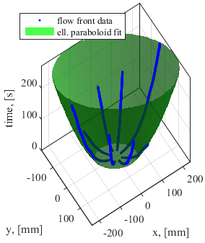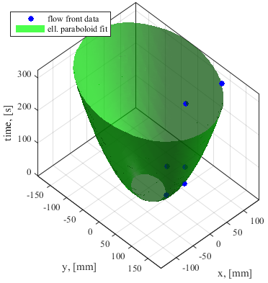

Figure 6: Elliptic paraboloid models fitted to flow front data acquired with linear capacitive sensors at IVW (left) as well as to flow arrival time data acquired with a cell at University of Nottingham (right).
Obviously, temporal and spatial availability of flow front data during the radial flow experiments strongly depends on the design of the permeability characterization cell as well as the particular type of sensors used for tracking the flow front:
- in cells based on optical systems, the flow front is temporally occluded by the mechanical elements used to increase the structural stiffness of the optically transparent part of the mould, e.g. the bar and cross-beam structure visible in Figure 2 and Figure 3, respectively,
- the test rig equipped with linear capacitive sensors shows limitations in the spatial traceability of the flow front as a result of the limited number of sensors as well as temporal limitations as the flow front can just be tracked along the finite length of a particular sensor and
- the in-plane permeability characterization cell with the pressure point sensors allows for the derivation of a distinct set of flow arrival times, the number of data points being limited to the number of sensors.

As a result, the total set of flow front data is incomplete to some degree as can be seen in Figure 5 and Figure 6, respectively. The proposed method of fitting the elliptic paraboloid model however, is capable of robustly handling this aspect. The validity of the ‘elliptic paraboloid method’ has already been verified by the authors as reported in [16]. There, data sets from radial flow experiments tracked by optical means as well as linear capacitive sensors have been evaluated and the results obtained have been compared to those of the conventional ‘stepwise ellipse fitting method’. In this work, the applicability of the method for evaluating sets of flow arrival time data is studied. For this purpose, a virtual radial flow experiment as well as a set of real experiments were evaluated. The virtual flow experiment was realized by running a flow simulation in PAM-RTM® on a flat plate geometry representing a fibrous preform of known in-plane permeability. The pressure point sensors were represented by virtual sensors in the simulation model and the fluid pressure characteristics at the sensor positions were evaluated to derive flow arrival time data. As with the data from the real experiments, these were finally processed towards in-plane permeability values k₁ and k₂ as well as the orientation angle $β$ according to (a) the method of Weitzenböck et al. [18,19] and (b) the newly proposed ‘elliptic paraboloid method’. Table 1 summarizes the results obtained for this analysis.

Table 1. Comparison of in-plane permeability values calculated from flow arrival time data derived from pressure point sensor characteristics in radial flow experiments.

Experi-ment number | Material | Weitzenböck / elliptic paraboloid method
 |  | k₁  [10⁻¹⁰ m²] | k₂  [10⁻¹⁰ m²] | $$β$$  [°]
1 | virtual experiment  (filling simulation) | 0.50 (input)  0.49 / 0.50 | 0.08 (input)  0.08 / 0.11 | 90 (input)  91 / 89
2 | orthogonal weave 3D carbon fibre fabric | 2.87 / 1.60 | 0.60 / 0.56 | -1 / 5
3 | twill weave glass fibre fabric | 0.53 / 0.57 | 0.31 / 0.32 | 93 / 99
4 | ± 45° glass fibre non crimp fabric | 0.20 / 0.24 | 0.16 / 0.16 | 111 / 122

Analysing the results obtained for the virtual experiment, a high level of conformity with the input data of the simulation model was found and the results of the ‘elliptic paraboloid method’ are well comparable to those obtained with the conventional method. Evaluation of the real experiments reveals highly comparable results as well with the only exemption being the data of the orthogonal weave (experiment number 2). This is most likely related to the high level of anisotropy inherent to this specific material, which is not reflected in the elliptic paraboloid model fitted to the data as a result of the low number of data points used for the fit. This in turn might cause the deviations in the results. This effect will be subject to future investigations in order to elaborate strategies for further improvement.

4. Summary and Conclusions

The present paper addresses a newly introduced method for modelling the flow front data collected during radial flow experiments for in-plane permeability characterization of reinforcing fibrous materials. This newly proposed ‘elliptic paraboloid method’ shows a number of advantages over conventional methods:
- The method is based on fitting an elliptic paraboloid to the entirety of flow front data collected during the experiment. Thus, it uses all of the available measurement data for the model fitting process.
- It allows for a direct computation of the in-plane degree of anisotropy, i.e. the ratio of minor and major principal in-plane permeability values, from the model parameters. As a result, this significantly simplifies the subsequent computation of anisotropic permeability data.
- The method can be uniformly applied to flow front data acquired with different types of sensors:
  - quasi-continuous flow front data as obtained from optically tracked radial flow experiments,
  - linear saturation data captured with linear capacitive sensors and
  - flow arrival time data as derived from pressure or electric point sensors.

The validity of this method was verified in a recent work of the authors on flow front data acquired by optical means as well as linear capacitive sensors. The paper at hand provides an extension of that work in terms of a successful study on the applicability of the method for evaluating flow arrival time data derived from pressure point sensors.

Acknowledgments

The authors kindly acknowledge the financial support through project MoVeTech (project no. 850466) provided by the Austrian Ministry for Transport, Innovation and Technology within the frame of the FTI initiative “TakeOff”, which is administered by the Austria Research Promotion Agency (FFG).

References
[1] J. Bear, Dynamics of fluids in porous media, Dover, New York, 1988.
[2] M. S. Rouhi, M. Wysocki and R. Larsson. Holistic modeling of composites manufacturing using poromechanics. Advanced Manufacturing: Polymer & Composites Science, 2:14–26, 2016.
[3] V. Michaud. A Review of Non-saturated Resin Flow in Liquid Composite Moulding processes. Transport in Porous Media, 115:581–601, 2016.
[4] K. M. Pillai. Modeling the Unsaturated Flow in Liquid Composite Molding Processes: A Review and Some Thoughts. Journal of Composite Materials, 38:2097–2118, 2004.
[5] Henry Darcy, Les fontaines publiques de la ville de Dijon: Exposition at application des principes a suivre et des formules a employer dans les questions de: Distribution d'eau ouvrage terminé par un appendice relatif aux fournitures d'eau des plusieurs villes au filtrage des aux et a la fabrication des tuyeaux de fonte, de plomb, de tole et de bitume, Victor Dalmont, Libraire des Corps imperiaux des ponts et chaussées et des mines, Paris, 1856.
[6] S. P. Neuman. Theoretical Derivation of Darcy's Law. Acta Mechanica, 25:153–170, 1977.
[7] M. Neitzel and P. Mitschang, eds., Handbuch Verbundwerkstoffe: Werkstoffe, Verarbeitung, Anwendung, Hanser, München, 2004.
[8] S. Bickerton and S. G. Advani. Characterization and modeling of race-tracking in liquid composite molding processes. Composites Science and Technology, 59:2215–2229, 1999.
[9] D. C. Berg, M. Dickert, D. Meiners and G. Ziegmann. Key Factors Causing Scatter in Permeability Measurements. Proceedings of TexComp 2013, Leuven, Belgium, 2013.
[10] S. Bickerton, E. M. Sozer, P. Šimácek and S. G. Advani. Fabric structure and mold curvature effects on preform permeability and mold filling in the RTM process. Part II. Predictions and comparisons with experiments. Composites Part A: Applied Science and Manufacturing, 31:439–458, 2000.
[11] S. Bickerton, E. Sozer, P. Graham and S. Advani. Fabric structure and mold curvature effects on preform permeability and mold filling in the RTM process. Part I. Experiments. Composites Part A: Applied Science and Manufacturing, 31:423–438, 2000.
[12] B. R. Gebart and P. Lidström. Measurement of in-plane permeability of anisotropic fiber reinforcements. Polymer Composites, 17:43–51, 1996.
[13] T. S. Lundström, B. R. Gebart and E. Sandlund. In-Plane Permeability Measurements on Fiber Reinforcements by the Multi-Cavity Parallel Flow Technique. Polymer Composites, 20:146–154, 1999.
[14] T. Lundström, R. Stenberg, R. Bergström, H. Partanen and P. Birkeland. In-plane permeability measurements: a nordic round-robin study. Composites Part A: Applied Science and Manufacturing, 31:29–43, 2000.
[15] R. Meier, A. Walbran, C. Hahn, S. Zaremba and K. Drechsler. Methods to Determine the Permeability of Textile Reinforcements. Journal of Plastics Technology, 27, 2014.
[16] E. Fauster, D. C. Berg, D. May, Y. Blößl and R. Schledjewski. Robust Evaluation of Flow Front Data for In-Plane Permeability Characterization by Radial Flow Experiments. Advanced Manufacturing: Polymer & Composites Science, 24–40, 2018.
[17] A. C. Liakopoulos. Darcy's Coefficient of Permeability as Symmetric Tensor of Second Rank. International Association of Scientific Hydrology. Bulletin, 10:41–48, 1965.
[18] J. Weitzenböck, R. Shenoi and P. Wilson. Radial flow permeability measurement. Part A: Theory. Composites Part A: Applied Science and Manufacturing, 30:781–796, 1999.
[19] J. Weitzenböck, R. Shenoi and P. Wilson. Radial flow permeability measurement. Part B: Application. Composites Part A: Applied Science and Manufacturing, 30:797–813, 1999.
[20] K. L. Adams, W. Russel and L. Rebenfeld. Radial penetration of a viscous liquid into a planar anisotropic porous medium. International Journal of Multiphase Flow, 14:203–215, 1988.
[21] A. W. Chan and S.-T. Hwang. Anisotropic in-plane permeability of fabric media. Polymer Engineering and Science, 31:1233–1239, 1991.
[22] E. J. Carter, A. W. Fell and J. Summerscales. A simplified model to calculate the permeability tensor of an anisotropic fibre bed. Composites Manufacturing, 6:228–235, 1995.

