**Comparative study of orthogonal decomposition of surface deformation in composite automotive panel**

K. Dvurecenska1, E. Hack2, G. Lampeas3, T. Siebert4 and E. Patterson5

1School of Engineering, University of Liverpool, Brownlow Hill, Liverpool, UK

Email: ksenija.dvurecenska@liverpool.ac.uk, Web Page: https://www.liverpool.ac.uk/engineering/staff/ksenija-dvurecenska/research/

2Empa, Ueberlandstrasse 129, Dubendorf 8600, Switzerland

Email: erwin.hack@empa.ch

3Athena Research and Innovation Center in Information Communication & Knowledge Technologies, Artemidos 6 Kai Epidavrou, Maroussi 151 25, Greece.

Email: labeas@isi.gr

4Dantec Dynamics GmbH, Kaessbohrerstrasse 18, Ulm 89077, Germany

Email: thorsten.siebert@dantecdynamics.com

5School of Engineering, University of Liverpool, Brownlow Hill, Liverpool, UK

Email: eann.patterson@liverpool.ac.uk, Web Page: http://RealizeEngineering.blog

**Keywords:**Validation metric, orthogonal decomposition, impact loading, digital image correlation

**Abstract**

Model validation is a major step in achieving computational models with good predictive capabilities. It is normal practice to validate simulation models by comparing their numerical results to experimental data. A critical issue when performing a validation procedure with information-rich data fields is the identification of effective techniques for data compression to allow the application of statistical measures to the comparison of predictions and measurements. Recently, image decomposition techniques have successfully been applied in a laboratory environment to condense data and extract features of surface deformation maps obtained with the aid of optical measurement techniques and finite element analysis. In this work, the integration of orthogonal decomposition with a validation metrics is explored and a new metric introduced. For the purpose of illustration, a case study of a composite car bonnet liner subject to impact loading has been used. Displacement fields from the entire surface of the bonnet liner were captured at equal time increments for 0.1s following the impact and then decomposed while a parallel process was applied to predictions from a finite element model. The validation metric was calculated from the resultant feature vectors and used to evaluate the quality of the predictions. It is anticipated that the outcomes of this investigation will support the development of a robust validation methodology for industrial applications.

1. Introduction

Guidance on the approach to be taken in the validation of a computational model has been provided by the ASME V&V guide [1]; and a CEN guide [2] provides explicit direction on undertaking a validation process for computational solid mechanics models using measurement data obtained for surface stresses or strains in an engineering component, based on earlier work in the EU FP7 project ADVISE [3]. The EU FP7 project VANESSA conducted an inter-laboratory (round-robin) exercise that demonstrated the applicability of this validation process in a laboratory environment [4]. The conclusions from the inter-laboratory study were that the validation process proposed in the CEN guide ‘was practical and viable in a range of circumstances’ and that the following issues required further development or clarification: the importance of designing experiments for the specific purpose of performing validation of a model; the requirement to utilize identical regions of interest (ROI) from the simulation and experiment datasets; and the need for a measure of quality of the simulation results. This final need is addressed by the work reported here.

Validation metrics can be classified in two ways: by the assumptions made, for example, that the simulation output or input is deterministic or requires multivariate analysis; or by the type of the validation outcome. From a philosophical point of view, most of the approaches have been divided into two categories: Frequentist and Bayesian [5]; however, a third category can be identified which is based on Hypothesis testing.The approach described in the CEN guide [2] is a form of hypothesis testing. The metric is based on a quantitative comparison of shape descriptors, representing prediction and measurement data, and includes a validation criterion based on the experimental uncertainty. Shape descriptors representing the measurement data set, *SM*, are plotted against shape descriptors representing the prediction data set, *SP*, and, if all the points on the graph are within the uncertainty limits, a model can be considered valid. Such a statement of the validity is very common, but it only gives a yes/no answer, which might be unsatisfactory for certain applications and does not allow for interpretation of the model’s quality with respect to the validation criteria.

Frequentist methods are based on the quantification of the difference between the two data sets, or, as defined in some literature, on a measure of error [6, 7]. The approach incorporates probability in some cases and can be summarized as mapping a discrepancy in the model response relative to the reference, for example the mean or the distribution of the experiment response. Measurements from experiment are assumed to be true and are used to compute the relative error of predictions from the model. In reality, measurement data cannot be taken as true; uncertainties and measurement errors are associated with the results and thus should be accounted for when evaluating the discrepancy between the data sets [8]. Most of the techniques falling into the frequentist category have been developed for time histories analysis in structural dynamics. For validation, Oberkampf and Barone [6] have used the approach to propose a technique that includes confidence intervals based on the experimental uncertainty. However, this approach is not appropriate for a system where a response quantity of interest cannot be time-averaged or when the values used for calculations are close to zero. As an alternative, Kat and Els [7] computed an absolute percentage relative error for each pair of data points considered for validation. By doing so, they highlighted an issue associated with drawing a conclusion about the overall data set that has a high variability of discrepancy over the quantity of interest. To overcome the issue, Kat and Els [7] evaluated the set of relative errors against a specified threshold, set by the assessment requirements, and consequently obtained the probability that the model is producing results at or below the threshold. However, the assumption is made that the data used is a deterministic quantity of interest and thus an uncertainty analysis is not included.

Similar to the hypothesis testing approach, the outcome of a Bayesian analysis does not directly give an indication of the quality of a model. The focus of work using this approach has been the model parameters. Hills et al [9] in their summary of the validation approaches to one of the Sandia validation challenge problems have stated that none of the participants who used Bayesian approaches presented a metric. Instead, these authors [10, 11] concentrated on uncertainty quantification and model parameter calibration.

In this study, the approaches adopted by the CEN guide [2] and developed by Kat and Els [7] have been integrated to develop a new validation metric.

2. Protocol for a new validation metric

Initially, two-dimensional strain or displacement fields of predictions and measurements should be decomposed separately but using identical processes to generate a series of shape descriptors [or moments], ${\left(S_{P}\right)}_{k}$ and ${\left(S_{M}\right)}_{k}$ representing the predictions and measurements respectively as recommended the CEN guide [2].

The new validation metric is found by calculating the normalised relative error, $e_{k}$ for each pair of shape descriptors, as

$e_{k}=\left|\frac{{\left(S_{P}\right)}_{k}-{\left(S_{M}\right)}_{k}}{{\left(S_{M}\right)}_{max}}\right|$ (1)

where ${\left(S_{P}\right)}_{k}$ and ${\left(S_{M}\right)}_{k}$ are the *k*th values of the shape descriptors or moments representing the predicted and measured results respectively and ${\left(S_{M}\right)}_{max}$ is the magnitude of the moment representing the measured data with the largest absolute value. Now, the weight, *wk* of each error can be defined as a percentage of the sum of the errors, i.e.

$w_{k}=\frac{e_{k}}{\sum_{k}^{n}{e_{k}}}×100$ (2)

where *n* is the number of moments required to achieve an acceptable decomposition based on the criteria defined in the CEN guide [2]. An error threshold, *eth ,*can be established by combining the approaches employed by Kat & Els [7] and Sebastian et al [3] and normalising the expanded uncertainty in the decomposed measurement data, i.e.

$e_{th}=\frac{2u_{exp}}{\left|{\left(S_{M}\right)}_{max}\right|}×100$ (3)

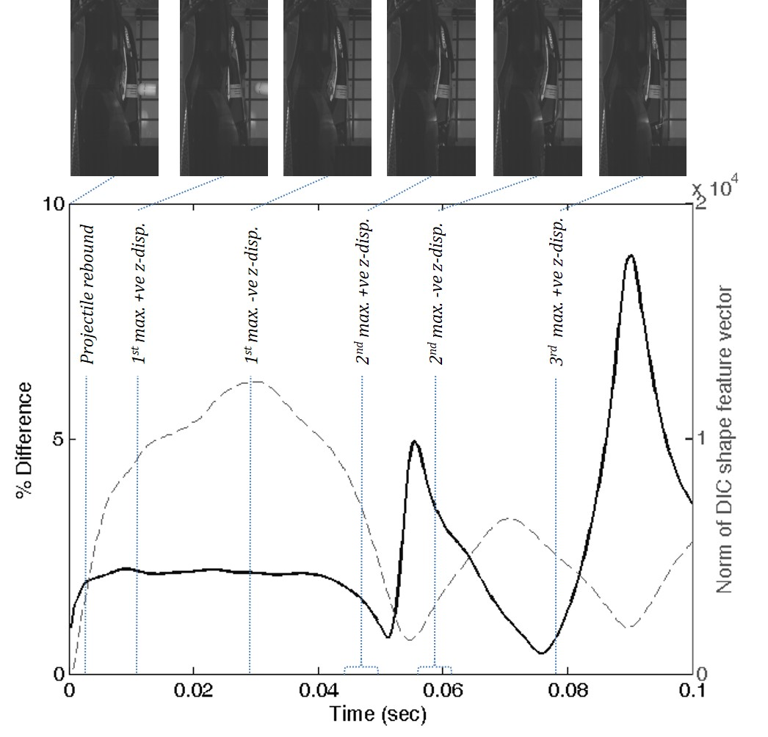

Figure 1: Percentage difference (solid line) between results from simulation and experiment evaluated as the Euclidean distance between the feature vectors normalised by the norm of feature vector representing the experiment (broken line & right axis) together with y-z views of the liner during impact at 0, 0.0114, 0.0290, 0.0466, 0.0598 & 0.0772 seconds after impact corresponding to the maximum z-displacement of the impact location (based on [12]).

Once these three steps have been completed, the weighted errors, *wk* can be compared to the error threshold, *eth* , and the sum of those weighted errors less than the error threshold computed to yield the validation metric, *VM*, i.e.

$VM=\sum{w_{i}}$ where $w_{i}=w_{k}<e_{th}$ (4)

Following the interpretation of Kat and Els [7], this sum corresponds to the probability of the normalized errors being equal to or less than the experimental uncertainty. From the validation perspective *VM* represents the probability that the model is representative of reality for a specified intended use.

**3. Analysis methodology**

The new validation metric was applied to data obtained in a previous study reported by Burguete et al [12] who analysed the displacement field for an automotive composite liner for a bonnet subject to an impact by a projectile. The composite liner, which had overall dimensions of approximately 1.5x0.65x0.03m, was subject to a high velocity (70m/s), low energy (<300J) impact by a 50mm diameter Teflon projectile with a hemi-spherical head. A digital image correlation system was used to measure the out-of-plane displacements at 0.2ms increments for 100ms using stereo pairs of images acquired with a pair of high speed cameras. A model of the composite liner was created with the finite element code Ansys-LS-Dyna using an elastic-plastic material model with isotropic damage and four-noded elements based on a Belytschko-Tsay formulation. Then, the maps of predicted and measured out-of-plane displacements were decomposed using adaptive geometric moment descriptors (AGMD) specifically tailored for the complex geometry of the composite liner. The feature vectors were compared using the Euclidean distance between the vectors by Burguete et al [12] as shown in figure 1 for the 100ms following impact. In this study, the probability of the model being acceptable was assessed using the validation metric in equation (4) for each increment of time for which a displacement field was measured, i.e. for which the high-speed cameras provided an image. The result is shown in figure 2 and shows that the model is a reasonable representation of the experiment for the initial 0.02 seconds.

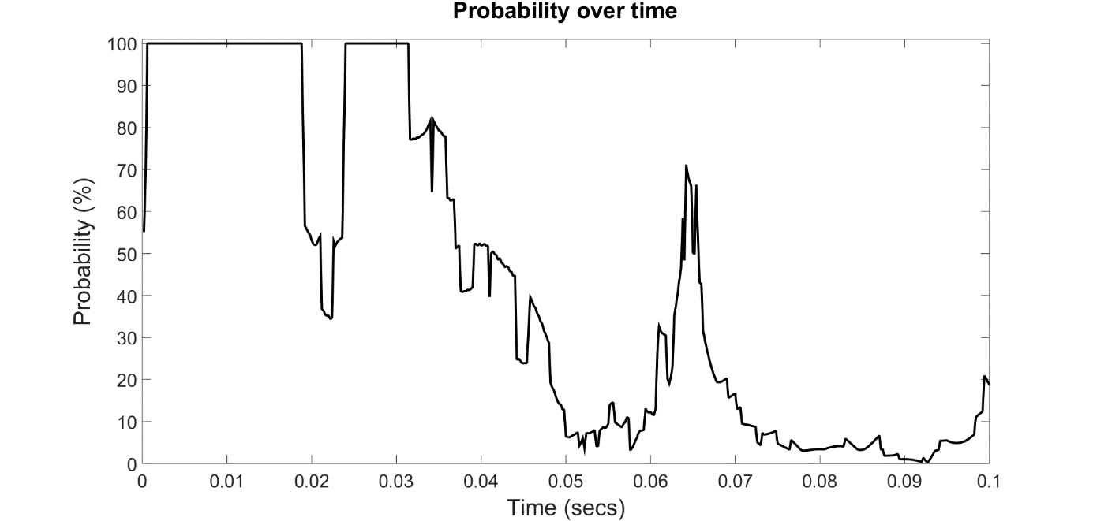

Figure 2: Probability of the predictions being a reliable representation of the measurements based on incorporating the weighted relative error and error threshold into the validation metric, *VM* using expression (4) for the 100ms following impact.

**4. Discussion**

Orthogonal decomposition was used to condense data obtained using digital image correlation system and finite element analysis. The technique was essential because it allowed equivalent data sets representing predicted and measured data fields to be obtained, which consequently allowed the implementation of the validation metric. This step is crucial in the validation process and in this paper displacement fields were treated as images and AGMDs were used to represent the main features of the deformation at each time increment.

The proposed validation metric is based on a relative error metric which avoids the flaws of prior Frequentist metrics by normalizing the relative error and the error threshold. This means that the new metric can evaluate data with a high variance between the individual values in the data set, including very small values close to zero. The new metric also incorporates the uncertainty in the experimental measurements. The result is a value for the probability that predictions from a model are a reliable representation of the measurements based on the uncertainty in the measurements used in the comparison.

Differences between the model and the experiment caused the errors identified by the validation metric. For instance, it was difficult to reproduce in the model the boundary conditions at the points where the bonnet liner would be fixed to the vehicle. In the experiments these fixtures were used and mounted on a rigid frame, whereas they were represented by constraints applied to nodes in the model.

These differences in constraint between the model and experiment are likely to have influenced the deformations local to the fixtures and also the reflection of stress waves from the constraints. In addition, the experiment revealed that a crack developed in the composite liner during the post-impact oscillations, or ringing, of the panel and no provision for fracture was incorporated into the model. This is most probably the reason for model’s predictions deviating from the measurements at around 0.02 seconds when the validation metric gives a small value.

Brynjarsdottir and O’Hagan [13] have discussed the issue that experiments and the simulations both mimic reality so that both have a certain level of approximation which has to be accounted for during a validation process. Hence, it is not enough to compare a simulation with an experiment, but also it is necessary to consider the relation of the experiment to reality.

**5. Conclusion**

A new metric has been developed for use in the validation of computational solid mechanics models that predict the deformation of engineering components. The metric provides the probability that the predictions from the model belong to the same population as the measurements made in the experiments performed in support of the validation process. The new validation metric has been applied to the displacement fields measured using digital image correlation during the impact of a composite bonnet liner by a projectile. The results showed that the computational model provides an acceptable representation of the experiment until a crack appeared in the panel during oscillations post-impact.

Acknowledgments

The work presented in this paper was performed while KD was supported jointly by the UK Engineering and Physical Sciences Research Council and the National Nuclear Laboratory. We acknowledge support through the EU project Nr 754660: MOTIVATE [Matrix Optimization for Testing by Interaction of Virtual and Test Environments].

References

[1] ASME, 2006, *Guide for verification and validation in computational solid mechanics*, New York: American Society of Mechanical Engineers, ASME V&V 10-2006.

[2] CEN, 2014, *Validation of computational solid mechanics models*, Brussels: Comite Europeen de Normalisation (CEN), CWA 16799(2014).

[3] Sebastian C, Hack E & Patterson EA., 2013, An approach to the validation of computational solid mechanics models for strain analysis*, J. Strain Analysis*, 48(1):36-47.

[4] Hack E, Lampeas G & Patterson EA, An evaluation of a protocol for the validation of computational solid mechanics models, *J. Strain Analysis,* 51(1):5-13, 2016.

[5] Berger JO &and M. J. Bayarri MJ, 2004, The Interplay of Bayesian and Frequentist Analysis, *Statistical Science*, 19(1):58-80.

[6] Oberkampf WL, Sindir M & Conlisk AT, 1998, Guide for the verification and validation of computational fluid dynamics simulations, *American Institute of Aeronautics and Astronautics*, Tech Rep. G-077-1998.

[7] Kat CJ & Els PS, 2012, Validation metric based on relative error, *Mathematical and Computer Modelling of Dynamical Systems*, 18(5):487-520.

[8] Upton G & Cook I, 2008, A Dictionary of Statistics, 2nd ed. Oxford: Oxford University Press.

[9] Hills RG, Dowding KJ & Swiler L, 2008, Thermal challenge problem: Summary, Computer Methods in Applied Mechanics and Engineering, 197(29-32):2490-2495.

[10] Higdon D, Nakhleh C, Gattiker J & Williams B, 2008, A Bayesian calibration approach to the thermal problem, *Computer Methods in Applied Mechanics and Engineering*, 197(29-32):2431-2441.

[11] Liu F, Bayarri MJ, Berger JO, Paulo R & Sacks J, 2008, A Bayesian analysis of the thermal challenge problem, *Computer Methods in Applied Mechanics and Engineering*, 197(29-32):2457-2466.

[12] Burguete RL, Lampeas G, Mottershead JE, Patterson EA, Pipino A, Siebert T & Wang W, 2014, Analysis of displacement fields from a high-speed impact using shape descriptors. *J. Strain Analysis,* 49(4):212–223.

[13] Brynjarsdóttir J & O’Hagan A, 2014, Learning about physical parameters: the importance of model discrepancy, *Inverse Problems*, 30(11):801812.

[14] Henninger HB, Reese SP, Anderson AE & Weiss JA, 2010, Validation of computational models in biomechanics. *Proc. Inst. Mech. Eng. H.*224(7):801–812.