Structural behaviour of the hybrid
FRP composite-concrete bridge span
under static and dynamic loading

Tomasz W. Siwowski¹, Aleksander Kozlowski² and Mateusz Rajchel³

¹Department of Roads & Bridges, Rzeszow University of Technology, Rzeszow, Poland
Email: siwowski@prz.edu.pl, Web Page: https://zdim.prz.edu.pl/
²Department of Building Structures, Rzeszow University of Technology, Rzeszow, Poland
Email: kozlowsk@prz.edu.pl, Web Page: https://kkb.prz.edu.pl/
³Department of Roads & Bridges, Rzeszow University of Technology, Rzeszow, Poland
Email: mrajchel@prz.edu.pl, Web Page: https://zdim.prz.edu.pl/

Keywords: FRP composites, bridge, hybrid structure, proof test, static/dynamic behavior

Abstract
FRP composites have become an integral part of the bridge engineering because of their excellent material properties. However, all-composite structural bridge systems have specific shortcomings such as high initial costs, low stiffness and existence of brittle failure modes. To make the best use of FRP composites and overcome the above drawbacks, combinations of FRP and concrete have recently been investigated by a number of researchers. The innovative hybrid idea of a FRP composite–concrete structural system for the first Polish FRP composite road bridge has been also proposed. The paper describes the bridge itself and presents the results of its static and dynamic proof tests. The in-test measured displacements and strains were compared to allowable values as well as to their equivalents calculated in bridge design. The actual load transverse distribution factors were also obtained. Finally, the dynamic behaviour of the bridge was evaluated on the basis of the dynamic coefficients, the natural frequencies and the logarithmic decrement of damping, determined in the tests. Very good results of all proof tests were the basis for the bridge service permission. The first Polish FRP bridge is in service since the beginning of 2016.

1. Introduction

FRP (fibre reinforced polymer) composites have become an integral part of the construction industry because of their versatility, high strength-to-weight ratio, enhanced durability, resistance to fatigue and corrosion, accelerated construction and lower maintenance and life-cycle costs. Advanced FRP composite materials are emerging for a wide range of civil infrastructure applications. These include everything from bridge girders and decks, bridge repairs and strengthening, seismic retrofit to marine waterfront structures. Transport infrastructure applications began in the 1980s with research on strengthening of bridges with carbon fibre-reinforced polymers and the construction of the first new FRP pedestrian bridge in China. More recently, smaller pedestrian and road bridges, bridge decks for new and rehabilitated structures, bridge enclosures and other structural applications have been undertaken using FRP composite components [1]. But there exist only very few FRP bridges that are suited for the heaviest traffic load classes.

However, all-composite structural bridge systems have specific shortcomings such as high initial costs, low stiffness (when glass fibre reinforced polymer is used) and existence of brittle failure modes. To make the best use of materials and overcome the above drawbacks, combinations of FRP and conventional materials have recently been investigated by a number of researchers [2-4]. According to them the most effective use of FRP composites in structural applications is in the form of a hybrid structure with concrete.

The main goal of the R&D project carried out by a research science - industry consortium was to develop and demonstrate the first Polish FRP composite road bridge, suited for the heaviest traffic load classes. The innovative hybrid idea of a FRP composite–concrete structural system has been proposed. The first Polish FRP bridge was constructed in late autumn 2015 and is in service since the beginning of 2016. The output of the R&D project gives a very promising future for the FRP composite bridge application in Poland. The paper describes the bridge itself and presents the results of its static and dynamic proof tests. Another aspects of this interesting R&D project, as for instance FRP laminas stacking system, their mechanical properties, FEM analysis and design of the bridge, the full-scale girder testing, manufacturing of FRP composite girders as well as bridge construction have been presented elsewhere [5-7].

2. Bridge description

The first Polish road bridge made of FRP composites is situated in southeast part of Poland, near Rzeszow, the capital of Podkarpackie district, along the local road over the Ryjak River. Its nominal carrying capacity is 40 tonnes according to the Polish bridge standard. This is a 22.0 m long single-span simple supported bridge with 10.5 m wide deck carrying 2 × 3.5 m wide roadway and 1 × 2.0 m wide sidewalk. The bridge superstructure is formed by four FRP composite girders with an overlying 0.18 m thick concrete slab (Fig. 1). The FRP girders have a U-shape cross-section with slightly inclined webs, maximum width of 1550 mm and depth of 1020 mm. Each top flange is 350 mm wide and the bottom flange of the box is 735 mm wide. The top flanges and the webs have a thickness of about 28 mm, while the bottom flange is 20 mm thick. The FRP laminates which form the walls of box-girders are made of epoxy resin matrix and hybrid glass-carbon fibre reinforcement. E-glass and carbon fibres in the form of stitched fabrics were chosen as the reinforcement of laminates. The top flanges are made of GFRP and the bottom flange has a hybrid CFRP/GFRP structure. The webs are made as a sandwich panels with 15 mm thick foam layer in between two GFRP laminates.

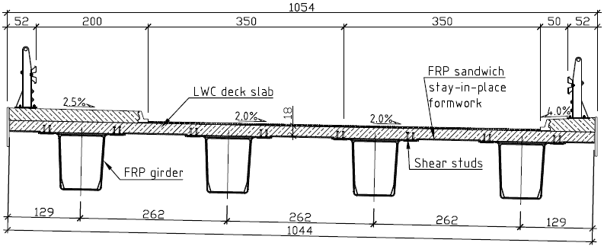

Figure 1. Cross-section of the bridge superstructure (units: [cm]).

To increase the torsional stiffness of the girder and to prevent shear - bending buckling of its webs, six internal diaphragms are placed along the length of the girder. The diaphragms are built as sandwich panels with a structure similar to webs. Similar sandwich panels are also bonded to the top flanges of the girder to be used as a stay-in-place formwork during concrete slab casting. The concrete deck slab is made of lightweight concrete lightweight concrete (LWC) 35/38 class, reinforced longitudinally and transversally with two layers of 12 mm GFRP bars. The GFRP bars were used to enhance the slab durability. The slab is connected to FRP box-girders through galvanized steel shear connectors which are welded to small steel plates and fastened to top flanges with epoxy adhesive. Finally, the support zones of the FRP girders are filled with concrete to form support cross-beams and to ensure transverse stiffness of the whole span. Steel shear connectors fastened to the webs inside boxes are used to create a composite action between the FRP composite and concrete in the support zones. The deck equipment consists of two concrete sidewalk slabs with safety barriers, polymer curbs, conventional insulation and stone mastic asphalt (SMA) pavement layers, drainage and expansion joints. The reinforced concrete (RC) abutments are founded on 10 continuous flight auger (CFA) piles with 0.60 m diameter and 5.0–7.0 m length. Four elastomer bearings are used to support the span on the abutments (Fig. 2).

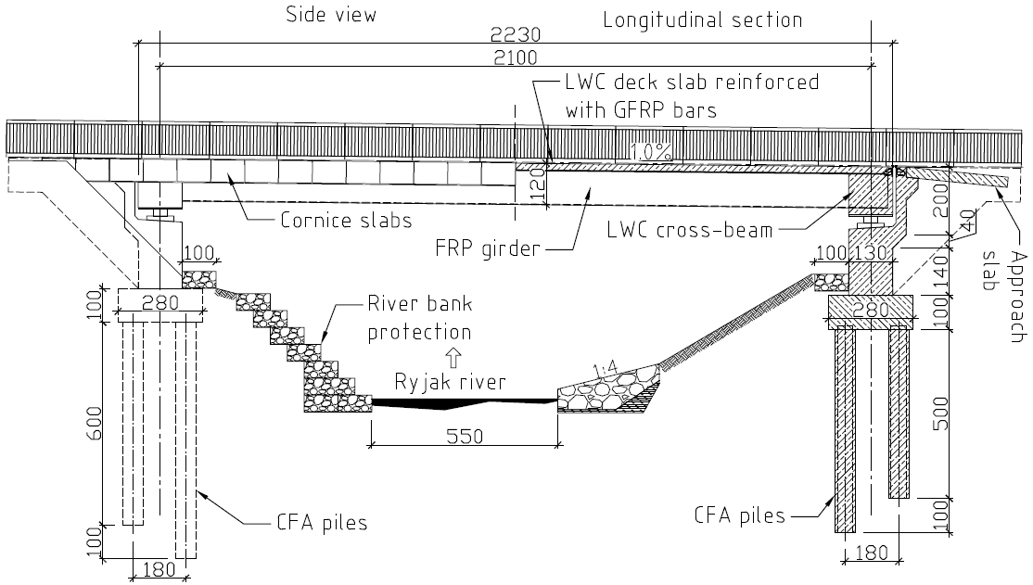

Figure 2. Side view and longitudinal section of the bridge (units: [cm]).

3. Static behaviour

Tests of the bridge under a trial static load were carried out in December 2015 as part of the proof tests before the bridge was open for service. Four 4-axis trucks with a nominal weight of 30 tons each and total weight of 128.3 tons were applied for static tests. Values of the vertical displacements of girders, composite and concrete strains, displacements of bearings and also the settlement of supports were measured during the tests. Tables 2 and 3 show the values of the girders' deflections and the selected values of composite strains under both an asymmetrical load of the bridge (schemes S1a, 2a and 3a) and a symmetrical load of the bridge (schemes S1b, 2b and 3b) (Fig. 3).

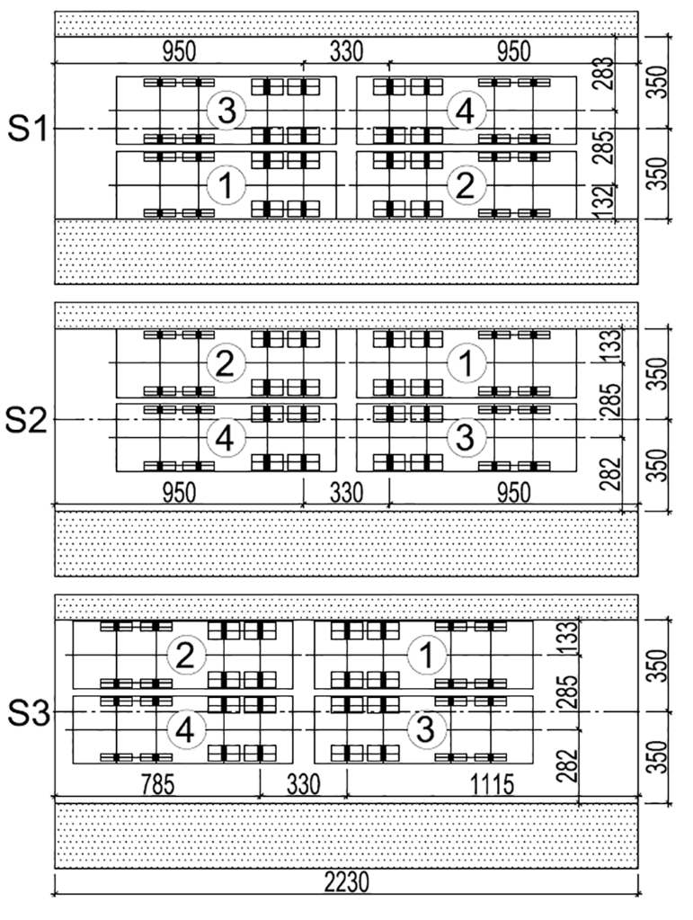 | 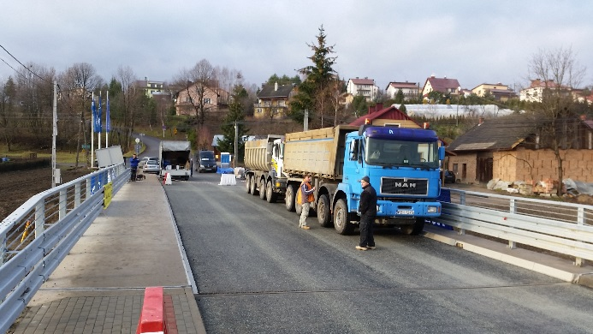
 | 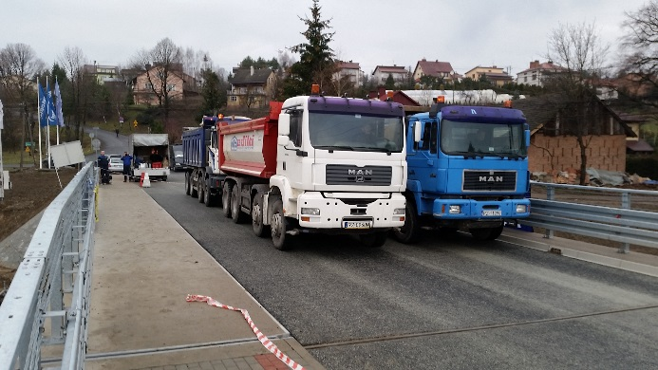

Figure 3. Position of trucks in subsequent schemes (right) and schemes S3 and S3a (left).
Table 1. Girder midspan deflections: experimental results.

Load scheme | Value of girder deflection [mm]
Load scheme | outer  (-3b/4) | inner  (-b/4) | inner  (b/4) | outer  (3b/4)
Asymmetric load
S1a | 6.30 | 10.60 | 13.70 | 11.30
S2a | 17.95 | 14.35 | 9.15 | 5.95
S3a | 16.40 | 13.10 | 8.30 | 5.40
Symmetric load
S1b | 21.35 | 27.65 | 26.45 | 19.35
S2b | 28.80 | 30.00 | 23.70 | 15.20
S3b | 25.60 | 26.40 | 21.05 | 13.55

Table 2. Bottom flange midspan longitudinal strains: experimental results

Load scheme | Value of the strain of the girder’s bottom flange [‰]
Load scheme | outer  (-3b/4) | inner  (-b/4) | inner  (b/4) | outer  (3b/4)
Asymmetric load
S1a | 0.134 | 0.196 | 0.279 | 0.250
S2a | 0.425 | 0.272 | 0.189 | 0.121
S3a | 0.397 | 0.256 | 0.176 | 0.110
Symmetric load
S1b | 0.487 | 0.528 | 0.579 | 0.433
S2b | 0.670 | 0.566 | 0.506 | 0.328
S3b | 0.608 | 0.508 | 0.450 | 0.291

As far as vertical displacements are concerned, the maximum measured elastic displacement in the mid-span of outer girder was 30.0 mm, which is only 57.1% of theoretical value and is also less than the allowable value of 70 mm (L/300). The main reason for this discrepancy is the influence of the equipment (i.e. concrete sidewalks, curbs and SMA pavement) placed on the deck slab and not included in the stiffness calculation. The maximum elastic composite strain measured in the bottom flange was 0.521‰ and constitutes 98% of the theoretical value. It proved the efficient modelling of the FRP structure and the accuracy of the FE analysis along with its appropriate material optimization [6, 7]. However, this actual strain is far less than the limit value for carbon fibre laminas (ε_{tc} = 0.99%) as well as for glass fibre laminas (ε_{tg} = 2.03%), both used for manufacturing of girder’s bottom flange.

The load transverse distribution factors of the bridge span, which were calculated in accordance with the known formulas (f.e. [6]) on the basis of the analysis of measured deflections of the outer and inner girder, are shown in Table 3. The load transverse distribution factors were also obtained on the basis of the unit strains measured in the bottom flange in the midspan of the girders. However, values other than those based on deflections were obtained. This is due to the occurrence of a complex stress state resulting from the summation of bending and torsion effects.

The load distribution factors obtained from the static tests were compared to the factors determined numerically with the use of the FEA. The numerical model of the bridge span was created in the FE environment in three-dimensional space using shell and solid finite elements [5]. A comparison of the experimentally and numerically determined influence lines of the load transverse distribution on the individual girders (outer and inner) of the bridge span is presented in Fig. 4.

Table 3. Load distribution factors determined experimentally

y  f | Measurement | Distance between the axis of the girder i and the axis of the span structure
y  f | Measurement | -3b/4 | -b/4 | b/4 | 3b/4
b/4 | deflections | 0,156 | 0,243 | 0,307 | 0,295
b/4 | strains | 0,214 | 0,260 | 0,286 | 0,240
3b/4 | deflections | 0,125 | 0,192 | 0,303 | 0,380
3b/4 | strains | 0,117 | 0,187 | 0,273 | 0,423

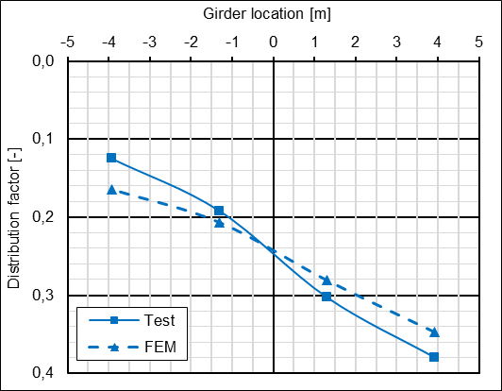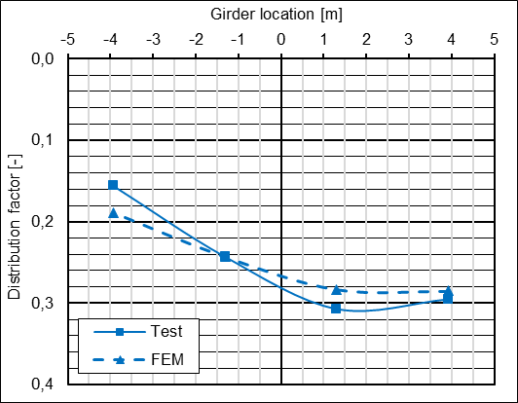

Figure 4. Load distribution influence lines: outer girder (left) and inner girder (right).

The high compliance with the actual behaviour of the span under the static load was obtained for the influence lines designated by the FE model. The maximum calculated values of the transverse distribution factors were as follows: equal to 0.347 for the outer girder and equal to 0.283 for the inner girder, which state 91.4% and 92.2% of the values obtained experimentally. However, there is the possibility to better match the numerically obtained transverse distribution to the one obtained during the load tests. The numerical FE model did not take into account several aspects that could affect the outcome of the analysis, for example precise laminate modelling, stay-in-place composite formwork, reinforcement in the deck slab and above all the bridge equipment – sidewalks, curbs etc.). Therefore, it seems that with a better matching of the numerical model to the actual bridge structure, the FE method will be the most appropriate way for the designing of a FRP composite – concrete bridges with a plate – girder structure.

4. Dynamic behaviour

The dynamic tests were carried out with one truck, same as applied in static tests, passing the bridge. Total of five dynamic test schemes were applied. In the loading schemes D1 to D3 the truck was passing the bridge with three velocities: 10, 30, 50 km/h, respectively. To enhance dynamic effect the transverse threshold 50 mm deep was used in D4 scheme (with the truck velocity of 10 k/h) and hard braking on the pavement was applied in D5 scheme (with the truck velocity of 30 k/h). In order to evaluate the dynamic behaviour of the bridge the displacement in two points were measured by means of the linear variable displacement transducers (LVDT’s). The measurement points were located in the midspan, under the deck slab cantilevers, close to outer edges of the deck. The selected "time – displacement" records for all test schemes are presented in Figs 5 and 6. The dynamic behaviour of the bridge span was evaluated on the basis of the dynamic coefficients determined for all velocities, the estimated natural frequencies and the determined logarithmic decrement of damping.
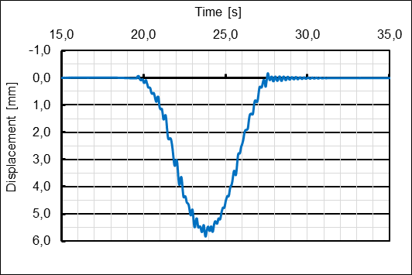
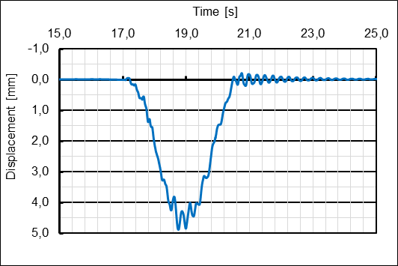
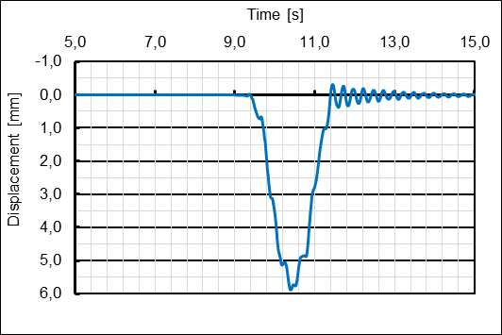

Figure 5. The exemplary "time – displacement" records for D1, D2 and D3 schemes
from top to bottom, respectively.

The dynamic coefficients were calculated as the ratio of the maximum dynamic displacement (deflection), i.e. the maximum value on the "time – displacement" record, and the maximum static displacement, i.e. the average of the minimum and maximum values on the "time – displacement" plots. Basing on recorded values the dynamic coefficients for three velocities 10, 30, 50 km/h were assessed as 1.055, 1.104 and 1.163, respectively. All these values are far less than the dynamic coefficient anticipated in bridge design according to the Polish bridge code (1.25).

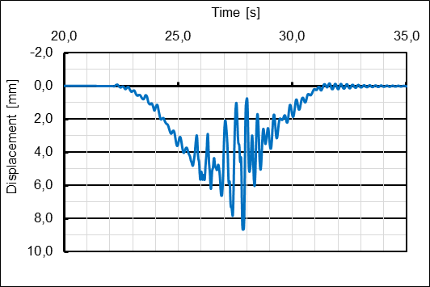
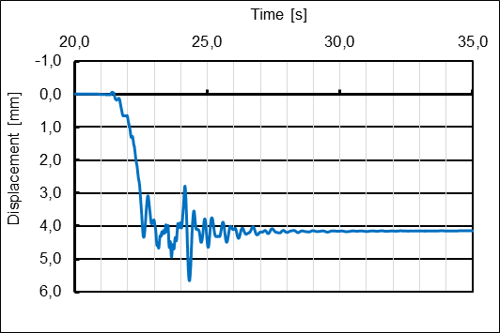

Figure 6. The exemplary "time – displacement" records for D4 (top) and D5 (bottom) schemes.

The natural frequencies of the bridge span were determined on the basis of the ‘time-displacement’ records for D4 and D5 loading schemes (Fig. 6). The frequencies were calculated as the ratio of the number of vibrations (n) and time (t_{s}) in which these vibrations occurred. Both values were read out on the subsequent "time – displacement" records. The estimated first natural frequency that equalled 3.98 Hz was higher (means better) than the recommended minimum value according to the said Polish bridge code (3 Hz).

The logarithmic decrement of damping δ were determined on the basis of the "time – displacement" records caused by truck in D4 and D5 schemas after using lowpass filter of the first natural frequency 3.98 Hz to separate first mode of vibration. The approximate value of the logarithmic decrement of damping δ was obtained according to the equation (1):
δ=1/n ln (A₁/A_{n}), | (1)
where:
A₁, A_{n} – the measured values of half-amplitudes in start and end points of the relevant vibration spectrum, respectively;
n – number of vibrations between amplitudes A₁, A_{n}.

The determined logarithmic decrement equalled 0.087 and proved the appropriate damping characteristic of the FRP bridge superstructure.

5. Conclusions

The good results of all proof tests and the final inspection, which revealed no damages after static and dynamic loading, were the basis for the service permission. The first Polish FRP bridge is in service since the beginning of 2016 (Fig. 7). In the frame of the said R&D project the comprehensive structural health monitoring (SHM) is provided. SHM results are believed to help further optimization of the FRP composite – concrete bridge structure and to evaluate the service life and durability of such bridges under road traffic and environment impact. The Polish experience in designing, research, manufacturing and construction of the FRP composite road bridge clearly revealed that this advanced and still emerging material can be valuable alternative for conventional materials used in bridge construction.



Figure 7. The first Polish FRP bridge in service.

Acknowledgments

This research project was supported by the Polish National Centre of Research and Development (NCBiR), in the frame of DEMONSTATOR+ programme, the project title: “Com-bridge: Innovative road bridge with FRP composites” (No. UOD-DEM-1-041-/001).

References

- M. Zoghi (ed.). The international handbook of FRP composites in civil engineering. CRC Press, Taylor & Francis Group, 2013.
- A. Hejll, B. Täljsten, M. Motavalli. Large scale hybrid FRP composite girders for use in bridge structures - theory, test and field application. Composites Part B: Engineering, 36:573 - 585, 2005.
- L. Cheng, V. M. Karbhari. New bridge systems using FRP composites and concrete: a state-of-the-art review. Progress in Structural Engineering and Materials, 8:143–154, 2006.
- A. Fam. T. Skutezky. Composite T-beams using reduced-scale rectangular FRP tubes and concrete slabs. Journal of Composites for Construction, 10:172–181, 2006.
- M. Rajchel, T. Siwowski. The FEM analysis and proof load test of a road bridge made of FRP composites. Journal of Civil Engineering, Environment and Architecture JCEEA, 34:407-422, 2017 (in Polish).
- T. Siwowski, M. Rajchel. Live load transverse distribution in a road slab-girder bridge made of FRP composite girders. Roads and Bridges - Drogi i Mosty, 16:131–145, 2017.
- T. Siwowski, D. Kaleta, M. Rajchel, L. Własak. The first Polish road bridge made of FRP composites. Structural Engineering International, 27:308 – 314, 2017.

