**Challenges of hybrid laminar flow control (HLFC) in aircraft design and manufacturing**

F. Martin de la Escalera1, Y. Essa1, M. Ángel Castello1, U. Pillai1, A. Chiminelli2, M. Lizaranzu2,

P. Maimi3

1AERNNOVA Engineering Division SAU, Spain

Email: Federico.martindelaescalera@aernnova.com, Web Page: <http://www.aernnova.com>

2 ITAINNOVA (Instituto Tecnológico de Aragón), Spain

Email: achiminelli@itainnova.es, Web Page: [www.itainnova.es](http://www.itainnova.es)

3AMADE, Universitat de Girona, Spain

Email: pere.maimi@udg.edu, Web Page: [http://amade.udg.edu](http://amade.udg.edu/)

**Keywords:** HLFC, adhesive joint, composite, titanium, OOA.

**Abstract**

The purpose of this paper is to describe barriers and efforts made in the design of an aircraft in terms of reducing pollution emission into the atmosphere throughout the structural optimization of the aircraft’s airfoils. In particular, the present work is focused on the design of a leading edge considering Hybrid Laminar Flow Control (HLFC) technology. The technological improvements of this topic are instilled through Clean Sky 2 platform. This will underpin innovative developments in the next generation of aircrafts; overcoming the risks and the technologies eventually to join the next market window to replace the current fleet.

One of the most important challenges in the design of this device is the feasibility of manufacturing advanced composites through “out of autoclave” (OOA) processes. The aircraft component under study is a leading edge structure, in which it is required to join different materials such as carbon fiber laminates and thin Titanium sheet, considering the viability of adhesive layer. In particular, one of the key contributions of this work is identification of the issues that need to be addressed to demonstrate the feasibility of Ti-Carbon joints manufactured throughout OOA processes. Furthermore, the component has to satisfy the structural integrity criteria, which is a prime necessity in the aeronautical industry. Among others, challenges related with the design, manufacture of specimens, and the methodology of data reduction considering interlaminar failure modes, are taken into account in the present work. Likewise, aspects such as techniques for surface pre-treatment, environmental effects and integration are also discussed.

1. Introduction

Natural Laminar Flow (NLF) is one of the principal new leading edge technologies to be applied in the near future to reach the demanding fuel-consumption and emission-reduction objectives stipulated in ACARE's Vision 2020. NLF airfoils are shaped in such a way to delay as much as possible laminar to turbulent flow transitions in cruise in order to decrease viscous drag, hence lower the fuel consumption and reduce carbon dioxide (CO2) emissions.

In the context of the JTI “CleanSky” SFWA, WP3 which aimed at testing innovative green technologies for future aircraft in large scale tests under operational conditions, Aernnova was already involved, together with SAAB, GKN, AIRBUS, SYTEC, ASCO, Dassault, among others, in the design and manufacturing of passive NLF Port and Starboard wings of A340-300, **Figure 1**.

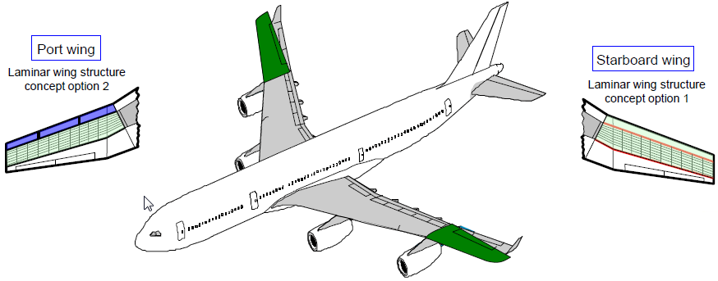

**Figure 1**. Smart passive laminar flow wings

Aernnova was involved in the BLADE Aircraft Flight Test Demonstrator. The demonstrator aimed to prove the effectiveness of Natural Laminar Flow on a wing. Furthermore, Aernnova has been actively participating in solving the problem of dimensional and geometric tolerances of aircraft components designed to operate on natural laminar flow (NLF) regime, which is a key technology to reduce drag and, thus, to significantly improve the airplanes performance and efficiency. **Figure 2a** illustrates the 3D simulation of Assembly Jig with fully assembled product, assembled at Aernnova facilities. **Figure 2b** shows the general overview of the assembly tooling.

**a)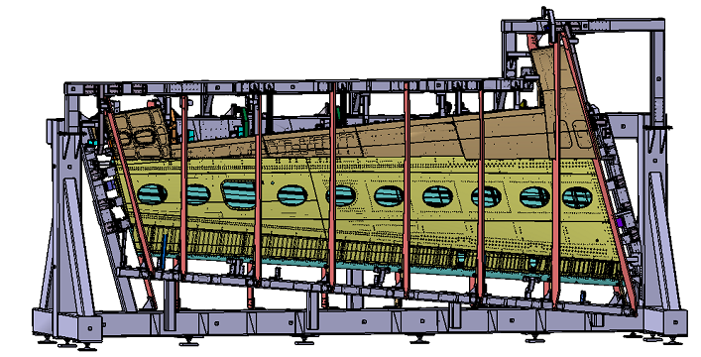 b)** 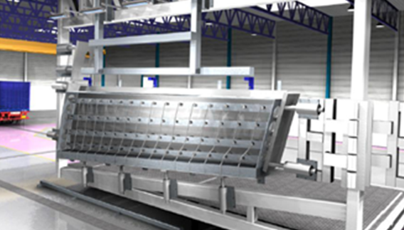

Figure 2. a) Assembly Jig at Aernnova b) NLF Wing Assembly tooling concept and layout of the assembly of the port wing

Aernnova applied the acquired technology in design, manufacturing and assembly of Clean Sky_1 for the achievement of the objectives of the present project. The layout of the Clean Sky assembly of the port wing can be seen from **Figure 2b**.

During last two decades, number of large research and technology programmes in Europe and USA, addressed the significant drag reduction potential of HLFC technology. In 2011, Boeing disclosed flight test pictures with a HLFC system applied on the vertical stabilizer of the B787-8 and announced that HLFC system as aerodynamic enhancement package for the B787. In spite of this pre-serial example by Boeing and although the technical principles and the physics are well known, there is no “industrial” technology could be developed so far to demonstrate the aerodynamic potential, while maintaining the weight and complexity of the required systems low.

**2. Challenges**

According to current projections by Airbus and Boeing, air traffic worldwide will increase by 5% annually over the next twenty years. This represents a doubling of air traffic every fifteen years. Therefore it will become mandatory to palpably reduce the specific fuel consumption of the aircrafts for environmental and economic reasons. As fuel consumption during cruise is mainly determined by viscous drag its reduction offers the greatest potential for fuel savings. The concept of HLFC on the wings and tails consists of a combination of surface suction, applied in the upper front part, and of a designed extended region of favourable pressure gradient, attained by profile shaping. This technology has shown its capability in significantly delaying laminar-turbulent transition. Laminar flow could be maintained up to 50% chord at a flight Mach number Ma=0.82. All recent studies used panels perforated by laser-drilled micro holes to suck air off the boundary-layer. The holes are typically 50-100 microns in diameter, the holes spacing lied between 500-800 microns leading to a porosity of the panel of 0.5-1%. Boundary layer is directly related to the speed of surface and the distance along the surface; first, laminar and then changing to turbulent as speed or distance increases. Laminar flow is difficult to attain and retain under most conditions of practical interest, e.g., on the surfaces of large transport airplanes.

Two basic techniques are available to delay transition from laminar to turbulent flow-passive and active. Laminar flow can be obtained passively over the forward part of airplane lifting surfaces (wings and tails) that have leading-edge sweep angles of less than about 10 degrees by designing the surface cross-sectional contour so that the local pressure initially decreases over the surface in the direction from leading edge towards the trailing edge. The laminar flow obtained in this passive manner is called natural flow (NLF). In the rearward region of well designed wings, where the pressure must increase with the distance towards the trailing edge (an adverse pressure gradient), active laminar-flow control must be used. Even in a favourable pressure gradient, active laminar-flow control is required to attain laminar flow to large distances from the leading edge.

Wind tunnel and flight tests have clearly demonstrated the potential of hybrid laminar flow control (HLFC) to reduce the friction drag constituting more than half of the total drag of a modern transport aircraft. A drag reduction of 15% can be achieved for the entire aircraft if HLFC is applied to wings, tail stablizers and nacelles. However, these tests also displayed that much of HLFC technology's advantage might be reduced by the weight of additional systems and structures. Consequently, the next step towards the application of hybrid laminar flow control is to diminish the complexity of suction systems. Also, the manufacturing, operational and maintenance cost needs to be brought down within acceptable standards.

The major challenges in the overall implementation of HLFC integrated wing thechnology can be broadly classified under the following major headings, as illustrated in **Figure 3**. For HLFC integrated aircraft wings and tails comprising Ti-Carbon laminates, these challenges become increasingly complex due to the criticality of these joints.

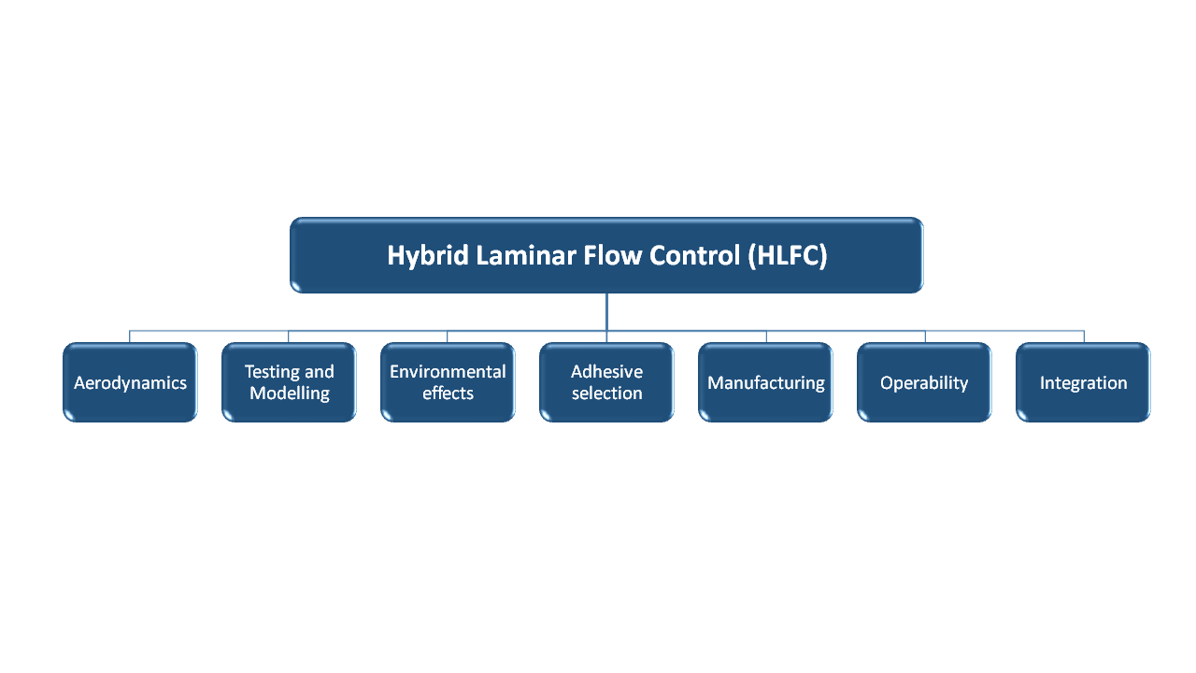

**Figure 3**. Classification of challenges faced for HLFC integrated aircraft wings and tails

1. **Challenges in aerodynamics**

Assessment of aerodynamic efficiency and potential enhancement is an important step which should be performed before integrating any new technology or system on the aircraft structure. With the application of HLFC, a major challenge which entails is the difficulty in testing the aerodynamic efficiency of active and passive HLFC through Wind-Tunnel Tests (WTT) of the model under transonic flow conditions. In addition, manufacturing of model wings and tails clamped with active and passive suction systems to perform HLFC is a cumbersome task. The HLFC integrated wing should also be able to demonstrate all principal functionalities when tested in an operational envelope limited to ground-based test conditions. This involves validation of following steps for a fully integrated HLFC wing with sub-structures and systems [11]:

1. Determination of operation envelope for aircraft with HLFC integrated wing.
2. Determination of the optimum aerodynamic shape and performance by performing stability calculations for boundary layer characterisation. This should consider surface perforations on titanium sheet and active suction conditions which are used to extend laminar flows to long distances from the leading edge. The numerical results must be validated with the experimental results obtained from the Wind-Tunnel model tests.
3. **Challenges in testing and modelling**

Aircraft structures require a thorough testing and assessment before deployment due to high economic and safety hazards involved. One of these assessments is damage detection and modelling, which is an important aspect of overall design and manufacturing lifecycle of aerospace structures. To ensure increased strength and resilience of the manufactured parts, the possibility of defects should be detected in the early stages of design cycle so that preventive measures could be taken. Thus, it is essential to evaluate the failure and damage characteristics, and subsequently load carrying capacity, of composite laminate structures to create an economic and reliable design. It is also equally important to develop a systematic work-plan of required tests and simulations to be conducted for proof of structure concept and system integrity, specially to test damage characteristics under scenarios like bird strike, hail strike, operation under ice conditions etc. For the HLFC solution proposed, the CFRP-Ti joint is identified as critical structural link in the system, and then the challenges in terms of testing and modelling are transferred to this joint.

The double cantilever beam test is frequently used to simulate mode-I type interlaminar fracture to provide meaningful insights into failure characteristics of adhesive layers. A schematic illustration of DCB test set-up consisting of titanium sheet and carbon-fibre reinforced polymer (CFRP) composite laminate bonded by an adhesive layer is shown in **Figure 4**.

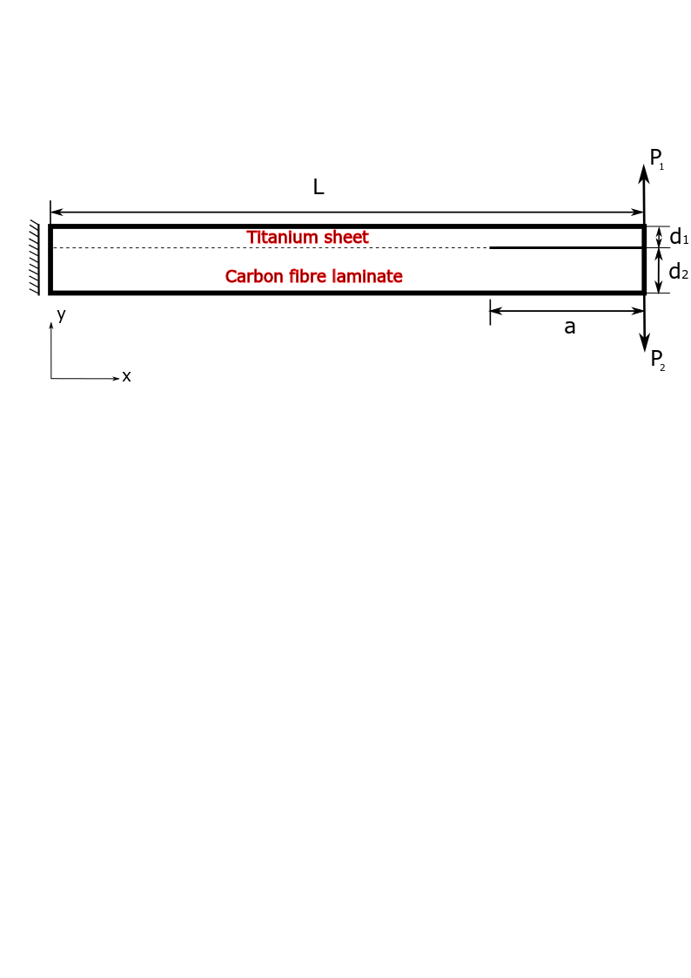

Figure 4. Schematic illustration of an asymmetric DCB test for adhesively bonded laminate

Inter-laminar cracking of fibre composite laminates is usually accompanied by bridging of fibres in the cracked zone, i.e. the fibres cling to the crack faces behind the crack tip and increase the frature resistance. Crack bridging is modelled using cohesive laws, wherein the material behaviour is explained with a traction-separation relationship. The basic principle behind cohesive-zone models is to redistribute the stress-state over a finite domain by creating a fracture process zone (FPZ), and describe the gap opening by means of a strength limit which is reduced until the interface has zero stiffness [3]. Due to ever increasing use of adhesive joining techniques in aerospace applications, it becomes primarily necessary to study their performance and mechanical behaviour under various loading modes.

The testing and simulation of inter-laminar mode-I delamination fracture using DCB test involves many challenges. Specially in bi-material system as the one shown in **Figure 4**, wherein the adherends posses different material properties and thickness, standard DCB tests are no longer applicable and an asymmetric DCB test must be used. Overcoming these challenges is necessary for accurate determination of fracture toughness values. Few other challenges faced while conducting asymmetric DCB test for Ti-Carbon joints are summarized below:

1. **Unequal flexural rigidity of the beams:**

In general, the flexural rigidity of the titanium and CFRP beams is not same because of dissimilar material properties and thicknesses. Due to this, the interlaminar fracture displays mixed-mode cracking behaviour due to disrupted symmetry at the interface. Even if the geometry and loading is symmetric with respect to the crack path, additional local shear and peeling stresses are generated at the crack front. This leads to significant shear slips happening at the interlayer in addition to normal separation of layers. An important challenge is to eliminate the effect of these shear stresses to allow a stable crack growth and accurately characterize mode-I fracture. This can be done through a proper design of both arms of the samples, as shown in **Figure 5**. Manoeuvring the flexural rigidity is achieved by backing either substrate with an additional thin sheet of metal, for e.g. aluminium, or composite. In addition, the analytical stress expression should also be modified by introducing appropriate decoupling conditions which can decouple interface shear/peeling stresses from the normal stresses and interfacial slip across the interlayer [5].

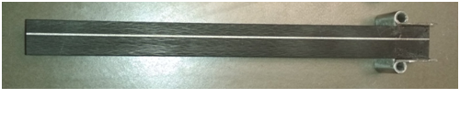

Figure 5. Ti-CFRP DCB sample designed taking into account the joint asymmetry

1. **Specimen design/manufacturing and effect of distortional stresses**

To effectively conduct DCB test on the Ti-Carbon laminate, the first step is to design and manufacture an appropriate test-specimen which allows for stable crack frowth, full mode mixity and is capable to characterise cohesive laws when large-scale fibre bridging occurs. Due to dissimilar mechanical properties of the substrates, the magnitude of deflection is different for Titanium and CFRP laminae, which in turn affects the symmetricity of the crack opening. To achieve symmetric crack topology, an asymmetric DCB with unequal bending moments, as shown in **Figure 4**, should be applied at the two beams. Sandwich specimens are often used for mode-I failure characterisations of bi-material systems. The main advantage of using these specimen is that even if the adhesive layer remains attached to the skin layer of one of the beams, the residual stresses do not affect the energy release rate [12,13]. The manufacturing of CFRP plates is done using RTM process at high temperatures followed by post-curing of the plates. The curing process usually involves volumetric shrinkage of the plates resulting in generation of distortional stresses. These distortional stresses often play an important role in determining deflection characterisitics of the beams, and act as a influential factor in analysing failure properties at the interface. Most often these stresses are ignored in the constitutive formulations used to simulate DCB tests. But in case of bi-material systems like Ti-CFRP laminates, wherein stress generation can be highly unsymmetric in two beams, accounting for these stresses can create significant variation of stress profiles in CFRP and affect inter-laminar fracture characteristics.

1. **Data reduction schemes for DCB tests**

DCB tests primarily use beam theory to mathematically determine the value of fracture toughness GIC. However, an accurate determination of GIC requires consistent crack tracking and measurement throughout the DCB test, which is quite difficult. Many times, the crack tip cannot be easily identified which can induce substantial errors in the calculation of derivative of compliance with respect to crack length, which is used in compliance calibration method [14]. To calculate precise R-curves for mode-I inter-laminar fracture using DCB tests, it is necessary to identify an appropriate data-reduction scheme to overcome difficulties related to crack measurements. ASTM and ISO standards [15,16] prescribe data reduction techniques such as modified beam theory (MBT) scheme and compliance calibration (CC) scheme. However, an important challenge to address is that most of these data reduction techniques are based on the assumptions of Linear Elastic Fracture Mechanics (LEFM) which fail in the case of fractures caused by large-scale bending, for e.g. in adhesive joints. In such cases, using an LEFM-based data reduction method to characterize fracture toughness is fundamentally inappropriate, and an alternate experimental data reduction methods based on J-integral approach may be used [17].

1. **Challenges of environmental effects**

Aircraft structures are subjected to extreme environements and temperatures during flight. The components need to be designed in such a way that they can bear the transition from very low temperatures prevailing at higher altitudes to much higher temperatures on the ground. Another challange which is faced while using bi-material systems like Ti-Carbon joints is that the thermal expansion coefficients are different for both materials. It is known that the mismatch between the coefficient of expansion of the substrates makes adhesively bonded metal/composite laminates highly susceptible to environmental degradation effects [6]. When exposed to extreme temperature transitions during flight, the titanium and CFRP laminae expand by different amounts leading to generation of high residual stresses (thermal and swelling) at the Ti-Carbon interface.

Environmental effects like temperature and humidity also deteriorate the performance of adhesive joints by often making permanent changes in the physical and chemical properties of the adhesive. This in turn, affects not only the interface bond strength, but also influences the mechanical properties of composite matrix and matrix-fibre bond [9]. In particular, adhesive joints show decrease in bond strength with increasing temperatures, while the presence of humidity can lead to variety of effects including plasticization, swelling and degradation of the joints [8]. Effect of humidity on bond-strength can be alleviated using a suitable drying method for CFRP prior to bonding.

1. **Challenges in adhesive selection**

It is known that adhesive properties significantly affect the strength of bond at the adhesive interlayer. The type of adhesive to be used highly depends on the properties of substrates to be bonded and the environmental operating conditions. Wide variety of options exist for adhesives used in common engineering applications and it’s difficult to find a universal adhesive suited for all applications. The challenge here is to select a suitable adhesive for interlayer Ti-CFRP bonds, which must possess high strength, temperature and moisture resistance and is able to sustain extreme fatigue loadings and stresses. It is also necessary to conduct experimental and numerical verification of the adhesive properties before a selection is made. Primary strength characterisation and the assessment of adhesive properties and fracture toughness can be made via DCB test. Epoxy adhesives are frequently used for bonding epoxy matrix based composites like CFRP, and can also prove to be a viable option for titanium/CFRP laminates.

1. **Challenges in manufacturing**

Development of a suitable manufacturing process for HLFC wing which is economical and allows for scalability in the long run is another challenge which needs to be realized. An ideal process should be such that it facilitates production of HLFC wings in lesser time and costs, in accordance with the wings of standard passenger aircrafts. Furthermore, titanium carbon laminates for HLFC integrated wing are produced using one-shot technology, a pioneering method introduced by Aernnova for manufacturing laminate structures. There are multiple challenges faced during one-shot manufacturing of leading edge structure with regards to sheet metal forming of titanium sheets and properly assembling it with the CFRP structure. The titanium sheets used in Ti-Carbon laminate are very thin, which when subjected to large bending moments during manufacturing, involves risk of degradation of overall mechanical strength of the laminate. Besides, the surface quality of micro-perforated titanium sheets, shapes/sizes of the holes, perforation gaps etc. also need to be maintained based on standard wing design directives [11]. The size of micro-perforated holes on Titanium sheets should fall within specific size range (between 50 and 100 micra of diameter), and should be produced with a high rate (up to 300 holes/second), which should be tested [18].

Furthermore, an appropriate pre-treatment of the titanium and CFRP surfaces is required before bonding, so that significant improvement in the mechanical properties and increase of bond strength can be achieved. The strength of the adhesive joint largely depends upon the quality of bonding surfaces. To form a strong bond, it is not only necessary that the adjoining surfaces are clean, but also to have a suitable surface chemistry. This is because most of the structural adhesives work as a result of covalent bond formation between the adhesive compounds and surface atoms of adherends [7,8]. In fact, interface failure characteristics does not get much affected due to contamination, but insufficient surface preparation during bonding can lead to poor durability of joints and in-service failures [10]. There are various surface treatment methods viz. Abrasion/solvent cleaning, grit blasting, acid etching, peel/tear-ply, corona discharge treatment, plasma treatment laser treatment etc. which can be used to increase the durability of adhesive bonds [8]. The method should be such that it increases surface tension and surface roughness, thereby generating long-lasting adhesive bonds. Selection of an appropriate surface treatment method in titanium-CFRP joints is currently a major challenge which needs to be addressed in order to achieve higher strength and durability.

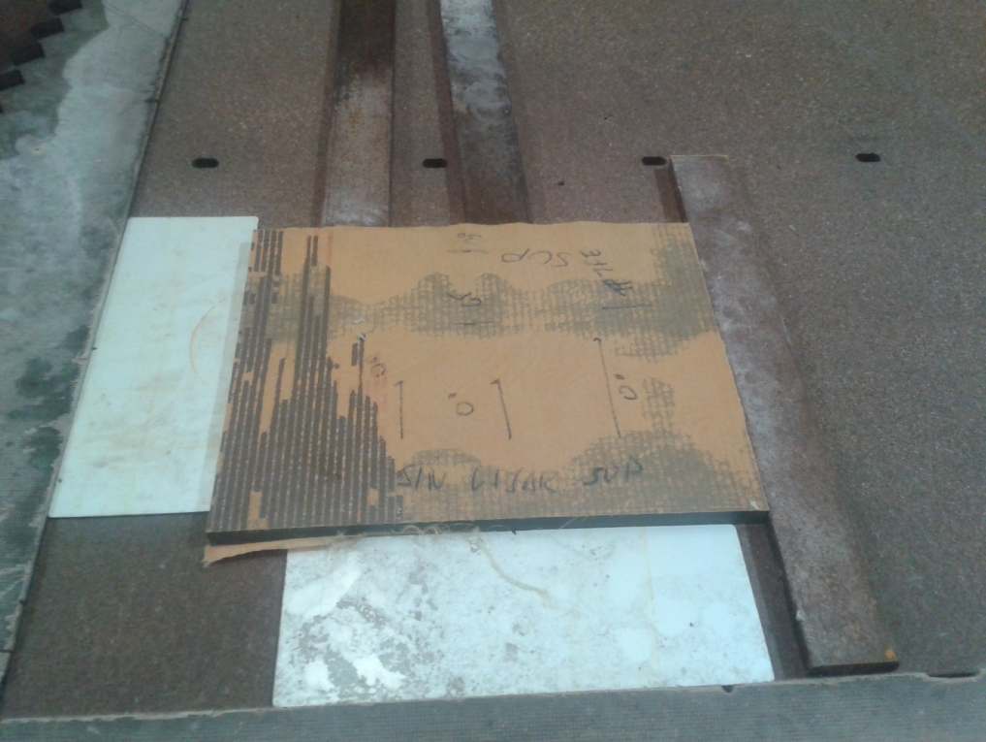 

Figure 6. Manufacturing of CFRP-Ti panels

1. **Challenges in operability**

Operability challenges include ease of recycling composite and titanium parts, overhauling and changing of titanium sheets periodically etc. The manufacturing process must adhere to highest ecological standards (ECO design) such as high recycling capability of materials, minimizing energy consumption etc [11]. Assessment of repair and interchangeability aspects also aid in determination and monitoring of recurring and non-recurring costs involved in operation and in-service maintenance of HLFC integrated wing structures.

1. **Challenges in integration**

Design and manufacturing methodology used for HLFC integrated must ensure that it´s feasible to integrate other sub-structures on the wing conveniently. This includes integration of all sub-structure elements like ribs, spar connections, any other supporting structures etc. In particular, the following objectives need to be achieved [11]:

1. Capability to integrate a functional ice protection system on the leading edge of HLFC wing
2. Integration of fully functional passive suction system or alternatively, keeping the active suction support to a minimum. The passive suction system should be able to demonstrate full setting range and accuracy for whole operational flight envelope.
3. Capability to integrate all other required systems like lift-devices, actuators, pipes, harness etc. on to the HLFC wing, considering aspects like mountability, space allocation, freedom of kinematic motion, failure cases etc.

However, the aim should be to keep the weight of these additional systems and structures to a minimum, so that the extra weight does not outweigh the fuel efficiency enhancemenets gained by reducing drag forces on the wings through HLFC technology.

**5. Conclusion**

The paper presents a detailed overview of challenges and corresponding efforts for design and manufacturing of HLFC integrated aircraft wings comprising Ti-Carbon laminates at the leading edge. It is evident that designing a fully-integrated HLFC wing system faces multiple challenges with regards to design, manufacturing, maintenance, operability, integration, validation test set-ups and assessment of their fracture characteristics. The paper also highlights the importance of minimizing the complexity and weight of the suction systems to realize true potential of HLFC technology in reducing the drag forces on the wing and thus increasing fuel efficiency. Furthermore, there are various factors which govern the failure characteristics of the Ti-Carbon laminate and also affect the accuracy of fracture energy estimations. These are briefly discussed and suggestive comments are made for a few cases. A precise understanding of all these factors can aid in performing accurate strength characterisation tests, and facilitate manufacturing of stronger and more durable laminate structures for the leading edge. By overcoming multiple challenges faced during structural optimization of HLFC aircraft wing, it is possible to achieve significant drag force reductions and higher fuel efficiencies, ultimately reducing pollution emissions into the atmosphere.

**Acknowledgement**

The authors would like to acknowledge the financial support received from European Union’s Horizon 2020, Clean Sky-2 research programme. The presented work is a part of work-package LPA-IADP-CS2-LPA-GAM-WP1.4.1.4.

References

[1] D.F. Fisher, and M.C. Fischer. Development flight tests of JetStar LFC leading-edge flight test experiment. *NASA Symposium on NLF and LFC Research*. NASA CP 2487, PP. 117-140, 1987.

[2] Boeing Commercial Airplane Group, Seattle, Washington. High Reynolds Number Hybrid Laminar Flow Control (HLFC) flight experiment IV. Published by National Aeronautics and Space Administration, Langley Research Center, National Technical Information Service, distributor in Hampton, Va, [Springfield, Va], 1999.

[3] P.F. Liu, and J.Y. Zheng. Recent developments on damage modeling and finite element

analysis for composite laminates: A review. *Materials & Design*, 31(8), pp.3825-3834, 2010.

[4] Z. Jiang, S. Wan, and Z. Wu. Calculation of energy release rate for adhesive composite/metal

joints under mode-I loading considering effect of the non-uniformity. *Composites Part B:*

*Engineering*, 95, pp.374-385, 2016.

[5] Z. Ouyang, G. Ji, and G. Li. On approximately realizing and characterizing pure Mode-I interface

fracture between bonded dissimilar materials. *Journal of Applied Mechanics*, 78(3), p.031020,

2011.

[6] C.D.M. Liljedahl, A.D. Crocombe, M.A. Wahab, and I.A. Ashcroft. Modelling the environmental

degradation of adhesively bonded aluminium and composite joints using a CZM approach. *International Journal of Adhesion and Adhesives*, 27(6), pp.505-518, 2007.

[7] A.J. Kinloch. Adhesion and adhesives. *Chapan and Hall*, 1987.

[8] M.D. Banea, and L.F. da Silva. Adhesively bonded joints in composite materials: an overview.

*Proceedings of the Institution of Mechanical Engineers, Part L: Journal of Materials: Design and Applications*, 223(1), pp.1-18, 2009.

[9] A.J. Kinloch. Durability of structural adhesives. *Appl. Sci. Publishers: London, New York*, 1983.

[10] M. Davis, and D. Bond. Principles and practices of adhesive bonded structural joints and

repairs. *International journal of adhesion and adhesives*, 19(2-3), pp.91-105, 1999.

[11] European Commision. Design of a wing with Hybrid Laminar Flow Control [HLFC] Technology.

*Clean Sky 2 Joint Undertaking, 4th Call for Core Partner (CPW04)*, pp.6-13, 2016

[12] J.S. Wang, and Z. Suo. Experimental determination of interfacial toughness curves using Brazil

nut-sandwiches. *Acta Metallurgica et Materialia*, 38(7), pp.1279-1290, 1990.

[13] B. F. Sørensen, K. Jørgensen, T.K. Jacobsen, and R.C. Østergaard. A general mixed mode

fracture mechanics test specimen: The DCB-specimen loaded with uneven bending moments.

(*Denmark. Forskningscenter Risoe. Risoe-R; No. 1394(EN)*), 2004.

[14] M.F.S.F. De Moura, J.J.L. Morais, and N. Dourado. A new data reduction scheme for mode I

wood fracture characterization using the double cantilever beam test. *Engineering Fracture*

*Mechanics*, 75(13), pp.3852-3865, 2008.

[15] ASTM D 5528-94a. Standard test method for mode I interlaminar fracture toughness of

unidirectional fibre-reinforced polymer matrix composites. *Annual Book of ASTM Standards*,

Vol. 15.03, 100 Barr Harbor Drive, West Conshohocken, PA 19428, USA, 1997

[16] ISO Standard [15024:2001]. Fibre-reinforced plastic composites––determination of mode I

interlaminar fracture toughness, GIC, for unidirectionally reinforced materials

[17] C. Sarrado, A. Turon, J. Renart and J. Costa. An experimental data reduction method for the

Mixed Mode Bending test based on the J-integral approach. *Composites Science and*

*Technology*, 117, pp.85-91, 2015.

[18] Community Research and Development Information Service (CORDIS), European Commission.

JTI-CS2-2016-CFP04-LPA-01-24 - High throughput micro drilling (HTMD) system, *CS2-IA*

*Innovation action*, 2017.