**Fatigue Testing and Fatigue Life Prediction of Injection Molded Carbon-fibre Reinforced Plastics for Automotive Oil-pan Application**

Jidong Kang1, Bin Li2, Jie Liang3 and Carlos C. Engler Pinto Jr.4

1CanmetMATERIALS, Natural Resources Canada, 183 Longwood Road South, Hamilton, Ontario, L8P 0A5, Canada

Email: [jidong.kang@canada.ca](mailto:jidong.kang@canada.ca), Web Page: https://profils-profiles.science.gc.ca/en/profile/dr-jidong-kang-peng-iwe

2CanmetMATERIALS, Natural Resources Canada, 183 Longwood Road South, Hamilton, Ontario, L8P 0A5, Canada

Department of Materials Science and Engineering, McMaster University, 1280 Main Street West, Hamilton, Ontario, L8S 4L7, Canada

Email: bin.li@canada.ca

3CanmetMATERIALS, Natural Resources Canada, 183 Longwood Road South, Hamilton, Ontario, L8P 0A5, Canada

Email: jie.liang@canada.ca

4Research and Innovation Centre, Ford Motor Company, 2101 Village Road, Dearborn, Michigan, 48124, USA

Email: cenglerp@ford.com

**Keywords:** injection molding, carbon-fibre reinforced plastics, fatigue behavior, fatigue life prediction

**Abstract**

Fatigue testing and fatigue life prediction of two injection molded carbon-fibre reinforced plastics are presented and discussed in the present paper. These two materials are being considered for automotive oil-pan application, namely PA66 LCF40, i.e. long carbon fibre-reinforced polyamide 66 pellets with 40 wt.% fibre concentration and PA66 SCF40, i.e. short carbon fibre-reinforced granules with 40 wt.% fibre concentration. Stress-controlled fatigue tests were carried out at room temperature under stress ratio, R= -1 and service temperature, 120 °C under stress ratio, R= -1, 0.1 and 10. The results showed that the fatigue behavior of LCF40 and SCF40 was similar at room temperature irrespective of the significantly higher ultimate tensile strength of LCF40 compared with SCF40. However, the fatigue performance of LCF40 was better than SCF40 at 120°C under R=-1 and 0.1while no apparent difference was observed under stress ratio, R=10 except the relatively higher fatigue strength at 2 million cycles for LCF40. Based on the fact that the measured fracture strains are statistically similar from fatigue and tensile testing, the Hwang & Han model was used to predict the fatigue performance, and the results are in good agreement with the experimental ones.

1. Introduction

Facing the increasing demand for structural lightweighting to improving fuel economy, fibre reinforced plastics are seen to replace metallic materials in automotive applications, with a further potential for mass reduction compared to lightweighting metallic materials [1]. Injection molded glass fibre polyamide composites are being considered for some automotive applications, such as oil pan due to their high specific stiffness and strength and better productivity [2]. With the recent development in carbon fibre manufacturing and recycling, there are renewed interests in using injection molded short carbon-fibre reinforced plastics for automotive oil-pan application due to their better mechanical properties at service temperatures ranging from -40 to 120°C. In collaborating with BASF and Montaplast, Ford Motor Company planned to convert the cast aluminum structural oil-pan of the 1.0 L3 GTDI Ford Ecoboost engine to a carbon fibre polyamide composite one [3].

Many studies focused on the mechanical performance including fatigue properties of glass fibre reinforced polymer for automotive applications [2, 4, 5]. Recently, Njuguna et al. [2] developed an oil-pan for ISF 3.8 Cummins engine using rubber toughened glass fibre reinforced polyamide composites. They reported that rubber-toughened polyamide 66 composites have better performance in terms of aging effect and impact resistance at service temperature. In contrast, carbon fibre reinforced polyamide composites have higher specific stiffness/strength and fatigue strength than glass fibre ones offering better opportunity for oil pan application. Mandell et al. [6,7] conducted fatigue tests at room temperature on neat nylon 66 and nylon 66 composites reinforced with carbon fibres and glass fibres. They discovered that fatigue failure was matrix-dominated and the fatigue life data could fall onto one master curve by normalizing the fatigue stress by corresponding static strength. Kawai et al. [8] investigated effect of temperature (up to 70°C) and stress ratio on fatigue life of carbon fibre reinforced polyamide 6 composites. They developed a temperature dependence parameter to predict the constant fatigue life diagrams, and the predictions agreed well with experimental data.

This contribution aims to study the fatigue behavior of two injection molded carbon fibre-reinforced polyamide 66 composites with different stress ratios and stress levels at room temperature (RmT) and 120 °C, i.e. the potential service temperature of the oil pan. Through analyzing the fatigue data, fatigue life models were established based on the strain failure assumption and the predictions were compared with the experimental data.

2. Materials and experimental procedures

2.1. Materials and specimen

Two injection molded carbon fibre-reinforced polyamide 66 composites were tested in this study: PA66 LCF40, i.e. long carbon fibre (about 0.40 mm long) reinforced polyamide 66 pellets composites with 40% weight fibre concentration; and PA66 SCF40, i.e. short fibre (about 0.20 mm long) reinforced granules composites with 40% weight fibre concentration.

The fatigue specimen geometry is shown in Fig. 1. All specimens were machined along the injection flow direction using water-jet cutting from plates in dimensions of 305 mm x 305 mm x 4 mm. The plates were manufactured and provided by BASF, Germany using its proprietary injection molding processes. Prior to testing, all specimens were ground up to Grade 800 on the machined edges to remove visible machining undulations and defects.

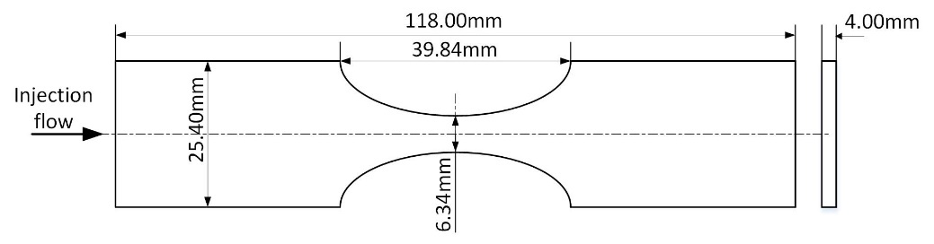

**Figure 1.** Geometry of the fatigue test specimen.

2.2. Experimental procedures

Static tensile and compression tests at room temperature (RmT) and 120°C were performed on an MTS Landmark test frame. For the tensile tests, minimum 5 specimens each temperature were tested at the crosshead displacement rate was 60mm/min. An extensometer with a 10mm gage length was used for strain measurement at RmT and an extensometer with 8 mm gage length at 120°C. For compression tests at 120°C, the crosshead displacement rate was chosen to be 0.3mm/min in order to mitigate potential damage to the test frame.

To avoid significant temperature increase during fatigue testing, the relationship between temperature increment and fatigue test frequency at given fatigue stress amplitude was mapped to ensure that suitable test frequency was chosen to limit the maximum temperature increase (≤ 10 °C) during fatigue testing. Fatigue tests under R=-1 at RmT were carried out at different combinations of test frequencies and maximum stress levels up to 2000 cycles. The relationship between temperature change measured at the last fatigue cycle versus test frequency and stress levels is mapped and the results for PA66 LCF40 are plotted in Figure 2. The results show that when the test frequency exceeds 15Hz or the stress level is higher than 70MPa, temperature increases more than 10 °C during fatigue testing. This is primarily due to internal friction heating inside the polyamide specimen during the fatigue process despite very little temperature rise on the surface, or there may be other complications from load cycling at low frequency. The higher the test frequency or the stress level is, the faster the temperature at the interior will reach the glass transition temperature, Tg [9]. Therefore, the fatigue test frequency for both PA66 LCF40 and PA66 SCF40 was chosen for 10Hz for fatigue stress level less than 65 MPa and 5 Hz for stress level exceeding 65MPa for all the fatigue tests in the present study.

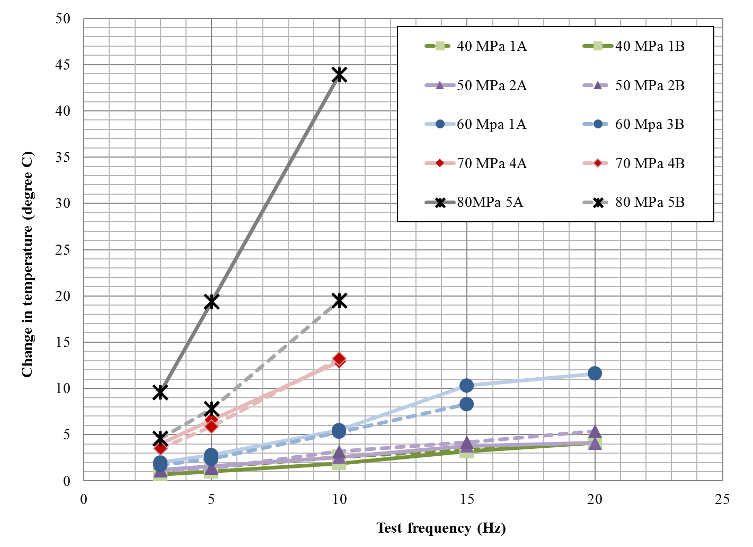

**Figure 2.** The relationship between temperature change at the last fatigue cycle (2000th cycle) vs. test frequency and stress level under R=-1 at room temperature for PA66 LCF40.

All fatigue tests were conducted on the same MTS Landmark test frame until the specimen were completely separated or were stopped at 2 million cycles as run-out. An extensometer with a 6mm gage length was used to measure cyclic strain variations and record the hysteresis loops at given fatigue cycles. For tests conducted at RmT with PA66 LCF40 and PA66 SCF40, a Flir infrared camera system (Model SC7000) was employed to record the surface temperature field of specimen. For testing at 120°C, a thermocouple was used to measure the surface temperature evolution. Fatigue tests were carried out at RmT under stress ratio R=-1 and 120 °C under R=-1, 0.1 and 10. Stair case method was used in the tests. 24 specimens were tested for PA66 LCF40 and PA66 SCF40 under R=-1, and 12 specimens were tested under R=0.1 and 10.

3. Results and discussion

3.1. Tension and compression properties at different temperatures

Table 1 shows the ultimate tensile strength (UTS) of PA66 LCF40 and PA66 SCF40 at RmT and 120°C and ultimate compression strength at 120°C. From Table 1, it is seen that PA66 LCF40 has significantly higher tensile strength than PA66 SCF40 at RmT and 120°C. However, the compressive strength of PA66 LCF40 is close to the SCF40 at 120°C. Clearly, tensile strength of both materials significantly decreases when the test temperature increases to 120°C.

**Table 1.** Ultimate tensile strength and ultimate compression strength of PA66 LCF40 & SCF40 at different temperatures

|  |  |  |  |  |  |
| --- | --- | --- | --- | --- | --- |
|  | Temperature  (°C) | Ultimate tensile strength | | Ultimate compressive strength | |
| Mean (MPa) | Standard deviation (MPa) | Mean (MPa) | Standard deviation (MPa) |
| PA66 LCF40 | RmT | 239 | 10.1 | - | - |
| 120 | 102 | 2.7 | 95 | 2.1 |
| PA66 SCF40 | RmT | 196 | 9.6 | - | - |
| 120 | 83 | 7.2 | 89 | 5.5 |

3.2. Fatigue behavior

**3.2.1. Fatigue behavior at different temperatures**

Fatigue life data under different temperatures and stress ratios were shown in Fig.3 (R=-1, RmT), Fig.4 (R=-1, 120°C), Fig.5 (R=0.1, 120°C), Fig.6 (R=10, 120°C), respectively. Note that in Fig. 3-6, the fatigue stress amplitude was normalized by the corresponding ultimate strength of PA66 LCF40 and PA66 SCF40 under tension or compression. To highlight the trend of the fatigue data, an alternative format (Eq. 2) of the commonly accepted Basquin equation (Eq. 1) was used to fit all the data.

$σ_{a}=σ_{f}{(2N)}^{b}$ (1)

$logN=-\frac{log⁡(2^{b}σ_{f})}{b}+ \frac{logσ_{a}}{b}$ (2)

where *σf* and *b* are the fatigue strength coefficient and fatigue strength exponent, respectively, N is the fatigue life, and *σa* is the fatigue stress amplitude.

The Basquin fitting curves are shown in Fig.3 to Fig6, respectively. The results showed that all the fatigue data were fit well with Eq. 2. It is seen in Fig. 3 that at RmT, the fatigue behavior of PA66 LCF40 and PA66 SCF40 under R=-1 is very similar irrespective of the significant higher UTS of LCF40 compared with SCF40. However, there were large scatters in the fatigue life data of PA66 LCF40. This is likely to be related to the manufacturing defects such as voids and matrix cracks formed during the injection molding process that are detrimental to mechanical properties, as the injection molding machine used approaches its loading capacity [3].

The fatigue property of PA66 LCF40 is much better than that of PA66 SCF40 at 120 °C under R=-1 and 0.1, as shown in Figs. 4 and 5. In addition, no apparent difference is observed for both materials at 120 °C under R=10 except the relatively higher fatigue strength at 2 million cycles for PA66 LCF40 and the trend lines are flat in Fig. 6.

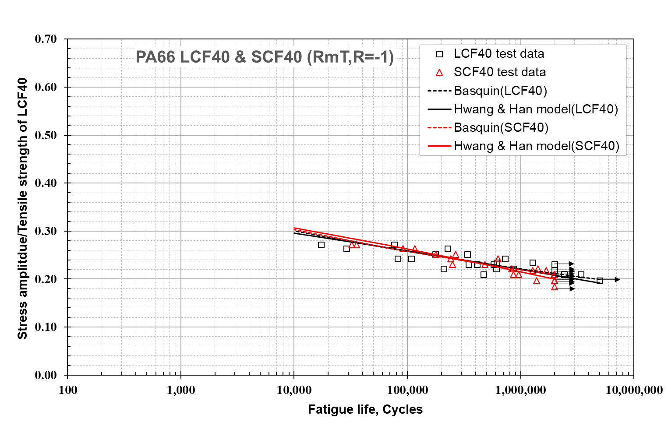

**Figure 3.** Fatigue test data and Hwang & Han model prediction at room temperature and R=-1 for PA66 LCF40 and PA66 SCF40.

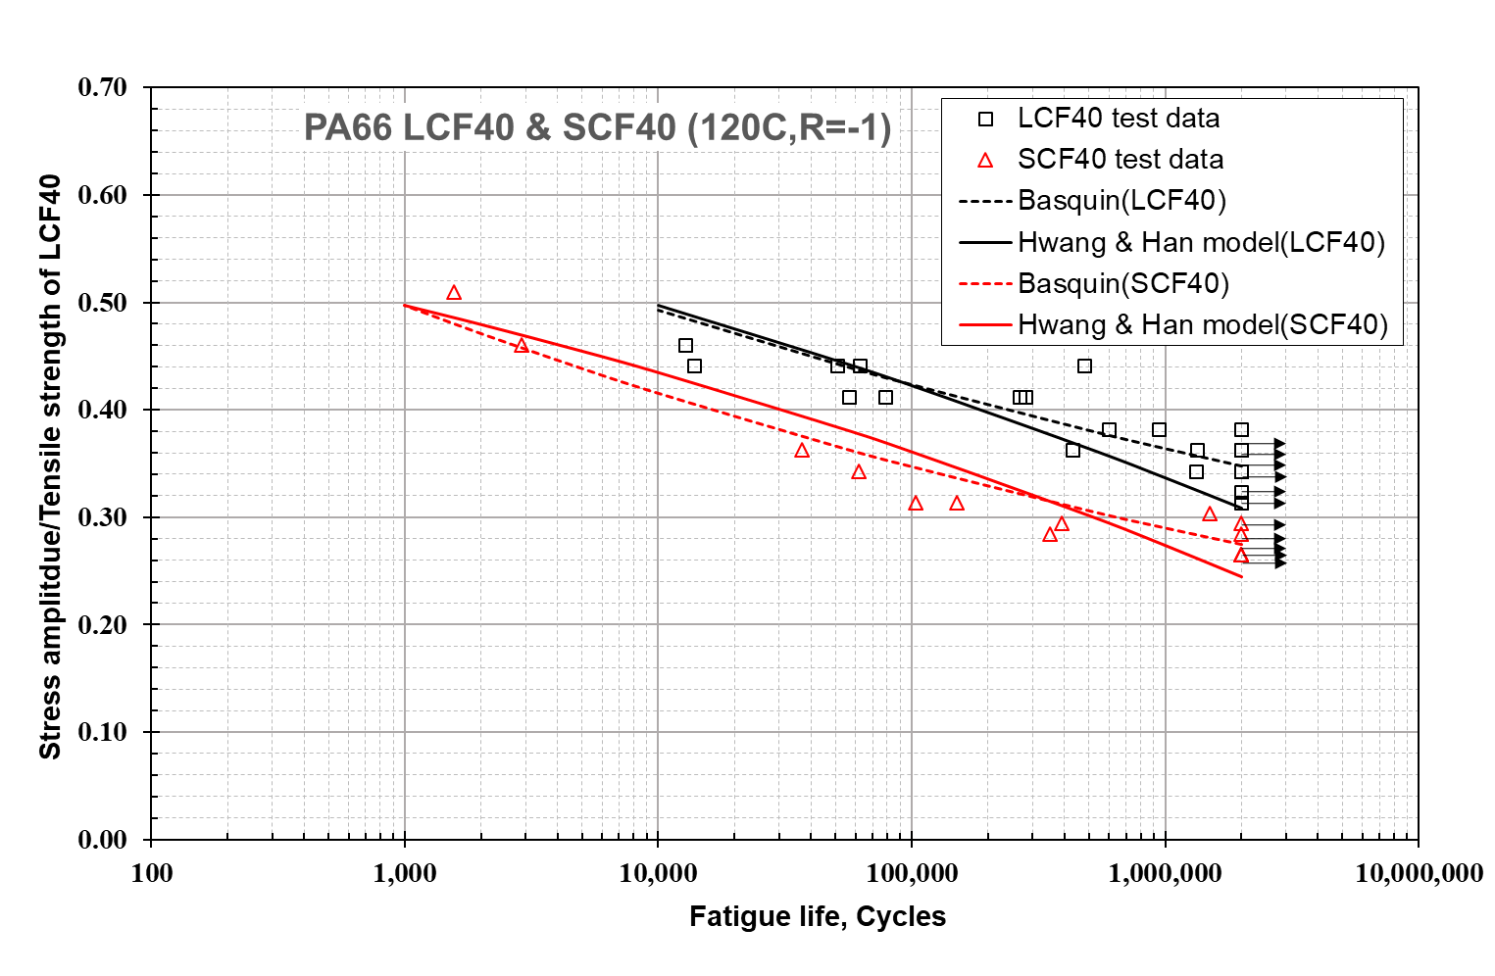

**Figure 4.** Fatigue test data and Hwang & Han model prediction at 120 °C and R=-1 for PA66 LCF40 and PA66 SCF40.

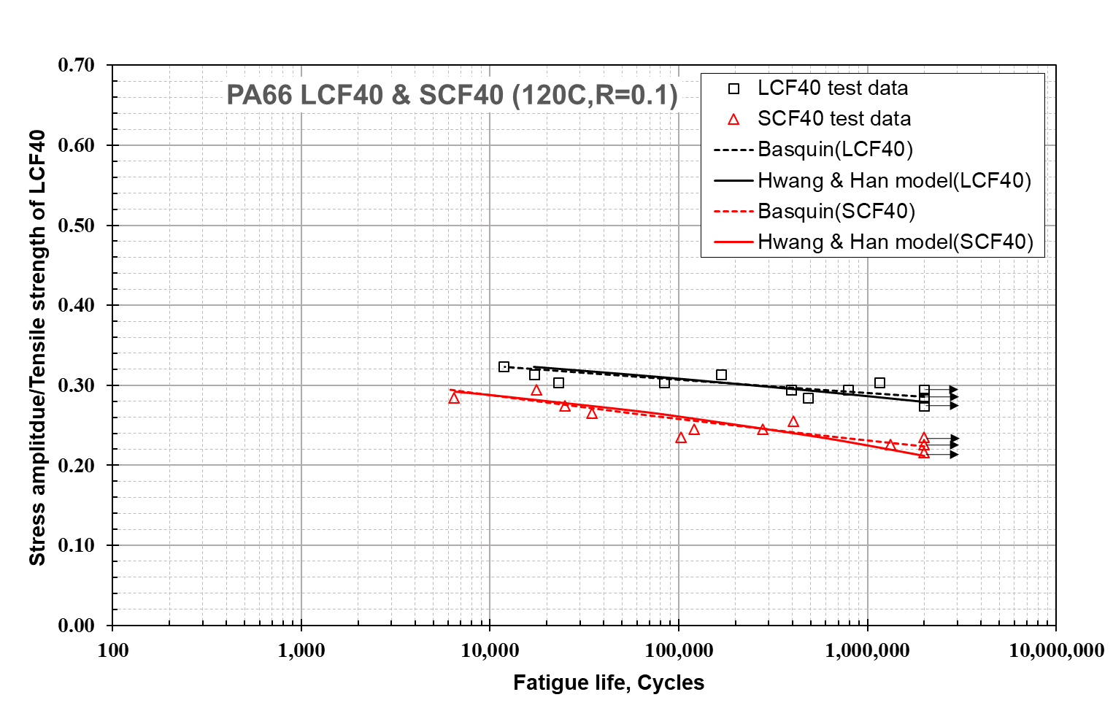

**Figure 5.** Fatigue test data and Hwang & Han model prediction at 120 °C and R=0.1 for PA66 LCF40 and PA66 SCF40.

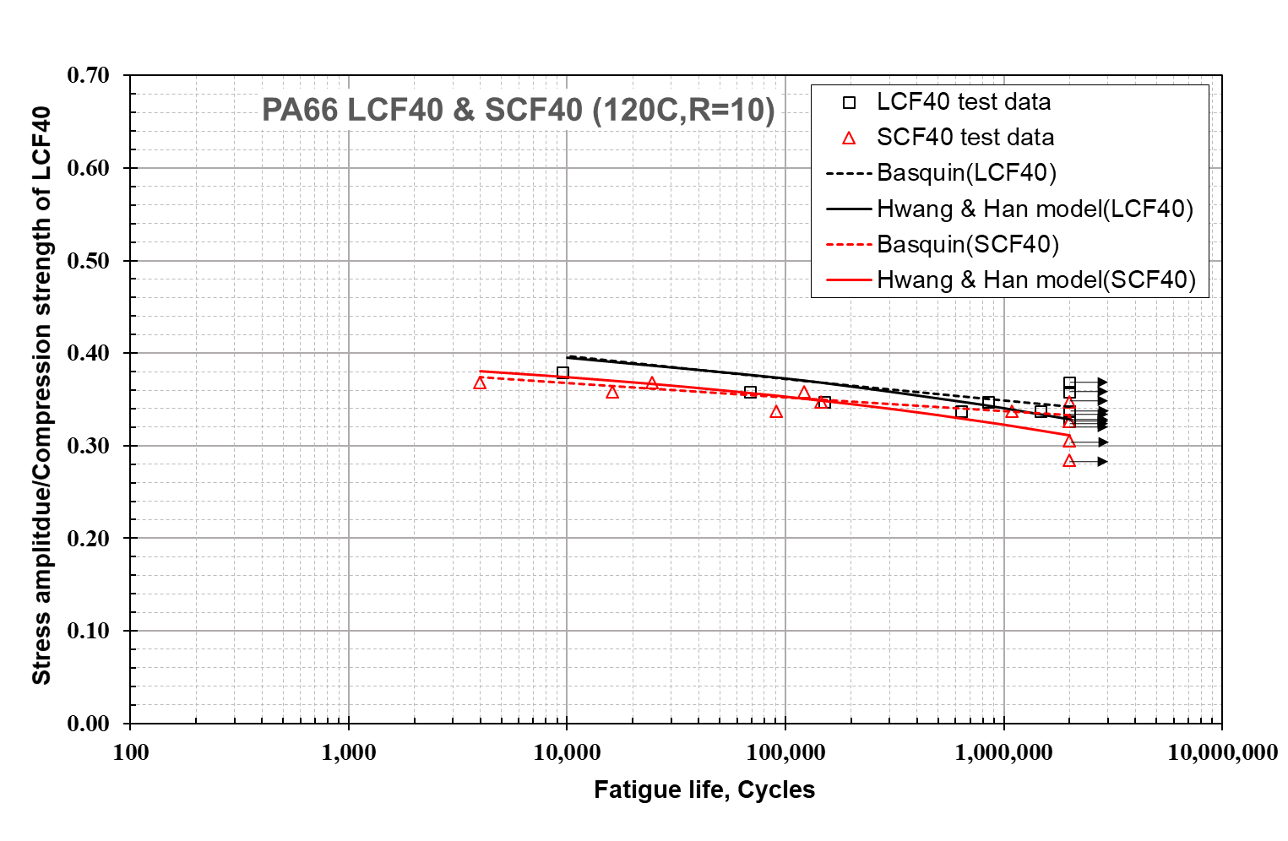

**Figure 6.** Fatigue test data and Hwang & Han model prediction at 120 °C and R=10 for PA66 LCF40 and PA66 SCF40.

In summary, fatigue data shown in Figs. 3-6 indicate that the fatigue strength of PA66 LCF40 is better than PA66 SCF40 at 120°C, although fatigue performance of PA66 LCF40 is similar to PA66 SCF40 at room temperature. This is mainly attributed to the fact that PA66 family materials are matrix-dominated composites as reported in the earlier studies [6-7]. This can be evident from the measured cumulative strain in fatigue compared with the ultimate tensile strain at fracture for both materials that will be discussed in detail next.

**3.2.2. Cumulative strain to failure in fatigue**

The ultimate tensile strains at fracture and the cumulative strains in fatigue were recorded during the tests. Fig.7 shows the cumulative distribution function curves of cumulative strain to failure and ultimate tensile strain at fracture for both PA66 LCF40 and PA66 SCF40 materials at RmT. As illustrated in Fig. 7, the distributions of both the fatigue cumulative strains and the ultimate tensile strains are similar while the mean value of the fatigue cumulative strains are relatively smaller than the ultimate tensile strains. This is consistent with observations from other researchers [6-7].

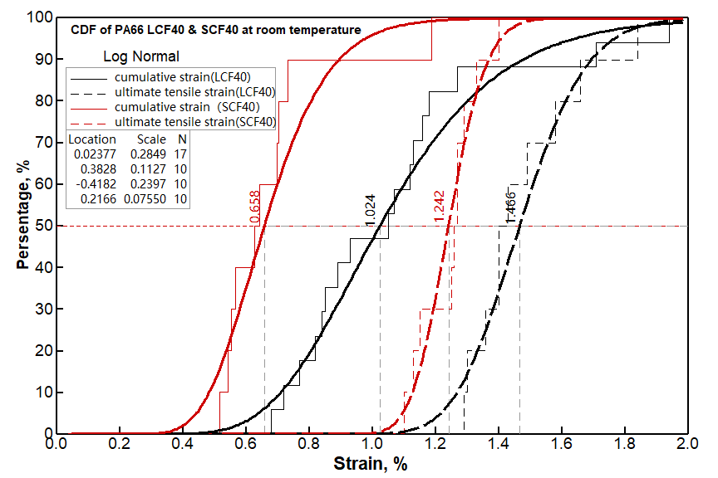

**Figure 7.** Cumulative distribution function of ultimate tensile strain and cumulative strain to failure of PA66 LCF40 and PA66 SCF40 at room temperature

**3.3. Fatigue life prediction**

Assuming that the rate of fatigue modulus degradation follows a power function of cycles, Hwang and Han [10] developed a model of fatigue life prediction for glass epoxy (G-IOCR Grade) composite material. In the model, it was further assumed that the fatigue cumulative strain at fracture is equal to the ultimate tensile strain at fracture, then the model can be simplified as follows,

 (3)

Where *B* and *c* are material constants. *r= Sa/Su,* which *r* is the ratio of applied stress, *Sa* to the ultimate strength of materials, *Su*.

In the present study, the relation of stress amplitude, *σa* and the applied stress, *Sa* is as follows,

$S_{a}=\frac{2}{1-ψ}σ_{a}, where ψ=\left\{\begin{aligned}R, for -∞<R<1 (tension-tension and reverse loading) \\ 1/{R,}for 1<R<∞ \left(compression-compression\right) \end{aligned}\right.$ (4)

Eq. 3 was used to predict fatigue life of both PA66 LCF40 and PA66 SCF40 materials under different temperatures and stress ratios and the results are shown in Figs. 3-6, respectively. It is seen in Figs. 3-6 that both the prediction and experimental data agree well. Moreover, the predicted fatigue strength is lower than the experimental one, i.e. more conservative in nature.

4. Conclusions

This paper presents a study on fatigue testing and fatigue life prediction of two injection molded carbon-fibre reinforced plastics, PA66 LCF40 and PA66 SCF40 at RmT and 120°C for an automotive oil pan application. The following conclusions can be drawn,

1) Tensile strength of PA66 LCF40 is higher than that of PA66 SCF40 at RmT but similar at 120°C. The compressive strength of both materials is similar at 120°C.

2) While the fatigue behavior of PA66 LCF40 and PA66 SCF40 under R=-1 is very similar at RmT, the fatigue performance of PA66 LCF40 is much better than PA66 SCF40 at 120 °C with R=-1 and 0.1. In addition, no apparent difference was observed under stress ratio, R=10 except the relatively higher fatigue strength at 2 million cycles for PA66 LCF40. This is attributed to the fact that both materials studied are matrix-dominated.

3) The Hwang & Han model was successfully used to predict the fatigue life of both materials under different stress ratios and temperatures and the predictions are in good agreement with experimental data.

Acknowledgments

The authors are grateful the financial support provided by the NorthernStar Program, Ford Motor Company.

References

[1] J.W. Mcauley. Global Sustainability and Key Needs in Future Automotive Design. *Environmental Science & Technology*, 37: 5414-5416, 2003.

[2] J. Njuguna. *Lightweight Composite Structures in Transport*, Elsevier, 2016.

[3] BASF, Ford and Montaplast partner to develop carbon fiber reinforced front engine cover and structural oil pan for the Multi-Material Lightweight Vehicle project. Website: <https://www.basf.com/us/en/company/news-and-media/news-releases/2015/04/P-US-14-76.html>

[4] S. Mortazavian and A. Fatemi. Fatigue behavior and modeling of short fiber reinforced polymer composites: A literature review. *International Journal of Fatigue,* 70: 297-321, 2015.

[5] S. Mortazavian and A. Fatemi. Fatigue of short fiber thermoplastic composites: A review of recent experimental results and analysis. *International Journal of Fatigue,* 102: 171-183, 2017.

[6] J.F. Mandell, F.J. McGarry, D.D. Huang and C.G. Li. Some effects of matrix and interface properties on the fatigue of short fiber-reinforced thermoplastics. *Polymer Composites*, 4: 32-40, 1983.

[7] K.L. Reifsnider. *Fatigue of composite materials*, Elsevier, 1991.

[8] M. Kawai, H. Takeuchi, I. Taketa and A. Tsuchiya. Effects of temperature and stress ratio on fatigue life of injection molded short carbon fiber-reinforced polyamide composite. *Composites: Part A*, 98: 9-24, 2017.

[9] J.A. Sauer and G.C. Richardson. Fatigue of polymer. *International Journal of Fracture*, 16: 499-532, 1980.

[10] W. Hwang and K.S. Han. Fatigue of composites - fatigue modulus concept and life prediction. *Journal of Composite Materials*, 20: 154-165, 1986.