Multi-spot ultrasonic welding of thermoplastic composite single-lap joints: effect of spot spacing and number of spots on weld strength

T. Zhao¹, I. Tsakoniatis¹, C. Rans¹, I.F. Villegas¹ and R. Benedictus¹

¹ Structural Integrity & Composites Group, Aerospace Structural & Materials, Delft University of Technology, Delft, the Netherlands
Email: T.Zhao@tudelft.nl, Web Page: http://staff.tudelft.nl/en/T.Zhao/
Email: I.Tsakoniatis@tudelft.nl, Web Page: http://staff.tudelft.nl/en/I.Tsakoniatis/
Email: C.Rans@tudelft.nl, Web Page: http://staff.tudelft.nl/en/C.D.Rans/
Email: I.FernandezVillegas@tudelft.nl, Web Page: http://staff.tudelft.nl/en/I.FernandezVillegas/
Email: R.Benedictus@tudelft.nl, Web Page: http://staff.tudelft.nl/en/R.Benedictus/

Keywords: Thermoplastic composites, spot welded joint, mechanical behaviour, secondary bending

Abstract
Thermoplastic composite spot welded joints are more well-suited for carrying shear load rather than peel load. However, peel load is difficult to be eliminated in single-lap joint configuration. In this paper, a series of mechanical tests were carried out to study the effects of the spot spacing and the number of welded spots on the secondary bending and subsequently on the strength of the multi-spot welded joints. Based on that, a comparative study was performed on the load-carrying capability of multi-spot welded and mechanically fastened joints assembled with multi-row fasteners. It was found that, by increasing the spot spacing and the number of welded spots, the secondary bending of the multi-spot welded joints can be effectively decreased, which eventually results in a comparable load-carrying capability with respect to the mechanically fastened joints.

1. Introduction

The inherent properties of thermoplastic composites (TPCs) have rendered them particularly appealing to aircraft manufacturers as an alternative to their thermoset counterparts. The high toughness and recyclability they exhibit are some of these properties, yet the main reason is the low-cost and rapid manufacturing techniques available for them due to their ability to be formed repeatedly [1-3]. Of special interest is their ability to be joined using welding, avoiding problems associated with mechanical fastening and adhesive bonding such as damaging of adherends and intricate surface preparation respectively. Ultrasonic welding is particularly promising as it can reduce welding times to a couple of seconds while offering welds of excellent strength [4,5].The ultrasonic welding method is suitable for spot welding of TPCs. A previous study has shown that ultrasonic single-spot welded (SSW) joints have comparable shear strength to that of mechanical fastened joints with a single fastener [6].

The most typical test configuration for assessing the tensile/shear behaviour of spot welded joints are single-lap joints, both for TPCs and metals [4-7]. The single-lap configuration is also widely used in structural joints. However, due to the eccentric load path in such joints, secondary bending occurs during tensile loading, resulting in out-of-plane deformation and hence peel stress [7,8]. Despite their good performance under shear loading in comparison to mechanically fastened joints, ultrasonic spot welded joints display a lower performance under peel loading [6]. It is therefore crucial for their application in structures to minimise the out-of-plane deformations during tensile loading. The main factor that can affect the loading path and deformations is the joint geometry, such as introducing multiple spot welds. Although there exist a few studies on metal spot welding [7], no research is available regarding the effect of joint geometry and secondary bending on the weld strength of spot welded TPCs.

Consequently, the aim of this research paper is to investigate the influence of the single-lap joint geometry, namely spot spacing (i.e. distance between spots) and number of spots, on the weld strength of multi-spot ultrasonically welded TPC joints. The effect of the abovementioned geometric parameters on the secondary bending and subsequently on the load-carrying capability (LCC) of the joints was evaluated and a comparative study with mechanically fastened joints with multi-row fasteners was carried out. The secondary bending was characterized by out-of-plane deformation of the joint overlap, which was captured by digital image correlation (DIC) technique during mechanical testing.

2. Experimental

2.1 Materials

The material used throughout the course of this study was carbon fibre reinforced Polyphenylene sulphide (CF/PPS) with 5 harness satin fabric reinforcement, provided by Ten Cate Advanced Composites (Netherlands). Laminates were manufactured using six 580 x 580 mm² powder-impregnated composite plies with stacking sequence of [0/90]_{3s} consolidated in a hot-platen press at 320 ºC and 1 MPa pressure for 20 min. The consolidated laminates were then cut using a water-diamond saw according to the test dimensions to be specified in the next section, such that the main apparent fibre orientation was parallel to the loading direction in the single-lap shear test.

2.2 Assembling techniques

The multi-spot welded (MSW) test specimens were welded using a 20 kHz Rinco Dynamic microprocessor-controlled ultrasonic welder with a maximum power output of 3000 W and a titanium circular sonotrode with a diameter of 10 mm. Fig. 1 displays the welding setup indicating the sonotrode, clamps and aluminium supporting plate used under the upper adherend for alignment. The adherends were positioned and clamped for every spot weld manually. The energy directors (EDs) used were circular with 4 mm diameter and were cut from 0.24 mm thick PPS film.

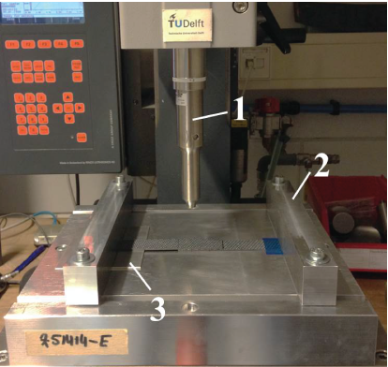

Figure 1: Ultrasonic welder and welding jig used in this study. 1: sonotrode, 2: bar clamp, 3: supporting plate for the upper adherend.

Displacement control, i.e. application of vibrations until a predefined vertical displacement of the sonotrode is reached, was used for producing all the welds. The optimum sonotrode displacement and welding amplitude were identified as 0.23 mm, 60.8 μm (peak-to-peak) respectively for obtaining maximum weld strength. The welding force was 1500 N in initiation and linearly increased at a rate of 1000 N/s during the vibration stage. Afterwards, the welds were consolidated at 1500 N for 4000 ms.
The mechanically fastened test specimens were fastened using Titanium HL10V6 Hi-Lok® fasteners with pin length of 4.8 mm and diameter of 4 mm. The adherends were pre-drilled with a wooden plate underneath to prevent delamination and the fasteners were manually installed with a ratchet wrench.

2.3 Mechanical Testing

The MSW joint test specimens were designed in a way to investigate the effect of the spot spacing as well as the number of spots on the secondary bending and consequently weld strength. For the spot spacing investigation, specimens consisted of two spot welds with varying spot spacing of 10, 20, 30 and 40 mm, referred to as 2SW-10, 2SW-20, 2SW-30 and 2SW-40 respectively. The distance between the spots and the overlap edge was kept constant (15 mm) and the free sheet length, i.e. the length between the grips and the edge of the overlap, was equal to the overlap so that it is large enough to not influence secondary bending [8]. Fig. 2 shows a schematic of the MSW joint configuration. Single-spot welds (1SW) were treated as a special case with zero spot spacing.

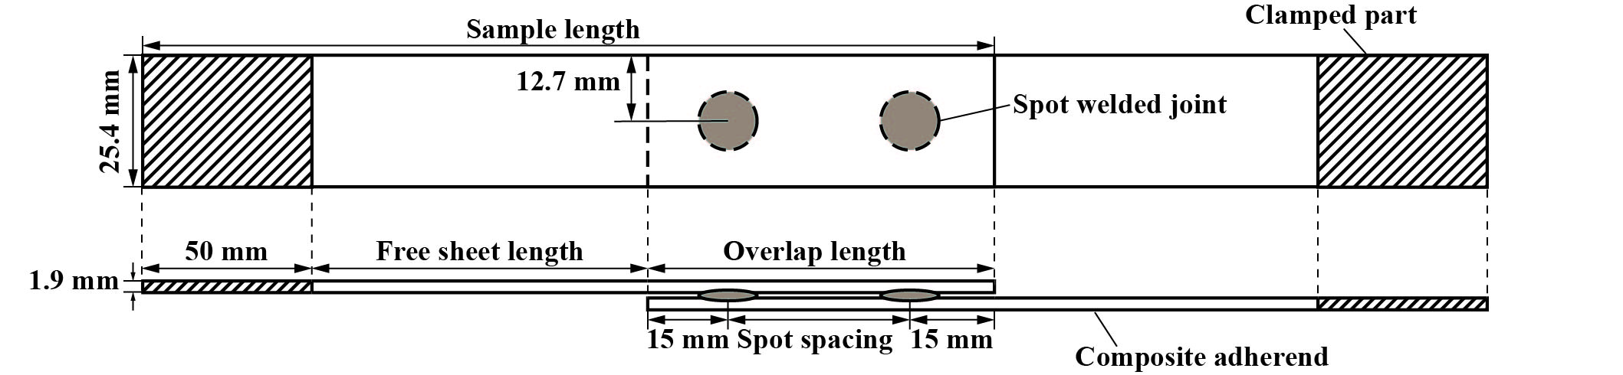
Figure 2: Schematic of the generic configuration of multi-spot welded single-lap shear joint specimen in this study.

For the investigation on the effect of the number of spots on the weld strength, the test specimen were welded with 2, 3 and 4 spot welds uniformly distributed along a fixed overlap of 70 mm and they are referred to as 2SW, 3SW and 4SW respectively. The MMF joint specimens that were tested for comparison had the same geometry and are referred to as 2MF, 3MF and 4MF respectively, for two, three or four mechanical fasteners.

All specimens were tested in single-lap shear according to the ASTM D1002 standard, using a Zwick /Roell 250 kN universal testing machine fitted with hydraulic grips. The tests were performed at a constant crosshead speed of 1.3 mm/min and five samples were tested for each joint configuration. The maximum load reached during the test will be noted as ultimate failure load (UFL) and considered the main indicator for the load-carrying capability (LCC) of the welded joints [6]. For the mechanically fastened joints, the LCC was linked to the onset failure load (OFL) obtained through a bilinear approximation of the load displacement curve, as the adherends are damaged beyond that point [9,10].

During testing, the out-of-plane deformation of the joint overlap was measured using Vic-3D DIC system, supplied by Limess Messtechnik & Software GmbH Inc, Germany. The setup can be seen in fig. 3. Two CCD cameras were coupled with a light source to track the top surface of the overlap, by capturing digital images at a frequency of 1 Hz. Using the first image as a reference, the accumulated strain was calculated by comparing to the subsequent images.
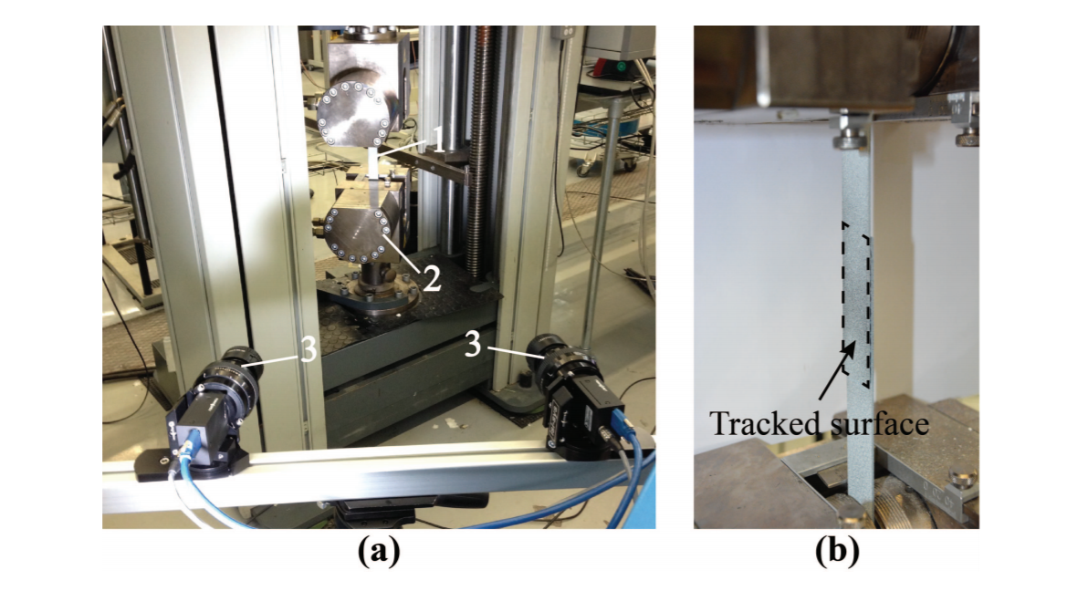

Figure 3: (a) Mechanical test set-up: 1, specimen, 2, hydraulic grips, 3, CCD cameras, and (b) the magnification.

3. Results and discussion

3.1. Effect of the spot-to-spot distance

The UFL of the 1SW (reference) and of various 2SW joints are plotted in Fig. 4. As depicted in the figure, the studied 2SW joints generally exhibited an increasing trend in their UFL when increasing the spot spacing. A significant increase (around 22 %) of the UFL was found from 2SW-10 to 2SW-20 joints. In contrast to that, 2SW-30 joints showed a comparable UFL to 2SW-20 joints and the UFL of the 2SW-40 joints was found just 6 % higher than that of the former two counterparts. Regarding to the 1SW joints, the UFL was significantly lower than that of the 2SW joints, which is reasonable considering that only one welded spot was produced.

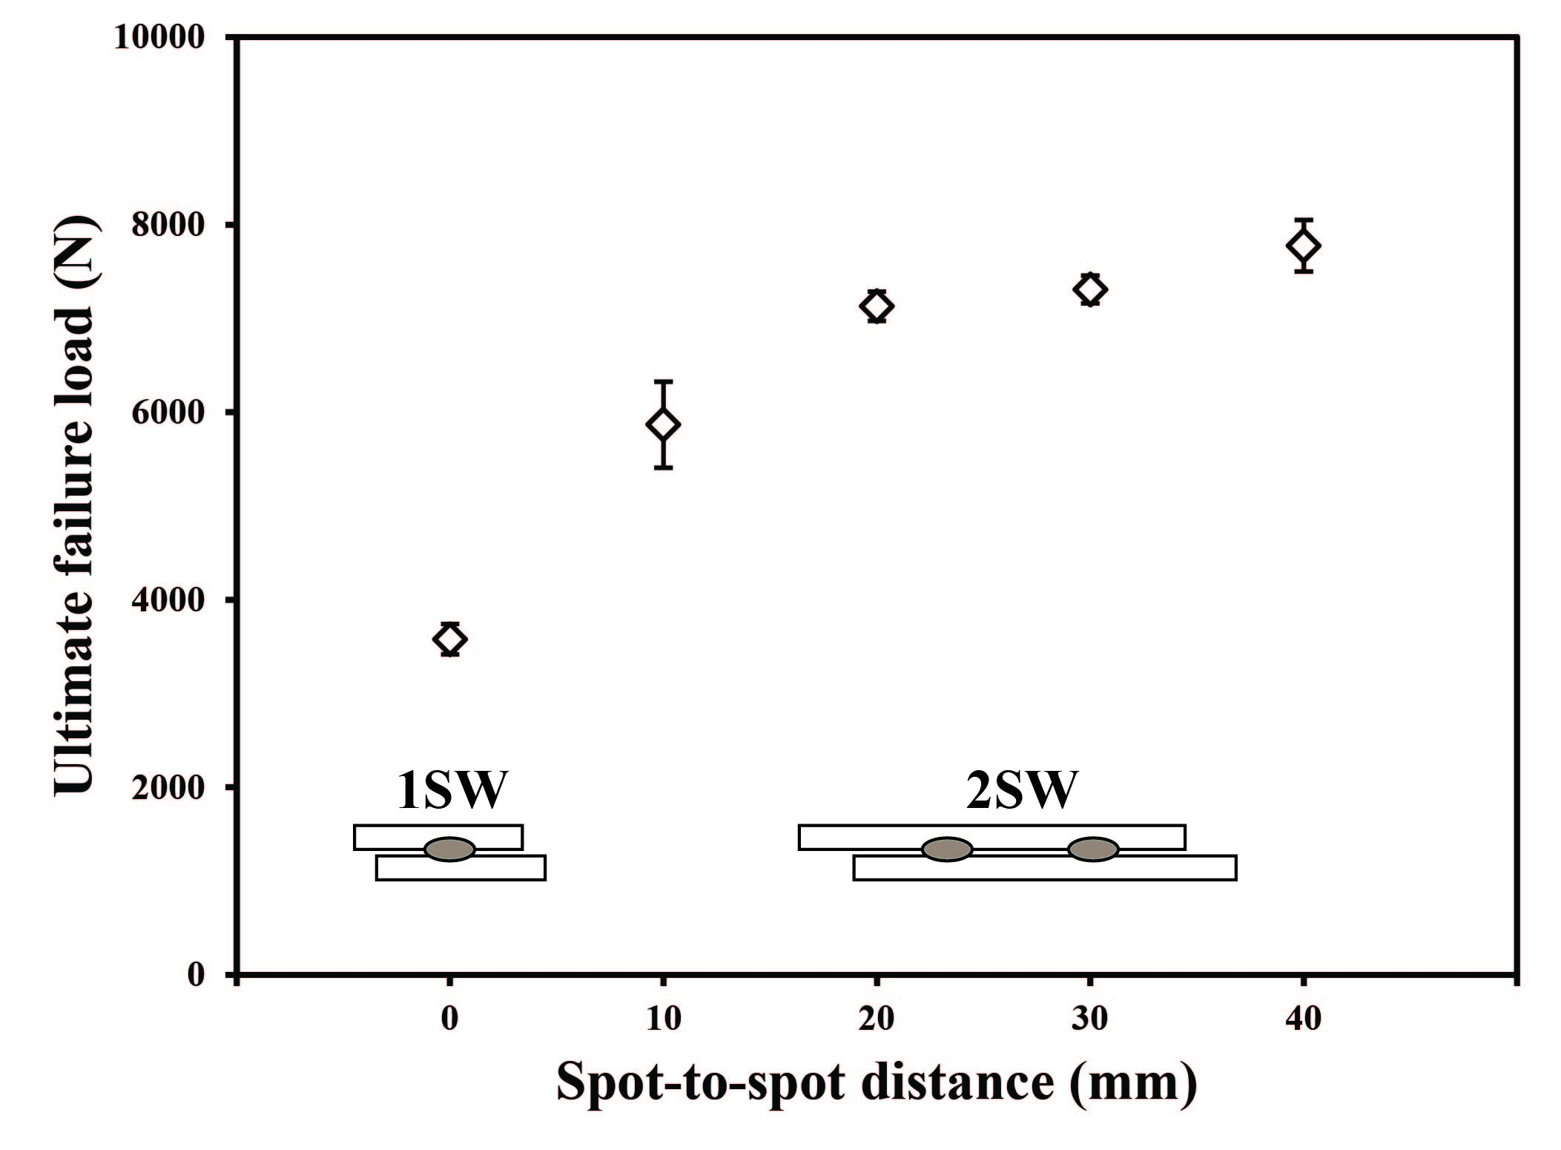
Figure 4. UFL of both the 1SW and the 2SW joints with different spot spacing. The dashed line corresponds the double of the average UFL of the 1SW joints.

The improvement of the UFL of the 2SW joints with larger spot spacing is likely owing to the decreased secondary bending of the joint overlap during the loading process. The comparison of out-of-plane deformation of the 1SW, 2SW-10 and 2SW-40 joints under the same loading condition (3000 N) is illustrated in Fig. 5. Although all the studied samples showed similar out-of-plane deformation, ranging from -0.2 mm to 0.4 mm, considering the largest spot spacing, the rotation of the overlap of the 2SW-40 joints was much less significant than that of the other two joint counterparts. As a result, the peel load introduced into the 2SW-40 joints was expected to be the lowest.

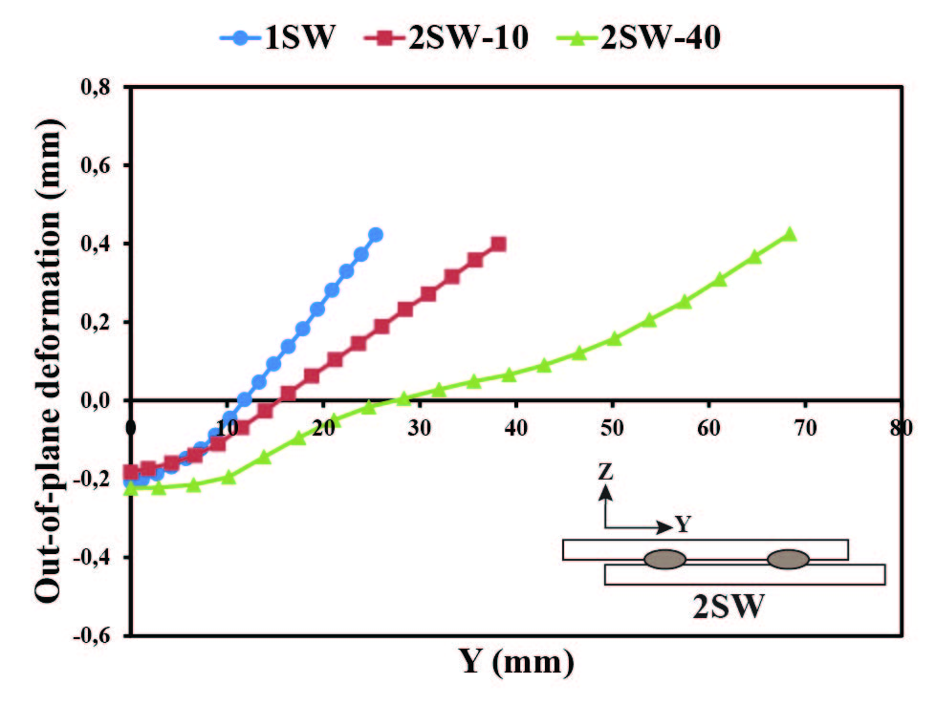
Figure 5. Out-of-plane deformation of the joint overlap under 3000 N load for different joint configurations: 1SW, 2SW-10 and 2SW-40.

However, the decrease of the peel load did not provide a very significant improvement for the UFL of the 2SW joints from 20 to 40 mm spot spacing. The biggest increase of the UFL was found from the 2SW-10 to 2SW-20 joints, which was, at least partially owing to the increase of the welded area. As illustrated in Fig. 6a, due to the short spot spacing, i.e. 10mm (approximately equal to the diameter of the welded spot), the flow fronts of the melted ED of Spot 1 (i.e. the first spot to be welded) was hindered by the pristine ED 2 during the welding process. Therefore, the welded area of the first spot was relatively smaller than that of the spots in the other 2SW joints, e.g. 2SW-20 (see Fig. 6b). Subsequently, the 2SW-20, as well as the 2SW-30 and 2SW-40, had bigger final welded areas than the 2SW-10 joints. Combined with the abovementioned lower peel stress, the UFL of the 2SW-20 joints achieved a significant improvement.

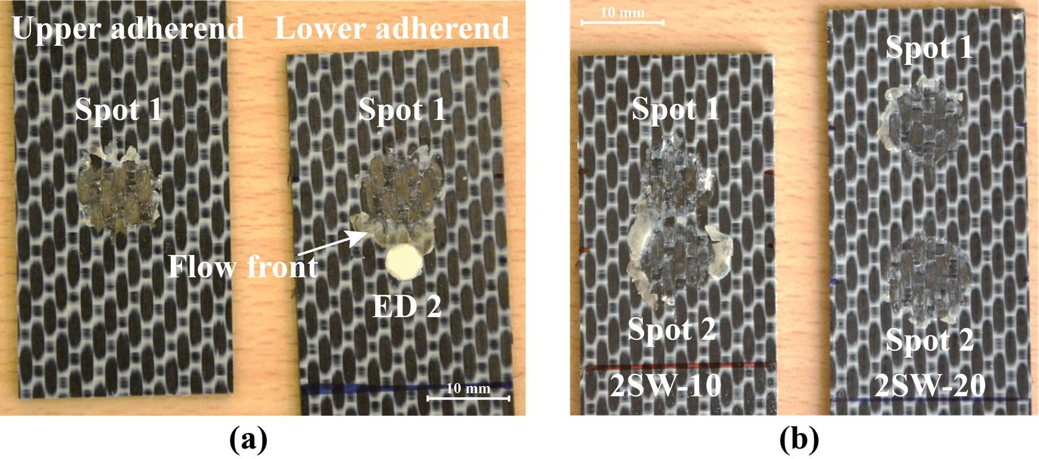
Figure 6. (a) Fracture surfaces of the 2SW-10 joints with only one spot welded and (b) the comparison of fracture surfaces between the 2SW-10 and the 2SW-20 joints.

3.2. Effect of the number of the welded spots

Based on the investigations carried out above, secondary bending can be effectively avoided when increasing the spot spacing between two spots. It should be noted that extra spots are still possible to be welded in between the two spots when they have a big spot spacing, e.g. 40 mm. This section mainly presents the effect of the number of welded spots in the UFL of the MSW joints.

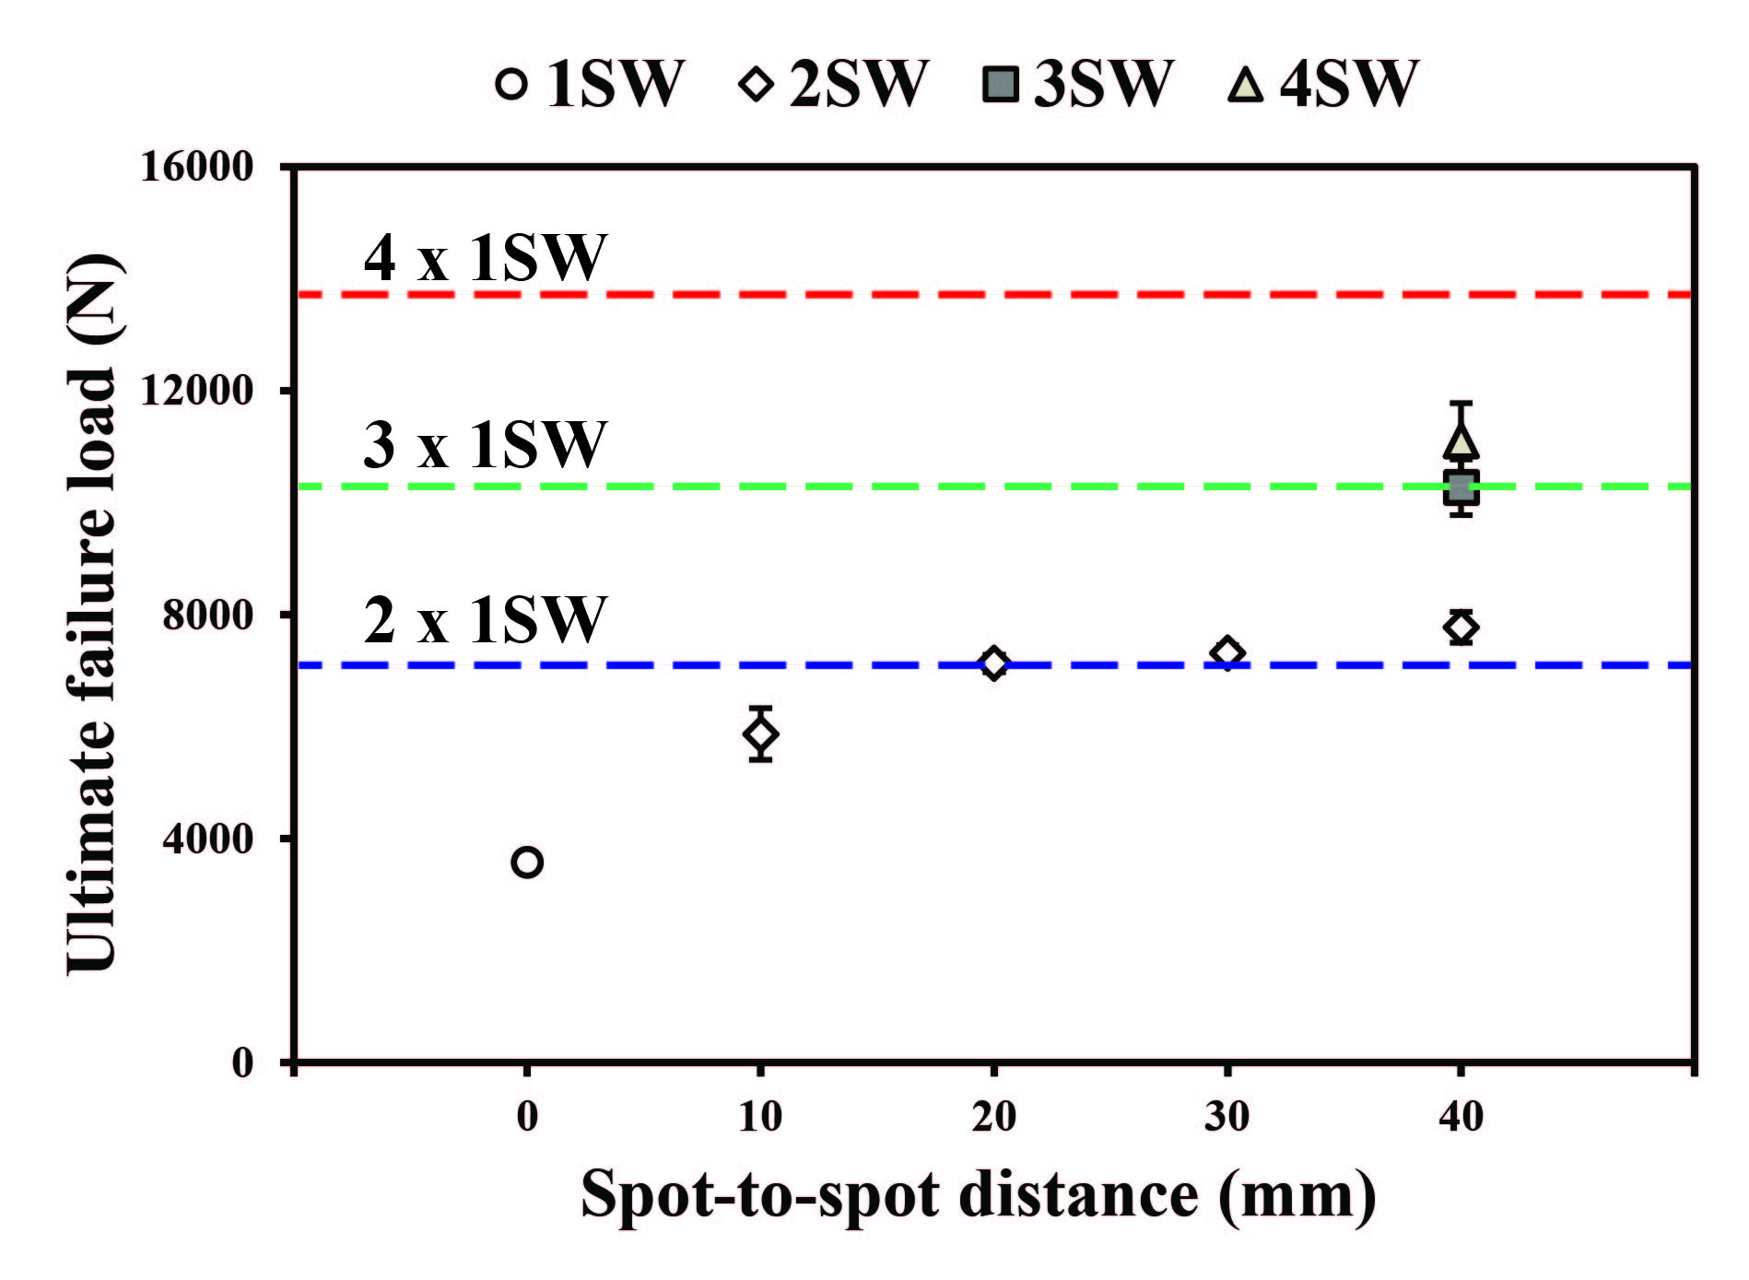
Figure 7. The increase of the UFL of MSW joints when increasing the spot spacing and the number of welded spots. Blue, green and red dashed lines indicate the two, three and four times of the UFL of 1SW joints, respectively.

The UFL of all the MSW joint configurations, including 1SW joints, considered in this study is plotted in Fig. 7. It can be seen that the UFL had a further increase when more spots were welded on the 2SW-40 samples, which is reasonable due to the increased amount of welded area. However, this increase was not proportional to the increased number of welded spots, i.e. increased welded area. The UFL of the 2SW-40, referred to as 2SW hereafter, joints was slightly (around 10 %) higher than the doubled UFL value of the 1SW reference (indicated by the blue dashed line). However, the UFL of the 3SW joints was similar to three times the magnitude of the 1SW UFL (green dashed line) and the UFL of the 4SW joints was similar to that of the 3SW samples and was obviously lower, by around 22 %, than the four times of the 1SW UFL (red dashed line). This behaviour is probably due to the non-uniform load distribution when more than two welded spots present on the joint overlap, which is expected to be similar to the case of mechanically fastened joints with multi-row fasteners [11]. During the loading process, the outer spots are expected to transfer more load than the inner ones. It is believed that the entire MSW joints failed once the outer spots reached its UFL. This finally resulted in a less significant increasing trend in the UFL of the MSW joints.

3.3. Comparison between MSW and MMF joints

According to the findings in [12], spot welded joints are not well-suited for carrying peel load as compared to mechanically fastened joints. Owing to the occurrence of secondary bending, peel loads cannot be avoided in the single-lap joint configuration. Therefore, it is likely that MSW single-lap joints should exhibit a lower strength than the MMF joints. However, as depicted in Fig. 8, the MSW joints assembled with two, three and four welded spots showed a comparable value regarding the load-carrying capability (LCC) to the MMF joints with the same number of mechanical fasteners. The 2SW joints showed relatively lower LCC, by around 9 %, than the 2MF joints. On the contrary, the LCC of the 3SW and 4SW joints was slightly higher, by around 5 % and 4 %, than their mechanically fastened counterparts.

The DIC results indicated that the similar load-carrying capability achieved by the MSW joints and their MMF counterparts was owing to the decreased secondary bending. The comparison of the out-of-plane deformation of the MSW and the MMF joints with two and four spots is summarized in Fig. 9a and 9b, respectively. It can be seen that for both cases, the welded joints exhibited a lower out-of-plane deformation in comparison to the MMF joints. As a consequence of that, a lower peel load was expected to be introduced to the MSW joints, which eventually provided similar load-carrying capability with the MMF joints. In addition, 4SW joints displayed less secondary bending (ranging from -0.4 to 0.4 mm) compared to the 2SW counterparts (ranging from -0.4 to 0.6 mm) under the same load condition. This is also one of the factors resulting in the improvement of the LCC of 4SW joints with regards to the number of welded spots, as shown in Fig. 7.

Figure 8. Comparison of the load-carrying capability between the MSW and MMF joints with different number of spots/fasteners.

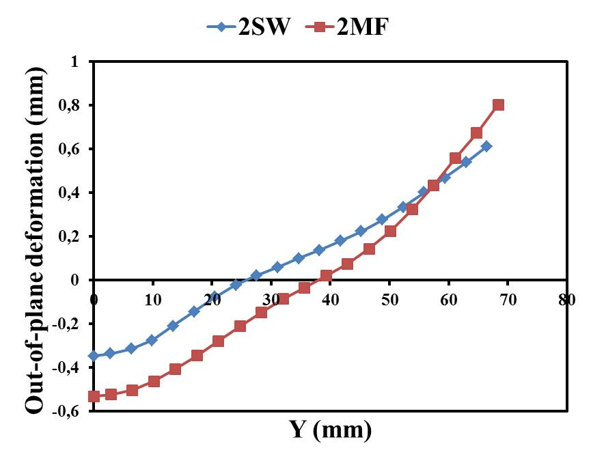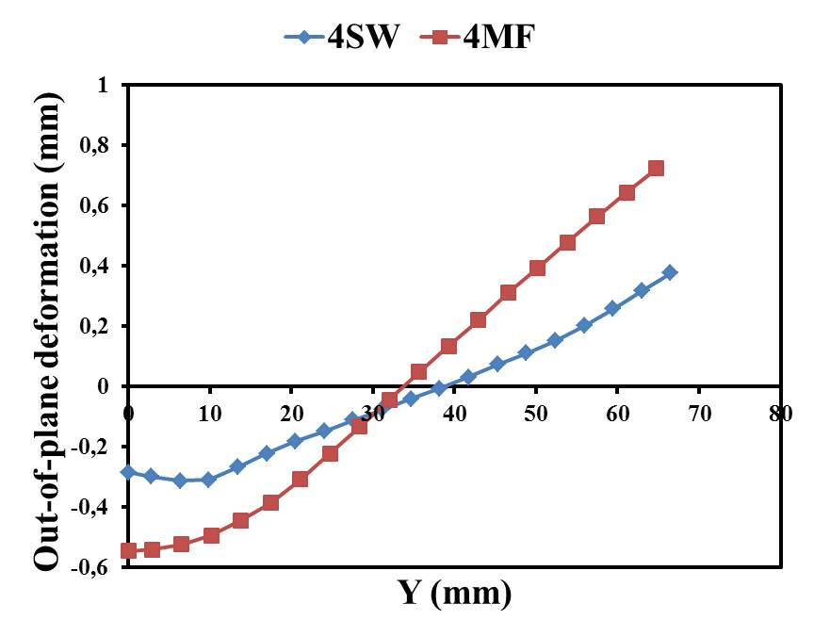
(a) (b)
Figure 9. Comparison of out-of-plane deformation of the joint overlap under 7000N load between the MSW and the MMF joints with different number of spots/fasteners: (a) 2 spots/fasteners; (b) 4 spots/fasteners.

4. Conclusions

In this study, a series of mechanical tests were carried out on multi-spot welded, single-lap joints to investigate the effect of the spot spacing and the number of welded spots on secondary bending and eventually on the ultimate failure load (UFL) of the welded joints. Secondary bending was inferred from the out-of-plane deformation of the joint overlap via the Digital Image Correlation (DIC) technique. In addition, a comparative study was also performed regarding the load-carrying capability of multi-spot welded and mechanically fastened joints. Based on the experimental results, the following conclusions can be made:

- The UFL of the welded joints consisted of two spots was increased when increasing the spot spacing. This is likely a consequence of the decreased secondary bending in the joints when increasing the distance between spots.
- Maintaining a fixed overlap length, the UFL was further improved when more welded spots were created. However, when more than two spots were produced on the overlap, the improvement of the UFL of MSW joints was less and less significant by increasing the number of spots.
- The multi-spot welded joints achieved a comparable load-carrying capability to the mechanically fastened joints assembled with multi-row fasteners given the same number of spots/fasteners. This also most probably resulted from the lower secondary bending in the welded joints.

Acknowledgments

T. Zhao thanks the PhD Scholarship Fund from China Scholarship Council (CSC) for overseas study. I. Tsakoniatis would like to thank the TU Delft Aerospace Engineering faculty and staff for the support.

References

[1] A. R. Offringa. Thermoplastic composites - Rapid processing applications. Part A:
Applied Science and Manufacturing, 27(4 PART A):329–336, 1996.
[2] C. Ageorges, L. Ye, and M. Hou. Advances in fusion bonding techniques for joining
thermoplastic matrix composites: A review. Composites - Part A: Applied Science
and Manufacturing, 32(6):839–857, 2001.
[3] A. Yousefpour, M. Hojjati, and J.-P Immarigeon. Fusion bonding/welding of thermoplastic
composites. Journal of Thermoplastic Composite Materials, 17(4):303–
341, 2004.
[4] I.F. Villegas. Strength development versus process data in ultrasonic welding of
thermoplastic composites with flat energy directors and its application to the definition of optimum processing parameters. Composites Part A: Applied Science and
Manufacturing, 65:27–37, 2014.
[5] G. Palardy and I.F. Villegas. On the effect of flat energy directors thickness on heat
generation during ultrasonic welding of thermoplastic composites. Composite Interfaces,
24(2):203–214, 2017.
[6] T. Zhao, G. Palardy, I.F. Villegas, C. Rans, M. Martinez, and R. Benedictus. Mechanical
behaviour of thermoplastic composites spot-welded and mechanically fastened joints: A preliminary comparison. Composites Part B: Engineering, 112:224–234, 2017.
[7] P. Wung, T. Walsh, A. Ourchane, W. Stewart, and M.Jie. Failure of spot welds under
in-plane static loading. Experimental Mechanics, 41(1):100–106, 2001.
[8] J. Schijve, G. Campoli, and A. Monaco. Fatigue of structures and secondary bending in structural elements. International Journal of Fatigue, 31(7):1111–1123, 2009.
[9] T.L. Qin, L.B. Zhao, and J.Y. Zhang. Fastener effects on mechanical behaviors of
double-lap composite joints. Composite Structures, 100:413 – 423, 2013.
[10] A.B. de Morais, A.B. Pereira, M.F.S.F. de Moura, F.G.A. Silva, and N. Dourado. Bilinear
approximations to the mixed-mode I–II delamination cohesive law using an inverse
method. Composite Structures, 122:361 – 366, 2015.
[11] H. Koerber, J. Xavier, P.P. Camanho, Y.E. Essa, and F. Martín de la Escalera. High strain rate behaviour of 5-harness-satin weave fabric carbon-epoxy composite under compression and combined compression-shear loading. International Journal of Solids and Structures, 54:172–182, 2015.
[12] P. Morgan. Carbon fibers and their composites. CRC Press Taylor & Francis Group, 2005.
[13] T. Hans and R. Hinterhölzl. A numerical approach modeling the braiding process for arbitrary mandrel shapes to calculate preform properties. Proceedings of the 20th International Conference on Composite Materials ICCM-20, Copenhagen, Denmark, July 19-24 2015.

