Novel Multi-Scale Carbon Nanotube Based Smart Composites: Processing, Characterization and Applications in Self-Sensing and Structural Health Monitoring

Erik T. Thostenson¹, Sagar M. Doshi², Andrew Rider³, Qi An⁴, Colleen Murray⁵

¹Department of Mechanical Engineering/Center for Composite Materials, University of Delaware, Newark, DE, USA
Email: thosten@udel.edu, Web Page: http://research.me.udel.edu/thosten/

²Department of Mechanical Engineering/Center for Composite Materials, University of Delaware, Newark, DE, USA
Email: smdoshi@udel.edu,

³Defence Science and Technology Group, Fisherman's Bend, Victoria, 3207, Australia
Email: ridera1@outlook.com

⁴Department of Materials Science and Engineering/Center for Composite Materials, University of Delaware, Newark, DE, USA
Email: qian@udel.edu

⁵Department of Mechanical Engineering/Center for Composite Materials, University of Delaware, Newark, DE, USA
Email: cmmurray@udel.edu

Keywords: carbon nanotubes, self-diagnosis, structural health monitoring, piezoresistive sensors, electrophoretic deposition

Abstract
In this research, a novel electrophoretic deposition (EPD) method is used to develop carbon nanotube based smart composites and the use for in situ sensing of deformation and damage in composites along with applications in structural health monitoring of steel and concrete structures are discussed. Integrating carbon nanotubes with conventional micron-sized fibers enables unique opportunities to enhance the properties of fiber composites. A highly efficient and scalable EPD technique is used for depositing carbon nanotubes on non-conductive fibers such as glass fibers and aramid fibers to create multifunctional composites. The EPD process is performed at ambient temperatures using a stable aqueous dispersion of functionalized carbon nanotubes. We have demonstrated that the EPD process can deposit carbon nanotubes on a variety of fibers such as carbon, glass, aramid, cotton, wool and nylon. Nanotubes deposited on glass fibers enable creation of multifunctional hybrid composites where the interfacial properties can be designed and the electrically conductive carbon nanotube network enables self-diagnosis and can be used for detecting the onset, nature and evolution of damage. Applications in structural health monitoring of steel and concrete have been explored by depositing carbon nanotubes on textiles can be bonded to steel/concrete infrastructure for structural health monitoring and crack detection.

1. Introduction

There has been a tremendous progress in the science and engineering of nanomaterials and its processing techniques over the two decades. Nanocarbons, such as carbon nanotubes and graphene, have been at the forefront of the development of the nanostructured composites due to their unique mechanical and physical properties [1, 2]. Integration of nanoscale reinforcement such as carbon nanotubes with conventional advanced fibers (such as glass/carbon/aramid fibers) offers unique opportunities to selectively tailor the mechanical and electrical properties of their composites. Conventionally, multiscale/hierarchical composites have been manufactured using chemical vapor deposition (CVD) to grow carbon nanotubes on the surface of the fibers [3-5]. The high temperature used to grow the carbon nanotubes using the CVD process (600°C – 1000°C) has been shown to deteriorate the properties of the reinforcing fibers and alters the surface by decomposing the fiber sizing. Electrophoretic deposition (EPD) is a process that has been recently established as a technique for creating multiscale/hierarchical composites. EPD, which is performed at ambient temperatures using an aqueous dispersion, does not degrade the properties of the reinforcing fibers in the composite and has the potential to be scaled up for future industrial applications.

Initially, carbon nanotubes were deposited onto conductive carbon fibers using the EPD process where the carbon fiber acts as one of the electrodes. The process has been recently extended to non-conductive fibers by backing the fibers with an electrode [6, 7]. The improvement in the fiber/matrix interfacial properties due to the carbon nanotube coating enhances the mechanical properties and makes the composites conductive, which enables in situ self-sensing of strain and damage [8]. Carbon nanotubes, when deposited onto nonwoven, randomly oriented carrier fabrics, form an electrically isotropic conductive composite that can be used as a sensing skin for structural health monitoring of steel/concrete structures [9, 10].

In this work, carbon nanotubes are deposited onto single glass fibers to improve the interface properties of fiber/matrix. Functionalized carbon nanotubes are deposited on E-glass fibers and microdroplet tests were conducted to study the interfacial properties in an epoxy matrix. Due to the carbon nanotube coating, the interfacial shear strength increased and the failure mode changed from fiber-resin interface to the carbon nanotube coated interphase. Carbon nanotubes were also deposited onto unidirectional E-glass fabric. The carbon nanotube coated fabrics were used to manufacture cross ply laminates. The electrically conductive network formed by carbon nanotubes is piezoresistive and able to effectively detect formation of transverse cracks in the 90° plies. Additionally, carbon nanotubes were deposited on a non-woven aramid fabric with randomly oriented fibers to create a sensing skin which was bonded to steel specimens for strain and damage sensing.

- Experimental

Multiwall carbon nanotubes (CM-95, Hanwha Nanotech, Korea) are dispersed in aqueous solution using ultrasonicated ozonolysis to create a stable aqueous dispersion. The carbon nanotube dispersion, cooled to 5°C is treated with ozone while being sonicated using a high power sonicator operating at 60W for 16 hours. Branched polyethyleneimine (PEI) (Mw: 25,000, Sigma-Aldrich) was added to the ozone-treated carbon nanotube dispersion and sonicated for an additional four hours. The concentration of carbon nanotubes and PEI in the solution is equal. The pH of the PEI and ozone-treated carbon nanotubes was adjusted using glacial-acetic acid (Sigma–Aldrich) to a pH of 6. The PEI used for functionalizing carbon nanotubes protonates, giving the carbon nanotubes a positive charge aiding in creating a stable dispersion and enabling the deposition of nanotubes on various substrates used in this work, such as E-glass and aramid fabric by applying an electric field. Error: Reference source not found(a) shows the schematic representation of the EPD setup for deposition of nanotubes onto individual fibers and Figure 1(b) shows a schematic used to coat fabric. Figure 1(c) is a photograph of non-woven aramid fabric before and after coating with carbon nanotubes, showing the uniformity of the coating.

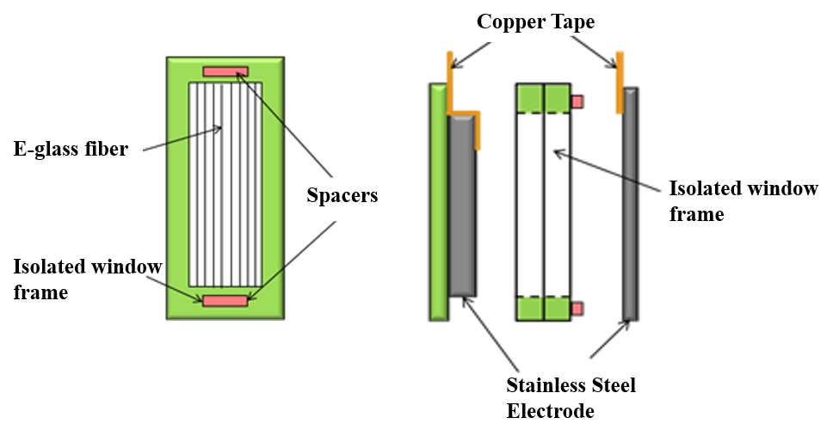 | 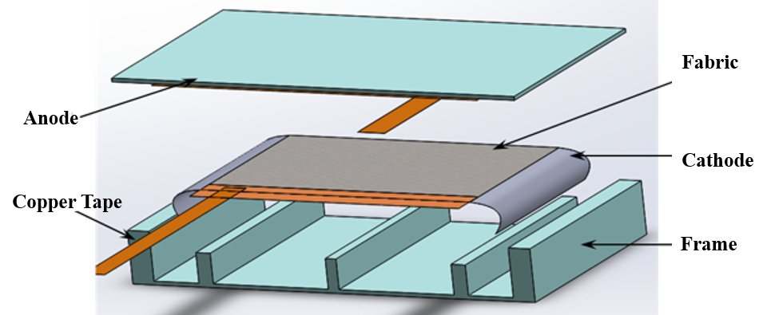
(a) | (b)
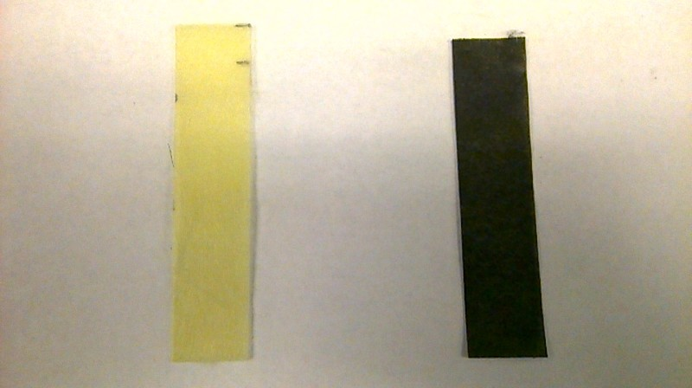
(c)

Figure 1 Schematic of the EPD process for deposition of carbon nanotubes on (a) single fibers and (b) unidirectional E-glass or aramid fabric. (c) A photograph of a non-woven aramid fabric before and after coating with carbon nanotubes using the EPD process

After depositing carbon nanotubes on individual E-glass fibers, microdroplet specimens were prepared by laying a single fiber on a tray and depositing a droplet of epoxy resin onto the glass fiber using a carbon fiber applicator. The resin droplets were allowed to gel at room temperature for 5 hours followed by curing at an elevated temperature of 80°C and 150°C for 2 hours. The gauge length and embedded length was measured before the tests. The test was conducted using the details and setup described by Gao et al. [11]. A schematic of the test setup is shown in Figure 2(a).

For the fabrics, both unidirectional E-glass (7721, Thayercraft Inc) and non-woven aramid (Technical Fiber Products), a field strength of 40 V/cm was used for 10 minutes. The coated E-glass fabrics were arranged to form a crossply composite, [0/90]_{s} and infused with epoxy resin EPON 862 using vacuum assisted resin transfer molding (VARTM). Electrodes and lead wires were attached to the specimen to measure resistance using conductive silver paint and conductive silver epoxy adhesive respectively. The specimens were tested using a screw driven mechanical testing equipment (Instron 5985) in a displacement-controlled mode at the rate of 0.05 inches/minutes. The tests were paused at peak loads to take a replica of the specimen edge using acetate solution, which was later analyzed under the microscope to determine transverse crack density.

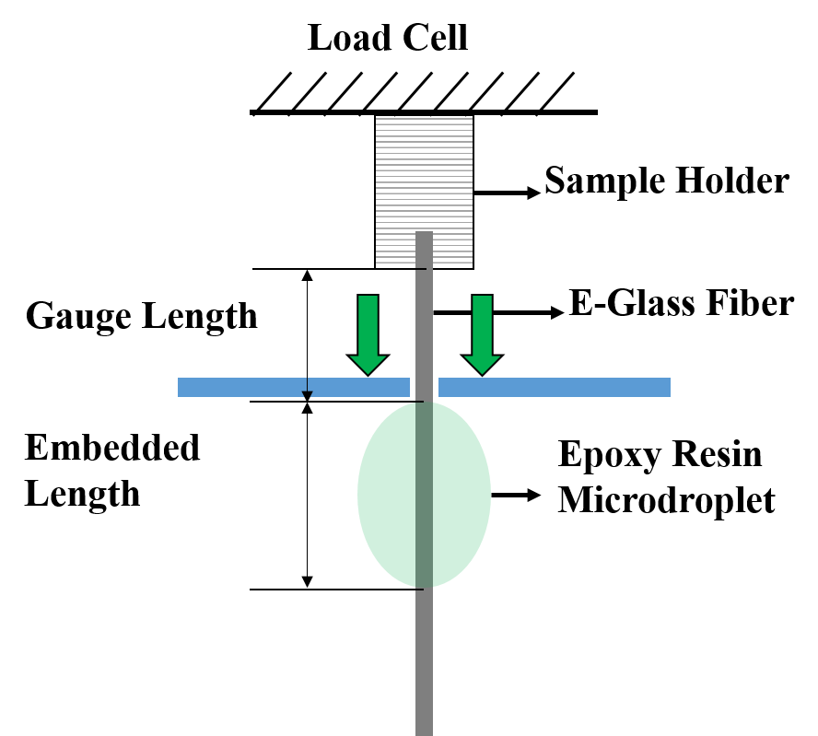  (a) | 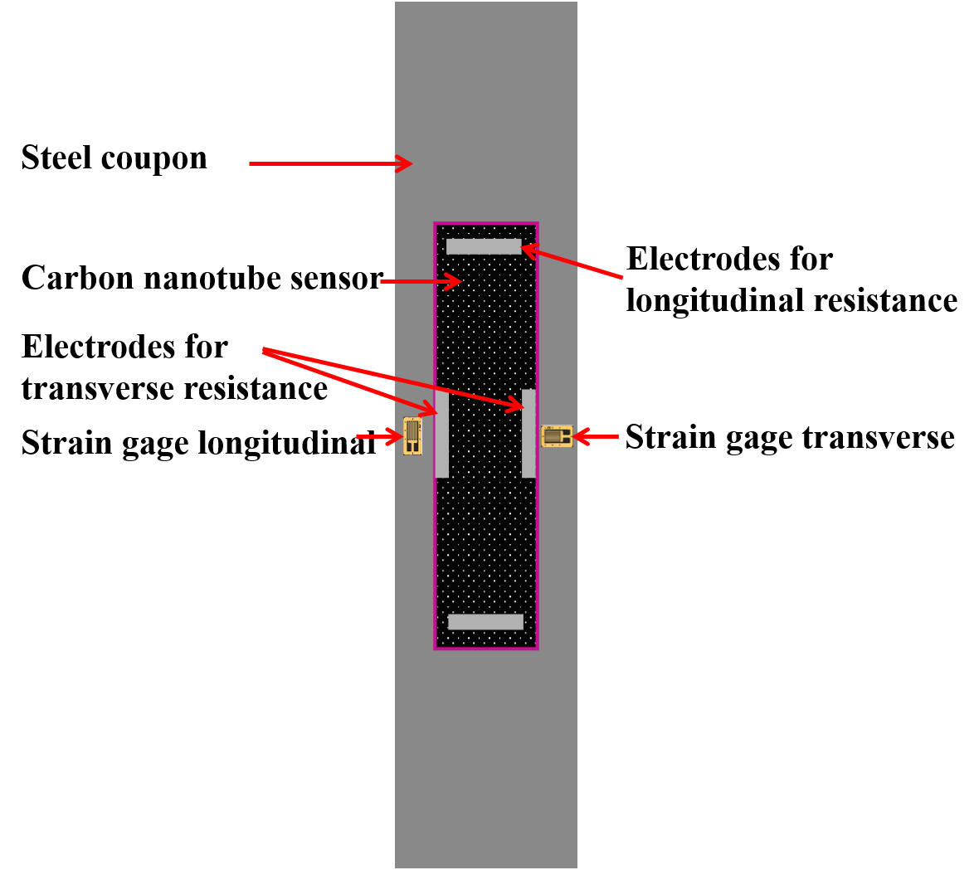  (b)
Figure 2 (a) A schematic illustration of the test setup for a microdroplet specimen and (b) a schematic representation of steel specimen with carbon nanotube sensing skin for structural health monitoring.

Figure 2(b) shows a schematic of the test specimen for structural monitoring of steel. The non-woven aramid-carbon nanotube based sensing skin was bonded onto a steel substrate and subjected to axial testing to characterize the tensile and compressive response of the sensor. Steel specimens 300 mm x 50 mm were cleaned with acetone followed by sandblasting to improve adhesion. A thin layer of adhesive (Hysol 9309) was applied and partially cured. This layer prevents the sensing layer from coming in direct contact with steel and hence acts as electrical insulator. The sensing layer is then glued on the insulating layer. The steel coupons are tested under axial tension and compression.

- Results and Discussion

Figure 3(a) shows the scanning electron micrograph of a single E-glass fiber coated with PEI functionalized carbon nanotubes using EPD process. A uniform coating of the carbon nanotubes is visible on the E-glass fiber confirming that the deposition method is effective. By varying the process parameters such as field strength and time of deposition, the thickness of the carbon nanotube coating can be controlled. Increased surface roughness and thickness due to the carbon nanotubes improves the interphase properties of the glass fiber-epoxy composites. The carbon nanotube coating can also play a critical role in arresting or slowing crack propagation and provides a gradient in elastic modulus between the high modulus fiber and low modulus matrix.

Figure 3(b) shows the microdroplet specimen after failure where interphase debonding is evident. Carbon nanotubes still adhered to the surface of the fiber are clearly visible. This type of fracture surface is consistent with the results from a model interphase study where the surface of a planar glass surface was modified with a silane coupling agent and PEI functionalized carbon nanotubes. Surface analysis of the fracture surfaces showed evidence of a covalent bond formed between the nanotubes and the fiber surface [12].

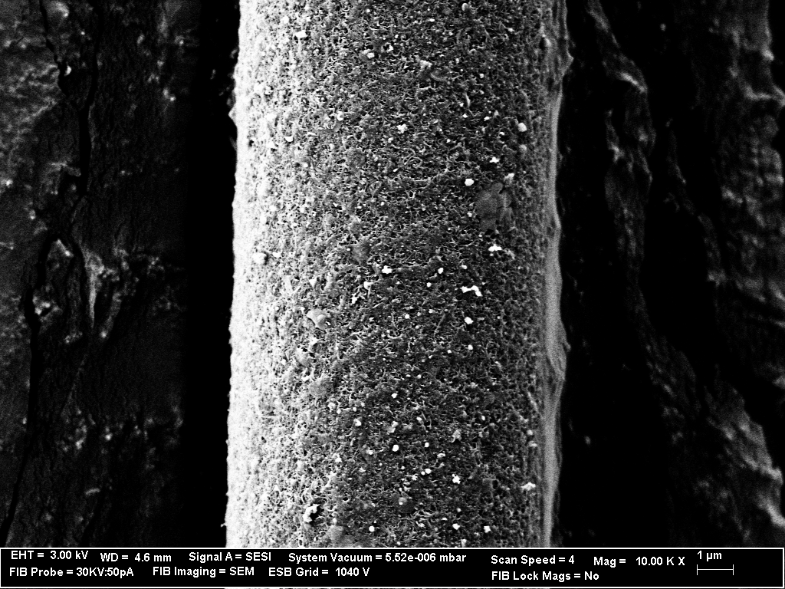  (a) | (b)
Figure 3 (a) SEM micrograph showing the uniform deposition of PEI-functionalized carbon nanotubes on a single glass fiber (b) SEM micrographs (left) the debonded microdroplet and (right) the fiber surfaces after debonding, showing carbon nanotubes bonded to the surface.[7]

We also demonstrate an approach for analyzing the microstructural evolution transverse cracks in cross-ply laminates subjected to progressively increasing loads. Figure 4(a) shows the electrical resistance response of the carbon nanotube coated cross-ply laminates when subjected to increasing cyclic loads. The resistance signal closely follows the applied stress. Due to the formation of transverse microcracks, a permanent change in resistance is observed. The number of cracks increases at higher stresses causing increased permanent damage, indicated by a higher permanent resistance change. Therefore, with knowledge of electrical resistance in the undamaged and damaged states it may be possible to establish resistance change as a function of accumulated cracks.

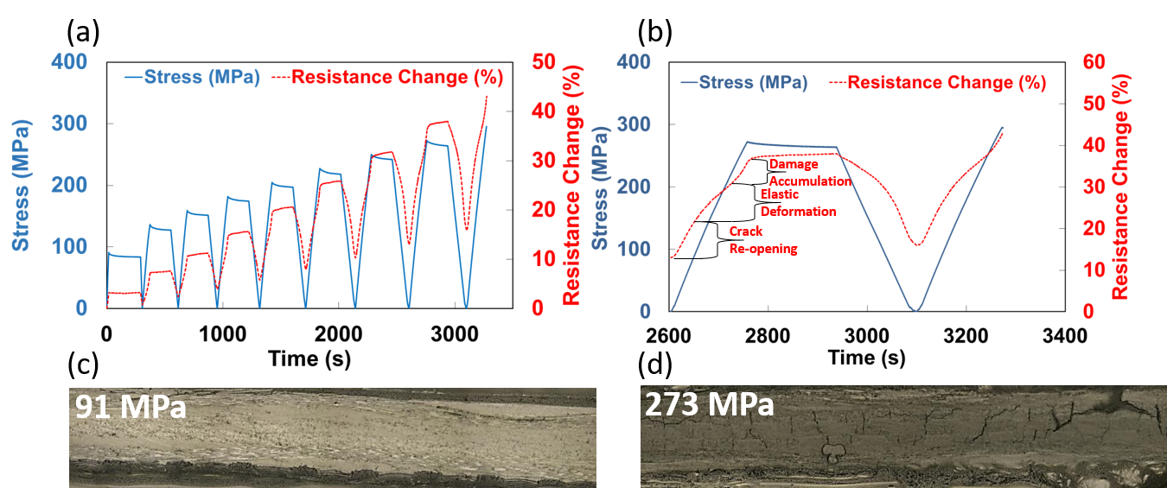
Figure 4 (a) Resistance response for a cross ply laminate [0/90]s when subject to cyclically increasing tensile loading (b) magnified view of the resistance response to the last complete loading cycle before failure. The non-linear regions indicating damage evolution in the laminate (c) crack density versus stress for glass fiber cross ply laminate (d) micrographs of the edge replica at 91MPa and 273 MPa, showing transverse microcracks

Figure 4(b), focuses on the 8th loading/unloading cycle of the data shown in Figure 4(a). The non-linear loading curves can be distinguished into three distinct regions. When the transverse cracks are formed in the previous (7th) loading cycle, they close during unloading since the longitudinal plies continue to behave elastically. During the early stages of the next loading cycle (8th), the cracks re-open easily when stress is applied and hence the increased slope of the resistance change curve. After all cracks have re-opened, the slope of the resistance change curve decreases, indicating piezoresistive elastic deformation without additional cracks being formed. The increase in slope in the last stage of the loading cycle corresponds to the continued damage accumulation and formation of transverse cracks. This response is similar to what Thostenson et al. [13] observed for crack detection in fiber composites using uniformly dispersed carbon nanotubes. The crack density in the transverse plies increases with increasing loads and saturates at higher loads. At saturation, the spacing between the cracks is consistent. Preliminary results show that the presence of carbon nanotubes at the interphase suppresses transverse crack formation and also results in a higher level of crack saturation before delamination. This is likely due to the decrease in stress concentration at the fiber-matrix interphase delaying the formation of transverse cracks. Figure 4(d) shows the edge replica of a carbon nanotube coated specimen analyzed under a microscope for two different stress states. At 91 MPa, the crack density is < 5 cracks/cm whereas at 273 MPa, the crack density is almost 40 cracks/cm.

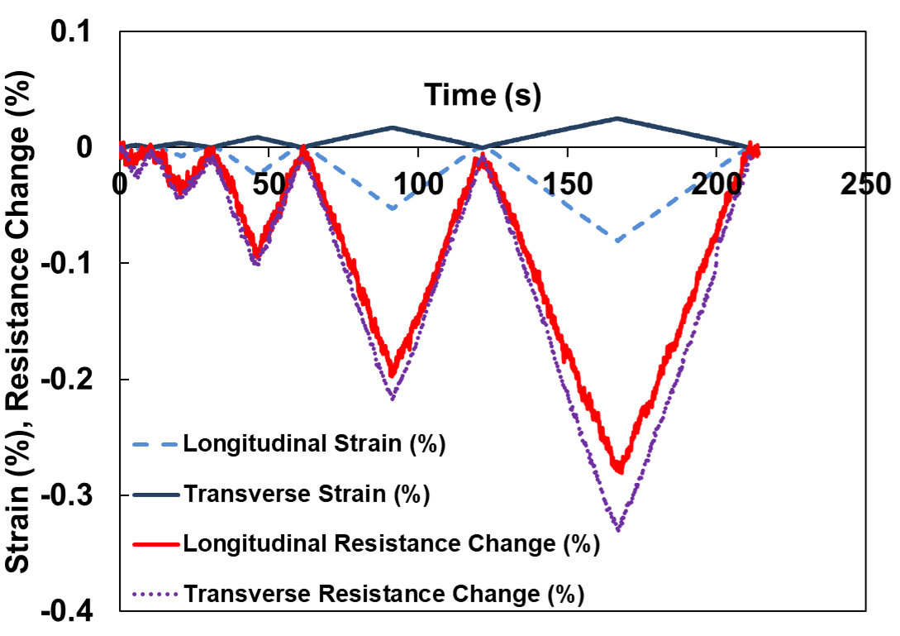
Figure 5 Transient resistance change and strain under progressively increasing cyclic loading when a steel coupon with carbon nanotube sensing skin is subjected to compressive stresses.

Figure 5 shows the transient electrical/mechanical response under compression for carbon nanotube sensing layer manufactured using the EPD approach. The sensing response of the nanotube/fiber composites were characterized under progressively increasing cyclic loading in both tension and compression. The carbon nanotube sensors have 2 pairs of electrodes, measuring longitudinal and transverse change in resistance. All of the sensors show a highly linear response with applied strain. The sensitivity of the sensors varied with the amount of carbon nanotubes deposited. Intuitively, the transverse resistance is expected to increase due to positive transverse strain, which will increase the tunneling gap and decrease the number of contacts between carbon nanotubes. Here, we see a significant decrease in resistance. This is because, at the nanoscale, there are changes in tunneling gaps associated with both longitudinal and transverse strains. Contrary to a conventional strain gage, the conductive carbon nanotube network between the electrodes may not be a straight line of carbon nanotubes in contact. It could be a more complex and random path which is sensitive to both longitudinal and transverse strain. In the current loading scenario, the longitudinal strain is much higher than transverse strain. Hence we observe a net increase in resistance.

- Conclusions

A novel EPD approach has been established as a highly repeatable technique to uniformly coat non-conductive E-glass and aramid fibers. As-coated fibers show a highly uniform and dense coating of nanotubes that completely surround the fibers. Microdroplet tests show improvement in interfacial shear strength when single glass fibers are coated with carbon nanotubes using EPD. Increased roughness and improved adhesion at the interface changes the failure mode of specimens. The EPD technique when scaled up to ASTM standard coupons can be used for in situ damage sensing and investigating the evolution of damage in fiber composites. The piezoresistive electrical-mechanical sensing behavior of the carbon nanotube sensing skins was characterized by bonding the composite sensor onto a steel substrate and subjecting axial compressive loading. All specimens show linear piezoresistivity under applied deformation. Carbon nanotube based novel multiscale composites can be used for self-diagnosis and in situ sensing of composites as well as sensing skins that can be externally bonded to steel/concrete members for structural health monitoring.

Acknowledgments

The authors gratefully acknowledge the funding support from Delaware INBRE program, with a grant from the National Institute of General Medical Sciences - NIGMS (P20 GM103446) and the state of Delaware and National Science Foundation (Grant CMMI-1254540) and Federal Highway Administration (FHWA cooperative agreement DTFH61-13-H-00010).

References

- Thostenson, E. T., Li, C., & Chou, T. W. (2005). Nanocomposites in context. Composites Science and Technology, 65(3-4), 491-516.
- Thostenson, E. T., Ren, Z., & Chou, T. W. (2001). Advances in the science and technology of carbon nanotubes and their composites: a review. Composites science and technology, 61(13), 1899-1912.
- Qian, H., Bismarck, A., Greenhalgh, E. S., & Shaffer, M. S. (2010). Carbon nanotube grafted silica fibres: Characterising the interface at the single fibre level. Composites Science and Technology, 70(2), 393-399.
- Garcia, E. J., Wardle, B. L., Hart, A. J., & Yamamoto, N. (2008). Fabrication and multifunctional properties of a hybrid laminate with aligned carbon nanotubes grown in situ. Composites Science and Technology, 68(9), 2034-2041.
- Rider, A. N., Yeo, E., Gopalakrishna, J., Thostenson, E. T., & Brack, N. (2015). Hierarchical composites with high-volume fractions of carbon nanotubes: Influence of plasma surface treatment and thermoplastic nanophase-modified epoxy. Carbon, 94, 971-981.
- An, Q., Rider, A. N., & Thostenson, E. T. (2012). Electrophoretic deposition of carbon nanotubes onto carbon-fiber fabric for production of carbon/epoxy composites with improved mechanical properties. Carbon, 50(11), 4130-4143.
- An, Q., Rider, A. N., & Thostenson, E. T. (2013). Hierarchical composite structures prepared by electrophoretic deposition of carbon nanotubes onto glass fibers. ACS applied materials & interfaces, 5(6), 2022-2032.
- Tamrakar, S., An, Q., Thostenson, E. T., Rider, A. N., Haque, B. Z., & Gillespie Jr, J. W. (2016). Tailoring interfacial properties by controlling carbon nanotube coating thickness on glass fibers using electrophoretic deposition. ACS applied materials & interfaces, 8(2), 1501-1510.
- Schumacher, T., & Thostenson, E. T. (2014). Development of structural carbon nanotube–based sensing composites for concrete structures. Journal of Intelligent Material Systems and Structures, 25(11), 1331-1339.
- Ahmed, S., Doshi, S., Schumacher, T., Thostenson, E. T., & McConnell, J. (2016). Development of a Novel Integrated Strengthening and Sensing Methodology for Steel Structures Using CNT-Based Composites. Journal of Structural Engineering, 143(4), 04016202.
- Gao, X., Jensen, R. E., McKnight, S. H., & Gillespie Jr, J. W. (2011). Effect of colloidal silica on the strength and energy absorption of glass fiber/epoxy interphases. Composites Part A: Applied Science and Manufacturing, 42(11), 1738-1747.
- Rider, A. N., An, Q., Brack, N., & Thostenson, E. T. (2015). Polymer nanocomposite–fiber model interphases: Influence of processing and interface chemistry on mechanical performance. Chemical Engineering Journal, 269, 121-134.
- Thostenson, E. T., & Chou, T. W. (2008). Real-time in situ sensing of damage evolution in advanced fiber composites using carbon nanotube networks. Nanotechnology, 19(21), 215713.

