Nanocarbon reinforced lightweight metal composites
Q. Li^{1a}, S. Nasiri^{2b} and M. Zaiser^{2c}
¹ Department of Aeronautics, Imperial College London, London, UK
² Institute of Material Simulation (WW8), University of Erlangen-Nuremberg, Fuerth, Germany
ªqianqian.li@imperial.ac.uk, ^{b} samaneh.nasiri@fau.de, ^{c}michael.zaiser@fau.de
The interest to use nanocarbon such as CNTs and graphene to reinforce light metals has increased in recent years. Our previous research showed by adding 0.1wt% CNTs, the mechanical properties of the Mg AZ91 composites were all improved up to 40% [1]. A similar improvement has also been observed for nanocarbon reinforced Al alloy composites [2]. However, the observed improvements are still below the theoretically predicted values [1-2] most likely due to the nanocarbon re-agglomerating during production.
In this paper we present for the first time using metal coated CNTs to produce such Mg AZ91 composites. In order to effectively disperse CNTs in the Mg melt, we coated Pt on the surface of CNTs as shown in Figure 1. TEM and EDX confirmed that atomic Pt has been successfully deposited onto CNTs. Different from coating metal layers on CNTs in literature [3], surface decoration of CNT with metals as in this study may provide further benefits. If, instead of a continuous coating layer, isolated metal nanoparticles are deposited on the CNT surface then these nanoparticles may serve a dual purpose that goes well beyond what can be achieved by a continuous coating. Discrete metal nanoclusters on the CNT surface can help to prevent agglomeration by the simple means of acting as geometrical ’spacers’. This effect is well known in the context of graphene where decoration of exfoliated graphene sheets with Pt nanoclusters was shown to prevent face-to-face aggregation of the sheets [4].
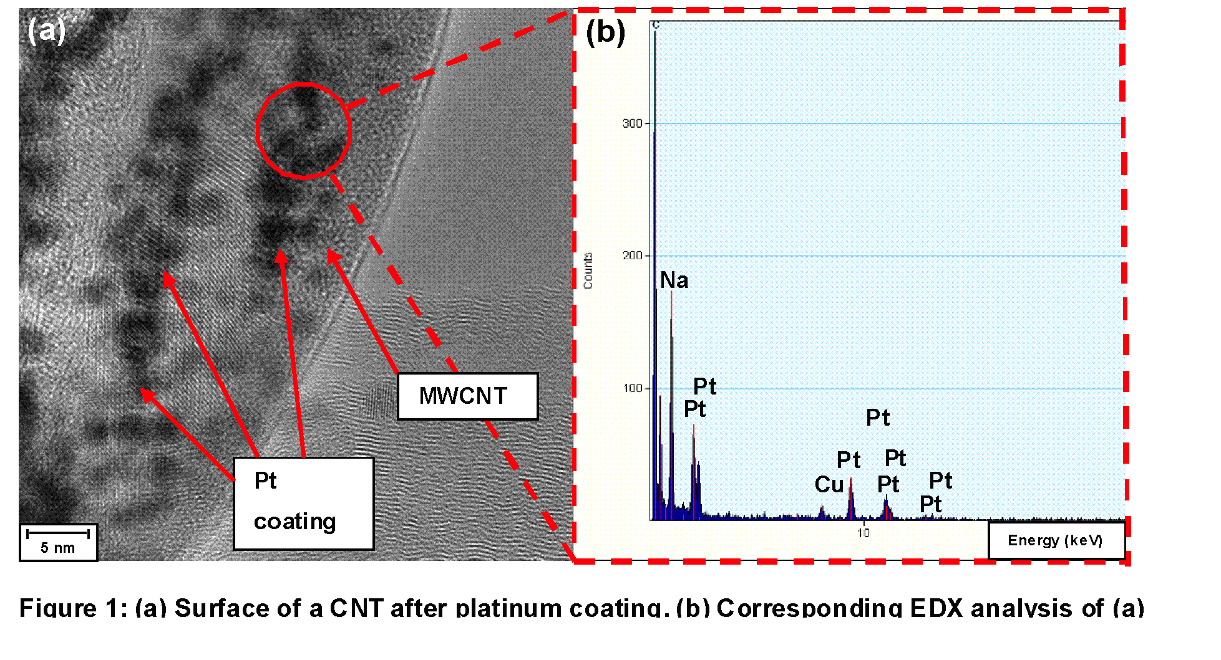
The dispersion ability of CNTs were improved by the Pt coating. The mechanical properties were all improved. Individual pulled out CNTs were observed on the fracture surface of the Pt-coated CNT/AZ91 composites under SEM. We attribut this to a better dispersion and a possible improved wettability of CNTs in Mg melt facilitated by the Pt coating.
LAMMPS simulation package was selected to perform molecular mechanics and molecular dynamics of a ternary system consisting of CNT, Pt coating and a lightweight metal matrix. Simulations demonstrate that Pt coating led to enhanced interfacial bonding between CNTs and a lightweight metal matrix and to efficient load transfer between matrix and embedded CNTs. The results confirm the advantages of coating nanoclusters on CNTs and agree with the assumptions above, as well as with the experimental data.

References :
[1] Q. Li, A. Viereckl, C.A. Rottmair and R.F. Singer, Comp. Sci. Tech. 69, 1933 (2009).
[2] Q. Li and R.F. Singer, Euromat 2013 (2013).
[3] N. Du, H. Zhang, P. Wu, J. Yu and D. Yang, J. Phys. Chem. C 113, 17387 (2009).
[4] N. Park, D. Sung, S. Lim, S. Moon and S. Hong, App. Phys. Lett. 94, 073105 (2009).

