Additive layered manufacturing simulation of fibrous thermosetting composites

Tassos Mesogitis^{1*}, Amit Visrolia¹
1 National Composites Centre, Feynman Way Central, Bristol & Bath Science Park, Emersons Green, Bristol, BS16 7FS
* Corresponding author (tassos.mesogitis@nccuk.com)

Keywords: Additive Layered Manufacturing (ALM), Polymer matrix composites (PMCs), Heat transfer, Cure simulation

Abstract
A framework able to simulate the manufacturing process of continuous fibrous thermosetting composites manufactured by Additive Layered Manufacturing was developed. The modelling framework addresses the heat transfer effects during the cure of Additive Layered Manufacturing processes and it can provide valuable information around the deposition rate, deposition route and material selection.

1. Introduction

During the last decades there is an abrupt increase in the use of additive manufacturing technologies in the areas of aerospace, automotive and medical [1,2]. Additive manufacturing has the potential to decrease process cycles avoiding the need for expensive tooling and thus can shorten manufacturing costs. In most cases, additive manufacturing applications involve the use of metals or pure plastics [3]. In the context of composite materials, additive manufacturing has been implemented in the case of thermoplastics using short fibres [3]. The growing demand for improving process efficiency and robustness in the area of composite manufacture has created an increasing interest in exploiting additive manufacturing technologies in the context of continuous carbon fibre- epoxy laminates. However, a modelling methodology able to simulate additive manufacturing processes in this context has not been developed yet. One of the key parameters in Additive Layered Manufacturing (ALM) processes is interlayer adhesion during deposition since it significantly affects the mechanical performance and in turn the quality of the manufactured part. Therefore, the development of a modelling framework able to incorporate these phenomena is of crucial importance.
This study aims at the development of a robust modelling framework appropriate to simulate the manufacturing process of continuous fibrous thermosetting composites manufactured by ALM. To this end, a manufacturing process simulation model focusing on the heat transfer effects during the deposition of continuous carbon fibre- epoxy laminates was developed. This model is capable of estimating the temperature and degree of cure distribution during deposition as well as process time. The evolution of the degree of cure is of crucial importance since it dictates interlayer adhesion during deposition and thus can provide valuable information towards resin selection, appropriate deposition rate and deposition route. In addition, the model is capable of predicting potential temperature overshoots which can deteriorate the performance of the manufactured part.

2. Methodology

2.1. Modelling framework

The modelling framewok was developed using the commercial Finite Element Analysis (FEA) code Abaqus/ Standard 2017. The developed model is three dimensional and transient. A heat transfer model appropriate to simulate the cure process during deposition was developed using the Abaqus
user defined subroutine UMATHT [4]. The heat transfer model comprises the material sub-models of cure kinetics, specific heat capacity and thermal conductivity, respectively. The deposition process was simulated using progressive element activation by employing Abaqus user defined subroutine UEPACTIVATIONVOL [4], whilst progressive cooling due to natural air convection and progressive thermal conductance between deposited layers were modelled using Abaqus user defined subroutines UFILM and GAPCON [4], respectively. In specific, natural air convection is activated at the free top surface of the laminate, whilst thermal conductance is activated between all layers in contact. A ply by ply approach was adopted; each layer is represented by a set of elements through the thickness. Figure 1 depicts a schematic representation of the ALM process model.

Figure 1. Schematic representation of ALM process model.

Given that interlayer adhesion is dictated by resin viscosity which in turn is a function of the degree of cure and temperature, a simple adhesion criterion was developed and incorporated into the model of this study. The adhesion criterion is based on the degree of cure at gelation. In specific, it is assumed that if the current degree of cure of a deposited layer reaches a value higher or equal than the degree of cure at gelation prior to the deposition of the next layer on top of it, no adhesion between the two layers can be reached.

2.2. Heat transfer model

The heat transfer model was based on an ambient temperature curing resin, whilst the reinforncement was a high specification carbon- fibre reinforcement used in aerospace applications. The cure kinetics model used in this study is appropriate to model the cure behavior of epoxy resins. The cure reaction rate is defined as [5]:

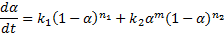 | (1)

here is the current degree of cure, , , the reaction rate constants, and , , the reaction orders. The reaction rate constants can be computed as follows [5]:

(2)

where is the current temperature, , are activation energies, , are pre- exponential factors and R the universal gas constant. The total heat of reaction H_{T} of the resin system of this study is 105 J/g. Table 1 summarises the cure kinetics parameters used in Eqns. (1)- (2). In this study, a degree of cure at gelation of 0.5 was assumed.

Table 1. Cure kinetics parameters.

Kinetic parameter | Value
 | 367363.9 [1/s]
 | 48206.9 [J/mol]
 | 141082 [1/s]
 | 42201 [J/mol]
 | 1.37
 | 0.6
 | 0.35

The specific heat capacity of the composite can be calculated using the rule of mixtures:

(3)

here is the fbre specific heat capacity, the specific heat capacity of the resin, whilst is the fibre weight fraction and is calculated as follows:

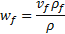 | (4)

where is the fibre volume fraction, and and the density of the fibre and composite density, respectively. The density of the composite is calculated using the rule of mixtures:

(5)

where is the resin density. A fibre volume fraction of 60% was assumed, whilst and is 1790 kg/m³ and 1170 kg/m³, respectively.

In addition, is 2000 J/kg/⁰C , whilst the specific heat capacity of the fibre was expressed as a linear function of temperature as follows [6]:

(6)

where is 2.05 [J/kg/⁰C²] and is 750 [J/kg/⁰C].

The thermal conducitivity of the composite in the longitudinal direction was calculated as follows [6]:

(7)

here is 7.69 [W/m/⁰C] and is 0.00156 [W/m/⁰C²].

The transverse thermal conducitivity of the composite was defined as:

(8)

where is -1.5 × 10-3, [W/m/°C²] , is 0.392 [W/m/°C], is 1 × 10-3 [W/m/°C²] and is 0.734 [W/m/°C].

4. Case studies

The manufacturing process of a thin flat laminate using ALM was simulated implementing the developed modelling framework. The length of the laminate was 100mm whilst its width was 60mm, respectively. In addition, the lay-up was [0⁰]₂ with a layer thickness of 0.5mm. The model comprised 30 elements and each layer was represented by 15 elements (see Figure 2). Figure 2 depicts the deposition route used in this study. To investigate the effect of deposition rate two deposition rates were used; 1mm/sec and 2mm/sec. A surface heat transfer coefficient of 5 [W/m²/⁰C] was used to represent natural air convection whilst the deposition temperature was set to 25 ⁰C representing ambient conditions.
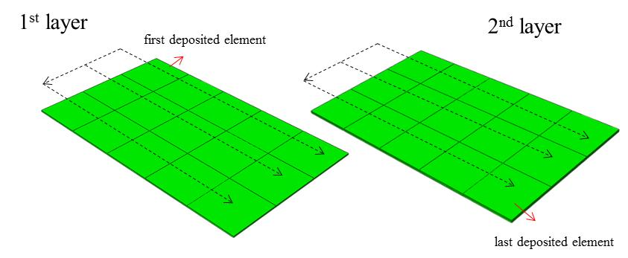

Figure 2. ALM process model of flat laminate. Deposition route.

Figure 3 and Figure 4 present the degree of cure and temperature evolution of the first and last deposited elements for the two deposition rates, respectively.

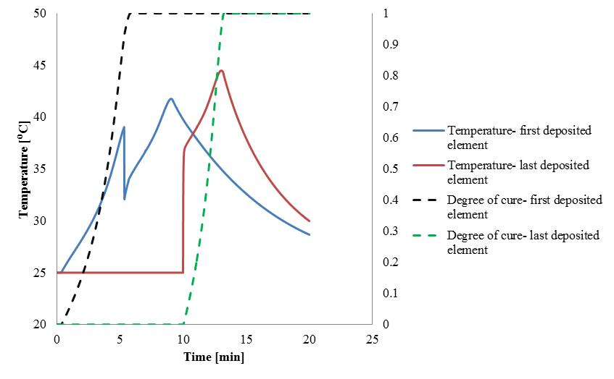

Figure 3. Degree of cure and temperature distribution of the first and last deposited element. Deposition rate1mm/s.

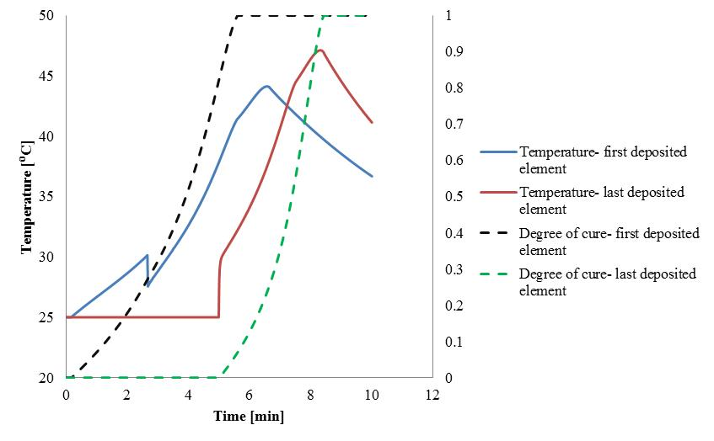

Figure 4. Degree of cure and temperature distribution of the first and last deposited element. Deposition rate 2mm/s.
As Figures 3 shows the temperature of the first deposited element increases from the deposition temperature (25 ⁰C) to around 37 ⁰C due to the exothermic heat caused by the curing reaction, followed by an abrupt decrease (at about 2.5 minutes) due to the fact that the first element of the second layer is deposited at 25 ⁰C. As the reaction proceeds the temperature increases reaching a maximum value (fully cured material), followed by a decrease due to heat dissipation caused by natural air convection. Similarly, the temperature of the last deposited element increases followed by a decrease due to natural air convection.
The degree of cure and temperature evolution showed similar behavior using a deposition rate of 2mm/s as shown in Figure 4. However, the simulation results indicated that using a deposition rate of 1mm/s can lead to considerable manufacturing defects caused by poor interlayer adhesion. In specific, it was shown that a number of elements of the first layer reached gelation prior to the deposition of the second layer implying that in these regions poor interlayer adhesion was reached. This is of crucial importance since interlayer adhesion during the manufacturing process can considerably affect the mechanical integrity and in turn the quality of the manufactured part.

5. Conclusions

A modelling framework appropriate to simulate ALM processes of continuous fibrous thermosetting composites was developed. The model accounts for the heat transfer effects occurring during deposition and can estimate interlayer adhesion based on resin gelation. The modelling framework presented in this study can be enhanced to predict residual stress formation between the deposited layers so that potential micro-cracks during the manufacturing process can be captured.Overall, the developments presented here can become a useful tool for designers leading towards the optimization of ALM process in the context of composite materials.

References
[1] Ning, F., Cong, W., Qiu, J., Wei, J. and Wang, S., 2015. Additive manufacturing of carbon fiber reinforced thermoplastic composites using fused deposition modeling. Composites Part B: Engineering, 80, pp.369-378.
[2] Zeng, W., Guo, Y., Jiang, K., Yu, Z., Liu, Y., Shen, Y., Deng, J. and Wang, P., 2013. Laser intensity effect on mechanical properties of wood–plastic composite parts fabricated by selective laser sintering. Journal of Thermoplastic Composite Materials, 26(1), pp.125-136.
[3] Ning, F., Cong, W., Qiu, J., Wei, J. and Wang, S., 2015. Additive manufacturing of carbon fiber reinforced thermoplastic composites using fused deposition modeling. Composites Part B: Engineering, 80, pp.369-378.
[4] Abaqus 2017 Documentation. https://www.3ds.com/

[5] Karkanas PI, Partridge IK. Cure modeling and monitoring of epoxy/amine resin systems. I. Cure kinetics modeling. Journal of applied polymer science. 2000 Aug 15;77(7):1419-31.
[6] Johnston A. An integrated model of the development of process-induced deformation in autoclave processing of composite structures, PhD Thesis, University of British Columbia, 1997.
.

