**Tensile behavior of basalt fiber reinforced composites at high strain rates**

Ahmed Elmahdy1, Esther Feldman2 and Patricia Verleysen1

1MST-DyMaLab, Department EEMMeCS, Ghent University, Technologiepark 903b, 9052 Zwijnaarde, Belgium

Email: ahmed.elmahdy@ugent.be

2Israel Aerospace Industries, Ben Gurion Airport, Israel

Email: efeldman@iai.co.il

**Keywords:** high strain rate, basalt fiber composites, split Hopkinson bar, digital image correlation

**Abstract**

The aim of this paper is to study the tensile behavior of basalt fiber reinforced epoxy composites at high strain rates. Reference quasi-static tensile experiments were carried out at strain rates of 0.003 and 0.03 s-1, while high strain rate experiments were performed using the split Hopkinson tensile bar technique at a strain rate of 130 s-1. The digital image correlation technique was used to measure the full strain fields on the surface of the samples for both quasi-static and high strain rate experiments. Results showed that the tested basalt/epoxy composite is strain rate sensitive in both the warp and the fill directions. With the increase in strain rates, the maximum strength increased by up to 35% of its low strain rate value, and the maximum strain increased by up to 41% of its low strain rate value. Analysis of full strain fields indicated that homogenous strains were developed within the gauge section during the progression of the tests.

1. Introduction

Basalt fibers and their composites have recently attracted a lot of interest from academic researchers and industry alike. This is attributed to the low cost, eco-friendliness, and the relatively easy production technique of these fibers. Basalt fibers are often compared to glass fibers in terms of stiffness and strength, as they tend to show comparable and sometimes higher elastic modulus and tensile strength values [1,2]. In addition, basalt fiber composites show better fatigue resistance and damping characteristics compared to glass fiber composites [3]. Therefore, basalt fiber composites can be used as a good alternative to conventional glass fiber composites [4]. Hybridization of basalt fibers with other types of fibers, such as aramic and carbon fibers, can result in composite materials with improved tensile strength [5], fatigue performance [6], and impact resistance [7]. As a result, basalt fibers can substitute a considerable percentage of the rather expensive carbon fibers without a significant decrease in the mechanical properties [8]. Basalt fiber composites were recently investigated for use in automotive and transportation applications [9]. In addition, a recent study has indicated that basalt fiber composites show better impact characteristics compared to carbon fiber composites [10]. This shows a growing interest in basalt fiber composites, especially for impact critical applications. Therefore, it is important to study their behavior at high strain rates. Some efforts were made to study the behavior of basalt fiber composites at medium and high strain rates in tension [11] and at high strain rates in compression [12]. Results generally showed an increase in the tensile and compressive strength with the increase of strain rates. Few attempts, however, were made to characterize this composite material at high strain rates in tension using the split Hopkinson bar technique. The aim of this paper is to study the tensile behavior of basalt fiber reinforced composites at high strain rates. High strain rate tensile experiments are carried out using the split Hopkinson tensile bar facility available at Ghent University. Reference quasi-static experiments are also carried out to establish a comparison of the behaviour at different strain rates. Axial strain distribution is measured on the surface of the sample using the digital image correlation )DIC( technique. Stress-strain response of basalt fiber reinforced composites and analysis of the full strain fields at quasi-static and high strain rates are presented and discussed.

2. Materials and Methods

2.1. Specimen material and geometry

The material used in this study was woven basalt fiber reinforced epoxy composite. A sheet of size 400x400 mm was made up of 10 plies, fiber volume of approx. 47%, and manufactured using wet layup technique. The thickness of each ply was 0.13 mm, and the total thickness of the plate was approx. 1.6 mm. The distance between each two consecutive fiber tows was 2 mm, and the size of the repeated unit cell of the woven fabric architecture was 4 mm. Dog-bone samples in both warp and fill directions were cut from the sheet using waterjet cutting. Figure 1 shows the geometry and dimensions of the tensile specimen used. The dimensions of the gauge section were chosen so that one repeated unit cell is covered within the width, and 3 repeated unit cells are covered within the gauge length. In that sense, the geometry was still representative of the material architecture, while fulfilling the requirements of a small size geometry for a vaild Hopkinson experiment. Aluminium tabs were glued at each side of the grip area of the specimens in order to account for any possible premature failure around the holes. In order to allow for digital image correlation measurements of strains, the gauge section of the sample was prepared by applying a black on white speckle pattern prior to testing. To avoid any discripensies related to sample geometry, the same sample geometry and boundary conditions were used for both reference quasi-static tests and high strain rate tests.

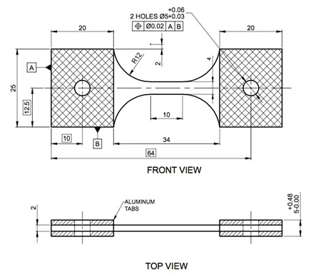

**Figure 1.** Geometry and dimensions of the tensile specimen

2.2. Quasi-static setup

Reference quasi-static tests were carried out using an Instron 5569 universal testing machine at a testing speed of 2 and 20 mm/min, corresponding to strain rates of 0.0033 and 0.033 s-1. The load was measured using a 50 kN load cell. Samples were placed between 2 long slotted bars and fitted using 5 mm diameter dowel pins. The 2D digital image correlation setup used for quasi-static testing consisted of a 5 megapixel camera fitted with a fixed focus lens having a focal length of 100 mm. Images of the speckled samples were recorded at a resolution of 2452x2056 pixels. Figure 2 shows the quasi-static setup used.

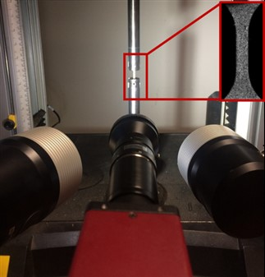

**Figure 2.** Quasi-static setup

2.3. Dynamic setup

Dynamic experiments were carried out using the split Hopkison tensile bar facility available at MST-DyMaLab of Ghent University. The input and output bars were made of high strength aluminium with diameter of 25mm and lengths of 6m and 3m, respectively. The dynamic tensile stress wave was generated by accelerating an impactor towards a flange at the end of the input bar, at speeds of 11m/s. Samples were placed between two slotted aluminium tabs and again fixed with 5 mm diameter dowel pins. A special alignment device was used to ensure good alignment along the centerline of the tabs and the bars. The incident (*ɛi*), reflected (*ɛr*), and transmitted (*ɛt*) strain waves were measured using strain gauges attached to both bars. When dynamic stress equilibrium is achieved at the input and output bar interfaces, the average stress (*σ*), strain (*ɛ*) and strain rate (*ɛ̇*) in the sample gauge section can be calculated from the classical Hopkinson bar equations as follows:

*ɛ̇* = 2 (C0/Ls)∙ *ɛr(t)*  (1)

*ɛ* = 2 (C0/Ls) ∙ *∫ₒᵗ**ɛr(t)* d*t* (2)

*σ* = Eb ∙ (Ab/As) ∙ *ɛt* (3)

where Ab and As are the cross section area of the bars and the sample, respectively, Co is the elastic wave speed in the bar material, Ls is the gauge length of the sample. The high speed DIC setup consisted of a Photron AX200 Mini high speed camera which captured images of the speckled sample during deformation at a speed of 86,400 frames per second. The lens used was Tamron Macro lens, which had a fixed focal length of 90mm. The images were recorded at a resolution of 128x288 pixels. Figure 3 shows the full dynamic tensile test setup used.

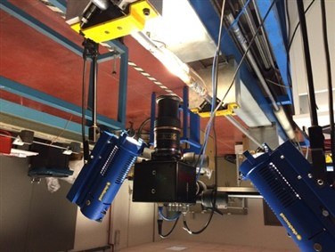

**Figure 3.** Dynamic setup

2.4. Processing parameters and data reduction for DIC

All captured images were analyzed and processed using MatchID commercial digital image correlation software, in order to obtain the full strain fields during the static and dynamic experiments. Table 1 indicates the different processing parameters and correlation criterion used. Local strains in the direction of loading were calculated as average values taken at a gauge area of 8x4 mm. In order to determine the strain resolution for both low and high speed DIC systems, 25 images were recorded at zero load (completely static conditions) and processed using the parmeters mentioned in table 1 prior to starting the tests. The strain resolution was calculated as the average standard deviation of generated strain fields. The chosen processing parameters allowed to achieve a strain resolution of approximately 100 microstrains for both quasi-static and dynamic experiments. For the dynamic experiments, the strain rate was calculated based on DIC strains.

**Table 1.** Processing Parameters for DIC

|  |  |
| --- | --- |
| **Parameter** | **Static and Dynamic 2D DIC** |
| **Correlation Criterion** | Zero normalized sum of square differences (ZNSSD) |
| **Interpolation Order** | Bicubic spline |
| **Shape function** | Affine |
| **Subset (pixels)** | 21x21 |
| **Step (pixels)** | 10 |
| **Strain window (pixels)** | 31 |
| **Strain convention** | Hencky |

3. Results and discussion

Figure 4 represents the engineering stress-strain response of basalt/epoxy composite at different strain rates in the warp direction. The strain rate achieved from the dynamic experiments was approximately 130s-1. It can be clearly seen that the material is strain rate sensitive in the warp direction. An increase in both maximum strength and strain can be seen with the increase of the strain rate. The maximum strength and strain increased from 356MPa and 0.022 at 0.003 s-1 strain rate, to 385MPa and 0.023 at 0.033s-1 strain rate. This corresponds to approx. 8% increase in maximum strength and 4.5% increase in maximum strain at quasi-staic strain rates. At dynamic strain rates (130 s-1), the increase in both strength and strain is much more significant: the maximum strength and strain increases significantly to 481.7MPa and 0.029 respectively. This corresponds to an increase of approx. 35% in the maximum strength and 32% in the maximum strain compared to that at 0.0033 s-1 strain rate.

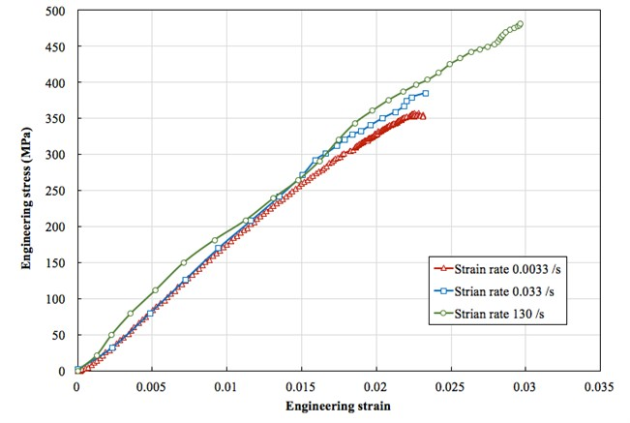

**Figure 4.** Engineering stress-strain behavior of basalt/epoxy composite at different strain rates in the warp direction

Figure 5 represents the engineering stress-strain response of basalt/epoxy composite at different strain rates in the fill direction. The strain rate achieved from the dynamic experiments was also approximately 130s-1. Similarly to the behavior in the warp direction, it can be clearly seen that the material is also strain rate sensitive in the fill direction. An increase in both maximum strength and strain can also be seen with the increase of the strain rate. The maximum strength and strain increased from 337.7MPa and 0.0252 at 0.003s-1 strain rate, to 387MPa and 0.0272 at 0.03 s-1 strain rate. This corresponds to approx. 14.5% increase in maximum strength and 8.1% increase in maximum strain at quasi-staic strain rates. At higher strain rates (130 s-1), the maximum strength and strain increase significantly to 458.9 MPa and 0.0356 respectively. This corresponds to an increase of approx. 35.8% in the maximum strength and 41% in the maximum strain compared to that at 0.0033s-1 strain rate.

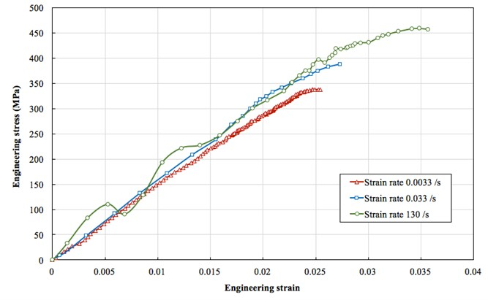

**Figure 5.** Engineering stress-strain behavior of basalt/epoxy composite at different strain rates in the fill direction

Similar findings were reported by H. Zhang et al [11], where maximum strength and strain increased with the increase of strain rate. However, the difference in values could be attributed to the difference of fiber configuration, fiber volume, and manufacturing technique. The basalt/epoxy composite used by H. Zhang was made of unidirectional basalt fibers with fiber volume of 21%, and manufactured by vaccum assisted resin infusion process, while in this study, the basalt/epoxy composite was made of woven basalt fibers with fiber volume of 47%, and manufactured using wet layup technique.

For both fill and warp directions, no change in stiffness can be seen up to strength level of 250MPa. A slight non-linear behavior can be seen in the stress-strain response of basalt/epoxy material in the warp direction at strength levels higher than 250 MPa. This non-linearity decreases with the increase of the strain rate. However, at all strain rates, the non-linear behavior at strength levels higher than 250 MPa is more pronounced in the fill direction. The non-linear behavior in both testing directions is due to the progressive failure of the fibers during testing up to total failure of the sample. The presense of significant non-linear behavior in the fill direction compared to the warp direction is due to the nature of the manufacturing process of the fabric. Fibers in the warp direction tend to be under pre-tension compared to the fibers in the fill direction. This leads to a more linear behavior towards failure in the warp direction compared to the fill direction.

The digital image correlation technique was used to monitor the sample during the test and to measure the full strain fields on the surface of the sample. Figure 6 shows the full strain fields for both quasi-static and high strain rate dynamic tests at different strain levels. The strain given below each field image represents the average strain extracted at a gauge area of 8x4mm. All fields indicate that a state of homogeneous strain was developing within the gauge section at the early stages of loading. During the progression of the test, strains tended to concentrate at the intersection between the curved section and the uniform section of the sample. Concentrations were also present at the edge of the gauge section in the quas-static strain fields, due to the complex state of stresses at the edges (free edge effect). Failure of the samples took place within the gauge section, however, close to the intersection between the curved shoulder and the uniform gauge section, where strain concentrations were present.

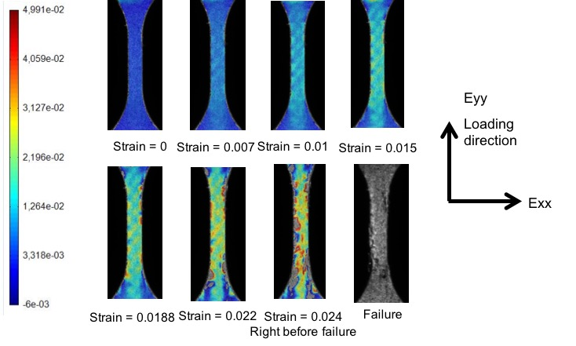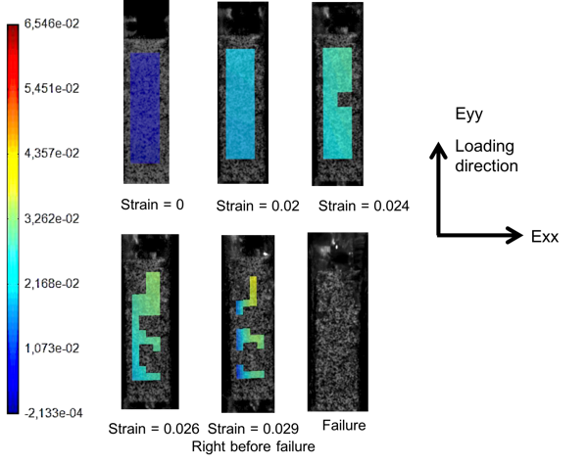

1. (b)

**Figure 6.** Full strain fields using DIC for warp direction: (a) strain rate 0.0033 s-1 (b) strain rate 130 s-1

4. Conclusions

Basalt fiber reinforced epoxy composites were tested at high strain rates (upto approx. 130s-1) using the split Hopkinson tensile bar technique. Reference quasi-static experiments were also carried out using the same tensile geometry to establish a comparison of the response at different strain rates. Strains were measured on the sample surface using the digital image correlation technique. Considering the current testing conditions and setups used, the following can be concluded:

1. The tested basalt/epoxy composite is strain rate sensitive in both fill and warp directions.
2. The maximum strength and strain increase by approx. 8% and 4% respectively in the warp direction , and by approx. 14% and 8.5% respectively in the fill direction when the strain rate is increased by one order of magnitude at quasi-static strain rates (0.0033 and 0.033 s-1).
3. At higher strain rates (130 s-1), the maximum strength and strain increase by approx. 35.8% and 41% respectively, compared to that at lower strain rate (0.0033 s-1).
4. The current testing conditions and sample geometry achieved a homogeneous strain field within the gauge section, which was confirmed by the digital image correlation technique.

Acknowledgments

The project “EXTEME” leading to this paper has received funding from the European Union’s Horizon 2020 research and innovation program under agreement No. 636549.

References

[1] T. Deák and T. Czigány.Chemical Composition and Mechanical Properties of Basalt and Glass Fibers: A Comparison. *Textile Research Journal*, 79:645–651, 2009.

[2] V. Lopresto, C. Leone, and I. De Iorio. Mechanical characterisation of basalt fibre reinforced plastic. *Composites Part B*, 42:717–723, 2011.

[3] A. Dorigato and A. Pegoretti. Fatigue resistance of basalt fibers-reinforced laminates. *Journal of Composite Materials*, 46:1773–1785, 2012.

[4] E. Quagliarini, F. Monni, S. Lenci, and F. Bondioli. Tensile characterization of basalt fiber rods and ropes: A first contribution. *Construction and Building Materials*, 34:372–380, 2012.

[5] Ö. Y. Bozkurt. Hybridization effects on tensile and bending behavior of aramid/basalt fiber reinforced epoxy composites. *Polymer Composites*, 38:1144–1150, 2015.

[6] Z. Wu, X. Wang, K. Iwashita, T. Sasaki, and Y. Hamaguchi. Tensile fatigue behaviour of FRP and hybrid FRP sheets. *Composites Part B*, 41:396–402, 2010.

[7] A. Dorigato and A. Pegoretti. Flexural and impact behaviour of carbon/basalt fibers hybrid laminates. *Journal of Composite Materials*, 48:1121–1130, 2013.

[8] N. M. Chikhradze, F. D. S. Marquis, L. A. Japaridze, G. S. Abashidze, and L. M. Okujava. Polymer Based Composite and Hybrid Materials for Wind Power Generation. *Materials Science Forum*, 654:2612–2615, 2010.

[9] Q. Liu, M. T. Shaw, and R. S. Parnas. Investigation of basalt fiber composite mechanical properties for applications in transportation. *Polymer Composites*, 27:41-48, 2006.

[10] F. A. Shishevan, H. Akbulut, and M. A. Mohtadi-Bonab. Low Velocity Impact Behavior of Basalt Fiber-Reinforced Polymer Composites. *Journal of Materials Engineering and Performance*, 26:2890–2900, 2017.

[11] H. Zhang, Y. Yao, D. Zhu, B. Mobasher, and L. Huang. Tensile mechanical properties of basalt fiber reinforced polymer composite under varying strain rates and temperatures. *Polymer Testing*, 51:29–39, 2016.

[12] F. Zhang, L. Wu, Y. Wan, R. K. Gideon, B. Gu, and B. Sun. Numerical modeling of the mechanical response of basalt plain woven composites under high strain rate compression. *Journal of Reinforced Plastics and Composites*, 33:1087–1104, 2014.