Discrete Damage Modeling for a Transverse Compression Experiment of
a Polymer Matrix Composite

Mark Flores¹, Nathanial Sesar², Bob Wheeler³, Andrew Sharits¹, David Mollenhauer¹

¹Air Force Research Laboratory, 2941 Hobson Way, WPAFB, OH 45433, USA
Email: mark.flores.7@us.af.mil,
²North Carolina State University, Raleigh, NC, , USA
³Microtesting Solutions LLc., Hilliard, OH 43016 USA

Keywords: transverse compression, in situ SEM, micromechanics, discrete damage modeling,

Abstract

Strengthening the fundamental understanding of micromechanical methods in continuity is a critical aspect in developing and designing future composite systems. Virtual testing has provided additional understanding of the behavior of materials on a microstructural scale. However, experiments must be executed to determine their validity. Modeling realistic microstructures under realistic loading conditions could help develop physically based micromechanical constitutive laws needed to predict the intrinsic failure. In this study, discrete damage modeling was performed on a the microstructure of polymer matrix composite under transverse compressive loading. The discrete damage model utilized a Regularized eXtended Finite Element Methodology (RXFEM formulation to initiate cracks, a Cohesive Zone Methodology (CZM) was used to simulate crack propagation, as well as debonding between the fibers and matrix. The discrete damage model provides insight to the microstructural behavior under transverse loading and correlates well with experiment.

1. Introduction

Despite significant improvements in polymer matrix composites,thematrix-fiber interfacial interactions under transverse compression are not well understood. It is well known that composites are strongest along the fiber direction, while their axial compressive performances are much lower than their tensile properties. Understanding what occurs at the fiber-matrix interface is crucial to improving performance, and can be studied through transverse compression loading. This will allow for performance improvents under axial compression for PMCs[1]. Performing micromechanical tests and models of transverse loading of PMCs can provide further insight into the compressive behavior of these materials. Developing accurate failure criteria and damage models is crucial to designing heterogeneous material systems. Understanding the micromechanical behavior of composite materials requires information about the fiber, matrix, and interface. With each system also possessing additional layers of complexity or heterogeneity. One essential aspect to modeling microstructural behavior is distinguishing what is needed to characterize the physical phenomena at these levels. Failure at these levels is often the consequence of the accumulation of micro-level failure events. Therefore, an understanding of the micro-mechanical damage mechanisms is crucial to developing accurate and physically based failure theories [1-3].

Singletary and Sockalingam performed transverse compression experiments of Kevlar fibers to obtain an effective transverse modulus and estimate the stress state in the fiber at the onset of yield using confocoal microscopy[4,5]. Finite element simulations were used in conjunction to describe the inelastic, transverse deformation. Primarily, the fibers experience micro-cracking and fibrillations at higher strains in the range of 40-60%[5]. Interestingly, Salisbury and Buckley performed transverse compression experiments on tendons, assuming that the tendons would exhibit hyperelastic behavior. The experiments showed varying degrees of stiffening with increasing load which can be attributed mostly to geometricchanges in the tendon[6,7].

Collings performed transverse compressive experiments using polymer matrix composites at the mesoscale to extract the elastic constants. Failure occurred by shear in a direction normal to the fiber on planes parallel to them, which was likely precipated by failure of the fiber-resin interface[8]. According to these studies, shear strengths were relatively insensitive to fiber volume fraction and are limited by the quality of the fiber-resin interface. It was also found that the shear stresses at failure appear similar to the axial compression stresses of the fibers. Tanks performed transverse compressive experiments on unidirectional composite bars[9] and found that damage resulted from high shear stress at the interface, as well as from normal stresses. Discrepancies between the current experimental work and modeling efforts could be the result of inadequate contact mechanics implemented in the modeling code. Vural studied the effect of strain rate utilizing a similar test and found that macroscopic transverse failue is dominated by shear stresses and occurs within localized bands through multiple fiber-matrix interface failures at the microscale. The orientation of shear failure bands was found to scatter over the range 49-60° for all the specimens inspected. Based on experimental evidence, a Mohr-Coulomb type failure mode was suggested to describe the transverse failure[10].

Developing failure criteria for polymer matrix composite structures has been studied extensively using statistical, phenomological, and micromechanical methods [11-18]. Puck identify a critical stress criteria needed to understand materials under transverse compression loading. The criteria uses a modified Mohr-Coulomb failure criteria to accurately predict failure.

This study will focus on transverse compressive experiments performed on polymer matrix composites at the microscale length scale. The methodology uses in situ SEM with complimentary digital image correlation to extract in situ measurements. Discrete damage modeling was implemented to understand the failure mechanicism for the model. The debonding between the matrix and fiber is calculated using the cohesive zone methodology(CZM). Matrix cracks are intiated utilizing the Regularized eXtended Finite Element Method (RXFEM). The propagation of matrix cracks is also simulated viathe cohesive zone methodology.

2. Test Method

Experiments were performed to evaluate the performance of PMC microstructures under transverse compression loading. A complex micro-pillar fabrication method is explored so that in situ SEM could be utilized to capture damage initiation and propagation. The microstructural specimen was speckled to perform digital image correlation in order to measure in situ displacement and strain during loading.

For this study, a 24-ply IM7/5250-4 unidirectional composite was fabricated using a standard autoclave curing cycle. The underlying assumptions for this experiment was that the fiber volume was 60%, with a fiber diameter of 5 µm. The nominal mechanical properties that were assumed for the carbon fiber and the resin are shown in Table 1. The Rule of Mixtures and Halpin-Tsai relationships were used to calculate the theoretical transverse elastic modulus while under compression. The initial prediction for transverse elastic modulus was calculated to be 8.394 GPa and 9.488 GPa.

Table 1. Constitutive Material Properties for a IM7 fiber and polymer 5250-4.
Material Properties | IM7 | 5250-4
Longitudinal Modulus, E₁₁ (TPa) | 0.276 | 0.00345
Transverse Modulus, E₂₂=E₃₃ (TPa) | 0.0276 | 0.00345
Axial Shear Modulus, G₁₂=G₁₃ (TPa) | 0.138 | 0.00128
Transverse Shear Modulus, G₂₃ (TPa) | 0.767 | 0.00128
Major Poisson’s Ratio, ν₁₂=ν₁₃ | 0.3 | 0.35
Minor Poisson’s Ratio, ν₂₃ | 0.8 | 0.35
Longitudinal Tensile Strength, X_{T}=Y_{T} (TPa) | 1.0 | 7.7e-5
Longitudinal Compressive Strength, X_{C}=Y_{C} (TPa) | 1.0 | 7.7e-5
Shear Strength, S=S₁₃ (TPa) | 1.0 | 7.7e-5

To fabricate the micro-compression samples, a 0.5” x 0.25” piece of composite was cut out. The side with fibers aligned parallel to the surface was ground with silicon carbide paper and polished using diamond lapping films. After reaching a final surface polish of 1 µm, a high-speed CNC mill was used to remove additional material to create a 600 µm x 600 µm pillar on top of the original piece of material. Using a diamond wafering blade with a thickness of 125 µm, the large pillar was cut down to 200 µm x 600 µm. Reducing the size of the pillar to 600 µm x 200 µm allowed for a minimization of milling time using a focused ion beam (FIB). Due to the relatively low current output of liquid gallium ion source, milling time is usually extremely long, and was reduced by using the aforementioned micromachining method to reduce material volume prior to FIB milling. Using a TESCAN LYRA 3 FEG-SEM x FIB, material was removed using a 30 nA current to remove bulk material. Once this stage was finished, a lower current of 2 nA was used to provide a smooth finish on the sample. A pillar of size 22.5 µm x 21.7 µm x 64.5 µm was fabricated using this specimen fabrication process, and is shown in figure 1.

Shoulder columns were manufactured to minimize post-catastrophic debris from axial compressed experiments[20]. The length of the shoulder columns allowed for 10 µm displacement and if catastrophic failure would occur, the columns would prevent the load platen from obliterating the specimen. This technique provides the capability to capture images during a catastrophic failure of a specimen without destroying the specimen, as is often seen in micromechanical experiments. Figure 1.a illustrates a representative pillar being subjected to a compressive load. Figure 1.b is an SEM image that shows the diamond platen (on top) with the pillar (on bottom). The 2-3 axis represent the transverse axis commonly represented in microstructures. The 1-axis is primarily used for the direction of a fiber which is perpendicular to the page.

It is expected that the resin matrix of the pillar will support all of the load during the experiment. Points around the fibers will act as crack initiation sites due to stress concentrations caused by debonding between the matrix and the fibers. Once the fibers debond from the matrix, cracks will begin to form in the matrix due to shear failure and form a 45° shear band that migrate around fibers in the specimen.

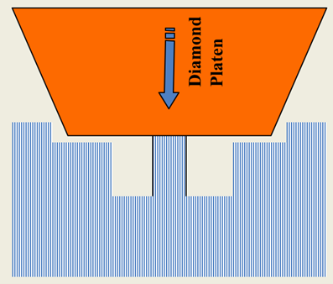 | 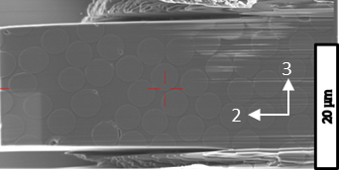 | 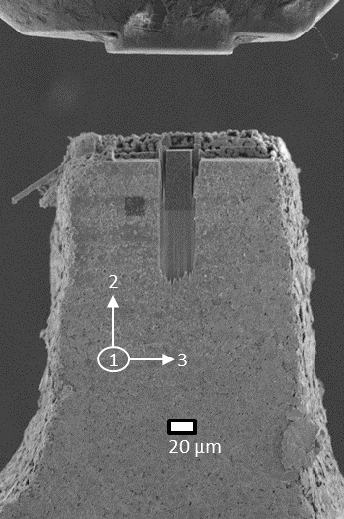
a) | b) | c)

Figure 1. Microstructure pillar of compression experiment a) idealized schematic b) SEM image of microstructure and c) experimental setup of a the microstructure with speckle pattern.

To test the specimen, a custom-built load fixture with in-situ SEM and X-ray capabilities was used. The fixture utilizes a piezoelectric actuator to allow for nano-scale resolution and control of the loading platen. The actuator has a maximum displacement of 150 µm. The fixture utilizes a 454g load cell with a 150 µm flat diamond platen to apply the load to the sample. The sample was fixed to a loading block that fits onto a x-y-z piezoelectric stage that allows for nano-scale resolution manipulation of the sample placement, as well as full angular control that can be adjusted manually. The sample stage and loading platen are controlled using LabVIEW software from National Instruments (NI). Using this same program, load cell and actuator displacement data are collected.

2.1. Experimental Results

The representative microstructure was loaded to 0.5g for each acquired SEM image. After each incremental load step was achieved, the load was held constant for 19 seconds for the SEM to acquire an image. During the experiment, load and displacement data was collected. Stresses were calculated using the representative area of the surface that was being compressed. Strain measurements were calculated using the difference in displacement between the recorded displacement and the spring displacement of the screw drive in the piezoelectric actuator.. Figure 2 shows an experimental stress vs strain curve. The transverse modulus of the experiment was calculated to be 10.589 GPa between 4-6% strain. Although, debonding and matrix cracks did occur under this load, it correlated well with the Rule of Mixtures and Halphin-Tsai expected behavior (Table 2). Slight deviations in the measured load can be seen during the hold period. As the load was increased the accumulated damage began to influence the behavior of the specimen. The piezoelectric actuator is unable to completely mitigate the response of the specimen during loading, so slight deviations in the measured load and displacement occur during testing. Ultimate failure of the specimen occurs near 460 MPa. The sample was then gradually unloaded. The purpose of unloading the specimen was to determine if crack closure occurred or to determine if additional damage would occur. Figure 3-4 show images of a transverse compression experiment at different loads.

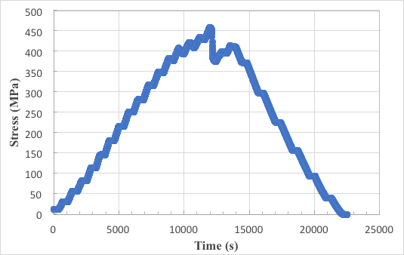 | 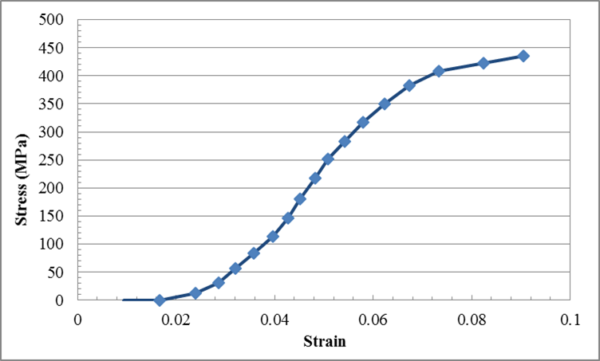
a) | b)

Figure 2. Graphical representation of a transverse compressive experiment’s a) Stress vs Time Curve and b) Stress vs Strain Curve

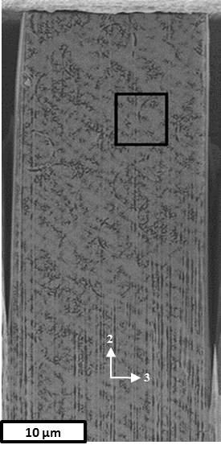 | 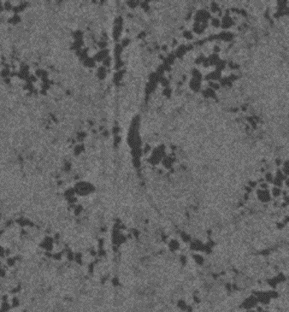 | 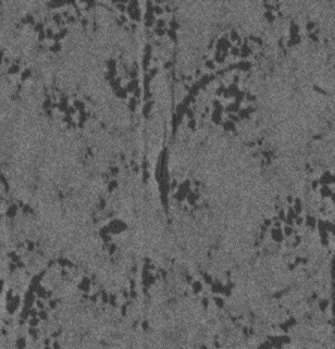
 | b) | c)
 | 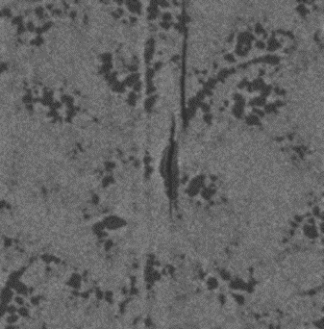 | 
a) | d) | e)

Figure 3. a) Undamaged microstructure under transverse compression loading with selected region of interest. b) At 9.73 grams, initial debonding between fiber and matrix occurs. c) At 12.69 grams, vertical matrix cracks occur around the region of the microstructure. d) At 15.72 grams, damage continues to propagate. e) At 18.31 grams, debonding occurs on adjacent fibers and the initiation of new damage

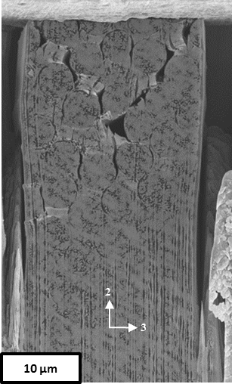 | 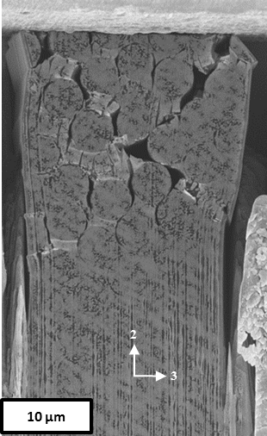
a) | b)
Figure 4. a) Damage of microstructure prior to ultimate failure b) damage of microstructure after ultimate failure

3. Discrete Damage Modeling

A simplified damage progression sequence of coupled matrix cracking and debonding is shown in Figure 5 a-c for the case of a microstructure subjected to a tensile load. Initially, the microstructure is undamaged, Figure 1a. As a result of the load application, debonding occurs at different locations in the microstructure (Figure 1.b). Even with a known distribution of fibers, the locations of the first debonding appears to be random, and cannot be known a priori. As the load increases, matrix cracks appear, and the spacing between them becomes increasingly deterministic. At some applied load, matrix crack initiates from the debonded regions (Figure 1.c). These cracks can propagate through the matrix causing ultimate failure of the microstructure. The failure scenario outlined here is intended for illustration purposes only in order to simplify the actual damage progression and failure process.
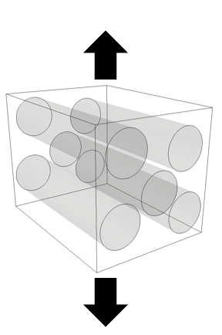 | 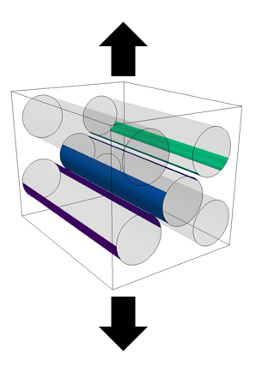 | 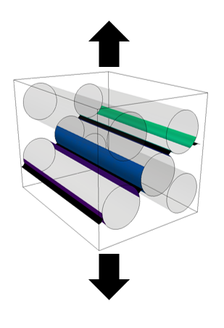
a) | b) | c)

Figure 5. Schematic of the damage evolution process of a microstructure a) undamaged microstructure b) interfacial debonding and c) matrix cracking

The DDM uses a coupled approach between a Regularized eXtended Finite Element Method (RXFEM), also called Mesh Independent Crack (MIC) modeling [20-23], where the step function used in traditional x-FEM methods to construct local enrichment for a crack discontinuity is replaced with a continuous function that is approximated by the same shape functions as those used for the initial displacement approximation. The surface of each crack is replaced with a diffuse zone (a volume where the gradient of the approximate step function is nonzero), and the surface fracture energy is replaced with the total cohesive energy in the diffuse zone.

A simulation begins without any initial damage. As the load increases, interfacial debonding (failure of the cohesive surface) between the matrix and fiber are occurrs according to the maximum principle stress failure criterion. The debond is inserted using the displacement enrichment necessary to model the displacement jump. The magnitude of the jump is initially zero and is controlled by an interface cohesive law developed by Turon [25-26]. Matrix cracks are inserted according to a maximum principal stress failure criterion. The criterion is evaluated at each integration point of a discretized element and if the criterion is exceeded, a matrix crack is added. Under maximum principal stress criterion, the fiber and matrix must have isotropic material properties given the plane stress and plane strain formulation. Fiber failure could be imposed utilizing a continuum damage methodology [26-28]. Fiber failure was not consider in this model since it did not exceed a strain of 40% [4,5].

Using a 0.2 µm resolution SEM image, a boundary box was defined. Each fiber within the microstructure was represented as a perfect circle. The centroid from each circle was recorded. The centroids from each circle were entered into an open source mesh generator (GMSH). The process is partially automated (Figure 6). The circles on the edges of the boundary require extra nodal coordinates to accurately capture the boundary of the microstructure. Once all the fibers were drawn, the remaining boundary lines were manually drawn. The surface map was extruded in 3D assuming that the fibers were perfectly straight. The mesh was then imported into the pre-processing tool (Virtual Textile Morphology Suite[29]), where boundary conditions were applied.

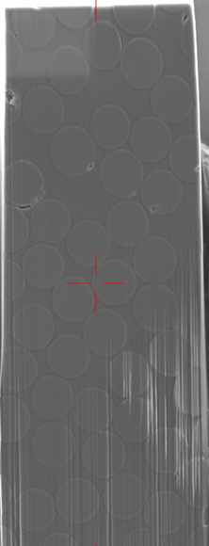 | 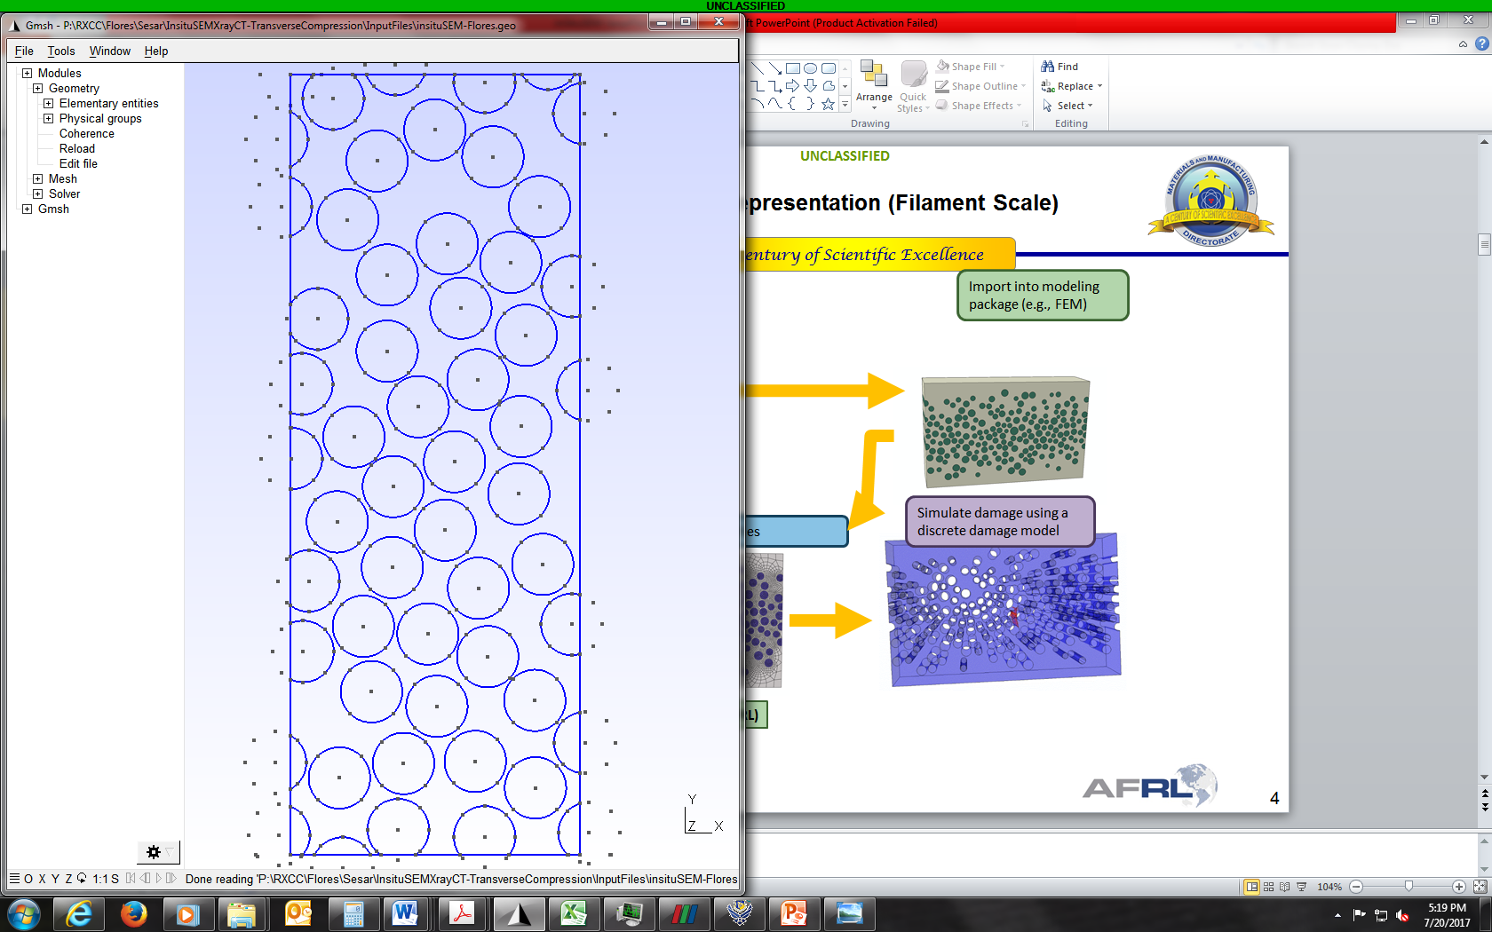 | 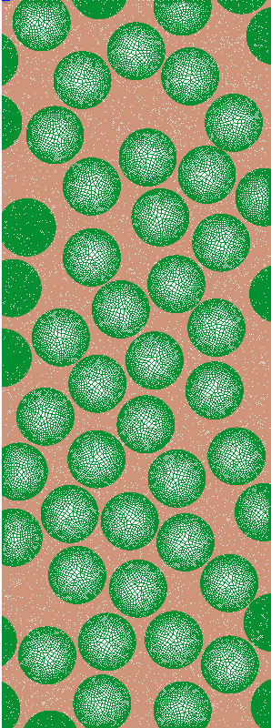
a) | b) | c)

Figure 6. Process to Generate a Representative Volume Element Mesh a) SEM Imaged Microstructure of Interest b) 2D Surface Construction and c) 3D Volumetric Mesh

Since maximum principal stress is an insufficient failure criteria, sensitivity analysis needed to be performed to ensure that the experimental behavior is adequately being predicted. Sensivity analysis was performed for a smaller statistical representative volume element not shown in this paper. Once the sensitivity analysis was complete, the compression strength of the matrix where the most sensitivity to loading configurations was identified. Using the aforementioned DDM, shear properties of the interface appeared to be the most sensitive. Figure 8 compares the experiment with the simulation. The DIC was able to capture global measurements of strain, however, the failure correlated well with experiment. The matrix cracks were parallel to the loading direction. The elastic modulus of the simulation correlated well with the experiment.

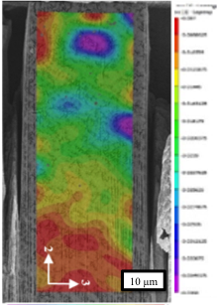
a) | b) | c)

Figure 8. a) DIC global in situ measurements of strain of a transversely loaded microstructure b) failure of transverse compressive loaded microstructure and c) discrete damage model of a PMC microstructure with strain contours.

Table 1. Transverse Compressive Modulus

E₂₂
(GPa)
Experimental | 10.589
Rule of Mixtures | 9.820
Halpin-Tsai Relation (ξ = 1) | 12.850
Simulation | 10.821

3. Conclusions

The transverse compression behavior at the micro-scale of a carbon fiber reinforced composites were investigated through a micro-scale experiment. Transverse compression experiments were run on an IM7/5250-4 specimen to explore the failure mechanisms and fiber-matrix interactions during compressive loading. The micro-pillar was manufactured using a micromachining and FIB method and was loaded using a custom-built test fixture. The pillar compressed and began to bow out as larger loads were applied, causing cracks to form within the matrix that propagated throughout the volume. DIC was performed on the specimen, but the data while consistent with the global response of the piezoelectric actuator, was not high-fidelity enough to determine critical information about the fiber-matrix interface.

After complete failure of the microstructure pillar, catastrophic failure was avoided without using the displacement-stopping shoulders, showing that during transverse loading of the microstructure there is still structural integrity after complete failure. In longitudinal loading, if the sample were to fail without the shoulders the sample would be lost, and post-failure analysis would be impossible. Since catastrophic failure doesn’t occur in the transversely loaded specimens it has verified this method of testing as viable, and will allow for more manufacturing of specimens for future work.

Performing these experiments can lead to a better understanding of how fibers interact with the matrix while under transverse compression loading. Understanding how the microstructure behaves could lead to better understanding of how cracks propagate throughout the matrix and how fibers debond from the matrix. With better understanding of these failure modes, composite microstructures and interfacial properties can be better understood.

Although DIC data was gathered during this experiment, the speckle pattern applied needs significant improvements, and other speckle patterns will be explored. For future work, different DIC patterns will be used and microstructure size effects will be explored. A displacement limited shoulder will continue to be used as a preventative measure to prevent catastrophic failure. These experiments will be used to feed a finite element analysis toolkit to improve the predictive computational model for these composite microstructures.

A discrete damage modeling methodology for analyzing microstructures under transverse compression loading was validated. A Maximum principal stress failure criteria was shown to beinsufficient to characterize the crack initiation for matrix cracks. However, it was able to capture the general behavior of the microstructure while under transverse compression loading. The simulation was able to approximate the overall behavior of the microstructure. The transverse compression modulus were close to the experiment.

References

[1] C Gonzalez, J LLorca, “Mechanical behavior of unidirectional fiber-reinforced polymers under transverse compression: Microscopic mechansims and modeling,” Composite Science and Technology 67, (2007), 2795-2806
[2] A Puck, H Schurmann, “Failure analysis of FRP laminates by means of physically based phenomenlological models,” Failure Criteria in Fibre Reinforced Polymer Composites, (2004), Ch 4, Elsevier
[3] TJ Vaughan, CT McCarthy, 2011, “Micromechanical modeling of the transverse damage behavior in fibre reinforced composites,” Composite Science and Technology, 71:388-396
[4] J Singletary, H Davis, MK Ramasubramanian, W Knoff, M Toney, 2000, “Transverse compression of PPTA fibers,” Journals of Materials Science, 35, p573-581
[5] S Sockalingam, R Bremble, JW Gillespie, M Keefe, 2016, “Transverse compression behavior of Kevlar KM2 single fiber,” Composites Part A, 81: 271-281
[6] CP Buckley, STS Salisbury, AB Zavatsky, “Viscoelasticity of Tendons Under Transverse Compression,” Journal of Biomedical Engineering, (2016), V138:101004.1-8
[7] STS Salisbury, CP Buckley, AB Zavatsky, “Transverse Compression of Tendons,” Journal of Biomechanical Engineering, (2016), V138, 041002.1-9
[8] TA Collings, “Transverse compressive behavior of unidirectional carbon fibre reinforced plastics”, (1974), Composites, 108-116
[9] JD Tanks, DK Harris, SR Sharp, “Mechanical Response of unidirectional composite bars loaded in transverse compression,” Composites Part B, (2016), 97, pages 18-25,
[10] M Vural, G Ravichandran, “Transverse Failure in Thick S2-Glass/Epoxy Fiber-reinforced Composites,” Journal of Composite Materials, (2004), Vol 38, No 7, p609-15
[11] C Sandino, E Correa, F Paris, “A study of the influence of a nearby fibre on the interface crack growth under transverse compression in composite materials,” (2018), 193: 1-16
[12] PP Camanho, MA Bessa, G Catalanotti, M Volger, R Rolfes, 2013 “Modeling the inelastic deformation and fracture of polymer composites – Part II: Smeared crack model,” Mechanics of Materials, 59, 36-49
[13] M Volger, R Rolfes, PP Camanho, 2013, “Modeling the inelastic deformation and fracture of polymer composites – Part I: Plasticity model,” Mechanics of Materials, 59: 50-64
[14] A Arteiro, G Catalanotti, AR Melro, P Linde, PP Camanho, “Micro-mechanical analysis of the effect of ply thickness on the transverse compressive strength of polymer composites.
[15] N Moustaghfir, etal, 2013, “Transverse compression behavior of textile rovings: finite element simulation and experimental study,” J Materials Science, 48: 462-472
[16] PP Camanho, A Arteiro, G Catalanotti, AR Melro, M Volger, 2015, “Numerical modeling of failure in advanced composite materials,” Elsevier, 111-150
[17] D Zhang, L Chen, Y Sun, etal, 2016, “Meso-scale progressive damage of 3D five-directional braided composites under transverse compression,” V50(24):3345-3361
[18] M Bishara, M Vogler, R Rolfes, 2017, “Revealing complex aspects of compressive failure of polymer composites – Part II: Failure interactions in multidirectional laminates and validation,” 169: 116-128
[20] T Quick, DH Mollenhauer, Bob Wheeler, Ali Kadhim, Nathan Sesar, “Microscale Investigation of the Compressive Behavior in Unidirectional PMCs Through In-Situ SEM and X-ray CT Experimentation,” American Society of Composites, 2016
[21] EV Iarve, MR Gurvich, DH Mollenhauer, CA Rose, CG Davila, 2011, “Mesh-independent matrix crack and delamination modeling in laminated composites,” Int J. Numerical Methods in Engineering, published online, DOI:10.1002/nme.319
[22] EV Iarve, DH Mollenaur, TJ Whitney, R Kim, 2006, “Strength prediction in composites with stress concentration classical weibull and critical failure volume methods with micromechanical considerations,” Journal of Materials Science, Vol 41 No 20, p5510-p6622
[23] MJ Swindermann, EI Iarve, RA Brockman, “Strength prediction in open hole composite laminates by using discrete damage modeling,” AIAA Journal, 51(4), 2012, P936-945
[24] DH Mollenhauer, L War, EV Iarve, S Putthanarat, K Hoos, S Hallett, X Li, “Simulation of discrete damage in composite overheight compact tension specimens,” Composites Part A, 43, 2010, p1667-167
[25] A Turon, PP Camanho, J Costa, CG Davila, “A damage model for the simulation of delamination in advanced composites under variable-mode loading,” Mechanics of Materials, Vol 38, No 11, Nov 2006, p1072-89
[26] PP Camanho, P Maimi, CG Davila, “Prediction of size effects in notched laminates using continuum damage mechanics,” Composite Science and Technology, 2007:67, p2715-2727
[27] CG Davila, PP Camanho, CA Rose, “Failure criteria of FRP laminates,” Journal of Composite Materials, Vol 39, No 4, 2005, p323-45
[28] ST Pinho, CG Davila, PP Camanho, L Iannuci, P Robinson, “Failure modes and criteria for FRP under in-plane or three-dimensional stress states including shear nonlinearity,” Hampton, VA, February 2005, NASA/TM-2005-2133530
[29] B-Spline Analysis Method User Manual (2014)

