A new strategy for balancing sensitivity and stretchability in strain sensor with well-controlled high-density cracks

Yangyang.Xin¹, Jian.Zhou¹, Xuezhu.Xu¹, G. Lubineau^{1*}

¹ King Abdullah University of Science and Technology (KAUST), Physical Science and Engineering, COHMAS Laboratory, Thuwal 23955-6900, Saudi Arabia
Email: gilles.lubineau@kaust.edu.sa
Web Page: https://cohmas.kaust.edu.sa/Pages/Home.aspx

Keywords: cracks, high sensitivity, high stretchability, compressibility, linearity, strain sensors

Abstract

With the increasing demands in new application such as wearable electronics, human health monitoring, and soft robotics, high-performance strain sensors with high sensitivity, and high stretchability, with the ability to measure both tensile and compressive strain, are highly desirable. However, based on the reported studies, it is difficult to get a strain sensor with both high sensitivity and high stretchability. Also, the response of the many strain sensor is nonlinear which makes their practical application difficult. Here, we introduce a strategy in which a carbon nanotube paper was embedded into an elastomeric substrate with laser-engraved technology to well control the crack density. Then the pre-cracks were changed into through-thickness cracks by a roll-to-roll process. This sensor can maintain high sensitivity with good stretchability (with a GA of over 4.2 × 10⁴ at 150% strain which is three times greater than that of no pre-cracked sensor). By changing the sensor’s substrate to a thermoplastic polymer, and applying a stretching-stress-releasing process, we are then capable of designing a highly-sensitive compressive strain sensor.

1. Introduction

With the rapid developments in stretchable electronics, stretchable strain sensors got high attention.¹⁻⁶ High-performance stretchable strain sensors are mainly determined by three factors: sensitivity, stretchability, and linearity.⁷⁻¹³ The sensitivity was often measured by gauge factor (GA) which is evaluated by the relative resistance change versus the applied strain. High gauge factor is useful to detect even small strain change which is important in some situations such as body blood pressure measurement and heart rate detection. High stretchability brings high detection range which plays a vital role in human body motion detection and soft robotic applications. The linearity of the stimulus/measurement response is also a required performance to get consistent level of precision over the whole measurement range. Current strain sensors technologies do not perform well on these three aspect in the compressive range. It is indeed difficult to have a good combination of high stretchability (strain>100%), high sensitivity(GA>100), high linearity, and high compressibility (>4%).

A classical way to bring stretchability to a component is to introduce cracks. An excellent stretchable strain sensor was reported based on cracked silver nanoparticles thin film in polydimethylsiloxane (PDMS). ¹⁴ This sensor can be stretched to 20% with a GA of 7. The good sensitivity and stretchability are attributed to the opening and closing of microcracks. We can find a lot of stretchable strain sensors based on cracks, such as deposited cracked platinum thin film on top of stretchable layers, embedded graphite thin films with short microcracks in elastomers.^{15,16} Due to the specific response of the cracked surfaces, both sensitivity and stretchability are tremendously increased. However such technologies do not perform well today for the measurement of compressive strains. Conductive aerogels have high compressibility, but underperform under tensile strain.^{17,18} Conductive film based compressible strain sensors have a very limited measurement range in compression (strain>-4%).^{19,20}

Here, we introduced a new strategy to construct a high-performance strain sensor with high sensitivity, high stretchability, high linearity, and high compressibility. First, we introduce pre-cracks with a laser-engraving process on the surface of the carbon nanotube thin film. Then, the engraved carbon nanotube film was embedded in polydimethylsiloxane (PDMS). To trigger the pre-cracks, we used a roll-to-roll pressing process. Thus we got a stretchable strain sensor with a maximum stretchability of 153% while maintaining a high sensitivity of 4.2 × 10⁴. Followed the above steps, we changed the PDMS to a thermoplastic elastomer (TPE) as the substrate. At last, pre-stretching the sensor followed by a heating annealing process released the stress caused by pre-stretching. Based on this method, we got a stretchable strain sensor capable to measure compressive strains up to 8% with a highly linear response.

2. Results and discussion

2.1. The controlled density of cracks and the opening of cracks

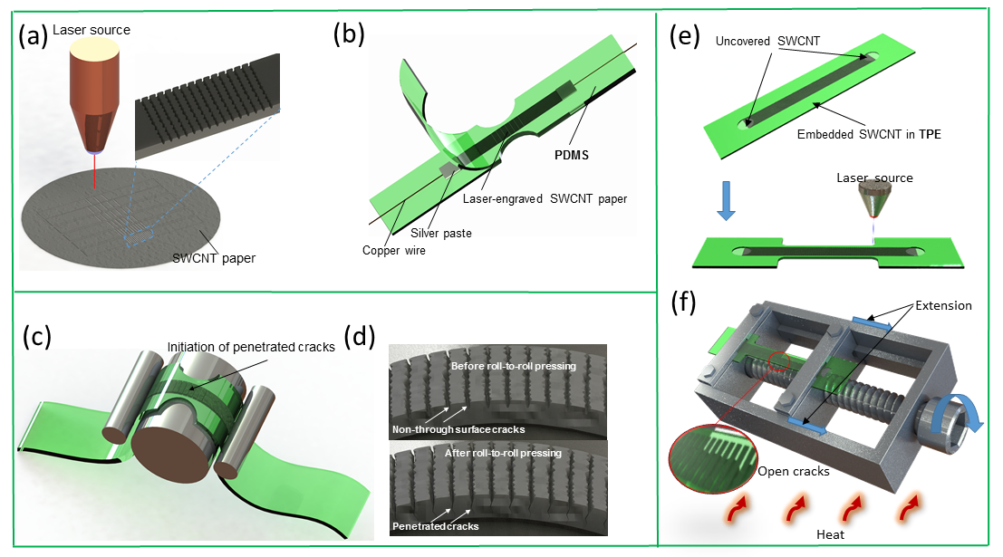

Figure 1. Proposed strategy to control the crack density of the SWCNT paper in an elastomer for high sensitivity, high stretchability, high linearity, and high compressibility in strain sensors. (a) the laser-engraving process for generating partial cracks on the SWCNT paper. (b) Embedded engraved SWCNT paper in PDMS substrate. (c) Roll-to-roll pressing process to trigger the pre-cracks. (d) Graphs to demonstrating pre-cracks before and after roll-to-roll pressing process. (e) Changing PDMS to a TPE as new substrate to fabricate a compressive strain sensor. (f) The pre-stretching and heating reheating process to form an open cracks structure for getting compressibility.

Fig. 1 shows the central concepts and steps to get a high-performance stretchable strain sensor. First, we used a laser to engrave the SWCNT paper to form non-through thickness macrocracks as shown in Fig.1.a. By adjusting the distance between two macrocracks, the density of non-through thickness macrocracks was well controlled. Next, we embedded engraved SWCNT paper into a PDMS substrate and connected two copper wires as electrodes (Fig.1.b). Then, we used a roll-to-roll pressing process to trigger the macrocracks propagation (Fig.1.c). The Fig.1.d is the demonstration of the cracks before and after the roll-to-roll pressing process. The non-through thickness cracks propagated to through thickness cracks after the roll-to-roll pressing process. For getting a compressive strain sensor, we changed the PDMS to a TPE film (Fig.1.e). Followed by the above steps, the sensor was pre-stretched by a steel extension device to open the cracks (Fig.1.f). At last, the sensor was heated to remove the internal stresses through an annealing process, so the new configuration with open cracks becomes the reference configuration, providing the sensor with the compressive-strain measurement capabilities.

2.2. Strain sensing

Fig.2.a shows the performance sensor with a low crack density (0.5) under incremental increasing loading. We can see that the change in resistance with strain was highly non-linear. Fig.2.b shows the performance of the sensor with a high crack density (3.3). The stretchability was increased to more than 150%, and the linearity and repeatability between loading and unloading step were largely improved. The relative changes in resistance versus strain of the high crack density sensor (3.3) was shown in Fig.2.c. It shows two linear stage, with a change in regime at about 25% strain. The maximum sensitivity of the sensor is 4.2×10⁴. We plotted the change in resistance with respect to strain under different loading rate in Fig.2.d. Based on the result shown in Fig.2.d, the loading rate has a small influence on the sensor’s response. The Fig.2.e and Fig.2.f show the response of the sensors under a cyclic compressive strain with a 25% and 50% pre-stretching strain, respectively. From these results, we can find that the increase in the pre-stretching strain can improve the sensor’s performance under compressive strain, but for the amplitude of the measurable range and for the linearity.

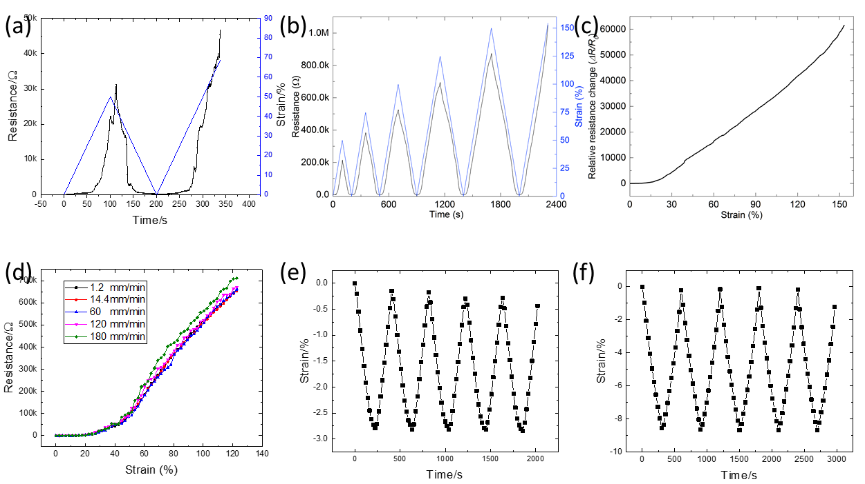
Figure 2. The sensing performance of different sensors with a low and high density of cracks, and the compressibility of the sensor based on TPE substrate. (a) The performance of sensor with a low crack density of 0.5 when used in cyclic tension. (b) The performance of sensor with a high crack density of 3.3 when used in cyclic tension. (c) Relative changes in resistance versus strain of the high crack density sensor (3.3) when used in tension. (d) The influence of the loading rate of the measured resistance (high crack density 3.3). (e) The performance of sensor with 25% pre-stretching strain under five repeated compressive loading. (f) The performance of sensor with 50% pre-stretching strain under five repeated compressive loading.

3. Experimental

3.1. Materials

SWCNTs with 2.7% COOH groups were purchased from CheapTubes, Inc., with over 90 wt% purity and containing more than 5 wt% of multi-walled CNT. The SWCNT length ranged from 5 to 30 mm and their outer diameter ranged from 1 to 2 nm. The true density of these SWCNTs was 2.1 g cm−3. SYLGARD 184 PDMS and methanesulfonic acid (CH3SO3H) were purchased from Sigma Aldrich.

3.2. Preparation of SWCNT paper

An environmentally friendly mild organic acid, methanesulfonic acid (CH3SO3H), was used to disperse SWCNTs to increase the safety of the material handling (compared to super acids like chlorosulfonic acid). A 0.5 wt% SWCNT dope was prepared by adding 0.2 g of SWCNTs into 40 g of CH3SO3H, sealing in a glass bottle, stirring for 5 min and bath sonicating using a Brason 8510 sonicator (250 W; Thomas Scientific) for 60 min. The mixture was then stirred again for 12 h at 500rpm. 15 g of the 0.5% SWCNT/CH3SO3H dispersion were vacuum-filtered through a ceramic filtration membrane (pore size: 20 nm, Whatman).

3.3. Laser engraving on the SWCNT paper

High-density grooves were created using a PLS6MW-Multi-Wavelength Laser Platform and a 1.06 μm fiber laser source (Universal Laser Systems). The sample was cut with a power of 24 W at a speed of 160 cm s−1 and a frequency of 400 kHz to ensure a non-through-thickness channel. The crack density was controlled in 0.5 and 3.3.

3.4. Preparation of SWCNT paper-based strain sensors

The strips of laser-engraved SWCNT paper were transferred onto 0.5 mm-thick PDMS substrates; copper wires were connected to the SWCNT paper strips by silver epoxy. Next, a second layer of PDMS precursor of equal weight was poured onto the sample and cured at 70 °C in an oven for 2 h to fully encapsulate the SWCNT paper.

3.5. Preparation of TPE (SIS) film.

Dichloromethane (DCM), was used to dissolve Polystyrene-block-polyisoprene-block-polystyrene (SIS) grains and a homogeneous SIS film was obtained by a solution-casting process. 10 wt.% SIS solution was prepared by adding 20 g of SIS grains into 180 g of Dichloromethane (DCM), sealed in a glass bottle, stirred for 1 hour at 800 rpm/min speed. Then 150 g of the solution was put into a steel container (59×7×20 cm) with a cap for evaporating for 12 hours. The semitransparent SIS film was then peeled off from the bottom of steel container.

3.6. Preparation of SWCNT paper-based strain sensors with TPE (SIS) substrat.

The strips of laser-engraved SWCNT paper was transferred onto an SIS strip. Next, the second layer of SIS strip was covered onto the sample. After that, the sample was sandwiched in the middle of two glass slides covered with Teflon paper. Two steel blocks weighting around 2 Kg were put onto a glass slide to give samples uniform pressure stress, and at the same time the sample was heated at 120 ⁰C for 2 h to fully encapsulate SWCNT strips. The samples were cut to dog-bone shape by the laser cutting machine (Universal Laser Systems).

3.7. Initiation of through-thickness cracks by the roll-to-roll pressing method

The samples were loaded into a self-designed roll-to-roll pressing device. Cracks were propagated through the whole thickness by pressing the sample in alternating clockwise and counterclockwise directions until all cracks were created.

3.8. Pre stretching and heating re healing process for compressive strain sensor

The samples were given different pre-stretching 25% and 50%, by a tensile device as shown in Fig.1.f. To release the tensile stresses, all the samples were annealed at 90 0C for 1h.

4. Conclusions

In summary, through increasing the crack density of SWCNT paper, the performance in sensitivity, stretchability, and linearity were improved. We also use a TPE film as the substrate to design a compressible strain sensor, using a pre deformed network of cracks stabilized by annealing. The sensor shows good linearity and high compressibility ( strain>8%) under compressive strain. We believe that these techniques can inspire various designs of other sensitive and reversible strain-responsive materials with widespread applications.

Acknowledgments

The research reported in this paper was supported by funding from the King Abdullah University of Science and Technology (KAUST). The authors are grateful to the KAUST for its support.

References

[1] Amjadi, Morteza, et al. "Stretchable, Skin‐Mountable, and Wearable Strain Sensors and Their Potential Applications: A Review." Advanced Functional Materials 26.11 (2016): 1678-1698.
[2] J. Park, I. You, S. Shin and U. Jeong, ChemPhysChem, 2015,16, 1155–1163.
[3] Zhou, Jian, et al. "Semi-metallic, strong and stretchable wet-spun conjugated polymer microfibers." Journal of Materials Chemistry C 3.11 (2015): 2528-2538.
[4] Zhou, Jian, et al. "High-ampacity conductive polymer microfibers as fast response wearable heaters and electromechanical actuators." Journal of Materials Chemistry C 4.6 (2016): 1238-1249.
[5] Miura, Hiroaki, et al. "Foldable Textile Electronic Devices Using All‐Organic Conductive Fibers." Advanced Engineering Materials 16.5 (2014): 550-555.
[6] Zhou, Jian, et al. "Temperature sensing of micron scale polymer fibers using fiber Bragg gratings." Measurement Science and Technology 26.8 (2015): 085003.
[7] Cao, Qing, and John A. Rogers. "Ultrathin films of single‐walled carbon nanotubes for electronics and sensors: a review of fundamental and applied aspects." Advanced Materials 21.1 (2009): 29-53.
[8] Yamada, Takeo, et al. "A stretchable carbon nanotube strain sensor for human-motion detection." Nature nanotechnology6.5 (2011): 296.
[9] Trung, Tran Quang, and Nae‐Eung Lee. "Flexible and Stretchable Physical Sensor Integrated Platforms for Wearable Human‐Activity Monitoringand Personal Healthcare." Advanced materials 28.22 (2016): 4338-4372.
[10] Zeng, Songshan, et al. "Bio-inspired sensitive and reversible mechanochromisms via strain-dependent cracks and folds." Nature communications 7 (2016): 11802.
[11] Zhou, Jian, et al. "Ultrasensitive, stretchable strain sensors based on fragmented carbon nanotube papers." ACS applied materials & interfaces 9.5 (2017): 4835-4842.
[12] Zhou, Jian, et al. "Deformable and wearable carbon nanotube microwire-based sensors for ultrasensitive monitoring of strain, pressure and torsion." Nanoscale 9.2 (2017): 604-612.
[13] Gong, Shu, et al. "A wearable and highly sensitive pressure sensor with ultrathin gold nanowires." Nature communications5 (2014): 3132.
[14] Lee, Jaehwan, et al. "A stretchable strain sensor based on a metal nanoparticle thin film for human motion detection." Nanoscale 6.20 (2014): 11932-11939.
[15] Park, Byeonghak, et al. "Dramatically Enhanced Mechanosensitivity and Signal‐to‐Noise Ratio of Nanoscale Crack‐Based Sensors: Effect of Crack Depth." Advanced Materials 28.37 (2016): 8130-8137.
[16] Amjadi, Morteza, et al. "Parallel microcracks-based ultrasensitive and highly stretchable strain sensors." ACS applied materials & interfaces 8.8 (2016): 5618-5626.
[17] Lv, Peng, et al. "Super-elastic graphene/carbon nanotube aerogels and their application as a strain-gauge sensor." Rsc Advances 6.14 (2016): 11256-11261.
[18] Huang, Hua-Dong, et al. "Cellulose composite aerogel for highly efficient electromagnetic interference shielding." Journal of Materials Chemistry A 3.9 (2015): 4983-4991.
[19] Lee, Jaehwan, et al. "A stretchable strain sensor based on a metal nanoparticle thin film for human motion detection." Nanoscale 6.20 (2014): 11932-11939.
[20] Liu, Nishuang, et al. "Electrospun PEDOT: PSS–PVA nanofiber based ultrahigh-strain sensors with controllable electrical conductivity." Journal of Materials Chemistry 21.47 (2011): 18962-18966.

