CARBON FIBRE-CARBON NANOTUBE MULTISCALE COMPOSITES - NANOENGINEERING OF THE FIBRE SURFACE FOR PROTECTION IN EXTREME PROCESSING CONDITIONS
Wojciech Szmyt^{1,2,3,4*}, Laurent Marot³, Michel Calame^{3,4,5}, Celestino Padeste^{2,4} and Clemens Dransfeld^{1,4}
¹Institute of Polymer Engineering, FHNW University of Applied Sciences and Arts Northwestern Switzerland, Klosterzelgstrasse 25210 Windisch, Switzerland
²Laboratory for Micro- and Nanotechnology, Paul Scherrer Institute, 5232 Villigen PSI, Switzerland
³Department of Physics, University of Basel, Klingelbergstrasse 82, 4056 Basel, Switzerland
⁴Swiss Nanoscience Institute, University of Basel, Klingelbergstrasse 82, 4056 Basel, Switzerland
⁵Transport at Nanoscale Interfaces Laboratory, EMPA Swiss Federal Laboratories for Material Science and Technology, Überlandstrasse 129, Dübendorf, Switzerland
*Email: Wojciech.Szmyt@fhnw.ch
Keywords: multiscale composites, CNT, carbon fibre, atomic layer deposition, interface shear strength
Abstract
The direct growth of carbon nanotubes (CNTs) on carbon fibres (CF) is a novel approach for a secondary reinforcement and an increase of surface area of the CF-matrix interface in composite materials. We are coating the CF with an alumina film by means of atomic layer deposition (ALD) in order to protect them during the process. We propose a new strategy of ozone pre-treatment of CF in order to obtain covalent bonds between CF and the alumina. Employing this method, we are aiming to obtain a CF-alumina interface that withstands the CNT growth conditions, at the same time providing a CF protection. In this work we present an improvement of interface shear strength between the fibre and the protective film compared to conventional ALD coatings, as tested after the heat treatment mimicking the CNT synthesis conditions. Our goal is to obtain a multiscale composite of enhanced mechanical performance, and constitute a next step in the development of advanced composite materials.

Introduction
Carbon fibre reinforced polymers (CFRPs) are materials of great importance in numerous industry branches, such as automotive, aeronautics or sports equipment [1] owing to their outstanding strentgh-to-mass ratio. There are however several constraints of the structural applications of CFRPs, such as low fibre-martix interface strength and low toughness of the matrix material. A novel approach to overcome this challenge is the direct growth of carbon nanotubes (CNTs) on carbon fibre (CF) by means of chemical vapour deposition (CVD) for a secondary reinforcement and an increase of surface area of CF-matrix interface. This way, one obtains a hierarchical structure, which we refer to as a multiscale composite. In the development of multiscale composites, one needs to consider phenomena that occur at atomic, nano- and microscale reflecting the properties of macroscale part, as depicted in Fig. 1.
In our previous studies we have shown that iron nanoparticles used as catalyst for CNT growth diffuse into the CFs deteriorating their mechanical properties [2, 3]. There have been approaches to inhibit this effect by modifying the CVD process [4], but they led to a tradeoff between CF mechanical properties and a yield and quality of the grown CNTs. In our study, we are coating the CF with an alumina film by means of atomic layer deposition (ALD) in order to protect the CF in the process. We have found however, that the CF-alumina interface gets significantly weakened at CVD processing conditions [3]. We propose a new strategy of modifying the ALD in a way, that an ozone pre-treatment of CF is performed at an initial stage of the process. Subsequently, the ALD is started with trimethylaluminium (TMA) and ozone as film synthesis precursors instead of TMA and water as previously. It has been shown, that ozone chemisorbs on the graphitic surfaces primarily by epoxide surface species formation [5] as we illustrated in the Fig. 1d. This provides covalent nucleation sites for the TMA on the entire surface of graphite, not only on the structure defects like in the case of water as an oxygen source in ALD, see Fig. 1e. Uniform coating of highly-oriented pyrolytic graphite with alumina was observed [6] as an effect of applying this technique. Ultimately, this approach might lead to a synthesis of a covalently bound and a strongly adherent film.
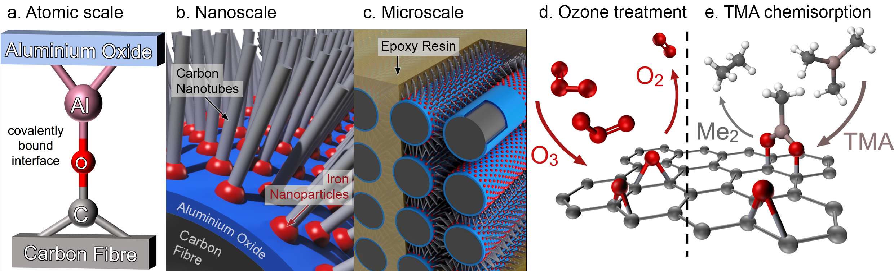
Figure 1. Schematic illustrating the multiscale composite at the three scales: a) atomic, b) nano- and c) microscale; d) ozone pre-treatment of a graphitic plane, e) chemisorption of TMA on the provided epoxide reaction sites.
In this work, we compare the alumina film growth rate and quality when ozone or water is used as oxygen source in ALD. For this purpose we used scanning electron microscopy (SEM) and X-ray photoelectron spectroscopy (XPS). This comparison was necessary in order to verify if the new ALD system can supersede the previously used one, which we have proven to provide preservation of the fibre strength upon exposition to CNT growth conditions [2]. We report the improved interface shear strength (ISS) between the protective alumina film and the CF after heat treatment at CVD processing temperature of 760 ºC as compared to the previously obtained results.

Experimental

Sample preparation

Single fibre isolation
Single carbon fibres were isolated by hand from a 12k tow of AS4 carbon fibre (Hexcel®, datasheet [7]). They were wound around custom made quartz frames under tension of ~900 MPa, which corresponds to ~20% of the nominal tensile strength of a fibre. It was achieved by fixing a ~3.6 g weight to one end of a fibre while handheld winding. We have shown previously, that keeping the fibre under tension is critical for preservation of the tensile strength in the CNT growth conditions [3]. The fibre was initially fixed to the quartz frame with a scotch tape and further on a ceramic adhesive 1400 by Unifrax® was used in order to fix the fibre and preserve its tension under high temperature processing conditions.

Ozone treatment and coating with alumina
Fibres wound on the quartz frames have undergone ozone pre-treatment followed by coating with alumina in an ALD process. The pre-treatment and coating were conducted in a sequence under vacuum inside a standard ALD reactor Savannah 100 (Cambridge NanoTech, UK).
For details of the principles of ALD we refer to [8]. Briefly, ALD allows for extremely uniform and conformal coating of complex structures with atomic precision in terms of the synthesized layer thickness. It is a cyclic process that is carried out in a vacuum chamber and in each cycle a well-defined thickness increment is obtained, referred to as growth per cycle (GPC). Each cycle divides into two half-cycles. In each half-cycle, the substrate is exposed to one reactant, referred to as precursor. During the exposition, respective surface reactions occur, that lead to chemical binding (chemisorption) of the precursor molecules to the substrate followed by evacuation of the volatile reaction by-products. In our case of synthesis of alumina, we used trimethylaluminium (TMA) as a precursor for aluminium and ozone as a precursor for oxygen. The process temperature was set to 225 ºC. The exact reaction mechanisms of ALD of alumina form TMA and ozone are discussed elsewhere [9]. The vacuum pump was constantly running and the chamber was constantly flushed by 20 sccm of nitrogen during the entire process resulting in a stable chamber pressure of 45 Pa.
We compare the new results with the previously obtained [3]. In that previous work, the sample preparation was analogous to the one that we carried out for the current study, with a difference that in [3] we employed a classical ALD system for alumina synthesis with TMA and water, performed a 10 min room-temperature UV-ozone treatment of the fibres instead of the ozone treatment. Moreover, for this study we increased the number of cycles to 120 from the previously performed 100 in order toaccount for the possibly lower GPC as suggested in [9], that we however have not observed. The ALD process that we employed is summarized stepwise in the Table 1. In each ALD synthesis, a 1 cm² piece of silicon wafer with a 400 nm thermal oxide was put in parallel with the fibre sample for reference.
Table 1. The sequence of the ozone pre-treatment and ALD process
Temperature (ºC) | Event | Duration
80 ºC | Sample put into the reactor | -
- | Heating up, nitrogen purging | ~1 h
225 ºC | Ozone pre-treatment | 15 s
225 ºC | TMA pulse | 0.15 s | ALD cycle  ×120
 | Nitrogen purging | 30 s
 | Ozone pulse | 0.10 s
 | Nitrogen purging | 30 s
- | cooldown | ~2 h
80 ºC | Sample extracted from the reactor | -

Heat treatment under inert atmosphere
The ALD-coated carbon fibres have been subjected to heat treatment in an annealing oven under a constant flow of argon set to 10 l min⁻¹. Two different heat treatments were applied: one at the temperature of 570 ºC, the other at 760 ºC. These temperature points were chosen in order to evaluate the CF-alumina ISS processed at conditions mimicking the CNT growth. The heating rate was 20 ºC min⁻¹ and the treatment duration was 10 min in each case. Subsequently as the oven reached 200 ºC after ~2 h cooldown time, the samples were extracted.

Measurement techniques
The silicon wafer reference pieces were used to compare the results of alumina film ALD synthesis performed using TMA with water and TMA with ozone. The samples were compared in terms of growth rate by means of scanning electron microscopy (SEM) of cross sections prepared using focused-ion-beam (FIB) cutting. The XPS was employed to compare the quality of the oxide, namely to identify if the oxidation degree is the same in both ALD systems. Further on, the alumina-coated and subsequently heat-treated carbon fibres were tested for their tensile strength using single fibre tensile test (SFTT) and the alumina-fibre interface shear strength using the single fibre fragmentation test (SFFT).

Scanning electron microscopy of focused-ion-beam cross sections
The alumina-coated reference silicon wafer samples were first sputtered with gold to provide conductivity in SEM imaging and prevent charging effects, detrimental to the image quality. For the FIB sectioning and SEM imaging we used a FEI™ Helios™ NanoLab™ 650 DualBeam™ with a gallium ion beam and electron beam. Prior to the FIB cross sectioning, the samples were additionally locally coated with several hundreds of nanometers of platinum using the classical FIB-induced-deposition technique [10]. This step was performed for an additional protection of the underlying layer structude during the destructive ion beam imaging and cutting. While the cross-sections were revealed, the SEM imaging has been carried out. The respective films were identified and the alumina film thickness was measured in the ImageJ image processing software.

X-ray photoelectron spectroscopy
The XPS measurements were conducted on alumina-coated silicon pieces. Measurements were performed as received and after argon sputtering for 15 min at 2.5 keV [11]. After Ar sputtering the wide range spectra reveal only Al and O (C was sputtered away). Only Al2p and O1s core spectra are presented in this paper. Fitting of the data was performed using UNIFIT software [12]. We have investigated the binding energies (BE) of Al2p and O1s. The spectra were subsequently analysed using the XPS spectra fitting software to compare the alumina films qualitatively in terms of number peaks present in each spectrum and their respective binding energies (BE).

Single fibre tensile testing
The SFTT has been carried out according to the ASTM C1557-03 standard [13]. The single fibres were placed onto paper frames of a gauge length of 20 mm and fixed with a cyanoacrylate adhesive. The test was carried out on a desktop tensile testing machine (Linkam TST 350, UK) with a Linkam 20 N load cell with a micronewton resolution. As the frames with fibres were mounted in the tensile testing machine, the jaws were closed by at least 10 μm and sides of the frame were cut allowing the fibre to take the subsequently introduced load. The loading was performed at a rate of 15 μm s⁻¹. According to [13], the tests which exceeded 30 s before fibre break were discarded. The peak force before break was recorded as the force at fracture $F_{f}$ and the individual fibre tensile strength $σ_{f}$ was estimated as
 | $$σ_{f}=F_{f}/A,$$ | (1)
where $A$ is the surface area of the fibre cross section estimated using the fibre diameter $d$=7.1 μm stated in the AS4 CF datasheet [7] and confirmed by us previously using SEM (not shown). The data analysis has been carried out using Weibull statistics applicable to brittle fibres such as CF [14]. In this approach, the culminative distribution of the fibre strengths is expected to follow the relation
 | $$P\left(σ_{f}\right)=1-\exp\left({\left[σ_{f}/β\right]}^{α}\right),$$ | (2)
where $P\left(σ_{f}\right)$ is a probability that the measured strength of the individual fibre is less than $σ_{f}$, whereas $α$ and $β$ are the fit parameters. An experimental culminative distribution function $P(σ_{f})$ is evaluated. Following the Eq. 2, a straight line is fitted to $\ln{\ln\left(1-P(σ_{f})\right)}$ as a function of $\ln{σ_{f}}$, while the Eq. 2 can be transformed accordingly resulting in a linear relation. This way, the $α$ and $β$ are extracted and the mean $σ_{f}$ can be evaluated as an expected value of the Weibull distribution using the equation
 | $$〈σ_{f}〉=β⋅Γ\left(1+α^{-1}\right),$$ | (3)
where $Γ$ is the mathematical gamma function. At least 7 fibres were taken for analysis from each sample. The uncertainty is estimated as a standard deviation of the average
 | $$u\left(〈σ_{f}〉\right)=\sqrt{V\left(σ_{f}\right)/N },$$ | (4)
where $u$ is the uncertainty, $V$ if the statistical variance and $N$ is the number of samples accounted for.

Single fibre fragmentation testing
In order to test the CF-alumina interface shear strength, the SFFT has been carried out. The principle of the SFFT has been discussed and derived in the early work of Kelly and Tyson [15]. They proposed a model, which relates the interface shear strength $τ$ to the critical fragment length $l_{c}$ of a brittle fibre that undergoes fragmentation within an elongating elastic matrix medium. The relation is given by
 | $$τ=\frac{σ_{f}d}{2l_{c}}.$$ | (5)
It is established [16], that the critical fragment length can be estimated as
 | $$l_{c}=\frac{4}{3}\overline{l},$$ | (6)
where $\overline{l}$ is the mean fragment length found within an observed area. Alumina-coated fibres have been put under constant tension of ~900 MPa in a dogbone mould using a 3.6 g weight on one fibre end. The gauge length of the dogbones was 12 mm and the square cross section area was 2.0$±0.1$ mm². The moulds were casted with a commercially available epoxy resin system Araldite LY1564 with Aradur 22962 (Huntsman, USA) that we are aiming to apply in the further developed material. We used a curing cycle of 1 h at 80 ºC followed by 2 h at 150 °C. Subsequently, the samples were demoulded, ground flat and smoothened with the sandpaper of a grade of up to 4000. The obtained dogbones were tested in the same tensile testing machine as for the SFTT, however with the 200 N load cell. The testing was conducted at a rate of 0.5 μm s⁻¹. The fragmentation of the fibre was monitored under an optical microscope in transmission mode in a cross-polarized light configuration. In this setting, the fibre fracture spots generate local strain patterns in the epoxy material resulting in distinctive birefringence patterns (not shown). This allows to identify the fracture spots. Six dogbones were taken for analysis from each type of sample. The uncertainty is estimated as a 95% trust region, which means a double standard deviation of the results.

Results

Film quality assessment
We have not identified a significant difference between the thicknesses of the alumina synthesized by ALD of TMA with water or with ozone – see: Fig. 2. It is of note, that the film measured thicknesses are both higher than expected. They imply a GPC of alumina of about 1.5 Å per cycle, that exceeds significantly the typical GPC for this system, both for ozone [17] and water [18] as an oxidant, where ~1.0 Å per cycle was observed. It is likely, that for the quantitative interpretation, the measurements need to be validated by a more reliable and accurate method of layer thickness evaluation like X-ray reflectometry or ellipsometry. Otherwise, the similar procedure can be repeated on the SEM/FIB on thicker films, at which the influence of measurement resolution would be negligible. Nonetheless, this preliminary study in terms of qualitative comparison of the two films is convincing, that the growth rates do not differ significantly. The stoichiometry of the film was analysed by XPS measurements. The Al2p and O1s were deconvoluted in one component at a binding energy (BE) of 75.5 eV and 532.5 eV, respectively (see Fig. 2c) for ALD configuration of TMA with ozone. In case of water there is a shift of 0.1eV. The BE corresponds to Al₂O₃ [19] and the ratio of the O and Al atomic concentration was close to 1.5. Similar results were measured for similar films deposited by ALD [20, 21].
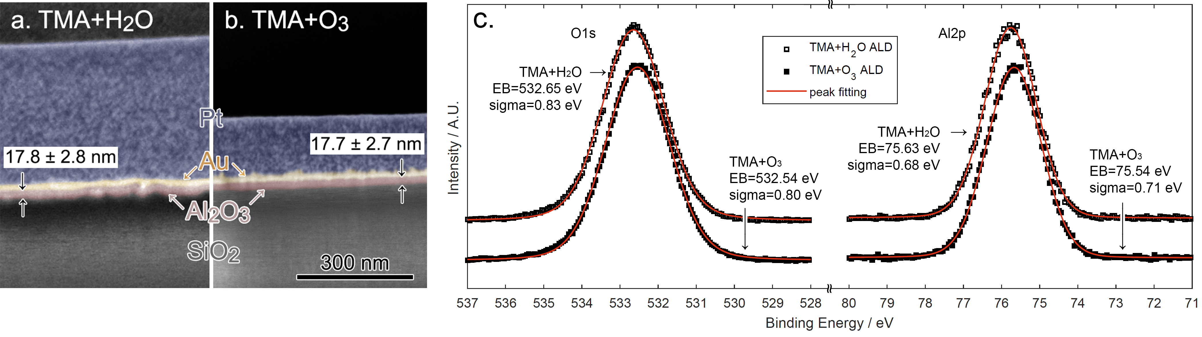
Figure 2. a,b -SEM images of FIB cross sections. The respective layers are labeled and artificially coloured for distinction (colors may be not be reproduced in print); c - XPS spectra of the alumina-coated silicon wafers using the ALD systems of TMA with water and TMA with ozone focused on the binding energies of O1s and Al2p. The peak fitting results are shown in the annotations.
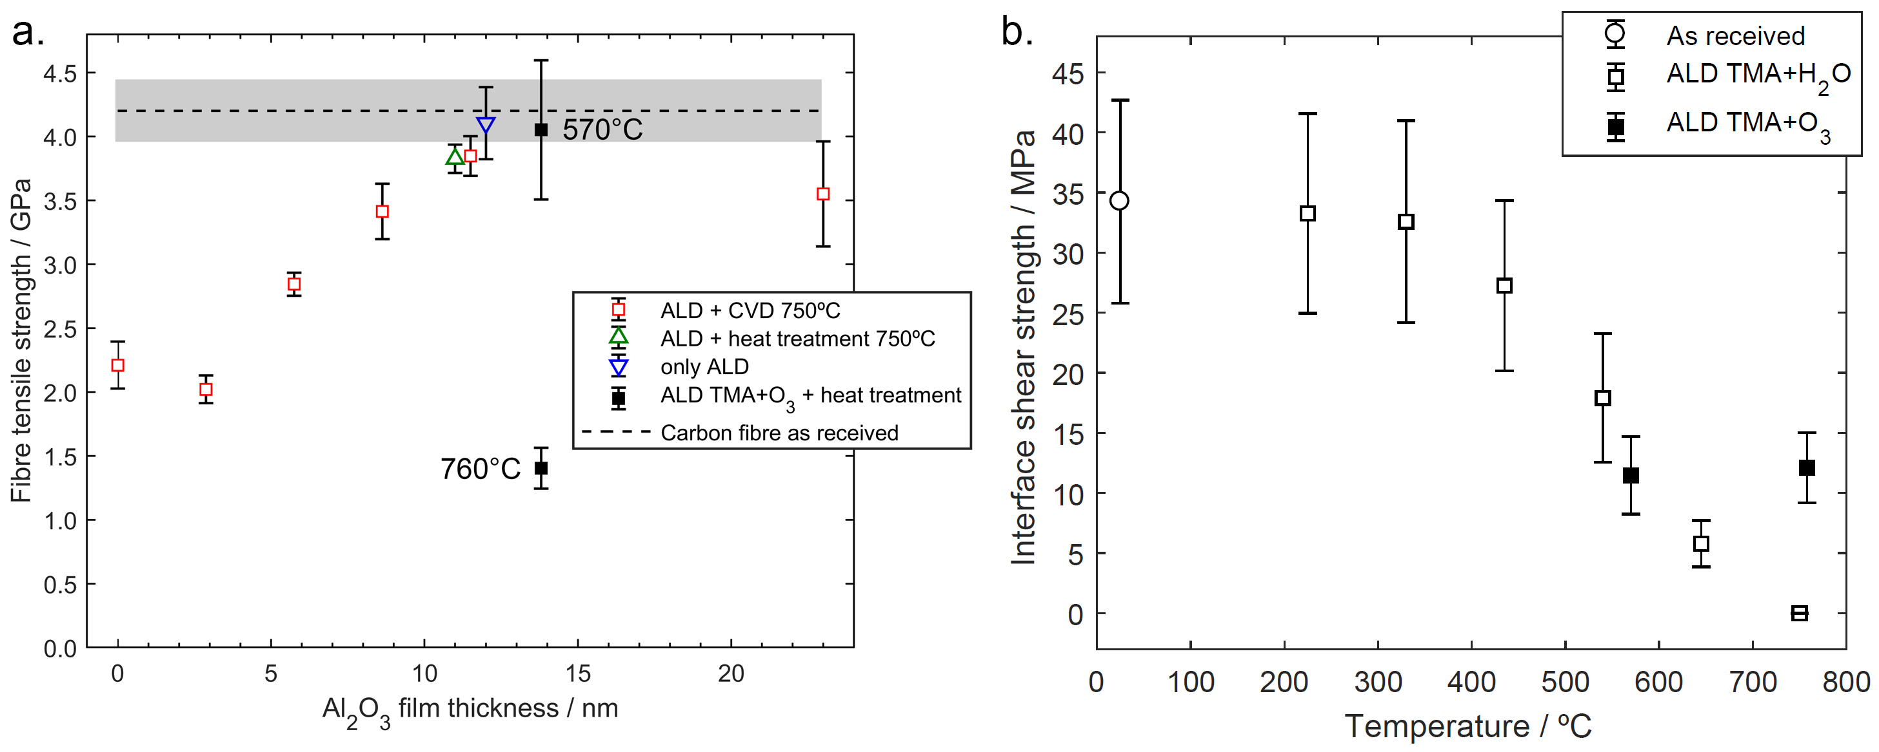
Figure 3. Results of the mechanical testing: a. The tensile strength of the fibres as measured by SFTT; b. The CF-alumina interface shear strength measured by SFFT.

Influence of inert atmosphere heat treatment on the strength of alumina-coated fibres
The new results of fibre tensile strength measured by SFTT are shown in the Fig. 3a. The new data for the TMA+ozone ALD system (black solid squares) is laid over our previously obtained data for the films obtained with TMA+water ALD [3]. According to the expectations, the $σ_{f}$ after the heat treatment at 570 °C has been retained, since its deviation from the baseline is statistically insignificant. On the other hand, the $σ_{f}$ the sample treated at 760 °C has dropped significantly. We attribute it to a possible flaw in the atmosphere inertness, that could have resulted in fibre oxidation. However, the purpose of the SFTT measurements in this study was the assessment of $σ_{f}$ for the interpretation of SFFT experiments, where the information about $σ_{f}$ is necessary in the Eq. 5 for the estimation of $τ$.

Alumina-carbon fibre interface shear strength after inert atmosphere heat treatment
As we can see in the graph in the Fig. 3b, after the heat treatment at 570 °C, the $τ$ of the CF-alumina interface lies well in line with the old data, where the classical TMA+water ALD process was applied. It suggests, that the ozone-treatment of the fibre that was not successful in preserving the $τ$. However, the $τ$ after 760 °C does not differ significantly from the 560 °C datapoint. In analogous conditions, we previously observed practically $τ$=0. It means, that the ozone-treatment may prevent further interface strength degradation below 12±3 MPa. However, one must treat this result with caution, since the observed fibre tensile strength degradation could have influenced the measurements.

Conclusion and outlook
Previously, we have demonstrated, that ultrathin alumina films allow to preserve the mechanical properties of CF during exposure to harsh conditions of CVD-CNT synthesis [2]. However, we have also found the CF-alumina ISS to diminish completely in the same conditions [3]. In this study, we have explored the influence of the ozone pre-treatment of CF prior to the coating with aluminium oxide on the CF-alumina ISS. We applied the heat treatment at 570 °C and 760 °C mimicking the conditions of CNT synthesis. We have found, that the ISS did not decrease below 12±3 MPa (see: Fig. 3b). It is an advancement with respect to the previous results showing the potential of the ozone treatment in promoting the CF-alumina adhesion. However, a fully preserved ISS is critical if the hierarchical composites are to supersede the classical CFRP solutions. Further planned attempts include of the ozone treatment optimization, combination of the pre-treatment with the UV-ozone or alternative CNT synthesis catalyst systems, allowing to preserve CF strength and not posing limitation on the ISS.

References
[1] N. Hiremath, J. Mays, and G. Bhat. Recent Developments in Carbon Fibers and Carbon Nanotube-Based Fibers: A Review. Polymer Reviews, 57:339–368, 2017.
[2] W. Szmyt, S. Vogel, A. Diaz, M. Holler, J. Gobrecht, M. Calame, and C. Dransfeld. Protective effect of ultrathin alumina film against diffusion of iron into carbon fiber during growth of carbon nanotubes for hierarchical composites investigated by ptychographic X-ray computed tomography. Carbon, 115:347–362, 2017.
[3] S. Vogel, C. Dransfeld, B. Fiedler, and J. Gobrecht. Protective effect of thin alumina layer on carbon fibre to preserve tensile strength during CNT growth by CVD. Proceedings of the 16th European Conference on Composite Materials ECCM16, Seville, Spain, June 22-26 2014.
[4] R. Cartwright et al. Low temperature growth of carbon nanotubes on tetrahedral amorphous carbon using Fe–Cu catalyst. Carbon, 81:639–649, 2015.
[5] G. Lee, B. Lee, J. Kim, and K. Cho. Ozone Adsorption on Graphene: Ab Initio Study and Experimental Validation. The Journal of Physical Chemistry C, 113:14225–14229, 2009.
[6] B. Lee, S.-Y. Park, H.-C. Kim, K. Cho, E. M. Vogel, M. J. Kim, R. M. Wallace, and J. Kim. Conformal Al₂O₃ dielectric layer deposited by atomic layer deposition for graphene-based nanoelectronics. Applied Physics Letters, 92:203102, 2008.
[7] Hexcel©. HexTow® AS4 Carbon Fiber Product Data Sheet available at www.hexcel.com/Resources/DataSheets/Carbon-Fiber-Data-Sheets/AS4.pdf. 2016.
[8] M. Leskelä and M. Ritala. Atomic layer deposition (ALD): from precursors to thin film structures. Thin Solid Films, 409:138–146, 2002.
[9] S. D. Elliott, G. Scarel, C. Wiemer, M. Fanciulli, and G. Pavia. Ozone-Based Atomic Layer Deposition of Alumina from TMA: Growth, Morphology, and Reaction Mechanism. Chemistry of Materials, 18:3764–3773, 2006.
[10] T. Tao. Focused ion beam induced deposition of platinum. Journal of Vacuum Science & Technology B: Microelectronics and Nanometer Structures, 8:1826, 1990.
[11] A. Krywko-Cendrowska, L. Marot, L. Philippe, M. Strawski, E. Meyer, and M. Szklarczyk. Spectroscopic characterization and photoactivity of SiO_{x} -based films electrochemically grown on Cu surfaces. Journal of Applied Electrochemistry, 47:917–930, 2017.
[12] R. Hesse, M. Weiß, R. Szargan, P. Streubel, and R. Denecke. Improved peak-fit procedure for XPS measurements of inhomogeneous samples—Development of the advanced Tougaard background method. Journal of Electron Spectroscopy and Related Phenomena, 205:29–51, 2015.
[13] ASTM C1557-03e1, Standard Test Method for Tensile Strength and Young’s Modulus of Fibers, ASTM International, West Conshohocken, PA, 2003, www.astm.org.
[14] C. P. Beetz. A self-consistent Weibull analysis of carbon fibre strength distributions. Fibre Science and Technology, 16:81–94, 1982.
[15] A. Kelly and W. R. Tyson. Tensile properties of fibre-reinforced metals: Copper/tungsten and copper/molybdenum. Journal of the Mechanics and Physics of Solids, 13:329–350, 1965.
[16] T. Ohsawa, A. Nakayama, M. Miwa, and A. Hasegawa. Temperature dependence of critical fiber length for glass fiber-reinforced thermosetting resins. Journal of Applied Polymer Science, 22:3203–3212, 1978.
[17] D. N. Goldstein, J. A. McCormick, and S. M. George. Al ₂ O ₃ Atomic Layer Deposition with Trimethylaluminum and Ozone Studied by in Situ Transmission FTIR Spectroscopy and Quadrupole Mass Spectrometry. The Journal of Physical Chemistry C, 112:19530–19539, 2008.
[18] J. L. van Hemmen, S. B. S. Heil, J. H. Klootwijk, F. Roozeboom, C. J. Hodson, M. C. M. van de Sanden, and W. M. M. Kessels. Plasma and Thermal ALD of Al₂O₃ in a Commercial 200 mm ALD Reactor. Journal of The Electrochemical Society, 154:G165, 2007.
[19] L. Moser, L. Marot, B. Eren, R. Steiner, D. Mathys, F. Leipold, R. Reichle, and E. Meyer. Towards plasma cleaning of ITER first mirrors. Nuclear Fusion, 55:063020, 2015.
[20] J. B. Kim, D. R. Kwon, K. Chakrabarti, C. Lee, K. Y. Oh, and J. H. Lee. Improvement in Al₂O₃ dielectric behavior by using ozone as an oxidant for the atomic layer deposition technique. Journal of Applied Physics, 92:6739–6742, 2002.
[21] B. Díaz, E. Härkönen, J. Światowska, V. Maurice, A. Seyeux, P. Marcus, and M. Ritala. Low-temperature atomic layer deposition of Al₂O₃ thin coatings for corrosion protection of steel: Surface and electrochemical analysis. Corrosion Science, 53:2168–2175, 2011.

