INJECTION MOLDING OF HYBRID CORK-WOOD COMPOSITES. MECHANICAL PROPERTIES OF PP AND PLA BASED MATERIALS

Marek Szostak¹, Jacek Andrzejewski¹

¹Institute of Materials Technology, Faculty of Mechanical Engineering and Management, Poznan University of Technology, Piotrowo 3 Street, 61-138 Poznan, Poland
Email: marek.szostak@put.poznan.pl, Web Page: http://www.plastics.put.poznan.pl

Keywords: hybrid composite, cork, wood, polypropylene, poly(lactic acid), injection molding

Abstract
Two types of hybrid composites based on mixed cork-wood flour filler were prepared in order to compare the efficiency of reinforcement in PP and PLA based composites. Injection molded samples were prepared with 10, 20 and 30% of different filler mixtures, in order to investigate the basic thermomechanical properties and morphology of the hybrid composites. The comparison of PLA and PP based materials revealed the large difference in reinforcing efficiency of prepared samples. The conducted research is aimed at assessing the influence of wood fibers on the relatively poor mechanical properties of cork based composites. Conducted research included determination of mechanical characteristics in tensile tests and Izod impact resistance measurements, thermo-mechanical properties were determined by DMTA analysis, DSC and TGA were technique was used to evaluate the changes in the thermal behavior of prepared composites. The used filler content was limited to 30% wt., due to the need to maintain a sufficient low viscosity during the injection molding process.

1. Introduction

The use of cork agglomerates/fillers as components of polymer compositions has been the subject of research for many years [1, 2]. Research into the use of by-products of the process of bottle stoppers is of particular importance here. Wastes of this type, previously used mainly in the production of cork boards, or other products obtained by compression molding with the use of thermosets, are now increasingly used in combination with thermoplastic polymers. In comparison to other natural fillers [3-5], the properties of the cork differ significantly from the commonly used lignocellulosic fibers, which is mainly related to its fine cellular structure. The porous structure significantly reduces the density of cork, which also makes it an ideal insulation material. The advantages of cork in composite systems are significantly dependent on its content in the material composition, however, like any other polymer filler, its increasing content limits the processability, especially in the injection molding method [6]. Due to these limitations, the content of the filler in the presented work was limited to 30%. The relatively small content of cork agglomerates in the tested composites results in the lack of properties characteristic for cork based material, such as limited flammability or thermal insulation. The reduced density is still expected feature, but due to the limited content of the cork and the ongoing hybridization with wood fibers, the main focus of the research is the optimization of mechanical properties [7]. The tested materials were not subjected to a process of compatibility, which was intended and aimed at eliminating additional factors that could affect the observed changes in structure and properties of the mixed cork/wood filled composites. Conducted research included basic mechanical tests, such as static tensile test and impact resistance measurements using the Izod method. Thermomechanical properties were examined with the use of DMTA analysis, while DSC method allowed to determine the level of crystallinity and the range of basic thermal transitions. Thermal stability was examined using TGA methodology. The research is complemented by structure observations made by SEM method. The research findings presented below include selected results of the mechanical measurements, DMTA analysis and appearance of microstructure.

2. Results and discussion

2.1. Mechanical characteristics

The detailed comparison of the mechanical properties reveals some differences between PP and PLA based samples. which results first of all from the different characteristics of the base polymers themselves, which is visible in the Fig. 1 in the form of tensile test plots. The icreasing content of wood flour in the filler system (from 0 to 100%) seems to be more beneficial for both PLA and PP based samples (see Fig. 2).

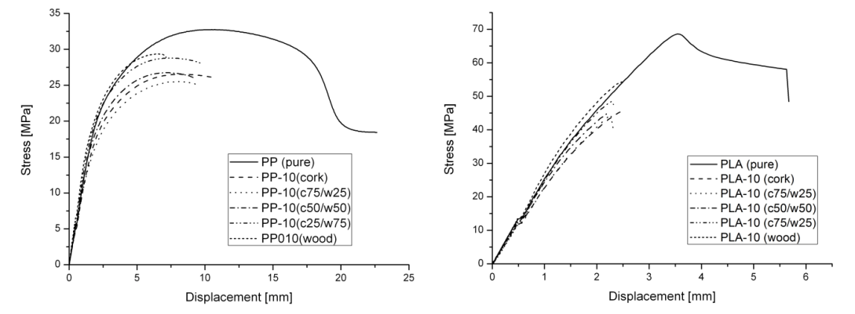
Figure 1. Stress-strain curve comparison for different types of PP (left) and PLA (right) based samples, for all presented samples the filler content (cork/wood) was 10%.

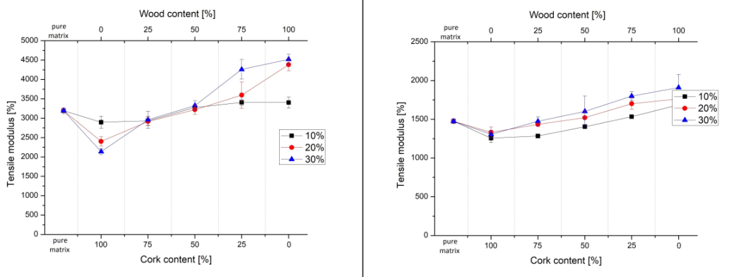
Figure 2. Tensile modulus comparison for PLA (left) and PP (right) based materials.

Also the dynamic characteristics measured by DMTA analysis from -50 to 150 °C are more favorable to wood flour rich samples. Interestingly, there are considerable differences in reinforcing effect between PP and PLA based sample, which can be observed comparing the storage modulus curves, where for polypropylene composites the increase in stiffness applies to all tested materials (Fig. 3), including 100% cork filler samples.

For PLA based composites the increased values of the storage modulus are reported only for wood flour rich samples (Fig. 4), while the stiffness of cork based composites drops down comparing to pure PLA samples. These inverse trends can be observed even for composites containing 30% of the filler, which can be seen in the Fig.2. The obtained results correspond with the so far conducted research works including the hybridization of compression molded and injection molded natural fillers hybrids of polypropylene and polyethylene composites [4].

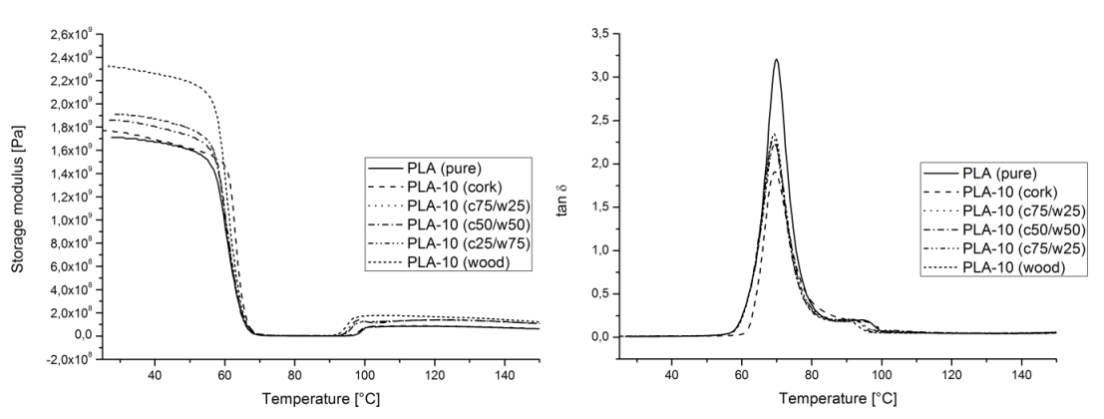

Figure 3. Storage modulus (left) and tan δ (right) plots comparison for PLA based samples.

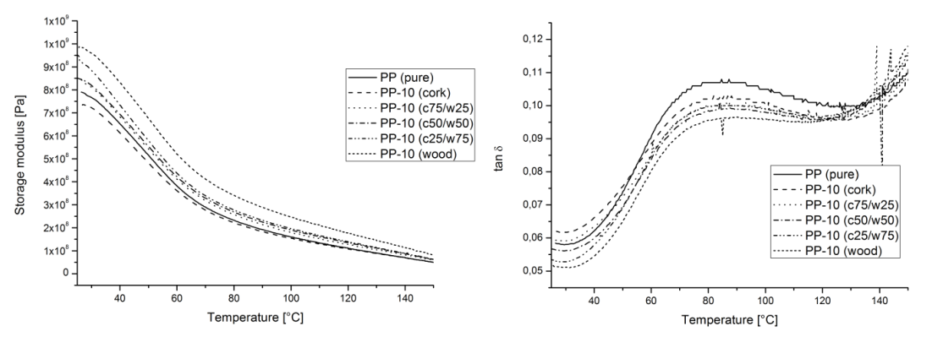

Figure 4. Storage modulus (left) and tan δ (right) plots comparison for PP based samples.

Summarizing the analysis of mechanical and thermo-mechanical measurements, the results clearly indicate the lack of a clear reinforcing effect for cork based filler. On the other hand, this confirms the rationality of conducting the hybridization process using wood fibers.

2.2. Structure observations

The structure images presented in the Fig. 5 were obtained from cryo fractured surface of the prepared samples, for clarity only the SEM images of the samples with 10% filler content are shown. Particularly noteworthy are samples containing cork agglomerates, because their porous structure has been significantly deformed as a result of high shear forces during injection stage. This deformation, in practice denoting compression of the cork particles, is the main reason for the lack of any significant changes in density for the prepared materials. For materials with the addition of wood flour, an important observed feature is the pull-out of wood fibers, which is the main mechanism causing the increase of mechanical properties for hybrid samples

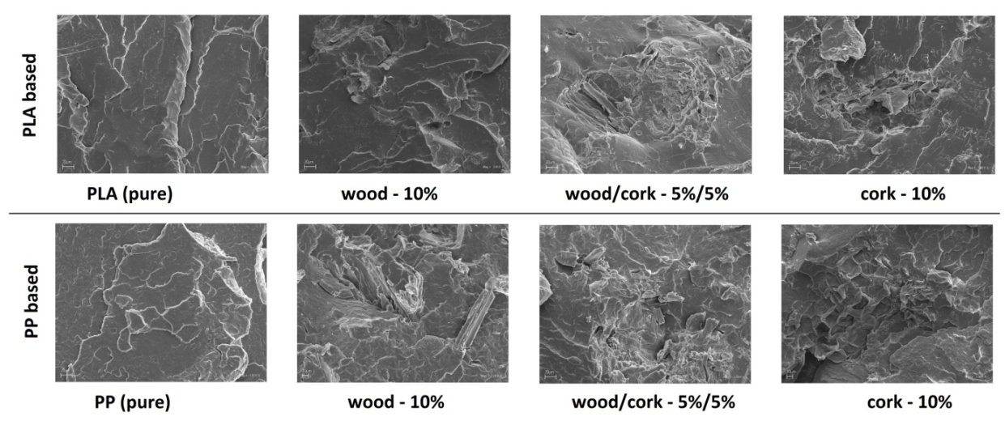
Figure 5. Structure comparison of PLA and PP based composites.

3. Conclusions

On the basis of the conducted research, it can be concluded that the hybridization treatment for composites filled with a cork/wood mixture results in the optimization of selected mechanical parameters, which was the main goal of the conducted research. For both PLA and PP-based composites, the use of cork filler did not cause a significant reduction in density. As confirmed by SEM observations, the main reason for the lack of significant changes is the disappearance of the porous cork agglomerate structure, which is the result of significant deformation/compression of the filler particles, due to the high shear stresses during the injection molding process.

References

[1] L. Gil. Cork power waste: an overview. Biomass and Bioenergy, 13:59–61, 1997.
[2] L. Gil. Cork composites: A review. Materials, 2:776–789, 2009.
[3] S. Zajchowski, J. Ryszkowska. Wood-polymer composites – general characteristics and their preparation from waste materials. Polymers, 54:754–762, 2009.
[4] M. Barczewski, D. Matykiewicz, A. Piasecki, M. Szostak. Composite Interfaces, 25:287–299, 2017.
[5] A.K. Bledzki, A.A. Mamun, J. Volk. Physical, chemical and surface properties of wheat husk, rye husk and soft wood and their polypropylene composites. Composites Part A, 41:480–488, 2010.
[6] S.P. Magalhães da Silva, P.S. Lima, J.M. Oliveira. Non-isothermal crystallization kinetics of cork-polymer composites for injection molding. Journal of Applied Polymer Science, 133:1–9, 2016.
[7] E.M. Fernandes, J.F. Mano, R.L. Reis. Hybrid cork-polymer composites containing sisal fbre: Morphology, effect of th fibre treatment on the mechanical properties and tensile failure prediction. Composites Structures, 105:153–162, 2013.

